Gediminas Dainius

4 November 2014

Killing Gods: The Quest for Meaning in *Final Fantasy VII*

Friedrich Nietzsche’s famous statement, “God is dead”, is an relevant one in a postmodern era searching for some remaining bastion of significance. In response to the nihilism induced by the loss of objective meaning, Nietzsche forged the idea of the Übermensch, or Overman, loosely understood here as an individual of ambition who imposes their own meaning on reality and whose love of life includes even the moments of suffering. The critically-acclaimed *Final Fantasy VII* (*FF7*) for Playstation can be read as an allegory for the progression of Man towards Overman, and its status as a videogame makes it a particularly suitable medium to experience this development. *FF7* intertwines narrative and game mechanics in a fashion that other mediums cannot replicate to give the player an active role in dispensing with godlike figures, gods being defined for the purpose of this essay as powerful beings capable of controlling the masses through brute force or the dissemination of suppressive power paradigms. Although the focus will be on *FF7,* elements will be drawn from the game’s prequel, *Crisis Core: Final Fantasy VII* (*CC*), and its sequel, the film *Final Fantasy VII: Advent Children* (*AC*) to inform my reading of *FF7* and the protagonist Cloud’s character arc. *FF7*’s function in implicitly conveying the progression of Man to Overman is most overtly present in the game parameters. To beat the game, the player must overcome Shinra, Gaia, and Jenova, three potentially destructive, godlike forces. In dethroning these loci of power, the game’s goal is achieved and the meaning-making seat left open for the player.

Gaia, the planet itself, being both conscious and dangerous, is one of these deities. Although not inherently malevolent, the serene quality generally attributed to nature is brought into question by Gaia’s presence as an enemy, especially since in trying to protect itself Gaia unleashes the Weapons, a group of enormous monsters that threaten the human race. The idea of a conscious Gaia is supported primarily by manifold clues in *CC*. The most difficult fight in this game is against a superboss called Minerva, who is coincidently fought deep underground in a cavern housing Emerald Weapon. Not only does she share a name with the Roman goddess, but beating her rewards the player with the powerful “Divine Slayer” accessory, suggesting that Minerva is Gaia’s avatar. Moreover, it is this same figure that appears to the main antagonist once he has been vanquished and judges whether he will continue to live or have his energy dispersed into the Lifestream, the stream from which all souls are born and to which all must return (See Figure 1). Minerva and Emerald Weapon are the most difficult battles in the two gamesand Gaia is therefore presented as the strongest, but least directly adversarial force in *FF7*’s setting.

Another controlling force in *FF7* is the Shinra Electric Power Company. Because of its monopoly on Mako, a non-renewable form of energy derived from the Lifestream, and its conspicuous military presence, Shinra is an extremely powerful influence in the game world that can be linked to contemporary society’s capitalistic paradigm. Additionally, Mako’s formation is similar to that of fossil fuels in that it is an energy source derived from the death of various beings much like how the formation of fossil fuels is based on the decomposition of once-living organisms. Furthermore, overuse is damaging to the planet, and therefore its inhabitants, much like how contemporary society’s dependence on fossil fuels has accelerated pollution and global warming. Mako has become a necessity for the inhabitants of the game world, and the distributors are the primary villains for much of the narrative. President Shinra even has Sector 7, a densely populated region of the city Midgar, destroyed along with those living there simply to stop a rebel group from destroying Mako reactors. In fact, he watches the destruction from his penthouse while Joseph Haydn’s *The Creation* plays in the background (Mitropoulos 137), an allusion to the story of the Emperor Nero playing the fiddle as he watches Rome burn. This scene equates President Shinra with a vengeful god who can create or destroy at will(See Figure 2).

The third force is the alien entity Jenova, who crash-landed on the planet 2000 years prior to the in-game events, fitting neatly with the advent of Christianity in the real world. The chamber housing her remains is even covered by an angel-like doll, suggesting divinity (See Figure 3). Furthermore, her name mixes the words Jehovah, the name of the Abrahamic God, and supernova, a stellar explosion, to outline a celestial figure that is destructive on a cosmic level. Significantly, certain individuals in *FF7*, including Cloud,areinjected with Mako energy and Jenova cells to enhance their physical abilities, but these additions allow *FF7*’s main villain Sephiroth to control them, which he does time and again.

Jonah Mitropoulos suggests that “Sephiroth’s name originates in Western Kabbalistic spirituality, where the sephirot represent the ten emanations of an Absolute God” (134). This seems fitting because in a re-imagining of the immaculate conception of Jesus, Sephiroth is injected with Jenova cells while still a foetus. Similarly, in the final battle he flies with one wing, a parody of the angelic, a being with immense power but none of the goodness (See Figure 4). Sephiroth becomes the primary antagonist in the game, and an amalgamation of the three loci of power previously discussed; as a member of Soldier, an elite military group run by Shinra, he is injected with Mako energy and Jenova cells, aligning him with the strength of all three groups. It is important to note that his status as a living legend makes him the logical final boss, as it turns his defeat into the final disavowal of a figure that was previously held up as a false exemplar to the masses.

Cloud’s journey is an allegory for modern man’s development into a being that can find meaning in the absence of signposts such as these. Numerous elements link his plight directly to that of the player. For one, he lives in the city of Midgar, which is phonetically similar to Midgard, the name for the world in which all humans live in Norse mythology. Moreover, the English release of *FF7* contains a two minute long scene of Sephiroth’s attack, Supernova, in which an energy beam slices through this solar system’s planets before grazing one that looks suspiciously like Earth (See Figure 5). As such, Cloud is the avatar a player can assume to go on an existential quest to eliminate negative influences in their lives, forces that can be most readily seen in this world as capitalism, religion, and the wild. Although forged by these powers, Cloud does not have to defer to them.

As Mia Consalvo and Nathan Dutton have asserted, when analyzing a game it is also important to look at information and choices the interface offers the player. In *FF7* the player’s level is one of the determining factors in their success. Level is determined by experience points, which can be linked to life experience in this case seeing that they are gained from defeating various enemies, most of which are aligned in some way to the three powers discussed earlier, for instance Shinra’s robots, Gaia’s lesser beasts, and literal pieces of Jenova. If these enemies can be interpreted as aspects of the godlike beings from which they derive, then the progression of these battles simulate the necessity of rejecting portions of an adverse belief before the whole thing can be disposed of. In like manner, the player can choose how to ‘build’ a character, focusing for instance on healing, offence, or support, suggesting that there is more than one type of person who can become an Overman. Different party builds will have varying rates of effectiveness, but given enough effort, any player can complete the story with their own individualized party.

Making the player assume the role of Cloud allows them to take an active role in becoming a god in their own right because the party must gain considerable strength to defeat the formidable adversaries awaiting them. To do this, the player must fight to increase not only their own level, but the levels of their Materia, small spheres made of condensed Mako energy, which allow their owners to use magic. Materia is fairly central to success in the game, and Summon Materia calls forth specific deities, such as Odin (See Figure 6). Using these Summon Materia implies a mastery over the influence of gods, and more specifically the sublimation of energies previously geared towards detrimental power paradigms. Moreover, it connects religiosity with nature, constructing a pantheism that can be beneficial rather than restrictive. In any case, part of gaining strength comes from dismantling the constructs of power and surpassing various constraints.

Overcoming limitations is present in much of the game’s mechanics. For instance, the encounter with Emerald Weapon occurs underwater, and without the Underwater Materia equipped, players must defeat what is arguably the hardest boss of the game in under 20 minutes (See Figure 7), serving as a metaphor for mankind’s need to overcome nature. The Knights of the Round Materia is irreplaceable in fights such as these because it enacts 13 hits as opposed to the normal single hit, exceeding one of the game’s fairly stable conventions. To get the Materia, players must breed and race large flightless birds called chocobos until a golden one is born. This golden chocobo can walk on water, which is the only way to access the cave housing this Materia (See Figure 8). Significantly, the ability to walk on water hints at something divine in the player. In both instances, however, flouting these barriers are intended transgressions of the game world’s rules.

Other limitations can be surpassed by less conventional means. Take the case of Megalixirs. These items replenish the entire party’s Hit Points and Magic Points, and so are of particular importance when fighting the more difficult bosses. Only 14 can be found in the game, although they are also obtainable from the hard to find and difficult to beat Master Tonberry enemy as a rare drop, and as a prize for wining an S class chocobo race (Final Fantasy Wiki). There is however an easily exploitable glitch that allows a player to duplicate items. As a typo with interpretive potential is fair game in literary criticism, so too is this widely-known glitch worthy of mention here. Exploiting this is not necessarily cheating because as Mia Consalvo’s research has shown, many players consider a videogame’s rules to be “contained within the game itself, in the game code” (85), making such a ‘bug’, if that is what it truly is, a part of those rules. Even if one were to call this cheating, and some do consider taking advantage of shoddy programming to be cheating (91), it amounts to much the same: the player is provided with an opportunity to break away from the logistics of the game world, simulating the need to think outside of what one knows to find the strength to retrieve the governing principles of their lives from external forces.

This sense of doing the impossible culminates in the final battle against Sephiroth in which Cloud’s consciousness is sucked out of his body, presumably making the fight one of mind against mind. The power dynamic shifts to reflect this and Sephiroth no longer appears as a god, but as a man, suggesting that once the individual lifts the deeply embedded veil that is the visible machinations of a particular paradigm, they expose its weak foundations. It makes sense that this battle cannot actually be lost. Moreover, the most powerful special ability in the game, Omnislash, is the only available attack, even if the player has not unlocked it, suggesting an omnipotence that speaks to Cloud’s status as a god figure (See Figure 9).One can ascertain from this secured victory that the battle is already won at the point in which the supernatural or absolute aspects have been stripped away reducing the conflict to one’s will against that of another. Cloud destroys Sephiroth, the figurehead of these negative power dynamics, and even if the player is unaware of the symbolic significance of their journey, it is clear that all is well with world.

So why then does the Cloud of *AC* appear so dejected? One of the first images the viewer is exposed to is that of a barren wasteland, Cloud’s iconic Buster Sword embedded in the ground, rusting (See Figure 10). This sword, it is revealed in *CC*, originally belonged to the noble character Angeal, and served as symbol of his honour and pride. The fact that the sword itself is gigantic and unwieldy speaks to pride itself: difficult to use properly, but a powerful tool nonetheless. This sword is then passed on to Zack who appropriates it as a symbol of his own honour. And finally, while Zack is dying in the cutscene at the end of *CC*, he says to Cloud, “My honour, my dreams, they’re yours now,” as he hands him the sword, linking the blade not only to self-worth, but to ambition (See Figure 11).

A primary concern in *CC* is the fine line separating heroes from monsters, and although this examination warrants its own essay, it is enough for our purposes to consider how Zack asserts that to be a hero “you gotta have dreams”. Heroes, as they are loosely defined in *CC*, can be linked to Overmen seeing as both require a constant state of striving. To have dreams means that there is something that is as of yet unattained, and therefore a meaning to existence. *FF7* serves to rid the world of the god figures that would subjugate it, and that is a noble quest, but it is one that is ostensibly completed by the end of the game.

*AC* portrays the adventurer after he has walked into the sunset, and as such problematizes his role. For instance, the film confronts the idea that heroes are defined primarily by their physical prowess by giving Cloud what is called Geostigma, a black discoloration of the skin occurring when the body attempts to rid itself of the lingering influence of Sephiroth’s cells. The condition leads to physical decline and eventually death (See Figure 12). The disease not only forecasts Sephiroth’s return, but connects the idea of decay to the godlike forces he represents. This development can be best considered in relation to Nietzsche’s concept of eternal recurrence, which is the idea that all that has happened is destined to occur again and again for eternity. The acceptance of and even desire for this cycle is integral to the development of the Overman. Even suffering is a key component of eternal recurrence because discipline stems from pain. Philip J. Kain explains that one must “love them [the suffering in life] in the way *warriors* love their enemies—that is, as a mark of distinction and an occasion for triumphing over them in battle” (67, author’s emphasis). It is therefore important to note that Sephiroth’s cryptic final words to Cloud in *AC*, “I will never be a memory”, connote this kind of cycle. To truly be an Overman Cloud must not only accept Sephiroth’s literal or symbolic return in this lifetime and the infinite instantiations of the eternal return, but embrace them fully, relishing the chance to prove his mettle.

But even this is a reactionary measure in light of a clearly definable obstacle. *FF7* does not, however, function only as the procedural negation of dominant power constructs; it promotes *amor fati*, a love of fate and life that juxtaposes the controlling forces in the game. As much is evinced in the narrative’s idealization of the Cetra, an itinerant race who were spiritual but not overtly religious. Their continual search for the Promised Land, which seems to be the Lifestream itself, exemplifies *amor fati*, affirming both life and death. Even without this information, the player meets Aerith, the last (Half-)Cetra in an old church with flowers growing from a hole in the floor, suggesting life-affirming spirituality.

It is therefore relevant that Aerith serves as the most likely love interest in the *FF7*. To elaborate, the game weighs heavily in her favour when deciding which party member will go on a date with Cloud; Aerith gains points more easily, loses them with greater difficulty, and begins with more than everyone else (qtd. in Lee). As Cloud’s romantic interest, her famous death scene gains considerable importance, for Sephiroth attempts to make Cloud commit the act. This in-game moment replaces the regular options on the controller with the options to shift weight, look from side to side, draw or sheathe Cloud’s weapon, or move toward or away from Aerith (See Figure 13). The player cannot advance with the story until they move toward the killing act, at which point the other party members stop Cloud, and Sephiroth does the deed himself. Patrick Lee explains that this is more effective than having the moment of possession occur during a cutscene or a scene of in-game dialogue because the convention is that the player does not have control during these periods anyway. Indeed, rather than experience empathy for Cloud, the choice to have the scene play out in-game serves to directly challenge the player’s own agency.

This death spurred a widespread outcry, and with good reason—the loss is not only a narrative one that sees the romantic interest murdered, but a mechanical one that bars access to what may have been an active party member. The death of a playable character is not unknown in gaming, but many contemporaneous RPGs such as *The Legend of Dragoon* lessen the impact on the gameplay itself by adding a replacement character with stats and moves identical to those of the lost character. *FF7*, however, accentuates the relevance of Aerith’s death by making the loss twofold. If Sephiroth comes to represent the controlling paradigms in one’s life, then by killing Aerith, with all her association to pantheism, the game illustrates how outside forces are detrimental to the individual in their obstruction of the most natural and beneficial path: a love of this world.

Killing Sephiroth cannot restore the love of fate that is lost with Aerith, nor can Cloud remain a “hero” because he no longer has dreams to realize. This tension is only resolved in *AC* when Cloud finds solace instead in his friends and the continuation of the community around him; as much is conveyed in the scene where each of the party members from *FF7* help to propel him higher into air so that he can reach and defeat the Summon Bahamut Sin (See Figure 14). The narrative is then wrapped up with imagery similar to that seen in Aerith’s church; Cloud performs a non-religious baptism, pouring the Lifestream over those still plagued by Geostigma to heal them (See Figure 15). Love of life itself becomes tied to community, and the two come together to purge the masses of the disease that is the insidious pull of exterior sources of meaning that seek to exploit their proponents. Cloud is placed in the symbolic position of a religious leader, but his only doctrine is love of life itself.

Nietzsche asks the question, “Must we ourselves become gods simply to seem worthy of it [God’s destruction]?” (qtd. in Wood 171), and it becomes evident that in many ways Cloud’s party has. Kain asserts in his explications of Nietzsche’s philosophy that in the same manner that the Christian God appeals to no higher authority because his seat of power lends authenticity to his interpretations, “So too the Übermensch needs no higher alien truth. He simply posits his own. He himself is the sole source of the highest meaning and value. He is subordinate to nothing” (106). This death of God indicates a new age where meaning cannot be unquestioningly derived from authoritative figures, religious or otherwise. As such Cloud, in his disposal of divine beings, has freed himself and humanity in general to become Overmen by loving fate, a dream that can be experienced in every moment but never completed. *AC*  leaves the viewer with an image of Cloud’s Buster Sword, now clean, resting in Aerith’s church (See Figure 17); a fitting picture that extends meaning for the hero and Overman past transient quests to the love of life more generally.

Nietzsche thought that humanity should strive to free itself from the bondage that religion and other similar institutions created. *FF7* and its surrounding narrative can be read as an allegory promoting this progression from Man to Overman since the game’s god figures are harmful, the player must surpass limitations to dispose of them, and Cloud does indeed eventually come to love fate. *FF7* does not offer a set of values with which to overcome nihilism, but suggests only that those artificially placed within us should be abandoned so that we may better enjoy life it, although perhaps it is the necessity of this continual endeavour that lends meaning to existence.

Works Cited

Consalvo, M. and N. Dutton. 2006. “Game Analysis: Developing a Methodological Toolkit

for the Qualitative Study of Games.” *Game Studies*. n.p. Web. 26 Oct. 2014

Consalvo, Mia. *Cheating: Gaining Advantage in Videogames*. Cambridge: Massachusetts

Institute of Technology, 2007. Print.

*Crisis Core: Final Fantasy VII*. Square Enix. 2008. Video game.

*Final Fantasy VII: Advent Children*. Dir. Tetsuya Nomura. Sony Pictures, 2005. DVD.

*Final Fantasy VII*. 1.06. Square. 1997. Video game.

Kain, Philip J. *Nietzsche and the Horror of Existence*. Plymouth: Lexington Books, 2009. Print.

Lee, Patrick. “Mechanics as Motif in *Final Fantasy VII*”. *Game Theory*. n.p. Web. 26 Oct. 2014.

“Megalixir.” *Final Fantasy Wiki.* Wikia, n.d. Web. 26 Oct. 2014.

Mitropoulos, Jonah. “Shinto and Alien Influences in *Final Fantasy VII*.”

*Final Fantasy and Philosophy: The Ultimate Walkthrough*. Eds. Jason P. Blahuta and Michel S. Beaulie. Hoboken: John Wiley & Sons, Inc., 2009. 125-41. Print.

*The Legend of Dragoon*. SCEI. 1999. Video game.

Wood, Christopher R. “Human, All too Human: Cloud’s Existential Quest for

Authenticity.” *Final Fantasy and Philosophy: The Ultimate Walkthrough*. Eds. Jason P. Blahuta and Michel S. Beaulie. Hoboken: John Wiley & Sons, Inc., 2009. 167-84. Print.

Figures

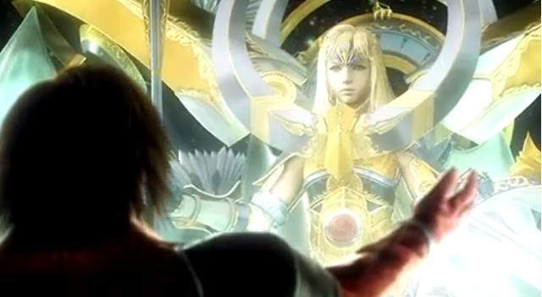

Figure 1: Genesis reaches out to Minerva.

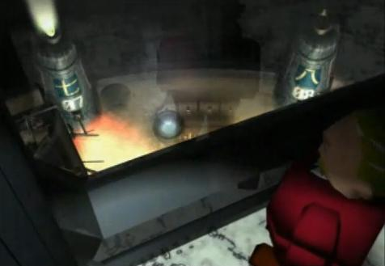

Figure 2: President Shinra watches the destruction of Sector 7.

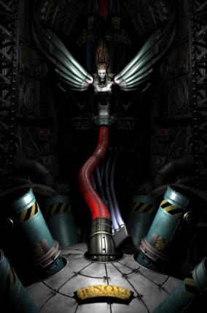

Figure 3: Jenova doll.

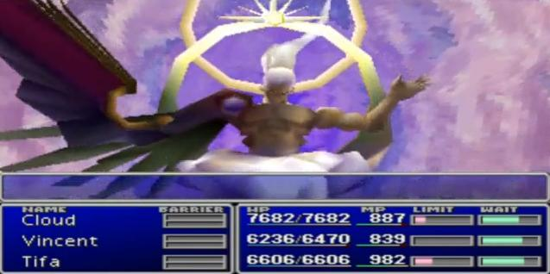

Figure 4: Sephiroth’s one-winged angel form.

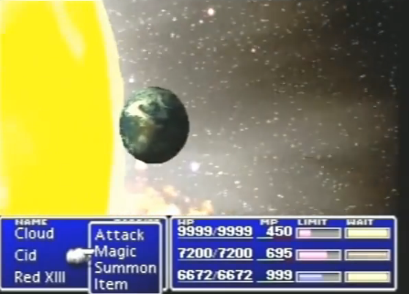

Figure 5: Sephiroth’s “Supernova” attack

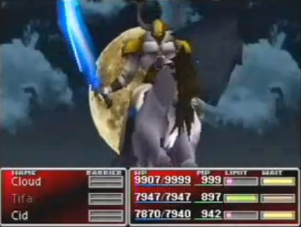

Figure 6: Odin is summoned to battle.

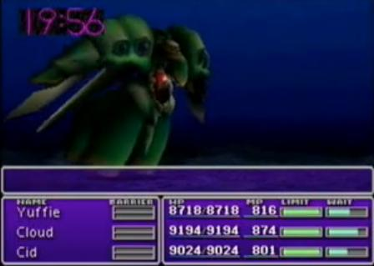

Figure 7: Emerald Weapon’s underwater time-limit.

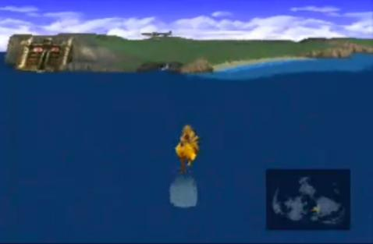

Figure 8: A golden chocobo walking on water.

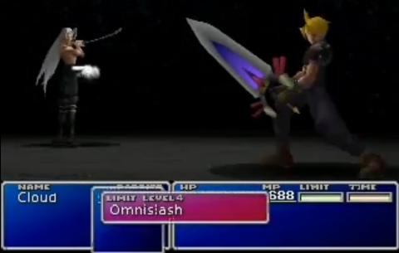

Figure 9: Cloud prepares to use “Omnislash” in the final battle.

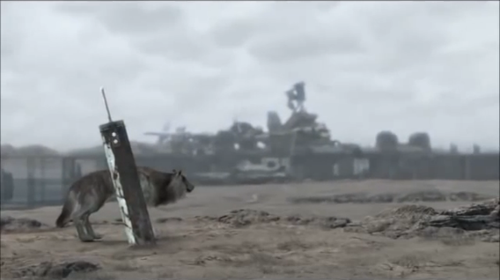

Figure 10: Cloud’s rusting Buster Sword.

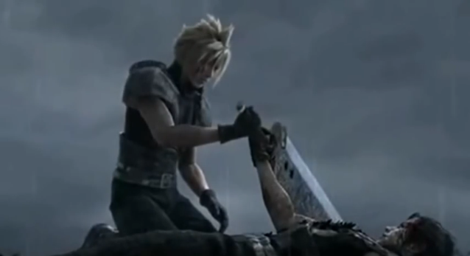

Figure 11: Zack gives Cloud the Buster Sword.

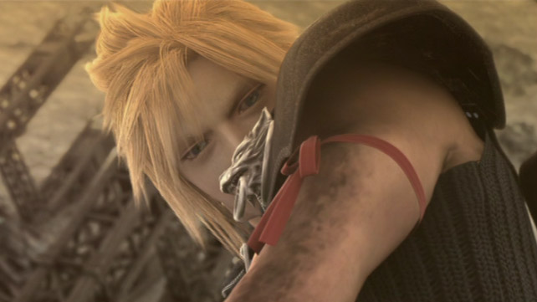

Figure 12: Geostigma.

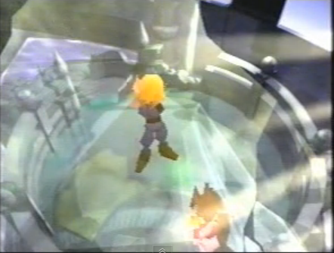

Figure 13: Cloud prepares to kill Aerith.

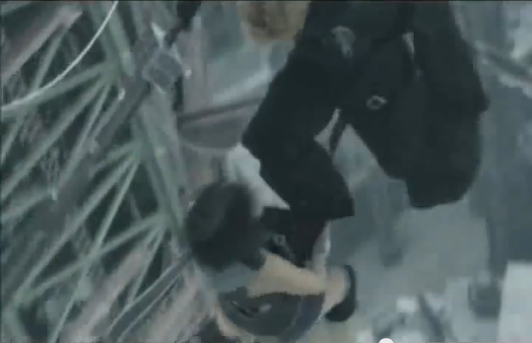

Figure 14: Yuffie gives Cloud a boost.

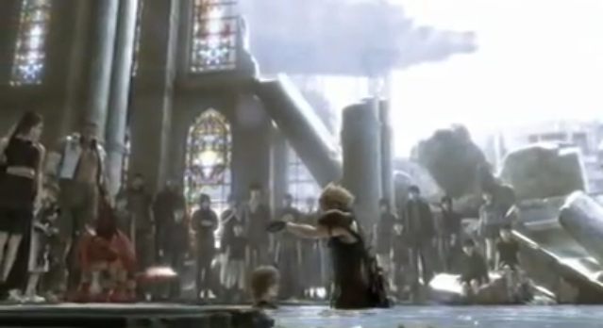

Figure 15: Cloud cures Denzel of Geostigma.

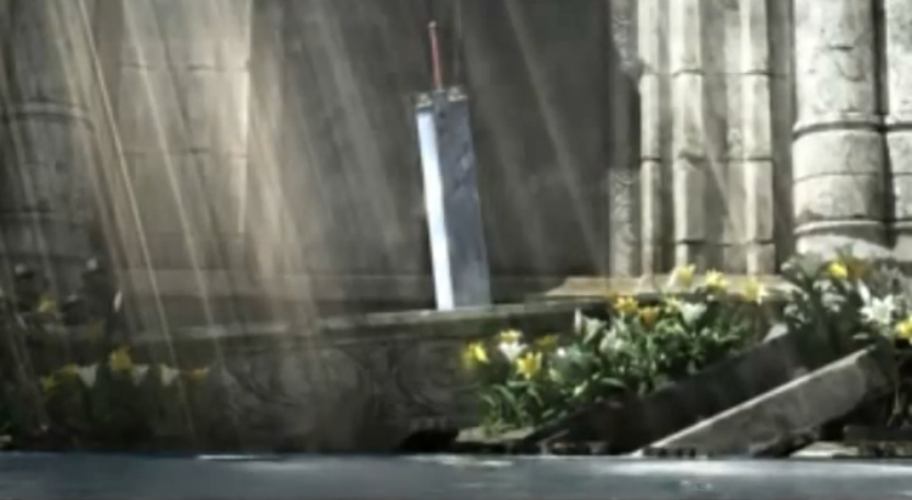

Figure 16: Cloud’s Buster Sword in Aerith’s church.