The Boeing 737-800 for FlightGear (D. Culp, S. Adams, I. Cunningham, M. Soitanen, G. Hernandez, J Redpath, J. Davidson) is becoming one of the best aircraft available in the FlightGear repositories on GitHub. In this review we will take a closer look at all the details of the aircraft.

The present development of the 737 was started in 2016 by G. Hernandez, J. Redpath, and J. Davidson. Basing their aircraft off an earlier development which added a quite complex autopilot system among other changes, these three developers decided to move ahead of their own accord, due to increasing delays with M. Soitanen's work. With permission from the original development, they quickly started to work on the aircraft. You may download the present state at <http://www.github.com/legoboyvdlp/737-800>.

For the purposes of this review we will start in Maiquetia Intl (SVMI), complete an entire circuit of the aerodrome, and land again on runway 10.

Upon startup of the simulator, the first noticeable thing is the wide variety of splash screens available. Someone evidently got busy with the 737, took lots of screenshots, polished them up, and sent them to M. Soitanen! Regardless, startup is relatively fast. My computer with a mediocre CPU launched the 737-800 within 25 seconds.

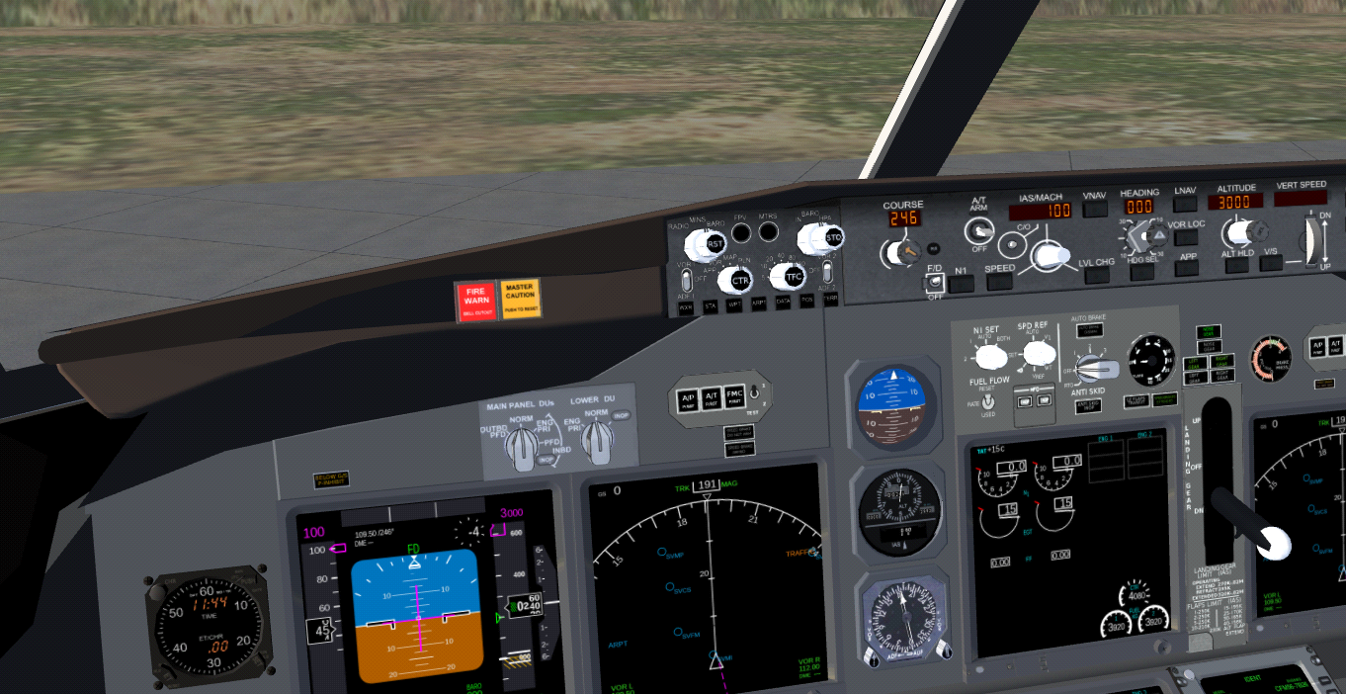

Here we have an initial view of the cockpit. As seen in the screenshot, the detail of the displays is quite good; the PFD in particular is fully working. All six main screens pop up upon a mouse click to show a similarly detailed 2D Panel. In fact, these displays are driven by the Canvas system where every detail involves drawing it in Inkscape and animating it through our Nasal scripting language. This system supports projecting the displays onto a dialog box. For example, see the screenshot below.

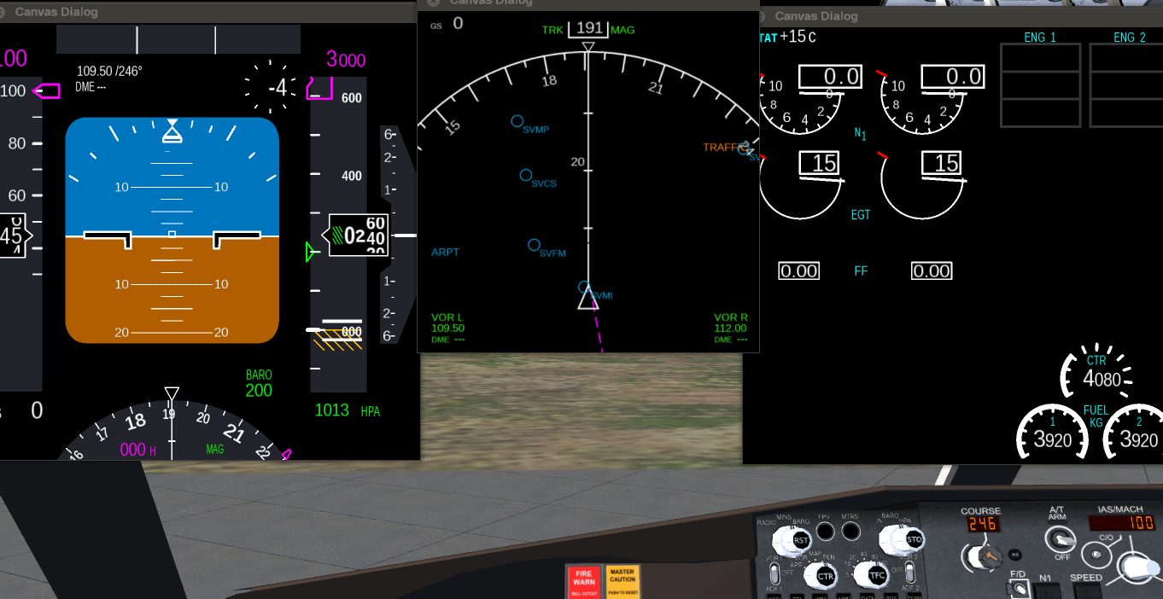

Earlier technologies used for displays involved projecting an image onto a 2D surface and animating it through XML. Each item had to be meticiously coded by hand, and it was an extremely time consuming process. This Canvas technology has allowed developers to go further than ever before when it comes to glass cockpits. Gijs de Rooy is presently developing a new Canvas CDU framework for the Boeing family, which may be adapted to the other Boeings when released.

However, when you pan around the cockpit, you see that things are certainly not at the standards that they ought to be at. Textures need considerable improvements; while they are clear and readable, they need improvement both to come closer to the real aircraft and to improve the asthetics. Presently there is simply a grey background to most of the displays, which ought to be improved. In particular, the pedestal needs a lot of work, and the yoke checklists must be redone at a higher resoloution.

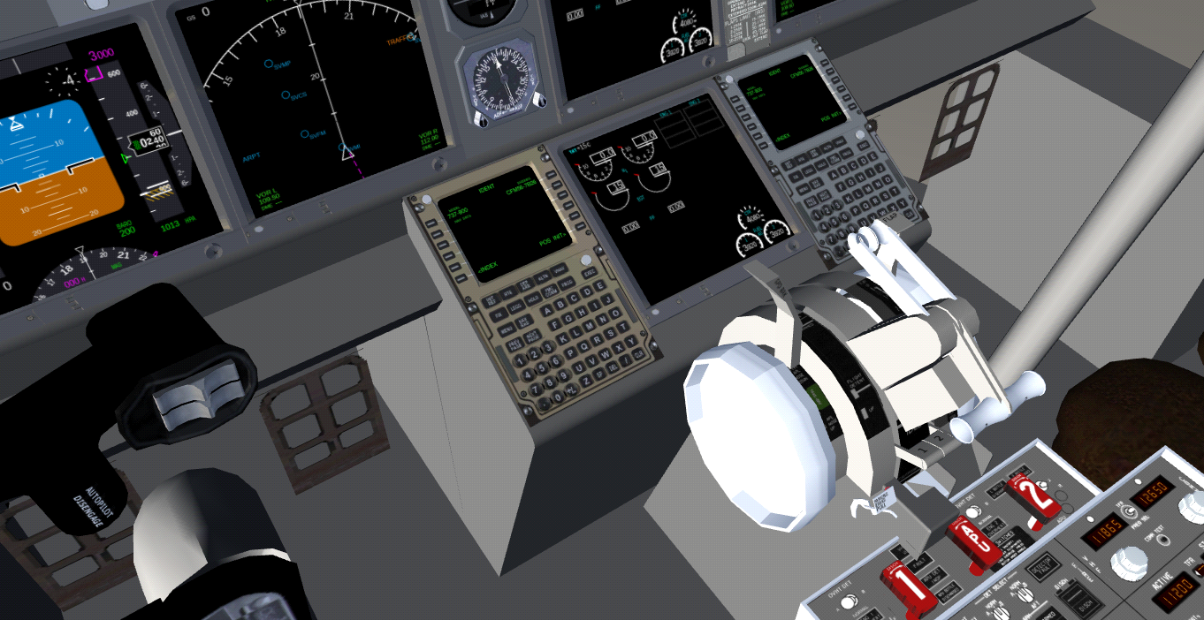

Despite all that, in general, the 3D modelling is sufficient, apart from some details that are easy to correct such as the lack of proper brake pedals. I just noticed a graphics bug there with the CDU; both ought to be grey! I will have that changed before the next release. As noted before, texturing needs a lot of work.

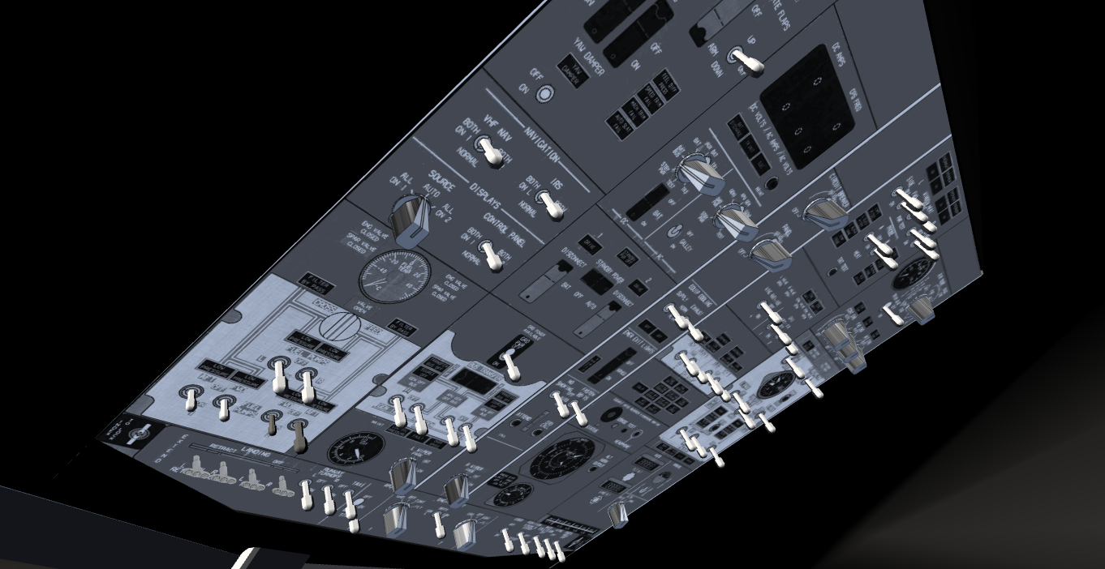Apart from the radio panels, in general the pedestal is mostly non-working 2D panels. The overhead panel has more 3D components, but till now, few of them work. This is mainly due to the fact that M. Soitanen has focused on the autopilot and displays, and neglected the 3D work! The present author hopes to improve the overhead before long; despite a lack of skills when it comes to 3D, I did manage to create, add, texture and animate the landing light switches, which if I may say it myself, look quite nice!

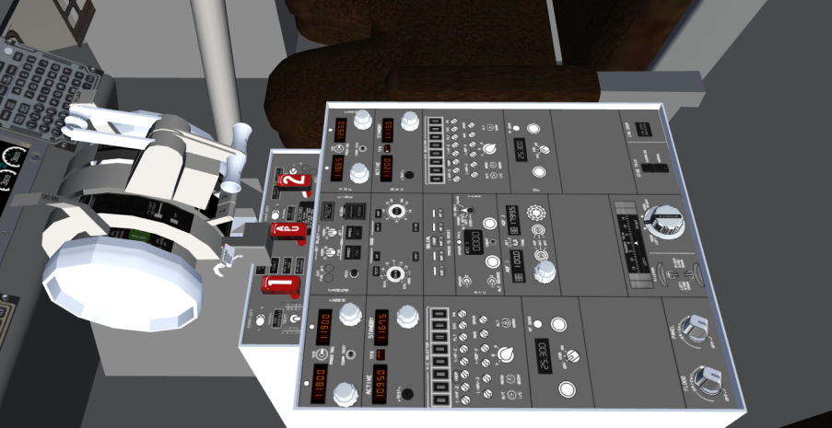

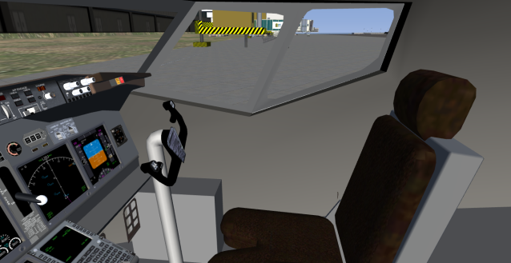

A look to the side reveals a nicely modelled cockpit seat, but I am not so sure about the texture chosen. If any of my readers have any comments, please let me know. Other details of note are the lack of detail behind the cockpit seats, the nicely done landing gear lever, and the yoke and its column.

It’s by far time to get started! Unfortunately, a realistic startup procedure is not yet modelled; for now we are forced to use ‘autostart’. We connect the pushback and ask for autostart and the CFM56-7s immediately begin to spin up. By the time we complete our pushback onto LINE SOUTH, the engines are already at idle.