**Instructions for Belt-Experiments:**

This experiment investigates the perceived direction of vibrations felt on your skin. During the experiment, you will be asked to wear a tactile belt over your T-shirt, while standing up. The belt contains vibrating motors that correspond to different directions in space around you. On each trial, different motors will vibrate. Your task is to indicate the direction of the vibration on this circular diagram, in which your body is facing upward.

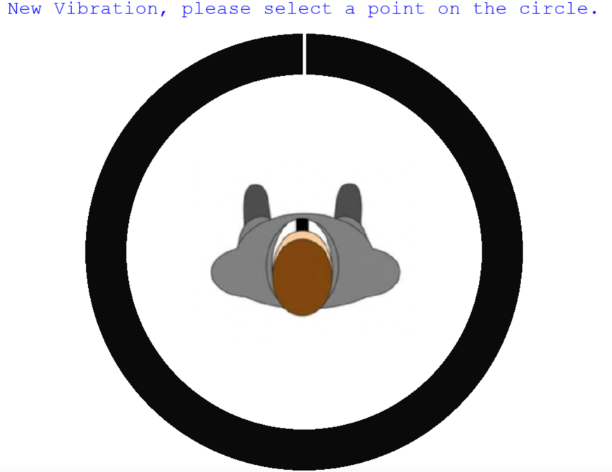

Each time you feel a vibration, use the mouse to select the point on the circle that corresponds exactly to the perceived direction of the vibration. Please do not touch the belt with your arms or hands. Instead, focus on feeling the vibrations with your waist. Each vibration lasts 2 seconds. Please wait until the end of the vibration before giving an answer, but you can already move the mouse to the intended position. Indicate the direction of the vibration as accurately as possible. After your response, a different motor will vibrate. Continue to select the matching point on the circle for each new vibration.

The experiment will take an hour in total and consists of 4 blocks. There will be a short break between each block. Be assured that you can stop at any time by telling us. Do you have any questions?

**Steps:**

1. Secure the belt around your naval area over your T-shirt, ensuring it is as tight as possible and has no gaps between the belt and your waist, while still allowing comfortable breathing. Position the buckle on the left side and the battery at the back.
2. Before the first experimental block, there will be a few practice trials to familiarize you with the vibrations you will experience during the main trial.