SMART ATTENDANCE AND WORKFORCE
MANAGEMENT SYSTEM
23CS54C – MODERN WEB TECHNOLOGIES
Submitted by
KARTHIKA R R 2403957610422079
In partial fulfillment for the award of the degree
of
BACHELOR OF ENGINEERING/TECHNOLOGY
in
COMPUTER SCIENCE AND ENGINEERING/ INFORMATION TECHNOLOGY

NATIONAL ENGINEERING COLLEGE
(An Autonomous Institution affiliated to Anna University, Chennai)
K.R.NAGAR, KOVILPATTI - 628503
OCTOBER - 2026

NATIONAL ENGINEERING COLLEGE
(An Autonomous Institution affiliated to Anna University, Chennai)
K.R.NAGAR, KOVILPATTI - 628503
BONAFIDE CERTIFICATE
This is to certify that this project report, “Smart Attendance and Workforce Management System”, is the bonafide work of KARTHIKA R R (2403957610422079) who carried out the project work under my supervision.
Course Instructor/Guide
Submitted to the 23CS54C – MODERN WEB TECHNOLOGIES Viva-Voce examination held at National Engineering College, K.R.Nagar, Kovilpatti on ____________
Internal Examiner Co Examiner

TABLE OF CONTENTS
CH NO TITLE PAGE NO
1 INTRODUCTION 4
2 OBJECTIVES 6
3 DESCRIPTION 7
4 CLASS DIAGRAM 9
5 TABLE STRUCTURES 13
6 ER DIAGRAM 30
7 TECH STACK 33
8 MODULES 35
9 CONCLUSION 105
CHAPTER 1

INTRODUCTION
In a continuously operating industrial manufacturing enterprise, the working day never truly ends. Production runs across rotating shifts, workers move between departments as the day's load demands, and the single fact that drives every downstream decision — who was actually present, in which shift, in which department — is captured not on paper but on a fingerprint reader mounted at a gate. When that one fact is wrong, everything built on top of it is wrong: the strength report that the production planner reads at the start of a shift, the overtime claim an operator files at the end of it, and the wage that is paid at the end of the month.
Manual and semi-manual attendance handling fails this environment in predictable ways. Registers are signed late or by proxy. A worker who punches in forty minutes early for the morning shift is recorded against the night shift that is just ending. A night shift that crosses midnight is credited to the wrong calendar date. Leave applications travel as paper slips and stall on a supervisor's desk, so the attendance sheet shows an absence where an approved leave should stand. Overtime is reconstructed from memory at month end. Each of these is a small error, and together they make the monthly attendance summary something that has to be argued over rather than relied upon.
The Smart Attendance and Workforce Management System is a standalone full-stack enterprise web application designed for comprehensive workforce tracking and attendance lifecycle management, built to eliminate attendance disputes in continuous industrial operations. It manages everything from biometric hardware integration, raw punch capture, automatic shift detection, and attendance finalisation to the complete leave lifecycle, overtime and special-entry recording, attendance-linked incentives, and department-wise strength and discrepancy reporting.
The system talks directly to ZKTeco-family biometric terminals. Punches are ingested in real time through a punch webhook as workers present their fingerprints, and again through a scheduled pull over the device SDK every five minutes that recovers anything a network interruption lost; a listener for the vendor's iclock push protocol handles the device handshake and heartbeat. Each punch is stored permanently as raw evidence, then processed twice: once immediately, to drive a live floor dashboard, and once again after the shift has closed, to produce the finalised attendance record that the rest of the organisation treats as authoritative.
The deliberate boundary of this project is that it stops at the day count. It produces, for every employee and every month, a verified set of counts — present days, paid and unpaid leave days, week-off days worked, holiday days, overtime hours, incentive qualification — and publishes them. It does not compute a rupee. This system focuses specifically on verified attendance, shifts, leave, and incentive governance, producing authoritative, verified monthly summaries ready for downstream organizational reporting and statutory compliance. This report documents the design, development and implementation of the attendance system, covering its architecture, data model, algorithms and user interface.
CHAPTER 2

OBJECTIVES
- To Capture Attendance at Source: Integrate directly with biometric terminals so that attendance originates from a fingerprint punch rather than a register entry, eliminating proxy marking and retrospective edits.
- To Guarantee No Punch Is Lost: Combine a real-time device webhook with a scheduled automatic pull from each device, so that a punch survives a network outage, a device reboot, or a server restart.
- To Detect the Correct Shift Automatically: Determine an employee's shift from the actual punch time against shift windows read from the database, correctly handling early arrivals, shifts that cross midnight, and staff and supervisors whose timings differ from workers'.
- To Separate Provisional Data from Final Data: Serve a live, provisional view to the floor during the shift, and produce a separate finalised record after the shift closes, so that a supervisor's live dashboard can never be mistaken for the record of account.
- To Automate the Leave Lifecycle: Move leave from paper to a multi-level approval workflow with quota allocation, monthly accrual, carry-forward limits and a complete audit history of every action taken on every request.
- To Record Overtime and Special Entries Accurately: Capture OT hours and 8-8 double-shift entries against a specific date, shift and worked department, with bulk entry screens for the volume a mill actually generates.
- To Compute Attendance-Linked Incentives by Rule: Evaluate configurable grade-wise, shift-wise incentive slabs — including multi-shift combination rules and category overrides — instead of relying on manual judgement.
- To Give Management Real-Time Workforce Visibility: Produce department-wise strength reports comparing the day standard against actual manpower, so that a shortfall is visible while the shift is still running and not after it has ended.
- To Surface and Resolve Discrepancies: Detect every day on which the biometric attendance and the department's own attendance entry disagree, and route it through a documented approval so that every correction carries a reason, an approver and a timestamp.
- To Protect the Record Once Settled: Lock attendance for a closed date so that finalised data cannot be altered silently, with an explicit, audited unlock for genuine corrections.
- To Publish a Clean Monthly Summary: Aggregate the verified day counts into a per-employee monthly summary that the payroll system can consume without re-deriving anything from raw punches.
- To Secure Access by Role: Apply JWT authentication and role-based route guards so that HR, department administrators and staff each reach only the screens their role permits.
CHAPTER 3

DESCRIPTION
The Smart Attendance and Workforce Management System is a full-stack web application built on React, Node.js, Express and MySQL. It is organised into six major functional areas.
1. Biometric Integration and Punch Capture
This area owns the boundary between physical hardware and the database. Biometric terminals are registered with a name, location, IP address, status and a per-device auto-sync flag. Punches arrive by two independent paths. The first is real-time: a punch webhook accepts each punch, rejects a repeat inside a two-minute window, stores it and triggers processing at once. The second is an active pull — a background service connects to each enabled device over the ZKTeco SDK every five minutes and imports any log the real-time path missed. Alongside these, a listener for the device's own iclock protocol answers the terminal's configuration request, heartbeat and ATTLOG push. Every punch is written to biometric_punches as raw evidence with its enrollment ID, device, timestamp, derived IN/OUT direction and validity status, kept separate from the attendance that is later derived from it.
2. Attendance Processing and Shift Detection
This is the analytical core of the system. Shift windows are not hardcoded; they are loaded at runtime from the shift_types table and cached briefly. When a punch arrives, the processor identifies the employee, decides whether worker logic or staff logic applies, and detects the shift by matching the punch time against those windows in three passes — a midpoint-capped window, then a ninety-minute early-arrival window, then the nearest shift start as a fallback — so that a worker arriving well before the morning shift is not misfiled into the night shift that is ending. A provisional attendance row is written immediately for the live dashboard. Later, a cron job scheduled from each shift's own end time plus a two-hour buffer re-reads every punch for the day, applies the full status rules, and marks the row finalised. Shifts that cross midnight are credited to the previous calendar date. Staff carry a monthly permission pool of 120 minutes, drawn down by lateness and early exit and limited to two days a month and sixty minutes a day; workers do not. A manual regeneration path lets an administrator re-run a date range after a correction, executed as a background job in a separate process so that a large rebuild does not block the API.
3. Shift and Roster Management
Shift types define start and end times, early check-in and late check-out allowances, grace periods for lateness and early exit, half-day and absent hour thresholds, the working-hours calculation method, and the holiday list that governs them. Shift assignments place an employee on a shift for a date or a date range, with optional recurring patterns. A separate monthly employee_shifts summary records, per employee per shift per month, the total present, permission, absent, leave, late and early-exit days along with total working and overtime hours — the compact form in which the month's attendance is handed downstream.
4. Leave Management
Leave is modelled end to end. Leave types define whether a leave is paid, whether it carries forward, whether holidays inside it count, and the maximum consecutive days. Leave policies attach accrual frequency and accrual days to an employment type. Leave periods define the leave year. Leave allocations grant an employee a quota for a type in a period, carrying forward from the previous period within a limit and expiry date, supporting pro-rating for mid-year joiners, monthly accrual, and a controlled negative balance. Leave requests move through draft, submission, multi-level approval and final approval or rejection, with cancellation and withdrawal paths; every transition is recorded in a history table with the actor, the action, the old and new status and the comments.
5. Overtime, Special Entries and Incentives
Overtime hours are recorded per employee per date with from-time, to-time, OT type, shift and the department actually worked in, entered either individually or through a bulk multiple-entry grid. 8-8 entries record the double-shift arrangement separately. Attendance incentives are evaluated against configurable conditions: a grade and shift combination defines a minimum qualifying day count, a low tier and a high tier with their own rates per day, a minimum day count for each shift in a multi-shift combination, and an optional experience-based override for male workers in specific grades. Hostel attendance incentives track resident workers over a date range, packaging incentives pay per bag above a threshold, and lunch attendance records the midday in and out punches.
6. Reporting, Discrepancy Control and Security
Strength reports present department-wise standard versus actual manpower for a date across all three shifts, converting trainee workload and overtime hours into manpower equivalents. The discrepancy report compares the finalised biometric attendance against the department-wise attendance entered by HR, lists every day on which the two disagree, and routes each one through an approval that stores the original status, the approved status, a reason, an optional supporting document, the approver and the time. Attendance locks freeze a date once it is settled. Attendance, biometric, shift, OT and department reports export to Excel and PDF. Access is secured with bcrypt password hashing, JWT bearer tokens and role-based route guards, with roles of Super Admin, Admin, HR, Department Admin and Staff.
CHAPTER 4

CLASS DIAGRAM
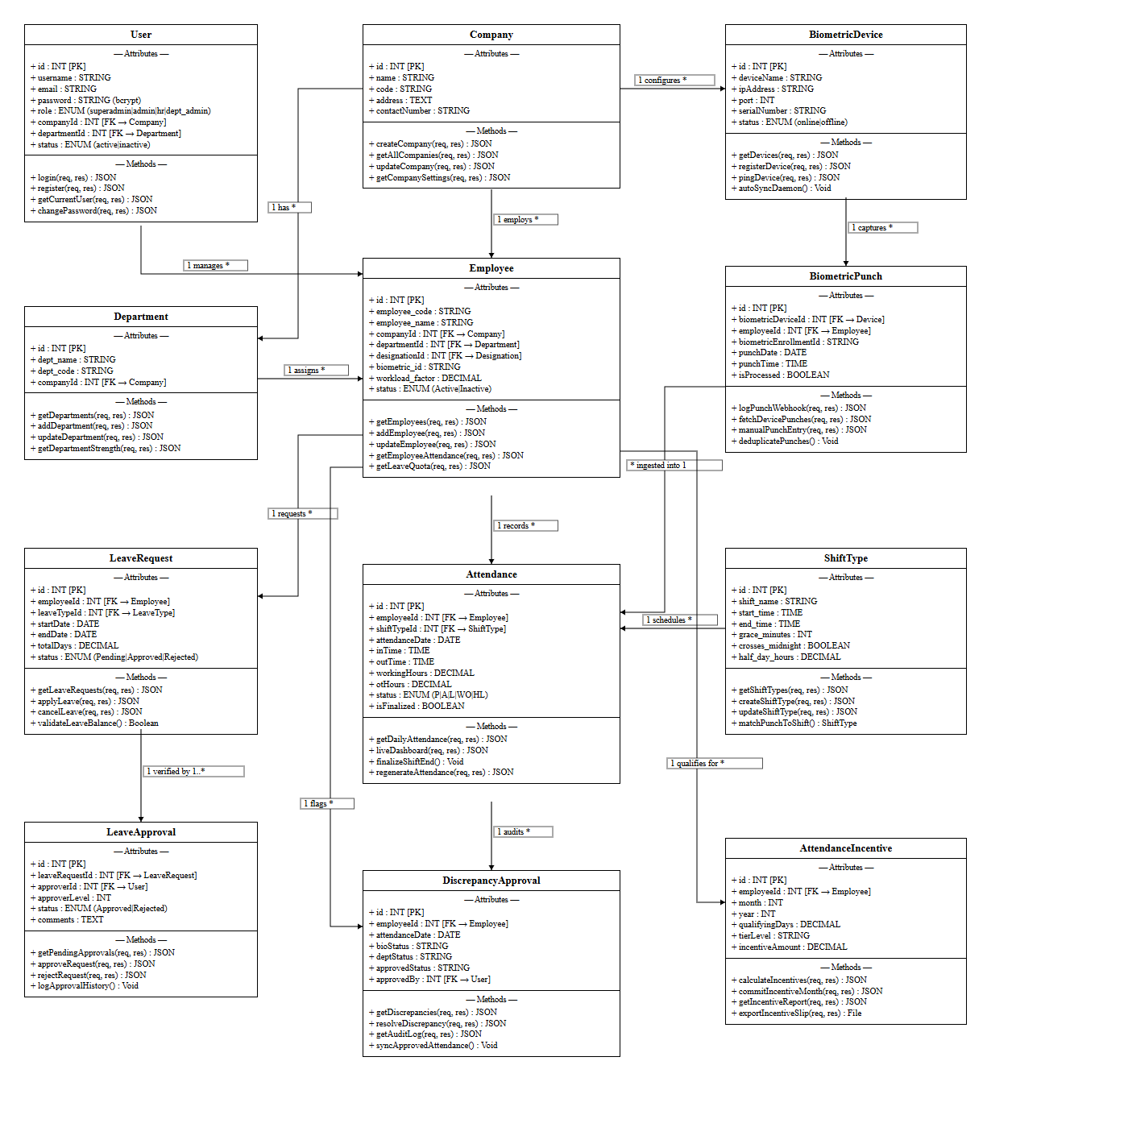
Fig 4.1 Class Diagram of the Smart Attendance and Workforce Management System
The class diagram shows the Sequelize model classes of the attendance system and the associations declared between them. Each class box lists key attributes of the model and the main operations exposed by its controller; 1 and * mark the one and many ends of each association. Employee sits at the centre: BiometricPunch, Attendance, DepartmentAttendance, ShiftAssignment, LeaveRequest, LeaveAllocation, OTHours, EightEightEntry, AttendanceIncentive and LunchAttendance all hold a foreign key to it. ShiftType is referenced by BiometricPunch, Attendance, ShiftAssignment and HolidayList. Company is the tenant root and is referenced by almost every table. LeaveRequest composes LeaveApproval and LeaveRequestHistory, and draws its quota from LeaveAllocation, which in turn depends on LeaveType and LeavePeriod.
CHAPTER 5

TABLE STRUCTURES
The system uses 32 tables in the shared MySQL schema. Their structures, taken from the Sequelize model definitions, are shown below.
5.1 Shared Master Tables
companies :
Field | Type | Null | Key | Default / Extra
id | INTEGER | NO | PRI | auto_increment
name | VARCHAR(255) | NO | UNI
logo | VARCHAR(255) | YES
registrationNumber | VARCHAR(255) | YES | UNI
addresses | JSON | YES |  | {}
phone | VARCHAR(255) | YES
email | VARCHAR(255) | YES
website | VARCHAR(255) | YES
tin | VARCHAR(255) | YES
pan | VARCHAR(255) | YES
gst | VARCHAR(255) | YES
bankName | VARCHAR(255) | YES
bankAccountNumber | VARCHAR(255) | YES
bankIfscCode | VARCHAR(255) | YES
financialYearStart | DATE | YES
financialYearEnd | DATE | YES
status | ENUM(Active, Inactive) | NO |  | Active
createdAt | DATETIME | NO
updatedAt | DATETIME | NO
Indexes: primary key only
departments :
Field | Type | Null | Key | Default / Extra
id | INTEGER | NO | PRI | auto_increment
slno | INTEGER | NO
departmentname | VARCHAR(255) | NO
acronym | VARCHAR(10) | NO
isTrain | TINYINT(1) | NO |  | 0
strengthRequired | DECIMAL(10,2) | NO |  | 0
companyId | INTEGER | NO | FK → companies
categoryId | INTEGER | NO | FK → category
createdAt | DATETIME | NO
updatedAt | DATETIME | NO
Indexes: primary key only
designations :
Field | Type | Null | Key | Default / Extra
id | INTEGER | NO | PRI | auto_increment
name | VARCHAR(255) | NO
acronym | VARCHAR(10) | NO
status | ENUM(Active, Inactive) | NO |  | Active
createdBy | INTEGER | YES |  | 1
updatedBy | INTEGER | YES |  | 1
companyId | INTEGER | NO | FK → companies
createdAt | DATETIME | NO
updatedAt | DATETIME | NO
Indexes: primary key only
employees :
Field | Type | Null | Key | Default / Extra
id | INTEGER | NO | PRI | auto_increment
curEmployeeCode | VARCHAR(255) | NO | UNI
newEmployeeCode | VARCHAR(255) | YES
firstName | VARCHAR(255) | NO
middleName | VARCHAR(255) | YES
lastName | VARCHAR(255) | NO
dateOfBirth | DATE | NO
adolescenceCertificate | VARCHAR(255) | YES
adolescenceCertificateNumber | VARCHAR(255) | YES
adolescenceCertificateValidity | DATETIME | YES
gender | ENUM(Male, Female, Other) | NO
bloodGroup | ENUM(A+, A-, B+, B-, O+, O-, AB+, AB-) | YES
maritalStatus | ENUM(Single, Married, Divorced, Widowed) | YES
profilePhoto | VARCHAR(255) | YES
categoryId | INTEGER | YES | FK → category
casteId | INTEGER | YES | FK → castes
religionId | INTEGER | YES | FK → religions
experience | INTEGER | YES |  | 0
personalEmail | VARCHAR(255) | NO
officialEmail | VARCHAR(255) | YES
mobileNumber | VARCHAR(255) | NO
alternateMobile | VARCHAR(255) | YES
emergencyContactName | VARCHAR(255) | YES
emergencyContactNumber | VARCHAR(255) | YES
emergencyContactRelationship | VARCHAR(255) | YES
currentAddressLine1 | VARCHAR(255) | NO
currentAddressLine2 | VARCHAR(255) | YES
currentCity | VARCHAR(255) | NO
currentState | VARCHAR(255) | NO
currentPincode | VARCHAR(255) | NO
currentCountry | VARCHAR(255) | NO
permanentAddressLine1 | VARCHAR(255) | YES
permanentAddressLine2 | VARCHAR(255) | YES
permanentCity | VARCHAR(255) | YES
permanentState | VARCHAR(255) | YES
permanentPincode | VARCHAR(255) | YES
permanentCountry | VARCHAR(255) | YES
designationId | INTEGER | NO | FK → designations
employmentTypeId | INTEGER | NO | FK → employment_types
employeeType | ENUM(Permanent, Contract, Temporary, Intern, Staff, Worker) | NO
dateOfJoining | DATE | NO
dateOfRejoining | DATE | YES
confirmationDate | DATE | YES
relievingDate | DATETIME | YES
leavingReason | TEXT | YES
probationPeriod | INTEGER | YES |  | 0
reportingManagerId | INTEGER | YES | FK → employees
workLocation | VARCHAR(255) | YES
employmentStatus | ENUM(Active, Resigned, Terminated, On Leave, Retired) | NO |  | Active
referencePersonName | VARCHAR(255) | YES
referencePersonContact | VARCHAR(255) | YES
shiftTypeId | INTEGER | YES | FK → shift_types
leavePolicyId | INTEGER | YES | FK → leave_policies
weeklyOff | ENUM(Sunday, Monday, Tuesday, Wednesday, Thursday, Friday, Saturday) | YES |  | Sunday
isOvertimeApplicable | TINYINT(1) | NO |  | 0
isLeaveApplicable | TINYINT(1) | NO |  | 1
biometricDeviceId | INTEGER | YES | FK → biometric_devices
curBiometricEnrollmentId | VARCHAR(255) | YES
newBiometricEnrollmentId | VARCHAR(255) | YES
basicSalary | DECIMAL(10,2) | YES |  | 0
providentFundNumber | VARCHAR(255) | YES
bankName | VARCHAR(255) | YES
bankAccountNumber | VARCHAR(255) | YES
ifscCode | VARCHAR(255) | YES
bankBranch | VARCHAR(255) | YES
paymentMode | ENUM(Bank Transfer, Cash, Cheque) | YES |  | Bank Transfer
uanNumber | VARCHAR(255) | YES
epfNumber | VARCHAR(255) | YES
esiNumber | VARCHAR(255) | YES
isTransportRequired | TINYINT(1) | NO |  | 0
busId | INTEGER | YES | FK → buses
pickupPoint | VARCHAR(255) | YES
isHostel | TINYINT(1) | NO |  | 0
isTrainee | TINYINT(1) | NO |  | 0
status | ENUM(Active, Inactive) | NO |  | Active
companyId | INTEGER | NO | FK → companies
workingType | VARCHAR(50) | YES
departmentId | INTEGER | NO | FK → departments
gradeId | INTEGER | YES | FK → employer_grades
workload | DECIMAL(10,2) | YES
createdAt | DATETIME | NO
updatedAt | DATETIME | NO
Indexes: primary key only
users :
Field | Type | Null | Key | Default / Extra
id | INTEGER | NO | PRI | auto_increment
email | VARCHAR(255) | NO | UNI
phoneNumber | VARCHAR(255) | NO | UNI
password | VARCHAR(255) | NO
role | ENUM(Staff, Admin, Department Admin, Super Admin, HR) | NO |  | Staff
status | ENUM(Active, Inactive) | NO |  | Active
companyId | INTEGER | NO | FK → companies
departmentId | INTEGER | YES | FK → departments
firstName | VARCHAR(255) | YES
lastName | VARCHAR(255) | YES
lastLogin | DATETIME | YES
passwordResetToken | VARCHAR(255) | YES
passwordResetExpires | DATETIME | YES
employeeId | INTEGER | YES | FK → employees
createdBy | INTEGER | YES | FK → users
updatedBy | INTEGER | YES | FK → users
createdAt | DATETIME | NO
updatedAt | DATETIME | NO
Indexes: UNIQUE (email); UNIQUE (phoneNumber); INDEX (companyId); INDEX (departmentId); INDEX (role)
buses :
Field | Type | Null | Key | Default / Extra
id | INTEGER | NO | PRI | auto_increment
name | VARCHAR(255) | NO
location | VARCHAR(255) | NO
status | ENUM(Active, Inactive) | NO |  | Active
companyId | INTEGER | NO | FK → companies
createdAt | DATETIME | NO
updatedAt | DATETIME | NO
Indexes: primary key only
5.2 Biometric and Punch Tables
biometric_devices :
Field | Type | Null | Key | Default / Extra
id | INTEGER | NO | PRI | auto_increment
name | VARCHAR(255) | NO
location | VARCHAR(255) | NO
deviceIP | VARCHAR(255) | YES
status | ENUM(Active, Inactive) | NO |  | Active
isAutoSyncEnabled | TINYINT(1) | NO |  | 1
companyId | INTEGER | NO | FK → companies
createdAt | DATETIME | NO
updatedAt | DATETIME | NO
Indexes: primary key only
biometric_punches :
Field | Type | Null | Key | Default / Extra
id | INTEGER | NO | PRI | auto_increment
employeeId | INTEGER | NO | FK → employees
biometricDeviceId | INTEGER | NO | FK → biometric_devices
biometricEnrollmentId | VARCHAR(255) | NO
punchTime | DATETIME | NO
punchDate | DATE | NO
punchType | ENUM(IN, OUT) | NO
shiftTypeId | INTEGER | YES | FK → shift_types
isLate | TINYINT(1) | YES |  | 0
isEarlyOut | TINYINT(1) | YES |  | 0
isManual | TINYINT(1) | YES |  | 0
remarks | TEXT | YES
companyId | INTEGER | NO | FK → companies
status | ENUM(Valid, Invalid, Duplicate) | YES |  | Valid
createdAt | DATETIME | NO
updatedAt | DATETIME | NO
Indexes: INDEX (employeeId, punchDate); INDEX (biometricDeviceId, punchTime); INDEX (companyId, punchDate); INDEX (biometricEnrollmentId, biometricDeviceId)
5.3 Attendance Tables
attendances :
Field | Type | Null | Key | Default / Extra
id | INTEGER | NO | PRI | auto_increment
employeeId | INTEGER | NO | FK → employees
companyId | INTEGER | NO | FK → companies
departmentId | INTEGER | YES | FK → departments
workedDeptId | INTEGER | YES | FK → departments
shiftId | INTEGER | YES | FK → shift_types
attendanceDate | DATE | NO
shiftName | VARCHAR(20) | YES
scheduledStartTime | VARCHAR(8) | YES
scheduledEndTime | VARCHAR(8) | YES
firstCheckIn | DATETIME | YES
lastCheckOut | DATETIME | YES
totalCheckIns | INTEGER | YES |  | 0
totalCheckOuts | INTEGER | YES |  | 0
workingHours | DECIMAL(5,2) | YES |  | 0
overtimeHours | DECIMAL(5,2) | YES |  | 0
status | ENUM(Present, Present with Permission, Present/Leave (P/L), Absent, Half Day, Leave, Holiday, Week Off) | NO |  | Absent
isFinalized | TINYINT(1) | YES |  | 0
isLate | TINYINT(1) | YES |  | 0
lateByMinutes | INTEGER | YES |  | 0
isEarlyExit | TINYINT(1) | YES |  | 0
earlyExitMinutes | INTEGER | YES |  | 0
permissionMinutes | INTEGER | YES |  | 0
isHoliday | TINYINT(1) | YES |  | 0
isWeekOff | TINYINT(1) | YES |  | 0
autoGenerated | TINYINT(1) | YES |  | 1
approvedBy | INTEGER | YES | FK → users
approvedAt | DATETIME | YES
remarks | TEXT | YES
createdBy | INTEGER | YES | FK → users
updatedBy | INTEGER | YES | FK → users
createdAt | DATETIME | NO
updatedAt | DATETIME | NO
shiftAssignmentId | INTEGER | YES | FK → shift_assignments
shiftTypeId | INTEGER | YES | FK → shift_types
Indexes: UNIQUE (employeeId, attendanceDate); INDEX (companyId); INDEX (attendanceDate); INDEX (status); INDEX (isFinalized)
attendance_locks :
Field | Type | Null | Key | Default / Extra
id | INTEGER | NO | PRI | auto_increment
companyId | INTEGER | NO | FK → companies
lockDate | DATE | NO
isLocked | TINYINT(1) | NO |  | 1
lockedBy | INTEGER | YES
lockedAt | DATETIME | YES
unlockedBy | INTEGER | YES
unlockedAt | DATETIME | YES
remarks | VARCHAR(255) | YES
createdAt | DATETIME | NO
updatedAt | DATETIME | NO
Indexes: UNIQUE (companyId, lockDate)
hr_department_attendance :
Field | Type | Null | Key | Default / Extra
id | INTEGER | NO | PRI | auto_increment
companyId | INTEGER | NO | FK → companies
departmentId | INTEGER | NO | FK → departments
workedDeptId | INTEGER | YES | FK → departments
employeeId | INTEGER | NO | FK → employees
ticketNo | VARCHAR(50) | YES
empName | VARCHAR(150) | YES
category | VARCHAR(50) | YES
attendanceDate | DATE | NO
status | ENUM(Present, Present with Permission, Present/Leave (P/L), Absent, Half Day, Leave, Holiday, Week Off) | NO |  | Present
shiftId | INTEGER | YES | FK → shift_types
shiftName | VARCHAR(50) | YES
remarks | TEXT | YES
createdBy | INTEGER | YES
updatedBy | INTEGER | YES
createdAt | DATETIME | NO
updatedAt | DATETIME | NO
Indexes: UNIQUE (employeeId, attendanceDate, shiftId); INDEX (companyId); INDEX (departmentId); INDEX (workedDeptId); INDEX (attendanceDate); INDEX (status)
5.4 Shift Tables
shift_types :
Field | Type | Null | Key | Default / Extra
id | INTEGER | NO | PRI | auto_increment
name | VARCHAR(255) | NO
startTime | TIME | NO
endTime | TIME | NO
beginCheckInBefore | INTEGER | NO |  | 15
allowCheckOutAfter | INTEGER | NO |  | 15
enableAutoAttendance | TINYINT(1) | NO |  | 1
requireCheckIn | TINYINT(1) | NO |  | 1
requireCheckOut | TINYINT(1) | NO |  | 1
allowMultipleCheckIns | TINYINT(1) | NO |  | 0
autoMarkAbsentIfNoCheckIn | TINYINT(1) | NO |  | 0
workingHoursCalculation | ENUM(first_to_last, fixed_hours, with_breaks) | NO |  | first_to_last
halfDayHours | DECIMAL(4,2) | NO |  | 4
absentHours | DECIMAL(4,2) | NO |  | 6
enableLateEntry | TINYINT(1) | NO |  | 1
lateGracePeriod | INTEGER | NO |  | 15
enableEarlyExit | TINYINT(1) | NO |  | 1
earlyExitPeriod | INTEGER | NO |  | 15
holidayListId | INTEGER | YES | FK → holiday_lists
markAutoAttendanceOnHolidays | TINYINT(1) | NO |  | 0
status | ENUM(Active, Inactive) | NO |  | Active
companyId | INTEGER | NO | FK → companies
createdAt | DATETIME | NO
updatedAt | DATETIME | NO
Indexes: primary key only
shift_assignments :
Field | Type | Null | Key | Default / Extra
id | INTEGER | NO | PRI | auto_increment
employeeId | INTEGER | NO | FK → employees
shiftTypeId | INTEGER | NO | FK → shift_types
assignmentDate | DATE | NO
startDate | DATE | YES
endDate | DATE | YES
isRecurring | TINYINT(1) | NO |  | 0
recurringPattern | ENUM(daily, weekly, monthly, custom) | YES
recurringDays | JSON | YES
status | ENUM(Active, Inactive, Cancelled) | NO |  | Active
notes | TEXT | YES
companyId | INTEGER | NO | FK → companies
createdBy | INTEGER | YES | FK → users
updatedBy | INTEGER | YES | FK → users
createdAt | DATETIME | NO
updatedAt | DATETIME | NO
Indexes: UNIQUE (employeeId, assignmentDate); INDEX (companyId, assignmentDate); INDEX (shiftTypeId)
employee_shifts :
Field | Type | Null | Key | Default / Extra
id | INTEGER | NO | PRI | auto_increment
employeeId | INTEGER | NO | FK → employees
companyId | INTEGER | NO | FK → companies
shiftName | VARCHAR(20) | NO
scheduledStartTime | VARCHAR(5) | YES
scheduledEndTime | VARCHAR(5) | YES
month | INTEGER | NO
year | INTEGER | NO
totalDays | INTEGER | YES |  | 0
presentDays | INTEGER | YES |  | 0
presentWithPermissionDays | INTEGER | YES |  | 0
absentDays | INTEGER | YES |  | 0
leaveDays | INTEGER | YES |  | 0
lateDays | INTEGER | YES |  | 0
earlyExitDays | INTEGER | YES |  | 0
totalWorkingHours | DECIMAL(10,2) | YES |  | 0
totalOvertimeHours | DECIMAL(10,2) | YES |  | 0
totalPermissionMinutes | INTEGER | YES |  | 0
firstSeenDate | DATE | YES
lastSeenDate | DATE | YES
createdAt | DATETIME | NO
updatedAt | DATETIME | NO
Indexes: UNIQUE (employeeId, companyId, shiftName, month, year); INDEX (companyId, month, year); INDEX (employeeId, year); INDEX (shiftName, month, year)
5.5 Leave Tables
leave_types :
Field | Type | Null | Key | Default / Extra
id | INTEGER | NO | PRI | auto_increment
name | VARCHAR(255) | NO
description | TEXT | YES
isPaid | TINYINT(1) | NO |  | 0
isWithoutPay | TINYINT(1) | NO |  | 0
isCarryForwardEnabled | TINYINT(1) | NO |  | 0
countHolidaysAsLeave | TINYINT(1) | NO |  | 0
maxConsecutiveLeaves | INTEGER | NO |  | 0
status | ENUM(Active, Inactive) | NO |  | Active
companyId | INTEGER | NO | FK → companies
createdAt | DATETIME | NO
updatedAt | DATETIME | NO
Indexes: primary key only
leave_policies :
Field | Type | Null | Key | Default / Extra
id | INTEGER | NO | PRI | auto_increment
name | VARCHAR(255) | NO
leaveType | ENUM(Sick Leave, Annual Leave, Maternity Leave, Paternity Leave, Casual Leave, Compensatory Off) | NO
employmentTypeId | INTEGER | YES | FK → employment_types
accrualFrequency | ENUM(Monthly, Quarterly, Yearly, On Joining) | NO |  | Yearly
accrualDays | INTEGER | NO |  | 0
maxCarryForward | INTEGER | NO |  | 0
allowEncashment | TINYINT(1) | NO |  | 0
encashmentRules | TEXT | YES
companyId | INTEGER | NO | FK → companies
status | ENUM(Active, Inactive) | NO |  | Active
createdAt | DATETIME | NO
updatedAt | DATETIME | NO
Indexes: primary key only
leave_periods :
Field | Type | Null | Key | Default / Extra
id | INTEGER | NO | PRI | auto_increment
name | VARCHAR(255) | NO
startDate | DATE | NO
endDate | DATE | NO
status | ENUM(Active, Inactive) | NO |  | Active
companyId | INTEGER | NO | FK → companies
createdAt | DATETIME | NO
updatedAt | DATETIME | NO
Indexes: primary key only
leave_allocations :
Field | Type | Null | Key | Default / Extra
id | INTEGER | NO | PRI | auto_increment
employeeId | INTEGER | NO | FK → employees
leaveTypeId | INTEGER | NO | FK → leave_types
leavePeriodId | INTEGER | NO | FK → leave_periods
companyId | INTEGER | NO | FK → companies
allocatedLeaves | DECIMAL(10,2) | NO |  | 0
carryForwardFromPrevious | DECIMAL(10,2) | NO |  | 0
usedLeaves | DECIMAL(10,2) | NO |  | 0
maxCarryForwardLimit | DECIMAL(10,2) | YES
carryForwardExpiryDate | DATE | YES
isProRated | TINYINT(1) | NO |  | 0
proRatedDays | DECIMAL(10,2) | YES
enableMonthlyAccrual | TINYINT(1) | NO |  | 0
monthlyAccrualRate | DECIMAL(10,2) | YES
accrualCondition | ENUM(first_year, all_employees, grade_based) | YES
totalAccruedTillDate | DECIMAL(10,2) | NO |  | 0
allowNegativeBalance | TINYINT(1) | NO |  | 0
maxNegativeLimit | DECIMAL(10,2) | YES |  | 0
status | ENUM(Active, Expired, Cancelled) | NO |  | Active
allocatedDate | DATE | NO |  | CURRENT_TIMESTAMP
effectiveFrom | DATE | NO
effectiveTo | DATE | NO
notifyEmployee | TINYINT(1) | NO |  | 1
notifyManager | TINYINT(1) | NO |  | 0
notes | TEXT | YES
createdBy | INTEGER | YES
updatedBy | INTEGER | YES
createdAt | DATETIME | NO
updatedAt | DATETIME | NO
Indexes: UNIQUE (employeeId, leaveTypeId, leavePeriodId)
leave_requests :
Field | Type | Null | Key | Default / Extra
id | INTEGER | NO | PRI | auto_increment
employeeId | INTEGER | NO | FK → employees
leaveTypeId | INTEGER | NO | FK → leave_types
leaveAllocationId | INTEGER | YES | FK → leave_allocations
companyId | INTEGER | NO | FK → companies
startDate | DATE | NO
endDate | DATE | NO
totalDays | DECIMAL(4,1) | NO |  | 0
leaveCategory | ENUM(Full Day, Half Day, Short Leave) | NO |  | Full Day
halfDayType | ENUM(First Half, Second Half) | YES
reason | TEXT | NO
hasDocuments | TINYINT(1) | NO |  | 0
documentPaths | JSON | YES |  | []
contactDuringLeave | VARCHAR(20) | YES
addressDuringLeave | TEXT | YES
status | ENUM(Draft, Pending, Approved, Rejected, Cancelled, Withdrawn) | NO |  | Draft
currentApprovalLevel | INTEGER | NO |  | 0
maxApprovalLevel | INTEGER | NO |  | 1
appliedDate | DATETIME | YES
submittedBy | INTEGER | YES | FK → employees
cancelledAt | DATETIME | YES
cancelledBy | INTEGER | YES | FK → employees
cancellationReason | TEXT | YES
finalApprovedBy | INTEGER | YES | FK → employees
finalApprovedAt | DATETIME | YES
finalRejectedBy | INTEGER | YES | FK → employees
finalRejectedAt | DATETIME | YES
rejectionReason | TEXT | YES
isDeleted | TINYINT(1) | NO |  | 0
notes | TEXT | YES
createdBy | INTEGER | YES
updatedBy | INTEGER | YES
createdAt | DATETIME | NO
updatedAt | DATETIME | NO
deletedAt | DATETIME | YES
Indexes: INDEX (employeeId, status); INDEX (companyId, status); INDEX (startDate, endDate); INDEX (leaveTypeId)
leave_approvals :
Field | Type | Null | Key | Default / Extra
id | INTEGER | NO | PRI | auto_increment
leaveRequestId | INTEGER | NO | FK → leave_requests
approverId | INTEGER | NO | FK → employees
approverLevel | INTEGER | NO
approverRole | VARCHAR(100) | YES
status | ENUM(Pending, Approved, Rejected, Forwarded, Skipped) | NO |  | Pending
comments | TEXT | YES
actionDate | DATETIME | YES
notificationSent | TINYINT(1) | NO |  | 0
notificationSentAt | DATETIME | YES
emailSent | TINYINT(1) | NO |  | 0
emailSentAt | DATETIME | YES
companyId | INTEGER | NO | FK → companies
createdAt | DATETIME | NO
updatedAt | DATETIME | NO
Indexes: UNIQUE (leaveRequestId, approverLevel); INDEX (approverId, status); INDEX (leaveRequestId)
leave_request_history :
Field | Type | Null | Key | Default / Extra
id | INTEGER | NO | PRI | auto_increment
leaveRequestId | INTEGER | NO | FK → leave_requests
action | ENUM(Created, Submitted, Approved, Rejected, Cancelled, Modified, Withdrawn, Forwarded, Deleted, Restored) | NO
actionBy | INTEGER | NO | FK → employees
actionDate | DATETIME | NO |  | CURRENT_TIMESTAMP
oldStatus | VARCHAR(50) | YES
newStatus | VARCHAR(50) | YES
comments | TEXT | YES
actionContext | JSON | YES
ipAddress | VARCHAR(45) | YES
userAgent | TEXT | YES
companyId | INTEGER | NO | FK → companies
createdAt | DATETIME | NO
Indexes: INDEX (leaveRequestId, actionDate); INDEX (actionBy); INDEX (action); INDEX (actionDate)
5.6 Overtime and Special Entry Tables
ot_hours :
Field | Type | Null | Key | Default / Extra
id | INTEGER | NO | PRI | auto_increment
companyId | INTEGER | NO | FK → companies
departmentId | INTEGER | NO | FK → departments
employeeId | INTEGER | NO | FK → employees
date | DATETIME | NO
otHours | DECIMAL(10,2) | NO |  | 0
remarks | TEXT | YES
workedDeptId | INTEGER | YES | FK → departments
shiftId | INTEGER | YES | FK → shift_types
otTypeId | INTEGER | YES
fromTime | VARCHAR(50) | YES
toTime | VARCHAR(50) | YES
otType | VARCHAR(50) | YES |  | HOURS OT
ticketNo | VARCHAR(50) | YES
empName | VARCHAR(150) | YES
createdBy | INTEGER | YES
updatedBy | INTEGER | YES
status | ENUM(Active, Inactive) | NO |  | Active
createdAt | DATETIME | NO
updatedAt | DATETIME | NO
Indexes: INDEX (companyId); INDEX (departmentId); INDEX (employeeId); INDEX (date); UNIQUE (employeeId, date)
eight_eight_entries :
Field | Type | Null | Key | Default / Extra
id | INTEGER | NO | PRI | auto_increment
companyId | INTEGER | NO | FK → companies
departmentId | INTEGER | NO | FK → departments
employeeId | INTEGER | YES | FK → employees
date | DATETIME | NO
entryType | VARCHAR(255) | NO
hours | DECIMAL(10,2) | NO |  | 0
remarks | TEXT | YES
workedDeptId | INTEGER | YES | FK → departments
shiftId | INTEGER | YES | FK → shift_types
createdBy | INTEGER | YES
updatedBy | INTEGER | YES
status | ENUM(Active, Inactive) | NO |  | Active
createdAt | DATETIME | NO
updatedAt | DATETIME | NO
Indexes: INDEX (companyId); INDEX (departmentId); INDEX (employeeId); INDEX (date); UNIQUE (employeeId, date, entryType)
5.7 Incentive Tables
attendance_incentives :
Field | Type | Null | Key | Default / Extra
id | INTEGER | NO | PRI | auto_increment
companyId | INTEGER | NO | FK → companies
departmentId | INTEGER | YES | FK → departments
employeeId | INTEGER | NO | FK → employees
shiftTypeId | INTEGER | YES | FK → shift_types
days | INTEGER | YES
entryDate | DATE | YES
slabDays | INTEGER | YES
otDays | INTEGER | YES
slot | INTEGER | YES
status | VARCHAR(255) | YES |  | Active
month | INTEGER | YES
year | INTEGER | YES
adjustedDays | INTEGER | YES
incentive | DECIMAL(10,2) | YES
ratePerDay | DECIMAL(10,2) | YES
shiftKey | VARCHAR(255) | YES
shiftLabel | VARCHAR(255) | YES
tier | VARCHAR(255) | YES
maleOverrideApplied | TINYINT(1) | YES |  | 0
savedAt | DATETIME | YES
createdAt | DATETIME | NO
updatedAt | DATETIME | NO
Indexes: primary key only
attendance_incentive_conditions :
Field | Type | Null | Key | Default / Extra
id | INTEGER | NO | PRI | auto_increment
companyId | INTEGER | YES | FK → companies
categoryId | INTEGER | YES | FK → category
departmentId | INTEGER | YES | FK → departments
departmentIds | TEXT | YES
shiftTypeId | INTEGER | YES
gender | VARCHAR(255) | YES |  | ALL
gradeKey | VARCHAR(255) | NO
gradeName | VARCHAR(255) | NO
shiftRuleKey | VARCHAR(255) | NO
shiftLabel | VARCHAR(255) | NO
minDays | INTEGER | YES |  | 22
lowTierDays | INTEGER | NO |  | 23
lowTierRate | DECIMAL(10,2) | NO |  | 0
highTierDays | INTEGER | NO |  | 24
highTierRate | DECIMAL(10,2) | NO |  | 0
minComboDays | INTEGER | YES |  | 12
maleExpOverride | TINYINT(1) | YES |  | 0
maleExpThreshold | INTEGER | YES |  | 3
status | VARCHAR(255) | YES |  | Active
remarks | VARCHAR(255) | YES
createdAt | DATETIME | NO
updatedAt | DATETIME | NO
Indexes: primary key only
hostel_attendance_incentives :
Field | Type | Null | Key | Default / Extra
id | INTEGER | NO | PRI | auto_increment
companyId | INTEGER | NO | FK → companies
departmentId | INTEGER | NO | FK → departments
employeeId | INTEGER | NO | FK → employees
fromDate | DATE | NO
toDate | DATE | NO
status | ENUM(Active, Inactive) | YES |  | Active
createdAt | DATETIME | NO
updatedAt | DATETIME | NO
Indexes: primary key only
packaging_incentives :
Field | Type | Null | Key | Default / Extra
id | INTEGER | NO | PRI | auto_increment
companyId | INTEGER | NO | FK → companies
departmentId | INTEGER | YES | FK → departments
employeeId | INTEGER | NO | FK → employees
shiftTypeId | INTEGER | YES | FK → shift_types
entryDate | DATE | NO
bagsPacked | INTEGER | NO |  | 0
ratePerBag | DECIMAL(10,2) | NO |  | 1
minBagsThreshold | INTEGER | NO |  | 45
incentiveAmount | DECIMAL(10,2) | NO |  | 0
month | INTEGER | YES
year | INTEGER | YES
remarks | VARCHAR(255) | YES
createdAt | DATETIME | NO
updatedAt | DATETIME | NO
Indexes: UNIQUE (companyId, employeeId, entryDate, shiftTypeId)
lunch_attendances :
Field | Type | Null | Key | Default / Extra
id | INTEGER | NO | PRI | auto_increment
employeeId | INTEGER | NO | FK → employees
departmentId | INTEGER | NO | FK → departments
companyId | INTEGER | NO | FK → companies
date | DATE | NO
lunchOutTime | VARCHAR(20) | YES
lunchInTime | VARCHAR(20) | YES
shiftId | INTEGER | YES | FK → shift_types
status | ENUM(Normal, Late IN, No Punch) | NO |  | Normal
createdAt | DATETIME | NO
updatedAt | DATETIME | NO
Indexes: primary key only
5.8 Calendar and Audit Tables
holiday_lists :
Field | Type | Null | Key | Default / Extra
id | INTEGER | NO | PRI | auto_increment
name | VARCHAR(255) | NO
startDate | DATE | NO
endDate | DATE | NO
weekOffs | JSON | NO |  | {"sunday":true,"saturday":false,"friday":false}
status | ENUM(Active, Inactive) | NO |  | Active
companyId | INTEGER | NO | FK → companies
createdAt | DATETIME | NO
updatedAt | DATETIME | NO
Indexes: primary key only
holidays :
Field | Type | Null | Key | Default / Extra
id | INTEGER | NO | PRI | auto_increment
date | DATE | NO
description | VARCHAR(255) | NO
type | ENUM(Holiday, Week Off) | NO |  | Holiday
holidayListId | INTEGER | NO | FK → holiday_lists
createdAt | DATETIME | NO
updatedAt | DATETIME | NO
Indexes: UNIQUE (date, holidayListId)
discrepancy_approvals :
Field | Type | Null | Key | Default / Extra
id | INTEGER | NO | PRI | auto_increment
employeeId | INTEGER | NO | FK → employees
attendanceDate | DATE | NO
originalStatus | VARCHAR(50) | NO
approvedStatus | VARCHAR(50) | NO
reason | TEXT | NO
documentPath | VARCHAR(255) | YES
approvedBy | INTEGER | NO | FK → users
approvedAt | DATETIME | NO |  | CURRENT_TIMESTAMP
createdAt | DATETIME | NO
updatedAt | DATETIME | NO
Indexes: UNIQUE (employeeId, attendanceDate); INDEX (approvedBy); INDEX (attendanceDate)
StrengthReports :
Field | Type | Null | Key | Default / Extra
id | INTEGER | NO | PRI | auto_increment
companyId | INTEGER | NO | FK → companies
departmentId | INTEGER | NO | FK → departments
categoryId | INTEGER | NO | FK → category
days | INTEGER | NO
s1_full | INTEGER | YES
s1_training | INTEGER | YES
s1_conv | INTEGER | YES
s1_ot_hrs | FLOAT | YES
s1_ot_con | INTEGER | YES
s1_total | FLOAT | YES
s2_full | INTEGER | YES
s2_training | INTEGER | YES
s2_conv | INTEGER | YES
s2_ot_hrs | FLOAT | YES
s2_ot_con | INTEGER | YES
s2_total | FLOAT | YES
s3_full | INTEGER | YES
s3_training | INTEGER | YES
s3_conv | INTEGER | YES
s3_ot_hrs | FLOAT | YES
s3_ot_con | INTEGER | YES
s3_total | FLOAT | YES
overall_conv | FLOAT | YES
overall_strength | FLOAT | YES
createdAt | DATETIME | NO
updatedAt | DATETIME | NO
Indexes: primary key only
CHAPTER 6

ER DIAGRAM
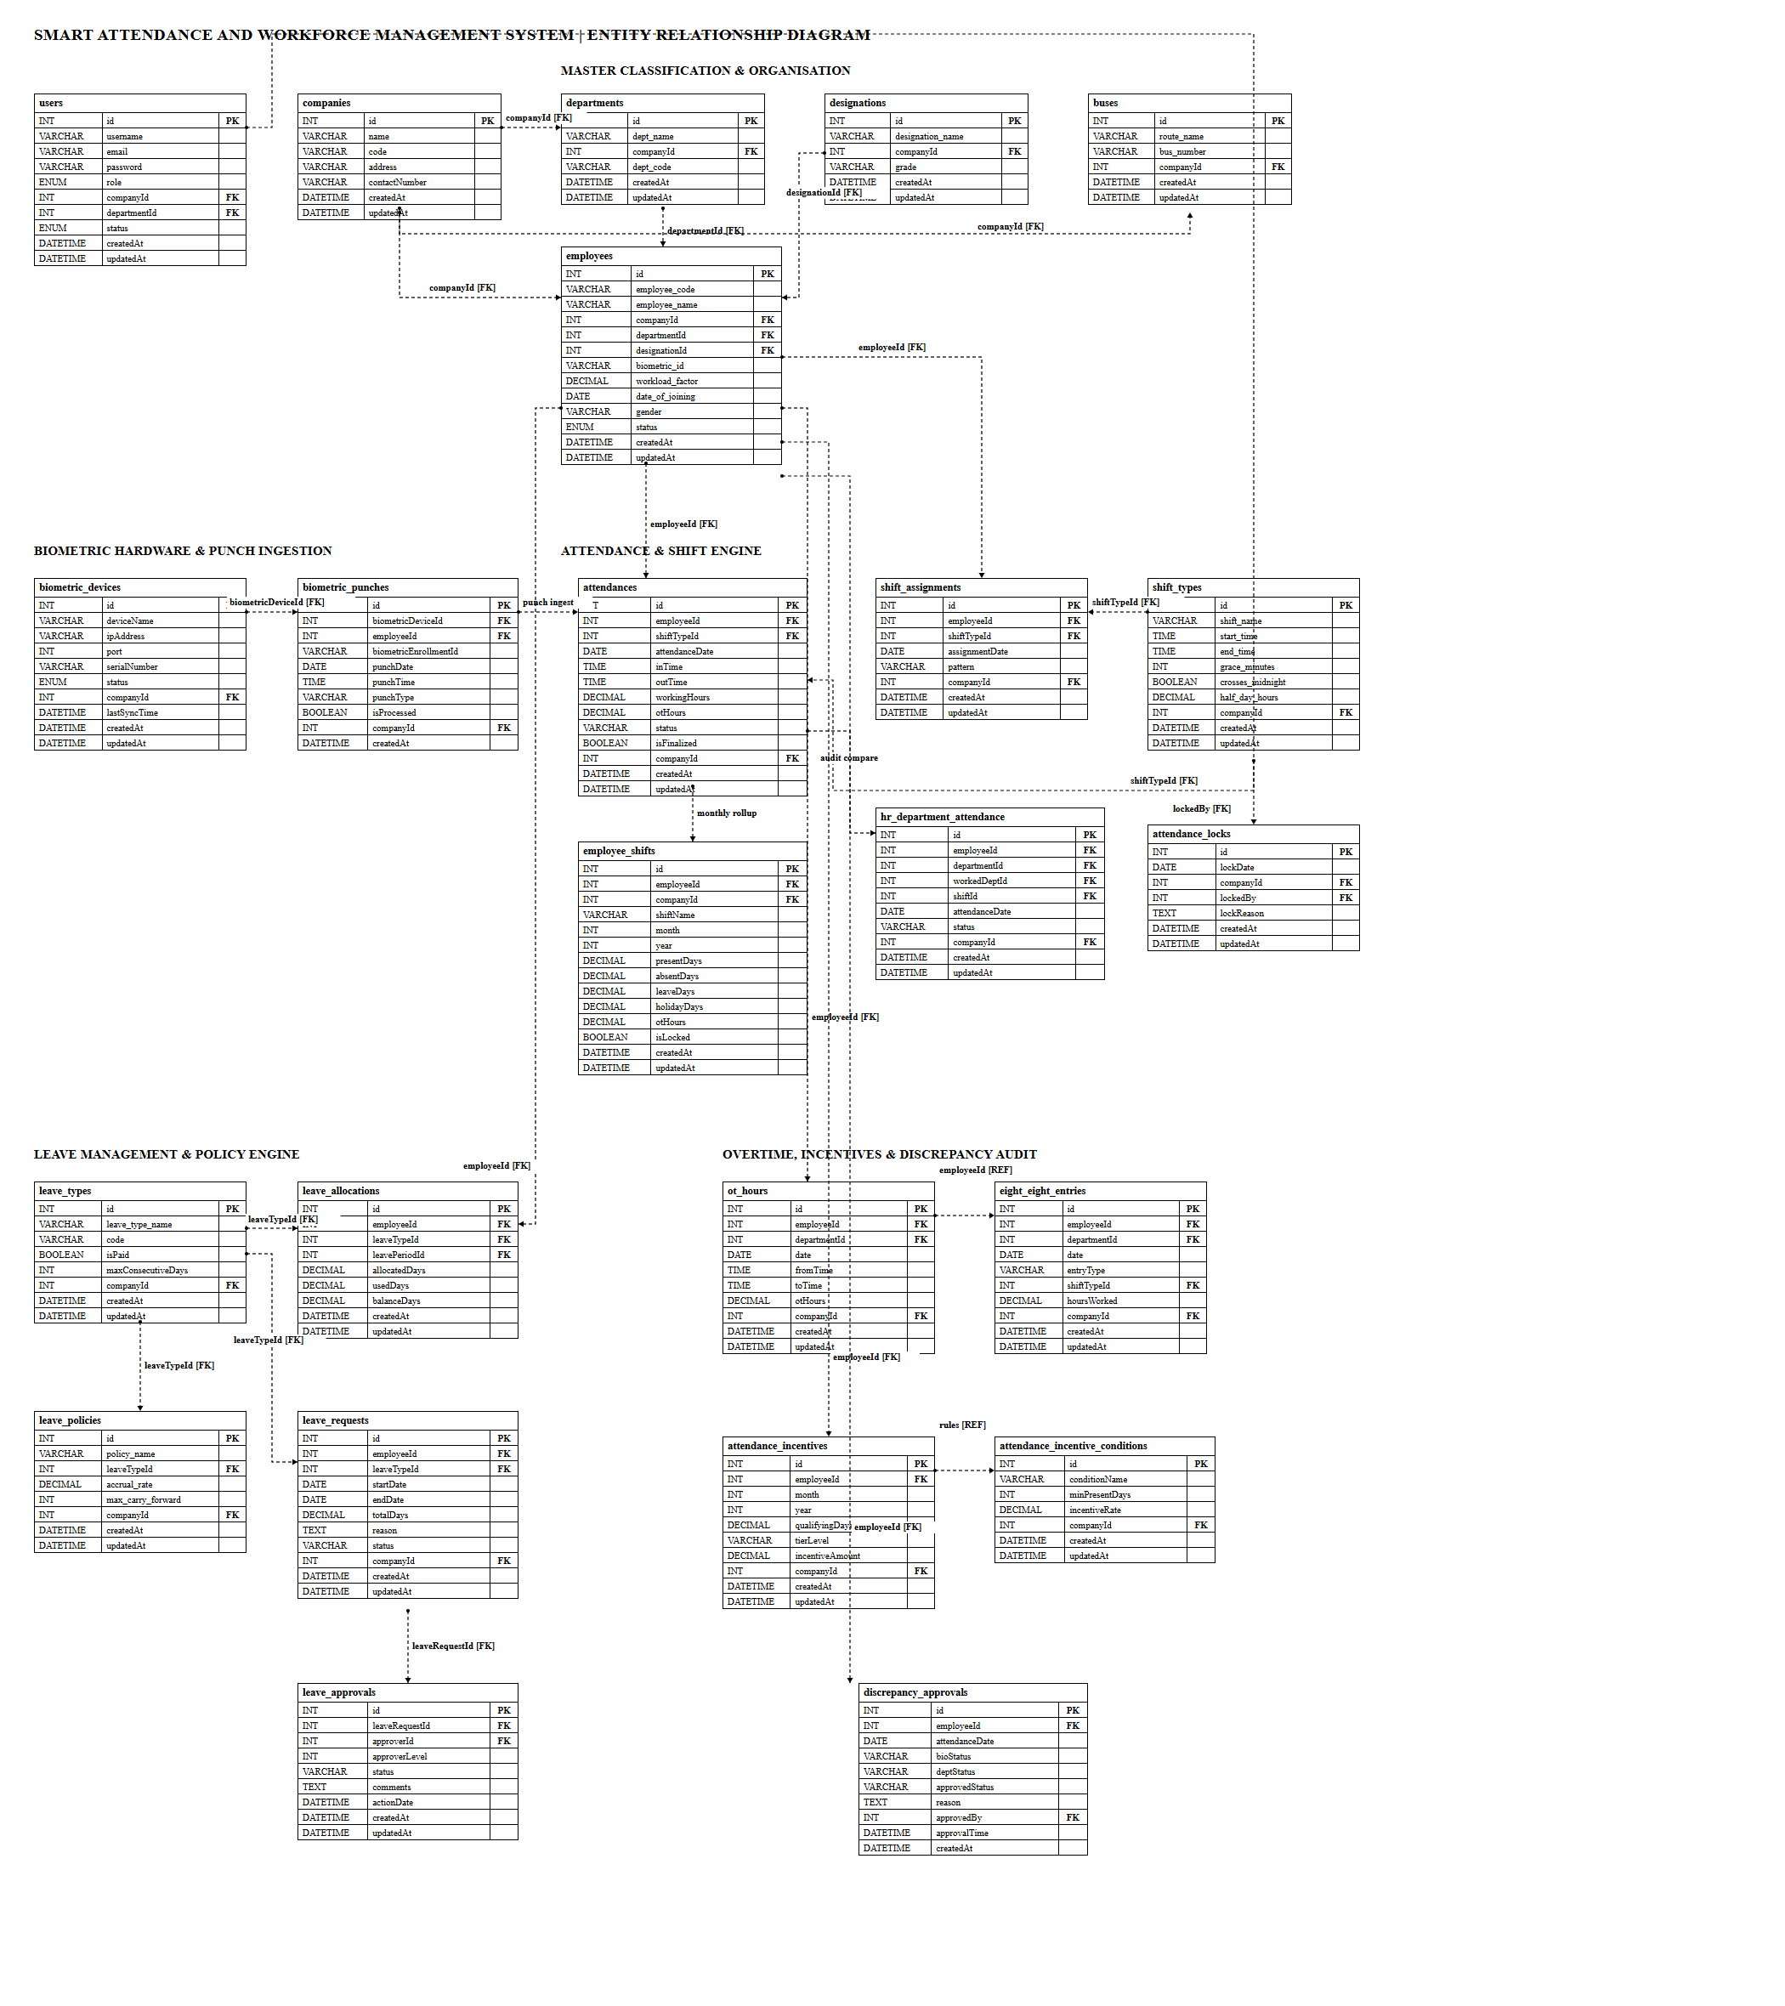
Fig 6.1 Entity-Relationship Diagram of the Smart Attendance and Workforce Management System
CHAPTER 7

TECH STACK

7.1 TECH STACK
Layer | Technology | Purpose
Frontend | React 19 (Vite 7) | Single-page application with dynamic UI
UI Framework | Material UI v7 + Tailwind CSS 3 | Component library and utility-first styling
Date Handling | MUI X Date Pickers + date-fns | Shift, attendance and leave date selection
HTTP Client | Axios | REST API communication with JWT auth
Routing | React Router DOM v7 | Protected client-side routes
Backend | Node.js + Express.js v5 | RESTful API server
ORM | Sequelize v6 | Database abstraction and model management
Database | MySQL (via mysql2) | Relational data storage
Biometric SDK | node-zklib | Direct TCP connection to ZKTeco terminals
Device Protocol | iclock listener endpoints (Express routes) | Device handshake, heartbeat and ATTLOG push stream
Date Arithmetic | moment | Shift windows, midnight-crossing shifts and date offsets
Scheduling | node-cron | Shift-end finalisation and device auto-sync
Authentication | JSON Web Tokens (JWT) + jwt-decode | Stateless, token-based authentication and client-side role guards
Security | bcryptjs, CORS, payload size limit | Password hashing and HTTP request control
Reports | ExcelJS, PDFKit (server); xlsx, jsPDF (client) | Excel and PDF report generation
File Upload | Multer | Discrepancy supporting documents, bulk uploads
Bulk Import | PapaParse, csv-parser, xlsx | CSV and Excel ingestion of employee, workload and holiday data

7.2 ARCHITECTURE OVERVIEW
Layer | Technology | Purpose
Model | Sequelize ORM + MySQL | Defines data structure, handles DB queries, manages relationships and validations
View | React.js + Material UI | Renders the UI, manages user interaction, communicates with the server via Axios
Controller | Node.js + Express.js | Receives HTTP requests, applies business logic, coordinates between Model and View
Service | attendanceProcessor, attendenceCron, BiometricAutoSyncService | Long-running and scheduled logic that is not request-driven

The service layer is the architectural feature that distinguishes this system from a conventional CRUD application. Three of its components run without any user present: BiometricAutoSyncService polls devices every five minutes, attendenceCron finalises attendance at shift end, and attendanceRegenerateWorker runs administrator-requested rebuilds in a separate process. Controllers remain thin and request-scoped; the attendance logic itself lives in attendanceProcessor.js and is called identically from the real-time webhook, the cron job and the manual regeneration path, so all three produce the same result from the same punches.
CHAPTER 8

MODULES

8.0 Design Approach
Each module of the Smart Attendance and Workforce Management System is described here the way a system design problem is solved: by walking through the same seven steps in the same order, every time. This keeps the explanation of every module complete and comparable, and shows why each design decision was taken rather than only what the screen looks like.
Step | Question it answers | Presented in each module as
1. Functional requirements | What must the module do? | Section x.1
2. Non-functional requirements | How fast, how big, how available? Where does the CAP trade-off fall? | Section x.2
3. Tech stack | Which tools suit this problem, and why? | Section x.3
4. Back-of-the-envelope | How many users, requests and how much storage? | Section x.4
5. Low-level architecture | Which components exist and who talks to whom? | Section x.5 (diagram + request flow)
6. API design | What is the contract between client and server? | Section x.6
7. DB design | Which tables, keys and indexes store the data? | Section x.7

Shared baseline for all modules
Non-functional baseline. Every API request travels through CORS and a 50 MB payload limit before it reaches a controller, and the browser attaches the JWT bearer token to every call. All data lives in a single MySQL database, so the system chooses consistency over availability in CAP terms (CP): a user may briefly be unable to save if the database is unreachable, but two users can never see conflicting versions of an attendance row or a leave balance. Almost every table carries a companyId, making the schema multi-tenant by construction. Hours and incentive amounts use DECIMAL, never floating point, so monthly totals reconcile exactly.
The one place where this system deliberately relaxes strict consistency is the live dashboard. A provisional attendance row written by the punch webhook is explicitly marked isFinalized = false; it is allowed to be incomplete, because it is read for situational awareness during a running shift, never for a wage calculation. The finalised row that the cron produces after the shift ends is the consistent record of account.
Sizing baseline (assumptions).
Quantity | Estimate | Basis
Employees on roll | ≈ 1,200 | Single enterprise manufacturing facility (assumption)
Named system users | ≈ 25 | HR, department admins, supervisors, management (assumption)
Shifts per day | 3 worker shifts (A, B, C), 3 supervisor shifts (SUP_A, SUP_B, SUP_C) and staff shifts | shift_types configuration
Punches per employee per day | ≈ 4 | IN, lunch OUT, lunch IN, OUT
Punches per day | 1,200 × 4 = 4,800 | Derived
Punches per year | 4,800 × 300 = 1,440,000 | 300 working days
Attendance rows per year | 1,200 × 365 = 438,000 | One row per employee per calendar day
Peak punch burst | ≈ 400 punches in 10 minutes ≈ 0.7 punch/s | Shift changeover at the gate
API load (interactive) | ≈ 0.3 req/s average, 3–5 req/s peak | 25 users × ≈ 350 requests per working day
Total tables | 32 | Model definitions

A single Node.js process and one MySQL instance handle this load comfortably. The design keeps the application stateless (JWT instead of server sessions), so extra Node.js instances can be added behind a load balancer if the mill adds units. The components that are not stateless are the cron scheduler and the in-memory regeneration job list; if the application is scaled out, these must be pinned to a single instance or moved to an external scheduler and store, and this is noted as a known constraint rather than an implemented feature.
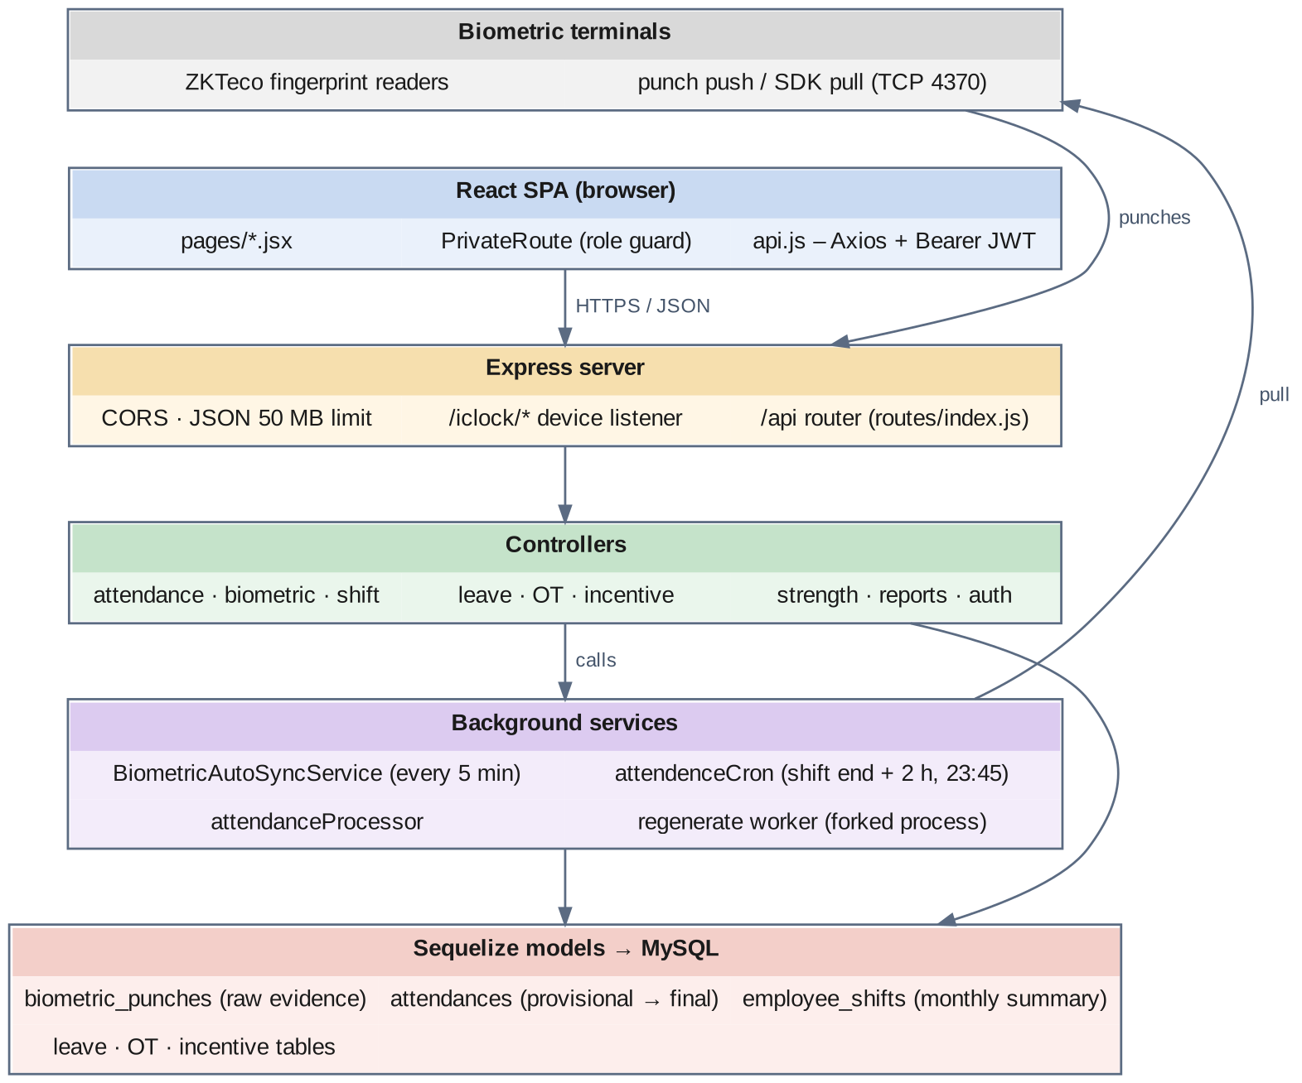
Fig 8.0 Overall request flow of the Smart Attendance and Workforce Management System

8.1 FOLDER STRUCTURE
payroll/
├── .github/
├── .vscode/
├── backend/
├── details/
├── frontend/
├── .gitignore
└── package.json
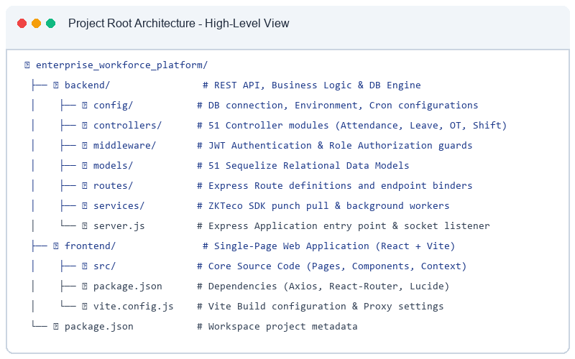
Fig 8.1.1 High-level view of the project

8.1.1 BACKEND FOLDER
backend/
├── config/
├── controllers/
├── middleware/
├── models/
├── routes/
├── scripts/
├── services/
├── utils/
├── migrate.js
├── package.json
├── server.js
└── sync_db.js
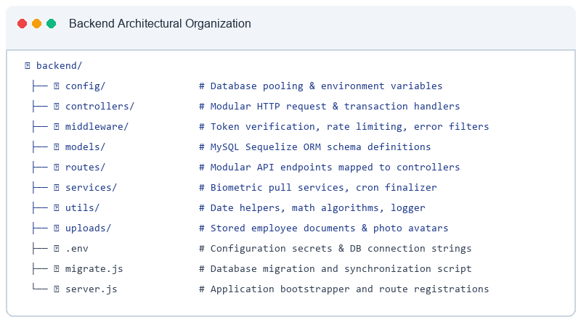
Fig 8.1.2 Backend folder structure – overall organisation of backend files and directories showing modular architecture
The backend separates concerns into models (Sequelize model definitions), controllers (request handling and business logic), routes (URL to controller mapping, assembled in routes/index.js), services (scheduled and long-running logic), middleware (authentication and file upload), config (database credentials and incentive configuration) and utils (attendance lock helpers, import job store).
backend/config/
├── AttendenceIncentiveConfig.js
├── database.js
└── db.js
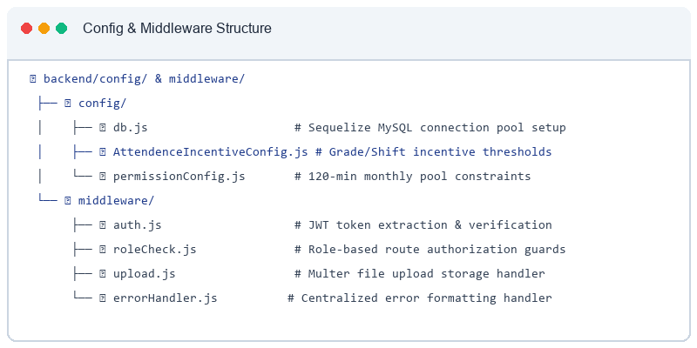
Fig 8.1.3 config folder structure
backend/controllers/  ├── attendanceController.js  ├── AttendanceIncentiveController.js  ├── attendanceLockController.js  ├── AttendanceReportController.js  ├── authController.js  ├── biometricDeviceController.js  ├── biometricPunchController.js  ├── busController.js  ├── companyController.js  ├── departmentController.js  ├── designationController.js  ├── eightEightController.js  ├── employeeController.js  ├── employeeReportsController.js  ├── employeeShiftController.js  ├── holidayController.js  ├── holidayListController.js | ├── hostelAttendanceIncentiveController.js  ├── importController.js  ├── leaveAllocationController.js  ├── leavePeriodController.js  ├── leavePolicyController.js  ├── leaveRequestController.js  ├── leaveTypeController.js  ├── lunchController.js  ├── otHoursController.js  ├── reportController.js  ├── shiftAssignmentController.js  ├── shiftReportController.js  ├── shiftTypeController.js  ├── strengthReportController.js  ├── strengthReportOldController.js  └── userController.js
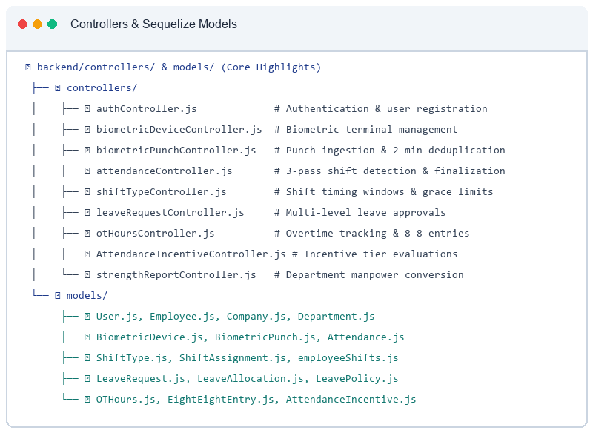
Fig 8.1.4 controllers folder – controllers used by this project
backend/services/
├── attendanceProcessor.js
├── attendanceRegenerateQueue.js
├── attendanceRegenerateWorker.js
├── attendenceCron.js
└── BiometricAutoSyncService.js
backend/utils/
├── attendanceLockUtil.js
└── ImportJobStore.js
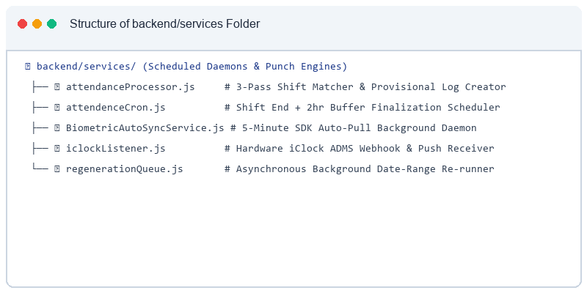
Fig 8.1.5 services folder – attendanceProcessor, attendenceCron, BiometricAutoSyncService and the regeneration queue and worker
backend/models/  ├── Attendance.js  ├── AttendanceIncentive.js  ├── AttendanceIncentiveCondition.js  ├── AttendanceLock.js  ├── BiometricDevice.js  ├── BiometricPunch.js  ├── Bus.js  ├── Company.js  ├── Department.js  ├── DepartmentAttendance.js  ├── Designation.js  ├── DiscrepancyApproval.js  ├── EightEightEntry.js  ├── Employee.js  ├── employeeShifts.js  ├── Holiday.js  ├── HolidayList.js | ├── HostelAttendanceIncentive.js  ├── index.js  ├── LeaveAllocation.js  ├── LeaveApproval.js  ├── LeavePeriod.js  ├── LeavePolicy.js  ├── LeaveRequest.js  ├── LeaveRequestHistory.js  ├── LeaveType.js  ├── LunchAttendance.js  ├── OTHours.js  ├── PackagingIncentive.js  ├── ShiftAssignment.js  ├── ShiftType.js  ├── StrengthReport.js  └── User.js
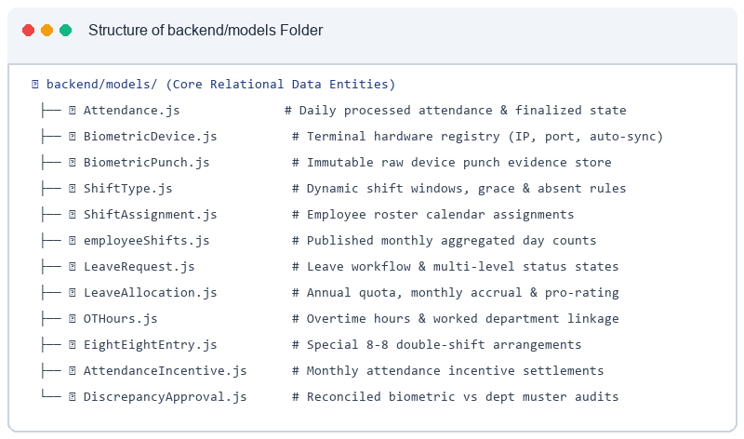
Fig 8.1.6 models folder – models used by this project

8.1.2 FRONTEND FOLDER
frontend/
├── public/
├── src/
├── .gitignore
├── eslint.config.js
├── index.html
├── package.json
├── postcss.config.js
├── README.md
├── tailwind.config.js
└── vite.config.js
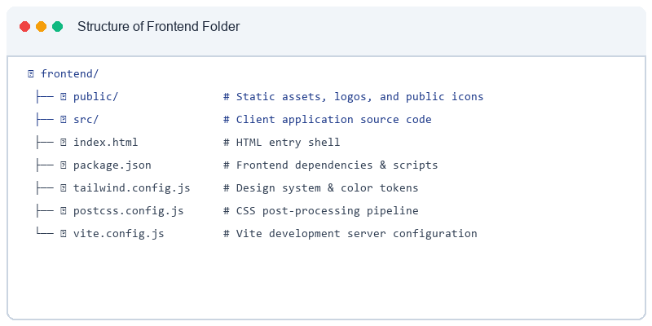
Fig 8.1.7 Structure of the frontend folder
frontend/src/
├── assets/
├── pages/
├── styles/
├── utils/
├── api.js
├── App.css
├── App.jsx
├── index.css
└── main.jsx
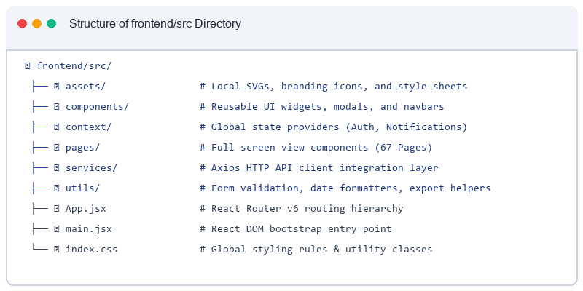
Fig 8.1.8 Structure of frontend/src
frontend/src/pages/  ├── AttendanceIncentiveManagement.jsx  ├── AttendanceManagement.jsx  ├── AttendanceReport.jsx  ├── Auth.jsx  ├── BiometricAttendance.jsx  ├── BiometricDeviceManagement.jsx  ├── BulkLeaveAllocationModal.jsx  ├── BusManagement.jsx  ├── CompanyManagement.jsx  ├── Dashboard.jsx  ├── DepartmentAttendanceMultiple.jsx  ├── DepartmentManagement.jsx  ├── DepartmentReports.jsx  ├── DesignationManagement.jsx  ├── DiscrepancyReport.jsx  ├── EightEightMultipleEntry.jsx  ├── EmployeeShiftManagment.jsx  ├── ForgotPassword.jsx  ├── HolidayListManagement.jsx  ├── Home.jsx  ├── HostelAttendanceIncentiveManagement.jsx  ├── LeaveAllocationManagement.jsx | ├── LeaveAllocationModal.jsx  ├── LeaveApprovalManagement.jsx  ├── LeavePeriodManagement.jsx  ├── LeavePolicyManagement.jsx  ├── LeaveRequestDetailModal.jsx  ├── LeaveRequestManagement.jsx  ├── LeaveRequestModal.jsx  ├── LeaveTypeManagement.jsx  ├── LoginManagement.jsx  ├── LunchInOutDownload.jsx  ├── OTHoursManagement.jsx  ├── OTReport.jsx  ├── OvertimeMultipleEntry.jsx  ├── ReportPage.jsx  ├── ResetPassword.jsx  ├── ShiftAssignmentManagement.jsx  ├── ShiftReportPage.jsx  ├── ShiftTypeManagement.jsx  ├── StrengthReport.jsx  ├── StrengthReportOld.jsx  ├── UserManagement.jsx  └── WorkloadManagement.jsx
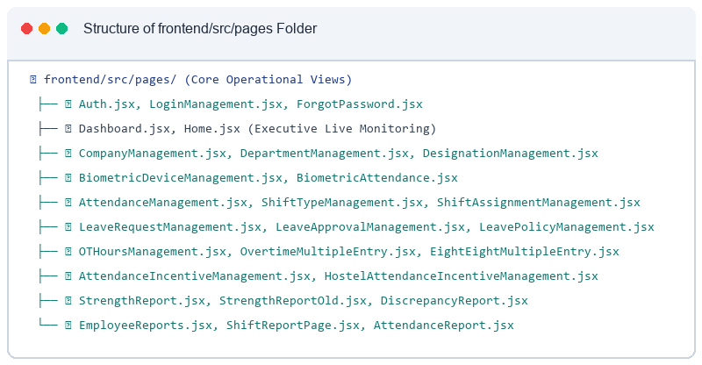
Fig 8.1.9 frontend/src/pages folder – pages belonging to this project
/ → LoginManagement.jsx
companies → CompanyManagement.jsx
departments → DepartmentManagement.jsx
designations → DesignationManagement.jsx
leave-policies → LeavePolicyManagement.jsx
leave-periods → LeavePeriodManagement.jsx
leave-types → LeaveTypeManagement.jsx
holiday-lists → HolidayListManagement.jsx
shift-types → ShiftTypeManagement.jsx
shift-assignments → ShiftAssignmentManagement.jsx
buses → BusManagement.jsx
biometric-devices → BiometricDeviceManagement.jsx
biometric-punches → BiometricAttendance.jsx
attendance → AttendanceManagement.jsx
workload-entry → WorkloadManagement.jsx
leave-allocations → LeaveAllocationManagement.jsx
leave-requests → LeaveRequestManagement.jsx
leave-approvals → LeaveApprovalManagement.jsx
user-management → UserManagement.jsx
attendance-reports → AttendanceReport.jsx
discrepancy-report → DiscrepancyReport.jsx
attendance-multiple → DepartmentAttendanceMultiple.jsx
overtime-multiple → OvertimeMultipleEntry.jsx
eight-eight-multiple → EightEightMultipleEntry.jsx
lunch-download → LunchInOutDownload.jsx
dept-reports → DepartmentReports.jsx
attendance-incentive → AttendanceIncentiveManagement.jsx
hostel-attendance-incentive → HostelAttendanceIncentiveManagement.jsx
ot-hours → OTHoursManagement.jsx
ot-reports → OTReport.jsx
strength-report → StrengthReport.jsx
strength-report-old → StrengthReportOld.jsx
employee-shifts → EmployeeShiftManagment.jsx
reports → ReportPage.jsx
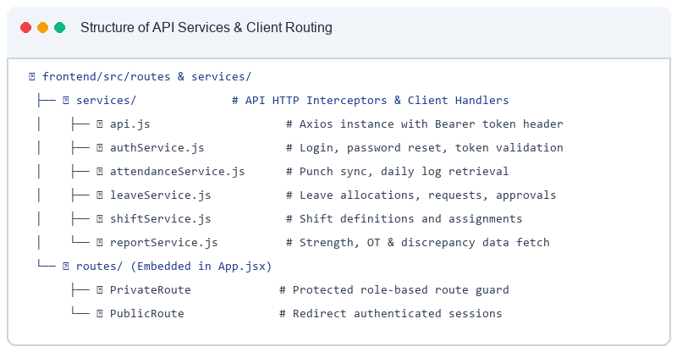
Fig 8.1.10 Route definitions in App.jsx for this project's pages (route path → page component)

8.2 USER AUTHENTICATION & ACCESS CONTROL

8.2.0 Purpose & Scope
Provides tokenized authentication, secure credential management and role-based access control across the enterprise, preventing unauthorized viewing or modification of attendance data.

8.2.1 Functional Requirements
What the module must do:
- A user signs in with an email address or phone number and a password and receives a signed JWT together with a profile.
- Five roles — Super Admin, Admin, HR, Department Admin and Staff — decide which screens a user may reach. The role is carried inside the token and read by the route guard.
- A user can reset a forgotten password through a tokenized flow; the reset token and its expiry are stored on the user record and cleared on use.
- An administrator can create, update, activate, deactivate and delete user accounts and change a user's password.
- Each account has an Active / Inactive status so access can be withdrawn without deleting the record, and the last login time is stored.
- The browser redirects unauthenticated users to the login screen, and removes a token that cannot be decoded.
- Default Admin and HR accounts, the four employment types and the three supervisor shifts are seeded at first start-up so a fresh installation is usable.
Out of scope: self-service sign-up, multi-factor authentication, and single sign-on. A Google OAuth client is present in the dependency set but is not part of the login path described here.

8.2.2 Non-Functional Requirements
How well the module must do it (the system-wide baseline in the chapter introduction also applies):
- Security: passwords are stored only as bcryptjs hashes with a cost factor of 10; the hash is never returned by the login response.
- No account enumeration: a failed login returns the same message whether the identifier or the password was wrong, and the forgot-password endpoint returns the same response whether or not the email exists.
- Session length: the JWT expires after seven days, which avoids repeated logins across a working week at the cost of a longer window for a stolen token.
- Scalability: because tokens are stateless, any server instance can validate a request without a shared session store.
- Latency target: login under 500 ms, dominated by the deliberate cost of bcrypt.
- Enforcement layer (current state): the server-side verification middleware middleware/auth.js is implemented and is attached to the discrepancy approval endpoints, where the approver's identity must come from the token. On most other routers it is prepared but not yet switched on, so role enforcement for those screens currently rests on the client-side route guard. Enabling the middleware on every router is the first hardening step and is recorded in the conclusion.
- Device endpoints: biometric terminals call /iclock/* without a JWT, because the hardware cannot carry one. These endpoints must be protected by network placement.
- CAP: the users table is a single MySQL source of truth — consistency is preferred, so a disabled account is refused immediately on the next login.

8.2.3 Tech Stack
Concern | Choice | Why it fits this module
Password hashing | bcryptjs (salted, cost 10) | Pure JavaScript, no native build step on the production server
Session | JSON Web Token, 7-day expiry | Stateless; the client keeps the token and sends it in the Authorization header
Verification | middleware/auth.js | Parses the Bearer header, verifies the signature, attaches req.user
Password reset | Token + expiry columns on users | No extra table; the token is single-use and time-boxed
Client guard | PrivateRoute in App.jsx + jwt-decode | Reads the role from the token and redirects when the role is not in the allowed list
Token transport | Axios request interceptor in api.js | Adds the Bearer header to every call from one place

8.2.4 Back-of-the-Envelope Estimation
Quantity | Estimate | Basis
Users | ≈ 25 rows, < 15 KB | Assumption (≈ 0.6 KB per row)
Logins per day | ≈ 10–25 | 7-day tokens, so most users log in once a week or after closing the browser session
Login burst | ≈ 15 logins in 10 minutes | Monday morning ≈ 0.03 login/s
CPU per login | ≈ 100 ms | Typical bcrypt compare; one core handles ≈ 10 logins/s
API calls carrying a token | ≈ 9,000 / day | 25 users × ≈ 350 requests
JWT verification cost | ≈ 0.05 ms | Signature check only, no database read

8.2.5 Low-Level Architecture
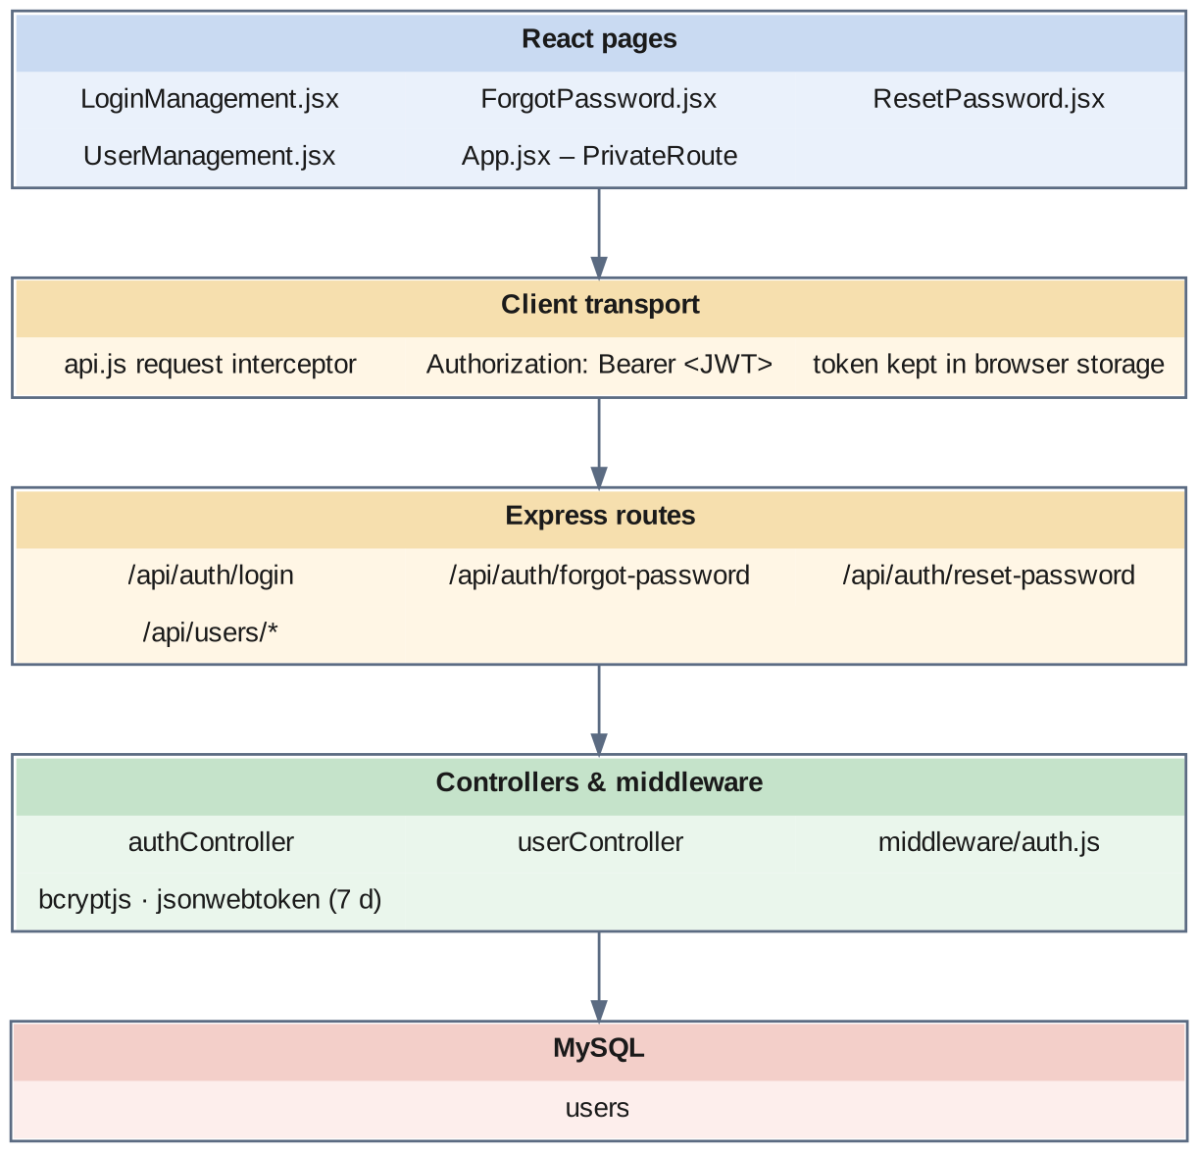
Fig 8.2.A Low-level architecture – USER AUTHENTICATION & ACCESS CONTROL
Request flow:
- LoginManagement.jsx posts the identifier and password to /api/auth/login.
- authController looks the user up by email or phone number, checks that the status is Active, and compares the password with the stored bcrypt hash.
- On success it signs a JWT carrying the user's id, role and company, valid for seven days, and returns it with the profile.
- The client stores the token in browser storage; the request interceptor in api.js adds it as a Bearer header on every later request.
- PrivateRoute in App.jsx decodes the token on each navigation. With no token, or a role outside the route's allowed list, it redirects to the login screen; a token that cannot be decoded is removed from storage.
- On endpoints where middleware/auth.js is attached, the server verifies the signature and expiry and exposes the decoded payload as req.user to the controller.
- For a forgotten password, ForgotPassword.jsx requests a token, which is written to passwordResetToken with passwordResetExpires; ResetPassword.jsx presents it back and the controller sets a fresh bcrypt hash and clears both columns.

8.2.6 API Design
Method | Endpoint | Purpose / contract
POST | /api/auth/login (public) | Body: identifier (email or phone), password. Returns a JWT and the user profile.
POST | /api/auth/forgot-password (public) | Body: email. Issues a reset token with an expiry.
POST | /api/auth/reset-password (public) | Body: token, new password. Stores a new bcrypt hash and clears the token.
GET | /api/users | List users.
GET | /api/users/:id | One user by primary key.
GET | /api/users/email/:email | Look a user up by email (uniqueness check).
GET | /api/users/phone/:phoneNumber | Look a user up by phone number.
GET | /api/users/:id/company | The company a user belongs to.
POST | /api/users | Create a user with a hashed password and a role.
POST | /api/users/generate-number | Generate the next user number.
PUT | /api/users/:id | Update profile, role, company or department.
PATCH | /api/users/:id/password | Change the password.
PATCH | /api/users/:id/toggle-status | Switch an account between Active and Inactive.
PATCH | /api/users/:id/last-login | Record the last login timestamp.
DELETE | /api/users/:id | Delete a user account.

8.2.7 DB Design
Table | Keys & indexes | Key columns
users | PK id (auto) · UNIQUE email · UNIQUE phoneNumber · INDEX companyId, departmentId, role | email, phoneNumber, password (bcrypt hash), role ENUM(Staff, Admin, Department Admin, Super Admin, HR), status ENUM(Active, Inactive), firstName, lastName, lastLogin, passwordResetToken, passwordResetExpires, companyId FK, departmentId FK, employeeId FK, createdBy, updatedBy

- The unique index on email makes the login look-up a single index read and prevents duplicate accounts.
- departmentId ties a Department Admin account to one department, which is the basis for narrowing that role's view.
- employeeId optionally links a login to an employee record, so that a supervisor's own attendance is visible from their account.

8.2.8 Screenshots
[ Paste screenshot here ]
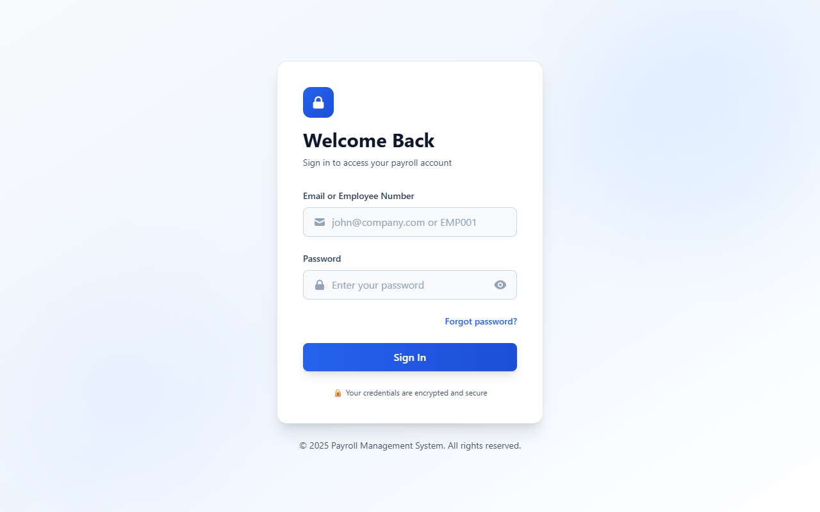
Fig 8.2.1 Login screen
The login screen collects the user's email address or phone number and password and submits them to the authentication endpoint. A failed attempt returns a message without revealing whether the identifier or the password was wrong. On success the token is stored and the user is taken to the dashboard.
[ Paste screenshot here ]
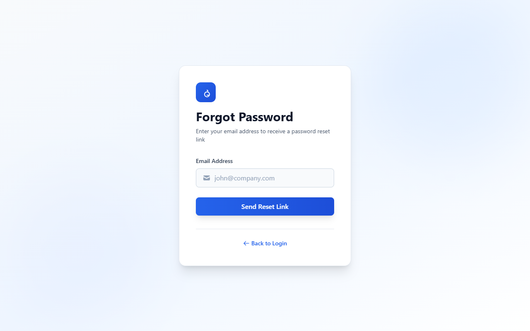
Fig 8.2.2 Forgot password request
The user enters the registered email address to begin the reset flow. The screen confirms that a reset link has been issued without disclosing whether the address exists, which avoids leaking the user list.
[ Paste screenshot here ]
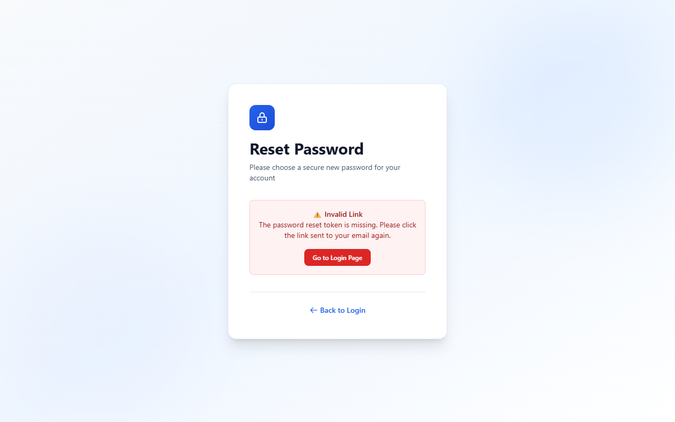
Fig 8.2.3 Reset password screen
The reset screen accepts the new password together with the token carried in the link. Submitting it replaces the stored hash and clears the reset token so the same link cannot be used twice.
[ Paste screenshot here ]
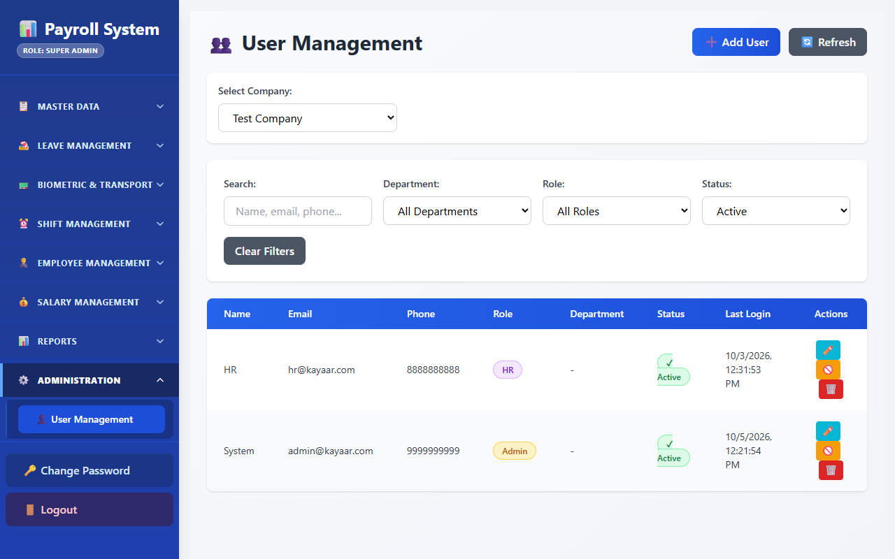
Fig 8.2.4 User management list
The user list shows each account with its role, company, department and status, alongside edit and delete controls. Administrators use this screen to withdraw access by switching an account to Inactive rather than deleting the record.
[ Paste screenshot here ]
Fig 8.2.5 Creating a user and assigning a role
The user form captures name, email, phone number, password, role, company and department. Selecting the Department Admin role makes the department field meaningful, because that account is tied to the chosen department.

8.3 ORGANISATION & WORKFORCE MASTERS

8.3.0 Purpose & Scope
Maintains the organisation reference data that every attendance transaction depends on — the company, its departments and designations, the transport master and the per-employee workload factor — so that attendance, shift and leave screens select from a controlled vocabulary instead of free text. The employee record maintains core workforce identity parameters; this module covers the parts of it that the attendance system reads and maintains.

8.3.1 Functional Requirements
What the module must do:
- Create, view, edit and delete records for Company, Department, Designation and Bus.
- Company profile: name, logo, registration number, multiple addresses stored as JSON, contact details, and financial year start and end.
- Department registry: department name, acronym, serial number, a strengthRequired figure (the day standard used by the legacy strength report), a flag marking training departments, and a link to a category.
- Read the employee roster for every attendance screen. The fields that matter here are the employee code, department, designation, employment type, date of joining, weekly off, default shift, the biometric enrollment ID, the trainee and hostel flags, and the workload factor.
- Dual codes: both a current and a new employee code — and a current and a new biometric enrollment ID — are stored, with virtual attributes resolving which one is in force, so that a renumbering does not break historical attendance.
- Workload factor: each trainee carries a workload figure expressing how much of a regular hand they represent; it can be edited singly, in bulk on screen, or uploaded from a file with a downloadable template.
- Count active departments and employees for the dashboard.
- Provide reference dropdowns to every attendance, shift and leave screen so users pick rather than type.

8.3.2 Non-Functional Requirements
- Read-heavy: masters are read far more often than they are written — every attendance screen, every report filter and every dropdown reads them — so look-ups must be fast and are the natural candidates for caching.
- Scale of lists: with roughly 1,200 employees, list endpoints accept filters so a screen requests only the employees it needs; server-side paging is the natural next refinement as the roster grows.
- Data quality: the employee code is unique; department and designation are foreign keys rather than text, which is what makes department-wise reporting reliable.
- Referential safety: an employee referenced by attendance rows must not be hard-deleted; status is switched instead.
- Access control: the master screens are reached through role-guarded routes.
- CAP: consistency first — a newly created employee must be visible to the punch processor immediately, because that employee may punch within minutes.

8.3.3 Tech Stack
Concern | Choice | Why it fits this module
List UI | React pages with Material UI tables and filter controls | One reusable pattern across every master screen
Server queries | Sequelize queries with where filters and eager-loaded associations | A department arrives with its category, an employee with department and designation, in one call
Workload upload | File upload parsed with xlsx, matched on ticket number | Loads workload factors for many trainees without typing each one
Row-level results | A results object with updated and failed counts and an error list | One bad row is reported, not fatal
Persistence | MySQL, one table per master | Simple relational lookup tables with primary and unique keys

8.3.4 Back-of-the-Envelope Estimation
Quantity | Estimate | Basis
Employees (read) | ≈ 1,200 rows ≈ 3.6 MB | ≈ 3 KB per row (about 80 columns)
Departments | ≈ 30 rows, < 20 KB | Assumption
Designations | ≈ 40 rows, < 20 KB | Assumption
One department's employees | ≈ 40 rows ≈ 120 KB | vs ≈ 3.6 MB for the full roster — the reason filters are applied on the server
Workload upload | ≈ 150 rows in one file | One row per trainee (assumption); processed row by row with a per-row result
Dropdown reads per day | ≈ 2,000 | Each attendance or leave screen loads 3–5 look-ups

8.3.5 Low-Level Architecture
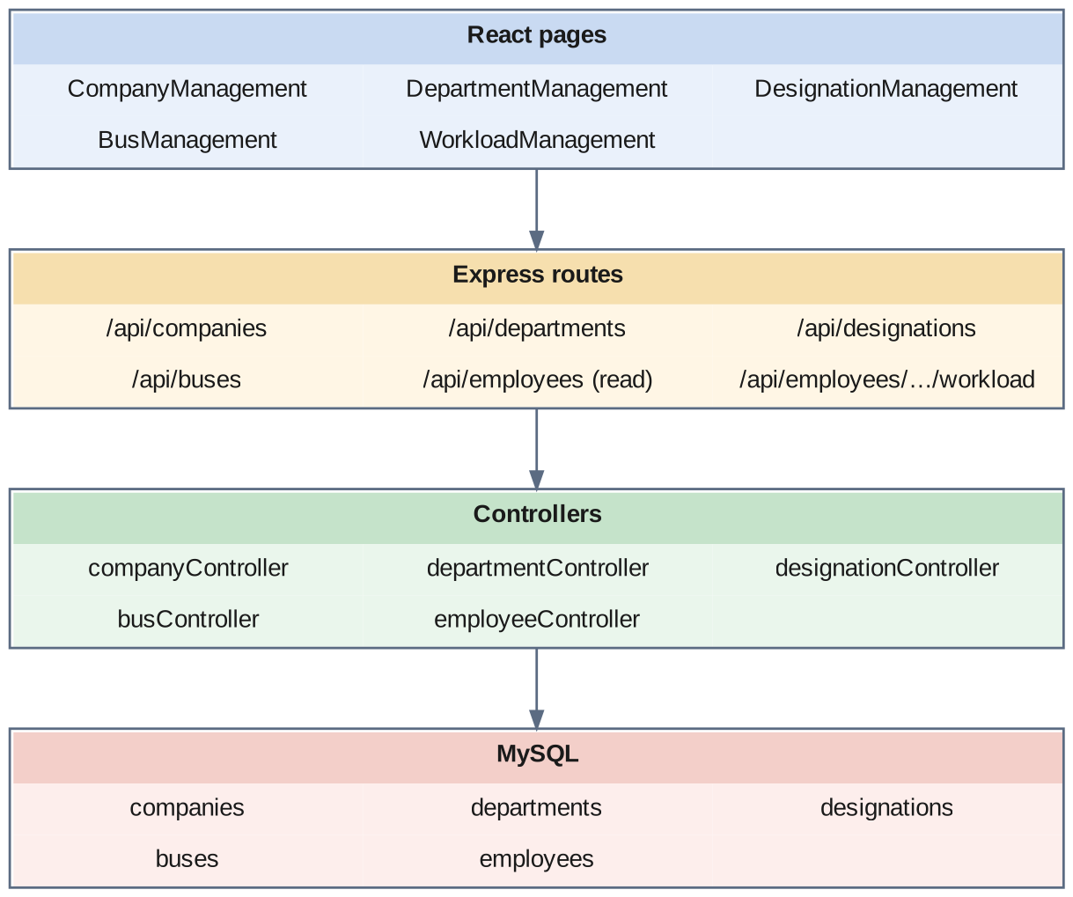
Fig 8.3.A Low-level architecture – ORGANISATION & WORKFORCE MASTERS
Request flow:
- A master page such as DepartmentManagement.jsx sends a GET with its filter values as query parameters.
- The matching controller turns them into a Sequelize where clause, eager-loads the related rows, and returns the list.
- Add and edit forms POST or PUT one record; the controller validates the required fields before writing.
- WorkloadManagement.jsx edits the workload factor for one employee, for many on screen, or from an uploaded file. For an upload the controller reads the file row by row, matches each row to an employee on the ticket number, updates the factor, and returns the count updated, the count failed and the reason for each failure.
- Attendance, shift and leave screens call the same list endpoints — including the employee list — to populate their dropdowns, so every selector shows current master data.

8.3.6 API Design
Method | Endpoint | Purpose / contract
GET | /api/companies · /api/companies/:id | List and fetch company profiles.
POST | /api/companies | Create a company profile.
PUT / DELETE | /api/companies/:id | Update or remove a company profile.
GET | /api/departments | List departments with their category and day standard.
GET | /api/departments/count/active | Count of departments for the dashboard.
POST | /api/departments | Create a department.
PUT / DELETE | /api/departments/:id | Update or remove a department.
GET | /api/designations · /api/designations/:id | List and fetch designations.
POST | /api/designations | Create a designation.
PUT / DELETE | /api/designations/:id | Update or remove a designation.
GET | /api/employees · /api/employees/:id | Read the employee roster for dropdowns and look-ups.
GET | /api/employees/count/active | Count of active employees.
PUT | /api/employees/:id/workload | Update one employee's workload factor.
PUT | /api/employees/bulk-workload | Update the workload factor for many employees at once.
POST | /api/employees/bulk-upload-workload | Upload workload factors from a file.
GET | /api/employees/download-workload-template | Download the workload upload template.
GET | /api/buses · /api/buses/:id | List and fetch buses.
POST | /api/buses | Create a bus.
PUT / DELETE | /api/buses/:id | Update or remove a bus.
PATCH | /api/buses/:id/toggle-status | Activate or deactivate a bus.

8.3.7 DB Design
Table | Keys & indexes | Key columns
companies | PK id (auto) · UNIQUE name · UNIQUE registrationNumber | logo, addresses JSON, phone, email, website, tin, pan, gst, financialYearStart, financialYearEnd, status
departments | PK id (auto) · FK companyId, categoryId | slno, departmentname, acronym varchar(10), isTrain boolean, strengthRequired decimal(10,2)
designations | PK id (auto) · FK companyId | name, acronym varchar(10), status, createdBy, updatedBy
employees | PK id (auto) · UNIQUE curEmployeeCode · FK companyId, departmentId, designationId, employmentTypeId, shiftTypeId, biometricDeviceId, busId, reportingManagerId | Attendance-relevant: curEmployeeCode, newEmployeeCode, employeeCode (VIRTUAL), firstName / middleName / lastName, gender, experience, dateOfJoining, weeklyOff, curBiometricEnrollmentId, newBiometricEnrollmentId, isOvertimeApplicable, isLeaveApplicable, isHostel, isTrainee, workload, employmentStatus, status
buses | PK id (auto) · FK companyId | name, location, status

- strengthRequired on departments is the day standard the legacy strength report compares against.
- employeeCode is a Sequelize VIRTUAL attribute, not a stored column: it resolves at read time from the current and new codes, so a renumbering does not require rewriting attendance history. The biometric enrollment ID is handled the same way.
- isTrainee and workload exist for the strength report: a trainee is counted as a head, and separately as the fraction of a regular hand given by workload.
- The employee repository maintains identity, department, designation, category, shift assignment, workload factors, and biometric enrollment parameters across the workforce lifecycle.

8.3.8 Screenshots
[ Paste screenshot here ]
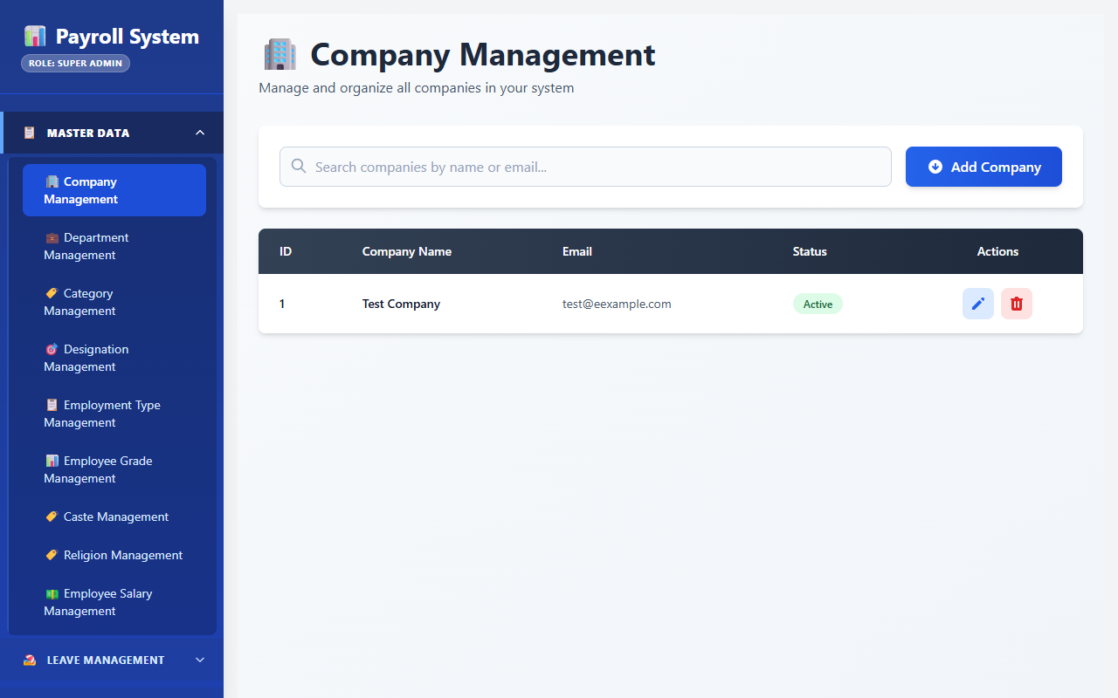
Fig 8.3.1 Company master
The company screen holds the organisation profile — name, registration number, addresses, contact details and financial year. These values appear in the headers of every exported attendance and strength report.
[ Paste screenshot here ]
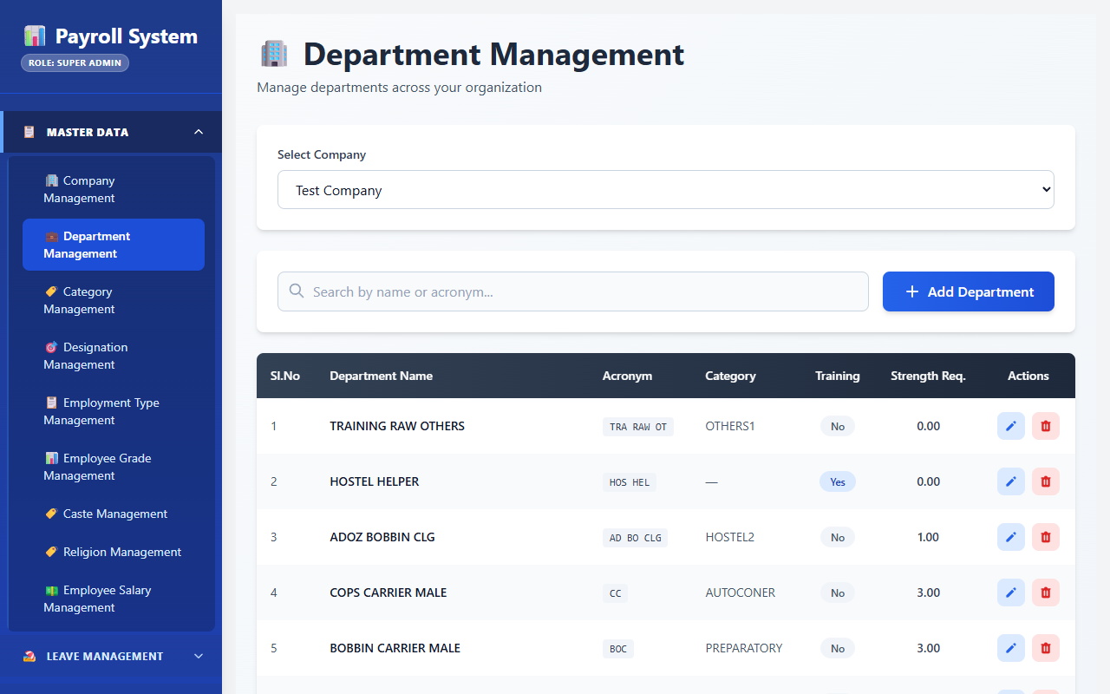
Fig 8.3.2 Department master list
Departments are listed with their acronym, category and required strength, with controls to add, edit and delete. The required strength column is the day standard used by the legacy strength report.
[ Paste screenshot here ]
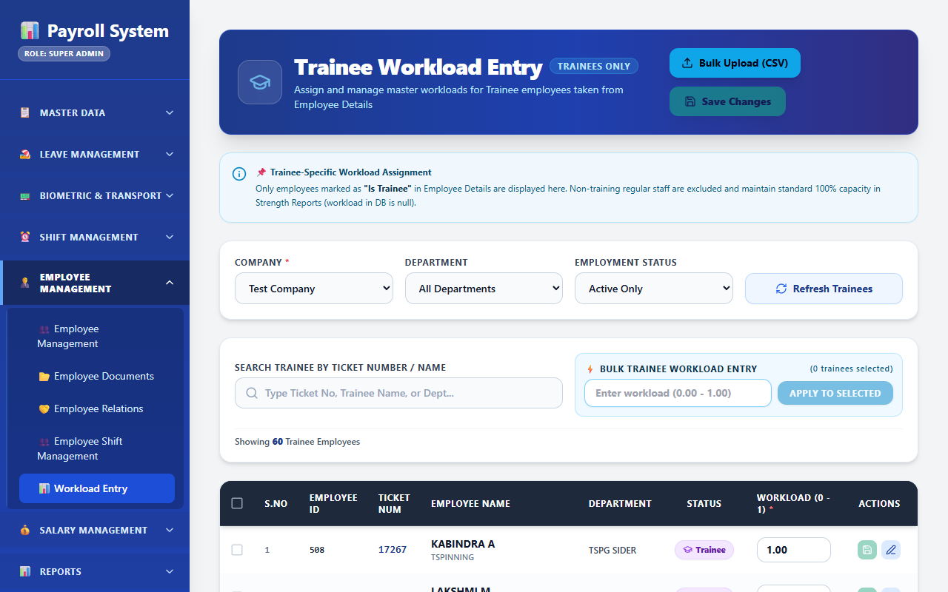
Fig 8.3.3 Workload entry
The workload screen edits the workload factor of trainee employees, singly, in bulk on screen or from an uploaded file. The factor expresses how much of a regular hand a trainee represents and feeds the converted-trainee column of the strength report.
[ Paste screenshot here ]
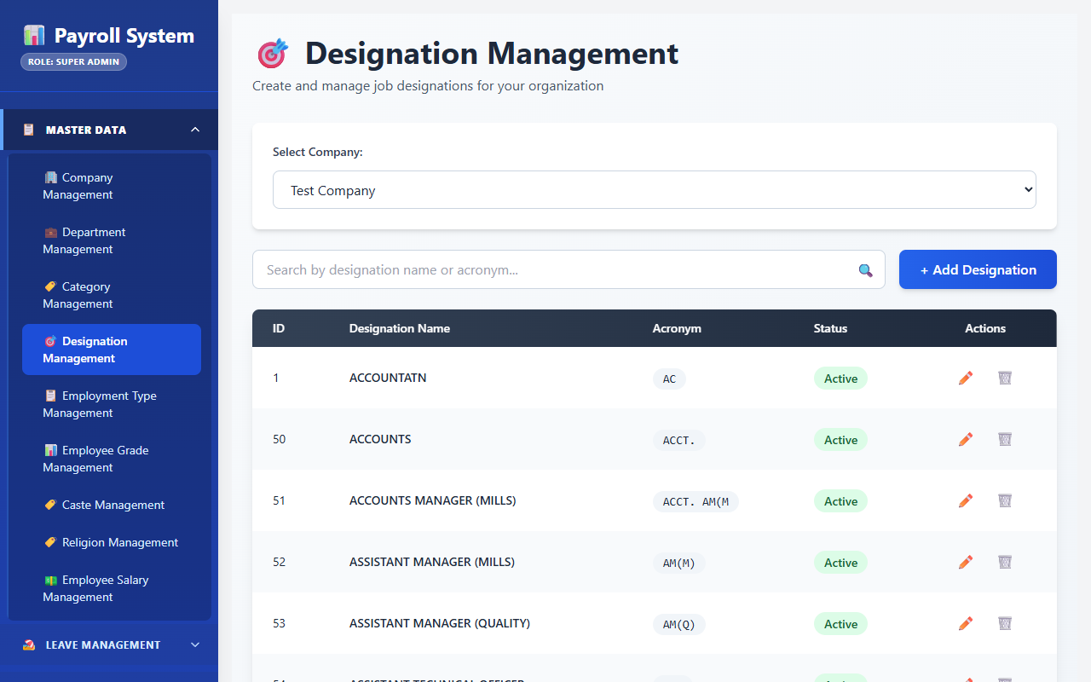
Fig 8.3.4 Designation master
Designations are maintained with a name, an acronym used in compact report columns, and an active status. Designation is a selectable reference on the employee record rather than free text, which keeps grouped reports consistent.
[ Paste screenshot here ]
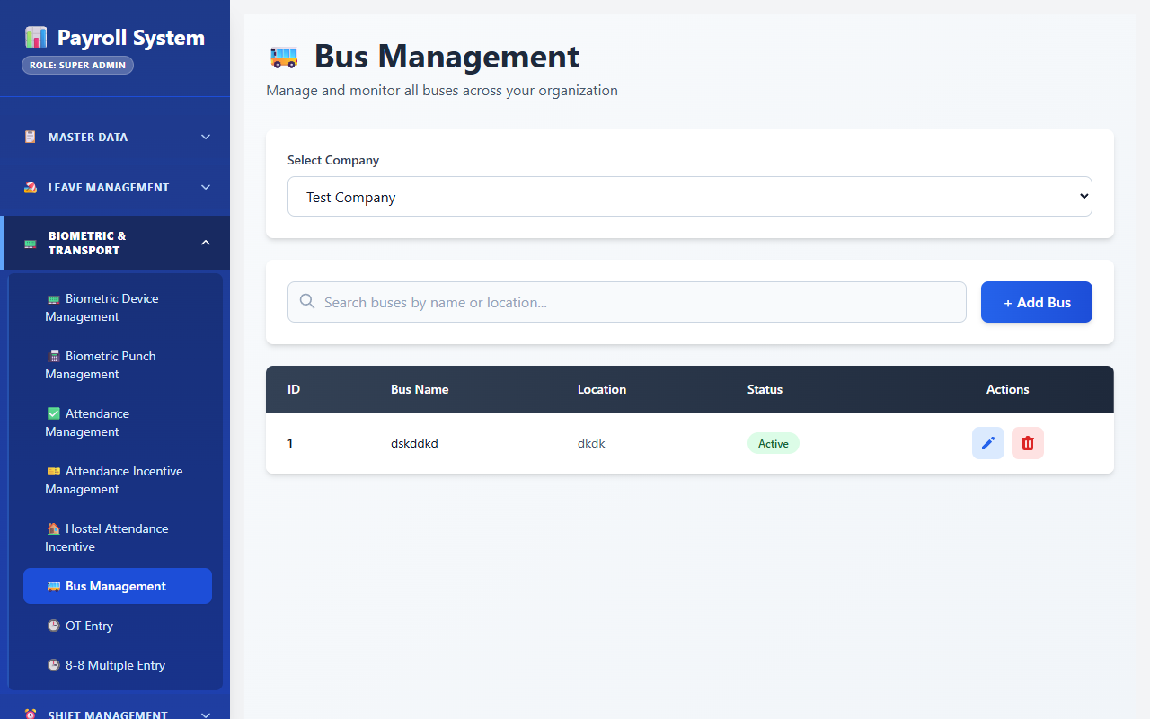
Fig 8.3.5 Bus master
Buses are maintained with a name, a location and an active status, and can be switched on or off without deleting the record. The bus is a selectable reference on the employee record for workers who use mill transport.

8.4 BIOMETRIC DEVICE & PUNCH CAPTURE

8.4.0 Purpose & Scope
Owns the boundary between physical biometric hardware and the database: registering terminals, receiving punches in real time, pulling punches on a schedule as a safety net, and storing every punch as raw evidence.

8.4.1 Functional Requirements
What the module must do:
- Register a device with a name, location, IP address, status and a per-device auto-sync flag, scoped to a company, and switch a device between Active and Inactive.
- Accept real-time punches through a punch webhook: validate the employee, resolve the punch direction, reject a repeat punch inside a two-minute window, store the punch and trigger attendance processing.
- Pull punches actively from each enabled device over the ZKTeco SDK (TCP port 4370), automatically every five minutes and on demand, so that a punch the real-time path missed is recovered.
- Answer the device's own protocol: serve the configuration block on GET /iclock/cdata, accept and parse ATTLOG lines on POST /iclock/cdata, answer the heartbeat on GET /iclock/getrequest, and accept command results on POST /iclock/devicecmd.
- Start, stop, trigger and inspect the auto-sync service from the user interface.
- Store every punch with its enrollment ID, device, full timestamp, date part, IN/OUT direction, detected shift, late and early-out flags, a manual-entry flag, remarks and a validity status of Valid, Invalid or Duplicate.
- Derive the punch direction from the shift windows when the device does not supply a usable one, because terminals are configured inconsistently across gates.
- Skip duplicates so that a punch already stored is not imported a second time by the pull.
- Allow a manual punch to be added, edited or removed by an administrator, clearly flagged as manual.
- Preview a device's log before importing it.

8.4.2 Non-Functional Requirements
- Durability above all: a punch is the only evidence that a person was present. Raw punches live in their own table; all interpretation happens in separate tables, so reprocessing attendance never touches the evidence.
- Burst tolerance: at shift changeover roughly four hundred punches arrive within ten minutes from a small number of gates. The webhook does a bounded amount of work per punch — one employee look-up, one duplicate check, one insert, one attendance upsert.
- Idempotency: the same punch delivered twice must not create two rows. The webhook ignores a punch for the same employee within two minutes of the previous one; the pull checks for an existing row before inserting, which the index on (biometricEnrollmentId, biometricDeviceId) makes cheap.
- Partition tolerance: this is the one place in the system where availability is preferred over immediate consistency. If the network between a device and the server drops, the device retains its log and the five-minute pull back-fills it. The attendance picture is briefly incomplete and then becomes correct — an AP choice at the edge, feeding a CP core.
- Connection discipline: each SDK connection is opened with a connect timeout and a read timeout, so one unreachable terminal cannot stall the sync of the others.
- Unauthenticated by necessity: the iclock routes carry no JWT, because the hardware cannot present one. They are mounted before the API router and must be protected by network segmentation.
- Current state of the `iclock` listener: it completes the handshake and parses each ATTLOG line, while durable storage is carried by the webhook and the pull. Routing the listener's parsed lines into the same storage function is a small, identified extension.
- Storage growth: roughly 1.44 million punch rows per year, the fastest-growing table in the system, which is why it is indexed on four access paths and is the first candidate for archival.

8.4.3 Tech Stack
Concern | Choice | Why it fits this module
Real-time path | POST /api/attendance/punch-webhook | One JSON punch per call; stores and processes in the same request
Pull path | node-zklib over TCP port 4370 | Speaks the ZKTeco SDK protocol directly, so the device log can be read without vendor software
Scheduling | node-cron (*/5 * * * *) inside BiometricAutoSyncService | Re-pulls each enabled device every five minutes without an external scheduler
Device protocol | Express routes on /iclock/* with express.text scoped to those routes only | The device posts tab-separated plain text; the text parser is scoped so it cannot consume multipart uploads elsewhere
Raw storage | biometric_punches table | Keeps the evidence separate from the interpretation
Duplicate control | Two-minute window on the webhook; existence check on the pull | Cheap, and tolerant of a worker pressing a finger twice

8.4.4 Back-of-the-Envelope Estimation
Quantity | Estimate | Basis
Devices | ≈ 4–8 terminals | One or two per gate (assumption)
Punches per day | ≈ 4,800 | 1,200 employees × 4 punches
Punches per year | ≈ 1,440,000 rows ≈ 430 MB | ≈ 300 bytes per row
Peak arrival rate | ≈ 0.7 punch/s, bursting to ≈ 2/s | 400 punches in 10 minutes at changeover
Auto-sync cycle | Every 5 minutes → 288 cycles per day | */5 * * * *, for devices with isAutoSyncEnabled
Worst-case delay of a missed punch | ≈ 5 minutes | One sync cycle
Payload per ATTLOG line | ≈ 60 bytes | PIN, timestamp, status, verify mode, tab-separated
Index overhead | 4 secondary indexes | Employee+date, device+time, company+date, enrollment+device

8.4.5 Low-Level Architecture
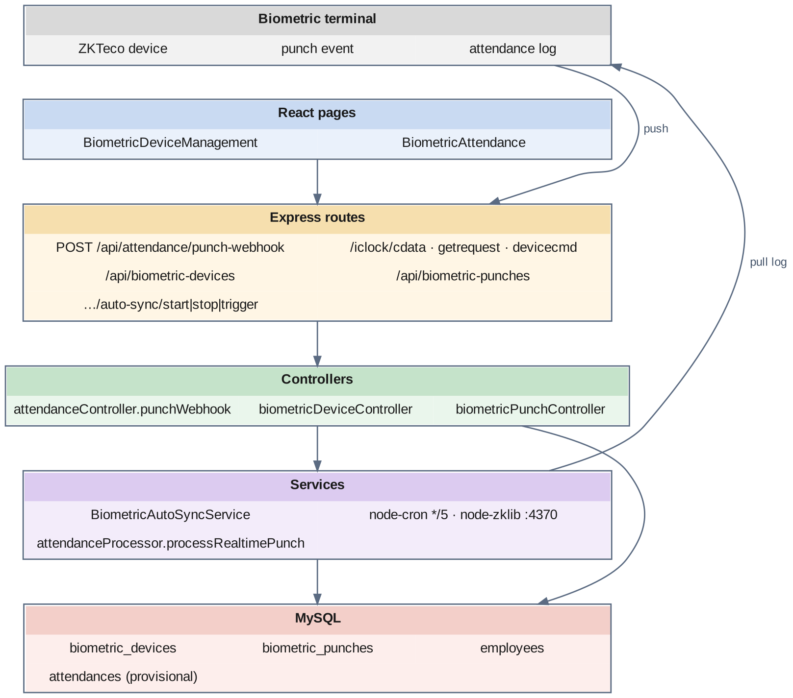
Fig 8.4.A Low-level architecture – BIOMETRIC DEVICE & PUNCH CAPTURE
Request flow — real-time path:
- A punch is posted to /api/attendance/punch-webhook with the employee, the punch time, an optional direction, the device and the company.
- The controller loads the employee with their employment type. If the direction is missing or unusable, derivePunchType decides IN or OUT from the punch time and the shift windows.
- A look-up for a Valid punch by the same employee in the preceding two minutes acts as the duplicate guard; a repeat is acknowledged and ignored.
- The punch is inserted into biometric_punches and handed to processRealtimePunch, which creates or updates the provisional attendance row described in module 8.5.
Request flow — pull path:
- BiometricAutoSyncService wakes every five minutes and lists devices that are Active with isAutoSyncEnabled = true.
- For each device it opens a node-zklib connection on port 4370 and reads the attendance log.
- For each log record it checks whether the punch already exists, resolves the employee from the biometric enrollment ID, and inserts the new ones, counting imported and duplicate records per device.
- BiometricDeviceManagement.jsx can start, stop, trigger and read the status of this service, and BiometricAttendance.jsx can preview and import one device's log on demand.
Device protocol listener:
- The terminal issues GET /iclock/cdata?SN=<serial> and receives a configuration block setting the transfer interval, real-time flag and delay values.
- It posts ATTLOG lines — PIN, timestamp, status and verify mode, tab-separated — to POST /iclock/cdata, polls GET /iclock/getrequest as a heartbeat, and posts command results to POST /iclock/devicecmd.

8.4.6 API Design
Method | Endpoint | Purpose / contract
POST | /api/attendance/punch-webhook | Body: employeeId, punchTime, punchType (optional), deviceId, companyId. Stores the punch and returns the provisional attendance row.
GET | /iclock/cdata (device) | Returns the device configuration block for the given serial number.
POST | /iclock/cdata (device) | Accepts tab-separated ATTLOG punch lines; returns OK.
GET | /iclock/getrequest (device) | Device heartbeat and command poll.
POST | /iclock/devicecmd (device) | Device command result callback.
GET | /api/biometric-devices · /api/biometric-devices/:id | List and fetch registered devices.
POST / PUT / DELETE | /api/biometric-devices · /api/biometric-devices/:id | Maintain device registrations.
PATCH | /api/biometric-devices/:id/toggle-status | Activate or deactivate a device.
GET | /api/biometric-punches · /api/biometric-punches/:id | List punches with filters; fetch one punch.
POST | /api/biometric-punches | Add a manual punch.
PUT / DELETE | /api/biometric-punches/:id | Correct or remove a punch.
GET | /api/biometric-punches/employee/:employeeId/daily | One employee's punches grouped by day.
GET | /api/biometric-punches/fetch-from-device/:deviceId | Read a device's log without importing it.
POST | /api/biometric-punches/fetch-and-import/:deviceId | Read and import a device's log.
GET | /api/biometric-punches/auto-sync/status | Whether auto-sync is running and the result of its last cycle.
POST | /api/biometric-punches/auto-sync/start · /stop · /trigger | Control the automatic sync service.

8.4.7 DB Design
Table | Keys & indexes | Key columns
biometric_devices | PK id (auto) · FK companyId → companies ON DELETE CASCADE | name, location, deviceIP, status ENUM(Active, Inactive), isAutoSyncEnabled boolean
biometric_punches | PK id (auto) · FK employeeId, biometricDeviceId, shiftTypeId, companyId · INDEX idx_employee_date (employeeId, punchDate) · INDEX idx_device_time (biometricDeviceId, punchTime) · INDEX idx_company_date (companyId, punchDate) · INDEX idx_enrollment_device (biometricEnrollmentId, biometricDeviceId) | biometricEnrollmentId, punchTime DATETIME, punchDate DATE, punchType ENUM(IN, OUT), isLate, isEarlyOut, isManual, remarks, status ENUM(Valid, Invalid, Duplicate)

- punchDate duplicates the date part of punchTime deliberately. Every attendance query filters by calendar day, and a stored DATE column is indexable in a way that a function on a DATETIME is not.
- The four indexes correspond exactly to the four ways the table is read: by employee for a day, by device for a time window, by company for a day, and by enrollment on a device for duplicate detection.
- isManual is what keeps an administrative correction honest. A manual punch is stored in the same table as a device punch but is permanently distinguishable from it.
- The employee is resolved from biometricEnrollmentId, which is stored on the punch as well as on the employee, so a punch remains traceable to the number the terminal actually reported.

8.4.8 Screenshots
[ Paste screenshot here ]
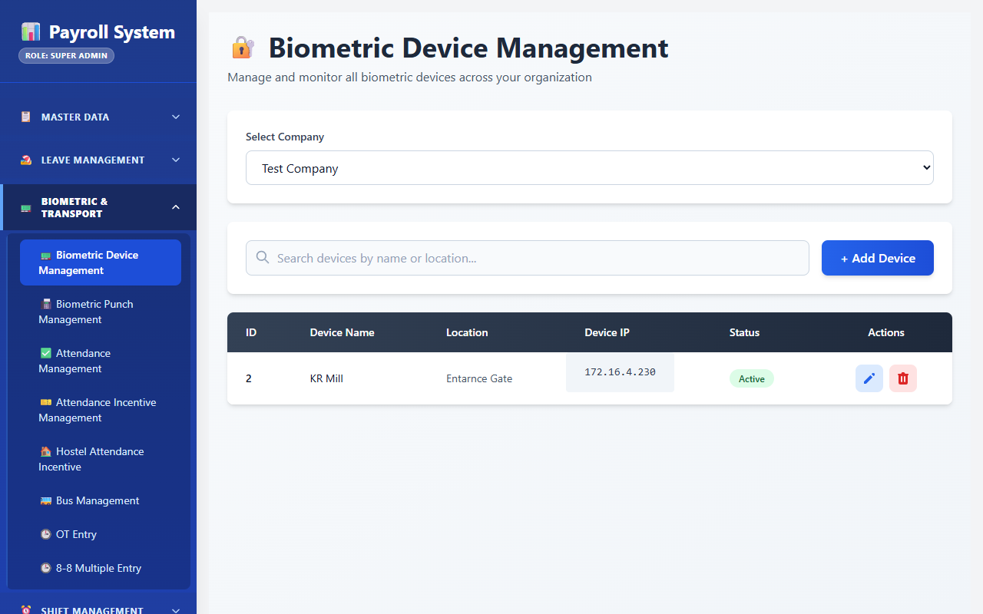
Fig 8.4.1 Biometric device list
The device screen lists each registered terminal with its name, location, IP address, status and auto-sync setting. Turning auto-sync off for one device leaves the others polling, which is useful while a terminal is being serviced.
[ Paste screenshot here ]
Fig 8.4.2 Registering a biometric device
The device form captures the display name, physical location, IP address and company. The IP address is what the pull service connects to on port 4370 when it reads the device log.
[ Paste screenshot here ]
Fig 8.4.3 Auto-sync service status
The status panel reports whether the automatic sync service is running and when it last completed a cycle, with controls to start, stop and trigger it immediately. An immediate trigger is the first step when a supervisor reports that a punch is missing.
[ Paste screenshot here ]
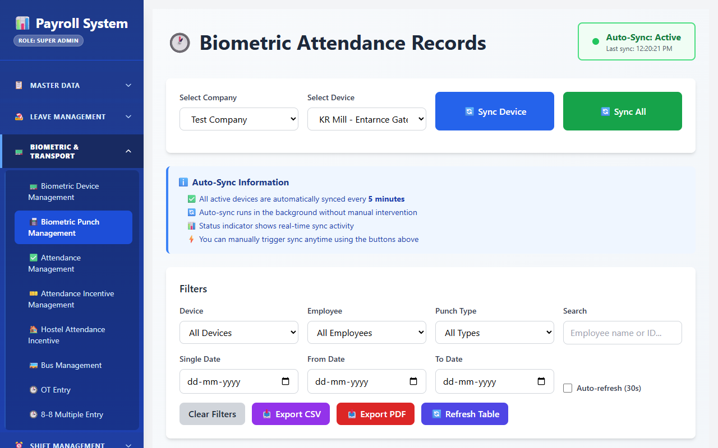
Fig 8.4.4 Raw punch log
The punch list shows every captured punch with the employee, device, timestamp, direction and validity status. Because attendance processing writes to separate tables, this list remains the evidence a disputed attendance record is checked against.
[ Paste screenshot here ]
Fig 8.4.5 Fetching punches from a device
The fetch screen reads a selected device's stored log so it can be inspected before it is imported. Separating the fetch from the import lets an administrator confirm what will be added rather than discovering it afterwards.
[ Paste screenshot here ]
Fig 8.4.6 Adding a manual punch
The manual entry form records a punch for an employee, date and time with a remark. The saved row is flagged as manual, so a later audit can tell at a glance which punches came from a fingerprint and which from a keyboard.

8.5 ATTENDANCE PROCESSING & SHIFT ENGINE

8.5.0 Purpose & Scope
Converts raw punches into finalised daily attendance: detecting the correct shift from punch time, applying grace, permission and status rules, finalising automatically at shift end, and publishing a monthly per-employee summary. This is the analytical core of the system.

8.5.1 Functional Requirements
What the module must do:
- Load shift windows from the database at runtime from shift_types, with a short-lived cache, so that an administrator changing a shift timing changes the processing behaviour without a code deployment.
- Route each employee to the right shift pool by employment type: worker and staff-per-day to the standard shifts A, B and C; supervisor to the supervisor shifts SUP_A, SUP_B and SUP_C; staff to the staff shifts, falling back to the general and then the standard shifts.
- Detect the shift from the punch time in three passes: a midpoint-capped window first, then a ninety-minute early-arrival window, then the nearest shift start as a fallback.
- Process in two phases. Phase 1 runs on every punch and writes a provisional row with isFinalized = false for the live dashboard. Phase 2 runs after the shift ends, re-reads all punches for the day, applies the full rules and sets isFinalized = true.
- Finalise on a schedule derived from the shifts themselves: a cron job is registered for each active shift's end time plus a two-hour buffer, with a fixed safety-net job at 23:45 to catch anything missed.
- Credit a midnight-crossing shift to the correct date. A shift whose end time is earlier than its start time, and the shifts named C and SUP_C, are finalised against the previous calendar date.
- Draw down a monthly permission pool for staff: 120 minutes per month after a 10-minute grace, usable on at most two days a month and for at most sixty minutes on any one day. Workers have no pool, and a staff member detected in an A, B or C shift is finalised with worker logic.
- Assign a status of Present, Present with Permission, Present/Leave (P/L), Absent, Half Day, Leave, Holiday or Week Off, and record lateness and early-exit minutes.
- Regenerate a date range on demand after a correction, as a background job with a job id and live progress, so that a large rebuild does not block the API.
- Lock a settled date against further change, and allow an explicit, recorded unlock.
- Record department-wise attendance entered by HR, including the department an employee actually worked in when it differs from their own.
- Publish a monthly summary per employee per shift into employee_shifts, which is the form the payroll system consumes.
- Record lunch out and in times from the punch log, with reports of late returns and missing punches.

8.5.2 Non-Functional Requirements
- Correctness over speed. This module is the system's point of highest consequence; every rule it applies is reproducible from stored punches, and the same module is called from the webhook, the cron and the manual regeneration so that all three give the same result.
- Provisional and final are structurally separate. isFinalized is a column, not a convention, so no screen can accidentally present live data as settled data. The discrepancy report, for example, reads finalised rows only.
- Timezone determinism. Punch timestamps come back from the database in UTC, while shift boundaries are stored as local times. Every punch is converted to local time once, in one helper, before it is compared with a shift window — the fix for a class of errors in which an early-morning punch was matched to the wrong shift.
- Idempotent reprocessing. Finalising the same date twice produces the same row; the unique index on (employeeId, attendanceDate) guarantees one row per employee per day.
- Bounded cache staleness. Shift windows are cached for five minutes, and the cache can be invalidated explicitly, so a changed timing is picked up within minutes at worst.
- Isolation of heavy work. A regeneration runs in a separate forked process, so a month-long rebuild cannot hold an HTTP connection open or slow the punch path. The last fifty completed jobs are kept in memory for status look-ups.
- Lock enforcement in one place. A single helper is consulted by the attendance, overtime and 8-8 write paths, so a locked date is refused consistently.
- CAP: CP for the finalised record, AP for the provisional one — the deliberate split described in the chapter baseline.

8.5.3 Tech Stack
Concern | Choice | Why it fits this module
Processing logic | services/attendanceProcessor.js | A single shared module called by the webhook, the cron and manual regeneration
Shift source | shift_types table, cached 5 minutes | No hardcoded timings; an administrator's edit changes behaviour within minutes
Scheduling | node-cron, expressions derived from shift end times at start-up | Finalisation time follows the shift configuration rather than a fixed clock
Date arithmetic | moment | Midnight-crossing shifts and date offsets are the hard part, and are handled explicitly
Rebuild isolation | attendanceRegenerateQueue.js forking attendanceRegenerateWorker.js (child_process.fork) | Keeps long rebuilds off the request path and reports progress by message passing
Lock enforcement | utils/attendanceLockUtil.js + attendance_locks | One helper consulted by every write path
Monthly rollup | employee_shifts table via upsertEmployeeShift() | A compact, query-ready summary for the payroll system

8.5.4 Back-of-the-Envelope Estimation
Quantity | Estimate | Basis
Attendance rows per day | ≈ 1,200 | One per employee per calendar day
Attendance rows per year | ≈ 438,000 rows ≈ 175 MB | ≈ 400 bytes per row
Punches read per finalisation | ≈ 1,600 per shift | 400 employees in a shift × 4 punches
Finalisation runs per day | One per distinct shift end time + 1 safety net | Worker, supervisor and staff shifts + the 23:45 catch-all
Finalisation duration | ≈ 20–60 s per shift | Bulk read, in-memory grouping, bulk upsert
Monthly regeneration | ≈ 36,000 rows | 1,200 employees × 30 days — run in a forked process, not inline
Shift cache hit rate | > 99% | 5-minute TTL against a table changed a few times a year
Permission pool | 120 minutes per staff member per month | PERMISSION_CONFIG.MONTHLY_POOL_MINUTES
Permission limits | 10 min grace · 2 days per month · 60 min per day | PERMISSION_CONFIG
Early-arrival window | 90 minutes before shift start | EARLY_ARRIVAL_WINDOW_MINUTES
Regeneration history | Last 50 jobs | MAX_HISTORY
Finalisation buffer | 120 minutes after shift end | FINALIZE_BUFFER_MIN

8.5.5 Low-Level Architecture
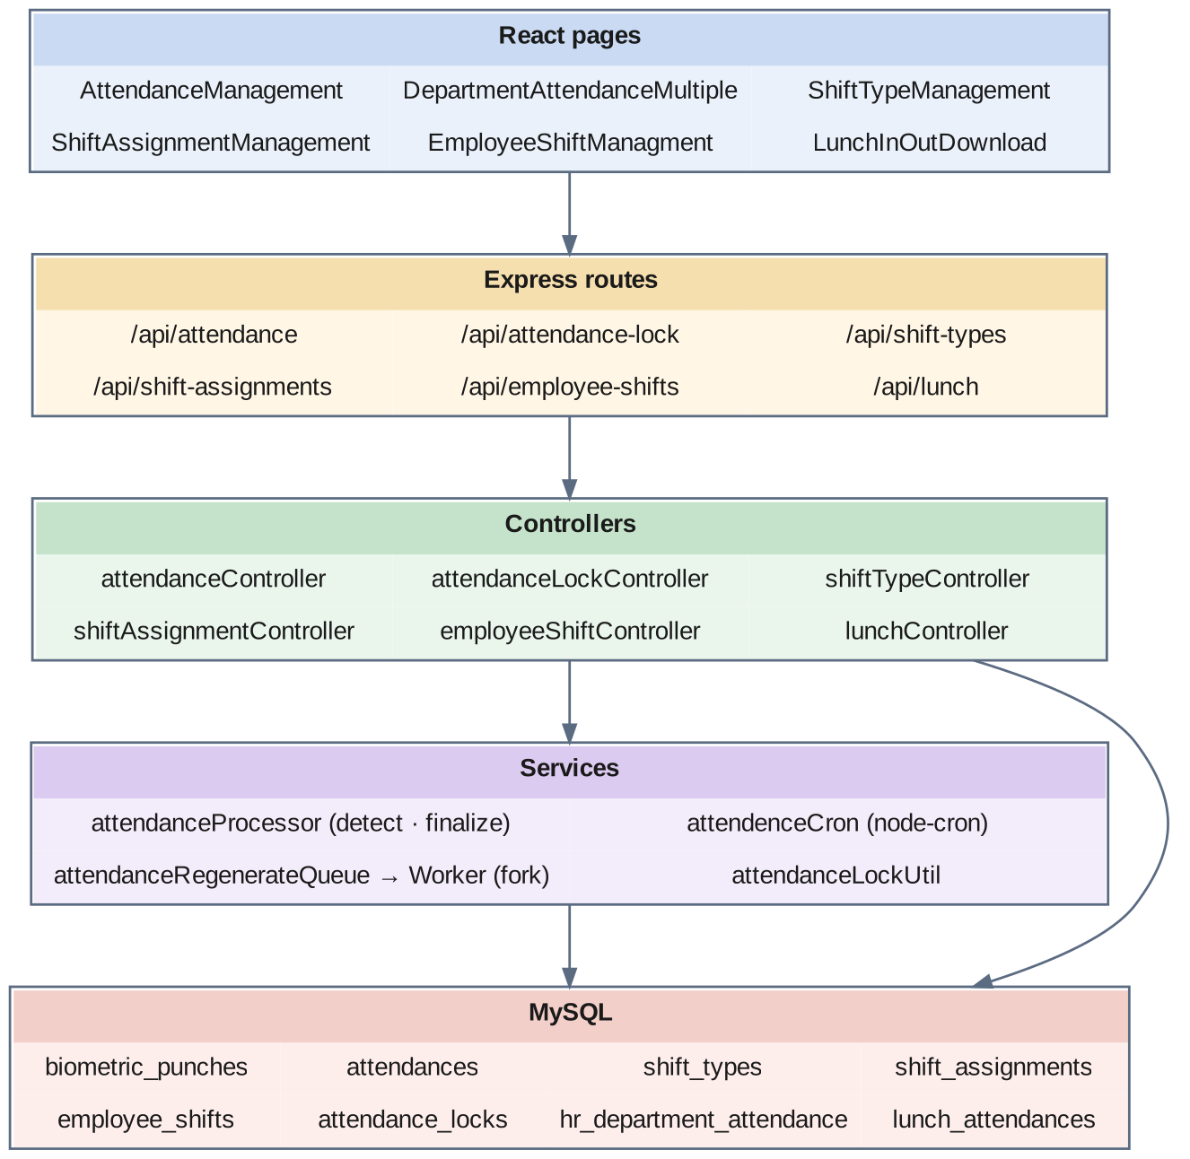
Fig 8.5.A Low-level architecture – ATTENDANCE PROCESSING & SHIFT ENGINE
Shift detection:
- loadShiftWindows() reads the active shift types and sorts them into pools — standard (A, B, C), supervisor (SUP_*), staff and general — and computes for each shift its check-in window and its midpoint. The result is cached for five minutes.
- getShiftForEmployee picks the pool from the employment type and calls detectWorkerShift or detectStaffShift.
- Pass 1 accepts a shift if the punch falls between the start of its check-in window and its midpoint. Capping the window at the midpoint is what stops a 07:46 arrival for the 08:30 shift from matching the night shift that is still open.
- Pass 2 accepts the shift that starts soonest within the next ninety minutes — the early-arrival case.
- Pass 3 falls back to the shift whose start is nearest to the punch.
Phase 1 — real-time flow:
- A punch arrives through the webhook and is stored in biometric_punches.
- processRealtimePunch resolves the employee and their employment type, converts the punch to local time, detects the shift, and creates or updates a provisional attendances row with isFinalized = false. The live dashboard reads these rows.
Phase 2 — finalisation flow:
- At start-up, the cron initialiser reads every active shift type and registers a job at each shift's end time plus the two-hour buffer, with a date offset of −1 for shifts that cross midnight and for shifts named C or SUP_C. A fixed job at 23:45 catches any record still unfinalised.
- When a job fires, finalizeAttendance loads every punch for the target date and groups them by employee.
- Worker finalisation takes the first valid IN and the last valid OUT within the allowed windows, computes worked hours, lateness against the shift's grace period and early exit, and sets the status.
- Staff finalisation additionally draws lateness and early-exit minutes from the monthly permission pool, within the per-day and per-month limits, and records the minutes consumed in permissionMinutes; once a limit is passed the day is no longer treated as a permitted lateness.
- Approved leave overrides the punch-derived status for the days it covers.
- The row is written with isFinalized = true, and upsertEmployeeShift() updates the monthly summary for that employee, shift, month and year.
Manual regeneration flow:
- An administrator submits a date range from AttendanceManagement.jsx.
- The queue creates a job, forks the worker process and returns the job id at once.
- The worker re-runs finalisation for each date and sends progress messages back to the parent, which the client reads through the job status endpoint.
Supporting screens:
- ShiftTypeManagement.jsx and ShiftAssignmentManagement.jsx maintain the shift definitions and assignments; EmployeeShiftManagment.jsx shows the monthly per-shift summary and can rebuild it.
- DepartmentAttendanceMultiple.jsx checks the lock status for the date and then loads and saves HR's department-wise attendance grid.
- LunchInOutDownload.jsx pulls lunch punches, posts them as lunch records, and lists late returns and missing punches.

8.5.6 API Design
Method | Endpoint | Purpose / contract
POST | /api/attendance/punch-webhook | Accepts a punch and runs real-time processing.
GET | /api/attendance/live-dashboard | Provisional, in-shift attendance picture for the floor.
POST | /api/attendance/regenerate | Start a background rebuild for a date range; returns a job id.
GET | /api/attendance/regenerate-job/:jobId | Progress and result of a rebuild job.
GET | /api/attendance/cron-status | Which finalisation jobs are registered and their schedules.
GET | /api/attendance/summary | Attendance summary per employee for a period.
GET | /api/attendance/permission-summary | Permission-pool consumption for staff.
GET | /api/attendance · /api/attendance/:id | List and fetch attendance rows with filters.
PUT / DELETE | /api/attendance/:id | Correct or remove an attendance row.
PATCH | /api/attendance/:id/approve | Approve an attendance row.
GET / POST | /api/attendance/multiple-entry | Load and save department-wise attendance entries in bulk.
PUT | /api/attendance/multiple-entry/:id | Update a department-wise entry.
POST | /api/attendance/multiple-entry/delete | Delete department-wise entries in bulk.
GET | /api/attendance-lock/status | Whether a given date is locked.
POST | /api/attendance-lock/toggle | Lock or unlock a date.
GET | /api/attendance-lock/list | All locked dates.
GET / POST / PUT / DELETE | /api/shift-types · /api/shift-types/:id | Maintain shift definitions.
PATCH | /api/shift-types/:id/toggle-status | Activate or deactivate a shift.
GET / POST / PUT / DELETE | /api/shift-assignments · /api/shift-assignments/:id | Maintain employee shift assignments.
PATCH | /api/shift-assignments/:id/cancel | Cancel an assignment.
POST | /api/shift-assignments/bulk-delete | Remove many assignments at once.
GET | /api/employee-shifts/shift-summary | Monthly per-employee, per-shift summary.
POST | /api/employee-shifts/shift-summary/rebuild | Rebuild the monthly summary from finalised attendance.
GET | /api/lunch · /api/lunch/employee/:empId | Lunch records, overall and for one employee.
POST | /api/lunch/download · /api/lunch/post | Pull lunch punches and save them as lunch records.

8.5.7 DB Design
Table | Keys & indexes | Key columns
attendances | PK id (auto) · UNIQUE unique_employee_date (employeeId, attendanceDate) · INDEX companyId, attendanceDate, status, isFinalized · FK employeeId, companyId, departmentId, workedDeptId, shiftId | attendanceDate, shiftName varchar(20), scheduledStartTime / scheduledEndTime varchar(8), firstCheckIn, lastCheckOut, totalCheckIns, totalCheckOuts, workingHours decimal(5,2), overtimeHours decimal(5,2), status ENUM(Present, Present with Permission, Present/Leave (P/L), Absent, Half Day, Leave, Holiday, Week Off), isFinalized, isLate, lateByMinutes, isEarlyExit, earlyExitMinutes, permissionMinutes, isHoliday, isWeekOff, autoGenerated, approvedBy, approvedAt, remarks
shift_types | PK id (auto) · FK holidayListId, companyId | name, startTime TIME, endTime TIME, beginCheckInBefore, allowCheckOutAfter, enableAutoAttendance, requireCheckIn, requireCheckOut, allowMultipleCheckIns, autoMarkAbsentIfNoCheckIn, workingHoursCalculation ENUM(first_to_last, fixed_hours, with_breaks), halfDayHours decimal(4,2), absentHours decimal(4,2), enableLateEntry, lateGracePeriod, enableEarlyExit, earlyExitPeriod, markAutoAttendanceOnHolidays, status
shift_assignments | PK id (auto) · INDEX (employeeId, assignmentDate), (companyId, assignmentDate), shiftTypeId | assignmentDate, startDate, endDate, isRecurring, recurringPattern ENUM(daily, weekly, monthly, custom), recurringDays JSON, status ENUM(Active, Inactive, Cancelled), notes
employee_shifts | PK id (auto) · UNIQUE uq_emp_shift_month (employeeId, companyId, shiftName, month, year) · INDEX (companyId, month, year), (employeeId, year), (shiftName, month, year) | shiftName varchar(20), scheduledStartTime / scheduledEndTime varchar(5), month, year, totalDays, presentDays, presentWithPermissionDays, absentDays, leaveDays, lateDays, earlyExitDays, totalWorkingHours decimal(10,2), totalOvertimeHours decimal(10,2), totalPermissionMinutes, firstSeenDate, lastSeenDate
attendance_locks | PK id (auto) · UNIQUE (companyId, lockDate) | lockDate, isLocked, lockedBy, lockedAt, unlockedBy, unlockedAt, remarks
hr_department_attendance | PK id (auto) · UNIQUE unique_dept_emp_date_shift (employeeId, attendanceDate, shiftId) · INDEX companyId, departmentId, workedDeptId, attendanceDate, status | ticketNo varchar(50), empName varchar(150), category varchar(50), attendanceDate, status, shiftName varchar(50), remarks, createdBy, updatedBy
lunch_attendances | PK id (auto) · FK employeeId, departmentId, companyId, shiftId | date, lunchOutTime varchar(20), lunchInTime varchar(20), status ENUM(Normal, Late IN, No Punch)

- The unique index (employeeId, attendanceDate) is the single most important constraint in the system. It is what makes reprocessing safe: finalisation upserts against it, so running the same job twice cannot produce two conflicting rows for one person on one day.
- shiftName, scheduledStartTime and scheduledEndTime are stored inline on the attendance row, not only as a foreign key to shift_types. The shift is detected from punch time and the detected values are frozen onto the record, so editing a shift definition later does not silently rewrite last month's attendance.
- hr_department_attendance is deliberately a second, independent record of the same day: attendances is what the fingerprint reader says, this table is what the department says. Keeping both is what makes the discrepancy report in module 8.9 possible.
- workedDeptId is kept alongside departmentId so that an employee lent to another department is counted in the strength of the department where the work actually happened, while remaining on their home department's roll.
- permissionMinutes holds the minutes actually deducted from the staff pool on that day. Summing the column for an employee over a month gives the pool consumption, which is why no separate ledger table is needed.
- The unique index on employee_shifts makes the monthly rollup an upsert: each finalisation adjusts one row per employee, shift and month.

8.5.8 Screenshots
[ Paste screenshot here ]
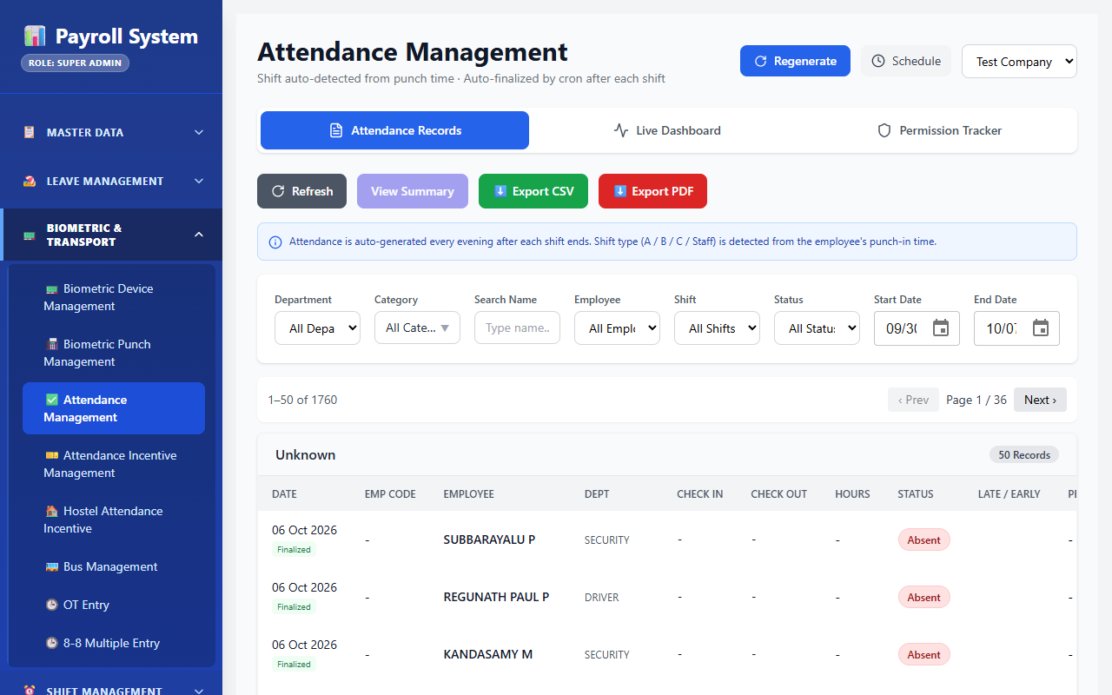
Fig 8.5.1 Attendance management list
The attendance screen lists finalised and provisional rows with the employee, date, detected shift, check-in and check-out times, working hours and status. The finalised flag distinguishes a settled record from one still being built during a running shift.
[ Paste screenshot here ]
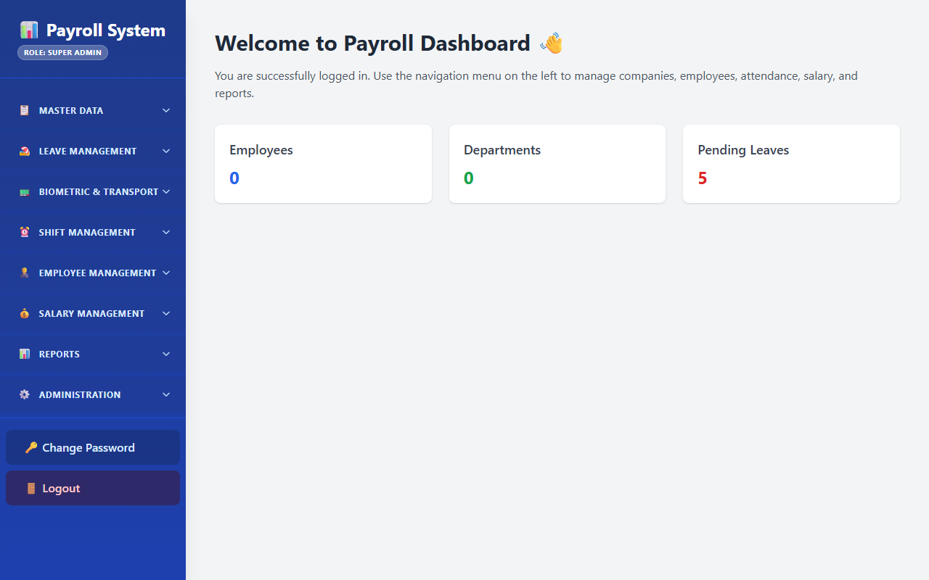
Fig 8.5.2 Live dashboard
The live dashboard shows the provisional attendance picture while a shift is in progress, built from punches as they arrive. It is intended for floor awareness, and the underlying rows are explicitly marked unfinalised so they cannot be mistaken for the record of account.
[ Paste screenshot here ]
Fig 8.5.3 Regenerating attendance for a date range
The regeneration control submits a date range for rebuilding and returns a job identifier. Because the work runs in a separate background process, a month-long rebuild does not hold the browser or block incoming punches.
[ Paste screenshot here ]
Fig 8.5.4 Cron status
The cron status panel lists the finalisation jobs registered from the shift definitions and when each next runs. The times shown are derived from each shift's end time plus the configured buffer rather than being fixed in code.
[ Paste screenshot here ]
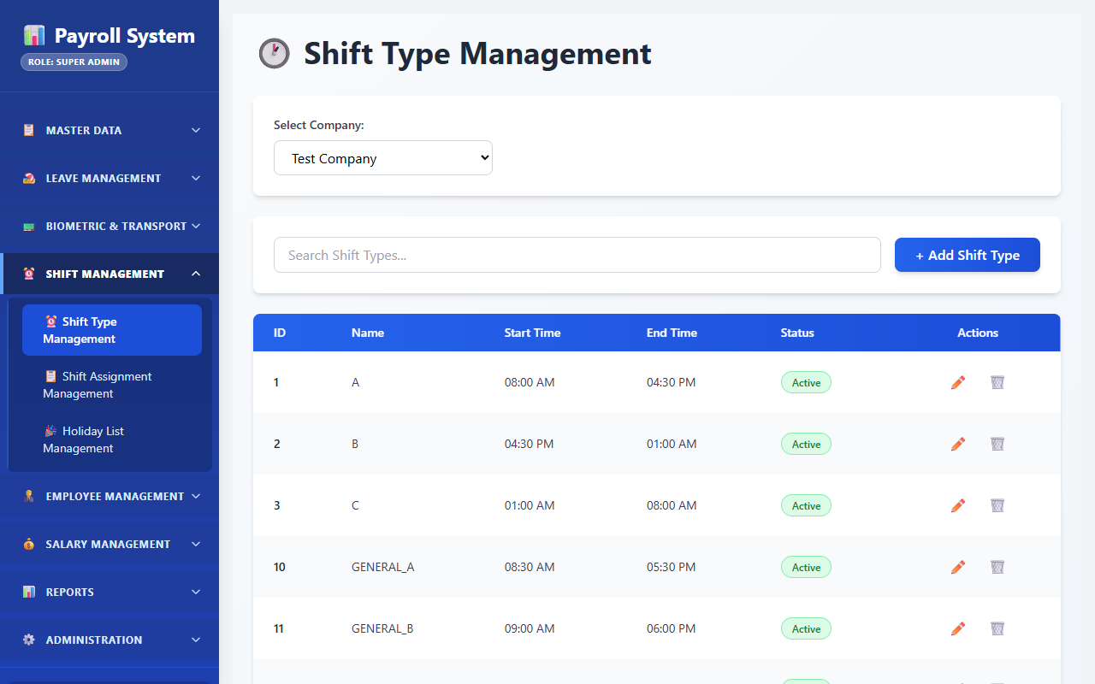
Fig 8.5.5 Shift type list
Shift types are listed with their start and end times, grace periods and status. These rows are the source the processor reads at runtime, which is why changing a timing here changes detection behaviour without a deployment.
[ Paste screenshot here ]
Fig 8.5.6 Creating a shift type
The shift form captures timings, early check-in and late check-out allowances, grace periods for lateness and early exit, half-day and absent hour thresholds and the working-hours calculation method. The holiday list selected here governs how holidays are treated for employees on this shift.
[ Paste screenshot here ]
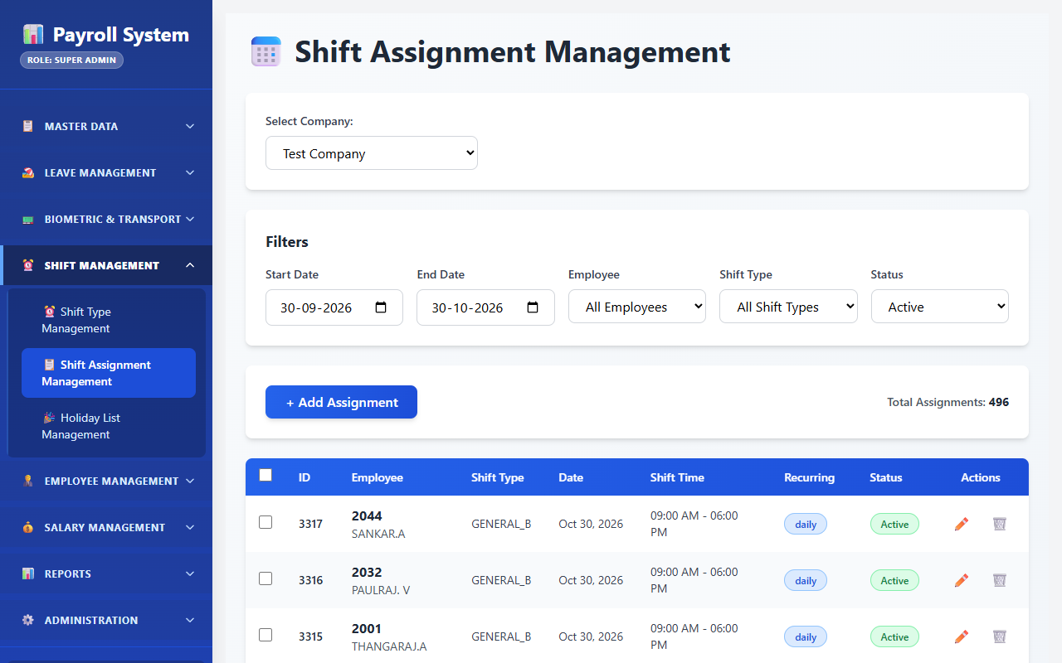
Fig 8.5.7 Shift assignment
The assignment screen places an employee on a shift for a date or a date range, with an optional recurring pattern. Assignments can be cancelled individually or removed in bulk when a roster is rotated.
[ Paste screenshot here ]
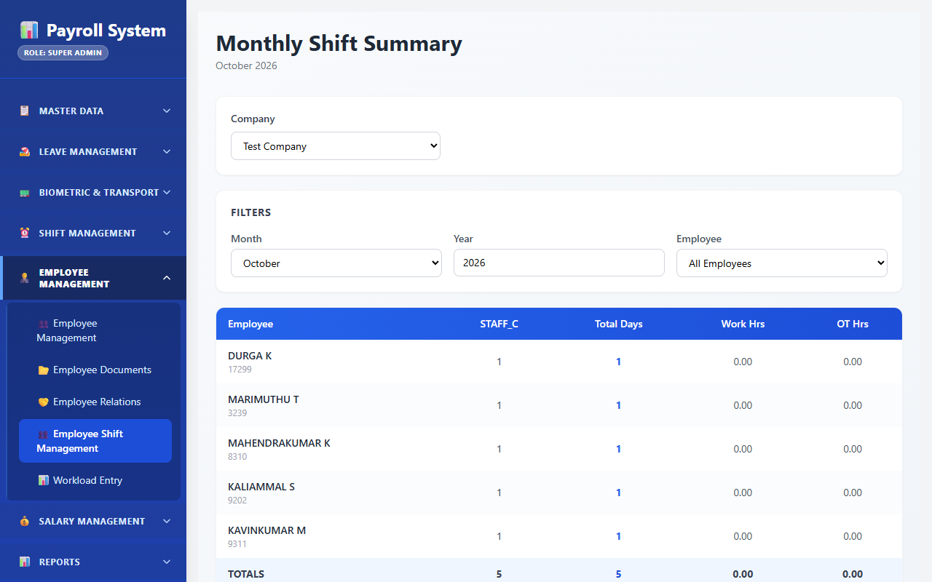
Fig 8.5.8 Employee shift summary
The monthly summary shows, per employee and shift, the present, permission, absent, leave, late and early-exit day counts together with total working and overtime hours. This is the compact record the payroll system consumes.
[ Paste screenshot here ]
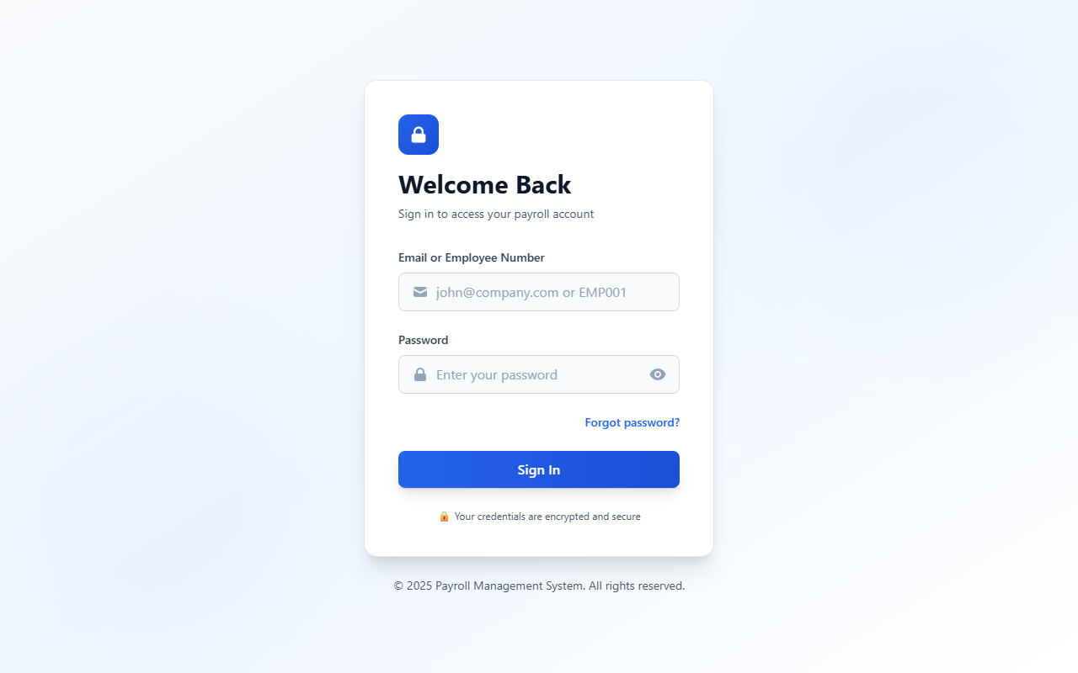
Fig 8.5.9 Department-wise multiple attendance entry
The multiple-entry grid is where HR records the department's own attendance for a date and shift, including the department each employee actually worked in. This independent record is what the discrepancy report later compares against the biometric attendance.
[ Paste screenshot here ]
Fig 8.5.10 Attendance lock
The lock control, reached from the strength report screen, freezes a settled date against further attendance, overtime and 8-8 entries, and records who locked it and when. Unlocking is an explicit, recorded action, so a late correction leaves a trail rather than happening silently.
[ Paste screenshot here ]
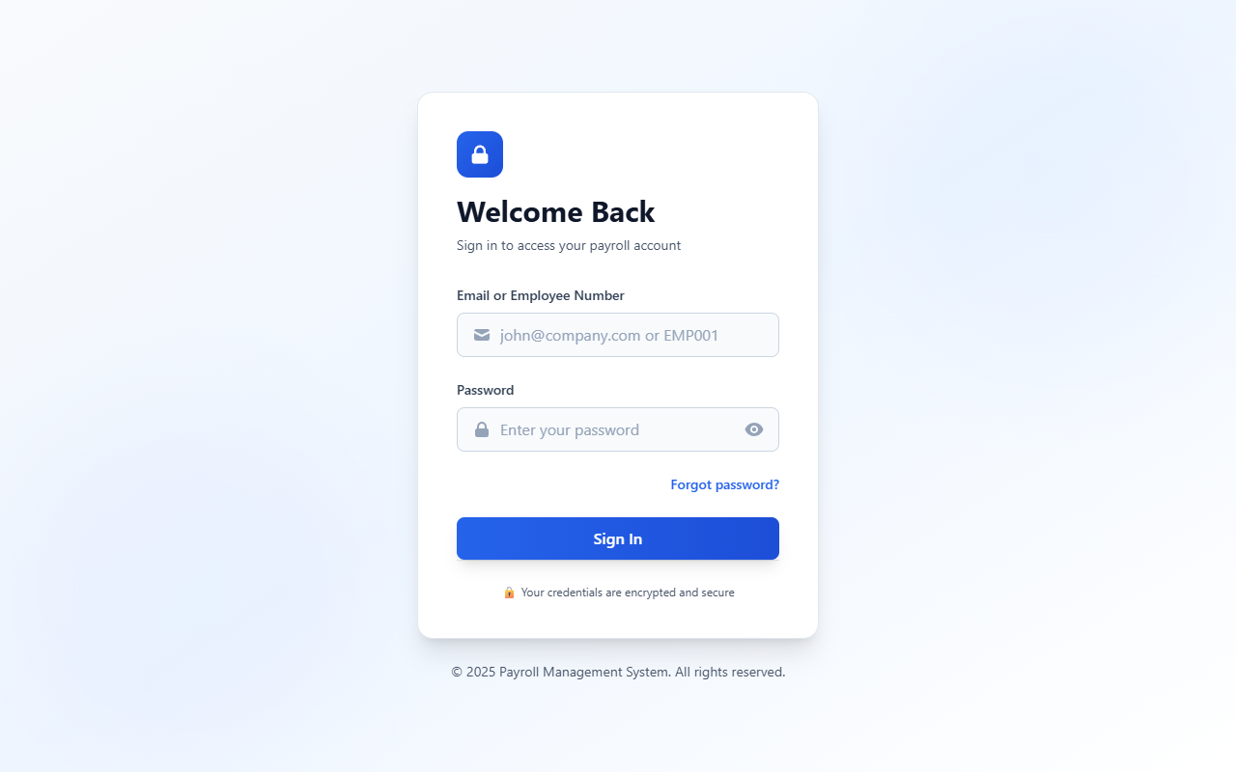
Fig 8.5.11 Lunch in and out download
The lunch screen lists midday out and in punches with a derived status and exports them. It is kept separate from the main attendance row because a missed lunch punch is an operational matter rather than an attendance dispute.

8.6 LEAVE MANAGEMENT & POLICY ENGINE

8.6.0 Purpose & Scope
Manages the complete leave lifecycle — defining leave types and policies, allocating quotas with accrual and carry-forward, routing requests through multi-level approval, and maintaining a full audit history of every action.

8.6.1 Functional Requirements
What the module must do:
- Define leave types with a name, description, whether the leave is paid, whether it is loss of pay, whether it carries forward, whether holidays falling inside it count as leave, and a maximum consecutive-day limit.
- Define leave policies that attach an accrual frequency (Monthly, Quarterly, Yearly, On Joining), accrual days, a carry-forward maximum and encashment rules to an employment type.
- Define leave periods — the leave year with a start and end date — so that allocations and balances are scoped to a period.
- Allocate quotas to an employee for a leave type in a period, with carry-forward from the previous period, a carry-forward limit and expiry date, pro-rating for mid-year joiners, optional monthly accrual with an accrual condition, and an optionally permitted negative balance within a limit.
- Allocate in bulk to many employees at once, and process monthly accrual across the workforce in one run.
- Raise a leave request for a date range with a category of Full Day, Half Day or Short Leave, a half-day indicator, a reason, supporting documents, and contact and address details during the leave.
- Route the request through multiple approval levels, tracking the current and maximum level, with each approver's decision, comments and action date recorded separately.
- Support the full state machine: Draft, Pending, Approved, Rejected, Cancelled and Withdrawn, with a soft-delete flag rather than physical deletion.
- Record every action in history with the actor, the action, the old and new status and the comments; the history table also provides columns for context, IP address and user agent.
- Reserve the balance at submission and release it again if the request is cancelled or rejected, so that two pending requests cannot both spend the same days.
- Show a team leave calendar and a pending-approvals queue for approvers.
- Report leave balances and leave taken, exportable to Excel and PDF.

8.6.2 Non-Functional Requirements
- Auditability above convenience. Every transition is written to leave_request_history, because a disputed leave approval is a human-resources matter where the trail matters more than the storage it costs.
- Balance integrity. allocatedLeaves, carryForwardFromPrevious, usedLeaves and totalAccruedTillDate are held on the allocation row, so a balance is a read of one row rather than an aggregation over the request history. A unique index allows only one allocation per employee, leave type and period.
- No double spending. The requested days are added to usedLeaves when the request is submitted, and the available balance is checked first, so a second request sees the reduced balance while the first is still pending.
- No silent overdraft. A negative balance is possible only when allowNegativeBalance is set, and only down to maxNegativeLimit.
- Approval ordering. A unique index on (leaveRequestId, approverLevel) allows exactly one approval row per level, and an approver's pending list shows a request only when currentApprovalLevel equals their own level, so levels are taken in order.
- Consistency: CP. An approved leave must be visible to the attendance finaliser immediately, because the finaliser may run within the hour and will otherwise mark the day absent.
- Retention. History rows are never deleted; a withdrawn or soft-deleted request keeps its trail.

8.6.3 Tech Stack
Concern | Choice | Why it fits this module
Workflow state | status ENUM + currentApprovalLevel / maxApprovalLevel on the request | The state machine is readable from one row
Approval records | Separate leave_approvals table, one row per level | Each approver's decision, comment and timestamp is preserved independently
Audit trail | leave_request_history, one row per transition | The full life of a request is readable in order
Level control | Unique index on (leaveRequestId, approverLevel) | The database itself refuses a second approval row for the same level
Documents | documentPaths JSON column on the request | Several supporting files per request without an extra table
Balance | Counters on leave_allocations | A balance check is an indexed single-row read
Accrual | processMonthlyAccrual endpoint, run monthly | One batch operation rather than per-employee jobs

8.6.4 Back-of-the-Envelope Estimation
Quantity | Estimate | Basis
Leave types | ≈ 6 rows | CL, SL, EL, maternity, paternity, compensatory off
Allocations per year | 1,200 × 6 = 7,200 rows ≈ 3.6 MB | One per employee per leave type per period
Leave requests per year | ≈ 9,000 | Roughly 7–8 requests per employee per year
Approval rows per year | ≈ 18,000 | Two approval levels per request on average
History rows per year | ≈ 45,000 | Roughly 5 transitions per request
Pending-approvals query | ≈ 20 rows per approver | Indexed on (approverId, status)
Monthly accrual run | 7,200 allocation rows updated | One batch per month

8.6.5 Low-Level Architecture
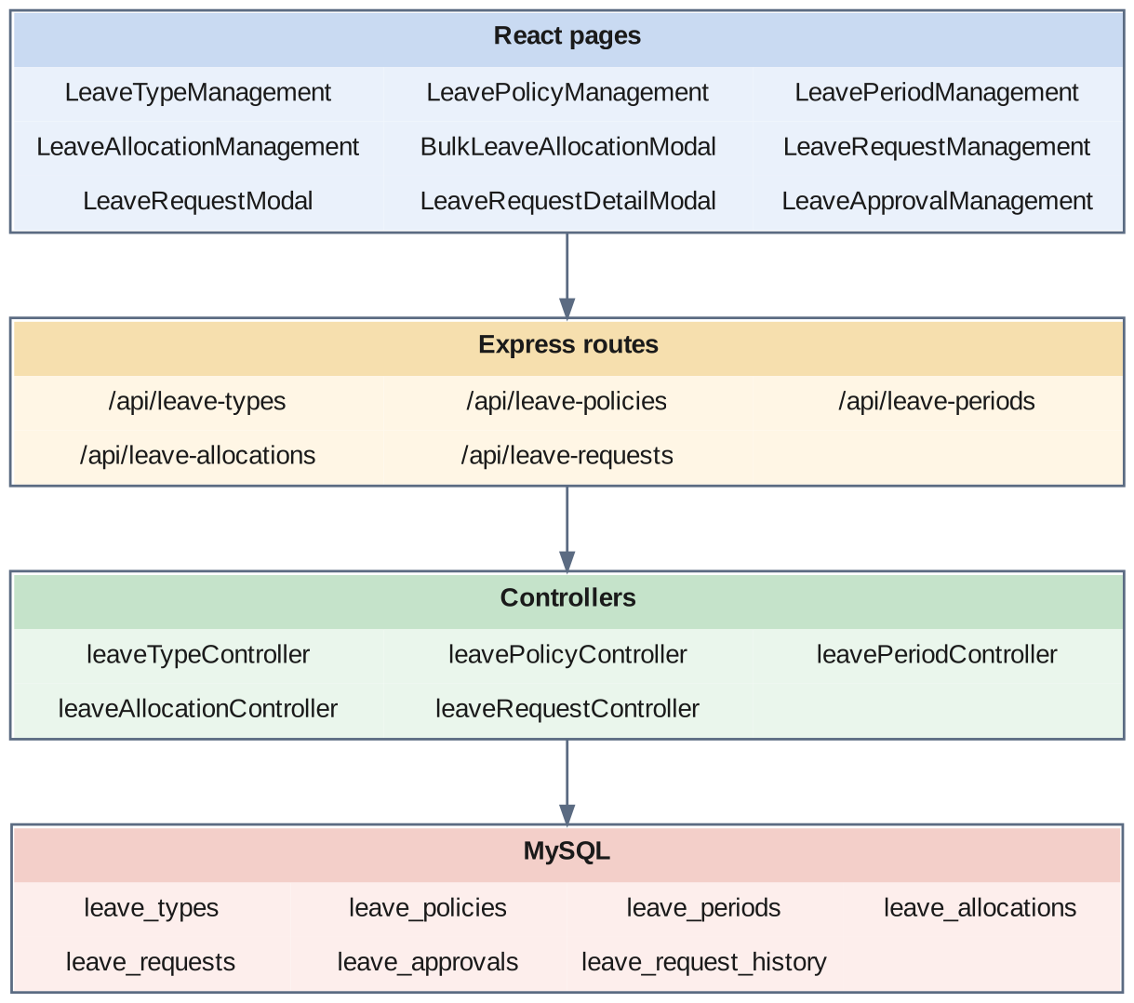
Fig 8.6.A Low-level architecture – LEAVE MANAGEMENT & POLICY ENGINE
Request flow:
- LeaveTypeManagement.jsx, LeavePolicyManagement.jsx and LeavePeriodManagement.jsx maintain the three definition tables.
- LeaveAllocationManagement.jsx creates allocations individually or, through BulkLeaveAllocationModal.jsx, for many employees at once; processMonthlyAccrual adds the monthly accrual to totalAccruedTillDate across all eligible allocations.
- From LeaveRequestManagement.jsx, LeaveRequestModal.jsx creates a request in Draft. Submitting it checks the available balance on the allocation, moves the status to Pending, sets maxApprovalLevel to the number of approvers, creates one leave_approvals row per level, and adds the requested days to usedLeaves.
- An approver opens LeaveApprovalManagement.jsx, which reads the pending-approvals endpoint and shows only the requests whose current level is theirs, and records a decision. Approving advances currentApprovalLevel; the request becomes Approved only when the final level approves.
- Cancelling or rejecting a request subtracts its days from usedLeaves again, returning the balance.
- Every transition writes a leave_request_history row capturing the actor, the action, the status change and the comments.
- The attendance finaliser reads approved requests, so those dates are recorded as Leave rather than Absent.

8.6.6 API Design
Method | Endpoint | Purpose / contract
GET / POST | /api/leave-types | List and create leave type definitions.
PUT / DELETE | /api/leave-types/:id | Update or remove a leave type.
GET / POST / PUT / DELETE | /api/leave-policies · /api/leave-policies/:id | Maintain accrual and carry-forward policies per employment type.
GET / POST | /api/leave-periods | List and create leave years.
PUT / DELETE | /api/leave-periods/:id | Update or remove a leave year.
GET | /api/leave-allocations · /api/leave-allocations/:id | List and fetch quota allocations.
POST | /api/leave-allocations | Allocate a quota to one employee.
POST | /api/leave-allocations/bulk | Allocate quotas to many employees at once.
POST | /api/leave-allocations/process-accrual | Run monthly accrual across eligible allocations.
GET | /api/leave-allocations/reports/balance | Leave balance report.
PUT / DELETE | /api/leave-allocations/:id | Update or remove an allocation.
GET | /api/leave-requests · /api/leave-requests/:id | List and fetch leave requests.
POST | /api/leave-requests | Create a leave request in Draft.
PUT | /api/leave-requests/:id | Update a Draft request.
POST | /api/leave-requests/:id/submit | Submit for approval; creates the approval chain.
POST | /api/leave-requests/:id/action | Record an approval or rejection at the current level.
POST | /api/leave-requests/:id/cancel | Cancel a request.
DELETE | /api/leave-requests/:id | Soft-delete a request.
GET | /api/leave-requests/approvals/pending | Pending approvals for the signed-in approver.
GET | /api/leave-requests/calendar/team | Team leave calendar.
GET | /api/leave-requests/summary/employee | Leave summary for one employee.

8.6.7 DB Design
Table | Keys & indexes | Key columns
leave_types | PK id (auto) · FK companyId | name, description, isPaid, isWithoutPay, isCarryForwardEnabled, countHolidaysAsLeave, maxConsecutiveLeaves, status
leave_policies | PK id (auto) · FK employmentTypeId, companyId | name, leaveType ENUM(Sick, Annual, Maternity, Paternity, Casual, Compensatory Off), accrualFrequency ENUM(Monthly, Quarterly, Yearly, On Joining), accrualDays, maxCarryForward, allowEncashment, encashmentRules, status
leave_periods | PK id (auto) · FK companyId | name, startDate, endDate, status
leave_allocations | PK id (auto) · UNIQUE unique_allocation_per_employee_type_period (employeeId, leaveTypeId, leavePeriodId) · FK employeeId, leaveTypeId, leavePeriodId, companyId | allocatedLeaves, carryForwardFromPrevious, usedLeaves, maxCarryForwardLimit, carryForwardExpiryDate, isProRated, proRatedDays, enableMonthlyAccrual, monthlyAccrualRate, accrualCondition ENUM(first_year, all_employees, grade_based), totalAccruedTillDate, allowNegativeBalance, maxNegativeLimit, status ENUM(Active, Expired, Cancelled), allocatedDate, effectiveFrom, effectiveTo, notes
leave_requests | PK id (auto) · INDEX (employeeId, status), (companyId, status), (startDate, endDate), leaveTypeId | startDate, endDate, totalDays decimal(4,1), leaveCategory ENUM(Full Day, Half Day, Short Leave), halfDayType ENUM(First Half, Second Half), reason, hasDocuments, documentPaths JSON, contactDuringLeave, addressDuringLeave, status ENUM(Draft, Pending, Approved, Rejected, Cancelled, Withdrawn), currentApprovalLevel, maxApprovalLevel, appliedDate, finalApprovedBy / finalApprovedAt, finalRejectedBy / finalRejectedAt, rejectionReason, isDeleted
leave_approvals | PK id (auto) · UNIQUE (leaveRequestId, approverLevel) · INDEX (approverId, status), leaveRequestId | approverLevel, approverRole, status ENUM(Pending, Approved, Rejected, Forwarded, Skipped), comments, actionDate, notificationSent, emailSent
leave_request_history | PK id (auto) · INDEX (leaveRequestId, actionDate), actionBy, action, actionDate | action ENUM(Created, Submitted, Approved, Rejected, Cancelled, Modified, Withdrawn, Forwarded, Deleted, Restored), actionBy, actionDate, oldStatus, newStatus, comments, actionContext JSON, ipAddress varchar(45), userAgent

- Holding usedLeaves on the allocation makes a balance check a single indexed row read instead of a sum over the request table — the right trade-off because balances are checked on every request screen load.
- The composite index (approverId, status) on leave_approvals is what makes the pending-approvals queue instant for an approver with hundreds of historical decisions.
- isDeleted rather than a physical delete preserves the audit chain; a deleted request and its history remain reconstructable.

8.6.8 Screenshots
[ Paste screenshot here ]
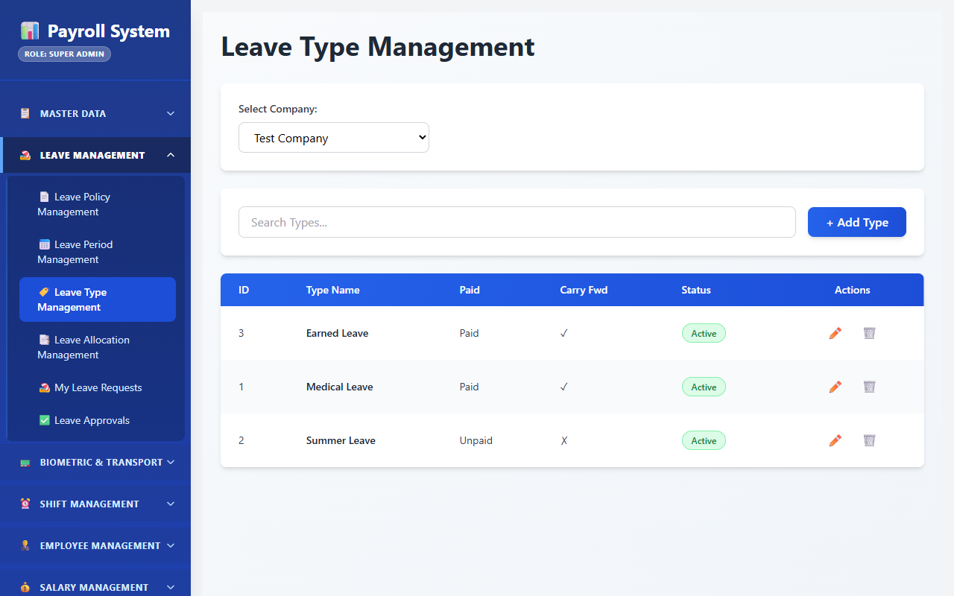
Fig 8.6.1 Leave type management
Leave types are maintained with flags for paid, loss of pay, carry-forward and whether holidays inside the leave count. These flags are what later decide whether a leave day is a paid day in the monthly summary.
[ Paste screenshot here ]
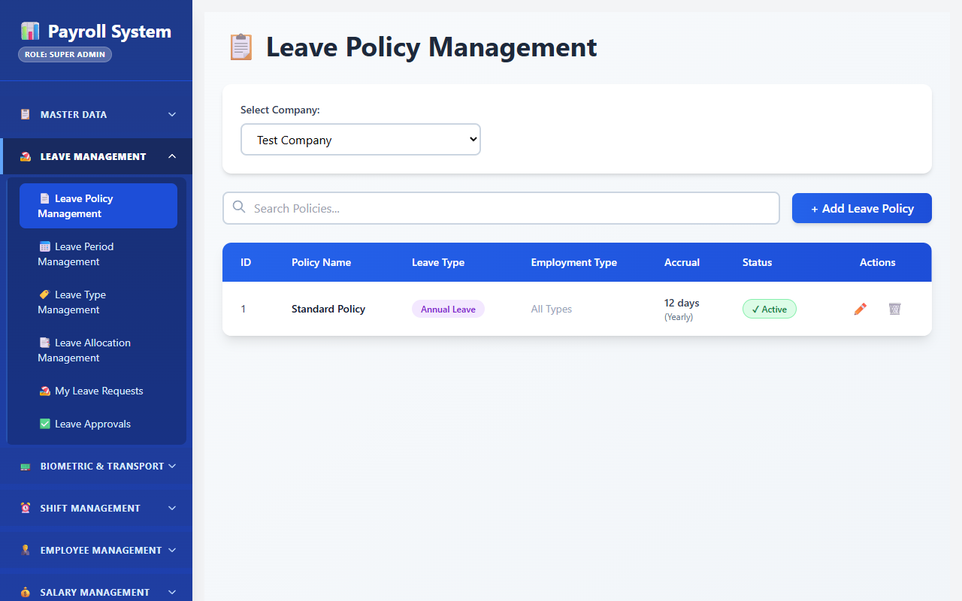
Fig 8.6.2 Leave policy management
Leave policies attach an accrual frequency, accrual days and carry-forward maximum to an employment type. Keeping the policy on the employment type means a new employee inherits the correct rules without individual configuration.
[ Paste screenshot here ]
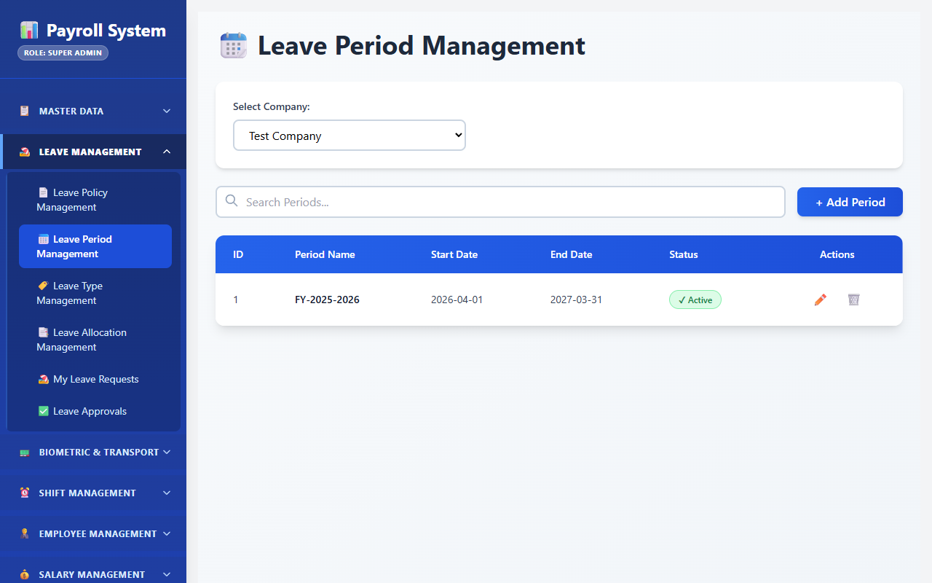
Fig 8.6.3 Leave period management
Leave periods define the leave year with a start and end date. Allocations and balances are scoped to a period, so a carry-forward is a deliberate transfer between periods rather than an open-ended balance.
[ Paste screenshot here ]
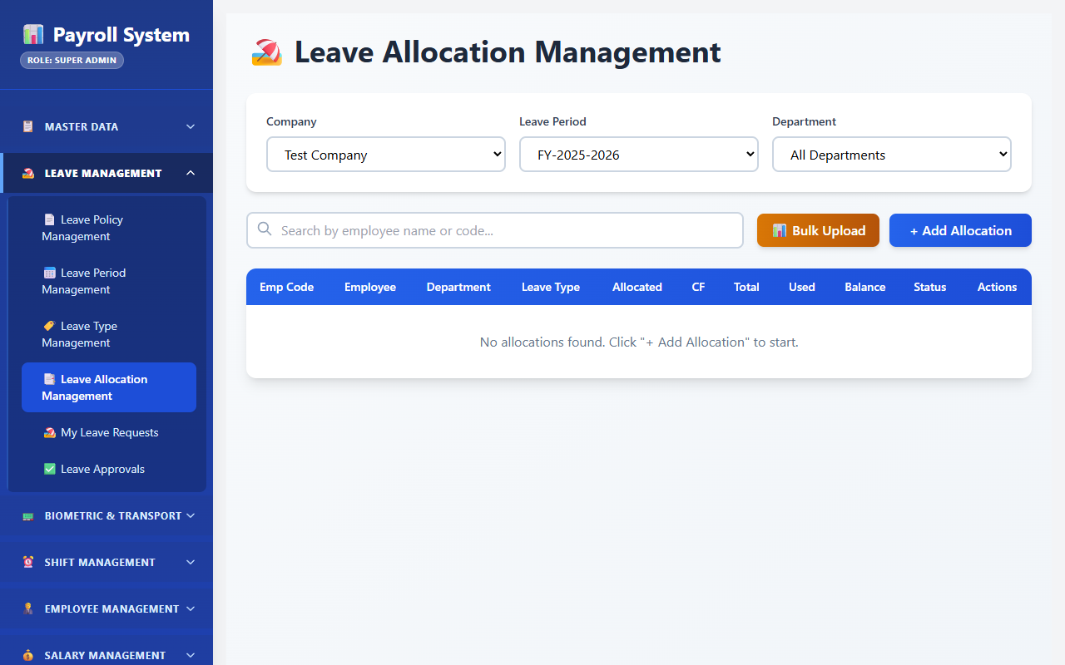
Fig 8.6.4 Leave allocation list
Allocations show the employee, leave type, period, allocated days, carry-forward, used days and the resulting balance. The balance is read directly from the row, which is why the list loads without aggregating the request history.
[ Paste screenshot here ]
Fig 8.6.5 Creating an allocation
The allocation form captures the quota, carry-forward limit and expiry, pro-rating, monthly accrual settings and any permitted negative balance. Pro-rating matters for mid-year joiners, who would otherwise receive a full year's quota.
[ Paste screenshot here ]
Fig 8.6.6 Bulk leave allocation
The bulk dialog allocates the same quota to a filtered set of employees in one operation. This is how the leave year is opened, since allocating to twelve hundred employees individually is not practical.
[ Paste screenshot here ]
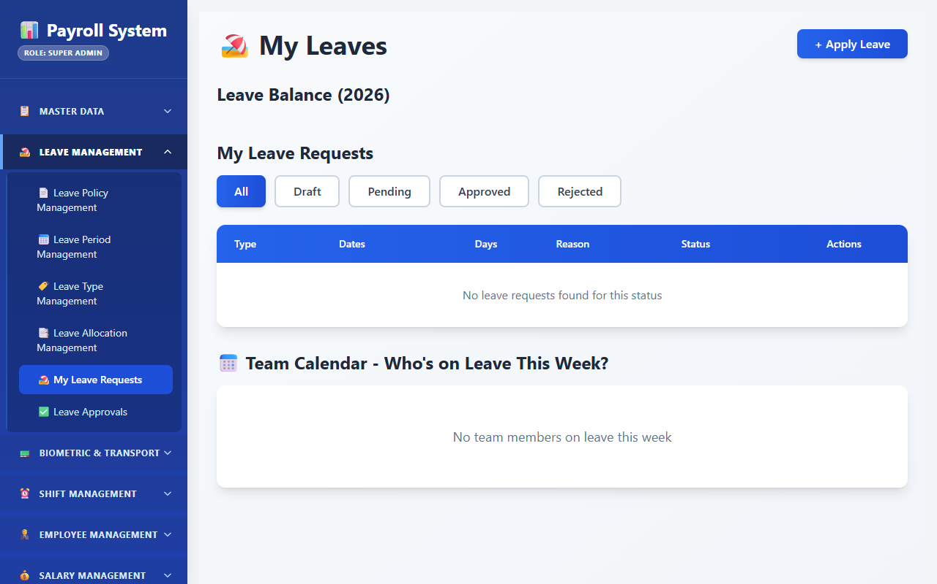
Fig 8.6.7 Leave request list
Requests are listed with the employee, leave type, dates, total days, category and current status. The status column reflects the state machine, so a request awaiting a second approver is visibly different from one already approved.
[ Paste screenshot here ]
Fig 8.6.8 Raising a leave request
The request form captures the date range, category, reason, supporting documents and contact details during the leave. Saving creates the request in Draft; submitting it is a separate action that builds the approval chain and reserves the days against the balance.
[ Paste screenshot here ]
Fig 8.6.9 Leave request detail and history
The detail view shows the request together with its approval rows and its allocation balance — who acted at each level, when, and with what comment. This trail is what settles a dispute about when an approval actually happened.
[ Paste screenshot here ]
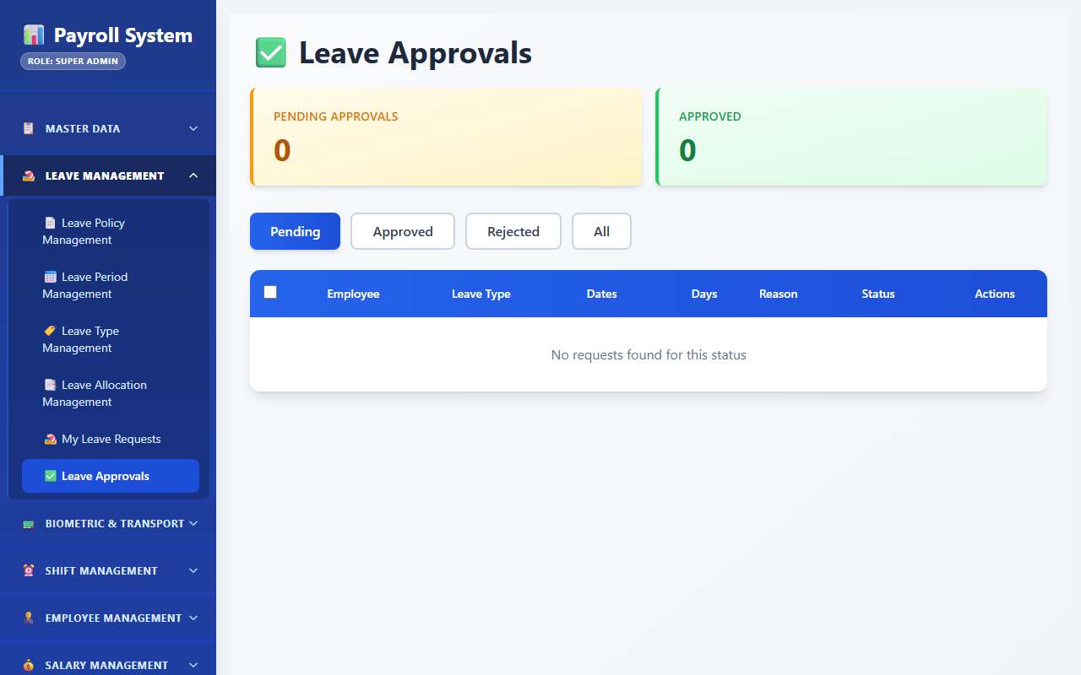
Fig 8.6.10 Pending approvals queue
The approval screen lists the requests waiting on the signed-in approver at their level. Approving advances the request to the next level; only the final level moves it to Approved.
[ Paste screenshot here ]
Fig 8.6.11 Team leave calendar
The calendar view shows approved and pending leave across a team for a period. It is the screen a supervisor uses before approving, because overlapping absences in one department are the practical constraint.

8.7 OVERTIME & SPECIAL ENTRY ENGINE

8.7.0 Purpose & Scope
Captures work performed outside the normal shift — overtime hours and 8-8 double-shift entries — against a specific date, shift and worked department, with bulk entry screens sized for the volume a mill generates.

8.7.1 Functional Requirements
What the module must do:
- Record OT hours for an employee on a date, with hours, from-time, to-time, OT type, the shift it relates to, the department actually worked in, a ticket number, the employee name as entered, and remarks.
- Record 8-8 entries separately, with an entry type and hours, for the double-shift arrangement where an employee covers two consecutive shifts.
- Enter in bulk through a grid, since OT is authorised for a group at the end of a shift rather than one person at a time, with bulk save, bulk delete and, for 8-8 entries, a history of past bulk saves.
- Filter and summarise OT by employee, department, date range and shift, with a statistics endpoint for totals.
- Delete by employee and date so that a wrongly entered day can be cleared without hunting for row identifiers.
- Produce OT reports in three shapes — day-wise, hours-wise and an abstract summary — each exportable.
- Respect the attendance lock, so OT cannot be added to a settled date without an explicit unlock.

8.7.2 Non-Functional Requirements
- Entry speed over entry elegance. The dominant cost in this module is a clerk's time. The multiple-entry grid exists because the realistic input is thirty rows at once.
- Separation from attendance. OT is stored in its own table rather than only as a column on the attendance row, because OT is authorised by a supervisor rather than derived from punches, and must remain attributable to whoever entered it.
- Worked-department accuracy. workedDeptId is recorded on every OT row so that overtime cost is attributed to the department that consumed it.
- Integrity: a unique index on (employeeId, date) prevents the common data-entry error of recording the same overtime twice for one person on one day; saving again updates the existing row.
- Entry rights: the bulk overtime grid is guarded for the HR role, and the 8-8 grid for Admin, Super Admin and Department Admin.
- Consistency: CP. OT hours feed directly into the monthly summary the payroll system reads, so a saved row must be immediately visible.

8.7.3 Tech Stack
Concern | Choice | Why it fits this module
Bulk entry UI | OvertimeMultipleEntry.jsx and EightEightMultipleEntry.jsx grids | Matches how OT is actually authorised — by the batch
Bulk API | Dedicated multiple-entry, bulk-save and bulk-delete endpoints | One round trip for thirty rows instead of thirty
Lock check | utils/attendanceLockUtil.js | A locked date is refused before anything is written
Filtering | Sequelize where on employee, department, date range and shift | The same filter set the reports use
Reporting | Overtime report endpoints with day-wise, hours-wise and abstract shapes | Three different questions management actually asks
Export | ExcelJS and PDFKit server-side | Reports leave the system as files for circulation

8.7.4 Back-of-the-Envelope Estimation
Quantity | Estimate | Basis
OT entries per day | ≈ 120 | Roughly 10% of the workforce on a normal day
OT entries per year | ≈ 36,000 rows ≈ 11 MB | 300 working days
8-8 entries per year | ≈ 4,000 rows | Less frequent than ordinary OT
Bulk grid submission | ≈ 30 rows per save | One shift's authorised OT
Report query span | ≈ 3,600 rows per month | Indexed on employee and date

8.7.5 Low-Level Architecture
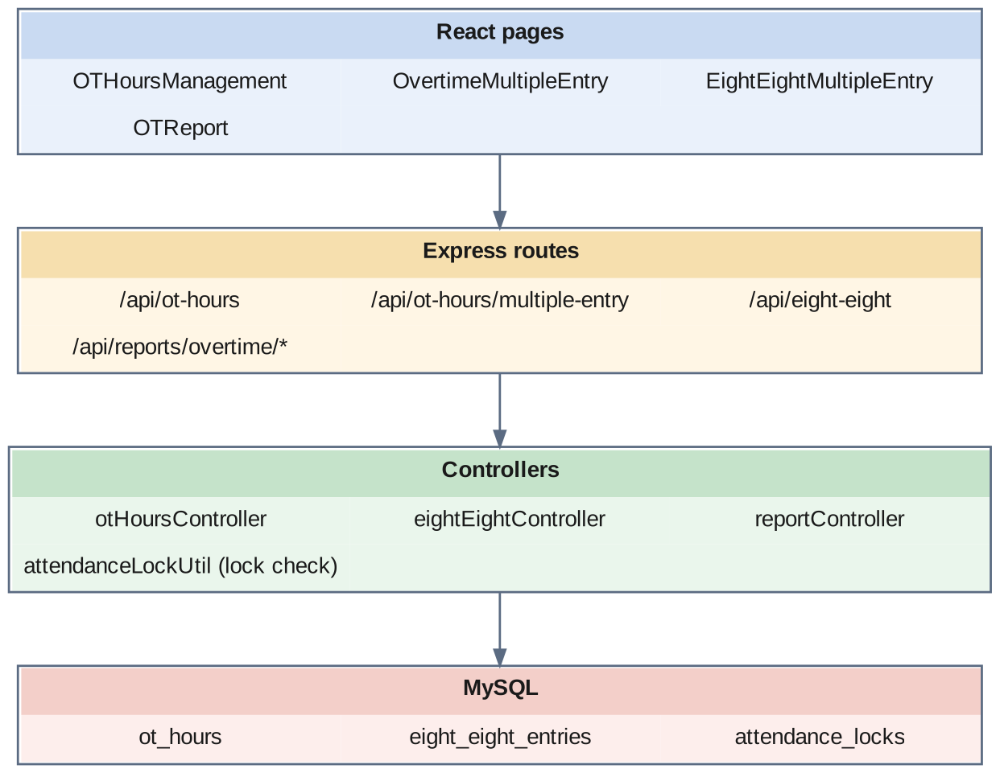
Fig 8.7.A Low-level architecture – OVERTIME & SPECIAL ENTRY ENGINE
Request flow:
- OTHoursManagement.jsx reads existing OT for a date and department through the filter endpoint.
- OvertimeMultipleEntry.jsx presents a grid of employees for the selected date, department and shift; the clerk enters hours against the relevant rows and saves once.
- otHoursController checks the date against the attendance lock, then creates or updates the rows, recording createdBy or updatedBy.
- EightEightMultipleEntry.jsx follows the same pattern against eight_eight_entries with its own entry type, saving a whole grid through the bulk-save endpoint.
- OTReport.jsx requests a day-wise, hours-wise or abstract report over a date range, which the report controller aggregates and returns for display and export.
- The monthly aggregation reads the OT hours alongside attendance when building the summary consumed by the payroll system.

8.7.6 API Design
Method | Endpoint | Purpose / contract
GET | /api/ot-hours | List OT rows.
GET | /api/ot-hours/filter | List with employee, department, date range and shift filters.
GET | /api/ot-hours/stats | Aggregated OT totals.
POST | /api/ot-hours | Create one OT row.
PUT / DELETE | /api/ot-hours/:id | Update or remove one OT row.
DELETE | /api/ot-hours/:employeeId/:date | Remove an employee's OT for a specific date.
GET | /api/ot-hours/multiple-entry | Load the bulk entry grid for a date, department and shift.
POST | /api/ot-hours/multiple-entry | Save the grid as a batch.
PUT | /api/ot-hours/multiple-entry/:id | Update one row within the grid.
POST | /api/ot-hours/multiple-entry/delete | Delete several grid rows at once.
GET | /api/eight-eight/multiple-entry | Load the 8-8 entry grid.
POST | /api/eight-eight/multiple-entry | Save 8-8 entries.
POST | /api/eight-eight/bulk-save | Save a whole 8-8 grid as a batch.
GET | /api/eight-eight/bulk-history | Past 8-8 bulk saves.
POST | /api/eight-eight/bulk-delete | Delete several 8-8 entries.
DELETE | /api/eight-eight/:id | Delete one 8-8 entry.
POST | /api/reports/overtime | Overtime report.
POST | /api/reports/overtime/day-wise | Day-wise overtime report.
POST | /api/reports/overtime/hours-wise | Hours-wise overtime report.
POST | /api/reports/overtime/abstract | Abstract overtime summary.

8.7.7 DB Design
Table | Keys & indexes | Key columns
ot_hours | PK id (auto) · UNIQUE (employeeId, date) · INDEX companyId, departmentId, employeeId, date | date, otHours decimal(10,2), remarks, workedDeptId, shiftId, otTypeId, fromTime varchar(50), toTime varchar(50), otType varchar(50), ticketNo varchar(50), empName varchar(150), createdBy, updatedBy, status
eight_eight_entries | PK id (auto) · UNIQUE (employeeId, date, entryType) · INDEX companyId, departmentId, employeeId, date | date, entryType, hours decimal(10,2), remarks, workedDeptId, shiftId, createdBy, updatedBy, status

- ticketNo and empName are denormalised onto the OT row on purpose. Storing the ticket number and name as they were entered makes a later reconciliation against the entry sheet possible even if the employee record changes.
- The unique index on eight_eight_entries includes entryType, because an employee can legitimately have two different 8-8 entry types on one date, which a two-column key would have wrongly refused.
- otTypeId separates a Full OT entry from an Hours OT entry. The strength report counts the first as a head and sums the second as hours.

8.7.8 Screenshots
[ Paste screenshot here ]
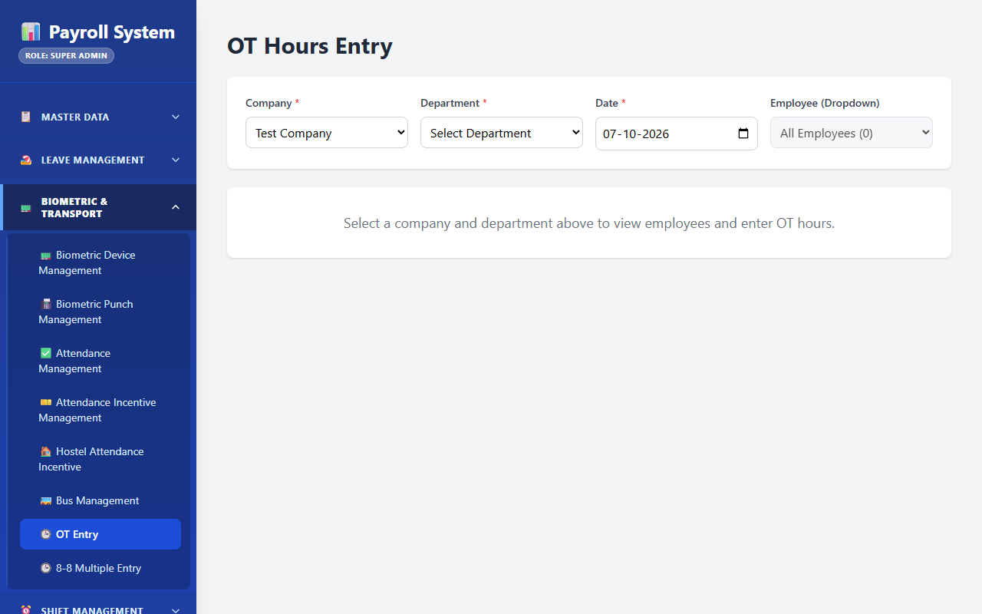
Fig 8.7.1 OT hours list
The OT screen lists recorded overtime with the employee, date, hours, type, shift and worked department. The worked department column is what allows overtime to be attributed to the department that actually consumed it.
[ Paste screenshot here ]
Fig 8.7.2 Overtime multiple entry grid
The grid presents the employees of a selected department and shift for a date, with an hours field against each. Entering a whole shift's authorised overtime in one save is the reason this screen exists alongside the single-row form.
[ Paste screenshot here ]
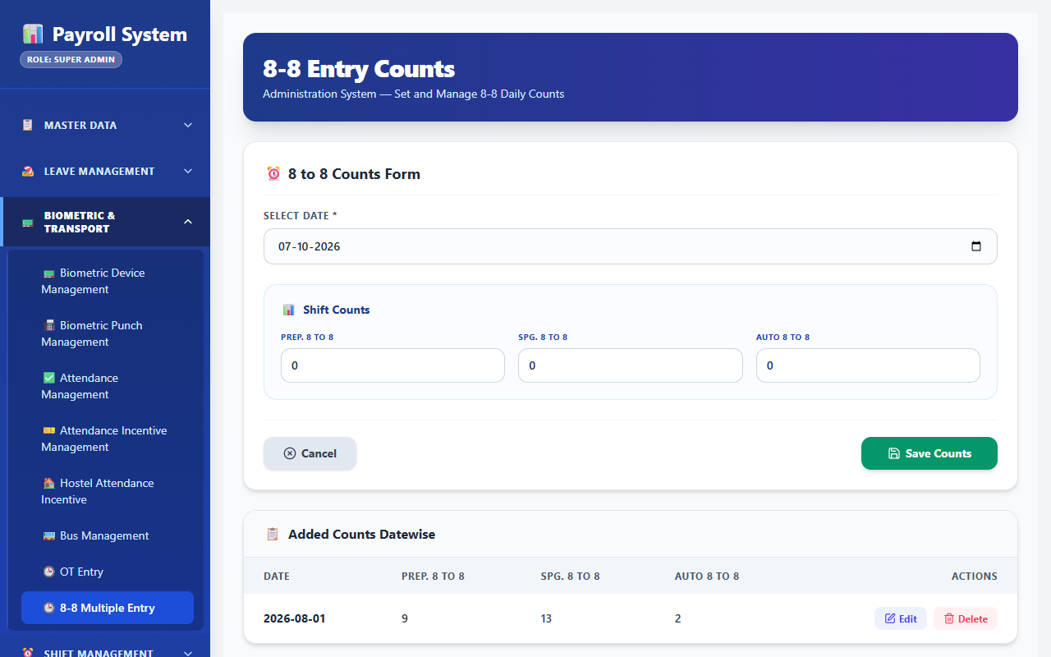
Fig 8.7.3 8-8 multiple entry
The 8-8 grid records double-shift coverage with its own entry type and hours. It is kept separate from ordinary overtime because the two are authorised differently and reported separately.
[ Paste screenshot here ]
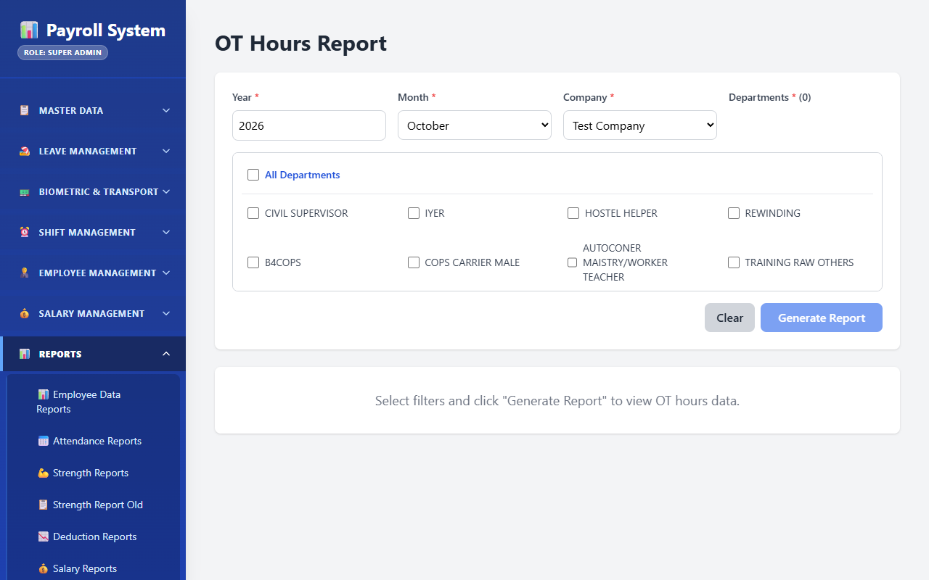
Fig 8.7.4 OT report
The report screen produces day-wise, hours-wise and abstract views of overtime over a date range, with export controls. The three shapes correspond to the three different questions management asks of the same data.

8.8 ATTENDANCE INCENTIVE ENGINE

8.8.0 Purpose & Scope
Evaluates attendance-linked incentives against configurable, grade-wise and shift-wise rules — including multi-shift combination thresholds and category-based overrides — and records the qualifying days, tier and amount for each employee and month.

8.8.1 Functional Requirements
What the module must do:
- Hold incentive conditions as data layered over a documented default: per company, category, department (single or a list), shift type, gender and grade, define a minimum qualifying day count, a low tier with its day count and rate per day, a high tier with its own, a minimum day count for each shift in a combination, and an optional experience-based override.
- Evaluate incentive for an employee and month from the monthly per-shift day counts in employee_shifts, mapping the employee's category to a grade, resolving the shift rule, applying the combination minimums, and selecting the low or high tier.
- Apply the combination rule: for a multi-shift combination to qualify, each of the constituent shifts must independently reach its minimum day count, and the total must reach the tier threshold.
- Apply the experience override where configured, so that male workers in specific grades above an experience threshold are evaluated on the single-shift rate only.
- Record the result with the adjusted day count, slab days, OT days, shift key and label, tier, whether the override applied, the rate per day and the computed incentive amount.
- Save individually, in bulk and by preview, so that a month can be calculated, reviewed and then committed.
- Reset conditions to the configured defaults when a rule set needs to be rebuilt.
- Evaluate hostel attendance incentives for resident workers with their own conditions, calculation and bulk save, over a date range.
- Record packaging incentives as bags packed against a rate per bag and a minimum threshold, with a monthly summary.

8.8.2 Non-Functional Requirements
- Rules as data, not deployments. Incentive slabs are negotiated and change. The engine starts from the documented default in config/AttendenceIncentiveConfig.js and overlays whatever rows exist in attendance_incentive_conditions, so a revised rate is a database update rather than a code release, and reset returns to the default.
- Reproducibility. The computed row stores not only the amount but the inputs that produced it — day counts, shift key, tier, whether the override applied — so a challenged incentive can be re-derived without re-running the engine.
- Separation of calculate and commit. The calculate endpoint is a pure evaluation; the save endpoints persist. A month can therefore be previewed before it is committed.
- Precision: rates and amounts are DECIMAL(10,2); day counts are integers.
- Consistency: CP. The incentive amount flows into the payroll system's earnings, so a committed row must be immediately and uniformly visible.

8.8.3 Tech Stack
Concern | Choice | Why it fits this module
Default rule set | config/AttendenceIncentiveConfig.js | Documents the negotiated grades, shifts and tiers; also the source for reset
Rule overrides | attendance_incentive_conditions table, overlaid on a copy of the default | Slabs are editable without a deployment
Input | employee_shifts monthly per-shift day counts | The engine reads a ready summary instead of scanning daily attendance
Evaluation | AttendanceIncentiveController calculate endpoint | Pure computation, separable from persistence
Multi-department scope | departmentIds TEXT alongside departmentId | A rule can apply to one department or to a list of them
Commit | save-one and bulk-save endpoints | Preview first, then commit a whole month

8.8.4 Back-of-the-Envelope Estimation
Quantity | Estimate | Basis
Condition rows | ≈ 40–60 | Grades × shift rules, from the documented configuration
Incentive rows per month | ≈ 1,200 | One per eligible employee
Incentive rows per year | ≈ 14,400 rows ≈ 4 MB | Twelve months
Qualifying thresholds | 22 minimum, 23 low tier, 24 high tier | INCENTIVE_CONFIG
Combination minimum | 12 days in each constituent shift | MIN_COMBO_SHIFT_DAYS
Experience override | 3 years, male workers in the configured grade | MALE_EXP_THRESHOLD
Monthly calculate run | 1,200 evaluations, each reading one month of day counts | Run once per month before commit

8.8.5 Low-Level Architecture
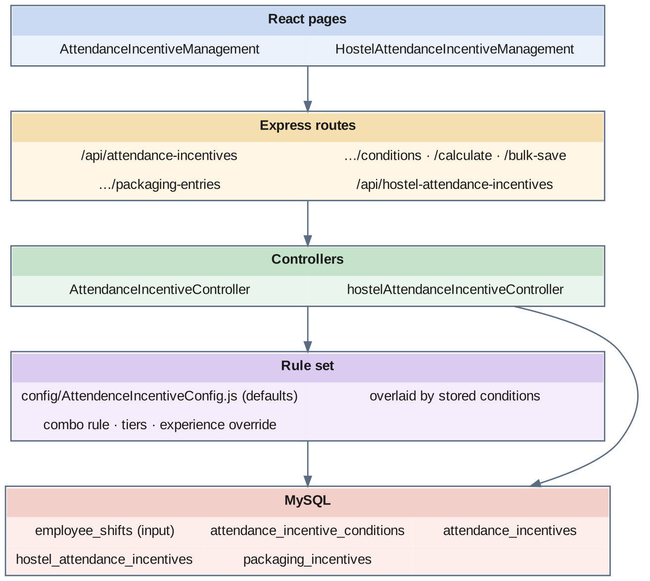
Fig 8.8.A Low-level architecture – ATTENDANCE INCENTIVE ENGINE
Request flow:
- AttendanceIncentiveManagement.jsx loads the current condition set from the conditions endpoint, and can reset it to the documented defaults.
- For a selected month, the screen calls the calculate endpoint. The controller copies the default configuration, overlays the stored condition rows, reads the monthly day counts per employee and shift from employee_shifts, and maps the employee's category to a grade.
- The combination rule is applied first: for a multi-shift rule, each constituent shift's day count is tested against the combination minimum. If any falls short, the rule does not apply and a single-shift rule is used instead.
- The experience override is applied where configured, restricting eligible employees to the single-shift rate.
- The total adjusted day count is tested against the low and high tier thresholds, and the corresponding rate per day is selected.
- The result — adjusted days, slab days, shift key and label, tier, override flag, rate and amount — is returned for review and then committed through save-one or bulk-save.
- HostelAttendanceIncentiveManagement.jsx follows the same calculate-then-save pattern for hostel residents, with a simpler rule: a single-shift rate, or the combined rate when more than one shift was worked.
- Packaging incentives are entered per day as bags packed and summarised by month.

8.8.6 API Design
Method | Endpoint | Purpose / contract
GET | /api/attendance-incentives/conditions | Current incentive rule set.
POST | /api/attendance-incentives/conditions | Create a condition row.
PUT / DELETE | /api/attendance-incentives/conditions/:id | Update or remove a condition.
POST | /api/attendance-incentives/conditions/reset | Restore the documented default rule set.
POST | /api/attendance-incentives/calculate | Evaluate incentives for a month without saving.
POST | /api/attendance-incentives/save-one | Commit one evaluated result.
POST | /api/attendance-incentives/bulk-save | Commit a month's evaluated results.
GET | /api/attendance-incentives/daily-entries | Day-level incentive inputs.
POST | /api/attendance-incentives/daily-entries | Record day-level incentive inputs.
GET / POST | /api/attendance-incentives | List and create committed incentive rows.
PUT / DELETE | /api/attendance-incentives/:id | Update or remove a committed incentive row.
GET / POST | /api/attendance-incentives/packaging-entries | Record and read packaging incentive entries.
GET | /api/attendance-incentives/packaging-summary | Monthly packaging incentive summary.
GET / POST / PUT / DELETE | /api/hostel-attendance-incentives · /:id | Maintain hostel attendance incentive periods.
GET | /api/hostel-attendance-incentives/calculations | Hostel incentive results for a period.
POST | /api/hostel-attendance-incentives/calculate · /bulk-save | Evaluate and commit hostel incentives.
GET / POST / PUT / DELETE | /api/hostel-attendance-incentives/conditions · /conditions/:id | Maintain hostel incentive conditions.
POST | /api/hostel-attendance-incentives/conditions/reset | Restore the default hostel conditions.

8.8.7 DB Design
Table | Keys & indexes | Key columns
attendance_incentive_conditions | PK id (auto) | companyId, categoryId, departmentId, departmentIds TEXT, shiftTypeId, gender, gradeKey, gradeName, shiftRuleKey, shiftLabel, minDays, lowTierDays, lowTierRate decimal(10,2), highTierDays, highTierRate decimal(10,2), minComboDays, maleExpOverride, maleExpThreshold, status, remarks
attendance_incentives | PK id (auto) | companyId, departmentId, employeeId, shiftTypeId, days, entryDate, slabDays, otDays, slot, month, year, adjustedDays, incentive decimal(10,2), ratePerDay decimal(10,2), shiftKey, shiftLabel, tier, maleOverrideApplied, savedAt, status
hostel_attendance_incentives | PK id (auto) | companyId, departmentId, employeeId, fromDate, toDate, status
packaging_incentives | PK id (auto) · UNIQUE uq_pkg_company_emp_date_shift (companyId, employeeId, entryDate, shiftTypeId) | bagsPacked, ratePerBag decimal(10,2), minBagsThreshold, incentiveAmount decimal(10,2), month, year, remarks

- departmentIds as TEXT alongside the single departmentId lets one condition row cover a list of departments that share a slab, without creating a join table for a rule set of a few dozen rows.
- maleOverrideApplied is stored on the result, not only evaluated at run time. Whether an override fired is exactly the question asked when an incentive is disputed, and recording it removes the need to re-derive it.
- shiftKey and shiftLabel are frozen onto the result so that renaming a shift rule later does not change the meaning of a historical incentive row.

8.8.8 Screenshots
[ Paste screenshot here ]
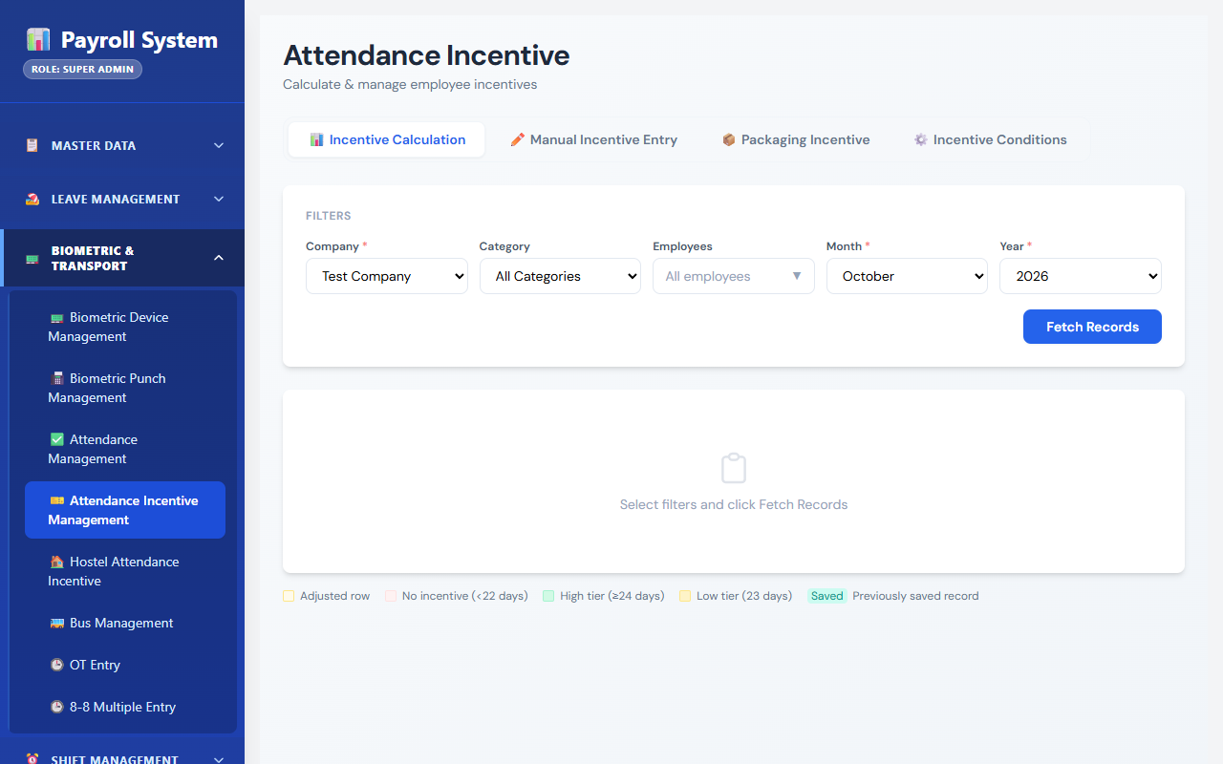
Fig 8.8.1 Incentive condition list
The conditions screen lists the configured slabs with their grade, shift rule, minimum days, tier day counts and rates. Holding these as editable rows is what allows a renegotiated rate to take effect without a code change.
[ Paste screenshot here ]
Fig 8.8.2 Editing an incentive condition
The condition form captures the grade, shift rule, department scope, gender, the low and high tier thresholds and rates, the combination minimum and the experience override. The combination minimum is the field that prevents a token day in a second shift from unlocking the higher combined rate.
[ Paste screenshot here ]
Fig 8.8.3 Calculating incentives for a month
The calculate view evaluates the selected month and shows, per employee, the qualifying days, the shift rule matched, the tier reached, the rate applied and the resulting amount. Nothing is saved at this point, so the month can be reviewed before it is committed.
[ Paste screenshot here ]
Fig 8.8.4 Committing the month
The bulk save control commits the reviewed results. Each saved row carries the inputs that produced it, so a challenged amount can be re-derived from the record rather than re-run through the engine.
[ Paste screenshot here ]
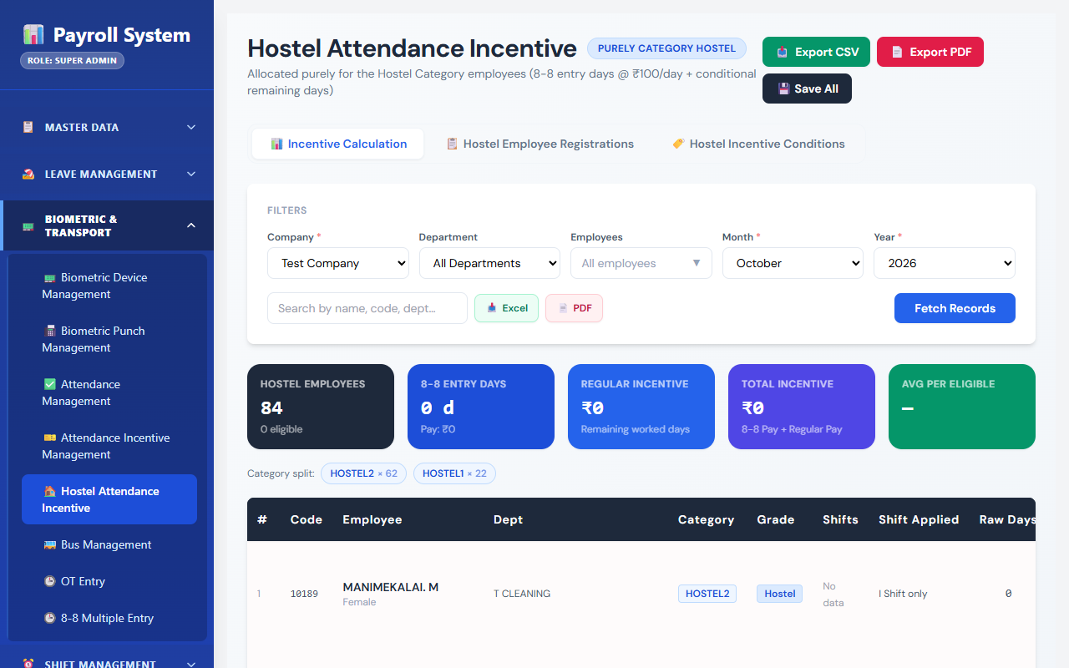
Fig 8.8.5 Hostel attendance incentive
The hostel screen evaluates and saves the incentive for resident workers over a date range. It is maintained separately because eligibility depends on residence as well as on attendance.
[ Paste screenshot here ]
Fig 8.8.6 Packaging incentive entry and summary
Packaging incentives record bags packed against a rate per bag and a minimum threshold, with a monthly summary. This is a piece-rate incentive and so is computed from output rather than from attendance days.

8.9 WORKFORCE STRENGTH & DISCREPANCY REPORTING

8.9.0 Purpose & Scope
Gives management real-time visibility of department-wise manpower against the day standard, surfaces disagreements between the biometric record and the department's own record for resolution, and exports the full set of attendance, biometric, shift and department reports.

8.9.1 Functional Requirements
What the module must do:
- Produce a department-wise strength report for a date, laid out as an industrial standard list of 54 departments grouped by category (Preparatory, Spinning, Autoconer, Hostel and Others), with one block of columns per shift.
- Convert everything to manpower. For each shift the report shows regular hands present (100%), trainees present (Trg), trainees converted by their workload factor (Con. Trg), full-OT heads (S OT), overtime hours (HRS OT), and overtime converted to hands by dividing by 8.5 (CON. OT). The shift total is regular + converted trainees + converted overtime.
- Compare against the day standard: the overall converted total is set beside the department's day standard and the difference is shown, so a surplus or shortfall is a single signed number.
- Count by worked department: an employee lent to another department is counted where they worked; a half day counts as half a hand.
- Maintain the legacy strength report alongside, which shows plain strength, full-OT count and OT hours per shift against strengthRequired on the department.
- Export both strength reports to Excel.
- Produce a discrepancy report that walks every employee and date in a range and lists each day on which the finalised biometric attendance and the HR department-wise entry carry different statuses.
- Approve a discrepancy with the original status, the approved status, a reason, an optional supporting document, the approver and the time, and keep the approval history.
- Produce attendance reports: a period attendance report for selected employees and a department-wise attendance report, exportable to Excel and PDF.
- Produce a shift report, a late-in report and a no-punch report, and a general report builder in which the user picks the fields and filters.
- Maintain holiday lists and holidays, including import of holidays from a file, since holidays change the meaning of an absence.

8.9.2 Non-Functional Requirements
- Freshness for strength. The strength report is read during a running shift, so it reads present attendance rows as they stand, provisional or final. It is a management view and is not the basis of any payment.
- Settled data for discrepancies. The discrepancy report reads finalised attendance only, so a day is never flagged merely because its shift has not yet closed.
- Every correction is attributable. A discrepancy approval stores the before and after status, a reason and an approver, and these two endpoints are the ones where the server verifies the JWT so that the approver's identity is taken from the token. A unique index allows one approval per employee and date.
- Read-only by construction. Apart from discrepancy approvals and holiday maintenance, every endpoint in this module only reads. The reports derive from attendance, overtime and punch data and own no state of their own.
- Export for circulation. A report that will be circulated is generated as a file; the on-screen view is for inspection.
- Query cost. Report queries span a day or a month and are served by the existing indexes on attendanceDate, companyId and status; no report introduces an index of its own.
- CAP: CP for approvals, deliberately relaxed for the live strength view.

8.9.3 Tech Stack
Concern | Choice | Why it fits this module
Strength layout | A fixed list of 54 standard departments with category, day standard and name aliases in strengthReportController | The report matches the organization's standard operational muster layout row for row
Manpower conversion | Workload factor for trainees; OT hours ÷ 8.5 | Puts trainees and overtime on the same scale as regular hands
Legacy parity | strengthReportOldController, separate route | Old figures remain reproducible without constraining the new report
Discrepancy detection | In-memory comparison of attendances and hr_department_attendance keyed by employee and date | Two bulk reads and a hash join instead of a query per day
Discrepancy approval | discrepancy_approvals table + Multer document upload + JWT middleware | A correction carries its justification and its approver
Export | ExcelJS and PDFKit on the server; xlsx and jsPDF on the client | Server export for large reports, client export for on-screen views
Report builder | reportController with field list and distinct-value endpoints | Users compose a report without a new screen being written

8.9.4 Back-of-the-Envelope Estimation
Quantity | Estimate | Basis
Strength report rows | 54 departments + category subtotals | Fixed standard list
Columns per row | 3 shifts × 7 columns + 3 overall = 24 | 100%, Trg, Con. Trg, S OT, HRS OT, CON. OT, Total per shift; Day STD, Con Total, Diff
Rows read per strength report | ≈ 1,200 attendance + ≈ 120 OT | One day's present rows and OT entries
OT conversion example | 17 OT hours ÷ 8.5 = 2 hands | OT_DIVISOR = 8.5
Discrepancy scan for a month | 1,200 × 30 = 36,000 employee-days | Two bulk reads, compared in memory
Discrepancies per month | ≈ 300 | Roughly 1% of employee-days (assumption)
Approval rows per year | ≈ 3,600 rows ≈ 1 MB | Twelve months
Excel export size | ≈ 2–4 MB per month | 36,000 rows with styling

8.9.5 Low-Level Architecture
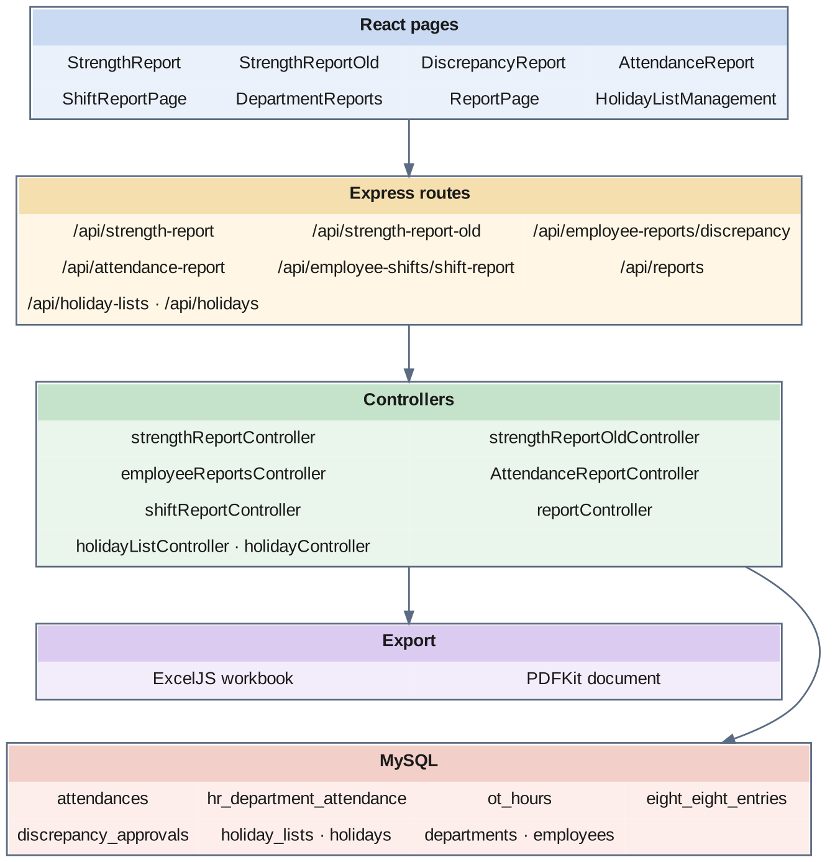
Fig 8.9.A Low-level architecture – WORKFORCE STRENGTH & DISCREPANCY REPORTING
Request flow — strength report:
- StrengthReport.jsx requests the report for a date. The controller builds the 54 standard department rows, each with an empty block for shifts A, B and C.
- It reads the day's attendance rows with a present-type status and, for each, picks the department from workedDeptId, then departmentId, then the employee's home department, and the shift from shiftName (supervisor shifts fold into A, B and C).
- A regular employee adds 1 to the 100% column — 0.5 for a half day. A trainee adds to the Trg column and adds their workload factor to Con. Trg.
- It then reads the day's OT entries: a full-OT entry adds a head to S OT, and OT hours add to HRS OT. CON. OT is HRS OT divided by 8.5.
- Each shift total is 100% + Con. Trg + CON. OT; the overall total is compared with the day standard to give the difference. The Excel endpoint writes the same structure to a workbook.
Request flow — discrepancy report:
- DiscrepancyReport.jsx requests a date range, optionally narrowed to a department or an employee.
- The controller reads the finalised attendances rows and the hr_department_attendance rows for the range in two queries and indexes both by employee and date.
- It walks every employee and date; where both records exist and their statuses differ, it emits a row showing the HR status, the master status, the check-in and check-out times and the working hours.
- Approving a discrepancy posts the chosen status, a reason and an optional document through the JWT-verified endpoint; the controller writes or updates the discrepancy_approvals row with the original status and applies the approved status.
Other reports:
- StrengthReportOld.jsx requests the legacy strength report and its export.
- AttendanceReport.jsx, ShiftReportPage.jsx, DepartmentReports.jsx and ReportPage.jsx call the corresponding report endpoints and offer Excel and PDF download.
- HolidayListManagement.jsx maintains holiday lists and the holidays inside each list.

8.9.6 API Design
Method | Endpoint | Purpose / contract
GET | /api/strength-report | Manpower-converted strength report for a date.
GET | /api/strength-report/export-excel | The same report as a workbook.
GET | /api/strength-report-old · /api/strength-report-old/export-excel | Legacy strength report and its export.
GET | /api/employee-reports/discrepancy | Days on which the biometric and HR records disagree.
POST | /api/employee-reports/discrepancy/approve (JWT) | Approve a discrepancy with reason and document.
GET | /api/employee-reports/discrepancy/history (JWT) | Previously approved discrepancies.
GET | /api/attendance-report | Period attendance report for selected employees.
POST | /api/reports/attendance | Department-wise attendance report.
GET | /api/employee-shifts/shift-report | Shift-wise report over a date range.
GET | /api/lunch/late-in · /api/lunch/no-punch | Late return and missing punch reports.
GET | /api/reports/fields · /api/reports/distinct-values/:fieldName | Fields and filter values for the report builder.
POST | /api/reports/generate | Run a composed report.
POST | /api/reports/download/excel · /api/reports/download/pdf | Download a composed report.
GET / POST | /api/holiday-lists | List and create holiday lists.
PUT / DELETE | /api/holiday-lists/:id | Update or remove a holiday list.
GET | /api/holidays/list/:listId | Holidays in a list.
POST / PUT / DELETE | /api/holidays · /api/holidays/:id | Maintain holidays.
POST | /api/import/holidays | Import holidays from a file as a background job.
GET | /api/import/status/:jobId | Progress of a holiday import.

8.9.7 DB Design
Table | Keys & indexes | Key columns
discrepancy_approvals | PK id (auto) · UNIQUE unique_employee_discrepancy_date (employeeId, attendanceDate) · INDEX approvedBy, attendanceDate · FK employeeId, approvedBy → users | attendanceDate, originalStatus varchar(50), approvedStatus varchar(50), reason, documentPath varchar(255), approvedBy, approvedAt
holiday_lists | PK id (auto) · FK companyId | name, startDate, endDate, weekOffs JSON, status
holidays | PK id (auto) · UNIQUE (date, holidayListId) · FK holidayListId | date, description, type ENUM(Holiday, Week Off)

- The strength report is computed on request from attendances, ot_hours, eight_eight_entries and employees, which is the correct design for a figure that must always reflect the current state. A StrengthReports table with per-shift columns (full, training, converted, OT hours, converted OT and total for each of three shifts) is also defined in the schema for holding a saved snapshot.
- The standard department list and day standards of the current strength report are held in the controller so that the output matches the operational muster format exactly; the legacy report reads departments.strengthRequired instead. Moving the standard list into a table is noted as future work.
- The unique index on discrepancy_approvals means a second approval for the same employee and date updates the first rather than adding a competing one.
- originalStatus and approvedStatus are stored as text rather than as a foreign key to the status enum, so that a later change to the enum does not rewrite the meaning of a historical approval.
- A holiday date is unique within its list, and weekOffs on the list is JSON because the weekly off pattern is a small, read-whole structure.

8.9.8 Screenshots
[ Paste screenshot here ]
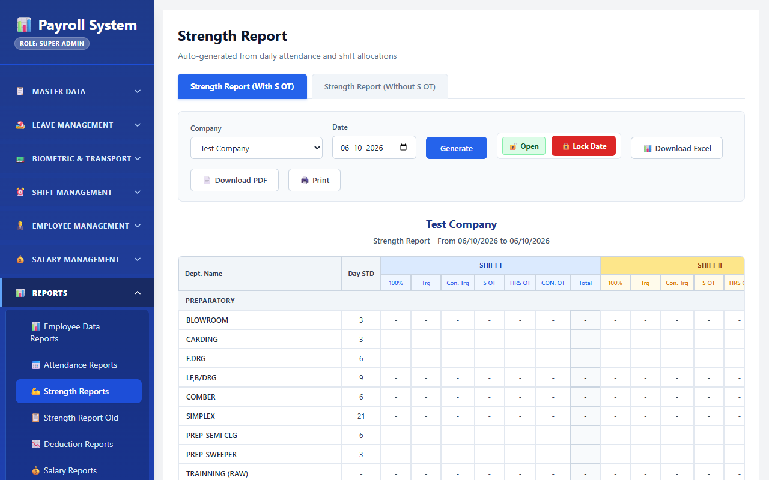
Fig 8.9.1 Department strength report
The strength report lists the standard departments by category with a block of columns for each shift — regular hands, trainees, converted trainees, full-OT heads, OT hours and converted OT — and sets the converted total beside the day standard. Because it reads the live attendance picture, a shortfall is visible while the shift is still running.
[ Paste screenshot here ]
Fig 8.9.2 Strength report export
The export control produces the same report as an Excel workbook for circulation, laid out with the same departments, shift blocks and totals as the on-screen view.
[ Paste screenshot here ]
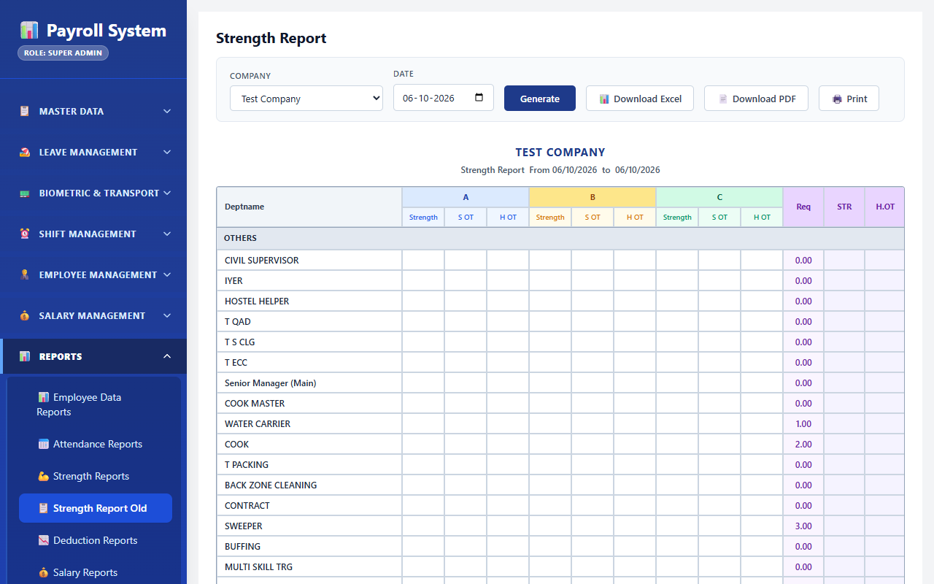
Fig 8.9.3 Legacy strength report
The legacy report shows plain strength, full-OT count and OT hours per shift against the required strength held on the department. Keeping it alongside the current report means a figure quoted from an older circular can still be verified.
[ Paste screenshot here ]
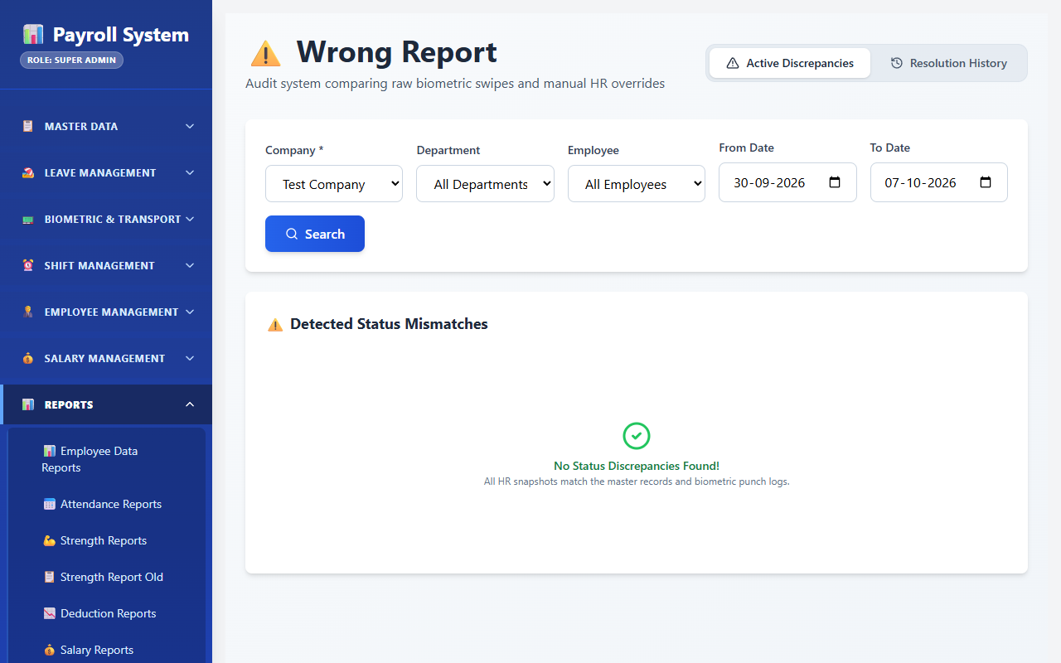
Fig 8.9.4 Discrepancy report
The discrepancy screen lists each day on which the status entered by HR and the status derived from the biometric record differ, showing both side by side with the punch times. Each row is a candidate for correction rather than an automatic adjustment.
[ Paste screenshot here ]
Fig 8.9.5 Approving a discrepancy
The approval dialog captures the status being approved, a reason and an optional supporting document. The saved approval records the original status alongside the new one, so the correction is auditable rather than invisible.
[ Paste screenshot here ]
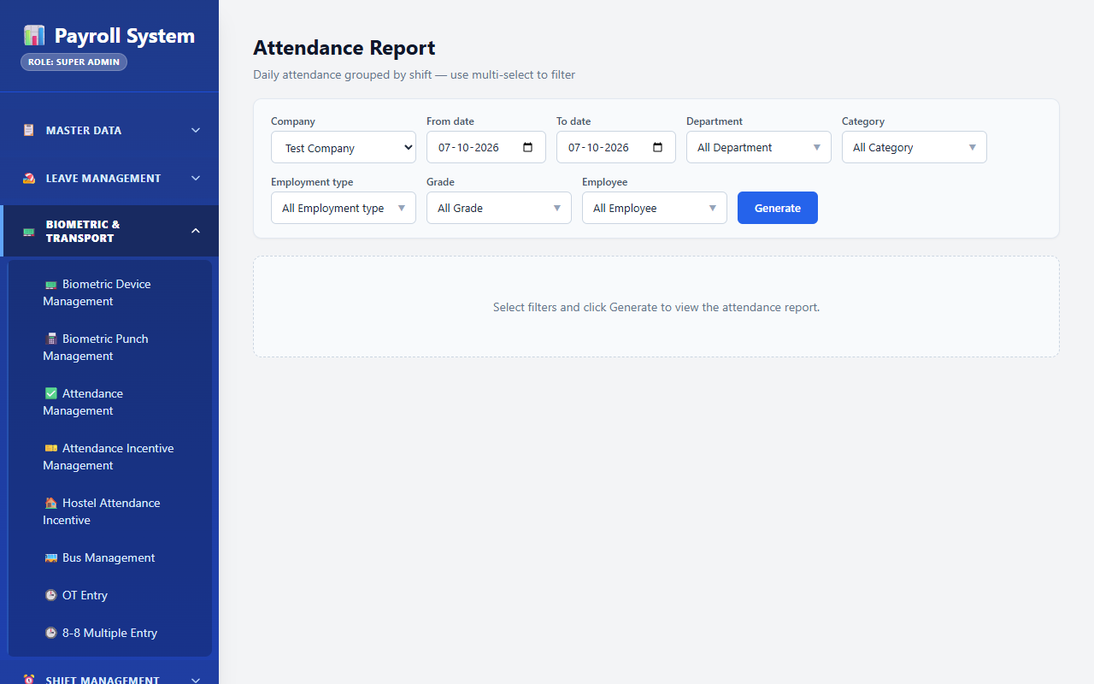
Fig 8.9.6 Attendance report
The attendance report presents attendance over a date range for the selected employees, with export. This is the report circulated at month end as the attendance position.
[ Paste screenshot here ]
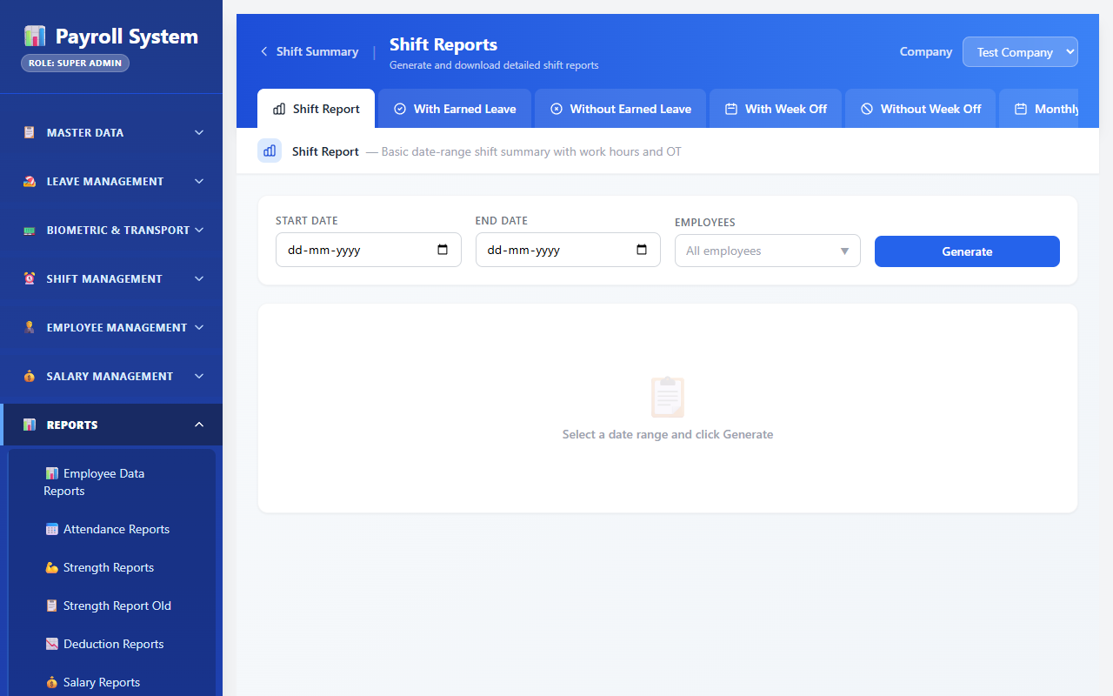
Fig 8.9.7 Shift report
The shift report summarises attendance by shift over a period. It is the view used when a shift pattern is being reviewed rather than an individual's attendance.
[ Paste screenshot here ]
Fig 8.9.8 Department reports
The department report aggregates attendance by department over a date range. Because the worked department is recorded on each row, lent labour is counted where the work happened.
CHAPTER 9

CONCLUSION
The Smart Attendance and Workforce Management System set out to make one fact trustworthy: who was present, in which shift, in which department, on each day. That it reaches that goal is largely a consequence of three design decisions taken early and held to throughout.
The first is that raw evidence and interpretation are kept apart. A punch is written to biometric_punches; every status, every lateness minute and every day count is derived in separate tables, and reprocessing those never touches the punch. When an attendance record is disputed, the evidence it was derived from still exists in its original form.
The second is that provisional data and final data are structurally distinct rather than distinguished by convention. A supervisor watching a running shift and an accountant settling a month are reading rows that differ by an explicit isFinalized column, which means the live view can be as approximate as it needs to be without ever contaminating the record of account.
The third is that the rules that change most often live in the database rather than in the code. Shift windows are read from shift_types at runtime, and incentive slabs are rows in attendance_incentive_conditions laid over a documented default. A changed shift timing or a renegotiated incentive rate is an administrative action, not a deployment — which is what allows the system to track a mill whose arrangements change more often than its software does.
Around these decisions the system delivers biometric integration over both a real-time and a pull path, three-pass shift detection that handles early arrivals and midnight-crossing shifts correctly, scheduled finalisation derived from the shift configuration itself, a complete leave lifecycle with multi-level approval and an audit trail, bulk overtime and special-entry capture, a rule-driven incentive engine, manpower-converted department strength reporting, and a documented discrepancy resolution path that reconciles the biometric record with the department's own — with JWT authentication and five roles guarding the screens.
The deliberate boundary of the project is equally important. The system produces verified day counts and publishes them through the employee_shifts monthly summary; it computes no wages. This modular architectural boundary ensures the workforce attendance engine provides authoritative, verifiable attendance logs and verified monthly day counts without coupling internal wage computations into the attendance pipeline.
Several limitations are worth recording honestly. The server-side JWT middleware is implemented but is switched on for only a few endpoints, so most role enforcement currently happens in the browser's route guard; enabling it on every router is the first hardening step. The iclock listener completes the device handshake and parses the push stream, but durable storage is carried by the webhook and the five-minute pull. Cron-based finalisation and the in-memory regeneration job list assume a single application instance. The standard department list of the strength report is held in code. The biometric_punches table grows by roughly 1.4 million rows a year and will eventually need an archival strategy. These are identified rather than hidden, and each has a clear remediation path.
Future work follows naturally from them: enforcing the token and role check on every API route, storing punches directly from the iclock listener, moving finalisation to a distributed scheduler, holding the strength standard in a table, partitioning the punch table by month, adding face-recognition terminals alongside fingerprint readers, and exposing a mobile application for leave application and approval so that a request no longer waits for an approver to reach a desk.

