KorfbalStats

# Function of the platform

# User input

The user input of the program can be a couple of different things. At least, it needs to have some specific functions. The most important function is to be able to add a shot or goal of a specific type to a players StatsList. This can be done using a button.

Some other functions would be nice, but are not needed for the basic functioning of the program. Those functions include:

* The ability to switch between the players in the attacking and defending zones
* The ability to switch players when they are substituted
* Starting a match, pausing and unpausing (and track the timing of shots and goals)

Each function will be further elaborated in the following subsections.

## Shots and goals

For the main screen and function of the program there are a couple UI options.

### Grid

The first option is to create a grid, with the columns being the different players on the field, and the different rows being the different types of shots. For goals to be registered, there is the option to add another button (which will register the next shot pressed as a goal) or have the user long press the shot button to register as a goal.

The advantages of this are that the user has to click only once to register a shot or goal. This will make the process of tracking the stats during the match much easier.

This solution is more geared towards using a tablet for the registration of the statistics, since the buttons will be only an eighth of the users display in height. Also, the app must be used in landscape mode which is less practical on smaller devices.

### Two lists

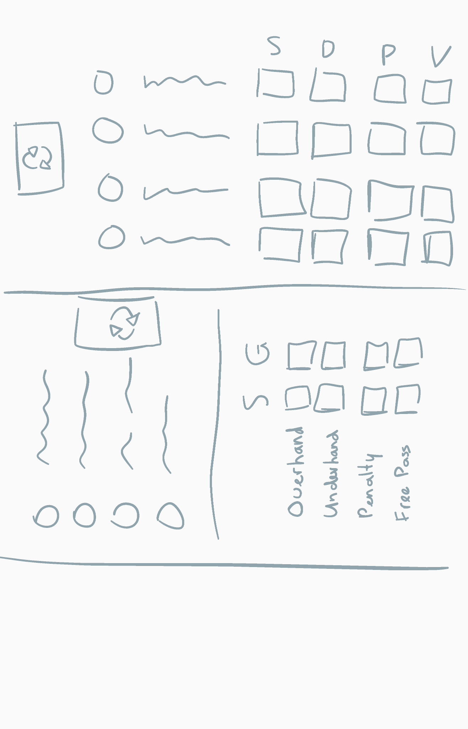Another option would be to create two lists: one list containing the players on the field, one list containing the different shots and goals.

The main advantage of this solution is that the user will have to thing a bit more to register the click, so that the user will be more mindful about the registration and not register the wrong player or type of shot.

The main disadvantage is the same what makes this option stand out: the user has to do two clicks to register the shot. This makes the process more longwinded and has the user less focused on the actual match.

## Switching Zones

Having the ability to switch between which zone is attacking and which is defending, has a couple of advantages and disadvantages. The main advantage of switching is that the screen has to show only the current four attacking players. This makes it so that the screen is more clean and that the UI can be more spaced out. This way it’s easier for the user to see which player did the action, since there are less players to choose from.

As an added benefit, the attacking and defending time of each zone can be tracked. This way, the amount of shots and goals can also be compared to the time that it took the zone to get these stats. Otherwise, stats can become quite misleading.

Switching zones can be easily implemented in the UI design. The only thing that needs to be added is a button which the user can press, which then performs the necessary actions. Those actions are a couple:

* The current attacking players need to be changed to the current defending players and vice versa.
* The time needs to switch from adding to the attacking zone to adding to the other zone, since the zones switch.

## Substituting players

The substitution of players is not difficult to add into the UI design. There should be a “Substitution” button above or below the “Change Zones” button. This button can then get the user to a pop-up menu, in which they can select the player being substituted out. When this player is selected, the screen will change for the user to select the player being substituted in.

At the end of this process, there can be, if it enhances the user experience, a screen in which the user can see the data of the substitution in the way it is saved. The user can chose between three buttons: cancel, change or approve. Cancel will simply close the pop-up menu and will not save the substitution. Change will bring the user back to choosing both players that are substituted out and in, for when the user has pressed the wrong player in one or both of the menu’s. The approve button will save the substitution and change the player in the corresponding zone.

## Timekeeping

On the subject of timekeeping, a couple of things must be in the program. First, the match must be able to be started, paused, un-paused and ended. All these options can be implemented in two buttons. These are inspired by the “Nike Running Club” app’s start, pause, un-pause and stop functions.

To start the match, after the match is created, there should be a start button. It should start the match making it possible for the user to start collecting data, as well as starting the timer. This button will change to a pause button after it is pressed.

The pause button will have the function of being able to pause the match in case of injury or another form of delay. When this button is pressed, it should pause the timer which keeps track of the length of the match and the length of the two zones attacking. It should also push the pause button a little to the side to make space for another button. The pause button should change in an un-pause button. The extra button should be the button to end the match.

When the un-pause button is pressed, it should un-pause the time. It should also fade out the button to end the match and turn the button back to a pause button.

The button to end the match will not work when only pressed. It should be kept pressed for a little while so the match will not close suddenly if someone mis-taps.