miniCURE: Human Gut 16S rRNA
September 10, 2026
Table of Contents

About this Course
This miniCURE has students design an independent research project around a question relating to the human gut microbiome. As they build their project, students will describe microbes using different taxonomic ranks, find and read scientific literature, and think about how community composition, biodiversity, and specific microbes can differ between samples. Finally, students will practice the scientific process to test their own question about the gut microbiome from their chosen dataset.
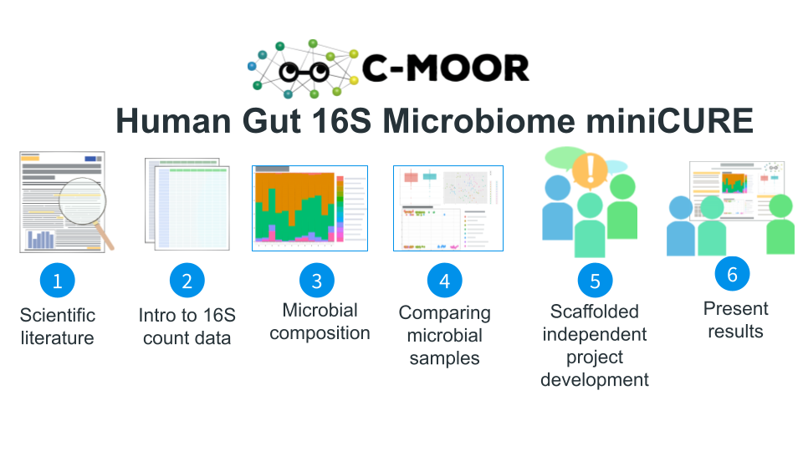

Skills Level
Genetics
Novice: Foundational understanding of prokaryotes and their relationships with hosts
Programming skills
Novice: No programming experience needed

Learning Goals
- Find and read scientific literature to interact with the greater scientific community and build an epistemological identity
- Analyze data (i.e. create and interpret plots) to generate novel conclusions and new lines of inquiry based on previous findings.
- Cultivate an “-omics” perspective, to identify the advantages of genomic science for large datasets and connect findings to biological insights
- Practice the scientific process, identifying avenues for research, designing experiments, analyzing data, and integrating results into the broader scientific discourse.

Core Competencies
This activity addresses several core concepts and competencies from the following sources:
- Vision and Change in Undergraduate Biology Education AAAS report
- Bioinformatics core competencies for undergraduate life sciences education by NIBLSE
See Appendix for details.

Instructor Guide

For instructors
Welcome to new and seasoned instructors alike! We are excited to have you use a C-MOOR module in your class. This section of our OTTR book is specifically for instructors and will help you prepare for teaching a C-MOOR offering as a part of your class.
A course-based undergraduate research experience (CURE) is a high impact practice (HIP) where students learn through authentic research. In addition to the standard concepts of the material and the technical skills required to complete lab exercises students gain critical thinking skills troubleshooting their research projects. They don’t just learn about science; they practice it!

How C-MOOR supports you
Our curriculum is designed to be accessible for anyone to teach and aims to remove many of the barriers that prevent instructors from trying computational biology methods.
- No previous experience in bioinformatics required. We’ll help with the code: We provide all code templates required to complete the analyses. You just bring your expertise as a researcher! For support with code and other technical issues reach out to us with a post on the C-MOOR Academy Discussion Forum. Someone will assist you as soon as you are available.
- Our curriculum comes with lectures, assignments, and rubrics for you to use: We do as much as possible to take the workload of creating these materials off your back. But you’re not beholden to use them; if you have materials you’ve used over the years and prefer to use or want to use only parts of ours you’re free to do so.
- We designed our miniCUREs to be modular to fit into your course: Our miniCURE curricula are designed to be compact, with just 6 main sessions followed by project work. We’ve taught our RNA-seq miniCURE in pre-established classes, such as introductory biology. You don’t have to design your entire course around them and the modules fit easily into your lessons about gene expression and microbiology.

New instructor to-do list
If you haven’t taught a C-MOOR curriculum in the past, here’s a list of tasks you should do, ideally before the semester begins:
- Make an introductory post on the C-MOOR Academy Discussion Forum in the general category. We recommend including:
- Your name
- Your institution
- The class you’re teaching that uses C-MOOR modules
- Your area of research expertise
- Any previous experience with bioinformatics
- The cloud platform you will be using to teach (see next item)
- Set up on a cloud platform: C-MOOR uses either SciServer or AnVIL for our cloud computing needs. If you’re not sure which is right for you, please mention this in your forum post so we can get you set up on whichever is more appropriate. Once you’ve chosen your cloud platform, follow the instructions in the respective section to access modules and learn how to grant your students the same access. While you can technically run the modules locally, running them on a cloud platform will prevent the need for students to download all the necessary components and provides you easier access to updates. Using a cloud platform will also grant your students access to computing resources beyond their local device.
- Go through the modules yourself: Familiarize yourself the curriculum and how to use the cloud platform and our fill-in-the-blank code chunks. Look through our resources and see what support is currently available; for example, our C-MOOR RNA-seq guide and our student made How To Get Started With Your C-MOOR Project Guide.
- Look over our generic C-MOOR Poster Rubric and alter it as neccessary. The rubric is designed so that you can choose what sections you want included in your students’ posters and what weight (point values) you want to give to each element. Students will use the rubric as a checklist as they create their posters. Some instructors share this rubric at the start of their class. Others may leave it until later. If you have a specific symposium or conference in mind, tailor the rubric to suit that venue (ex. if your school’s research day requires posters with abstracts and no introductions, change the rubric to reflect this requirement).
- Consider your syllabus and where each module fits into your class schedule. We provide estimated times for each module and the activities within as well as sample schedules from instructors who have taught the curriculum before. Some instructors teach a wet lab alongside the C-MOOR curriculum, using downtime (ex. waiting for the results of a gel electrophoresis lab) to do computational activities.
- Have students create an account on your chosen cloud platform and provide the neccessary information to you: Do this well in advance of the first day you’re using the C-MOOR curriculum to avoid technical issues on the day of (ex. students without Google associated email addresses on AnVIL, students who have unknown errors logging into SciServer). You will need to collect the students’ email addresses (AnVIL) or their usernames (SciServer). We recommend using tools in your LMS or a Google form to expedite this process.

Content overview
Name | Length | Notes
Overview / Scientific Process | 1 hr
#1: Scientific Literature | Full lab | Pre-lab: Scientific Literature
#2: 16S rRNA Data in spreadsheets | Full lab
#3: Exploring 16S rRNA Data with Phyloseq | Full lab
#4: Analyzing 16S rRNA Data with Phyloseq | Full lab
#5: Kickstart Project Work | Flexible
Poster presentation | Flexible | Optional

1 Introduction

1.1 C-MOOR miniCURE Overview
## Warning: Chunk option fig.align is not supported for docx output
## Warning: Chunk option fig.alt is not supported for docx output

1.1.1 What is C-MOOR?
C-MOOR is a project to invite students to join the data science revolution and be part of the next generation of data scientists. This project provides online materials to help students and instructors incorporate authentic research experiences in lower division courses.
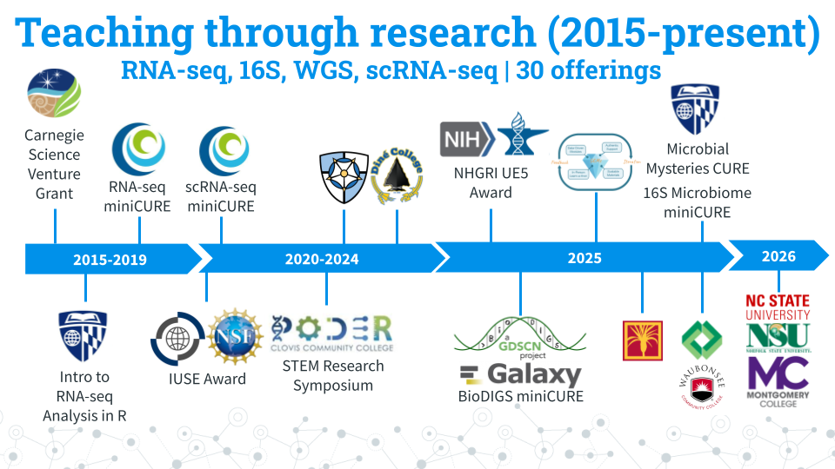
Over the years, C-MOOR has expanded its curricula to include RNA-seq, scRNA-seq, 16S amplicon sequencing, and WGS modules. Here’s some statistics about C-MOOR students:
- Students taught: 950+.
- 90% of our students are first years: We break the myth that only advanced-level students can perform and excel in real research.
- Student research posters: 100+. We choose a poster as our final deliverable to facilitate participation in research symposiums. Posters also allow us to evaluate the efficacy of our curricula over the years and make it easy for instructors to quickly and objectively grade student work. You can see a handful of posters here!
- 50% + Students choose to present posters at optional symposiums: C-MOOR posters have served as the impetus for establishing a new research symposium at Clovis Community College. Our students have attended and won awards at their institution’s research days and at conferences such as GRADS-4C and the ASM Maryland Branch Meeting.

1.1.2 Why data science?
Data Science is an evolving career path for individuals (data scientists) in fields that need to manipulate large amounts of data. The job of a Data Scientist was called by the Harvard Business Review “the sexiest job of the 21st century” Data Scientists are individuals with a curiosity to look through data, identify patterns and develop testable hypotheses. In the Biological Sciences, data scientists dig through data to answer questions about health, disease, evolution, ecology, drug development, and much more. A currently relevant example is compiling and looking at the similarities and differences between the different SARS-CoV-2 strains and identify differences between strains that may lead to differences in rates of infection.

1.1.3 Learning Goals
- Engage with real and current scientific data
- Explore available research resources online
- Recognize the interdisciplinary nature of biological sciences
- Synthesize findings from scientific literature
- Summarize findings and discuss results with your peers
- Collaborate with peers on a data exploration activity

1.2 The Scientific Process
Estimated time: 30 min
Watch this 10 min video and answer the questions below.
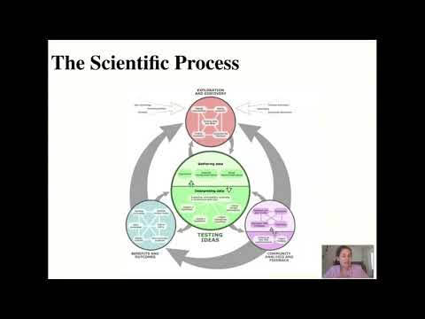
[video][slides]
Describe the key aspects of each of the following elements of the scientific process:
- Exploration and Discovery
- Testing Ideas
- Community Analysis and Feedback
- Benefits and Outcomes
Learn more at Understanding Science 101
## Warning: Chunk option fig.align is not supported for docx output
## Warning: Chunk option fig.alt is not supported for docx output
## Warning: Chunk option fig.align is not supported for docx output
## Warning: Chunk option fig.alt is not supported for docx output
## Warning: Chunk option fig.align is not supported for docx output
## Warning: Chunk option fig.alt is not supported for docx output
## Warning: Chunk option fig.align is not supported for docx output
## Warning: Chunk option fig.alt is not supported for docx output

1.3 SciServer Onboarding

1.3.1 Join SciServer

1.3.1.1 Purpose
Students will create a SciServer account and be added to a SciServer by their instructor, which gives them access to the images and data needed to access learning modules and complete their research project. The steps in this section only need to be completed once.

1.3.1.2 Learning Objectives
- Create an account on SciServer
- Confirm your email address
- Share your username with your instructor
- Confirm your access to class materials on SciServer
This video (video)(slides) shows you how to create a SciServer account. You can follow along with the video, or follow the steps below.

1.3.1.3 Introduction
SciServer is an online platform for doing scientific data analysis. It is used by scientists studying astronomy, biology, oceanography, and more, and is free as long as you are using it for scientific research. Using SciServer means you do not need a fancy computer or need to install any special programs on your computer, you can just log in with your internet browser to start doing research. For this course, we have set up SciServer with customized collections of programs for RNA-seq analysis, as well as the data that we’ll be analyzing. Once you sign up for SciServer and are added to the group for this course, you will be able to access these tools and begin your data analysis journey!
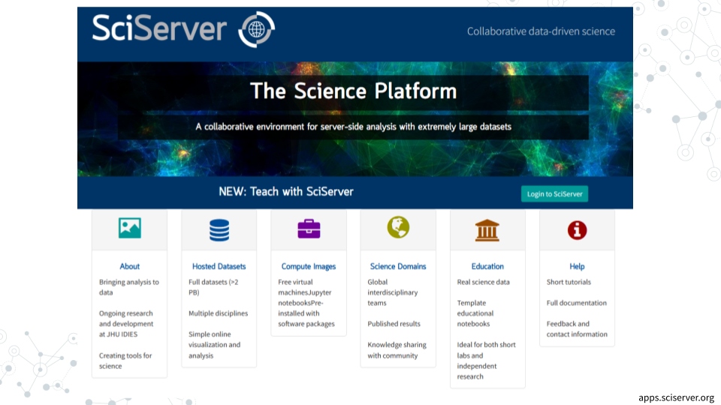

1.3.1.4 Part 1 – Create an account on SciServer
- Open sciserver.org in a web browser
  - It is a good idea to bookmark this page so that you can easily access it throughout the course.
- Click “Login to SciServer”
- Click “Create a new account”
- Enter a User name, Email, etc. and click “Create account”
  - Note that you cannot change your username once you have made your account

1.3.1.5 Part 2 – Confirm your email address
- Important!: Click the verification link in your email inbox.
  - If you do not verify your account you will get locked out and will need to contact your instructor to unlock your account.
  - If you do not see an email, try checking your spam folder.
- After clicking the verification link, confirm that your username appears in the upper right hand corner.

1.3.1.6 Part 3 – Share your username with your instructor
Refer to your instructor on how to share your username with them. Your instructor will add you to a group that will give you access to all the necessary resources.
- Share your username with you instructor and await invitation to the SciServer group

1.3.1.7 Part 4 – Accept the invitation to join a SciServer group
This video (video)(slides) shows you how to join a SciServer group. You can follow along with the video, or follow the steps below.
- Open sciserver.org in a web browser and log in to your account.
- Click “Groups”
- On the left, you should see a list of all the groups you have joined or been invited to. Click on the name of the group for this course, then click “Accept invitation”.
  - Your instructor must have your username to invite you to the group. If you do not see an invitation, contact your instructor with your SciServer username.
- Confirm that you can access course data
  - On the top menu bar, click “Files”
  - On the left-hand menu, click “Data Volumes”
  - Confirm that you see “C-MOOR-Data”
- Confirm that you can access course computing resources
  - Click “Home” in the top menu to return to the home page.
  - Scroll down to the second set of boxes and click “Compute”
  - Click “Create container”
  - In the “Compute Image” drop-down menu, confirm that you can see “C-MOOR LearnR” and “C-MOOR R-Studio”
  - Under “Data Volumes”, confirm that you can see “C-MOOR Data”
  - You can close the Create Container dialog box (by clicking the “X” in the top right) once you’ve confirmed that you can see the C-MOOR content

1.3.1.8 Troubleshooting
- Some students have had issues signing up or logging into SciServer but were successful at a later date/time. We suggest giving students time to sign up well in advance of their first module on SciServer in case of technical difficulties.

1.3.1.9 Footnotes

1.3.1.9.1 Contributions and Affiliations
- Katherine Cox, Johns Hopkins University
- Frederick Tan, Carnegie Institution
- Sayumi York, Notre Dame of Maryland University
Last Revised: June 5, 2026

1.3.2 Running modules on SciServer

1.3.2.1 Purpose
The purpose of this assignment is to learn how to access the modules for your course on SciServer and properly close out your session when finished.

1.3.2.2 Learning Objectives
- Start up a C-MOOR LearnR compute container
- Access a C-MOOR module
- Delete your C-MOOR LearnR compute container when finished

1.3.2.3 Introduction
Before beginning this assignment, you should have already created a SciServer account and submitted your SciServer username to your instructor. In this assignment you will learn how to set up a “compute container” on SciServer. Compute containers are how you use programs on SciServer. There are two C-MOOR compute containers on SciServer: “C-MOOR LearnR” has tutorials that will teach you how to run data analyses, and “C-MOOR R-Studio” is where you can work on your own data analysis projects. This assignment shows you how to set up the C-MOOR LearnR compute container and start up your first tutorial.

1.3.2.4 Part 1 – Start up a “C-MOOR LearnR” compute container
This video (video)(slides) shows you how to create and start up a C-MOOR LearnR compute container. You can follow along with the video, or follow the steps below.
- Open sciserver.org in a web browser and log in to your account.
  - If you are already logged in, click “Home” in the top menu to return to the home page.
- Scroll down to the second set of boxes and click “Compute”
- Click “Create container”
  - Give your container a name. This can be anything you like, but it’s useful if it says something about the purpose of the container so you can tell your containers apart. You could name this container “Tutorials”, since you’ll be using it to access tutorials.
  - In the “Compute Image” drop-down menu, select the C-MOOR LearnR that your instructor chooses
  - Under “Data Volumes”, check the box next to “C-MOOR Data”
  - Click “Create”. This may take a moment.
- You should now see a new entry in your list of containers
  - “Created At” should be a few moments ago.
  - “Name” should be the name you chose
  - “Image” should be “C-MOOR LearnR”
- Start your C-MOOR LearnR container by clicking on its name (whatever name you chose when you created it). This will open in a new tab.
  - You should see a list of tutorials, organized by topic.
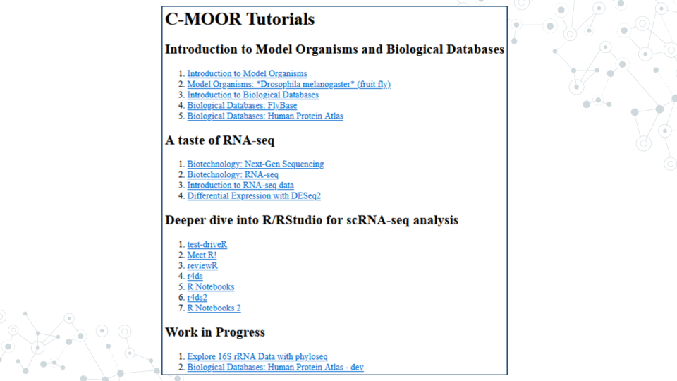
- If instead you see an error message, you most likely forgot to check the box next to “C-MOOR Data” when you created the container.

- If you see something else, you may have picked the wrong “Compute Image” from the drop-down menu.
If anything goes wrong, you can always delete your container by clicking the red “X” in the last column, and create a new container.

1.3.2.4.1 Resources
- sciserver.org
- Get help with SciServer on the C-MOOR Discourse

1.3.2.5 Part 2 – Opening C-MOOR modules
- If you’re not there already, go to the SciServer compute page and start up the C-MOOR LearnR container.
  - Open sciserver.org in a web browser and log in to your account.
  - If you are already logged in, click “Home” in the top menu to return to the home page.
  - Scroll down to the second set of boxes and click “Compute”.
  - Start your C-MOOR LearnR container by clicking on its name.
- Click on the module chosen by your instructor. The tutorial will open in a new tab.
- Complete the tutorial.

1.3.2.5.1 Resources
- sciserver.org
- Get help with SciServer on the C-MOOR Discourse

1.3.2.6 Part 3 – Delete your C-MOOR LearnR compute container
Compute containers are meant to be temporary, and you can only have 3 containers total on SciServer. So it’s generally a good idea to clean up after yourself and delete your containers when you’re done using them. Also, if any updates are made to the C-MOOR LearnR container, you will need to create a new container to get the latest updates.
Deleting your container will delete your progress in a tutorial, so don’t delete the container until you have completed the tutorial and submitted any required items to your instructor.
To delete a container:
- If you’re not there already, go to the SciServer compute page.
  - Open sciserver.org in a web browser and log in to your account.
  - If you are already logged in, click “Home” in the top menu to return to the home page.
  - Scroll down to the second set of boxes and click “Compute”.
- Find the container you want to delete.
- Click on the red “X” in the last column.
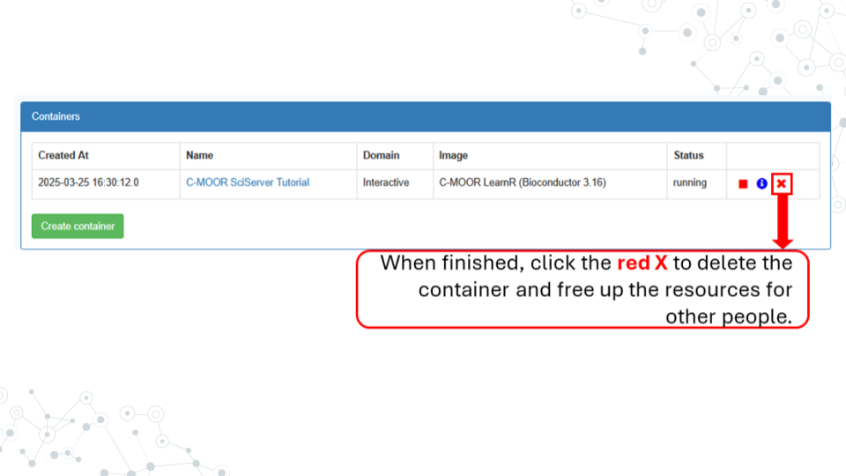

1.3.2.6.1 Resources
- sciserver.org
- Get help with SciServer on the C-MOOR Discourse

1.3.2.7 Footnotes

1.3.2.7.1 Contributions and Affiliations
- Katherine Cox, Johns Hopkins University
- Frederick Tan, Carnegie Institution
- Sayumi York, Notre Dame of Maryland University
Last Revised: June 5, 2026
## Warning: Chunk option fig.align is not supported for docx output
## Warning: Chunk option fig.alt is not supported for docx output
## Warning: Chunk option fig.align is not supported for docx output
## Warning: Chunk option fig.alt is not supported for docx output
## Warning: Chunk option fig.align is not supported for docx output
## Warning: Chunk option fig.alt is not supported for docx output
## Warning: Chunk option fig.align is not supported for docx output
## Warning: Chunk option fig.alt is not supported for docx output
## Warning: Chunk option fig.align is not supported for docx output
## Warning: Chunk option fig.alt is not supported for docx output
## Warning: Chunk option fig.align is not supported for docx output
## Warning: Chunk option fig.alt is not supported for docx output
## Warning: Chunk option fig.align is not supported for docx output
## Warning: Chunk option fig.alt is not supported for docx output
## Warning: Chunk option fig.align is not supported for docx output
## Warning: Chunk option fig.alt is not supported for docx output
## Warning: Chunk option fig.align is not supported for docx output
## Warning: Chunk option fig.alt is not supported for docx output
## Warning: Chunk option fig.align is not supported for docx output
## Warning: Chunk option fig.alt is not supported for docx output
## Warning: Chunk option fig.align is not supported for docx output
## Warning: Chunk option fig.alt is not supported for docx output
## Warning: Chunk option fig.align is not supported for docx output
## Warning: Chunk option fig.alt is not supported for docx output

1.4 AnVIL Onboarding

1.4.1 Join AnVIL

1.4.1.1 Purpose
You will need an account on AnVIL in order to use the platform. In this section we’ll go over the specifics of account creation.

1.4.1.2 Learning Objectives
- Create an account on AnVIL
- Login to AnVIL
- Share the email you used to sign up for AnVIL with your instructor (if applicable)

1.4.1.3 Introduction
AnVIL (The Genomic Data Science Analysis, Visualization, and Informatics Lab-space) is a platform created by the National Human Genome Research Institute (NHGRI) in collaboration with cloud computing platform providers like Google and Microsoft. Using AnVIL we can access computing resources on the cloud through your browser without need for any fancy physical equipment. Through AnVIL you will also have access to all the software and data necessary to complete your research project.
In this section, we will set up our accounts on AnVIL and go through the entire lifecycle of an RStudio environment from creation to deletion. You will repeat this process throughout the semester; feel free to refer back to this section if you need a refresher on how to use AnVIL.


1.4.1.4 Part 1 – Create an account on AnVIL
Follow the written steps below or refer to the slides or video guide.
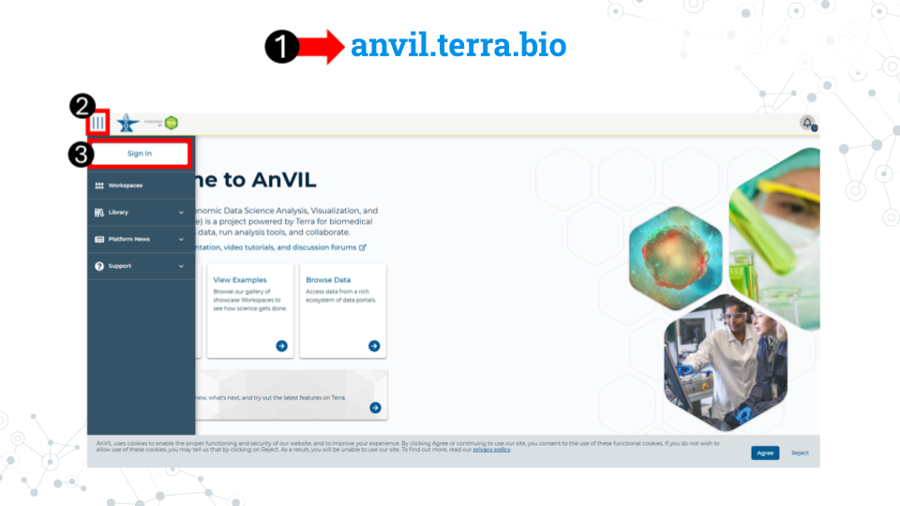
- Open anvil.terra.bio in Google Chrome . Google Chrome is the only officially supported web browser for AnVIL. Because of this, while you can run AnVIL in other browsers you strongly suggest using Chrome.
  - Tip: bookmark this page so that you can easily access it throughout the course.
- Click the hamburger icon (3 lines) in the top left corner of the screen
- Click “Sign in”
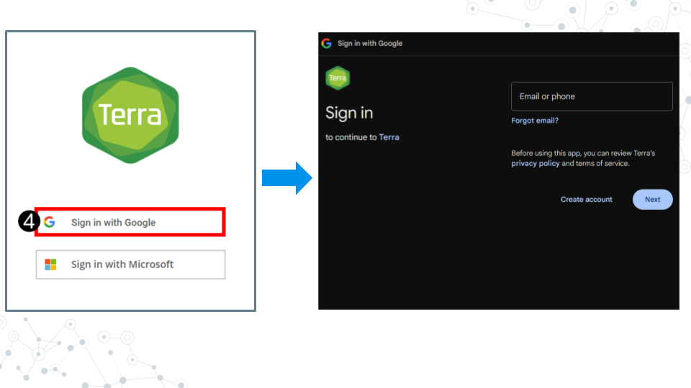
- Click “Sign in with Google”.
- Sign in with a Google associated email address such as an institutional email that uses Gmail or a personal Gmail account. You must use a Google associated email address to gain access to Google Cloud computing resources.
- If you are a student, share the email you used to sign up for AnVIL with your instructor following their instructions.
Instructors should collect the student emails and use them in the next section, “Setting up workspaces on AnVIL.” Students do not need to set up a workspace, and should proceed to the section, “Running a module on AnVIL”.

1.4.1.4.1 Resources
- AnVIL
- How to add a bookmark in Chrome
- AnVIL support home

1.4.2 Running a module on AnVIL


1.4.2.1 Purpose
In this section we will go over how to run C-MOOR modules on AnVIL. We will go over how to create an RStudio environment in that workspace to run the module and properly end a session on AnVIL to prevent runaway costs.

1.4.2.2 Learning Objectives
- Launch a module through the cloned workspace
- Close out a session on AnVIL properly to prevent runaway costs

1.4.2.3 Introduction
Before beginning this assignment, you should have already created an AnVIL account and submitted the email you used to sign up for AnVIL to your instructor. In this assignment you will learn how to setup an RStudio environment on AnVIL. This environment is analogous to preparing a lab space for a physical lab. You have to have the right equipment and reagents to be able to do the activity.
This assignment shows you how to set up the RStudio environment and start up your first C-MOOR tutorial.

1.4.2.4 Part 1 – Confirm you have access to your class workspace
The workspace is the heart of AnVIL. To be able to run modules, you need to have access to the class workspace. Here are some key points about workspaces:
- Every workspace comes with its own Google Bucket (our cloud storage). Your bucket will be empty.
- Every workspace has its own billing project. Students who are not yet associated with a billing project will not be able to compute on their workspace.
- We can control access levels of users and set them either as owners, writers, or readers. Students will be writers with compute access.
The workspace is the heart of AnVIL.
- Open AnVIL in Google Chrome
- Click on the hamburger icon in the top left corner
- Login to your AnVIL account
- Click on the hamburger icon in the top left corner again
- Click workspaces
- Confirm you see your class workspace
- Click on the workspace name to enter the workspace.

1.4.2.4.1 Resources
- AnVIL
- Get help with AnVIL on the C-MOOR Discourse

1.4.2.5 Part 2 – Start access a module
When you open the workspace, you will be on the dashboard tab by default. The dashboard contains the instructions on how to use the workspace, links to C-MOOR websites, and the startup script. Let’s try running a module.
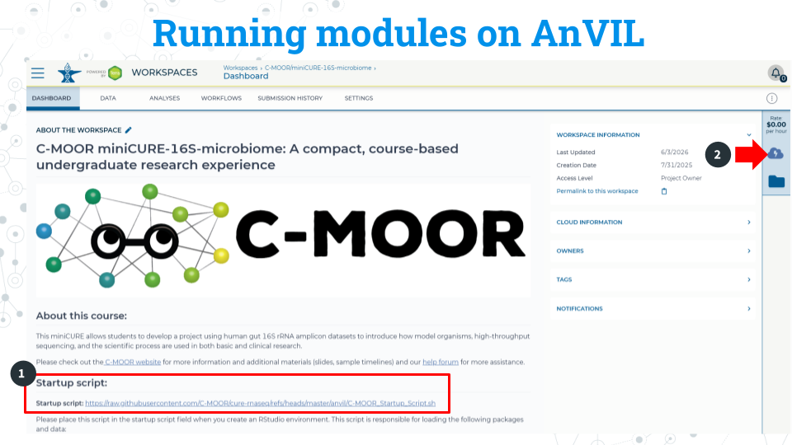
- Copy the URL of the startup script. Make sure there are no spaces before or after what you copy. This script is held in the original workspace everyone cloned. You will need to input this URL soon.
- Click on the Environment Configuration button, the cloud with a thunderbolt.
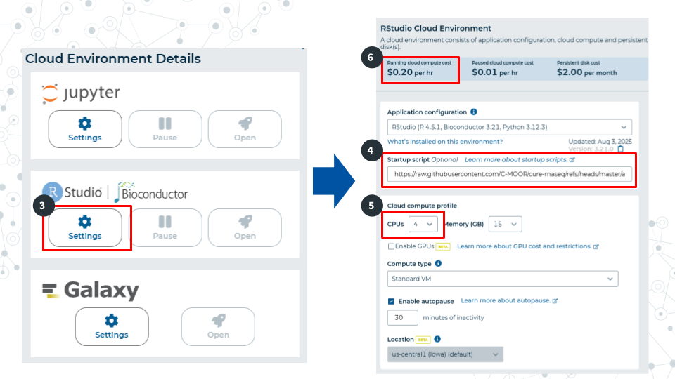
- In the RStudio section, click Settings
- In the startup script field, paste the URL for the startup script.
- Select 4 CPUs and 15 gigabytes of memory.
- Confirm that the cloud compute cost is 20 cents per hour. If it is not 20 cents per hour, reselect CPUs and memory allocation in step 5 This is a known bug in AnVIL at the writing of this guide.
- Scroll to the bottom of the window and click “Create”. It will take about 2 minutes for the environment to be created.
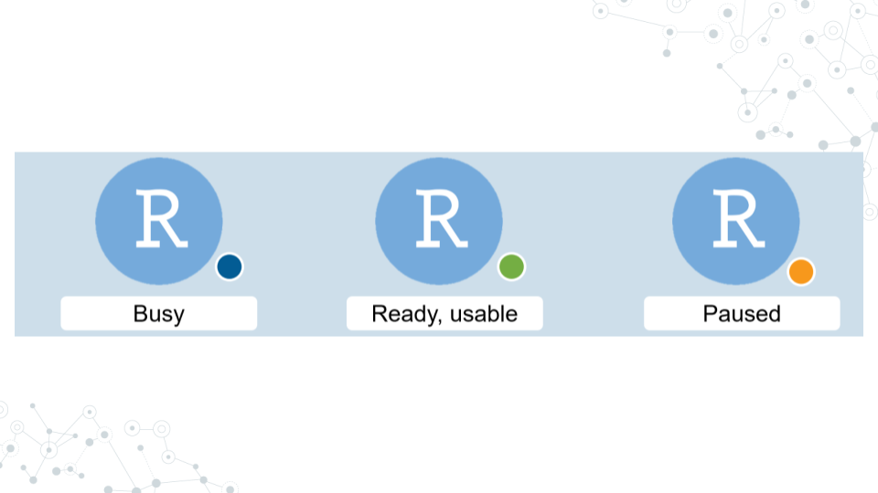
It will take some time for the RStudio Environment to be created. You can keep track of the status of the environment based on the colored dot next to the RStudio icon. The dot will turn green when the environment is ready. While it is loading (blue), you cannot interact with it.
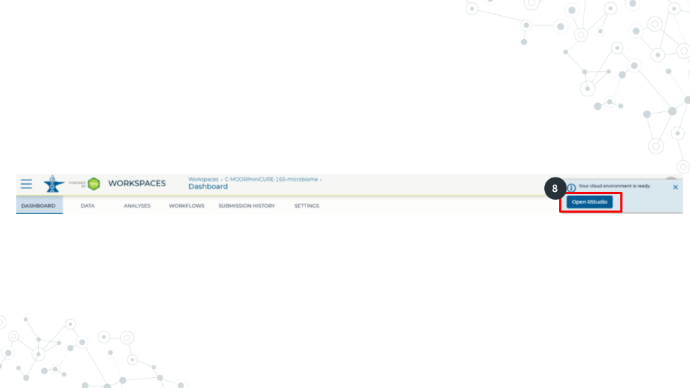
- When the environment is ready, use the Open RStudio button that will pop up. If you hold down Ctrl as you click, you can open RStudio in a new window.
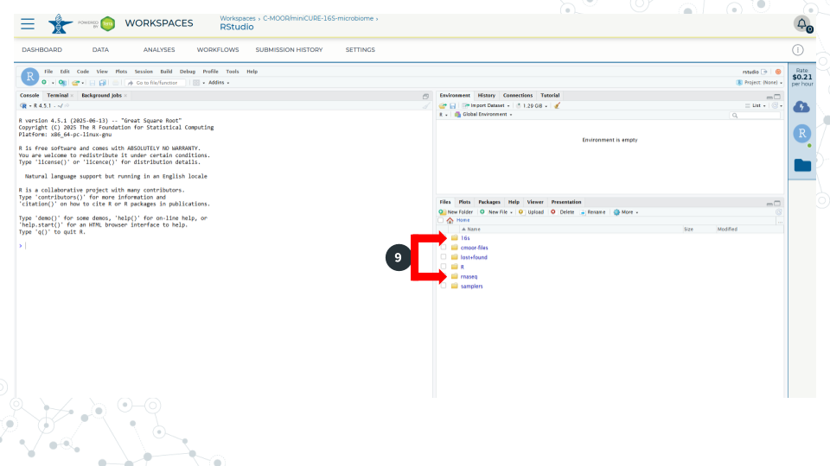
- Use the file explorer in RStudio to navigate to your module of choice. First, enter the folder of the curriculum you are using, either rnaseq (not cure-rnaseq) or 16s. Then enter the folder of the module you want to run.
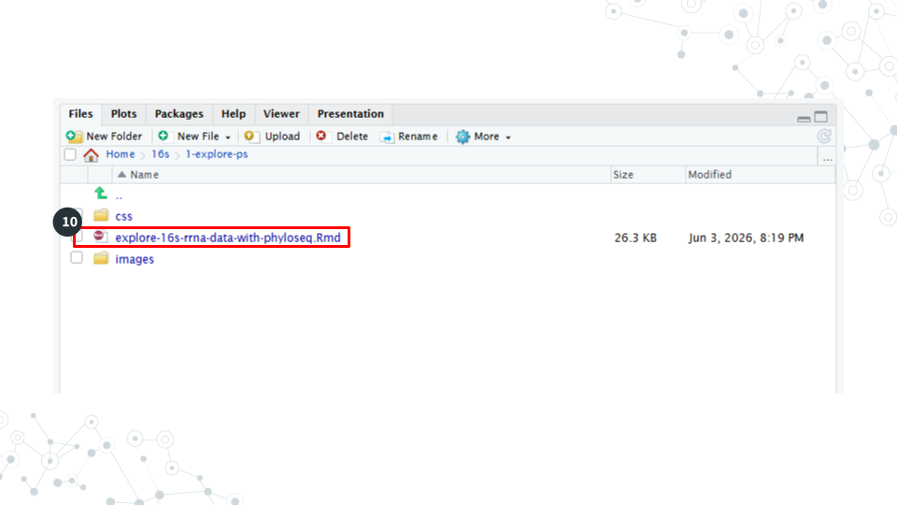
- In the module’s directory, open the .Rmd file by double clicking its name.
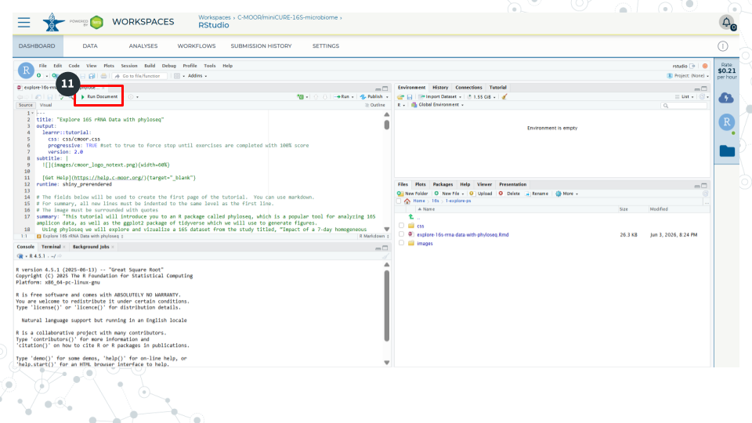
- Click Run Document in the open .Rmd file
When you are finished, make sure you close out your session properly to prevent runaway costs!.

1.4.2.5.1 Resources
- AnVIL
- Get help with AnVIL on the C-MOOR Discourse

1.4.2.6 Part 3 – Closing out a session on AnVIL
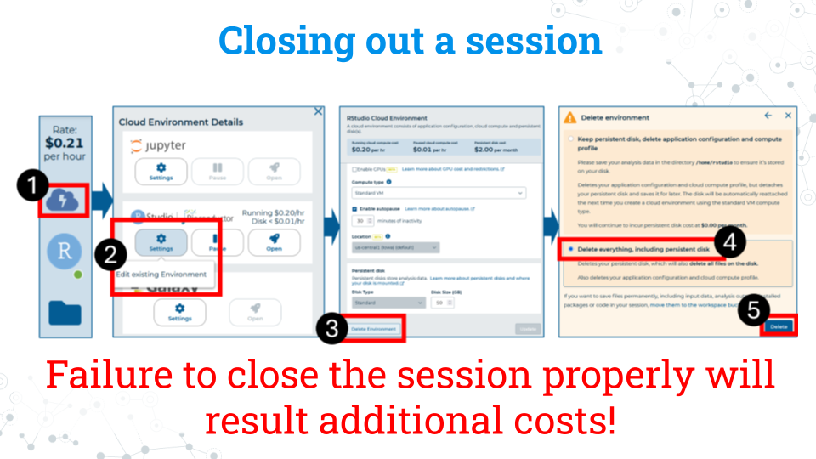
- On the right side of the screen, click the Cloud Environment button. This is the Cloud with the lightning symbol.
- Under the RStudio section, click settings.
- Scroll to the bottom of the new window and click delete environment.
- Check Delete everything, including the persistent disk or your instructor’s billing account will incur costs for storage.

1.4.2.6.1 Resources
- AnVIL
- Get help with AnVIL on the C-MOOR Discourse

1.4.2.7 Footnotes

1.4.2.7.1 Contributions and Affiliations
- Sayumi York, Notre Dame of Maryland University
Last Revised: June 5, 2026

2 Scientific Literature

2.1 Pre-lab - Scientific literature
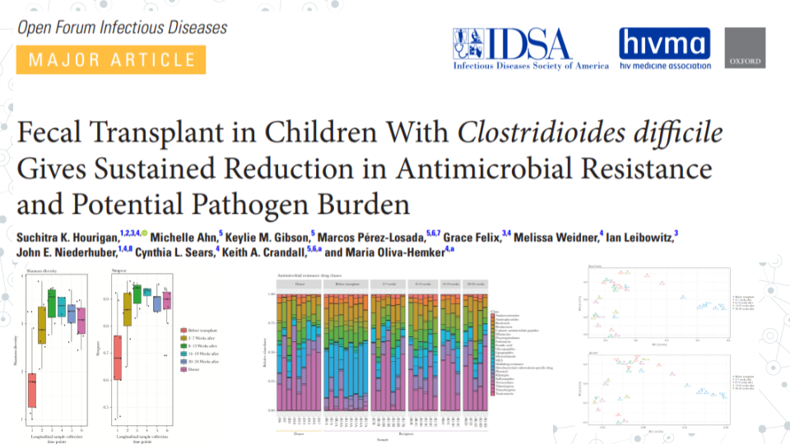

2.1.1 Purpose
We’ve all heard the saying. The best way to learn is by doing. So, let’s jump right in and read a science paper! As you read through the paper, keep in mind that you are not expected to understand everything the first time through. We will go through the paper in detail in the lab.
Reading this paper will give us a first taste of scientific literature and start familiarizing ourselves with the 16S rRNA analyses you will complete as a part of your research project.

2.1.2 Grading criteria
Download the assignment to your local computer as a .docx, complete it, and upload the assignment to your LMS (Blackboard, Canvas, Google Classroom).

2.1.3 Activity
Estimated time: 30 minutes

2.1.3.1 Instructions
Read the paper “Fecal transplant in children with Clostridioides difficile gives sustained reduction in antimicrobial resistance and potential pathogen burden” by Hourigan et al. (2019) and answer the following questions.

2.1.3.2 Questions
1. What is one thing you find interesting in the paper?

2. Define a term that is new to you.

3. Ask a question about the paper.

2.1.4 Footnotes

2.1.4.1 Resources
- Google Doc
- Paper

2.1.4.2 Contributions and affiliations
- Valeriya Gaysinskaya, Johns Hopkins University
- Frederick Tan, Johns Hopkins University
- Katherine Cox, Johns Hopkins University
- Sayumi York, Notre Dame of Maryland University
- Stephanie Coffman, Clovis Community College
- Rosa Alcazar, Clovis Community College

2.2 Lecture - Reading a paper
Estimated time:

Lecture

2.3 Activity - Scientific Literature

2.3.1 Purpose
Examine research where a 16S rRNA-based approach is used to compare metagenomic diversity in children with Clostridioides difficile infection (CDI), before and after fecal microbiota transplantation (FMT) by reading: “Fecal transplant in children with Clostridioides difficile gives sustained reduction in antimicrobial resistance and potential pathogen burden” by Hourigan et al. (2019)

2.3.2 Learning Objectives
- Understand the purpose and experimental setup of the paper
- Understand the presented evidence (Figures and Tables) of the paper

2.3.3 Introduction
In this study, the effect of fecal transplantation on microbial composition and diversity in children with CDI is examined using short read shotgun metagenomics. Data visualization and taxonomic comparison between the samples was performed using R-based phyloseq, a tool you will use for 16S rDNA amplicon-seq analysis later in the course. Using phyloseq authors measure alpha diversity between samples, examine beta diversity with Principal Coordinate Analysis(PCoA) plots and use taxonomy barplots for comparing relative abundance of microbes.

2.3.4 Instructions
Based on the study, answer the following questions. The main text of the paper can be found below, in the ‘Resources’ section of this assignment.

2.3.5 Activity 1 - Overview of the paper
Estimated time: 30 minutes Determine the main objectives and purpose of the paper.
1. What is the purpose of this study?

2. What is the hypothesis in this study?

3. Describe the knowledge gap. In essence, what did the scientific community not know that this study was trying to answer?

4. What were the main conclusions the authors made in this study?

2.3.6 Activity 2 - Methods and Figure Analysis (in class and homework)
Estimated time: 45 minutes

2.3.6.1 Activity 2.1 – Examine the Methods and Data presented in this study
1. Summarize one aspect of sample-associated metadata used for this study? e.g. What is the range of subjects’ age; what is the spectrum of subjects’ medical problems?

2. Discuss one method or analysis used in this paper.

3. Summarize one figure presented in this paper.

2.3.6.2 Activity 2.2 - Figures and a Table
Describe the method/approach used to generate this data
Method/Approach
Table 1
Fig. 2
Fig. 3A
Fig. 3B

Describe the main result/observation from each figure
Main result/Observation
Table 1
Fig. 2
Fig. 3A
Fig. 3B

2.3.6.3 Activity 3 Conclusions
Estimated time: 10 min
1. Compare your conclusions to author conclusions.
- How similar are the conclusions you came up with to the authors?
- Were there any differences in interpreting the data?
- Do you think they are over-stating their findings? Do you think their conclusions are accurate and appropriate?
Summarize one figure presented in this paper.

2.3.6.4 Activity 4 Future Directions
Estimated time: 10 min
1. Scientific work builds on previous studies. What do you believe could be the next step to further the work these researchers did? - What follow-up question(s) do you have for the authors?
2. What is the impact of this research area in general (or this study in particular?) - Do you believe further research in this area may benefit society? Can we build on what this study found?

2.3.7 Grading criteria
Download the assignment to your local computer as a .docx, complete it, and upload the assignment to your LMS (Blackboard, Canvas, Google Classroom).

2.3.8 Footnotes

2.3.8.1 Resources
- Google Doc
- Paper

2.3.8.2 Contributions and affiliations
- Valeriya Gaysinskaya, Johns Hopkins University
- Frederick Tan, Johns Hopkins University
- Sayumi York, Notre Dame of Maryland University

3 16S rRNA Data in spreadsheets

3.1 Meet the MISO study
Let’s get prepared to do some research using 16S rRNA data! In this section, we’ll be exploring data from Impact of a 7-day homogeneous diet on interpersonal variation in human gut microbiomes and metabolomes by Guthrie et al. (2022). This study is one of many that explores the relationship between diet and the human gut microbiome and will help familiarize us with the format that 16S rRNA data takes. We’ll start slow and look at just a few lines of data in Google Sheets and then use phyloseq and DESeq2 in R to take our analysis to the next level.
Human diet has been implicated heavily in the establishment and maintenance of the gut microbiome. For example, human babies undergo a drastic change in the gut microbiome following the transition to solid food.
It’s difficult to capture the mechanisms and effects of diet on the gut microbiome given the sheer number of variables involved. The microbiome individuality and stability over time (MISO) study aimed to explore the connection between diet, microbiome, and metabolites by looking at the effect of feeding a standardized diet to people over 7 days.

3.1.1 MISO study diet and sampling schedule
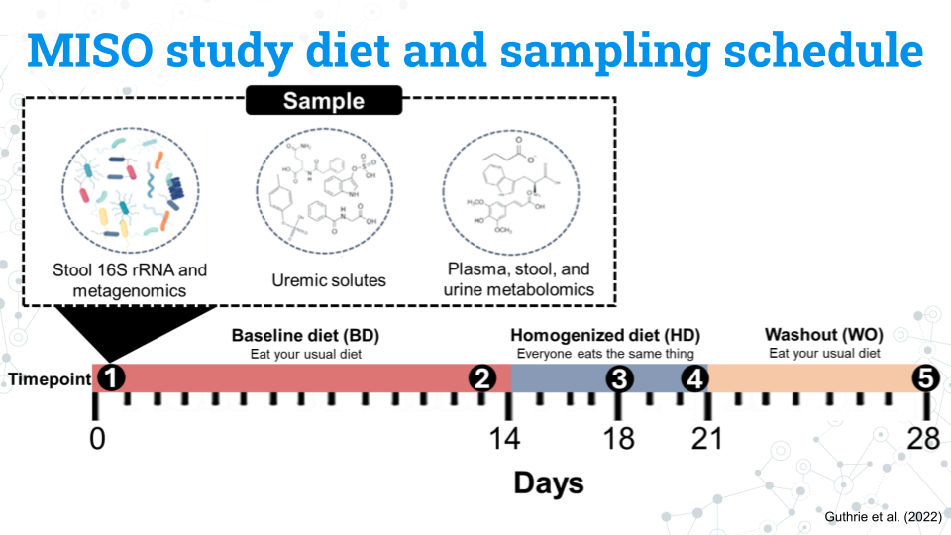
The figure above shows the study design for the MISO study. You do not need to memorize all these details; feel free to refer to this page throughout the project:
- Participants eat their usual, baseline diet (BD) for 14 days
- Participants all eat the same diet, the homogenized diet (HD), for 7 days
- Participants return to their usual diet during the washout (WO) period for 7 days
The study lasts a total of 28 days. Samples from the blood, stool, and urine, our metabolite and 16S rRNA data are taken at 5 different timepoints:
- Timepoint 1: Day 0 (the start of the study)
- Timepoint 2: Day 13
- Timepoint 3: Day 17
- Timepoint 4: Day 21
- Timepoint 5: Day 28

3.1.2 MISO study variables and factors
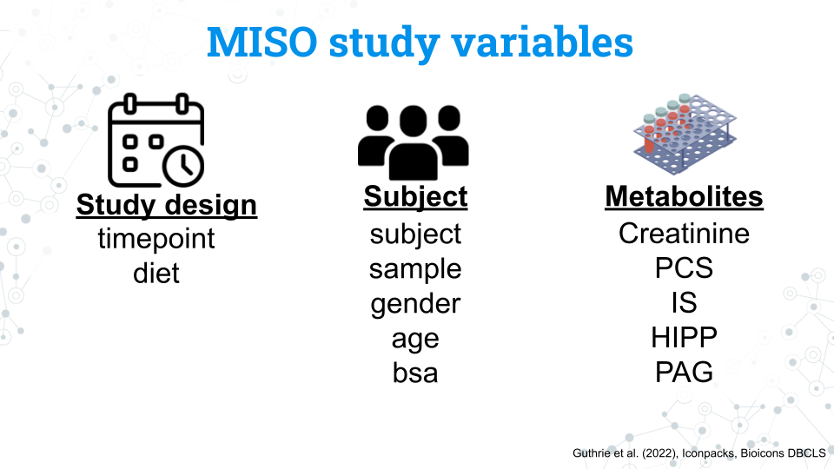
We have a number of variables we can use in our analysis. Notice that the variables for the study and subjects are in lowercase. This is also how you will access these variables in R.

3.1.2.1 Study design variables
Variable | What is it? | Factors
timepoint | The 5 samplings that occur on days 0, 13, 17, 21, and 28 coded as timepoints 1 through 5 | 1, 2, 3, 4, 5
diet | The diet the subject was on during the sampling | BD, HD, WO

3.1.2.2 Subject variables
Variable | What is it? | Factors
subject | A unique ID given to each subject (participant) | S## (ex. S02 is subject 2. Note that while there are a total of 21 subjects in the study, but their subject numbers are not 1 through 20
sample | A unique ID given to every sample taken during the study that includes the subject and timepoint of the sample | MISO-Subject##-Sample# (ex. MISO1-S02-1 is the sample from subject 2 at timepoint 1)
gender | The gender of the subject | M, F. All subjects were cisgender
age | The age in years of the subject | A continuous variable from 23 to 75 years old
bsa | Body surface area; a measure of body size | A continuous variable from 1.6 to 2.8

3.1.2.3 Metabolite variables
Variable | What is it? | Factors
Creatinine | Creatinine | A continuous variable from 1072 to 3971
PCS | p-cresol sulfate | A continuous variable from 2 to 95
IS | Indoxyl sulfate | A continuous variable from 3 to 58
HIPP | Hippuric acid | A continuous variable from 16 to 1119
PAG | Phenylacetylglutamine | A continuous variable from 16 to 318

3.1.3 Amplicon sequence variants (ASVs) data
Finally we have our microbe count data, or our Amplicon Sequence Variants (ASVs). Each ASV is a unique sequences that differs by as little as a single nucleotide from other ASVs and represents a specific microbe. We have assigned taxonomy to these microbes, but not all microbes have taxonomic data through the species level. These missing fields will appear as NA in the data.
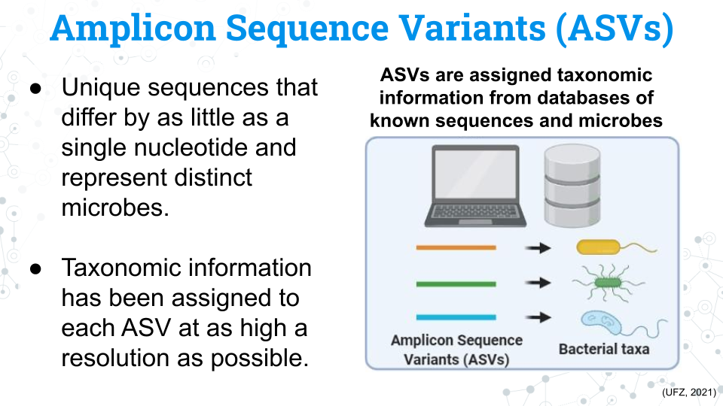
You may see the word Operational Taxonomic Unit (OTU) in phyloseq and in other published studies. ASVs and OTUs have some differences between them but they both represent distinct units of microbial taxa, although they have some key differences.
Each sample is associated with a count of each ASV. We can compare the counts of these ASVs between samples to determine differences in the composition of the microbiome between samples.
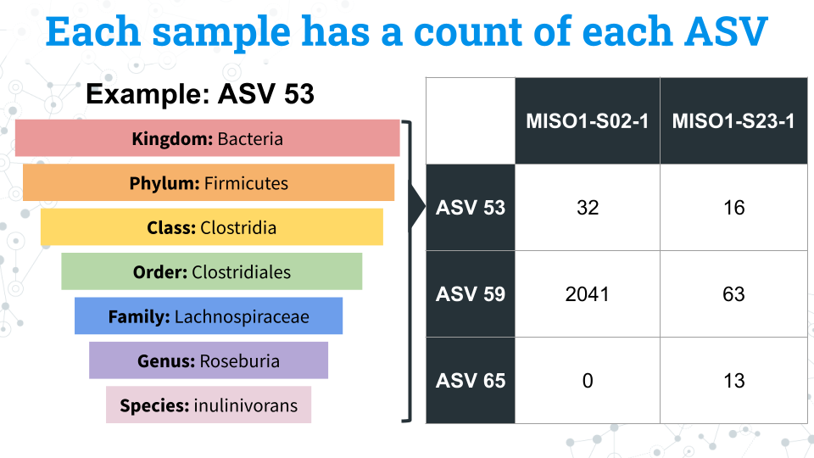

3.1.4 Footnotes

3.1.4.1 Resources

3.1.4.2 Contributions and affiliations
- Sayumi York, Notre Dame of Maryland University

3.2 Exploring 16S rRNA data in spreadsheets
In this section we will look at 16S data in a spreadsheet via Google Sheets. We will familiarize ourselves with the format of 16S data and manipulate just a few ASVs to better understand what kinds of research questions we can ask with the data. Through this exercise we will also come to understand the necessity of more powerful analysis tools in R; sorting through trends in a spreadsheet could take years!

3.3 Lecture - Introducing 16S rRNA Data Using Spreadsheets
Estimated time:

Lecture

3.4 Activity - Introducing 16S rRNA Data Using Spreadsheets

3.4.1 Purpose
To explore bacterial diversity based on 16S rRNA gene sequencing using data from the “Impact of a 7-day homogeneous diet on interpersonal variation in human gut microbiomes and metabolomes” by Guthrie et al., 2023. This study is also referred to as the MISO study for “Microbiome Individuality and Stability Over Time” because the study aims to understand variation (or stability) of microbiomes in individuals.
This spreadsheet activity aims to orient you towards understanding the data and metadata content of this study. In subsequent activities, you will explore and analyze this data using the R/Bioconductor package phyloseq. Google Sheets and R are both useful for doing different analyses, so keep in mind the tools at your disposal and what will be the most efficient way to answer your research questions.
Please note that this activity takes place in Google Sheets. It is possible to do the same analysis in Microsoft Excel although the individual steps you will take are different. To help make things easier for everyone, we strongly recommend everyone uses Google Sheets; all our instructions will be specific to Sheets. Students who do not have a Google-associated email address can sign up for a free Gmail account and gain access to Google Sheets this way.
A Google Sheets cheatsheet that covers the necessary steps for this activity is available in our Spreadsheets 101 guide. Students who are not experienced using spreadsheet software should note that the instructions build on prior steps.

3.4.2 Learning objectives
- Explore Amplicon Sequence Variants (ASVs) through the taxonomy profile of select ASVs, and sample metadata for a subset of ASVs.
- Ask research questions based on data and metadata
- How many different microbes (ASVs) are there in a given sample?
- Is there an even abundance of microbes (ASVs) in a sample or are there a few that dominate?
- How varied are ASVs and their abundance across subjects?
- How varied are ASVs and their abundance across diets?

3.4.3 Introduction
The most popular sequencing technique for the analysis of bacterial diversity is targeted sequencing, or sequencing of a specific gene (or region of a gene, e.g. a hypervariable region of the bacterial 16S ribosomal rRNA gene) using Polymerase Chain Reaction (PCR) to create sequences called amplicons. Sequence variation in the resulting amplicons creates Amplicon Sequence Variants (ASVs). ASVs varying from as little as one single nucleotide are defined as separate ASVs and as little as 1% difference in ASV sequence can be associated with different species. In this activity you will be exploring ASVs generated with sequencing 250 nucleotides (nt) Illumina sequencing, where Amplicon sequence variants (ASVs) were identified.

3.4.4 Activity 1 – Quick data overview based on 1 sample
Estimated time: 10 min
Although the full dataset contains 105 samples from 21 subjects and 5 timepoints (representing 3 dietary conditions), in this activity we will familiarize ourselves with the data by exploring data from 1 sample only.

3.4.4.1 Activity 1-1. Explore data contents using one sample only, namely MISO1-S02-1 (subject 2, timepoint 1).
Access ‘MISO1-S02-1’ file and open it with Google Sheets.
- Rows = ASVs
- Columns = Samples and taxonomy:
  - Col A = ASV id
  - Cols B-H = Taxonomic information
  - Col I = ASV counts (for sample MISO1-SO2-1)
1-1.1 How many microbes (ASVs) are there? This is the # of rows there are in the spreadsheet. Scroll down to the bottom of the sheet and look at the row number or select column A and see the count of all the cells in a row at the bottom right of the window. Remember to not count the header row.

1-1.2 How many microbes are there in this sample? In other words, what is the total number of ASVs per sample?
- We can count cells with a specific condition using the following formula: =COUNTIF(CELLS, “<>0”), where CELLS is replaced by the range of cells you want to use in the calculation.
- For example, for this sample (MISO1-S02-1) in cell J1 enter the formula =COUNTIF(I2:I2185, “<>0”). This formula says, count cells in the range between I2 and I2185 that are not equal to 0. Note that we do not include I1 in the calculation as that is the name of the sample name.
# Microbes:

1-1.3 What taxonomy is associated with ASV1? Include all taxonomic ranks, even those that are listed as NA.
Kingdom:
Phylum:
Class:
Order:
Family:
Genus:
Species:

1-1.4 What taxonomy is associated with ASV2? Include all taxonomic ranks, even those that are listed as NA.
Kingdom:
Phylum:
Class:
Order:
Family:
Genus:
Species:

1-1.5 For sample 1 (MISO1-S02-1) what is the count of ASV 1?

1-1.6 For sample 1 (MISO1-S02-1) what is the count of ASV 2?

1-1.7 Are ASVs equally abundant throughout the sample? Plot the ASV count distribution (range of ASV abundance) for sample MISO1-S02-1.

A) Make a bar graph of ASV distribution. Your chart should have the same format as the example.
- To make a bar graph with this data, hold the Command key on a Mac or Ctrl on Windows to select data that are not immediately next to each other and then click on columns A (“ASV”, which contains ASV ids) and I ( “MISO1-S02-1”, which contains counts)
- In the menu at the top of the screen, select Insert > Chart.
- Make sure your graph is a bar plot: click on the 3 dots in the top right corner of the plot → edit chart and in the Chart editor, under Chart type, selecting Column Chart.
- Copy the bar graph into a box below: click on the 3 dots in the top right corner of the plot, select copy chart, then, paste it below.
- Your graph should look similar to the example graph with the ASVs on the x-axis and counts on the y-axis (although the Y axis is titled the same name of the MISO sample, since this is the name of the column).
Insert graph here:

B) What is the ASV with the highest abundance (count) in sample 1? To find this answer hover over the tallest bar in your ASV distribution plot from activity at its highest point.

C) Describe the pattern of abundance in ASVs for this sample. Is the abundance of ASVs evenly distributed (left in the example graph) where each ASV is approximately the same abundance (count) or is the abundance of ASVs unevenly distributed (right in the example graph), where some ASVs have very high and/or very low counts?

3.4.5 Activity 2 – Explore variation between individuals
Estimated time: 10 min
One aspect of the Guthrie et al. study is the extent to which diet contributes to interpersonal microbiome variation (variation in microbiome between individuals). How does what you eat affect your gut microbiome?
To this end, authors standardized the diet for all individuals with the same diet to evaluate how much of an effect the diet has on the microbiome. If people all eat the same diet, will their gut microbiome become more similar to each other? The study period was 28 days long and had 3 dietary conditions:
- BD (Baseline diet): which lasted 14 days (2 time points collected) and has participants eating what they usually eat.
- HD (Homogenized diet): which lasted 7 days (2 time points collected), and has all participants on the same diet
- WO (washout diet): which lasted for 7 days where participants choose their own diet again
To explore variation between individuals, here we simplify the dietary variation to a single condition, WO.
- For this activity, the data file MISO_WO contains samples pre-filtered for WO condition only (and excludes samples corresponding to BD and HD).
- Since there is only 1 WO datapoint per individual, each WO sample corresponds to a different individual, so you should see 21 samples.

3.4.5.1 Activity 2-1 - What are the most common ASVs between individuals?
IMPORTANT: An ASV is associated with an individual if it is NOT a zero. Zero means that particular ASV was not found in the individual, so you need to exclude zeroes from your calculations.
A) Calculate the number of samples associated with each ASV. Record first 5 values below.
- Create an empty new first column for temporary calculations by right clicking column A and selecting “Insert 1 column left”.
- In cell A1, label this new column “Occurrence”.
- We will use the formula =COUNTIF(range, “<>0”) again to count how many cells have a non-0 value. For example, for ASV1 enter the formula = COUNTIF(C3:W3, “<>0”) into cell A3.
- If the formula and its placement are correct, cell A3 should calculate to 17 (so 17 of 21 WO samples have ASV1). Confirm your calculation is working correctly.
- Apply the calculation to all cells in the column by copy pasting the formula. For a reminder on how to do this, see the Google Sheets cheatsheet.
ASV1:
ASV2:
ASV3:
ASV4:
ASV5:

B) Calculate % of samples associated with each ASV and record the first top 5. record the first top 5.
- Create another new column by right clicking on column A and selecting “Insert 1 column left”.
- In cell A1, give the new column a name, “% of samples with this ASV”.
- Calculate % by dividing a value you obtained in part A) by 21 (samples) and multiplying by 100. To do this, starting with cell A3 (corresponding to ASV1), use the formula =100*(B3/21).
- Apply the calculation to all cells in the column by copy pasting the formula. For a reminder on how to do this, see the Google Sheets cheatsheet.
ASV1:
ASV2:
ASV3:
ASV4:
ASV5:

C) How many ASVs are present in all 21 individuals and what are their ids?
To do so, find the number of ASVs that have a % of samples with this ASV = 100%.
- In cell A2 use the formula = COUNTIF(A3:A2186, “=100”). This formula says, count a cell if it is equal to 100.

3.4.5.2 Activity 2-2. Explore the taxonomy of the most common ASVs
2-2.1 Which ASV is found in 100% of samples? This ASV has a % of samples with this ASV = 100%. Hint: This ASV is found within the first 20 ASVs.

2-2.2 What is the taxonomy assigned to the most common ASV you found in Activity above?
- Return to your copy of ‘MISO1-S02-1’.
- Columns B-H correspond to taxonomic information.
Kingdom:
Phylum:
Class:
Order:
Family:
Genus:
Species:

2-2.3 This ASV was found in every subject. What might this mean about the function this ASV plays in the gut microbiome?

3.4.6 Activity 2-3. Plot individual variation in abundance of the most common ASV.
The most common ASV is represented in all samples, but does each sample have the same abundance of this ASV?
A) Make a bar graph of most common ASV distribution across 21 individuals
1.Return to your version of the MISO_WO spreadsheet.
- Hold the Command key on a Mac or Ctrl on Windows to select data that are not immediately next to each other to select the header row (D2:X2, sample names) and the row corresponding to the most common ASV you identified above.
- In the menu at the top of the screen, select Insert > Chart. Make sure your graph is a bar plot: click on the 3 dots in the top right corner of the plot → edit chart and in the Chart editor, under Chart type, selecting Column Chart.
- Copy the bar graph into a box below: click on the 3 dots in the top right corner of the plot, select copy chart, then, paste it below. Your graph should look similar to the example graph below, with multicolored bars that each represent one sample’s count of the ASV. The example shows a different ASV plotted with 5 samples.
- Your chart will have more bars and the legend may not be in the same place; do not worry if there is no legend or the legend text is not visible as in the example.
Insert chart here

B) Is the abundance of this ASV similar or dissimilar across samples? Each bar represents the count (abundance) of this ASV for a given subject. Ignore the axis title, which only has 1 sample name. Compare your graph to the example figure. Which is more like the graph you made?

C) What might this mean for the function of this ASV in the gut microbiome?

3.4.7 Activity 3 – Explore variation within a single individual associated with diet
Estimated time: 10 min
Although the full dataset contains 105 samples from 21 subjects and 5 timepoints (representing 3 dietary conditions), in this activity we will zoom into ASV counts data for 1 individual (comprised of 5 samples representing the 5 timepoints collected from that individual).
- Timepoints 1 and 2: BD (Baseline diet) prior to normalization with homogenized diet
- Timepoints 3 and 4: HD (Homogenized diet): normalized to be same for all
- Timepoint 5: WO (Washout diet), subjects can choose to eat what they want again

3.4.7.1 Activity 3-1 Explore differences between dietary changes in one subject
3-1.1 Calculate variation in ASV abundance within individual 1 (MISO1-S02) and record the first 5 values below.
How varied is the ASV abundance across timepoints?
- This involves plotting counts for ASV 1-10 for MISO1-SO2 timepoints 1 through 5.
- To calculate variation within a sample, we will use the VAR.S function in google sheets to calculate the variance of a sample. For more information on variance, see the Google Sheets cheatsheet.
- Access ‘MISO_Subject1’
- Label an empty Column G by putting “Variance” in cell G1. Use this column to calculate variance.
- Starting with the first ASV use the following formula: =VAR.S(range) to calculate ASV abundance variation in the 5 samples/timepoints collected for individual MISO1-SO2. For example, for ASV1 enter formula =VAR.S(B2:F2) in cell G2.
- If imputed correctly, cell G2 should calculate to 14947547.8. Confirm this.
- Apply the calculation to all cells in the column by copy pasting the formula. For a reminder on how to do this, see the Google Sheets cheatsheet.
- Record the first 5 variance values below.
ASV1 Variance:
ASV2 Variance:
ASV3 Variance:
ASV4 Variance:
ASV5 Variance:

3-1.2 Plot ASVs with highest variance.
These are the ASVs whose abundance changed the most over the course of the study and could potentially depend heavily on diet. By plotting their counts, we will be able to see how the abundance of a given ASV changed throughout the experiment.
A) Sort the ASVs by the variance column with the largest variance values at the top.
- Click on cell G2.
- Go to Data > Sort sheet > Sort sheet by column G (Z to A)
- Record the top 5 ASVs with the highest Variance and their Variance values below.
ASV# Variance:
ASV# Variance:
ASV# Variance:
ASV# Variance:
ASV# Variance:

B) After sorting ASVs based on high to low variance, make a plot of ASV counts corresponding to top 15 ASVs with the highest variance.
- To make a bar graph highlight top 16 rows corresponding to sample names and the 15 ASVs with highest variance, for samples MISO1-S02-1 through 5. Do not include the “Variance” column.
- In the menu at the top of the screen, select Insert > Chart.
- Make sure your graph is a bar plot: click on the 3 dots in the top right corner of the plot → edit chart and in the Chart editor, under Chart type, selecting Column Chart.
- Copy the bar graph into a box below: click on the 3 dots in the top right corner of the plot, select copy chart, then, paste it below. Your chart should look similar to the example chart with different ASVs
Insert chart here

3.4.7.2 Activity 3-2. Are there any ASVs whose abundance changes with different diets?
Recall that there samples 1 and 2 are from the baseline diet (BD), samples 3 and 4 are on the uniform homogenized diet (HD) and sample 5 is from the washout diet.
- ASV_A in the example graph seems tightly linked to diet - timepoints from the same diet are similar to each other, and timepoints from different diets are different from each other.
- ASV_B shows a pattern that doesn’t seem connected to diet. Samples from timepoints within the same diet are not similar, while samples from different diets are.
A) List an ASV that changes with diet and one that changes seemingly without the influence of diet:
ASVs that seem to change in abundance based on diet:
ASVs that seem to change in abundance that do not appear connected to diet:

B) What factors other than diet do you think might change the abundance of a microbe in the gut microbiome?

3.4.8 Grading criteria
- Download the assignment to your local computer as a .docx, complete it, and upload the assignment to your LMS (Blackboard, Canvas, Google Classroom).

3.4.9 Footnotes

3.4.9.1 Resources
- Google Doc
- Spreadsheets 101
- ‘MISO1-S02-1’ spreadsheet
- MISO_WO spreadsheet
- ‘MISO_Subject1’ spreadsheet

3.4.9.2 Contributions and affiliations
- Valeriya Gaysinskaya, Johns Hopkins University
- Gauri Paul, Clovis Community College
- Frederick Tan, Johns Hopkins University
- Sayumi York, Notre Dame of Maryland University
Last Revised: January 2026

4 Exploring 16S rRNA Data with phyloseq

4.1 Exploring 16S rRNA Data with phyloseq

4.2 Lecture - Exploring 16S rRNA Data with phyloseq
Estimated time:
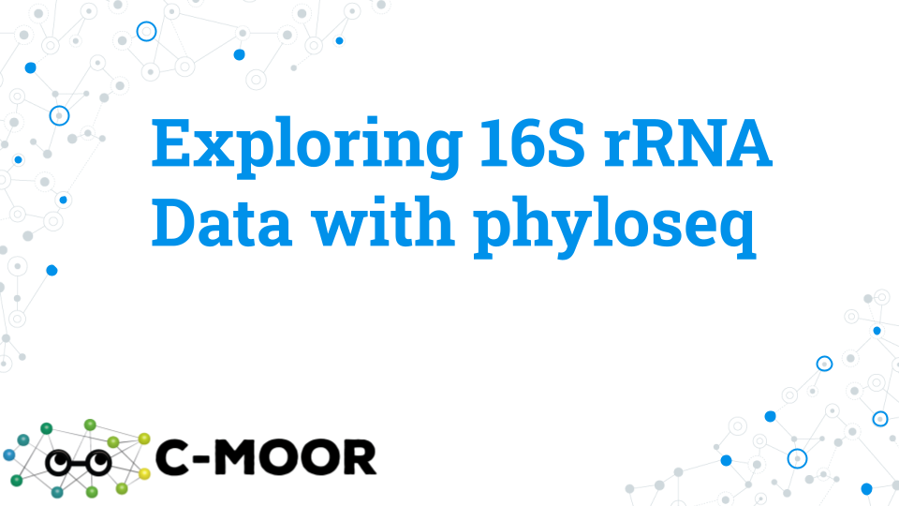
Lecture

4.3 Activity - Exploring 16S rRNA Data with phyloseq

4.3.0.1 Purpose
To explore bacterial diversity based on 16S rRNA gene sequencing using data from the “Impact of a 7-day homogeneous diet on interpersonal variation in human gut microbiomes and metabolomes” by Guthrie et al., 2023. This study is also referred to as the MISO study for “Microbiome Individuality and Stability Over Time” because the study aims to understand variation (or stability) of microbiomes across individuals.
This activity aims to explore and profile the metagenomic diversity using the R/Bioconductor package phyloseq which leverages various R-based tools to produce publication-quality taxonomy profiling and analysis graphics.

4.3.1 Learning objectives
- Use phyloseq to explore data associated with Amplicon Sequence Variants (ASVs).
- In phyloseq, subset data based on metadata and taxonomy.
- In phyloseq, profile and plot taxonomy.

4.3.2 Introduction
The most popular sequencing technique for the analysis of bacterial diversity is targeted sequencing, or sequencing of a specific gene (or region of a gene, e.g. a hypervariable region of the bacterial 16S ribosomal rRNA gene) using polymerase chain reaction (PCR) to create sequences called amplicons. Sequence variation in the resulting amplicons creates amplicon sequence variants (ASVs). ASVs varying from as little as one single nucleotide can be defined as separate ASVs, which can be further clustered into OTUs (Operational Taxonomic Units) based on sequence similarity; e.g. as ASVs within 1% sequence difference can clustered into the same species/OTU.

4.3.3 Activity 1 – Explore 16S rRNA Data with phyloseq tutorial
Estimated time: 25 min
Explore a phyloseq object through the “Explore 16S rRNA Data with phyloseq” tutorial on your cloud platform.
- Access the C-MOOR Tutorials
- If you are using SciServer, log into SciServer, click on compute and open your “C-MOOR LearnR” container. Visit SciServer Guides and FAQs if you need to jog your memory on how to do this.
- If you are using AnVIL, log into AnVIL, navigate to your class Workspace, start up an RStudio Cloud Environment, and open RStudio. Visit the AnVIL Guides and FAQs if you need to jog your memory on how to do this. This module can be found in the “1-explore-ps” folder of the “16s” curriculum folder.
- If you are using an alternative setup, follow the instructions provided by your instructor.
- Start the “Explore 16S rRNA Data with phyloseq” tutorial.
- To move through the activities click “Continue” at the bottom of the screen. When you are done with a topic, click “Next Topic” to move on.
- This tutorial has small boxes in which you can enter and run short lines of code to analyze the data.
- As you work through the tutorial, take snapshots of your work and paste your answers in the grey boxes below:
1-1. OTU_table section – Take a snapshot and paste your code and the output for the following question in the tutorial: “What is the normalized count for ASV115 in sample 10?”

1-2. Visualizing Taxonomy section – Take a snapshot and paste your code and the output for the following question in the tutorial: “What timepoint has the lowest proportion of phylum Verrucomicrobia?”

Using subset_taxa() section – Take a snapshot and paste your code and the output for the following question in the tutorial: “What are the 2 most abundant orders in the class Gammaproteobacteria?”

4.3.4 Activity 2 – Try it out questions
Estimated time: 60 min
With your group, perform some exploratory data analysis selecting from one of the four questions below or coming up with your own question. Each question has its own section with code templates for you to use below. Select a question here, then go to the page specific to your question.

4.3.4.1 Question 1. What has more impact on human microbial variation, diet or individuality?
Diet is suggested to play an important role in shaping the human gut microbiome. However, other factors that are specific to an individual such as their physical fitness, metabolism, and genotype are also suspected to play a strong role. Here we will explore the impact of diet and individuality on human gut microbiome.
Approach: Examine high-level (Phylum) taxonomy for 5 timepoints and 21 individuals and evaluate if the change of diet or inter-individual differences have more impact on microbe variation.
- Evaluate the effect of diet – Plot the three dietary groups BD, HD, and WO corresponding to 5 experimental timepoints (where timepoints 1 and 2 are BD, timepoints 3 and 4 are HD and timepoint 5 is WO).
- Evaluate the effect of individuality – Plot the microbiome for all 21 individuals but focus on just the HD timepointgroup (where diet is the same).

4.3.4.2 Question 2. What are some of the most abundant microbes when viewed at different taxonomic resolutions?
Microbes within the core microbiome - the most common and abundant species across samples in a given group - are likely to be involved in key functions of the holobiont. Here we will explore some of the most common microbes at increasing levels of taxonomic resolution.
Approach: Examine microbial composition for most abundant taxonomic ranks in the human gut of the 21 individuals. To do so, you will use progressive sub-setting of the most abundant taxonomic ranks ranging from Phylum down to Species.
- Plot all the Phyla and identify the most abundant Phylum
- Subset the most abundant Phylum, and plot all the Orders
- Subset the most abundant Order, and plot all the Families
- Subset the most abundant Family, and plot all the Genera
- Subset the most abundant Genus, and plot all the Species

4.3.4.3 Question 3. Does gender have an impact on the human gut microbiome?
The biological sex of the host has been suggested to help shape or influence its gut microbiome. Some candidate microbes have been implicated in sex differences. Here we will explore the potential gender-based differences in the human gut microbiome.
Approach: Test if Phyla and/or species vary based on gender. First you will survey the differences between male and female subjects in the composition of their Phylum and species. Then you will select some candidate microbes of interest to examine in further detail.
- Survey differences in phylum and species composition by gender.
- Plot differences in species for a high abundance phylum by gender.
- Plot differences in species for a low abundance phylum by gender.
- Plot two candidate microbes reported in the literature to vary with gender.

4.3.4.4 Question 4. Does age have an impact on human gut microbiomes?
The human gut microbiome has been associated with age-related disease states, immune-system changes, and metabolic function. Here we will explore the potential microbiome changes associated with aging.
Approach: Test if Phylum and/or species composition differs by age across the dataset. First you will plot the relationship between age and phylum; we will see that age is a more challenging variable to work with than our categorical variables. You will collapse and transform the data to fix this issue to create a final plot for your interpretation.
- Plot all Phyla based on age.
- Normalize age that includes multiple individuals to avoid overestimation (e.g., 2 individuals are of age 27, 46 and 58, and 3 individuals are 54).
- Profile candidate Phyla Firmicutes based on age.
- Profile candidate Phyla Bacteroidetes based on age.

4.3.5 Grading criteria
- Download the assignment to your local computer as a .docx, complete it, and upload the assignment to your LMS (Blackboard, Canvas, Google Classroom).

4.3.6 Footnotes

4.3.6.1 Resources
- Google Doc
- 16S rRNA R Quick Reference

4.3.6.2 Contributions and affiliations
- Valeriya Gaysinskaya, Johns Hopkins University
- Gauri Paul, Clovis Community College
- Frederick Tan, Johns Hopkins University
- Sayumi York, Notre Dame of Maryland University

4.4 Try it Question 1 - What has more impact on human microbial variation, diet or individuality
Diet is suggested to play an important role in shaping the human gut microbiome. However, other factors that are specific to an individual such as their physical fitness, metabolism, and genotype are also suspected to play a strong role. Here we will explore the impact of diet and individuality on the human gut microbiome.
Approach: Plot high level taxa (Phyla) for all timepoints and subjects and compare the plots to determine which factor has a stronger effect on microbiome composition.

4.4.1 Step 1A: Plot high-level taxonomy (Phylum level) for each timepoint using the plot_bar() function.** Specifically, your plot should show Phyla diversity across all 5 timepoints.
- Refer to the “Explore 16S rRNA Data with phyloseq” tutorial for help using the plot_bar() function.
- Ensure your plot has a title
- Remember, the BD diet includes timepoints 1 and 2, the HD diet includes timepoints 3 and 4, and the WO diet includes timepoint 5.
- Use the following code as a template:
plot_bar(miso, "fill in the blank", fill = "fill in the blank", title = "choose a name for your graph") +
geom_bar(aes(color = fill in the blank, fill = fill in the blank), stat = "identity", position = "stack")
1A-1. Paste figure 1A below.

1A-2. Does the gut microbiome at the phyla-level look similar for the two samples within the baseline diet treatment (timepoints 1&2)?

1A-3. Does the gut microbiome at the phyla-level look similar for the two samples within the homogenous diet treatment (timepoints 3&4)?

1A-4. Does the gut microbiome at the phyla-level look different between diet treatments (timepoints 1 & 2 vs. 3 & 4 vs 5?)

1A-5 Based on what you wrote above, conclude the effect of diet on the gut microbiome at the level of phylum.

4.4.2 Step 1B: Plot high-level taxonomy (Phylum level) for each individual, using only normalized homogenized diet “HD” timepoints to minimize contribution of diet to the analysis using the plot_bar() function.
misoHD = subset_samples(miso, diet == "HD")
plot_bar(misoHD, "fill in the blank", fill = "fill in the blank", title = "choose a name for your graph") +
geom_bar(aes(color = fill in the blank, fill = fill in the blank), stat = "identity", position = "stack")
- Specifically, your plot should show Phyla diversity across all 21 individuals at HD timepoints.
- Refer to the “Explore 16S rRNA Data with phyloseq” tutorial for help using the plot_bar() function.
- Check that your plot has a title
- Use the command below to create a phyloseq object with only “HD” timepoints and fill in the template code to make your plot.
1B-1. Paste your Figure 1B below:

1B-2. How different is the gut microbiome between subjects?

1B-3. Based on this figure, what is the effect of the individual on the gut microbiome composition at the level of phylum? Remember, this figure contains data for subjects who were all eating the same homogenized diet. So, the effect of diet is controlled for here and we can see the effect of the individual, which encompasses their lifestyle, genetic factors, age, and unique biology.

4.4.3 Grading criteria
- Download the assignment to your local computer as a .docx, complete it, and upload the assignment to your LMS (Blackboard, Canvas, Google Classroom).

4.4.4 Footnotes

4.4.4.1 Resources
- Google Doc
- 16S rRNA R Quick Reference

4.4.4.2 Contributions and affiliations
- Valeriya Gaysinskaya, Johns Hopkins University
- Gauri Paul, Clovis Community College
- Frederick Tan, Johns Hopkins University
- Sayumi York, Notre Dame of Maryland University

4.5 Try it Question 2 - What are some of the most abundant microbes when viewed at different taxonomic resolutions
Microbes within the core microbiome - the most common and abundant species across samples in a given group - are likely to be involved in key functions of the holobiont. Here we will explore some of the most common microbes at increasing levels of taxonomic resolution.
Approach: Plot progressively lower level taxa for all individuals, subsetting most abundant from each rank.

4.5.1 Step 2A. Plot Phyla across all subjects and identify the most abundant Phyla. Specifically, your plot should show Phyla diversity across all 21 individuals.
- Refer to the “Explore 16S rRNA Data with phyloseq” tutorial for help using the plot_bar() function.
- Use the following code as a template:
plot_bar(miso, "fill in the blank", fill = "fill in the blank", title = "choose a name for your graph") +
geom_bar(aes(color = fill in the blank, fill = fill in the blank), stat = "identity", position = "stack")
2A-1. Insert the resulting plot below:

2A-2. Enter the name of the most abundant Phyla below:

4.5.2 Step 2B. Subset the most abundant Phyla, and plot Order (Skip Class)
- Refer to the “Subset taxonomy” section of the “Explore 16S rRNA Data with phyloseq” tutorial for help using the subset_taxa and plot_bar() functions.
- Use the following code as a template:
subset = subset_taxa(miso, Phylum == "fill in the blank")
plot_bar(subset, "subject", fill = "Order", title = "choose a name for your graph") +
geom_bar(aes(color = fill in the blank, fill = fill in the blank), stat = "identity", position = "stack")
2B-1. Insert the resulting plot below. Your plot’s abundance should be more varied and less than all the previous plots you have made so far, as it is only including a subset of the overall dataset.

2B-2. Enter the name of the most abundant Order of your chosen phylum below:

4.5.2.1 Step 2C. Subset the most abundant Order, and plot associated Family
- Refer to the “Subset taxonomy” section of the “Explore 16S rRNA Data with phyloseq” tutorial for help using the subset_taxa and plot_bar() functions.
- Use the following code as a template:
subset = subset_taxa(miso, Order == "fill in the blank")
plot_bar(subset, "subject", fill = "Family", title = "choose a name for your graph") +
geom_bar(aes(color = fill in the blank, fill = fill in the blank), stat = "identity", position = "stack")
2C-1. Insert the resulting plot below:

2C-2. Enter the name of the most abundant Family below:

4.5.2.2 Step 2D. Subset most abundant Family, and plot associated Genus
- Refer to the “Subset taxonomy” section of the “Explore 16S rRNA Data with phyloseq” tutorial for help using the subset_taxa and plot_bar() functions.
- Use the following code as a template:
subset = subset_taxa(miso, Family == "fill in the blank")
plot_bar(subset, "subject", fill = "Genus", title = "choose a name for your graph") +
geom_bar(aes(color = fill in the blank, fill = fill in the blank), stat = "identity", position = "stack")
2D-1. Insert the resulting plot below:

2D-2. Enter the name of the most abundant Genus of your chosen Family below:

4.5.2.3 Step 2E. Subset the most abundant Genus, and plot associated Species
- Refer to the “Subset taxonomy” section of the “Explore 16S rRNA Data with phyloseq” tutorial for help using the subset_taxa and plot_bar() functions.
- Use the following code as a template:
subset = subset_taxa(miso, Genus == "fill in the blank")
plot_bar(subset, "subject", fill = "Species", title = "choose a name for your graph") +
geom_bar(aes(color = fill in the blank, fill = fill in the blank), stat = "identity", position = "stack")+
theme(legend.text=element_text(size=6)) +
theme(legend.key.size = unit(6, "pt"))
- Note, given the many different Species associated with an abundant Genus, we may need to reduce the legend text and key size in order to visualize the plot better. We have added some code above to help see the legend.
2E-1. Insert the resulting plot below:

2E-2. Enter the name of the some of the most abundant species below:

2E-3. After looking through all your plots, summarize your conclusion regarding individual microbiome composition diversity. Explain what reasoning led you to your conclusion.

2E-4. If an ASV is listed as NA at a given taxonomic rank, it means taxonomic information is not available at that level for that microbe. Are there are lot of ASVs with NA annotations across different levels?

2E-5. Look up one of the species you found. How might it serve a function in the gut microbiome?

4.5.3 Grading criteria
- Download the assignment to your local computer as a .docx, complete it, and upload the assignment to your LMS (Blackboard, Canvas, Google Classroom).

4.5.4 Footnotes

4.5.4.1 Resources
- Google Doc
- 16S rRNA R Quick Reference

4.5.4.2 Contributions and affiliations
- Valeriya Gaysinskaya, Johns Hopkins University
- Gauri Paul, Clovis Community College
- Frederick Tan, Johns Hopkins University
- Sayumi York, Notre Dame of Maryland University

4.6 Try it Question 3 - Does gender contribute to individual microbiome variation
The biological sex of the host has been suggested to help shape or influence its gut microbiome. Some candidate microbes have been implicated in sex differences. Here we will explore the potential sex-based differences in the human gut microbiome.
Approach: First survey the differences in microbiome across gender at the level of phyla and species, and identify potential candidates that may differ between males and females. Then, plot your candidates of interest and additional candidate microbes previously associated with gender-based variation.

4.6.0.1 Step 3A. Perform an initial survey to see if there are any differences in phyla and species composition between genders.
Specifically, your plot should show phyla diversity within male and female groups.
- Refer to the “Explore 16S rRNA Data with phyloseq” tutorial for help using the plot_bar() function.
- Use the following code as a template:
plot_bar(miso, "fill in the blank", fill = "fill in the blank", title = "fill in the blank") +
geom_bar(aes(color = fill in the blank, fill = fill in the blank), stat = "identity", position = "stack")
3A-1. Insert the resulting plot below:

Consider any initial differences you see, then choose one high-abundant and one low-abundant candidate Phylum that shows hints of being differentially abundant between genders.
3A-2. Record the phylum you chose:

4.6.0.2 Step 3B. Test gender-based difference in Species for the high abundant phylum you selected. Specifically, your plot should show species diversity within male and female groups for only your phylum of choice.
- Refer to the “Subset taxonomy” section of the “Explore 16S rRNA Data with phyloseq” tutorial for help using the subset_taxa and plot_bar() functions.
- Use the following code as a starter:
subset = subset_taxa(miso, Phylum == "fill in the blank")
plot_bar(subset, "fill in the blank", fill = "Species", title = "choose a name for your graph") +
geom_bar(aes(color = fill in the blank, fill = fill in the blank), stat = "identity", position = "stack")+
theme(legend.text=element_text(size=6)) +
theme(legend.key.size = unit(6, "pt"))
- We may need to reduce the legend text and key size in order to visualize the plot better. We have added some code above to help see the legend.
3B-1. Insert the resulting plot below:

3B-2. Do you observe any differences in species based on gender within your highly abundant phylum?

4.6.1 Step 3C. Test gender-based difference in Species for the low abundant phylum you selected.** Specifically, your plot should show species diversity within male and female groups for only your phylum of choice.
- Refer to the “Subset taxonomy” section of the “Explore 16S rRNA Data with phyloseq” tutorial for help using the subset_taxa and plot_bar() functions.
- Use the code you used in Step 3B as a template for your code
- You may receive an error if you chose a phylum that has no species data (all NA). Please choose a new low abundant phylum and try again.
3C-1. Insert the resulting plot below:

3C-2. Do you observe any differences in species based on gender within your low abundant phylum?

4.6.2 Step 3D: Plot the individual abundance of 2 candidate microbes for gender differences based on your analysis above, and/or the curated menu of microbes below (previously associated with gender variation), with color denoting gender.
- Specifically, your plot should show the chosen microbial group across 21 subjects with the bars colored by gender.
- Refer to the “Subset taxonomy” section of the “Explore 16S rRNA Data with phyloseq” tutorial for help using the subset_taxa and plot_bar() functions.
- Use the following code as a template:
subset = subset_taxa(miso, Phylum == "fill in the blank")
plot_bar(subset, "subject", fill = "gender", title = "fill in the blank") +
geom_bar(aes(color = gender, fill = gender), stat = "identity", position = "stack")
Here is the candidate list of different microbes previously implicated in gender-based variation.
- Phylum: Proteobacteria
- Order: Clostridiales
- Family: Ruminococcaceae
- Genus: Prevotella
- Genus: Fusobacterium
- Species: muciniphila
3D-1. Insert the plot from your first chosen microbial group below. Your plot should have subjects on the x-axis, with each subject denoted as male or female by a colored bar. The height of the bars will vary.

3D-2. Insert the plot from your second chosen microbial group below: Your plot should have subjects on the x-axis, with each subject denoted as male or female by a colored bar. The height of the bars will vary.

3D-3. Based on the all graphs you made, did you identify any candidate Phylum or Species that may differ between genders?

3D-4. Based on the graphs you made, what conclusion can you make about microbiome differences between genders? Do you think gender is connected to a difference in the gut microbiome?

3D-5. Which seems to have more effect on microbial compositions? Gender or individual subject? Are there bigger differences between genders or between individuals of the same gender?

4.6.3 Grading criteria
- Download the assignment to your local computer as a .docx, complete it, and upload the assignment to your LMS (Blackboard, Canvas, Google Classroom).

4.6.4 Footnotes

4.6.4.1 Resources
- Google Doc
- 16S rRNA R Quick Reference

4.6.4.2 Contributions and affiliations
- Valeriya Gaysinskaya, Johns Hopkins University
- Gauri Paul, Clovis Community College
- Frederick Tan, Johns Hopkins University
- Sayumi York, Notre Dame of Maryland University

4.7 Try it Question 4 - Does age contribute to individual microbiome variation
The human gut microbiome has been associated with age-related disease states, immune-system changes, and metabolic function. Here we will explore the potential microbiome changes associated with aging.
Approach: Survey the differences in microbiome across age, refining the plot to accommodate a continuous variable (age) and unequal sample sizes (some individuals in the study are the same age). Then, test if there is a shift in microbiome abundance of phyla Firmicutes and Bacteroidetes, two phyla suggested previously to change with age.

4.7.1 Step 4A. Perform an initial survey to see if there are any differences in phyla related to age.
Specifically, your plot should show the relationship phyla diversity and age of an individual.
- Refer to the “Explore 16S rRNA Data with phyloseq” tutorial for help using the plot_bar() function.
- Use the following code as a template plot_bar(miso, “fill in the blank”, fill = “fill in the blank”, title = “fill in the blank”) + geom_bar(aes(color = fill in the blank, fill = fill in the blank), stat = “identity”, position = “stack”)
plot_bar(miso, "fill in the blank", fill = "fill in the blank", title = "fill in the blank") +
geom_bar(aes(color = fill in the blank, fill = fill in the blank), stat = "identity", position = "stack")
4A-1. Insert the resulting plot below: It will be a very unusual looking graph!

- You probably found it difficult to discern any differences.
- Abundance is additive, so having more samples of the same age will result in adding the abundances together, so if there are say 2 samples with age 27 (as is the case), the abundance of the bar will be much higher than other ages that have only one individual.

4.7.2 Step 4B. Merge samples by age, then re-normalize and finally re-plot Phyla by age.
- Merge samples of the same age, saving the resulting phyloseq object as ‘merge’. You will probably get a warning message letting you know “NAs were introduced by coercion.” That is OK.
merge <- merge_samples(miso, "age")
- Check your merged phyloseq object. Your new ‘merge’ object should have 16 samples corresponding to 16 unique ages in the MISO dataset.
merge
phyloseq-class experiment-level object
otu_table() OTU Table: [ 1702 taxa and 16 samples ]
sample_data() Sample Data: [ 16 samples by 32 sample variables ]
tax_table() Taxonomy Table: [ 1702 taxa by 9 taxonomic ranks ]
- Normalize the sample counts using the function transform_sample_counts. Our function, (100* x/sum(x)) will transform all the samples into proportions.
merge <- transform_sample_counts(merge, function(x) 100 * x/sum(x))
- Re-plot Phyla by age.
plot_bar(merge, x= "age", fill = "fill in the blank", title = "fill in the blank") +
geom_bar(aes(color = fill in the blank, fill = fill in the blank), stat = "identity", position = "stack")+
theme(legend.text=element_text(size=6)) +
theme(legend.key.size = unit(6, "pt"))
- We may need to reduce the legend text and key size in order to visualize the plot better. We have added some code above in light blue to help see the legend.
- You will need to run all the commands in the same code chunk to produce the plot.
4B-1. Insert the resulting plot below:

4B-2. Do you observe any candidate Phyla that changes with age?

4.7.3 Step 4C. Candidate Phyla implicated in age variation include Firmicutes and Bacteroidetes. Plot these specific phyla on their own, separately, to observe any shift that occurs with age.
- Use your new merged and normalized ‘merge’ phyloseq object as input. This means the new code must be placed in the same code block as the previous and run together.
- Refer to the “Subset taxonomy” section of the “Explore 16S rRNA Data with phyloseq” tutorial for help using the subset_taxa and plot_bar() functions.
- Use the following code as a template:
subset = subset_taxa(merge, Phylum == "fill in the blank")
plot_bar(subset, "age", fill = "fill in the blank", title = "fill in the blank") +
geom_bar(aes(color = fill in the blank, fill = fill in the blank), stat = "identity", position = "stack")
4C-1. Insert the plot that graphs the relationship of age to the Phylum Firmicutes below: The graph should have age on the axis, and just one color of bar that varies in height.

4C-2. Do you observe any changes in Firmicutes based on age?

4C-3. Insert the plot that graphs the relationship of age to the Phylum Bacteroidetes below: The graph should have age on the axis, and just one color of bar that varies in height.

4C-4 Do you observe any changes in Bacteroidetes based on age?

4.7.4 Grading criteria
- Download the assignment to your local computer as a .docx, complete it, and upload the assignment to your LMS (Blackboard, Canvas, Google Classroom).

4.7.5 Footnotes

4.7.5.1 Resources
- Google Doc
- 16S rRNA R Quick Reference

4.7.5.2 Contributions and affiliations
- Valeriya Gaysinskaya, Johns Hopkins University
- Gauri Paul, Clovis Community College
- Frederick Tan, Johns Hopkins University
- Sayumi York, Notre Dame of Maryland University

5 Analyzing 16S rRNA Data with phyloseq

5.1 Analyzing 16S rRNA Data with phyloseq
In this section we will do more advanced analyses in phyloseq. These include:
- Profiling biodiveristy of sample through alpha diversity
- Plotting samples in a multidimensional plot which will allow us to easily see similarities between samples
- Performing a differential abundance analysis to compare the abundance of microbes between two conditions
- Relating all the above to different metadata variables in our datasets such as subject, age, and gender
These analyses are slightly more complex to run and interpret, but students who have completed the chapter on scientific literature will have previous exposure to these figures.

5.2 Lecture - Analyzing 16S rRNA Data with phyloseq
Estimated time:
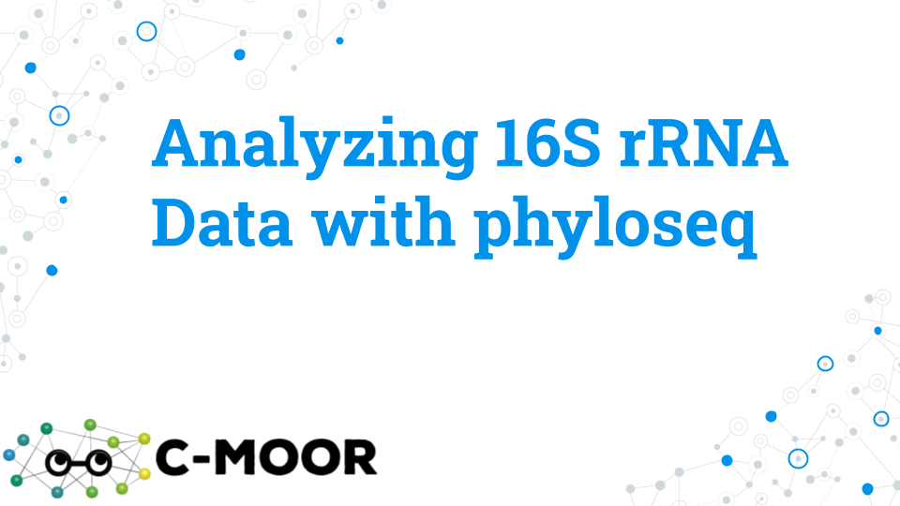
Lecture

5.3 Activity - Analyzing 16S rRNA Data with phyloseq

5.3.1 Purpose
To analyze bacterial diversity based on 16S rRNA gene sequencing using data from the “Impact of a 7-day homogeneous diet on interpersonal variation in human gut microbiomes and metabolomes” by Guthrie et al., 2023. This study is also referred to as the MISO study for “Microbiome Individuality and Stability Over Time” because the study aims to understand variation (or stability) of microbiomes across individuals.
This activity aims to analyze metagenomic diversity using the following R packages:
- phyloseq: A popular package for taxonomy profiling
- DESeq2: A package originally designed for differential expression which we will use for differential abundance
- ggplot2: A tidyverse package that produces high-quality figures

5.3.2 Learning objectives
- Use phyloseq to cluster samples based on the similarity of their microbial compositions using multidimensional scaling methods (NMDS or PCoA)
- Use phyloseq to profile alpha diversity (Shannon and Simpson’s indices)
- Use DESeq2 to perform differential abundance analysis

5.3.3 Introduction
16S data can be manipulated and visualized in a variety of ways. In Google Sheets, we explored the data manually to gain an understanding at the level of 1-10 ASVs. Through phyloseq we collapsed ASVs with the same taxonomic annotation to survey microbial diversity and perform the same exploration across the entire dataset. In this activity, we will use the functions of phyloseq and DESeq2 that are more advanced. These analyses would be extremely difficult and tedious to do manually and will allow us deeper insights into our dataset. We will cluster samples based on similarity of ASV counts, survey alpha diversity, and search for differentially abundant ASVs between different groups.

5.3.4 Activity 1 – Analyze 16S rRNA Data with phyloseq tutorial
Estimated time: 35 min
Activity 1. Explore a phyloseq object through the “Analyze 16S rRNA Data with phyloseq” tutorial.
- Access the C-MOOR Tutorials
- If you are using SciServer, log into SciServer, click on compute and open your “C-MOOR LearnR” container. Visit SciServer Guides and FAQs if you need to jog your memory on how to do this.
- If you are using AnVIL, log into AnVIL, navigate to your class Workspace, start up an RStudio Cloud Environment, and open RStudio. Visit the AnVIL Guides and FAQs if you need to jog your memory on how to do this. This module can be found in the “2-analyze-ps” folder of the “16s” curriculum folder.
- If you are using an alternative setup, follow the instructions provided by your instructor.
- Start the “Analyze 16S rRNA Data with phyloseq” tutorial.
- To move through the activities click “Continue” at the bottom of the screen. When you are done with a topic, click “Next Topic” to move on.
- This tutorial has small boxes in which you can enter and run short lines of code to analyze the data.
- As you work through the tutorial, take snapshots of your work and paste your answers in the grey boxes below:
1-1. Alpha diversity section: Take a snapshot and paste the code for an alpha diversity plot (Simpson) from the quiz question: What male subject has the data point for the LOWEST alpha diversity? HINT: Use subset_samples() to subset males, and specify individuals (subject) on x-axis of the alpha diversity plot

1-2. PCoA section: Take a snapshot and paste the code for a PCoA plot from the quiz question: In a PCoA with only data from ASVs with the class Bacteroidia, what is the percent of variance in the dataset explained by principal coordinate 1? HINT: You will need to change the code subsetting phylum and Firmicutes

1-3. Differential abundance: Take a snapshot and paste the code for the differential abundance plot for the quiz question: Which of the following Phylum have ASVs that are differentially abundant between the subject S02 and subject S03?

5.3.5 Activity 2 – Try it out questions
Estimated time: 60 min
With your group, perform some exploratory data analysis selecting from one of the four questions below or coming up with your own question. Each question has its own section with code templates for you to use below. Select a question here, then go to the page specific to your question.

5.3.5.1 Question 1. How sensitive is microbial diversity to variables like diet, age and gender?
Alpha diversity is a measure that estimates how the distribution of microbes changes due to a variable (or metadata category). Alpha diversity measures changes in the richness (the number of different organisms or ASVs) and evenness (how evenly are these organisms distributed in terms of their abundance). Using the “MISO” study dataset we will use Simpson (or specifically, Gini-Simpson) alpha diversity to evaluate changes in microbial diversity in individuals due to different metadata variables.
Approach: Plot Simpson alpha diversity using plot_richness() command in phyloseq and assess the impact of different study variables on changes in microbial diversity. Identify variables that impact alpha diversity. Visible shifts in alpha diversity suggest a shift in microbial diversity, and a higher alpha diversity value indicates an increase in alpha diversity (either richness or abundance).
- Evaluate the impact of diet on alpha diversity by plotting ASVs based on “diet” variable.
- Evaluate the impact of individuality on alpha diversity by plotting ASVs based on “subject” variable.
- Evaluate the impact of gender on alpha diversity by plotting ASVs based on “age” variable.
- Evaluate the impact of gender on alpha diversity by plotting ASVs based on “gender” variable.
- Evaluate the impact of gender on alpha diversity by plotting ASVs based on the 5 different levels of metabolites in the study (Creatinine, PCS, IS, HIPP, PAG).

5.3.5.2 Question 2. Do diet, age, gender and levels of metabolites correlate with microbe variation between individuals?
A PCoA plot is a principal coordinate analysis used to represent similarity between samples (sample microbiomes in our case). Using the “MISO” study dataset, we will use the PCoA plot to summarize individuals based on ASVs and plot the resulting relationships between individuals. Based on how well color-coding the different variables matches the sample distribution on the PcOA plot, we will aim to help explain potential sources of sample similarity.
Approach: Perform multidimensional scaling (also known as principal component analysis) to establish a relationship between the samples given multivariate data (metadata variables). Using a PcOA plot (via commands ordinate() and plot_ordination() in phyloseq), you will condense the original high-dimensional data into a low-dimensional one by converting data to distance map (matrix) with 2 dimensions, x and y, that best explain variability in your data. From your PCoA plot you will assess the contribution of different study variables to sample diversity and identify variables that correlate with sample diversity. In a PcOA plot, samples with similar microbial profiles will be plotted close and may appear as groups.
- Make a PCoA plot, ordinate on the entire dataset (all ASVs) and color by individual. Investigate the shape of the resulting PCoA plot.
- Correlate PCoA plot shape with metadata variables by coloring the PCoA plot with different variables including diet, subject, age and gender. Do any of the variables correlate with the shape of PCoA plot and data groupings?
- Correlate PCoA plot shape with the levels of metabolites in the study (Creatinine, PCS, IS, HIPP, PAG). From the color-coding pattern, identify 1. which variables help potentially explain the data groups formed in the PCoA plot. Subset “HD”, ordinate on “HD”, and make a new PCoA plot.

5.3.5.3 Question 3. What microbes (ASVs) differ between males and females, and does age have an impact?
Approach: Perform DESeq2 differential abundance analysis between females and males and determine how many differentially abundant microbes are there between the sexes. Then examine if age has a further impact on the differential abundance of the microbes between the sexes.
- Perform DESeq2 analysis between females and males and identify differences.
- Test if younger age contributes to differential microbe abundance between females and males by subsetting younger (< 50 years old) individuals.
- Test if older age contributes to differential microbe abundance between females and males by subsetting older (> 50 years old) individuals.

5.3.5.4 Question 4. Is there diet and age interaction and what microbes (ASVs) correlate with changes in diet-age interaction?
Variables and conditions can interact with each other in complex ways. Here we will try to tease apart the relationship between the gut microbiome, diet, and age. What does an interaction look like? In this example, we’re looking at whether or not a change in diet affects people of different ages in different ways. We might imagine for example that a young person’s gut is more resilient to change than an older person’s or vice versa. Changes at one age group may be different in the other.
Approach: Use alpha diversity measure and DESeq2 tools to answer this question. Using alpha diversity, determine if there is an interaction between diet and age. Then use DESeq2 to see if any ASVs are associated with changes in die-age interaction. Using Simpson alpha diversity measure (or specifically, Gini-Simpson) evaluate how microbial diversity changes with age and diet in general, or age and BD, HD and WO diet specifically. Then, use DESeq2 to evaluate if younger or older age changes ASVs associated with diet.
- Plot alpha diversity based age for the population in general, and then for individuals subsetted for BD, HD and WO diets. Look for shifts in alpha diversity with change in diet.
- Perform DESeq2 analysis based on the diet for the population in general, establishing baseline differential abundance between dietary groups HD and BD.
- Perform DESeq2 analysis based on the diet for the younger (<= 50 yo) and older (>=50 yo) individuals, evaluating age-associated changes in differential abundance between dietary groups HD and BD.

5.3.6 Grading criteria
- Download the assignment to your local computer as a .docx, complete it, and upload the assignment to your LMS (Blackboard, Canvas, Google Classroom).

5.3.7 Footnotes

5.3.7.1 Resources
- Google Doc
- 16S rRNA R Quick Reference

5.3.7.2 Contributions and affiliations
- Valeriya Gaysinskaya, Johns Hopkins University
- Gauri Paul, Clovis Community College
- Frederick Tan, Johns Hopkins University
- Sayumi York, Notre Dame of Maryland University

5.4 Try it Question 1 - How sensitive is microbial diversity to variables like diet, age and gender
Alpha diversity is a measure that estimates how the distribution of microbes changes due to a variable (or metadata category). Alpha diversity measures changes in the richness (the number of different organisms or ASVs) and evenness (how evenly are these organisms distributed in terms of their abundance). Using the “MISO” study dataset we will use Simpson (or specifically, Gini-Simpson) alpha diversity to evaluate changes in microbial diversity in individuals due to different metadata variables.
Approach: Plot Simpson alpha diversity using plot_richness() command in phyloseq and assess the impact of different study variables on changes in microbial diversity. Identify the variables that impact alpha diversity. Visible shifts in alpha diversity measure suggests a shift in microbial diversity, and higher alpha diversity value indicates an increase in alpha diversity.
Note, when plotting this data you may get a warning below. That is ok!
Warning: The data you have provided does not have any singletons. This is highly suspicious. Results of richness estimates (for example) are probably unreliable, or wrong, if you have already trimmed low-abundance taxa from the data.We recommended that you find the un-trimmed data and retry.
- Refer to the “alpha diversity” section of the “Analyze 16S rRNA Data with phyloseq” tutorial for help using the plot_richness() function.

5.4.1 Step 1A. Plot alpha diversity of the full MISO dataset by subject (individuals).
- subject is on the x-axis
- Color is by subject
- Use the following code as a template:
plot_richness(miso_counts, x="fill in the blank",
color="subject",
measures= "Simpson")
1A-1. Paste your plot below:

1A-2. Examine the alpha diversity plot you made. Are the points for an individual highly clustered or far apart?

1A-3. Is the alpha diversity metric for one individual similar to another’s?

1A-4. When the points for an individual are highly clustered, this means their gut microbiome has the same level of biodiversity over the length of the experiment (although the exact community of microbes may not be the same). Conversely, when the points are farther apart, their gut microbiome’s biodiversity has changed through the experiment. What does it mean to see a varied pattern of clustering across individuals in the study?

1A-5. Do you think a healthy microbiome has a high or low alpha diversity? Why or why not?

5.4.2 Step 1B. Plot alpha diversity of the full MISO dataset by diet
- diet is on the x-axis
- Color is by subject
- Use the following code as a template:
plot_richness(miso_counts, x="fill in the blank",
color="fill in the blank",
measures= "Simpson")
1B-1. Paste your plot below:

1B-2. Based on the plot above, does diet change the overall alpha diversity metric of the gut microbiome (ex. Are the points higher or lower overall in one diet versus the others?)

1B-3. Based on the plot above does diet change how varied the alpha diversity is between individuals? (ex. Are the points more spread out in one diet versus the others?)

1B-4. Do you think diet has an impact on gut microbial alpha diversity?

5.4.3 Step 1C. Plot alpha diversity of the full MISO dataset by age.
- age is on the x-axis
- Color is by subject
- Use the following code as a template:
plot_richness(miso_counts, x="fill in the blank",
color="fill in the blank",
measures= "Simpson")
1C-1. Paste your plot below:

1C-2. Do younger or older individuals have a higher alpha diversity of the gut microbiome overall (ex. Which group has an overall higher alpha diversity measure)?

1C-3. Do younger or older individuals have a more consistent alpha diversity of the gut microbiome (ex. Are points clustered more closely in younger or older subjects)?

1C-4. What do you think the impact of age on the alpha diversity of the gut microbiome is?

5.4.4 Step 1D. Plot alpha diversity of the full MISO dataset by gender.
- gender is on the x-axis
- Color is by subject
- Use the following code as a template:
plot_richness(miso_counts, x="fill in the blank",
color="fill in the blank",
measures= "Simpson")
1D-1. Paste your plot below:

1D-2. Do males or females have a higher alpha diversity of the gut microbiome overall (ex. Which group has an overall higher alpha diversity measure)?

1D-3. Do males or females have a more consistent alpha diversity of the gut microbiome (ex. Are points clustered more closely in males or females)?

1D-4. What do you think the impact of gender on the alpha diversity of the gut microbiome is?

5.4.5 Step 2. Plot alpha diversity of the full MISO dataset, grouping based on levels for 5 different metabolites: Creatinine, PCS, IS, HIPP, PAG.
Plot alpha diversity for the 5 metabolites independently then choose your favorite metabolite (e.g. one with most difference) and show plot below.
- metabolite on the x-axis (one at a time: Creatinine, PCS, IS, HIPP, PAG)
- Color is by subject
- Use the following code as a template:
plot_richness(miso_counts, x="fill in the blank metabolite name",
color="fill in the blank",
measures= "Simpson")
2A-1. Paste your metabolite plot(s) below:

2A-2. Which metabolite did you choose to show and why?

2A-3. Are there any trends in alpha diversity as this metabolite increases in level?

5.4.6 Footnotes

5.4.6.1 Resources
- Google Doc
- 16S rRNA R Quick Reference

5.4.6.2 Contributions and affiliations
- Valeriya Gaysinskaya, Johns Hopkins University
- Gauri Paul, Clovis Community College
- Frederick Tan, Johns Hopkins University
- Sayumi York, Notre Dame of Maryland University

5.5 Try it Question 2 - Do diet, age, gender and levels of metabolites correlate with microbe variation between individuals
A PCoA plot is a principal coordinate analysis used to represent similarity between samples (sample microbiomes in our case). Using the “MISO” study dataset, we will use the PCoA plot to summarize individuals based on ASVs and plot the resulting relationships between individuals. Based on how well color-coding the different variables matches the sample distribution on the PcOA plot, we will aim to help explain potential sources of sample similarity.
Approach: Perform multidimensional scaling (also known as principal component analysis) to establish a relationship between the samples given multivariate data (metadata variables). Using a PcOA plot (via commands ordinate() and plot_ordination() in phyloseq), you will condense the original high-dimensional data into a low-dimensional one by converting data to distance map (matrix) with 2 dimensions, x and y, that best explain variability in your data. From your PCoA plot you will assess the contribution of different study variables to sample diversity and identify variables that help explain sample diversity. In a PcOA plot, samples with similar microbial profiles will be plotted close and may appear as “clusters”.

5.5.1 Step 1. Make a PcOA plot, ordinating on the entire miso dataset, and coloring by individual. Investigate resulting plot shape.
- Ordination is a term used to summarize a multidimensional dataset when projected onto a low-dimensional space (like X & Y axes) and then observing any pattern the data may possess with a visual inspection.
- Subsequent coloring of the pattern with metadata variables can reveal underlying relationships between data and experiment variables.
- color - by subject
- Include a title for your PCoA plot
- Use the following code as a template:
#Ordinate
miso.pcoa <- ordinate(miso, method="PCoA", distance="bray")
#Plot PCoA
plot_ordination(miso, miso.pcoa,
color = "fill in the blank",
title="fill in the blank")
1A-1. Paste your plot below:

1A-2. Does the PCoA organize samples into groups? Is there any pattern?

1A-3. Do you observe any sample clustering by individual? This is represented by points of the same color clustering together. If so, give an example of an individual who shows this pattern.

1A-4. Offer one question you want to ask about this PCoA plot?

5.5.2 Step 2. Using the PCoA plot from Step 1 above, look for any correlations between the shape of your PCoA plot and diet, gender and age
Step 2A. Using the PCoA plot from Step 1, look for any correlations between the shape of your PCoA plot and diet?
How well is your data explained by the variation in the diet - look for signs of correlation between PCoA shape and variable “diet” representing BD, HD and WO diets. Note that since we are using the same plot, we do not need to re-ordinate (no ordinate() function).
- Color - by diet
- Include a title for your PcOA plot
- Use the following code as a template:
#Ordinate
miso.pcoa <- ordinate(miso, method="PCoA", distance="bray")
plot_ordination(miso, miso.pcoa,
color = "fill in the blank",
title="fill in the blank")
2A-1. Paste your plot below:

2A-2 Do samples of the same diet treatment (color) cluster together?

2A-3 Based on what you wrote above, are samples from the same diet treatment similar to each other?
Step 2B. Using the PCoA plot from Step 1, look for any correlations between the shape of your PCoA plot and gender?
How well is your data explained by the variation in the gender - look for signs of correlation between PcOA shape and variable “gender”.
- Color - by gender
- Include a title for your PcOA plot
- Use the following code as a template.
#Ordinate
miso.pcoa <- ordinate(miso, method="PCoA", distance="bray")
plot_ordination(miso, miso.pcoa,
color = "fill in the blank",
title="fill in the blank")
2B-1. Paste your plot below:

2B-2 Are samples from the same gender similar to each other?
Step 2C. Using the PCoA plot from Step 1, look for any correlations between the shape of your PCoA plot and age? How well is your data explained by the variation in the age - look for signs of correlation between PcOA shape and variable “age”.
- Color - age
- Include title name for your PcOA plot
- Use the following code as a template. To enhance the color range of the age variable, additionally included below (in blue) is the command to specify the color gradient with yellow–to-blue gradient.
- Try running the code with and without the scale_colour_gradient() command to appreciate the difference.
#Ordinate
miso.pcoa <- ordinate(miso, method="PCoA", distance="bray")
plot_ordination(miso, miso.pcoa,
color = "fill in the blank",
title="fill in the blank") +
scale_colour_gradient(low = "blue", high = "yellow")
2C-1. Paste your plot below:

2C-2 Are samples of a similar age similar to each other?

5.5.3 Step 3. Using the PCoA plot from Step 1, look for any correlations between the shape of your PCoA plot and the level of metabolites.
How well is your data correlated with the variation in the 5 metabolites: Creatinine, PCS, IS, HIPP, or PAG? Test each metabolite by coloring each metabolite at a time, then, choose your favorite metabolite (e.g. one with most difference) and show the plot below.
- Color - metabolite one at a time: Creatinine, PCS, IS, HIPP, PAG
- Include a title for your PcOA plot
- Use the following code as a template:
#Ordinate
miso.pcoa <- ordinate(miso, method="PCoA", distance="bray")
plot_ordination(miso, miso.pcoa,
color = "fill in the blank",
title="fill in the blank") +
scale_colour_gradient(low = "blue", high = "yellow")
3A-1. Paste your metabolite plot(s) below:

3A-2. Which metabolite did you choose to show and why?

3A-3. Are samples of the same metabolite level similar to each other?

5.5.4 Step 4. One way of checking if the metabolite levels indeed correlate with your data, is to see if subsetting smaller chunks or specific chunks of the data will still maintain the metabolite-data relationship or break it.
Using the subset() command, subset out e.g. HD diet specifically, and then BD diet. Then, generate new PCoA plots and see if the correlation with your metabolite of interest still holds.
Step 4A. Subset “HD”, ordinate on “HD”, and make a new PCoA plot.
- Subset data - by the diet “HD”
- Ordinate - misoHD
- Color - by your selected metabolite from part 3
- Include a title for your PcOA plot
- Use the following code as a template:
#Subset only “HD” timepoint from your miso data, creating a new phyloseq object called “misoHD”
misoHD = subset_samples(miso, diet == "fill in the blank")
#Ordinate using only “HD” subset, creating a new ordination matrix called “pcoa.misoHD”
pcoa.misoHD <- ordinate(misoHD, method="PCoA", distance="bray")
#Make a PCoA plot using your “HD” subset.
plot_ordination(misoHD, pcoa.misoHD,
color = "fill in the blank",
title="fill in the blank")
4A-1. Paste your plot below for HD subset:

4A-2 Are samples of the same metabolite level similar to each other considering only samples from the HD diet?

4A-3 Has the relationship between the metabolite and samples changed within the HD diet compared to the entire dataset? (ex. Have any new patterns emerged or disappeared?)
Step 4B. Repeat the analysis on only the BD diet samples. Subset “BD”, ordinate on “BD”, and make a new PCoA plot.
- Subset data - by the diet “BD”
- Ordinate - misoBD
- Color - by your selected metabolite from part 3
- Include a title for your PcOA plot
- Use the code below as a template.
misoBD = subset_samples(miso, diet == "fill in the blank")
pcoa.misoBD <- ordinate(misoBD, method="PCoA", distance="bray")
plot_ordination(misoBD, pcoa.misoBD,
color = "fill in the blank",
title="fill in the blank")
4B-1. Paste your plot below for BD subset:

4B-2 Are samples of the same metabolite level similar to each other considering only samples from the BD diet?

4B-3 Has the relationship between the metabolite and samples changed within the BD diet compared to the entire dataset? (ex. Have any new patterns emerged or disappeared?)

5.5.5 Footnotes

5.5.5.1 Resources
- Google Doc
- 16S rRNA R Quick Reference

5.5.5.2 Contributions and affiliations
- Valeriya Gaysinskaya, Johns Hopkins University
- Gauri Paul, Clovis Community College
- Frederick Tan, Johns Hopkins University
- Sayumi York, Notre Dame of Maryland University

5.6 Try it Question 3 - What microbes (ASVs) differ between males and females, and does age have an impact
Approach: Perform DESeq analysis between females and males and determine how many differentially abundant microbes are there between the sexes. Then examine if age has a further impact on the abundance of the microbes between the sexes.

5.6.1 Step 3A. Perform differential abundance analysis between genders.
- Design - is based on gender (no double quotes)
- Groups to compare - females, F and males, M (baseline)
- Plot Phylum on the X-axis and color by Class
- Make sure your graph has a title that includes the comparison you are making (ex. WO vs HD)
- Refer to the “Differential abundance” section of the “Analyze 16S rRNA Data with phyloseq” tutorial for help using the plot_ordination() function.
- Use the code below as a template:
# STEP 2: Select the groups to compare, where the latter group is your baseline
my_comparison <-c("gender", "fill in the blank", "fill in the blank (baseline)")
# STEP 3: Run the differential abundance analysis
Significant_DEseq2_ASVs<-Differential_Abundance(miso_counts, DESeq2, my_comparison, 0.05)
# STEP 4: Retrieve the list of ASVs with a significant difference in abundance between the chosen groups
Significant_DEseq2_ASVs
# STEP 5: Plot the results with your chosen x axis and legend
ggplot(significant_ASVs, aes(x = fill in the blank, y=log2FoldChange, color= fill in the blank)) + geom_point(size=4, position="jitter") +
theme(axis.text.x = element_text(angle = -90, hjust = 0, vjust=0.5))+
ggtitle("fill in the blank")
3A-1. Insert the resulting plot below:

3A-2. How many differentially abundant ASVs were identified? This is the number of rows in the result table.

3A-3. Give an example of a differentially abundant ASVs that was significantly higher in females than males. Include ASV ID and taxa. HINT: If male was your baseline, then an example of an ASV that is higher in females will have a positive log2FC, and vice versa if female was your baseline group. Use the arrows in the header row of the table to scroll through the taxonomy of an ASV.

3A-4. Look up this microbe. What function does it serve in the human gut, and how might its abundance be connected to gender?

3A-5. Give an example of a differentially abundant ASVs that was significantly higher in males than females. Include ASV ID and taxa. HINT: If male was your baseline, then an example of an ASV that is higher in males will have a negative log2FC, and vice versa if female was your baseline group. Use the arrows in the header row of the table to scroll through the taxonomy of an ASV.

3A-6. Look up this microbe. What function does it serve in the human gut, and how might its abundance be connected to gender?

5.6.2 Step 3B. Determine the impact of younger age on differential abundance in males and females, by subsetting age < 50 data from the phyloseq object, and performing DESeq2 analysis on this subset.
- Subset phyloseq object to only include younger individuals (age < 50)
- For DESeq2 analysis, keep the design the same as in part A - based on gender
- Groups to compare: females (F) and males (M, baseline)
- Plot Phylum on the X-axis and color by Class
- Use template code below:
# STEP 1: subset by age < 50
ageA = subset_samples(miso_counts, age <50)
# STEP 2: Convert the phyloseq object to a DESeq2 object and specify experimental design
DESeq2 <- phyloseq_to_deseq2(ageA, design = ~ fill in the blank)
# STEP 3: Select the groups to compare, where log2FoldChange reported will correspond to y/x.
my_comparison <-c("gender", "fill in the blank", "fill in the blank (baseline)")
# STEP 4: Run the differential abundance analysis
Significant_DEseq2_ASVs<-Differential_Abundance(miso_counts, DESeq2, my_comparison, 0.05)
# STEP 5: Retrieve the list of ASVs with a significant difference in abundance between the chosen groups
Significant_DEseq2_ASVs
# STEP 6: Plot the results with your chosen x axis and legend
ggplot(Significant_DEseq2_ASVs, aes(x = fill in the blank, y=log2FoldChange, color= fill in the blank)) + geom_point(size=4, position = "jitter") +
theme(axis.text.x = element_text(angle = -90, hjust = 0, vjust=0.5))+
ggtitle("fill in the blank")
3B-1. Insert the resulting plot below:

3B-2. How many differentially abundant ASVs were identified?

3B-3. Give an example of a differentially abundant ASVs that was significantly higher in younger females than younger males. Include ASV ID and taxa. HINT: If male was your baseline, then an example of an ASV that is higher in females will have a positive log2FC, and vice versa if female was your baseline group. Use the arrows in the header row of the table to scroll through the taxonomy of an ASV.

3B-4. Give an example of a differentially abundant ASVs that was significantly higher in younger males than younger females. Include ASV ID and taxa. HINT: If male was your baseline, then an example of an ASV that is higher in males will have a negative log2FC, and vice versa if female was your baseline group. Use the arrows in the header row of the table to scroll through the taxonomy of an ASV.

3B-5. Compared to the overall dataset, do younger individuals have more or less differentially abundant microbes between genders?

5.6.3 Step 3C. Determine the impact of older age on differential abundance in males and females, by subsetting age >= 50 data from the phyloseq object, and performing DESeq2 analysis on this subset.
- You can use template code below:
# STEP 1: subset by age >= 50
ageB = subset_samples(miso_counts, age >= 50)
# STEP 2: Convert the phyloseq object to a DESeq2 object and specify experimental design
DESeq2 <- phyloseq_to_deseq2(ageB, design = ~ fill in the blank)
# STEP 3: Select the groups to compare, where log2FoldChange reported will correspond to y/x.
my_comparison <-c("gender", "fill in the blank", "fill in the blank")
# STEP 4: Run the differential abundance analysis
Significant_DEseq2_ASVs<-Differential_Abundance(miso_counts, DESeq2, my_comparison, 0.05)
# STEP 5: Retrieve the list of ASVs with a significant difference in abundance between the chosen groups
Significant_DEseq2_ASVs
# STEP 6: Plot the results with your chosen x axis and legend
ggplot(Significant_DEseq2_ASVs, aes(x = fill in the blank, y=log2FoldChange, color= fill in the blank)) + geom_point(size=4, position = "jitter") +
theme(axis.text.x = element_text(angle = -90, hjust = 0, vjust=0.5))+
ggtitle("fill in the blank")
3C-1. Insert the resulting plot below:

3C-2. How many differentially abundant ASVs were identified? This is the number of rows in the result table.

3C-3. Compared to the overall dataset, do older individuals have more or less differentially abundant microbes between genders?

3C-4. Compare all the plots you have made. Give a specific example of one difference you see.

5.6.4 Footnotes

5.6.4.1 Resources
- Google Doc
- 16S rRNA R Quick Reference

5.6.4.2 Contributions and affiliations
- Valeriya Gaysinskaya, Johns Hopkins University
- Gauri Paul, Clovis Community College
- Frederick Tan, Johns Hopkins University
- Sayumi York, Notre Dame of Maryland University

5.7 Try it Question 4 - Is there an interaction between diet and age and the microbiome
Variables and conditions can interact with each other in complex ways. Here we will try to tease apart the relationship between the gut microbiome, diet, and age. What does an interaction look like? In this example, we’re looking at whether or not a change in diet affects people of different ages in different ways. We might imagine for example that a young person’s gut is more resilient to change than an older person’s or vice versa. Changes at one age group may be different in the other.
Approach: Use alpha diversity measure and DESeq2 tools to answer this question. Using alpha diversity, determine if there is an interaction between diet and age. Then use DESeq2 to see if any ASVs are associated with changes in die-age interaction. Using Simpson alpha diversity measure (or specifically, Gini-Simpson) evaluate how microbial diversity changes with age and diet in general, or age and BD, HD and WO diet specifically. Remember, shifts in alpha diversity measure suggest a shift in microbial diversity, with high alpha diversity suggesting high microbial diversity. Then, use DESeq2 to evaluate if ageing changes ASVs associated with diet.
Note, when plotting this data you may get a warning below. That is ok!
Warning: The data you have provided does not have any singletons. This is highly suspicious. Results of richness estimates (for example) are probably unreliable, or wrong, if you have already trimmed low-abundance taxa from the data.We recommended that you find the un-trimmed data and retry.
- Refer to the “alpha diversity” section of the “Analyze 16S rRNA Data with phyloseq” tutorial for help using the plot_richness() function.

5.7.1 Step 1. Plot alpha diversity based on age for all dietary groups, and then for BD, HD and WO.
Step 1A. Plot alpha diversity based on age for all dietary groups, and then for BD, HD and WO.
Plot alpha diversity based on age for all dietary groups.**
- Subset data - None
- age is on the x-axis
- Color is by subject
- Use the following code as a template:
plot_richness(miso_counts, x="fill in the blank",
color="fill in the blank",
title = "miso",
measures= c("Simpson"))
1A-1. Paste your plot below:

1A-2. Does alpha diversity change in value with increasing age (overall alpha diversity measure) ?

1A-3. Does alpha diversity grow more varied between individuals with increasing age (are points less clustered with increasing age) ?
Step 1B. Plot alpha diversity based on age for BD diet only.
Plot alpha diversity based on age for BD diet only.
- Subset data - diet BD
- age is on the x-axis
- Color is by subject
- Use the following code as a template:
# Subset only BD samples
miso_counts_BD = subset_samples(miso_counts, diet == "BD")
plot_richness(miso_counts_BD, x="fill in the blank",
color="fill in the blank",
title = "fill in the blank",
measures= c("Simpson"))
1B-2.Paste your plot below:

1B-2. Did the relationship between age and alpha diversity change when only looking at the BD diet data points? Explain your answer by describing the trend or lack thereof in the graph.
Step 1C. Plot alpha diversity based on age for HD diet only.
- Subset data - diet HD
- age is on the x-axis
- Color is by subject
- Use the following code as a template:
#Step1: Subset data for HD only
miso_counts_HD = subset_samples(miso_counts, diet == "fill in the blank")
plot_richness(miso_counts_HD, x="fill in the blank",
color="fill in the blank",
title = "fill in the blank",
measures= c("Simpson"))
1C-1. Paste your plot below:

1C-2. Did the relationship between age and alpha diversity change when only looking at the HD diet data points? Explain your answer by describing the trend or lack thereof in the graph.
1D-1. Plot alpha diversity based on age for WO diet only.
- Subset data - diet WO
- age is on the x-axis
- Color is by subject
- Use the following code as a template:
#Step1: Subset data for WO only
miso_counts_WO = subset_samples(miso_counts, diet == "fill in the blank")
plot_richness(fill in the blank, x="fill in the blank",
color="fill in the blank",
title = "fill in the blank",
measures= c("Simpson"))
1D-1. Paste your plot below:

1D-2. Did the relationship between age and alpha diversity change when only looking at the WO diet data points? Explain your answer by describing the trend or lack thereof in the graph. Remember, the WO only has half as many datapoints compared to the BD and HD since there is only 1 WO timepoint (versus 2 for BD and HD).

5.7.2 Step 2. Perform differential abundance analysis comparing HD to BD for the population in general, and then for older individuals specifically.
Step 2A. Perform differential abundance analysis between HD and BD.
- Design - is based on diet (no double quotes)
- Groups to compare - HD and BD (baseline)
- Plot Phylum on the X-axis and color by Class
- Make sure your graph has a title that includes the comparison you are making (ex. WO vs HD)
- Refer to the “Differential abundance” section of the “Analyze 16S rRNA Data with phyloseq” tutorial for help using the plot_ordination() function.
- Use the code below as a template:
# STEP 1: Convert the phyloseq object to a DESeq2 object and specify experimental design
DESeq2 <- phyloseq_to_deseq2(miso_counts, design = ~ diet)
# STEP 2: Select the groups to compare, where the latter group is your baseline
my_comparison <-c("diet", "HD", "fill in the blank (baseline)")
# STEP 3: Run the differential abundance analysis
Significant_DEseq2_ASVs<-Differential_Abundance(miso_counts, DESeq2, my_comparison, 0.05)
# STEP 4: Retrieve the list of ASVs with a significant difference in abundance between the chosen groups
Significant_DEseq2_ASVs
# STEP 5: Plot the results with your chosen x axis and legend
ggplot(Significant_DEseq2_ASVs, aes(x = Phylum, y=log2FoldChange, color= fill in the blank)) + geom_point(size=4) +
theme(axis.text.x = element_text(angle = -90, hjust = 0, vjust=0.5))+
ggtitle("fill in the blank")
2A-1. Insert the resulting plot below:

2A-2. How many differentially abundant ASVs were identified? This is the number of rows in the result table.

2A-3. Did a change in diet from BD to HD cause there to be a lot of changes in microbe abundance?

5.7.3 Step 2B. Perform differential abundance analysis between HD and BD for older individual (> 50 yo.)
- Subset data - older age (> 50 yo)
- Design - is based on diet (no double quotes)
- Groups to compare - HD and BD (baseline)
- Plot Phylum on the X-axis and color by Class
- Make sure your graph has a title that includes the comparison you are making (ex. WO vs HD)
- Refer to the “Differential abundance” section of the “Analyze 16S rRNA Data with phyloseq” tutorial for help using the plot_ordination() function.
- Use the code below as a template:
#First, subset miso_counts object to only include older individuals over age 50
subset = subset_samples(miso_counts, age >50)
# STEP 1: Convert the phyloseq object to a DESeq2 object and specify experimental design
DESeq2_subset <- phyloseq_to_deseq2(subset, design = ~ diet)
# STEP 2: Select the groups to compare, where the latter group is your baseline
comparison_subset <-c("diet", "HD", "fill in the blank (baseline)")
# STEP 3: Run the differential abundance analysis
Significant_ASVs_subset <- Differential_Abundance(miso_counts, DESeq2_subset, comparison_subset, 0.05)
# STEP 4: Retrieve the list of ASVs with a significant difference in abundance between the chosen groups
Significant_ASVs_subset
# STEP 5: Plot the results with your chosen x axis and legend
ggplot(Significant_ASVs_subset, aes(x = Phylum, y=log2FoldChange, color= fill in the blank)) + geom_point(size=4) +
theme(axis.text.x = element_text(angle = -90, hjust = 0, vjust=0.5))+
ggtitle("fill in the blank")
2B-1. Insert the resulting plot below:

2B-2. How many differentially abundant ASVs were identified? This is the number of rows in the result table.

2B-3. Did a change in diet from BD to HD cause there to be a lot of changes in microbe abundance in older individuals?

2B-4. How do these results compare to the results when we looked at the entire dataset (2A-1)?

2B-5. When this analysis is repeated for a younger population (<=50), 3 differentially abundant ASVs are found. Do you think there is a diet-age interaction? A reminder that an interaction would cause different age groups to react to the change in diet differently.

5.7.4 Footnotes

5.7.4.1 Resources
- Google Doc
- 16S rRNA R Quick Reference

5.7.4.2 Contributions and affiliations
- Valeriya Gaysinskaya, Johns Hopkins University
- Gauri Paul, Clovis Community College
- Frederick Tan, Johns Hopkins University
- Sayumi York, Notre Dame of Maryland University

6 Kickstart Project Work
Purpose
The purpose of this lab is to gain practice in scientific communication, project exploration and work on your scientific poster!
Learning Objectives
- Engage with the Scientific Process
- Communicate your findings
- Create an outline for further exploratory research
- Develop your plot images using R code
Introduction
It’s time to begin working on your independent research projects! You have your choice of a few datasets, each which allows you to ask a different set of questions and examine different variables.
Here’s a few ideas to get you started:
- Pre- and probiotic supplements have been gaining visibilty over time as the field next generation sequencing has grown. What taxa are included in popular supplements? Can you find them in these datasets and if so, how are they correlated with different conditions?
- Many disease states are reflected in the gut microbiome, even if they themselves are not gastrointestinal disorders. Think of some disease states that you’re interested in. What kinds of microbiome compositions do we see in different states and how is biodiversity impacted?
- While we often focus on the most common core microbes, some datasets have a wealth of rare taxa to explore and may be important to the host’s phenotype. Consider looking at a few less common microbes in more detail and see if one catches your eye.

6.0.1 Activity 1 – Use the project work module to come up with a research question
Estimated time: 90 minutes, however may vary greatly by research team
- Access the C-MOOR Tutorials
- If you are using SciServer, log into SciServer, click on compute and open your “C-MOOR LearnR” container. Visit SciServer Guides and FAQs if you need to jog your memory on how to do this.
- If you are using AnVIL, log into AnVIL, navigate to your class Workspace, start up an RStudio Cloud Environment, and open RStudio. Visit the AnVIL Guides and FAQs if you need to jog your memory on how to do this. This module can be found in the “3-16s-project” folder of the “16s” curriculum folder.
- If you are using an alternative setup, follow the instructions provided by your instructor.
- Start the “16S rRNA Human Gut Microbiome Project Work” tutorial.
- This tutorial allows you to jump to different datasets and analyses of your choice and run short lines of code to analyze the data.
- Consult your research group and instructor as your research idea progresses until you’ve come up with a testable idea that everyone is satisfied with.

6.0.2 Footnotes
- 16S miniCURE Guide

6.0.2.1 Resources

6.0.2.2 Contributions and affiliations
- Valeriya Gaysinskaya, Johns Hopkins University
- Gauri Paul, Clovis Community College
- Gugulethu Sakana, Clovis Community College
- Frederick Tan, Johns Hopkins University
- Rosa Alcazar, Clovis Community College
- Stephanie Coffman, Clovis Community College
- Sayumi York, Notre Dame of Maryland University
Last Revised: June 5, 2026

7 Additional Datasets

7.0.1 The FeFiFo Study
You have probably heard that some fermented foods like yogurt and cheese contain bacteria that help support a healthy gut. Likewise, fiber is known for positively impacting digestion (though you can also have too much of all of these foods).
Wastyk et al. (2021) explored these foods further in their study Gut-microbiota-targeted diets modulate human immune status We call this the FeFiFo study because the experimental design includes fermented and fiber-rich food treatment groups.
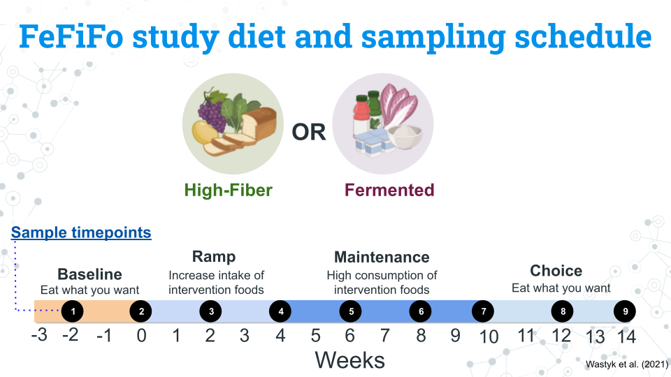
The researchers examined effect of either high fiber (n=18) or fermented foods on the gut microbiome (n=18). Rather than controlling diet entirely through standardized portions, participants were allowed to select what foods they ate so long as these foods were high in fiber or were fermented. Additional metadata was collected from participants including ethnicity, relationship status, employment status, and education level. Similarly to the MISO study, participants had a baseline diet before switching to an intervention diet and finally returned to being allowed to eat whatever they wanted.

7.0.1.1 Some questions to get you started
- How variable is the change of microbiome composition and alpha diversity across individuals? Do all individuals change the same amount or are there some individuals much more sensitive to their chosen food group?
- What are the most abundant microbes in each treatment (fiber, fermented)? Are they similar taxa or different?
- Is there any relationship between ethnicity, education, employment, relationship status and microbiome composition and/or alpha diversity?
- Are the subject’s microbiomes at a given timepoint similar to each other? Similar to other samples from the same subject no matter the timepoint?

7.0.2 Alzheimer’s dataset
Our body requires our organs working in tandem and communicating with each other in order to function. One of the key relationships you may have heard of is the gut-brain axis, a bidirectional relationship between the gastrointestinal system and the central nervous system.
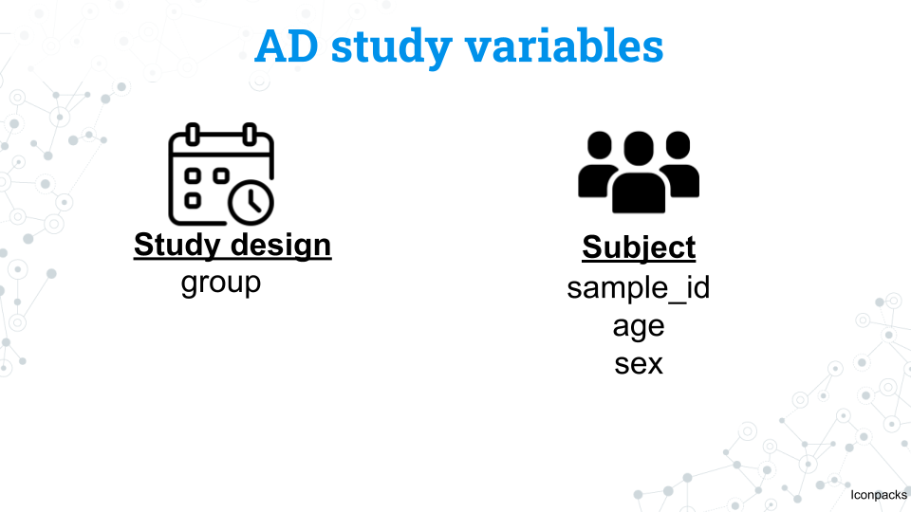
To explore this relationship within the specific context of a disease, we have a dataset from Gut microbiota is altered in patients with Alzheimer’s disease by Zhuang et al. (2018). This dataset was selected by a student from Clovis Community College and integrated into our curriculum! In this study researchers sequenced the gut microbiome from 43 patients with Alzheimer’s disease and 43 patients from age and sex matched controls. The metadata is more sparse than our other datasets, but a wealth of taxonomic information remains unanalyzed!
As computational methods and biological databases have advanced in the nearly decade since, we reanalyzed the raw data from this study with a more recent database (SILVA 138.2). As such, you may find that your results are drastically different from the original study, and its possible that changes in our understanding of microbiology and the processed data may lead us to draw different conclusions than the original authors.

7.0.2.1 Some questions to get you started
- How similar are microbiomes between healthy and AD individuals in composition and/or alpha diversity?
- Looking at other published research studies, are the microbial taxa associated with AD also found in this study?
- Select a microbial taxa of interest (perhaps from the idea above) and explore it at increasing levels of resolution up to the level of species. Looking at other published research studies, what functions are these taxa associated with? Do they have any relation to AD or other neurodegenerative diseases?

7.0.3 Footnotes

7.0.3.1 Resources
- 16S miniCURE Guide
- Wastyk et al. 2021
- Zhuang et al. 2018

7.0.3.2 Contributions and Affiliations
- Sayumi York, Notre Dame of Maryland University
Last Revised: June 5, 2026
## Warning: Chunk option fig.align is not supported for docx output
## Warning: Chunk option fig.alt is not supported for docx output
## Warning: Chunk option fig.align is not supported for docx output
## Warning: Chunk option fig.alt is not supported for docx output
## Warning: Chunk option fig.align is not supported for docx output
## Warning: Chunk option fig.alt is not supported for docx output
## Warning: Chunk option fig.align is not supported for docx output
## Warning: Chunk option fig.alt is not supported for docx output
## Warning: Chunk option fig.align is not supported for docx output
## Warning: Chunk option fig.alt is not supported for docx output
## Warning: Chunk option fig.align is not supported for docx output
## Warning: Chunk option fig.alt is not supported for docx output
## Warning: Chunk option fig.align is not supported for docx output
## Warning: Chunk option fig.alt is not supported for docx output
## Warning: Chunk option fig.align is not supported for docx output
## Warning: Chunk option fig.alt is not supported for docx output
## Warning: Chunk option fig.align is not supported for docx output
## Warning: Chunk option fig.alt is not supported for docx output
## Warning: Chunk option fig.align is not supported for docx output
## Warning: Chunk option fig.alt is not supported for docx output

8 Scientific Posters
In this section we will go over how to create a scientific poster. We chose a poster as our final deliverable in C-MOOR because they:
- Facilitate participation in research symposiums: Students can use their poster to apply to present at research symposiums or conferences with minimal additional effort beyond what they do in class. If your institution does not have a research day, consider starting one using these posters as a foundation as we did at Clovis Community College! Your school’s library is another great point of contact in getting a poster session or research day set up. Some of the events students have participated in using their C-MOOR projects include:
  - The Clovis Community College Research Day
  - The Notre Dame of Maryland University Research Day
  - The GRADS-4C Conference (2025)
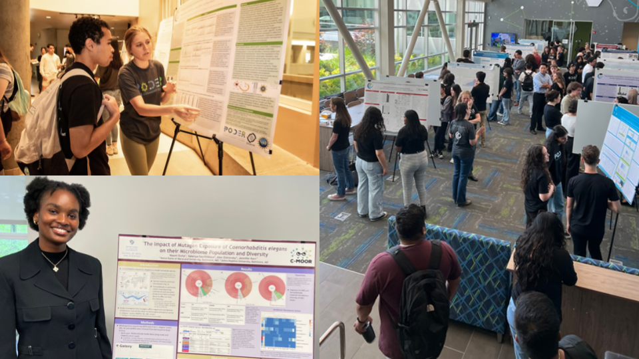
- Serve as a physical representation of student achievement: If printed, once finished with the class, students can choose to take their poster with them or leave it with the class to be hung up around the classroom or the hallways. This gives their research project more visibility, serves as an advertisement for other students who might be interested in taking the class, and showcases what students have accomplished.
- Can easily be shared digitally: A presentation can’t be repeated twice without a recording, and each recording can take up a lot of digital storage. A poster on the other hand, is a great compressed product that can be posted on a student’s (or the institution’s) social media and help get their work seen by others. Posters are even small enough that they can be attached to an email and sent to prospective supervisors and collaborators interested in a quick summary of their work. See our Look at This! category on the C-MOOR Academy Discussion Forum to see all the posters students have created and shared so far!
- Posters can be used to measure student achievement and understanding: We have previously used these posters to evaluate student learning, even years after students have left the classroom. Check out our poster on posters!

8.1 Making a Group Poster

8.1.1 Preparing to make a poster
An important part of scientific research is presenting your findings. Poster is a powerful visual way to communicate new and exciting findings, share ideas and get feedback. No wonder Poster sessions are an integral part of any conference or symposium. Throughout research project work, students will work with their groups to put together a scientific research poster.

8.1.2 Part 1 - Choose a Template
Estimated time: 5 minutes
- With your group, open a suggested poster template to use for your poster.
- Discuss with your group how you will divide up the work and exchange important information (e.g. phone numbers, email). Consider the following sections:
- Abstract/Introduction
- Methods
- Results
- Conclusions/Discussion
- References
- Acknowledgments
Notice these posters are sized at 36 x 42 inches, but there are many other commonly used sizes. Refer to your instructor on what poster size to use; not every poster will fit every stand when printed (if applicable). Notice that the posters in this slidedeck come in two-column, three-column, and mixed formats. Think about your figures and tables and select a format that makes the most sense for them. There are also some example posters in the last two slides that we will use to examine the anatomy of a research poster further in the next part.

8.1.3 Part 2 - Make an Academic Research Poster
Estimated time: —
Complete the following components of your research poster with your group. You might not do them in this order, but these are the components you are being graded on. For more details on each of these sections and their role in a scientific paper, see the Scientific Literature Lab.

8.1.3.1 The header: title, authors, and affiliations
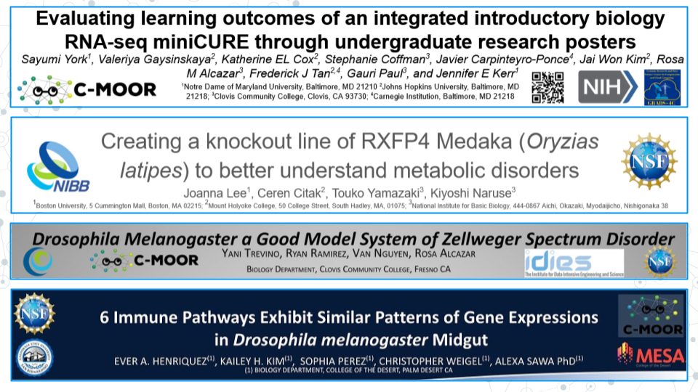
Since you completed this work as a team of scientists, all of your team members are considered authors. List your team members in alphabetical order. The author’s affiliation is the university, college, research institution or company that the work was conducted at.
- An example affiliation for Clovis Community College would be: “Department of Biology, Clovis Community College, California, United States.”
- If multiple institutions exist, you will need to use superscript to denote who has what affiliation (see the example poster).
Include the C-MOOR logo, the logo of your institution(s), and the most immediately relevant funding source (if applicable) in the header.
Check the header of your poster:
- All authors are listed
- All authors’ home institutions are referenced
- The title of the poster is short and focused on your specific project topic
- Appropriate logos are included: E.g. the C-MOOR logo, the logo of your institution
- Relevant funding source (if applicable) is listed
A note on the title:
- The title of the poster describes the main result of your research
- The title of the poster does not overstate the findings or significance of your research

8.1.3.2 Abstract
C-MOOR Abstract examples:
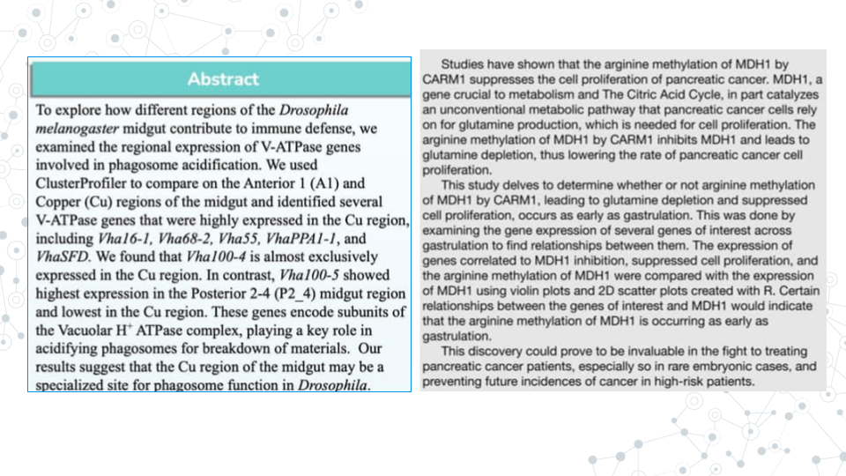
An abstract is a concise summary of your work. An effective abstract will be well designed and communicated, and will inform the reader of the relevant background to the research, scientific hypothesis being tested, the purpose of the study, the main methods, and the most important results and conclusions.
Abstract can be difficult to write because it combines all research pieces and requires effective and consice communication of those sections. Many scientists choose to write the abstract last, after they fully understand the conclusions and implications of their work.
Your abstract should do the following:
- Clearly and briefly state purpose, hypothesis, aims, and/or objectives of the research.
- e.g. Our hypothesis is that the healthy gut microbiome has more microbial diversity than the gut of an individual with a celiac disease.`
- e.g. We hypothesize that maternal antibiotic treatment correlates with higher antibicrobial resistance in infant microbiome.`
- Clearly and briefly summarize relevant background information such as:
- A problem or question at hand
- Model organism
- The gene of interest and its function
- The relevant phenotypes (e.g. disease-state)
- The known connection between genotype and phenotype
- Relevant biological processes
- Clearly and briefly summarize the main results of your study, and how they may relate to the hypothesis.
- e.g. We found that gene X was differentially abundant between the eye and all other tissues, suggesting gene X plays an important role in the eye. This may be important for learning more about eye development and X condition.`
- e.g. We found an association between age and the presence of Y bacteria, which supports our hypothesis that Y bacteria is involved in the disease state`
- Clearly and briefly summarize methodology you used in your research.
- e.g. Using Galaxy we analyzed the genomic diversity of the gut microbiome and compared fecal samples between individuals with Celiac Disease (CD) and a control group on a healthy diet without CD.`
- e.g. We analyzed a publically available dataset comparing RNA-seq gene expression between the left and right eye in DESeq2.`
Overall, the Abstract is heavy on summary aspect of things, and lean on details aspect of things.

8.1.3.3 Introduction
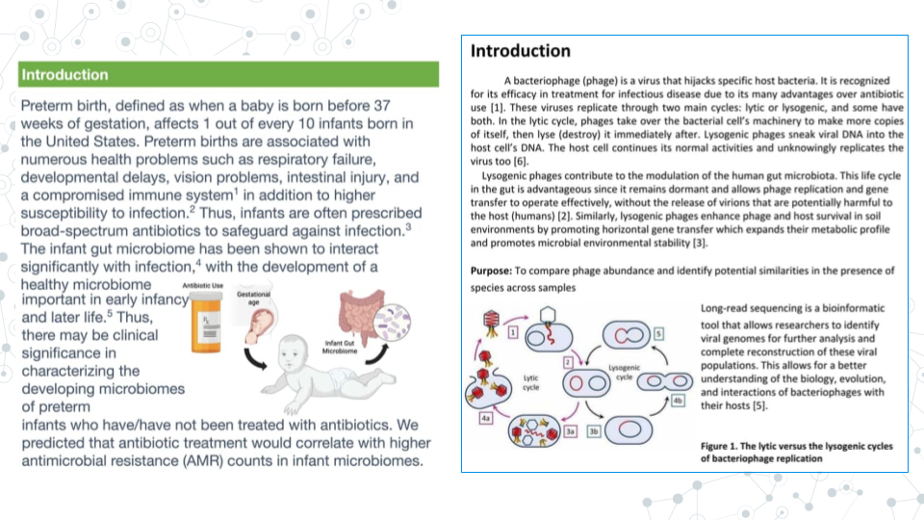
An introduction typically appears immediately after the Abstract section, and while abstract is very brief and consise, Introduction provides more context and background information to your research. Indeed, the main goal of the Introduction is to clearly elaborate on relevant background information and provide context for research gap and hypothesis.
Overall, the Introduction is longer than the Abstract, heavier on providing research context and background, and leaner on result summary and conclusions..
- Sometimes, you will se an Introduction section used instead of the Abstract + Introduction sections, in which case, the Introduction will contain both, abstract information plus additional background information, such as this published PacBio’s abstract on ‘Genome-resolved metagenome assembly of human oral microbiome using highly accurate long-read sequencing’.
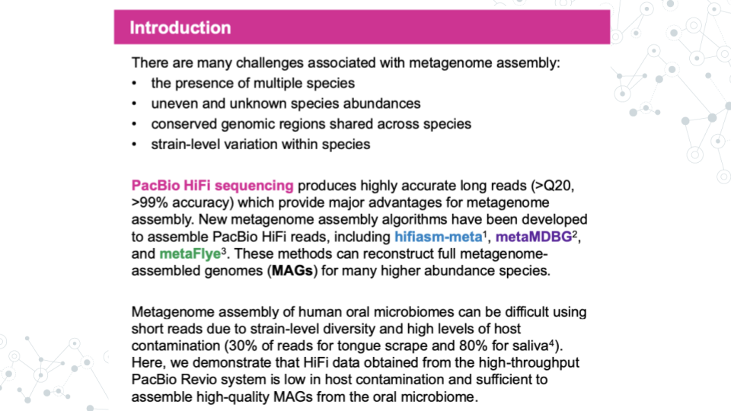

8.1.3.4 Materials and Methods
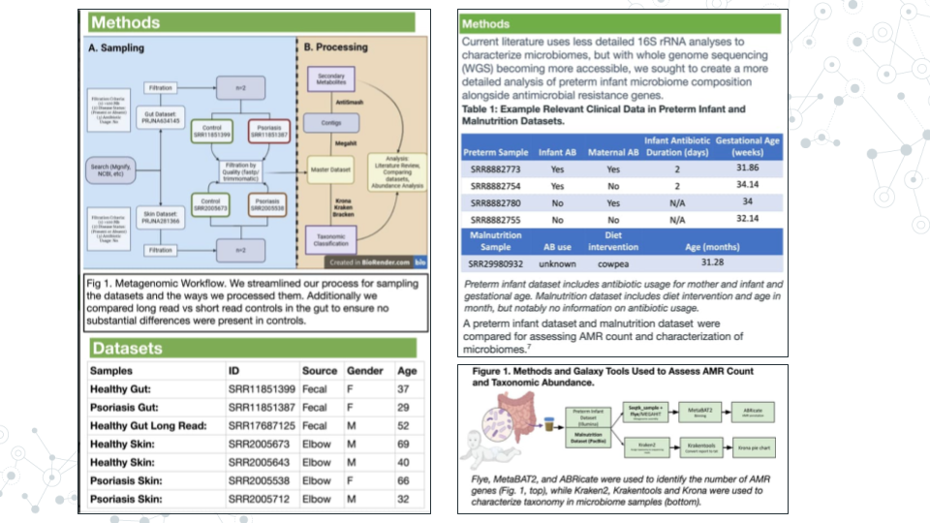
The materials and methods section will detail your analysis of the data. Don’t provide any of your results, just the methods. If you did not generate the data yourself from raw samples, you will simply cite the paper that made them instead of detailing their construction. We will also need to list any programs we used and provide credit to their creators.
Some other things you might include would be what type of analysis you decided to do (which parts of the body parts you analyzed, sets of genes, what p-value you used, etc.).

8.1.3.5 Results
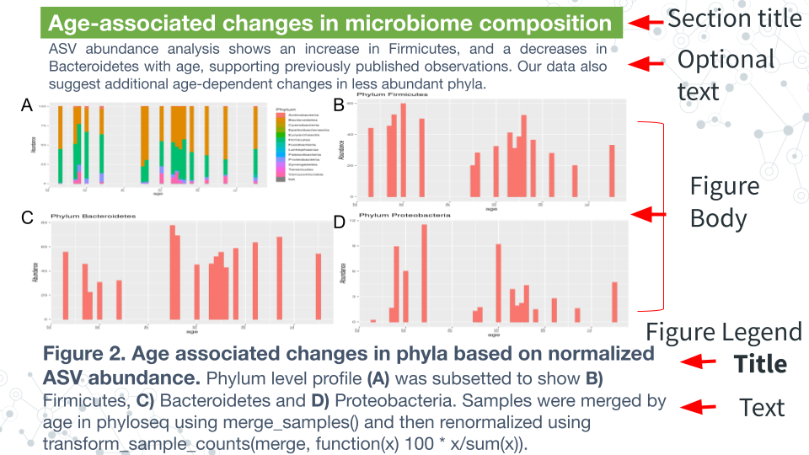
The Results section is where you will detail your data primarily through figures and tables, though sometimes written text is included. Begin by creating your tables and figures.
Figure body:
- Has high resolution images, well spaced and labeled parts and text.
- Place the figures and tables in order of how you want to present them and name them such as Figure 1, Figure 2, Table 1, Table 2, etc.
Figure Legend:
- Figures have their legends underneath them. Tables may have their legends also above them.
- The legend should be in a smaller font than the main text on the poster.
- A legend should includes a figure title, which is a declarative statement that summarizes findings.
- A legend also includes figure text which a) identifies (and can briefly describe parts), b) includes brief description of of methods necessary to understand figure and c) should include relevant statistics (stats).
Optional components
- Figures and Tables can have additional (optional) text. E.g.an optional text can describe the findings of the figure upfront to engage.
- A Section Title/Header which summarizes section or figure in a manner that is broader than figure legend title - an attention grabber.
- Bullet pointed text that summarizes the main findings of the figures/tables.

8.1.3.6 Conclusions/Discussion
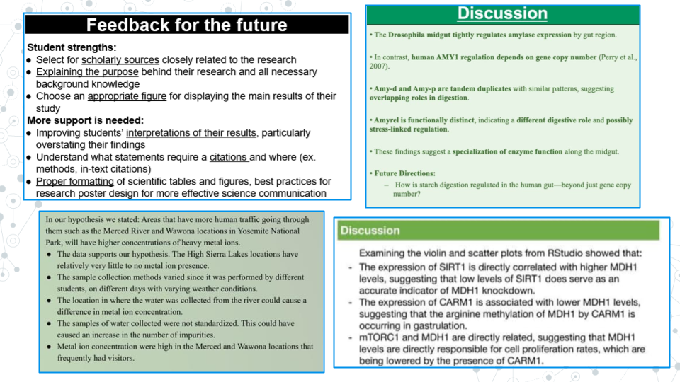
The discussion section of the paper is your chance to analyze and interpret your results. The discussion section generally addresses the following:
- What do your results mean?
- How do they fit into the bigger picture?
- If any experiments did not give expected results, hypothesize why that might have been the case and propose alternate experiments that could confirm or clarify your results.
- Include at least one sentence of future work that you would do if you had more time or what students in upcoming semesters could do to continue to answer your questions.

8.1.3.7 References
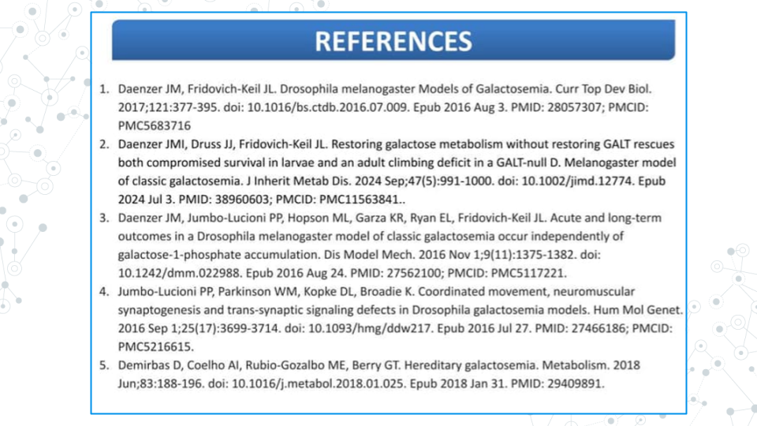
All the references that you cite on your poster must be present in a References section including the following sections: Introduction, Methods, and Discussion. To save space on our posters, we will number our references (ex. 1-5) and use the numbers as citations throughout the text of your poster. You may have a lot of references; it is okay to put them in tiny text if you have to in order to make them fit.
There are many different ways to format the reference section. We will make ours in alphabetical order by the first author’s last name. All of your sources must be scientific journals and should use the following format:
Authors (year) “Title.” Journal Name, vol. #, page #s, DOI
Online article that is also in print:
Haussecker D., Huang Y., Lau A., Parameswaran P., Fire A. Z. and M. A. Kay (2010) “Human tRNA-derived small RNAs in the global regulation of RNA silencing.” RNA, Vol. 16, page 637-695, doi:10.1261/rna.2000810
Online article only:
Marianes, A. and A. C. Spradling (2013) “Physiological and stem cell compartmentalization within the Drosophila midgut.” eLife, doi:10.7554/eLife.00886

8.1.3.8 Acknowledgements
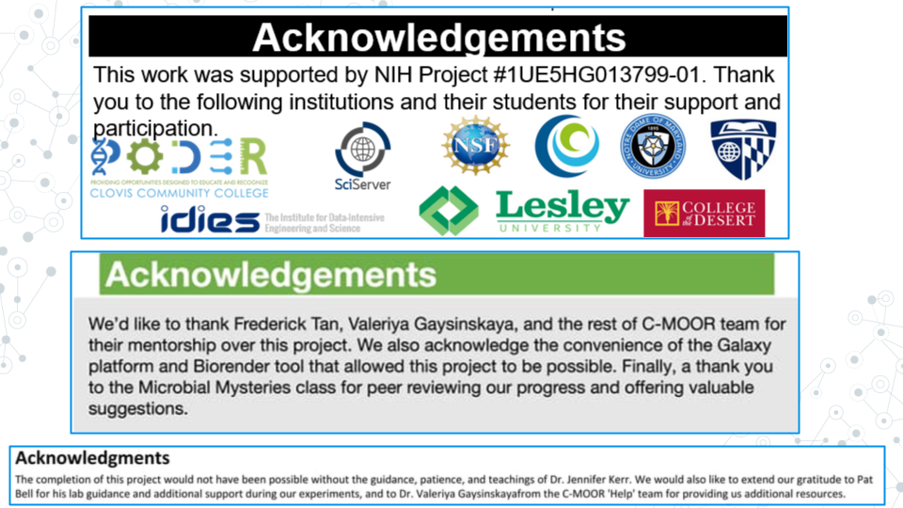
The acknowledgements section is where you give thanks to the people, organizations, and institutions that have supported you in your research. If relevant, include the grant ID # of your funding source. Institutions and organizations that have contributed to your research - but you do not belong to - can be thanked here.

8.1.4 Part 3 - Proofread and Add Final Touches
Estimated time: 30 min to an hour
- Each group member should re-read the poster from beginning to end and fix any typos or grammatical errors.
- Check the alignment of figures, text boxes, titles, etc.
- Add some finishing touches. You can play with the color, the font, add additional images if it’s relevant.

8.1.5 Part 4 - Canvas Discussion
Estimated time: 30 min
You will turn in your poster to be graded as a group in a Canvas Assignment and post it to a Canvas Discussion to be viewed by the class.
- Convert your poster to a pdf.
- Have one member of your group turn in the pdf of your poster to the Graded Canvas Assignment. This assignment is already set up so that if one group member turns it in, it will show as submitted for all students in the group. This is where your instructor will grade you poster as a group.
- Have one member of your group post a pdf of your poster in the Canvas C-MOOR Poster Discussion.
  - With your poster, introduce your group members and copy and paste your abstract into the post.
  - Insert your pdf into the post and edit the link so that it automatically shows the inline preview. This will make it easier for students to view your poster.
- As an individual, read through the other posters from different groups.
- Post comments

8.1.5.1 Grading Criteria
Your instructor will provide for you a rubric specific to your class. Refer to the rubric as your build your poster to make sure you have all the neccessary components.

8.1.5.2 Footnotes
Resources
- [Google Doc]
- Generic rubric
References
- Abstract vs. Introduction
- [Preparing and presenting effective research posters] (https://onlinelibrary.wiley.com/doi/10.1111/j.1475-6773.2006.00588.x)
Contributions and Affiliations
- Stephanie R. Coffman, Clovis Community College
- Valeriya Gaysinskaya, Johns Hopkins University
- Frederick Tan, Johns Hopkins University
- Sayumi York, Notre Dame of Maryland University
Last Revised: August 2025
## Warning: Chunk option fig.align is not supported for docx output
## Warning: Chunk option fig.alt is not supported for docx output
## Warning: Chunk option fig.align is not supported for docx output
## Warning: Chunk option fig.alt is not supported for docx output
## Warning: Chunk option fig.align is not supported for docx output
## Warning: Chunk option fig.alt is not supported for docx output
## Warning: Chunk option fig.align is not supported for docx output
## Warning: Chunk option fig.alt is not supported for docx output
## Warning: Chunk option fig.align is not supported for docx output
## Warning: Chunk option fig.alt is not supported for docx output
## Warning: Chunk option fig.align is not supported for docx output
## Warning: Chunk option fig.alt is not supported for docx output
## Warning: Chunk option fig.align is not supported for docx output
## Warning: Chunk option fig.alt is not supported for docx output
## Warning: Chunk option fig.align is not supported for docx output
## Warning: Chunk option fig.alt is not supported for docx output
## Warning: Chunk option fig.align is not supported for docx output
## Warning: Chunk option fig.alt is not supported for docx output
## Warning: Chunk option fig.align is not supported for docx output
## Warning: Chunk option fig.alt is not supported for docx output

8.2 Lecture - Scientific Posters
Estimated time: —

Scientific Posters

8.3 Activity - Scientific Posters

8.3.1 Activity
Estimated time: —

8.3.1.1 Instructions
- Review Presentations Guidelines for Posters
- Skim three posters from among the following (must be Biology if from UMBC Posters)
- Look at This! Category on the Academy Discussion Forum
- UMBC Biology Posters
- The example PacBio Poster
- Pick one poster and address the following points.
- Notice – What about this poster most interests you?
- Wonder – Two or three questions you would ask the authors.
- Support – Two or three suggestions on how the poster could be improved.

8.3.2 Grading Criteria
Comment on your class’ LMS (Blackboard, Canvas, Google Classroom) discussion board or refer to your instructor’s choice.

8.3.3 Footnotes
Contributions and Affiliations
- Valeriya Gaysinskaya, Johns Hopkins University
- Frederick Tan, Johns Hopkins University
- Sayumi York, Notre Dame of Maryland University
Last Revised: January 2026

8.4 Activity - Share Your Poster

8.4.1 Introduction
It’s almost time! Prepare for your final presentation by thinking about how to describe the great work that you’ve done this semester in both written and oral form. Assume that your audience has a basic scientific background but does not know a lot about your particular field. Provide enough context to give your listener a reason to care about your project and each of the results you will describe. You have five minutes to get your story across so have a plan and practice.

8.4.1.1 Activity 1 – Share Your Poster
Estimated time: 20 min

8.4.1.2 Instructions
- Convert and/or download your poster as a .png file in full resolution. Make sure you look at the .png file and confirm the poster is high enough quality that even small text can be read.
- In Google Slides:
  - Go to File > Download > select PNG image or JPEG image.
  - Locate the downloaded file on your computer. By default, most computers will download files to the “Download” folder or the Desktop.
- In PowerPoint:
  - Enter the File tab to the top of the window, to the left of the Home tab
  - Select Save As
  - Select This PC
  - In the field underneath the file name, select the .png or .jpg format
  - Select save
  - Locate the saved file on your computer. By default, most computers will save the file in the same location as the original PowerPoint (.pptx) file.
- Have one person on behalf of the group create a New Topic on your instructor’s chosen forum below with the title of your poster as the topic title and your .png file as the contents in either the:
  - C-MOOR Academy Discussion Forum’s Look at This! category if every member of your group agrees to share your work publicly.
  - Class category on the C-MOOR Academy Discussion Forum (if applicable) to keep your work private
  - The forum or outlet of your instructor’s choice
- Have each person in the group reply to your topic using your own words answering your choice of 2 of the following 5 questions, with the question included as part of the post. Your answers should be specific and refer directly to your research poster:
  - What was your favorite part about doing the research project and why?
  - What was something about your project or the research process that surprised you and why?
  - What is one specific skill in biology and/or research that you learned through this project? Give an example how you used this in your project.
  - What is an example of a challenge that you had to overcome during this research project?
  - What is one thing you learned from this project that you can take forward in your future work? How do you see it being helpful in your chosen field?

8.4.1.3 Questions
1. A copy of your written answers here:

2. Provide the URL of your Discussion Forum post (if applicable)

8.4.2 Activity 2 – Present Your Poster
Estimated time: 40 min

8.4.2.1 Instructions
- Create a plan for a 5 min presentation taking into consideration:
  - Who will speak when
  - What each person will cover
- Practice your presentation
  - In your group
  - To the class

8.4.2.2 Questions
Create a bullet point outline of who will speak what when:
Overview (question, background, hypothesis)
Approach (dataset, general methods)
Results (detailed methods, notable results)
Conclusions (summary, next steps)

8.4.3 Grading Criteria
- Submit your work on your LMS (Blackboard, Canvas, Google Classroom) or refer to your instructor’s choice.

8.4.4 Footnotes
Resources
- Google Doc
Contributions and Affiliations
- Valeriya Gaysinskaya, Johns Hopkins University
- Frederick Tan, Johns Hopkins University
- Sayumi York, Notre Dame of Maryland University
Last Revised: January 2026

9 Professional Development
Now that you’ve finished your C-MOOR project, how do you close out your research experience or take it further? In this section we’ll explore how to publicize and use your experience to help build your professional career.
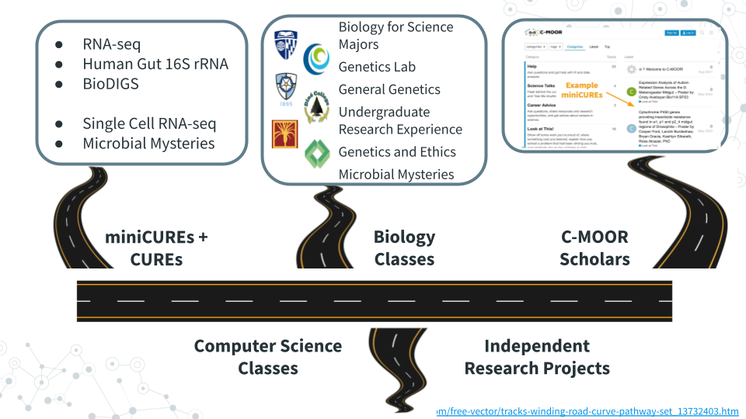

9.1 Lecture - Next Steps
Estimated time: —

Slides: Next Steps

9.2 Activity - Next Steps

9.2.1 Introduction
Congratulations on completing your research project! Take a moment and reflect on all that you’ve accomplished during this semester, especially those of you for whom this was your first research experience! Did you experience all the ups and downs of the research project from coming up with a research idea hypothesis, dealing with unexpected set-backs, and discovering something new?
We’ll wrap up here with several next steps including completing feedback to improve the next offering of this course, researching opportunities to do more science, exploring communities where scientists openly share insights, and optionally sharing more work.

9.2.2 Activity 1 – Complete Feedback
Estimated time: 15 min

9.2.2.1 Instructions
Help us improve this course! If you’re willing to have your feedback used in an official educational research survey, you will need to use a pre-authorized survey link from C-MOOR. Either way, your instructor will connect you to any feedback form.

9.2.3 Activity 2 – Research Opportunities
1. Knowing what you know now about research, what related skills are you interested in developing further and why?
Your text here:

2. REU – Which NSF Research Experiences for Undergraduates program would you attend and why?
a. Overview – https://www.nsf.gov/funding/initiatives/reu/students
b. Search – https://www.nsf.gov/funding/initiatives/reu/search
- Consider filtering by Research Area (e.g. Biology)
Your text here:

9.2.4 Activity 3 – Explore Communities
Estimated time: 15 min

9.2.4.1 Instructions
Spend a little bit of time browsing communities that discuss genomics, data analysis, and more. Paste the URLs for a couple of posts that you find interesting with a brief comment.

9.2.4.2 Questions
- Specialized Communities
- SEQanswers: the next-generation sequencing community
- https://www.seqanswers.com
- Biostars: bioinformatics explained
- https://www.biostars.org
Post URL of interest for Specialized Communities and your comments here:

- General Communities
- Reddit: The heart of the internet
- https://www.reddit.com/r/metagenomics
- Twitter/X: It’s what’s happening
- https://x.com/search?q=%23metagenomics
- Bluesky: Social media as it should be
- https://bsky.app/search?q=metagenomics
Post URL of interest for General Communities and your comments here:

9.2.5 Grading Criteria
- Download as Microsoft Word (.docx) and upload to your LMS (Blackboard, Canvas, Google Classroom) or refer to your instructor’s choice.

9.2.6 Footnotes
Resources
- Google Doc
Contributions and Affiliations
- Valeriya Gaysinskaya, Johns Hopkins University
- Frederick Tan, Johns Hopkins University
- Sayumi York, Notre Dame of Maryland Univeristy

9.3 Create your CV
Estimated time: 10 min
Everyone who completes a C-MOOR project can add their experience to their resume or CV! We advise you and your students to do this as soon as possible after the end of class while your research project is still on your mind.

9.3.0.1 Resume or CV?
You may hear the terms resume and CV being used interchangeably. While both are drawn from the same information, they vary in brevity and focus.
A resume is a one-page (sometimes two-page) document of your experiences generally used for jobs outside of academia and research labs. It’s not uncommon for people to have more than one resume, as it’s best to tailor every resume to each specific role you’re applying to.
A Curriculum Vitae (CV) is an extensive document that can take as many pages as needed to list the entirety of your research and academic experience. It often includes sections that aren’t found in non-academic fields such as publications, conferences, and published papers.
Most positions will detail which they require from applicants and most colleges and universities will be able to help you build either at your library or career center. We suggest that current students and recent graduates interested add their C-MOOR research experience to either their classwork or projects section. Remember to acknowledge the contributions of your team members if applicable; this does not count against you in your applications! Here are some examples of how you might word your experiences; notice how they’re similar to an abstract in just one or two sentences:
- An RNA-seq project: Along with a partner, examined differential expression data of the period (per) gene along the Drosophila melanogaster midgut from a published dataset (Marianes & Spradling 2013) using DESeq2 and ClusterProfiler. We discovered an elevated expression of per in the anterior region of the midgut where the primary digestion and absorption of carbohydrates occur. Our results were presented as a research poster at the 2025 Kuntz Research Day symposium and have implications for using Drosophila as a model for the connection between the circadian rhythm and metabolic disorders.
- A 16S project: My group and I profiled the abundance of Archean ASVs in the gut microbiome from a published 16S study comparing the gut microbiota of people before, during, and after a standardized diet (Guthrie et al. 2022). As a part of this study, we created a PCoA and performed an alpha diversity analysis in phyloseq. Archean community members are often overlooked in microbiome studies; we found differential abundance in Methanobacteria between male and female participants regardless of diet and hypothesize this may be due to consumption of fiber reported by male subjects pre- and post-diet.
- A WGS project: Public data (SRA#######) from Robinson et al. (2021) was analyzed in Galaxy using Trimmomatic, Megahit, and Krona to determine the viral abundance in samples from tap water from various North American Lakes and make comparisons to lake depth. Viral abundance was correlated with geographic distance between samples; future studies could examine if this pattern persists in samples sourced from Europe and Oceana.
Your blurb is a strong blurb when:
- ☐ You credit the source of your data (Citation, SRA #, Project #)
- ☐ You describe why your research project matters
- ☐ You list some of the computational platforms or software you used
Q: Will people think I am an expert in genomics and bioinformatics if I put my project on my resume/CV? I don’t want to look like a phony.
A: As a current student or new graduate, you are not expected to have mastery over any scientific domain. What you are trying to show is you have taken an idea and brought it to completion, your ability to learn new concepts and skills, and your previous exposure to research. You can explain more about your role in the project in an interview.
Q: Can I list things like R or Galaxy in my skills section?
A: You can, however we suggest being explicit in your experience and add the level at which you feel comfortable with each respective platform. Are you R (Beginner) or R (Proficient)? Can you teach someone else how to do your project? Can you perform your project with novel data? How good are you at troubleshooting? This answer may seem contrary to the previous one, but remember that other people who are listing these platforms in their skills section includes computer/data scientists (majors) and bioinformaticians (majors), so people may assume mastery. Think about it the same way you would a foreign language. Spanish (Beginner) describes a different level of skill than ‘just’ Spanish.

10 C-MOOR Scholars

10.1 C-MOOR Scholars

C-MOOR Scholars are research clubs that function as an extension of the C-MOOR curriculum. You can explore techniques and concepts from modules you’ve yet to take to learn about different approaches we can use to explore different questions through genomics, connect with other scholars and mentors, and experience the climate of a research lab.
Fill out our C-MOOR Scholars Interest Form if interested, and meet some C-MOOR Scholars at Clovis Community College!
What C-MOOR Scholars is:
- A place to grow your skills
- A place to network
- A place to connect science with the greater community
What C-MOOR Scholars is not:
- A commitment to pursuing research as a career
- A graded class where we score work
- A drop-in drop-out popular science club
Less formal than a class, more formal than just a gathering of like-minded minds, C-MOOR Scholars provides structure for your growth as a scientist. We are actively looking to recruit new scholars for chapters at our established sites (CCC, JHU, & NDMU); speak with your instructor for more information or reach out to us at the C-MOOR Academy Discussion Forum to hear about any remote opportunities we have.

10.1.1 C-MOOR Scholars links
Share your interests via C-MOOR Scholars Interest Form and learn how C-MOOR community can support you.
- C-MOOR Scholars Interest Form
Meet some of the C-MOOR Scholars and learn how you can support them
- C-MOOR Scholars at CCC

10.2 Pursue further research
Perhaps you’re interested in pursuing research beyond what C-MOOR currently provides. Maybe you’re more interested in wet lab work, or a specific model organism. We encourage you to try all sorts of different opportunities even if you feel totally comfortable working with C-MOOR so you can better understand what kind of roles suit you best. This section serves as a guide for some common jumping off points to find outside research opportunities.
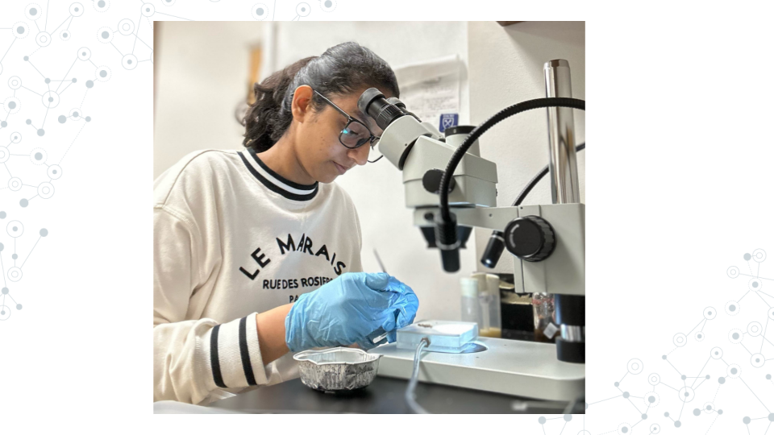

10.2.1 Research opportunities at your institution
Many colleges and universities have research programs for their students or resources available to connect you to some. You can ask your instructor, adviser, or library for more information. Some popular programs include:
- Undergraduate Research Opportunity Programs (UROP): Which often provide a database or pipeline of research opportunities for students at the univeristy or from surrounding areas.
- Research experiences for undergraduates (REU): Similar to UROP, but generally open for a wider audience of students from outside the community. See the NSF REU website for more information.
Opportunities come and go and often follow the academic-year in terms of availability. If you can’t find something immediately, keep trying!

10.2.2 Find a research lab to join
You can choose to pursue additional research opportunities in what we consider the more traditional way: by reaching out to a professor or research scientist whose work you are interested in and asking if they might be willing to have you in their lab. As these opportunities are at the discretion of the lab leader they will vary widely in their scope, duration, and ability to provide financial support.
An email to a potential research lab should contain:
- ☐ An introduction about yourself (name, class year, institution, major)
- ☐ 1-2 sentences about your previous experience in research
- ☐ 1-2 sentences about why you’re interested in their lab specifically
- ☐ A polite, open ended request to work with them
Dear Professor Penguin,
My name is Student, and I am a junior at My University majoring in biology (or other). I read your chapter on the genetics yellow-eyed penguins in Penguins: Natural history and conservation, and then checked out your profile on the University website. My interests are broadly defined in environmental toxicology and I am interested in the work you are doing using eDNA and studies on the effects of plastic on developing penguin transcriptomes.
I previously completed a project as a part of an RNA-seq miniCURE and have some exposure to working with DESeq2, though I still have much to learn. My group and I profiled the gene expression of the genes XYZ in the Drosophila midugt and I presented our poster at our university’s research day poster session.
Thank you for your time and consideration in reading my email. Please let me know if you are currently available to mentor an undergraduate in your lab and if you would be willing to have me as a potential student. I hope to hear from you soon!
Don’t be surprised if it takes the researcher a while to get back to you or if they respond curtly. They likely get many requests and are very busy. Continue to reach out to labs and apply to programs; it is difficult to know when opportunities are available as funding fluctuates.

10.3 BioDIGS
This section is primarily geared toward instructors as students will be able to get access to the BioDIGS data through their local C-MOOR Scholars chapter.
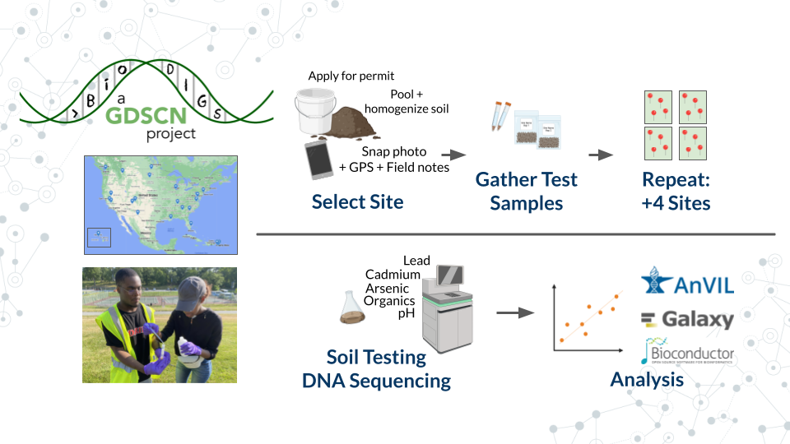
What is BioDIGS?: BioDIGS is a project from the Genomic Data Science Community Network (GDSCN), which aims to characterize the microbiome of soil throughout sites in the US while connecting scientists to research.
What makes BioDIGS different?: Soil is hypothesized to be the most diverse system on our planet, and BioDIGS is gathering sequence data and matching environmental data to elucidate the connection of soil microbes to abiotic variables and human health. Students at participating sites can take the entire project from soil sampling all the way through computational analysis. Curricula and more information on how to get a soil sampling kit are available on the BioDIGS website.

11 Online Community
The genomic data science community is a remarkably open community that continually strives to increase opportunitites and broaden access to the scientific enterprise (e.g. GDSCN 2022). There are many opportunities to interact online with scientists that share a common research question, career stage, or even favorite tool! Below is a sampling of some discussion forums that you may find useful:
- C-MOOR Academy Discussion Forum for help with and example miniCUREs
- Galaxy forum for all things Galaxy
- Bioconductor forum for all things R/Bioconductor
- AnVIL forum for all things related to the cloud computing platform, AnVIL
- BioDIGS for interactions with the GDSCN BioDIGS consortium
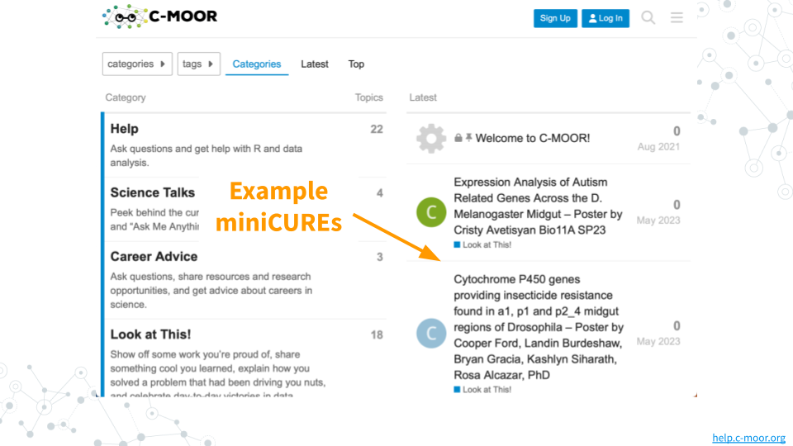
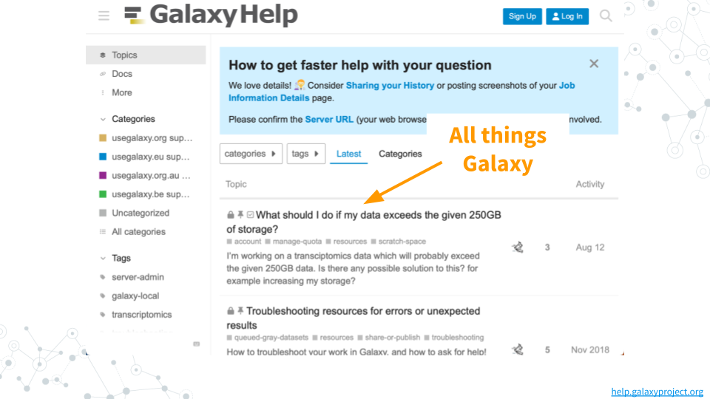
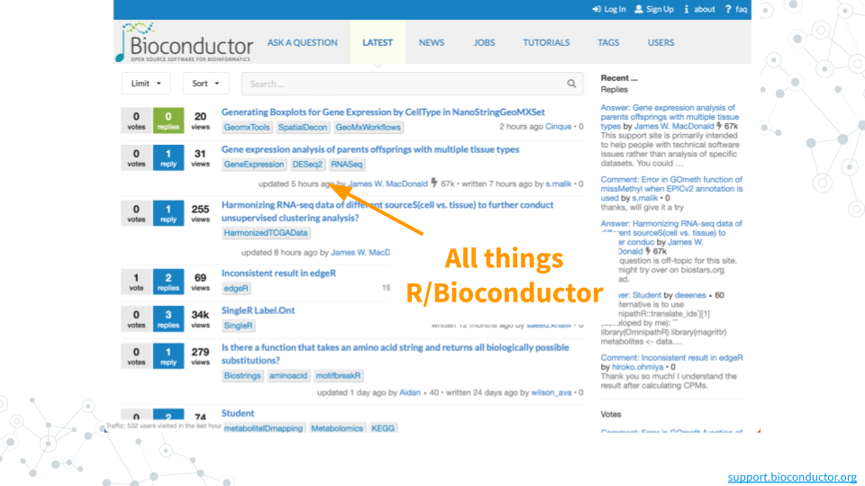
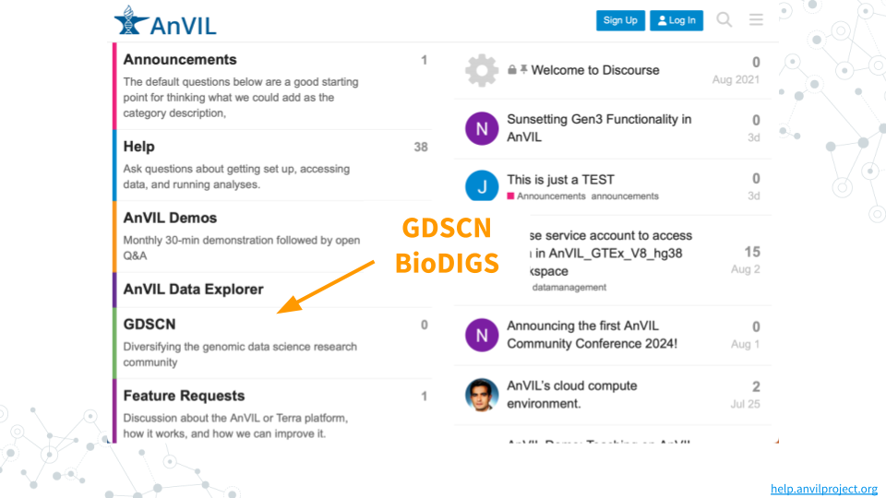
## Warning: Chunk option fig.align is not supported for docx output
## Warning: Chunk option fig.alt is not supported for docx output
## Warning: Chunk option fig.align is not supported for docx output
## Warning: Chunk option fig.alt is not supported for docx output
## Warning: Chunk option fig.align is not supported for docx output
## Warning: Chunk option fig.alt is not supported for docx output
## Warning: Chunk option fig.align is not supported for docx output
## Warning: Chunk option fig.alt is not supported for docx output
## Warning: Chunk option fig.align is not supported for docx output
## Warning: Chunk option fig.alt is not supported for docx output
## Warning: Chunk option fig.align is not supported for docx output
## Warning: Chunk option fig.alt is not supported for docx output
## Warning: Chunk option fig.align is not supported for docx output
## Warning: Chunk option fig.alt is not supported for docx output

12 Spreadsheets 101
Spreadsheets are tables that organize data using rows and columns. Spreadsheets are used in nearly every field of study and in personal life. The two most popular spreadsheet programs are Google Sheets and Microsoft Excel. While they can do approximately the same things, the exact steps to perform analyses are slightly different. To keep things standardized between students we ask all students to use Google Sheets, which is also free for users with a Gmail account.
This section will cover some of the basic functions of Google Sheets.

12.0.0.1 Right clicking?
A traditional mouse has a left button, a right button, and sometimes a center button. Typically, you click with the left button. Right clicking refers to clicking with the right button.
Modern laptops and tablets have translated this feature in different ways. If you’re not using a mouse or find that clicking with the right or right-bottom corner of the trackpad doesn’t work, try the following:
- Right click by holding Ctrl and left-clicking
- Tapping with two fingers as opposed to one

12.0.1 Getting a copy of the spreadsheet
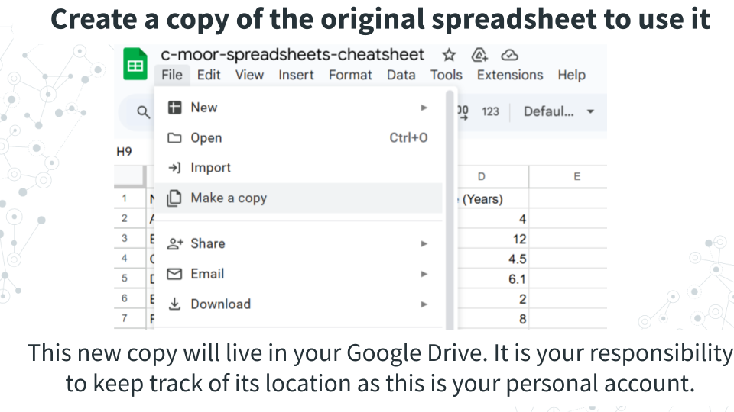
Spreadsheets are featured in some of our C-MOOR curricula. We keep an original copy of the spreadsheet that can’t be edited by students and ask users to create a new copy to do their calculations in.
You will need to make a copy of the original spreadsheet in order to interact with it. To do so, in the top left corner of the window, under the name of the spreadsheet and to the right of the spreadsheet icon, click File > Make a copy. This new copy is yours to keep track of in your Google Drive.

12.0.2 Basic spreadsheet terms
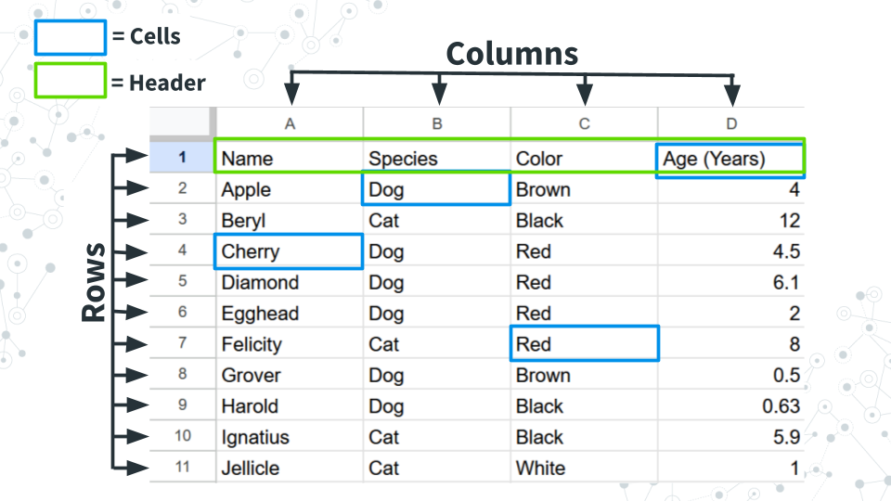
Columns: Refers to the vertical groupings of data types and called by a letter (ex. Column A, B, C, and D.
Rows: Refers to the horizontal grouping of data types and called by a number (ex. Row 1, 2, 3…). In this example data, each row refers to a pet.
Cells: Refer to the intersection between a given row and column and can be called by a combination of their column and row. Example: B2 refers to the intersection of column B, row 2 (which contains “Dog”).
Header: Used to refer to the first row, which contains metadata or describes the data in each column.

12.0.3 Summary statistics by row or column
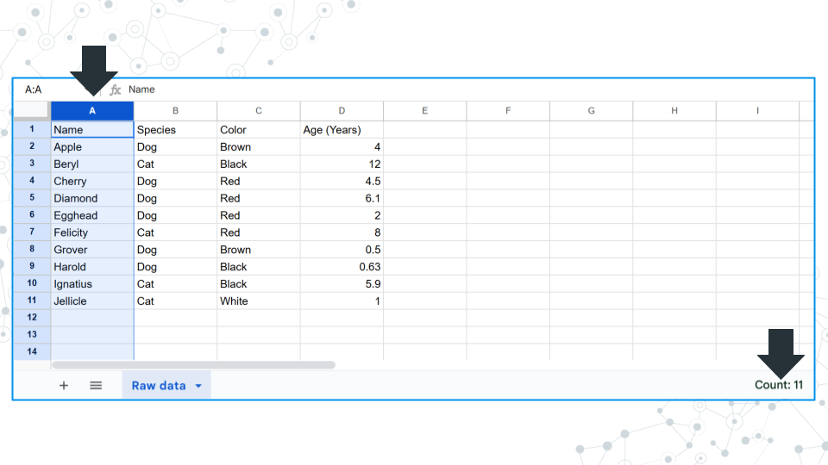
Clicking on a column or row gives you the count of how many filled in cells there are in the bottom right area of the window. Notice how there are 11 cells filled and reported but only 10 of them contain real data. Cell A1 contains “Name”, which is a label for what kind of data is stored, but not data itself. Keep this in mind when answering questions about count.
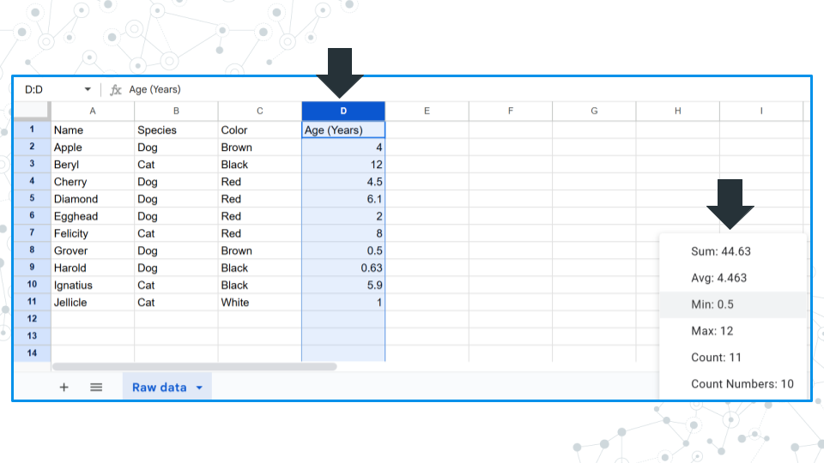
If numerical data is detected, you can click on the field in the bottom right corner and toggle it to display the sum, average, minimum, maximum, count value, and count value only including numbers.

12.0.4 Adding data to cells
To add data to a cell, click on the cell and enter your data. Confirm the entry with the “Enter” or “Return” key on your keyboard or by clicking or moving to another cell with the arrow keys.
Notice: Above the columns there is a field where you can see what is in a selected cell.
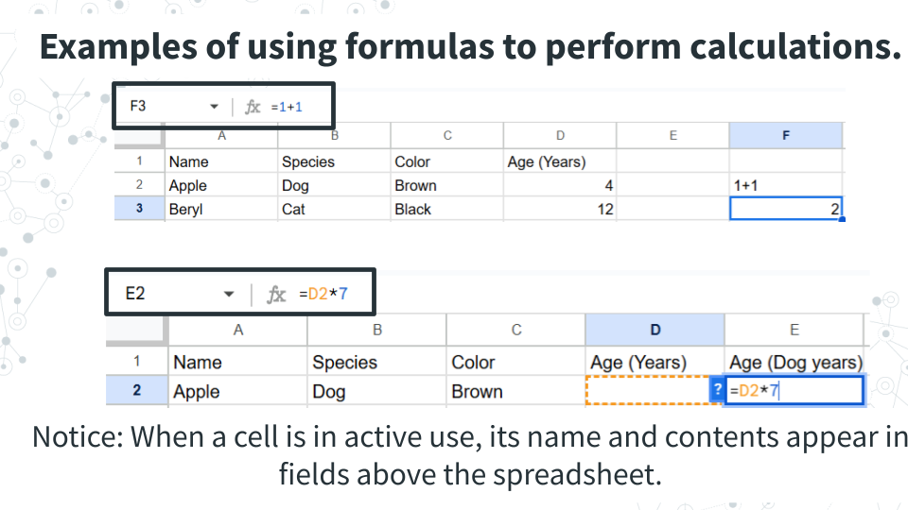
To add calculations to a cell, use the = sign. Spreadsheet software will treat any cell with an = sign as a calculation, and it will treat any cell without an = sign as text. To do this, compare what happens when you have cells with the following.
- 1+1
- = 1+1
1+1 will remain at 1+1, where as = 1+1 will cause the cell to calculate 2. We can see the original calculation we put into the cell above the columns. Calculations only work for numerical values. Cells with invalid calculations will cause a pop-up to warn you the cell is invalid.
To add calculations based on cell values, the formula must contain the specific cell. We can manually type out the combination of column and row that refers to a cell (ex. D2, or:
- Type = into a cell
- Click on the cell you want to use in a calculation
- Complete the calculation formula.
Notice: The cell used has colored borders matching the formula. You can interact with these borders to select different cells and find what is currently selected.

12.0.5 Applying a calculation to many cells
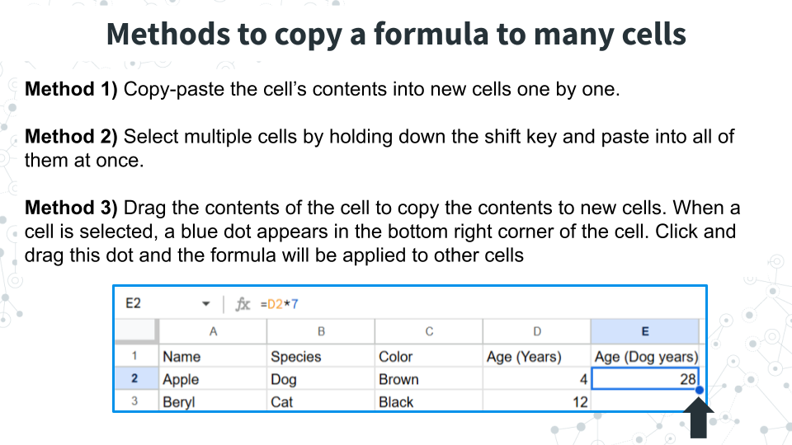
To use the calculation multiple times, we can do the following, all of which will copy the formula and carry down the selected cells so you don’t have to reselect the cells used for new rows and columns. Try the following below to see what we mean.
Method 1) Copy-paste the cell’s contents into new cells one by one. You can copy the cell with Ctrl+C or right clicking the cell and selecting copy. You can paste the calculation formula into new cells with Ctrl+V or right clicking the new cell and selecting paste.
Method 2) Paste into multiple cells at one time. If you have a calculation that needs to be applied many times, it can be inconvenient to paste a copied formula over and over. In this case, select multiple cells by holding down the shift key and paste into all of them at once.
Method 3) Drag the contents of the cell to copy the contents to new cells. When a cell is selected, a blue dot appears in the bottom right corner of the cell. Click and drag this dot and the formula will be applied to other cells

12.0.6 Manipulating the spreadsheet
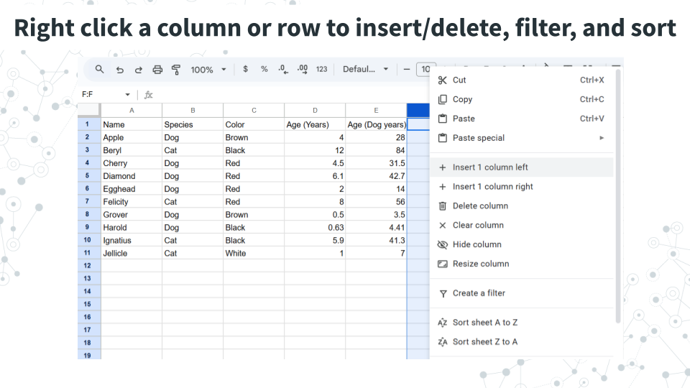
Right clicking a column or row brings up a menu with options for adding or deleting columns/rows, filtering data, or sorting the spreadsheet.
Add or delete columns/rows: Insert or delete a column or row.
Filtering data: Filter data so that only rows that have a specific value are shown. In the above example, you could filter by species and retain only rows (pets) that are dogs.
Sort the spreadsheet: Sort the spreadsheet based on the values in the selected column (does not work for rows): alphabetically (A to Z), reverse alphabetically Z to A), lowest to highest (A to Z), highest to lowest (Z to A).

12.0.7 Useful formulas in Google Sheets
Calculation | Formula
Sum | =sum(CELLS)
Average (Mean) | =average(CELLS)
Median | =median(CELLS)
Maximum | =max(CELLS)
Minimum | =min(CELLS)
Count cells that meet a certain condition | = COUNTIF(CELLS, “condition, where if true, the cell will be counted”)
Variance within a sample | =var.s(CELLS)

12.0.7.1 On variance
Variance is a measure of how spread out or consistent a dataset is, and is similar in concept to the standard deviation of a dataset (although there are differences in how they are calculated). For both variance and standard deviation there are alternate formulas for datasets that comprise a sample - var.s (which is used above), and for datasets that comprise entire populations (var.p). We use the population version when our dataset encompasses the entire population that we are interested in. Make sure you select the right formula for the right question! The majority of times, var.s will be more appropriate. If you’re not sure what to use, ask your instructor.
## Warning: Chunk option fig.align is not supported for docx output
## Warning: Chunk option fig.alt is not supported for docx output
## Warning: Chunk option fig.align is not supported for docx output
## Warning: Chunk option fig.alt is not supported for docx output
## Warning: Chunk option fig.align is not supported for docx output
## Warning: Chunk option fig.alt is not supported for docx output
## Warning: Chunk option fig.align is not supported for docx output
## Warning: Chunk option fig.alt is not supported for docx output

13 Figure and tables guide
Figures and tables are found in all forms of scientific communication: posters, papers, and presentations. The information on this page is specific to posters and papers, although a good presentation will build off the materials here.

13.0.1 Figures
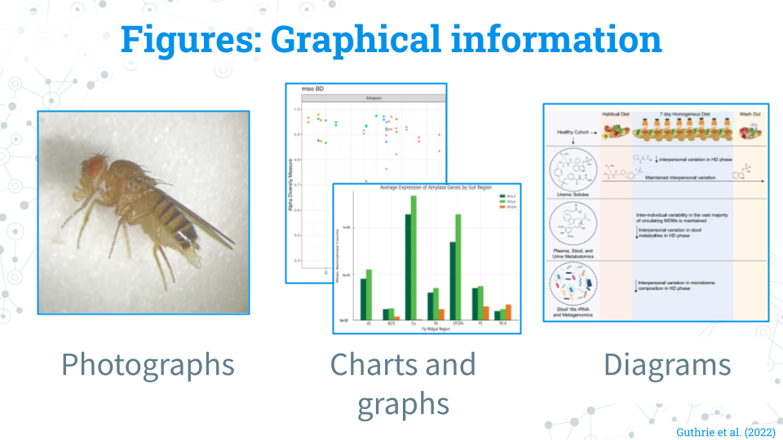
What counts as a figure: Pretty much everything that isn’t a table that contains graphical information: Photographs, charts/graphs, and diagrams (digital and traditional) all count as figures! If it’s an image, it probably belongs as a figure!
Cleaning a figure: Prepare the figure in a program like Google Slides or Powerpoint that will allow you to change the text size and fonts; you can do this with a creative use of cropping and text boxes with a solid white background. Add notes and adjustments where they would make the figure more easily understandable (ex. ordering samples by group and labeling their groups). The most important thing is that your figure is at a high enough quality and resolution that the pictures and text are not blurry!
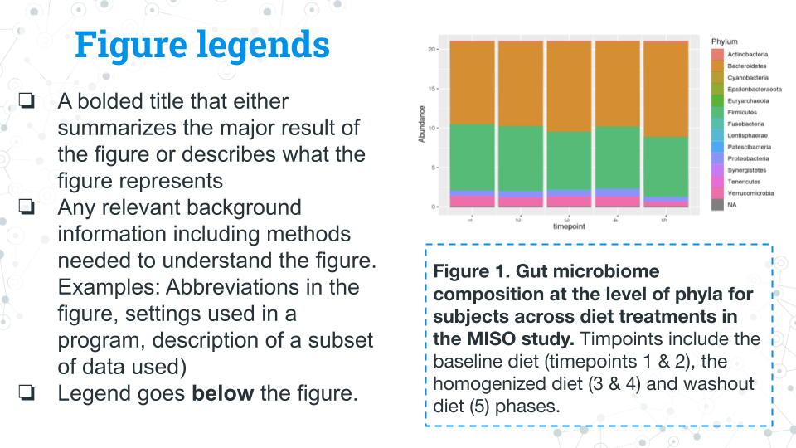
Figure legends: Figure legends (also interchangably called figure captions) go underneath their figures. Figure legends should include the following (feel free to ask your peers or instructor to review your legends): - A comprehensive title in bold that describes what the figure is about or the methods used to make the figure - Text describing the main takeaway from the figure - Text describing the methods used to generate the figure if needed - Text detailing any other background information or methodology needed to understand the figure (ex. abbreviations, settings of a program, description of subsetted data) - The legend/caption goes below the figure
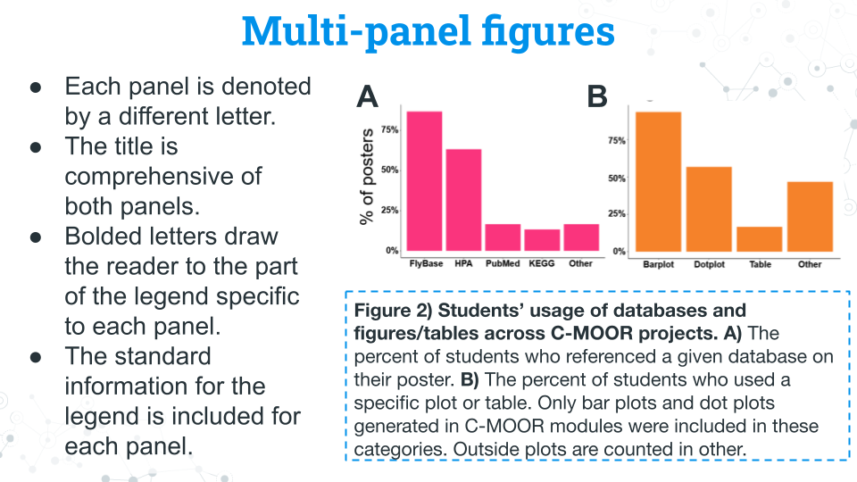
Multi-panel figures: You may encounter or want to make a figure with multiple panels. These figures are a collection of figures that are denoted alphabetically (ex. A, B, C, D…etc.). Multi-panel figures often are used to save space or group related figures together. In most published work you will see only figures in panels; your instructor may allow or encourage you to use tables in panels for your project.
- Each panel is denoted by a different letter.
- The title is comprehensive of both panels.
- Bolded letters draw the reader to the part of the legend specific to each panel.
- The standard information for the legend is included for each panel.

13.0.2 Tables
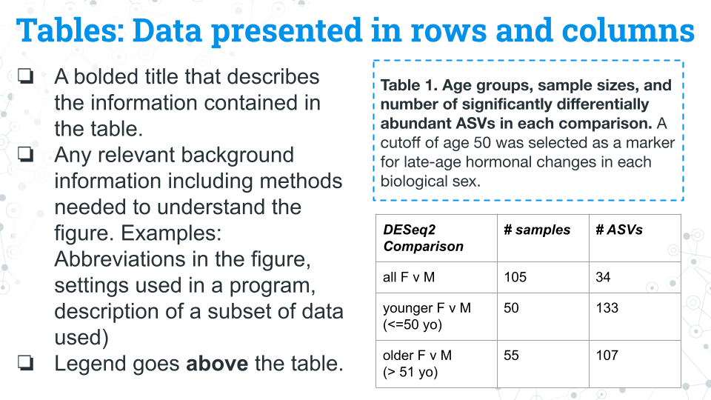
Tables contain information organized into rows and columns. Common examples of information that gets put in tables include: subject metadata (age, ethnicity, etc.) and sample sizes (how many samples of each condition) throughout the experiment. Tables generally stand alone and are not included in published multi-panel figures, though your instructor may allow or encourage you to do so for your project.
Table legends: - A title that describes the information contained in the table - Any relevant background information including methods needed to understand the table. Examples: Abbreviations in the figure, settings used in a program, description of a subset of data used) - Legend/caption goes above the table.

14 16S miniCURE Guide
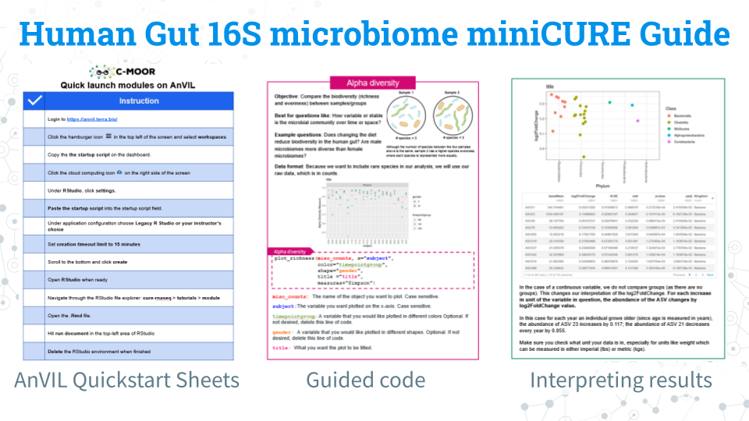
We have a comprehensive guide for this miniCURE!
This guide is a complete packet that contains an overview of the learning objectives for ecah module, instructions for accessing modules on AnVIL, highlights of content, guided code blocks, and an overview of each dataset we have available for research projects!
Download the PDF for a digital reference and print out selected sheets for use in the classroom!

14.0.1 Footnotes
Contributions and Affiliations
- Sayumi York, Notre Dame of Maryland University
Last Revised: August 2025

Appendix

15 Core Competencies
The activities in this miniCURE address several core concepts and competencies as identified by professional societies and working groups. The table below lists the relevant core concepts and competencies from the following sources:
- Vision and Change in Undergraduate Biology Education AAAS report
- Bioinformatics core competencies for undergraduate life sciences education by NIBLSE

Vision and Change
Concepts
5: SYSTEMS: Living systems are interconnected and interacting.
Competencies
1: Ability to apply the process of science
2: Ability to use quantitative reasoning
4: Ability to tap into the interdisciplinary nature of science
5: Ability to communicate and collaborate with other disciplines
6: Ability to understand the relationship between science and society
Bioinformatics
C1: Explain the role of computation and data mining in addressing hypothesis-driven and hypothesis-generating questions within the life sciences
C3: Apply statistical concepts used in bioinformatics
C4: Use bioinformatics tools to examine complex biological problems in evolution, information flow, and other important areas of biology
C5: Find, retrieve, and organize various types of biological data
C6: Explore and/or model biological interactions, networks and data integration using bioinformatics

About the Authors
These credits are based on our course contributors table guidelines.

Credits | Names
Pedagogy
Lead Content Instructor(s) | FirstName LastName
Lecturer(s) (include chapter name/link in parentheses if only for specific chapters) - make new line if more than one chapter involved | Delivered the course in some way - video or audio
Content Author(s) (include chapter name/link in parentheses if only for specific chapters) - make new line if more than one chapter involved | If any other authors besides lead instructor
Content Contributor(s) (include section name/link in parentheses) - make new line if more than one section involved | Wrote less than a chapter
Content Editor(s)/Reviewer(s) | Checked your content
Content Director(s) | Helped guide the content direction
Content Consultants (include chapter name/link in parentheses or word “General”) - make new line if more than one chapter involved | Gave high level advice on content
Acknowledgments | Gave small assistance to content but not to the level of consulting
Production
Content Publisher(s) | Helped with publishing platform
Content Publishing Reviewer(s) | Reviewed overall content and aesthetics on publishing platform
Technical
Course Publishing Engineer(s) | Helped with the code for the technical aspects related to the specific course generation
Template Publishing Engineers | Candace Savonen, Carrie Wright, Ava Hoffman
Publishing Maintenance Engineer | Candace Savonen
Technical Publishing Stylists | Carrie Wright, Ava Hoffman, Candace Savonen
Package Developers (ottrpal) Candace Savonen, John Muschelli, Carrie Wright
Art and Design
Illustrator(s) | Created graphics for the course
Figure Artist(s) | Created figures/plots for course
Videographer(s) | Filmed videos
Videography Editor(s) | Edited film
Audiographer(s) | Recorded audio
Audiography Editor(s) | Edited audio recordings
Funding
Funder(s) | Institution/individual who funded course including grant number
Funding Staff | Staff members who help with funding

## ─ Session info ───────────────────────────────────────────────────────────────
## setting value
## version R version 4.3.2 (2023-10-31)
## os Ubuntu 22.04.4 LTS
## system x86_64, linux-gnu
## ui X11
## language (EN)
## collate en_US.UTF-8
## ctype en_US.UTF-8
## tz Etc/UTC
## date 2026-09-10
## pandoc 3.1.1 @ /usr/local/bin/ (via rmarkdown)
##
## ─ Packages ───────────────────────────────────────────────────────────────────
## package * version date (UTC) lib source
## bookdown 0.46 2025-12-05 [1] CRAN (R 4.3.2)
## cachem 1.0.8 2023-05-01 [1] RSPM (R 4.3.0)
## cli 3.6.5 2025-04-23 [1] CRAN (R 4.3.2)
## devtools 2.4.5 2022-10-11 [1] RSPM (R 4.3.0)
## digest 0.6.34 2024-01-11 [1] RSPM (R 4.3.0)
## ellipsis 0.3.2 2021-04-29 [1] RSPM (R 4.3.0)
## evaluate 1.0.5 2025-08-27 [1] CRAN (R 4.3.2)
## fastmap 1.1.1 2023-02-24 [1] RSPM (R 4.3.0)
## fs 1.6.3 2023-07-20 [1] RSPM (R 4.3.0)
## glue 1.7.0 2024-01-09 [1] RSPM (R 4.3.0)
## htmltools 0.5.7 2023-11-03 [1] RSPM (R 4.3.0)
## htmlwidgets 1.6.4 2023-12-06 [1] RSPM (R 4.3.0)
## httpuv 1.6.14 2024-01-26 [1] RSPM (R 4.3.0)
## knitr 1.50 2025-03-16 [1] CRAN (R 4.3.2)
## later 1.3.2 2023-12-06 [1] RSPM (R 4.3.0)
## lifecycle 1.0.4 2023-11-07 [1] RSPM (R 4.3.0)
## magrittr 2.0.3 2022-03-30 [1] RSPM (R 4.3.0)
## memoise 2.0.1 2021-11-26 [1] RSPM (R 4.3.0)
## mime 0.12 2021-09-28 [1] RSPM (R 4.3.0)
## miniUI 0.1.1.1 2018-05-18 [1] RSPM (R 4.3.0)
## pkgbuild 1.4.3 2023-12-10 [1] RSPM (R 4.3.0)
## pkgload 1.4.1 2025-09-23 [1] CRAN (R 4.3.2)
## profvis 0.3.8 2023-05-02 [1] RSPM (R 4.3.0)
## promises 1.2.1 2023-08-10 [1] RSPM (R 4.3.0)
## purrr 1.0.2 2023-08-10 [1] RSPM (R 4.3.0)
## R6 2.6.1 2025-02-15 [1] CRAN (R 4.3.2)
## Rcpp 1.0.12 2024-01-09 [1] RSPM (R 4.3.0)
## remotes 2.4.2.1 2023-07-18 [1] RSPM (R 4.3.0)
## rlang 1.1.6 2025-04-11 [1] CRAN (R 4.3.2)
## rmarkdown 2.25 2023-09-18 [1] RSPM (R 4.3.0)
## sessioninfo 1.2.2 2021-12-06 [1] RSPM (R 4.3.0)
## shiny 1.8.0 2023-11-17 [1] RSPM (R 4.3.0)
## stringi 1.8.3 2023-12-11 [1] RSPM (R 4.3.0)
## stringr 1.5.1 2023-11-14 [1] RSPM (R 4.3.0)
## urlchecker 1.0.1 2021-11-30 [1] RSPM (R 4.3.0)
## usethis 2.2.3 2024-02-19 [1] RSPM (R 4.3.0)
## vctrs 0.6.5 2023-12-01 [1] RSPM (R 4.3.0)
## xfun 0.55 2025-12-16 [1] CRAN (R 4.3.2)
## xtable 1.8-4 2019-04-21 [1] RSPM (R 4.3.0)
## yaml 2.3.12 2025-12-10 [1] CRAN (R 4.3.2)
##
## [1] /usr/local/lib/R/site-library
## [2] /usr/local/lib/R/library
##
## ──────────────────────────────────────────────────────────────────────────────

References

