Model Organisms and Biological Databases

July 06, 2023

Table of Contents

# About this Course

## 0.1 Available course formats

# Instructor Guide

Coming soon!

# 1 Pre-lab: Model Organisms

Scientists frequently use a few specific organisms, called “**model organisms**” for their experiments. This pre-lab will introduce you to a few of the most popular model organisms and will discuss why these organisms were chosen and what they are useful for.

1. Part 1 will give a general overview of model organisms.
2. Part 2 will take a more in-depth look at a specific model organism - the fruit fly *Drosophila melanogaster*.

## 1.1 Introduction to Model Organisms

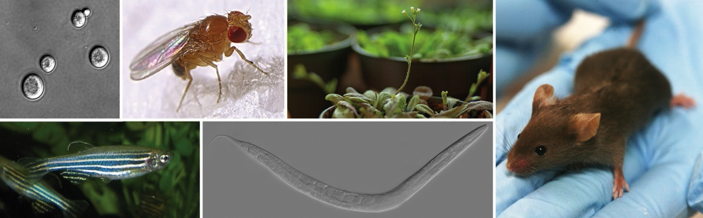

Figure : Figure 1.1: Max Westby. Some of the most important genetic model organisms in use today. Clockwise from top left: yeast, fruit fly, arabidopsis, mouse, roundworm, zebrafish. <http://cubocube.com/dashboard.php?a=1179&b=1228&c=103> License: [CC ANS 2.5](https://creativecommons.org/licenses/by-nc-sa/2.5/)

#### Learning Goals

* Explain what a “model organism” is and why they are useful
* Define **ortholog** and explain how model organisms can be used to understand human genes.
* Name 4 commonly used model organisms
* Compare and contrast the pros and cons of different model organisms

### 1.1.1 What is a model organism?

Scientists who study biology often choose to focus their work on a few specific organisms. These are called **model organisms**, because they are being used as a “model” for biological processes occurring in many species. This works because many biological processes are **conserved** - they work the same way in many different organisms.

Coordinating our experiments in the same organisms has many advantages:

* We can easily compare results and build off of each other’s work
* Tools and techniques developed in one lab can be used by many other researchers
* We build up a strong understanding of those organisms, which makes it easier to understand new results.

Besides studying basic biology, model organisms can also be useful for learning more about humans and human diseases. There are many questions we would like to answer for which we **can’t conduct human experiments**, either for ethical reasons, or just because it is too difficult.

It’s often much **faster, cheaper, and easier** to conduct experiments in model organisms. A common strategy is to start by doing many experiments in a simple organism (like yeast), and then follow up on the most promising results in more complex organisms.

#### Models of Huntington’s disease

In the following video, you will hear about how researchers are using yeast and fruit flies as model organisms to study Huntington’s disease.

### 1.1.2 What makes a good model organism?

Some of the most common model organisms are:

* Mouse (*Mus musculus*)
* Fruit fly (*Drosophila melanogaster*)
* Yeast (*Saccharomyces cerevisiae*)
* E. coli (*Escherichia coli*, a type of bacteria)

These organisms were chosen for a combination of practical and historical reasons

* They have useful properties that makes it easy to do experiments (for example, short generation times make genetic experiments easier)
* Important discoveries were made with them, and scientists continued to work with them to follow up on those discoveries

The more a model organism is studied, the more useful it becomes for future research.

* New tools and techniques are developed, so there are more options for carrying out experiments
* As we learn more about an organism, it becomes easier to interpret new results. It’s a lot easier to understand how a particular mutation might be causing problems if we already know a lot about the gene the mutation was found in.

### 1.1.3 Choosing a model organism

Obviously, the most accurate way to learn about humans is to study humans, but this is not always the best option. In fact, it can often be more efficient to conduct experiments in simpler organisms - they are smaller, easier to care for, and have shorter generation times, so we can do a lot more experiments. Then, as we come to have a better understanding of our particular question, we can investigate the nuances in more complex organisms.

Generally the more complex and more similar an organism is to a human, the more confident we can be that the results of an experiment will apply to humans as well. But, there are other important considerations:

1. **Ethical concerns**: More complex organisms require more care and consideration for their treatment. We take care to avoid causing unnecessary distress, and evaluate whether a study can be conducted effectively with less complex organisms.
2. **Expense**: More complex organisms are more expensive to care for and tend to reproduce more slowly and in smaller quantities. With limited time and resources we need to think about how to efficiently obtain the information we are seeking.
3. **Available tools and techniques**: Some organisms are easier to work with than others for particular types of experiments. Yeast are great for genetics - it’s easy to edit their genome. Fruit flies are similarly useful for genetics - they aren’t as easy as yeast, but they are the easiest multicellular model organism to work with for genetic experiments. Zebrafish embryos are transparent, so they are particularly good for microscopy experiments.

### 1.1.4 Common model organisms

#### Mouse

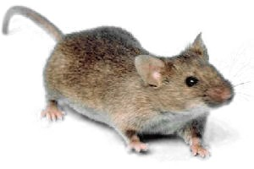

Figure : Ilmari Karonen (2006) Common house mouse (*Mus musculus*), wild type. <https://commons.wikimedia.org/wiki/File:Mouse_white_background.jpg> Public Domain

##### Genome

* ~3 billion bases in length (similar to human)
* ~25,000 genes
* **> 99% of human genes have homologs in mice**

##### Reproduction

* Generation time: ~10 weeks
* Usually 6-8 offspring per generation (range ~3-14)
* How long to get 1000 offspring? **~ 6-8 months**

#### Fruit fly

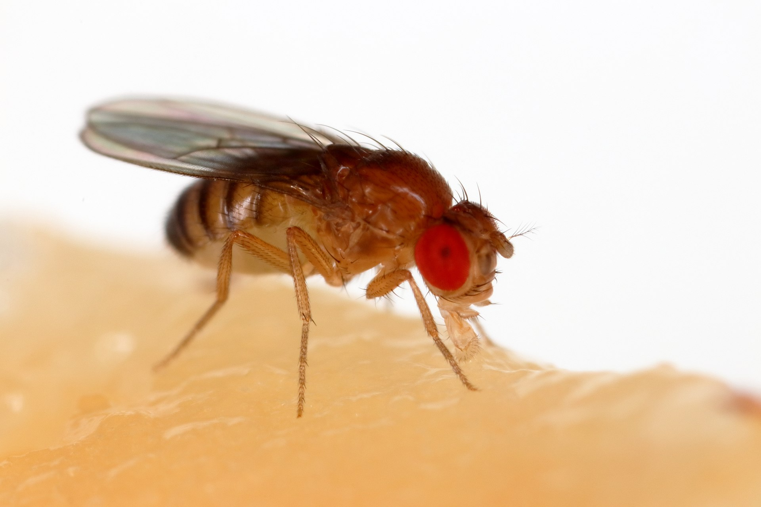

Figure : Sanjay Acharya (2017) A fruit fly (*Drosophila melanogaster*) feeding off a banana. <https://commons.wikimedia.org/wiki/File:Drosophila_melanogaster_Proboscis.jpg> License: [CC BY 4.0](https://creativecommons.org/licenses/by-sa/4.0/deed.en)

##### Genome

* ~140 million bases in length
* ~17,000 genes
* **~ 60% of human genes have orthologs in flies**

##### Reproduction

* Generation time: ~2 weeks
* Hundreds of offspring per generation
* How long to get 1000 offspring? **~ 1 month**

#### Yeast

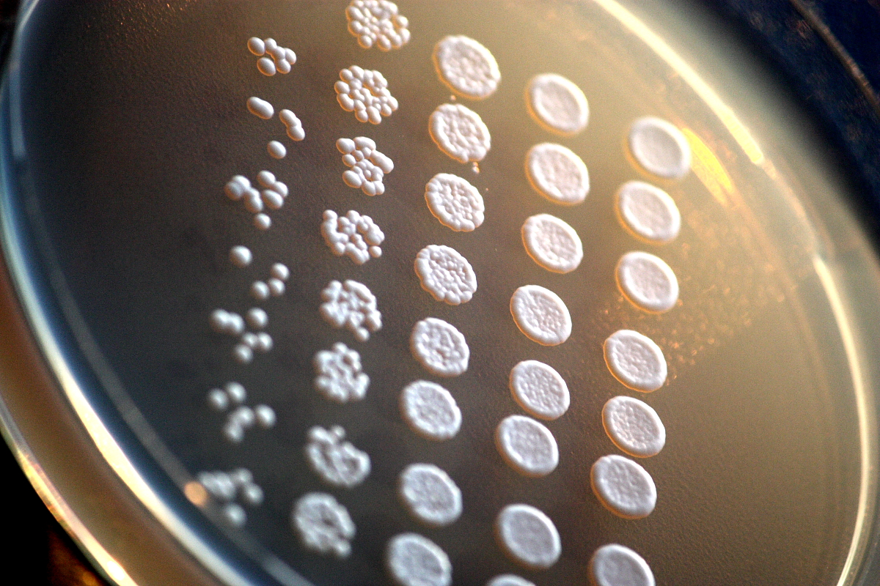

Figure : Rainis Venta (2011) Drop-inoculation of laboratory baker´s yeast (*Saccharomyces cerevisiae*) mutants on agar plate. <https://en.wikipedia.org/wiki/Saccharomyces_cerevisiae#/media/File:Laboratoorne_pagarip%C3%A4rm_(Saccharomyces_cerevisiae)_agariplaadil>..JPG License: [CC BY-SA 3.0](https://creativecommons.org/licenses/by-sa/3.0/)

##### Genome

* ~12 million bases in length
* ~6,000 genes
* **~ 23 of yeast genes have homologs in humans**

##### Reproduction

* Generation time: ~2 hours
* 1 offspring per reproduction (“budding”)
* How long to get 1000 offspring? **1 day**

#### *E. coli*

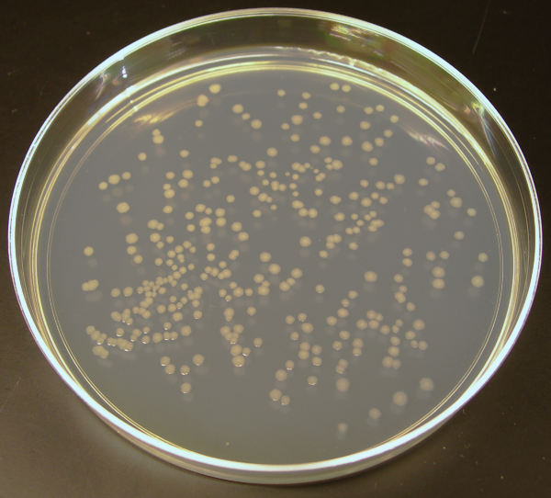

Figure : Madprime (2007) K12 *E. coli* colonies on a plate. <https://commons.wikimedia.org/wiki/File:Ecoli_colonies.png> License: [CC0 1.0 Universal Public Domain Dedication](https://creativecommons.org/publicdomain/zero/1.0/deed.en)

##### Genome

* ~5 million bases in length
* ~4,000 genes

*E. coli* are quite different from humans (much more so than yeast - yeast are still eukaryotes like humans, but *E. coli* are bacteria). *E. coli* aren’t really used to study the functions of human proteins or their orthologs in a living organism, the way yeast are. But they are very useful for mass-producing copies of a human protein if we want to study it in the lab (for example, measure the activity of an enzyme under different conditions, or try to figure out the structure of a particular protein).

##### Reproduction

* Generation time: ~20 minutes
* 1 offspring per reproduction (“binary fission”)
* How long to get 1000 offspring? **4 hours**

#### Other organisms

Many other organisms have been used as model organisms, though they are less common. They may be more difficult to work with, be less well studied, or not have as many tools and techniques available, and therefore tend to be used for particular types of experiments where they are particularly well suited. Some examples include:

* **Non-human primates** can be used when we need to get as close as possible to human biology. Primates are highly intelligent (presenting ethical concerns) are expensive to care for, and have slow generation times, so they are typically only used when there is a strong need for a closer similarity to humans than we can get with other organisms.
* **Rats** (*Rattus norvegicus*) are sometimes used as an alternative to mice. They are larger (making them more expensive to care for, but also easier to handle) and more intelligent, which can be useful for some types of experiments. For some diseases, rat models are more similar to humans than mouse models are.
* **Frogs** (*Xenopus laevis* and *Xenopus tropicalis*) eggs and oocytes are quite large and the embryos develop externally, making them relatively easy to manipulate. This makes them a good model for early vertebrate development, as well as basic cell and molecular biology.
* **Zebrafish** (*Danio rerio*) are similarly useful for studying early development, as their eggs are fertilized externally (easy to manipulate). They are particularly useful for microscopy studies, as the embryos are transparent.
* **Worms** (*Caenorhabditis elegans*) are also useful for studying development. They are transparent throughout their lives, and have small enough body plan that we can keep track of every single cell.

### 1.1.5 Summary

* Model organisms allow scientists to conduct many experiments faster, cheaper, and easier than could be done in humans.
* Model organisms allow us to conduct experiments that would be unethical or impossible in humans.
* A common strategy is to start by doing many experiments in a simple organism (like yeast), and then follow up on the most promising results in more complex organisms, including humans.
* Some of the most common model organisms are:
  + Mouse (*Mus musculus*)
  + Fruit fly (*Drosophila melanogaster*)
  + Yeast (*Saccharomyces cerevisiae*)
  + E. coli (*Escherichia coli*, a type of bacteria)

## 1.2 *Drosophila melanogaster* (fruit fly)



Figure : Figure 1.1: Sanjay Acharya (2017) A fruit fly (*Drosophila melanogaster*) feeding off a banana. <https://commons.wikimedia.org/wiki/File:Drosophila_melanogaster_Proboscis.jpg> License: [CC BY 4.0](https://creativecommons.org/licenses/by-sa/4.0/deed.en)

#### Learning Goals

* Provide 3 reasons why fruit flies are useful for scientific research
* List 3 ways in which fruit flies are similar to humans
* Compare and contrast the fruit fly genome to the human genome
* Briefly describe the fruit fly life cycle

### 1.2.1 Why fruit flies?

At first glance, fruit flies don’t look anything like humans. But at a deep level, we share many anatomical structures, physiological systems, and developmental patterns. Many *Drosophila* genes have parallels (“orthologs”) in humans that perform similar functions.

Studying fruit flies can give important insights into basic biological processes that are shared across many organisms. Discoveries made in fruit flies have made important contributions to our understanding of genetics, development, aging, immunology, and neuroscience, to name just a few. Fruit fly research is also being used to investigate many diseases, including Huntington’s disease, epilepsy, obesity, and Alzheimer’s.

The following video highlights some of the reasons fruit flies make such great model organisms, and discusses an example of how a gene first discovered studied in fruit flies turned out to have an important role in polydactyly (having extra fingers or toes) and cancer.

### 1.2.2 Meet *Drosophila melanogaster*

#### Anatomy and Physiology

Almost every organ in humans has a match in flies, and the genes that control their development and functions are often shared across species.

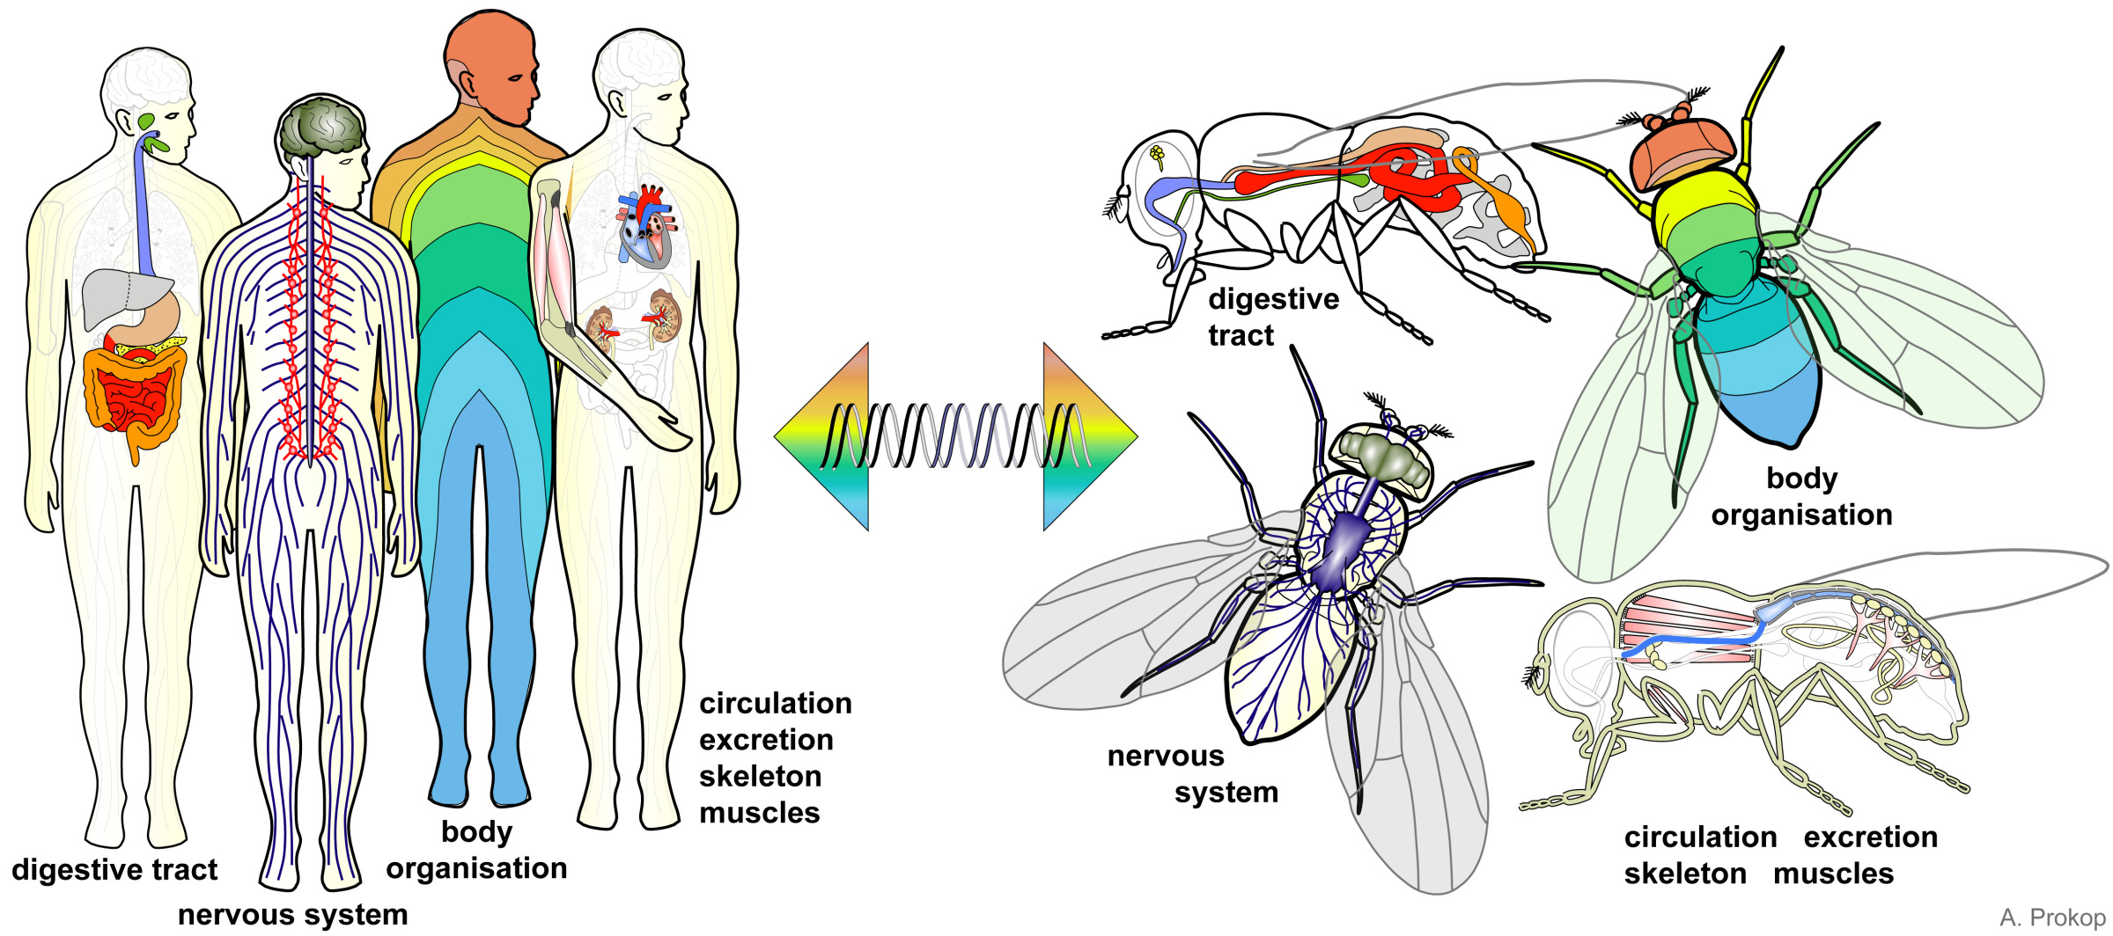

Figure : Figure 1.2: Prokop, Andreas; Patel, Sanjai (2018): Biology lessons for schools using the fruit fly Drosophila. figshare. Dataset. <https://doi.org/10.6084/m9.figshare.1352064.v31> License: [CC BY 4.0](https://creativecommons.org/licenses/by/4.0/)

* **Eyes** - While *Drosophila* eyes are quite different from humans (*Drosophila* have compound eyes), the same genes that control development of fly eyes are involved in eye development in many species including frogs, mice, and humans.
* **Nervous system** - The central nervous systems of *Drosophila* and humans have a similar subdivision into a **brain** and **spinal cord** (ventral cord in *Drosophila*). The **nerve cells** of *Drosophila* are quite similar to humans and many of the same genes are involved in their function.
* **Heart** - The structure of the *Drosophila* heart is different from a human, but they use the same mechanisms to control their heartbeats. Both human and *Drosophila* heart cells have electrical properties that allow them to operate without being stimulated by the nervous system, and they both have **pacemaker cells** to regulate their heartbeat.
* **Digestive system** - The digestive systems of *Drosophila* and humans have similar organizations with regions that perform similar functions. First is the **esophagus**, which carries food to the **crop** (stomach in humans) where it is broken down. Then the **midgut** (small intestine), and **hindgut** (large intestine) are responsible for absorbing the food so it can be used by the rest of the body.
* **Reproductive tract** - Like humans, *Drosophila* have **testes** which produce sperm and **ovaries** which produce eggs.

#### Genetics

The *Drosophila* genome:

* About 140 million bases in length
* ~17,000 genes
  + About 60 percent of all human genes have orthologs in flies (retain the same function and came from a common ancestor)
  + About 75 percent of human disease-associated genes have orthologs in flies
* 4 pairs of chromosomes:
  + 3 pairs of autosomes (non-sex chromosomes)
  + 1 pair of sex chromosomes. Like humans, females have two X chromosomes, and males have an X and a Y chromosome.

There are many genetic tools and techniques available for Drosophila; here are just a few:

* **P-element transformation** - a technique that allows researchers to insert genes in the *Drosophila* genome
* **GAL4/UAS expression** - a technique that allows researchers to control expression of a gene, “turning on” the gene in a specific tissue or under specific conditions
* **Mutation libraries** - collections of fly strains where each strain has a mutation in a different gene

#### Life Cycle

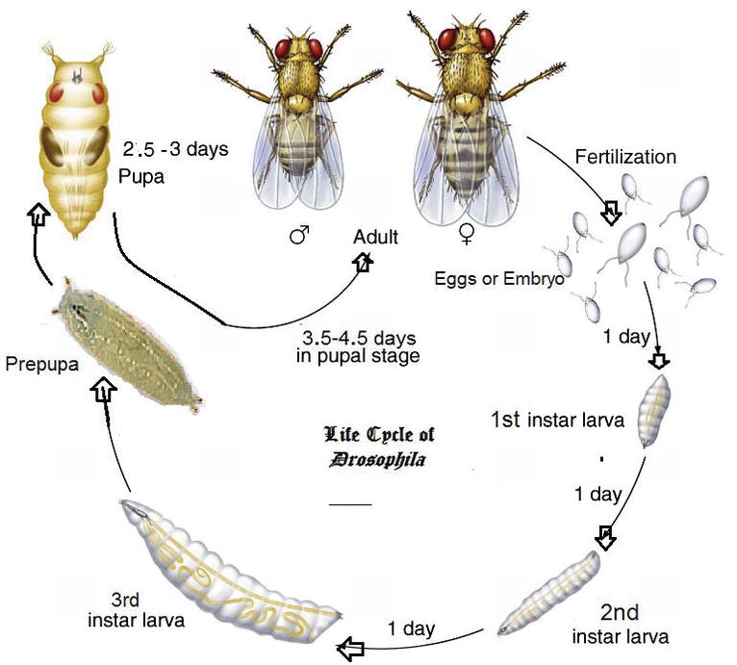

Figure : Figure 1.3: **Life‐cycle of Drosophila** from Farzana Khan Perveen (February 28th 2018). Introduction to Drosophila, Drosophila melanogaster - Model for Recent Advances in Genetics and Therapeutics, Farzana Khan Perveen, IntechOpen, DOI: 10.5772/67731. Available from: <https://www.intechopen.com/books/drosophila-melanogaster-model-for-recent-advances-in-genetics-and-therapeutics/introduction-to-drosophila> License: [CC BY 3.0](https://creativecommons.org/licenses/by/3.0/)

The *Drosophila* life cycle has 4 stages:

* **Egg** - Female *Drosophila* can lay hundreds of eggs! When living in a vial, they will lay their eggs on the surface of the food.
* **Larva** - Larva look like worms. When flies are living in a vial, you can see larvae at the bottom, crawling around on the surface of the food, and even burrowing into the food.
* **Pupa** - A larva constructs a hard shell around itself. It will emerge a couple of days later as an adult fly (similar to a butterfly). When flies are living in a vial, the larvae will crawl up and attach themselves to the sides of the vial before forming pupae.
* **Adult** - the familiar fruit fly. When flies are living in a vial, the adults will flit around the vial, eating food from the bottom, flying around the top, and resting on the sides of the vial. Flies are attracted to light, so if there is a directional light source, they will move towards it.

Under optimal conditions, the complete life cycle takes about 10 days. With lower temperatures, less available food, or other unfavorable conditions the generation time will be longer.

### 1.2.3 Working with *Drosophila*

So far we’ve talked about some of the advantages and characteristics of *Drosophila* as a model organism. But what does it look like to actually work with *Drosophila* in the lab? Here are a couple of videos demonstrating some day-to-day procedures in a fruit fly lab.

#### “Fly flipping”

This video shows one of the most common tasks for fly maintenance - transferring flies to a fresh vial of food. This is sometimes called “fly flipping” because it involves sliding the new vial over the old one and then flipping the vials over so the flies end up in the new vial.

Notice how she taps the vials on the lab bench to shake the flies down to the bottom of the vial before removing the stopper - this helps prevent the flies from escaping as she makes the transfer.

#### Dissection

For many experiments, the fruit flies must be dissected in order to obtain the tissues we’re interested in studying. The tissues might then be viewed under a high-power microscope, or have their DNA or RNA sequenced.

Dissecting a fruit fly is challenging, because it is so small! Scientists use special tweezers with very thin tips (“fine forceps”) to manipulate the flies. A dissecting microscope helps them see what they’re doing. Carbon dioxide or ether is used to anesthetize the flies before the procedure.

The following video shows dissection of the reproductive tracts from *Drosophila*. Similar processes can be used to collect other tissues, such as the gut or brain. Don’t worry too much about the names for all the different organs mentioned in the video. Focus on the overall procedure, and think about how this process of dissection is an essential part of many experiments.

### 1.2.4 *Drosophila* disease models

There are hundreds of disease models that have been generated in *Drosophila* - you can see a list on the [FlyBase Disease Model](https://flybase.org/lists/FBhh/) page.

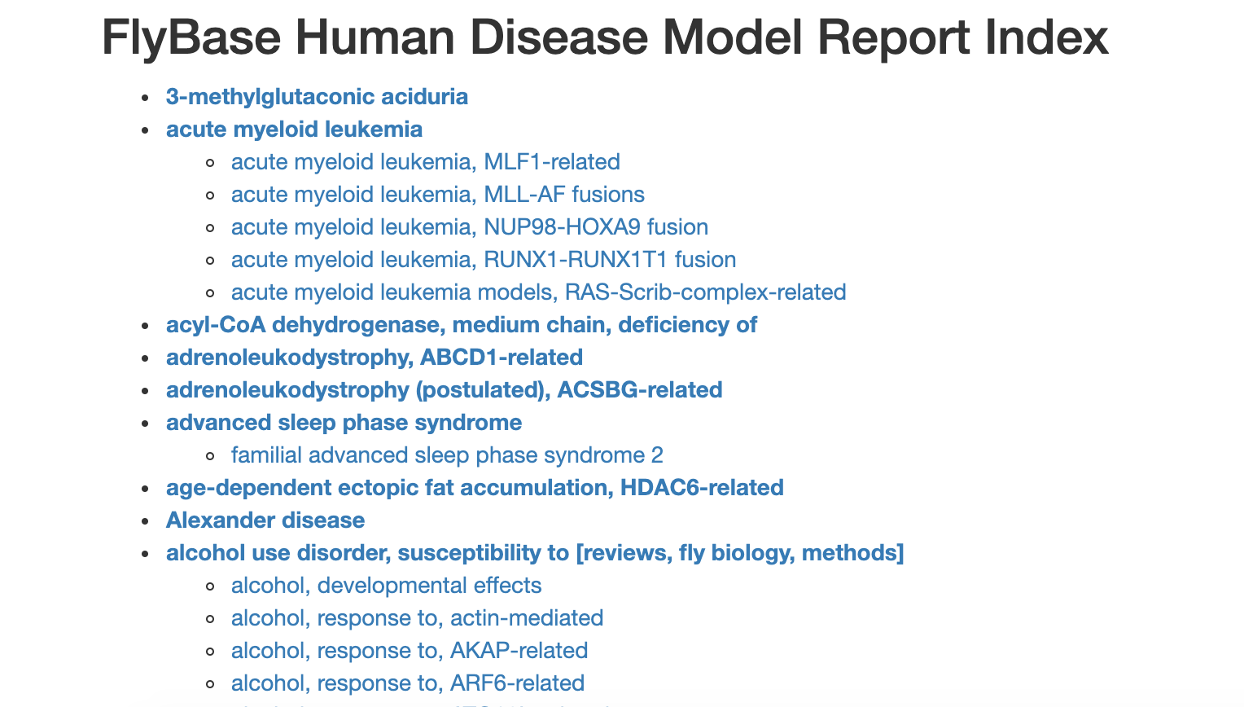

Figure : Figure 1.4: Katherine Cox (2021). Screenshot of the FlyBase Disease model page <https://flybase.org/lists/FBhh/>. License: [CC BY 4.0](https://creativecommons.org/licenses/by/4.0/)

There is even [a blog](http://flydiseasemodels.blogspot.com/) to help keep track of *Drosophila* disease model developments.

Many of these disease models are available through *Drosophila* Stock Centers - organizations that maintain collections of fly “strains” (distinct genotypes) and distribute them to researchers. When a researcher develops a new fly strain, they can submit it to a stock center so that other researchers can use it.

### 1.2.5 Summary

* Fruit flies share many commonalities with humans including organs and organ systems, anatomical organization, and genes.
  + About 60 percent of all human genes, and about 75 percent of human disease-associated genes have orthologs in flies
* Fruit flies have a short generation time, produce many offspring, and are easy to work with in the lab. You can do lots of experiments without needing too much time or money.
* Many important discoveries have been made using fruit flies
* Fruit flies are used today for many types of research, from development to disease. Many human diseases can be modeled and studied in fruit flies.

# 2 Lab Lecture: What is a Gene?

# 3 Exercises: Biological Databases

# 4 Assignment: Research a Gene

# Appendix

# About the Authors

These credits are based on our [course contributors table guidelines](https://www.ottrproject.org/more_features.html#giving-credits-to-contributors).

| Credits | Names |
| --- | --- |
| **Pedagogy** |  |
| Lead Content Instructor(s) | [FirstName LastName](link%20to%20personal%20website) |
| Lecturer(s) (include chapter name/link in parentheses if only for specific chapters) - make new line if more than one chapter involved | Delivered the course in some way - video or audio |
| Content Author(s) (include chapter name/link in parentheses if only for specific chapters) - make new line if more than one chapter involved | If any other authors besides lead instructor |
| Content Contributor(s) (include section name/link in parentheses) - make new line if more than one section involved | Wrote less than a chapter |
| Content Editor(s)/Reviewer(s) | Checked your content |
| Content Director(s) | Helped guide the content direction |
| Content Consultants (include chapter name/link in parentheses or word “General”) - make new line if more than one chapter involved | Gave high level advice on content |
| Acknowledgments | Gave small assistance to content but not to the level of consulting |
| **Production** |  |
| Content Publisher(s) | Helped with publishing platform |
| Content Publishing Reviewer(s) | Reviewed overall content and aesthetics on publishing platform |
| **Technical** |  |
| Course Publishing Engineer(s) | Helped with the code for the technical aspects related to the specific course generation |
| Template Publishing Engineers | [Candace Savonen](https://www.cansavvy.com/), [Carrie Wright](https://carriewright11.github.io/), [Ava Hoffman](https://www.avahoffman.com/) |
| Publishing Maintenance Engineer | [Candace Savonen](https://www.cansavvy.com/) |
| Technical Publishing Stylists | [Carrie Wright](https://carriewright11.github.io/), [Ava Hoffman](https://www.avahoffman.com/), [Candace Savonen](https://www.cansavvy.com/) |
| Package Developers ([ottrpal](https://github.com/jhudsl/ottrpal)) [Candace Savonen](https://www.cansavvy.com/), [John Muschelli](https://johnmuschelli.com/), [Carrie Wright](https://carriewright11.github.io/) |  |
| **Art and Design** |  |
| Illustrator(s) | Created graphics for the course |
| Figure Artist(s) | Created figures/plots for course |
| Videographer(s) | Filmed videos |
| Videography Editor(s) | Edited film |
| Audiographer(s) | Recorded audio |
| Audiography Editor(s) | Edited audio recordings |
| **Funding** |  |
| Funder(s) | Institution/individual who funded course including grant number |
| Funding Staff | Staff members who help with funding |

## ─ Session info ───────────────────────────────────────────────────────────────  
## setting value   
## version R version 4.0.2 (2020-06-22)  
## os Ubuntu 20.04.5 LTS   
## system x86_64, linux-gnu   
## ui X11   
## language (EN)   
## collate en_US.UTF-8   
## ctype en_US.UTF-8   
## tz Etc/UTC   
## date 2023-07-06   
##   
## ─ Packages ───────────────────────────────────────────────────────────────────  
## package * version date lib source   
## assertthat 0.2.1 2019-03-21 [1] RSPM (R 4.0.5)   
## bookdown 0.24 2023-03-28 [1] Github (rstudio/bookdown@88bc4ea)   
## cachem 1.0.7 2023-02-24 [1] CRAN (R 4.0.2)   
## callr 3.5.0 2020-10-08 [1] RSPM (R 4.0.2)   
## cli 3.6.1 2023-03-23 [1] CRAN (R 4.0.2)   
## crayon 1.3.4 2017-09-16 [1] RSPM (R 4.0.0)   
## desc 1.2.0 2018-05-01 [1] RSPM (R 4.0.3)   
## devtools 2.3.2 2020-09-18 [1] RSPM (R 4.0.3)   
## digest 0.6.25 2020-02-23 [1] RSPM (R 4.0.0)   
## ellipsis 0.3.1 2020-05-15 [1] RSPM (R 4.0.3)   
## evaluate 0.20 2023-01-17 [1] CRAN (R 4.0.2)   
## fastmap 1.1.1 2023-02-24 [1] CRAN (R 4.0.2)   
## fs 1.5.0 2020-07-31 [1] RSPM (R 4.0.3)   
## glue 1.4.2 2020-08-27 [1] RSPM (R 4.0.5)   
## htmltools 0.5.5 2023-03-23 [1] CRAN (R 4.0.2)   
## knitr 1.33 2023-03-28 [1] Github (yihui/knitr@a1052d1)   
## magrittr 2.0.3 2022-03-30 [1] CRAN (R 4.0.2)   
## memoise 2.0.1 2021-11-26 [1] CRAN (R 4.0.2)   
## pkgbuild 1.1.0 2020-07-13 [1] RSPM (R 4.0.2)   
## pkgload 1.1.0 2020-05-29 [1] RSPM (R 4.0.3)   
## prettyunits 1.1.1 2020-01-24 [1] RSPM (R 4.0.3)   
## processx 3.4.4 2020-09-03 [1] RSPM (R 4.0.2)   
## ps 1.4.0 2020-10-07 [1] RSPM (R 4.0.2)   
## R6 2.4.1 2019-11-12 [1] RSPM (R 4.0.0)   
## remotes 2.2.0 2020-07-21 [1] RSPM (R 4.0.3)   
## rlang 1.1.0 2023-03-14 [1] CRAN (R 4.0.2)   
## rmarkdown 2.10 2023-03-28 [1] Github (rstudio/rmarkdown@02d3c25)  
## rprojroot 2.0.3 2022-04-02 [1] CRAN (R 4.0.2)   
## sessioninfo 1.1.1 2018-11-05 [1] RSPM (R 4.0.3)   
## stringi 1.5.3 2020-09-09 [1] RSPM (R 4.0.3)   
## stringr 1.4.0 2019-02-10 [1] RSPM (R 4.0.3)   
## testthat 3.0.1 2023-03-28 [1] Github (R-lib/testthat@e99155a)   
## usethis 1.6.3 2020-09-17 [1] RSPM (R 4.0.2)   
## withr 2.3.0 2020-09-22 [1] RSPM (R 4.0.2)   
## xfun 0.26 2023-03-28 [1] Github (yihui/xfun@74c2a66)   
## yaml 2.2.1 2020-02-01 [1] RSPM (R 4.0.3)   
##   
## [1] /usr/local/lib/R/site-library  
## [2] /usr/local/lib/R/library

# References