

Nature of Enterprise Computing

CA 2

Due Date : 27/2/2026 at 17:00
By Andile Ngwenya X00228810 and Charles McAdam A00025809

Overview
As the group we chose a student performance data which was recorded over one semester. The students are either male or female from ages 17 to 25 which. The data was chosen because it was relevant to the us as students. The columns consisted of students personal details and their performance including their sleeping hours. The data consisted of more than 500 rows and 12 columns. The columns have records of student identity numbers, age, gender, daily screen time, social media hours, online study hours, gaming hours, sleep hours, attendance percentage, offline study hours, current semester GPA and previous semester GPA. The data was extracted onto an excel sheet for better analysis and cleaning.
Data Cleaning
Before the data was analysed, it was cleaned using Microsoft excel application. The first thing that was done was to paste the raw data onto a new sheet named cleaned data. The data was checked if every cell contained the correct data types as per requirement those which were not were removed or changed. Also empty cells and those that contained null values were removed. Extra spaces were removed using the (=TRIM) function on excel to make sure that all extra spaces were removed to avoid getting biased analysis results. Outliers were checked and fixed. Blank and duplicate columns were also removed in the process and from the data set there were 2 duplicates as shown in the screenshot below
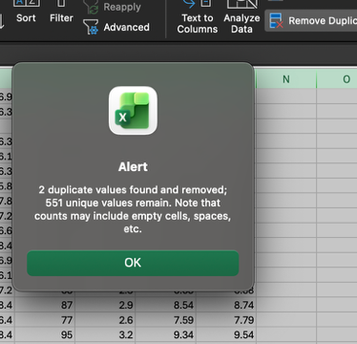
Descriptive Analysis Statistics

After the data was cleaned, the team moved on to do the data analysis. Most of the analysis was done in Microsoft excel and then some visuals were displayed in HTML. In excel, histograms, a scatter plot and a pie chart were used to demonstrate the statistics. The scatter plot above was used to display the performance of students against their study hours which included both offline and online studying. This kind of plot was chosen because it is the most appropriate graph that shows the relationship between the three numerical variables. It is also easy to identify outliers from the scatter plot and fix when there is need. A scatter plot made room for each and every student data to be presented on the graph to make it possible to observe their patterns and behaviours and how those affect their performance. From the scatter plot, it was observed that many students actually prefer to study online rather than offline, also most students who study both online and offline tend to perform much better than students who studies offline or online. It is also easy to identify outliers from the scatter plot and fix when there is need to

A frequency table was used to demonstrate the students attendance of classes for the semester. From the chat the attendance percentage is grouped from 55%-100 which suggests that none of the students have less than 55% attendance. The graph shows that most students lie in the range of 55% and 80%, which indicates that a significant number of students have an average attendance level in this range. As attendance percentages increase above 85%, the frequency of students decreases. This means fewer students have very high attendance levels between 90% and 100%. The lowest frequency is observed in the 95% to 100% range, indicating that only a small number of students consistently attend nearly all classes. The histogram was very useful to see the average attendance of students and it was also used to compare the students marks against their attendance levels.

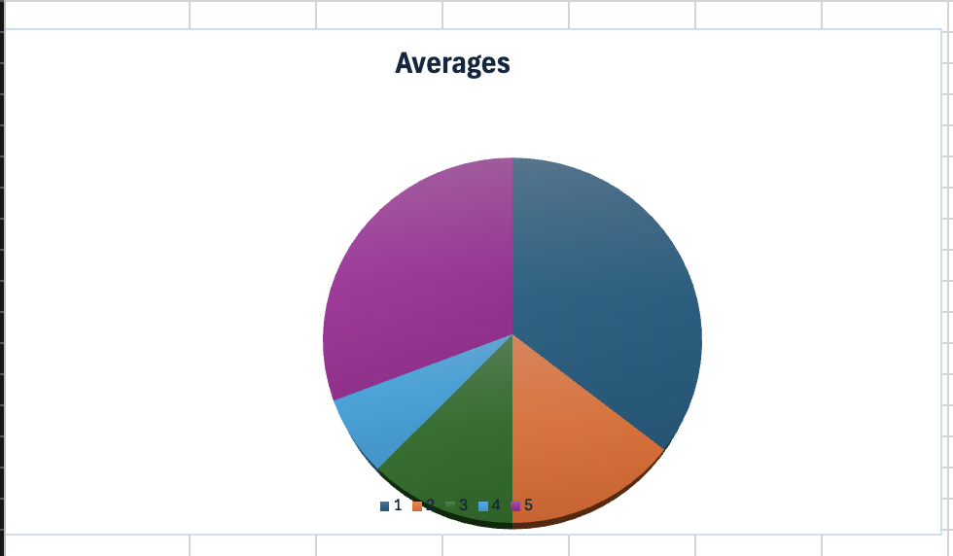
A pie chart was used to demonstrate the averages of student lives. It consists of the students ‘offline and online studying, attendance parentage, daily screen time and sleeping hours. This chart was used to display the ideal daily lives of the students. From the chat students’ daily screen time has an average of 36% followed by the sleep time with 31%. This shows that most of the students spend time sleeping and on the screens. As already observed in the scatter plot above, that the students prefer study online rather than online, it comes to as proof as to why the students screen time has the biggest percentage. The pie chart helped to give a clear visual information of the average daily lives of the students. It made it easier to identify patterns between study behaviour, academic performance and students daily living.
Machine Learning
In this project, a simple machine learning concept was used to understand how study patterns affect student performance.
Linear regression was used to predict the current semester CGPA based on total study hours. A scatter plot with a regression line showed a positive relationship, meaning that students who studied more hours generally had higher CGPA. The regression equation also showed that CGPA increases as study hours increase, confirming that study time is an important factor in academic performance.
Logistic regression was used to predict whether a student would pass or fail based on their study hours. Students with a CGPA of 8.0 or higher were classified as pass. The logistic regression graph showed an S-shaped curve, indicating that the probability of passing increases as total study hours increase.
Overall, these models demonstrated that study habits are strongly related to academic success and show how machine learning can be used to predict student performance.

Limitations and Ethics
It is of paramount significance to note that there are several limitations to this analysis. Firstly, the dataset may only represent a small group of students and may not reflect all students. This means the results cannot be applied to all educational settings. Also, some data may be missing or incomplete. Even after cleaning, missing values can affect the accuracy of statistical analysis and predictions. Lastly, academic performance is influenced by many factors, such as motivation, teaching quality, mental health, and personal circumstances. Study time alone does not fully explain student performance.
There are also ethical considerations when analyzing student data. Student information must be kept confidential and used responsibly. Personal identities should not be shared, and data should only be used for educational purposes.

Conclusion
To conclude, this project collected a dataset containing information about students’ academic performance and study patterns. The data was cleaned by removing duplicate records, handling missing values, and ensuring correct formats to ensure accuracy. Descriptive statistical analysis was performed to calculate measures such as mean, median, minimum, maximum, and standard deviation. These statistics helped summarize student performance and study behavior.
Visual analysis using graphs showed clear relationships between study time, screen time, and academic performance. Students who studied more hours generally achieved better academic results, while excessive screen time appeared to have a negative effect.
A basic machine learning concept was introduced to demonstrate how student performance could be predicted based on study patterns. This showed how data analysis can be used to support educational decision-making.

