# CprE 381 – Computer Organization and

# Assembly-Level Programming

# Lab-03 Report

Student Name ______________________________________________

## Section / Lab Time _________________________

***Submit a typeset pdf version of this on Canvas by the due date (i.e., the start of your next lab section). Refer to the highlighted language in the Lab-03 instructions for the context of the following questions****.*

1. [Prelab] At the end of Chapter 5, answer question 5. At the end of Chapter 7, answer exercise 2.
2. [Prelab] In your Lab #3 report PDF, provide the Canvas group name for your project team, and a listing of its members. On a scale of 1-10, how comfortable with VHDL does each team member currently feel?
3. [Part 1 (a)] Draw the interface description for the MIPS register file. Which ports do you think are necessary, and how wide (in bits) do they need to be?

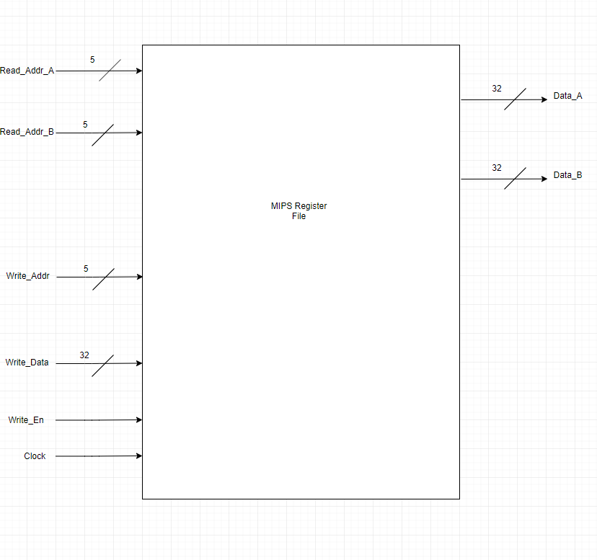

1. [Part 1 (b)] Create an N-bit register using this flip-flop as your basis.
2. [Part 1 (c)] Waveform.
3. [Part 1 (d)] What type of decoder would be required by the MIPS register file and why?

1. [Part 1 (e)] Waveform.
2. [Part 1 (f)] In your write-up, describe and defend the design you intend on implementing for the next part.
3. [Part 1 (g)] Waveform.
4. [Part 1 (h)] Draw a (simplified) schematic for the MIPS register file, using the same top-level interface ports as in your solution for part a), and using only the VHDL components you have created in parts (b), (e), and (g).
5. [Part 1 (i)] Waveform.
6. [Part 2 (b)] Draw a schematic of the simplified MIPS processor datapath consisting only of the component described in part (a) and the register file from problem (1).
7. [Part 2 (c)] Include in your report waveform screenshots that demonstrate your properly functioning design.
8. [Feedback] You must complete this section for your lab to be graded. Write down the first response you think of; I expect it to take roughly 5 minutes (do not take more than 10 minutes).
   1. How many hours did you spend on this lab?

|  |  |  |
| --- | --- | --- |
| **Task** | **During lab time** | **Outside of lab time** |
| Reading lab |  |  |
| Pencil/paper design |  |  |
| VHDL design |  |  |
| Assembly coding |  |  |
| Simulation |  |  |
| Debugging |  |  |
| Report writing |  |  |
| Other: |  |  |
| Total |  |  |

* 1. If you could change one thing about the lab experience, what would it be? Why?
  2. What was the most interesting part of the lab?