LIBRARY IEEE;

USE IEEE.STD_LOGIC_1164.ALL;

ENTITY or8g IS

PORT(i_A: IN STD_LOGIC_VECTOR(7 DOWNTO 0);

o_F : OUT STD_LOGIC);

END or8g;

ARCHITECTURE behavior OF org8 IS

BEGIN

logic_process: PROCESS(ins)

BEGIN

IF ( ins = "00000000" ) THEN

o_F <= '0';

ELSE

o_F <= '1';

END IF;

END PROCESS logic_process;

END behavior;

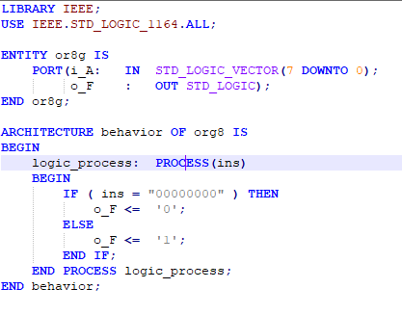

LIBRARY IEEE;

USE ieee.std_logic_1164.all;

ENTITY dff_1 IS

PORT(

S,D,CLK,R : IN STD_LOGIC;

Q,Inv_Q : OUT STD_LOGIC);

END dff_1;

ARCHITECTURE behavior OF dff IS

SIGNAL q_temp : STD_LOGIC;

BEGIN

dff_process: PROCESS(CLK,S,R) IS

BEGIN

IF (S = '0') THEN

q_temp <= '1';

ELSIF (R = '0') THEN

q_temp <= '0';

ELSIF (RISING_EDGE(CLK)) THEN

q_temp <= D;

END IF;

END PROCESS dff_process;

Q <= q_temp;

Inv_Q <= NOT q_temp;

END behavior;

