# CprE 381 – Computer Organization and

# Assembly-Level Programming

# Lab-04 Report

Student Name Colby McKinley

## Section / Lab Time Section / Wednesday 6:10p – 8:00p

***Submit a typeset pdf version of this on Canvas by the due date. Refer to the highlighted language in the Lab-04 instructions for the context of the following questions****.*

1. [Prelab] Based on the waveforms, provide a description in your own words of how this component operates. This can be in the form of a textual description, flow chart, or state machine

See /prelab

1. [Part 1 (a)] What are the MIPS instructions that require some value to be sign extended? What are the MIPS instructions that require some value to be zero extended?

Signed Extended: Subi, Subiu, lw, sw

Zero Extended: Addi, Addiu, lw, sw

1. [Part 1 (b)] what are the different 16-bit to 32-bit “extender” components that would be required by a MIPS processor implementation?

There are two extenders, a zero extender and sign extender are both used as a second option for the adder/subtractor unit.

1. [Part 1 (d)] Waveform.

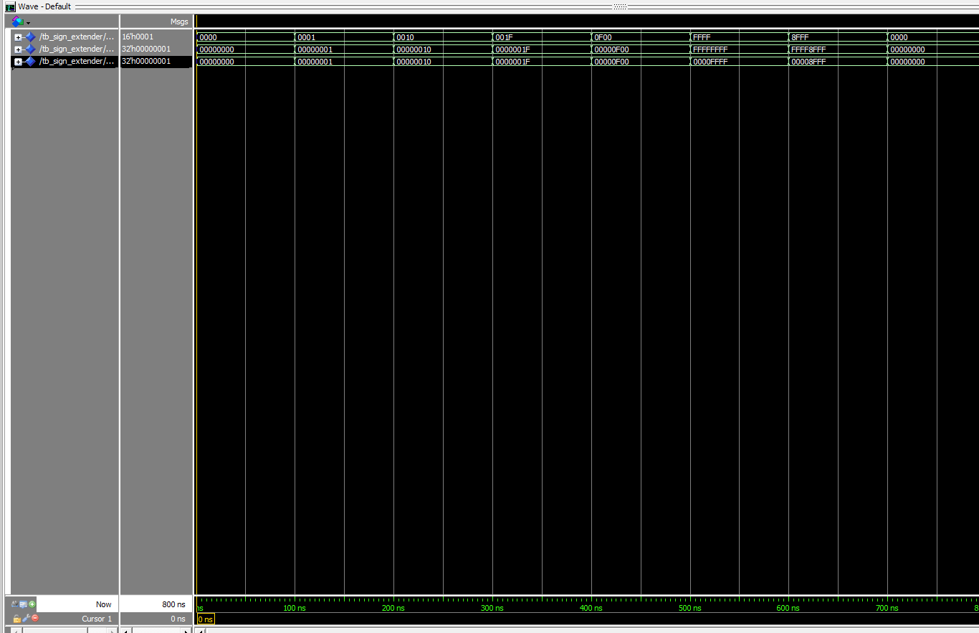

1. [Part 2 (b)] Provide a 2-3 sentence description of each of the individual ports (both generic and regular).

The DATA_WIDTH generic specifics the width of each register inside the memory block. Given that the mem.vhd defaults to 10, we know that the max value which can be written to a register is $2^{32}-1$.

The ADDR_WIDTH generic specifies the amount off registers inside the block. Given that the mem.vhd defaults to 10, we know that there are $2^{10}-1$ registers available to write to.

The clock port is the clock which dictates if a memory address can be overridden. The implementation of mem.vhd dictates that we can write only on a rising clock edge.

The addr port is the address to read or write in memory. This port width is the size of the generic ADDR_WITDH.

The data port is the data value that could be written to a memory addr. This port width is the size of the generic DATA_WITDH.

The we port is the write enable for the memory block. This is the control bit for if a value at the given addr will be overridden.

The q port is the memory value read from the given address inside the memory block. This signal is not dependent on the clock signal.

1. [Part 2 (c)] Waveform.

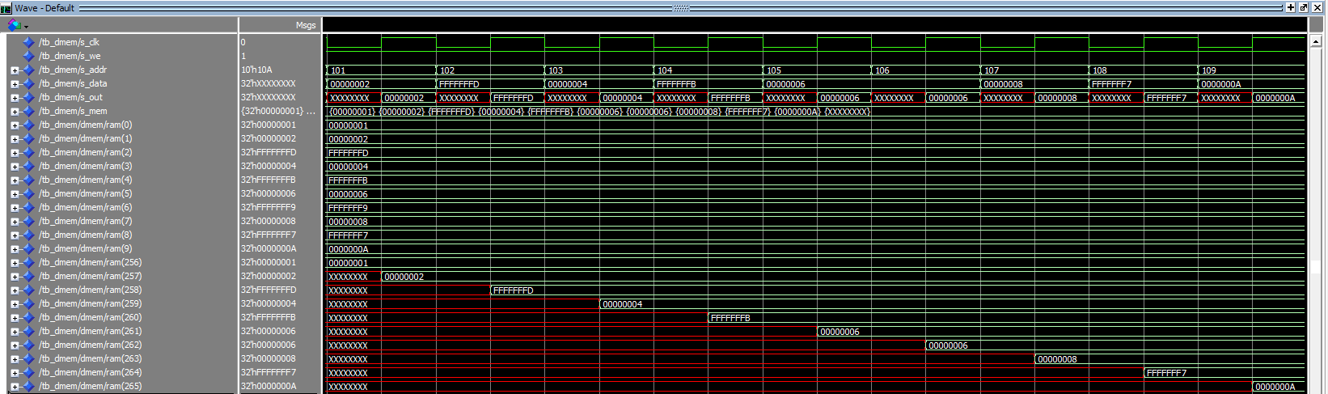

1. [Part 2 (d)] Briefly describe how the waveforms for this mem.vhd module differ from those that you analyzed as part of the pre-lab.

One difference is that q is undriven for half the clock cycles. In this we do not observe the byteena signal. It most resembles the

1. [Part 3 (a)] what control signals will need to be added to the simple processor from Lab #3? How do these control signals correspond to the ports on the mem.vhd component analyzed in problem 2)?

One design decision I made immediately was to have a single opcode drive all my values. I wanted my MIPS processor to be reusable later. I use the opcode to drive 4 control bits, mem_result, which dictates if the value fetched from memory should be used in the register file’s write data port or the value from the alu; n_add_sub, which dictates if the adder subtractor module should add or subtract; alusrc, which dictates if the immediate value should be used or the value read from the secondary read out from the register file; and we, which dictates if register values will be overridden. In my component ports, you will also find a function, shamt, however these were not required for the instruction we are supporting this week.

1. [Part 3 (b)] Draw a schematic of a simplified MIPS processor consisting only of the base components used in Lab #3, the extender component described in problem (1), and the data memory from problem (2).

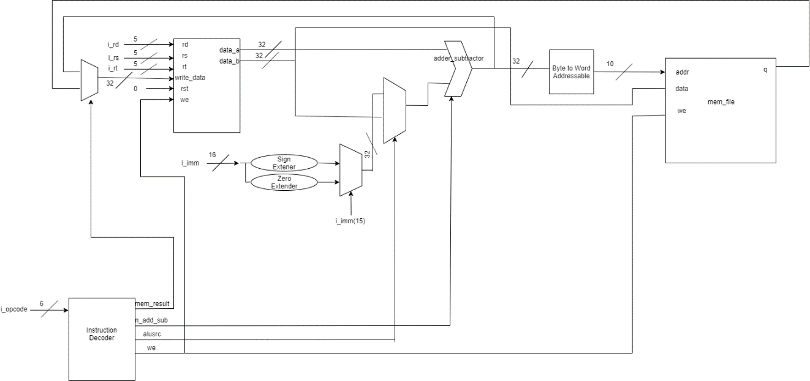

1. [Part 3 (c)] Waveform.

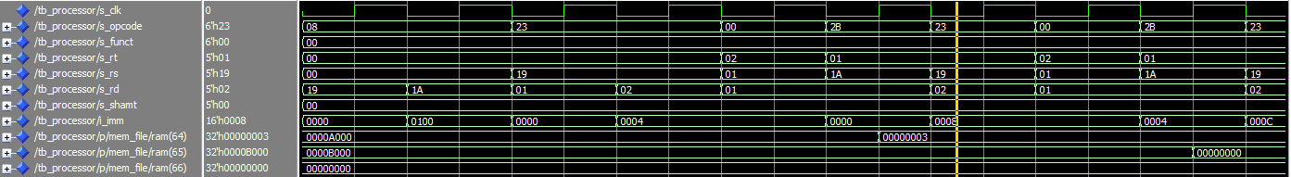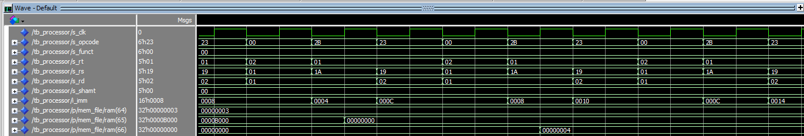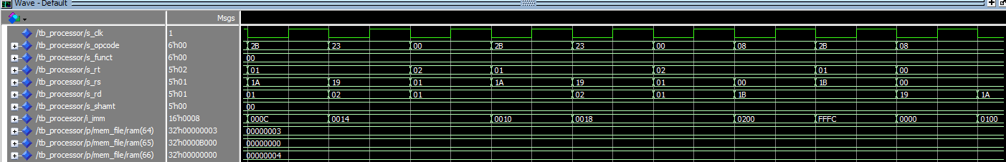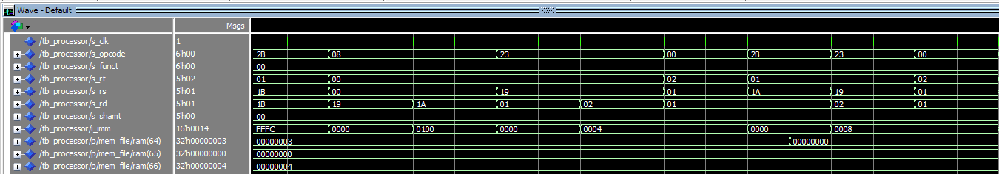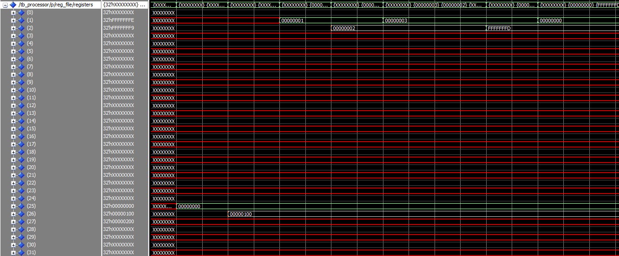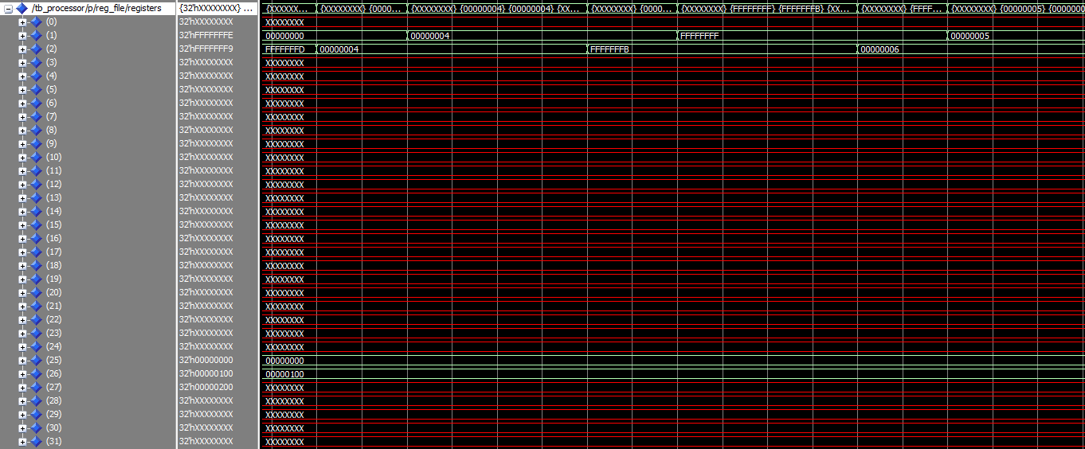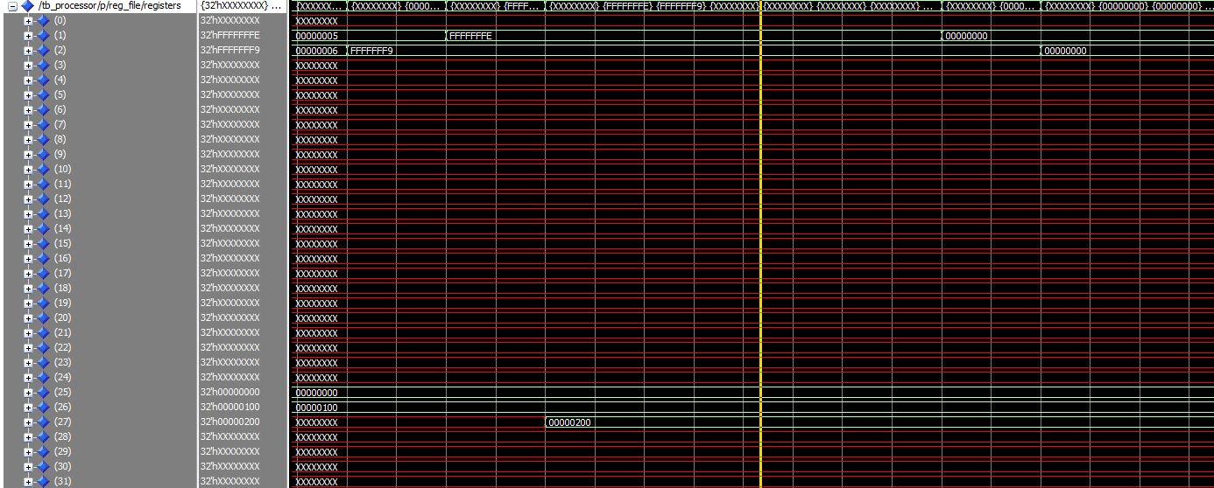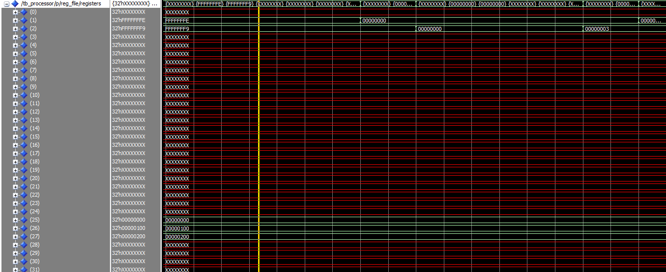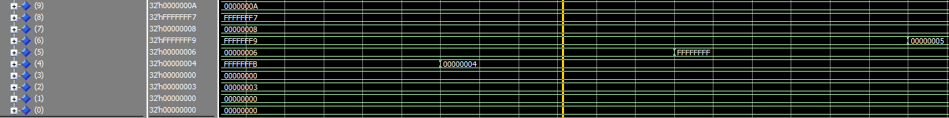

1. [Feedback] You must complete this section for your lab to be graded. Write down the first response you think of; I expect it to take roughly 5 minutes (do not take more than 10 minutes).
   1. How many hours did you spend on this lab?

|  |  |  |
| --- | --- | --- |
| **Task** | **During lab time** | **Outside of lab time** |
| Reading lab | 10 min | 10 min |
| Pencil/paper design | 20 min | 40 min |
| VHDL design | 2hr 20 min | 30 min |
| Assembly coding | 0 min |  |
| Simulation | 1 hr | 1 hr |
| Debugging | 10 min | 6 hr |
| Report writing | 0 min | 1 hr |
| Other: |  |  |
| Total | 4 hr | 9 hr 20 min |

* 1. If you could change one thing about the lab experience, what would it be? Why?

The directions for part c are very ambiguous, the only starting point I had was piecing together many small components designed in lecture, and discussing architecture design with a ta in lab.

* 1. What was the most interesting part of the lab?

The picture I drew of the MIPS processor is interesting.