CprE 381 – Computer Organization and

Assembly-Level Programming

Proj-A Report

Lab Partners Colby McKinley
Tyler Dawson
Jordan Silvers

Section / Lab Time Section 5 / W 6:10 p – 8:00

Submit a typeset pdf version of this on Canvas by the due date. Refer to the highlighted language in the Proj-A instructions for the context of the following questions.

- [Part 0] With your project group members, create a list of best practices / tips for designing, compiling, and testing VHDL modules based on your experiences so far with these labs, both working individually and as a group.

See /prelab.pdf

- [Part 1 (a)] Draw a schematic for a 1-bit ALU that supports the following operations: add/sub (both signed and unsigned), slt, and, or, xor, nand, and nor. What are the inputs and outputs that are needed?

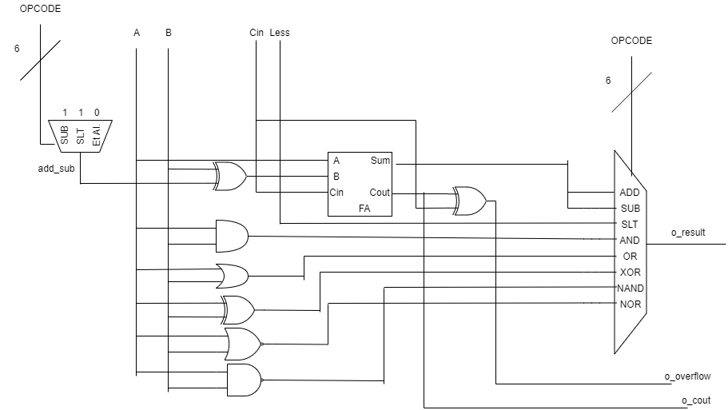

- [Part 1 (b)] In your project writeup, describe your design in terms of the VHDL coding style you chose and the control signals that are required.

I used the opcode to create a secondary control signal called add_sub, which determines if the full adder will be used to subtract or to add. The operations sub and slt will use a subtracting result. The add_sub signal is used to either negate or preserve b, which is fed into the full adder. The set signal is driven by xoring the overflow value with the sum from the full adder. I think having two control signals, opcode and funct will be required going forward to handle all the ALU operations.

- [Part 1 (c)] Describe how the execution of the different operations corresponds to the Modelsim waveforms in your writeup.
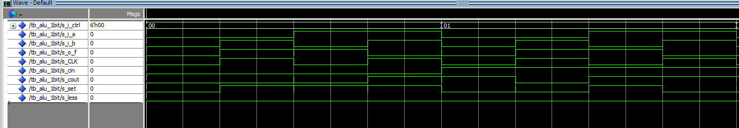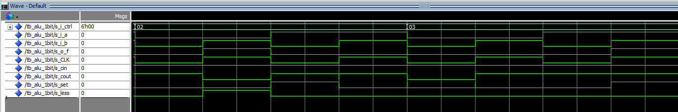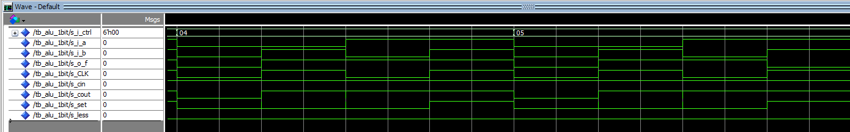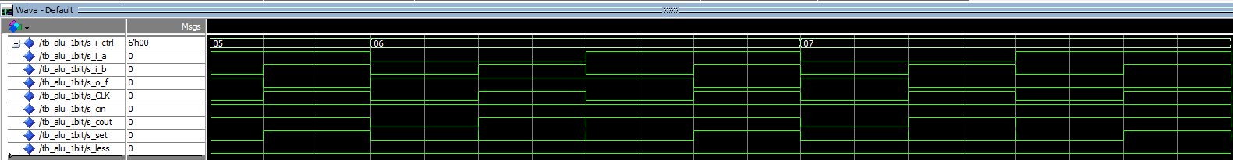

- [Part 2 (a)] Draw a simplified schematic for this 32-bit ALU. Consider the following questions: how is Overflow calculated? How is Zero calculated? How is slt implemented?

Overflow is calculated by xoring the final carry out with the final carry in. Zero is calculated by xoring the resulting 32 bit to see if any individual one is turn on. SLT is computed by xoring the final overflow with the final sum value of A - B.
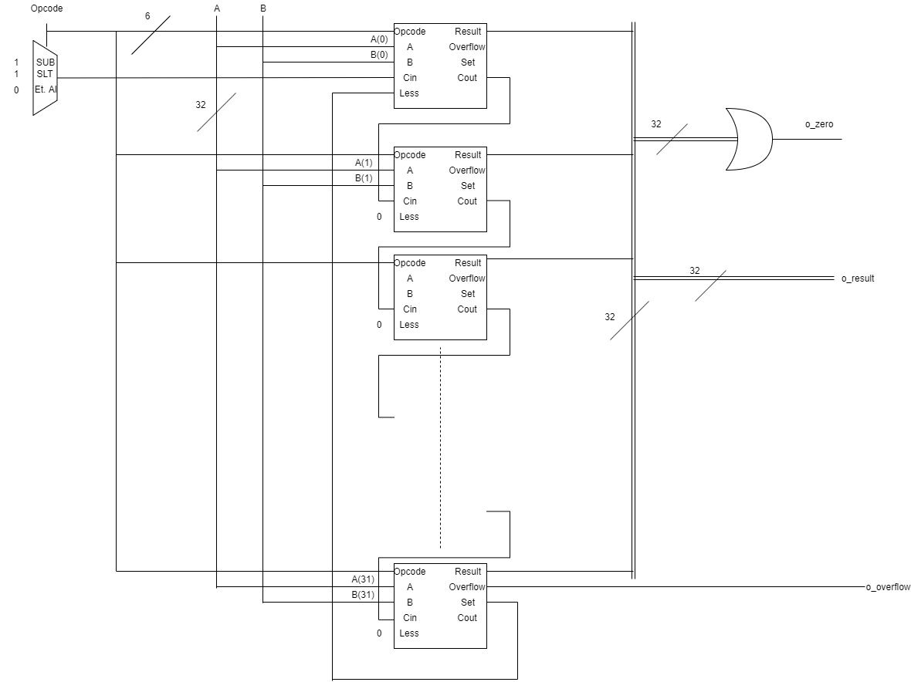

- [Part 2 (b)] In your writeup, describe what challenges (if any) you faced in implementing this module.

Instruction which required subtracting did not work, i.e. SUB and SLT. After redesigning how subtracting work in the alu, these instructions worked fine.

- [Part 2 (c)] Describe how the execution of the different operations corresponds to the Modelsim waveforms in your writeup.
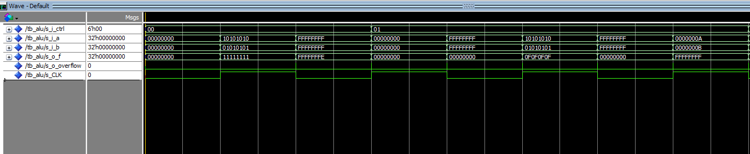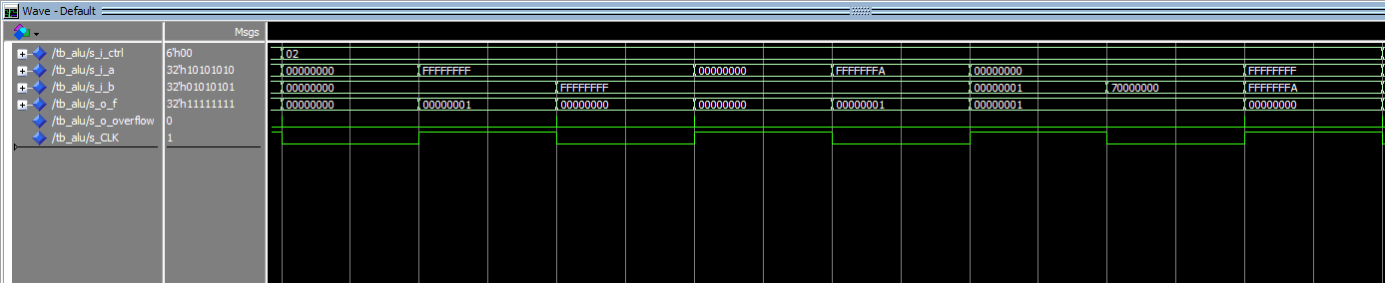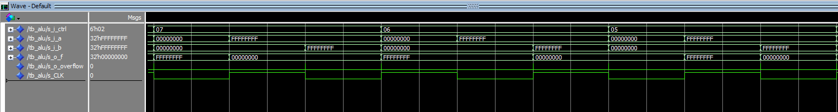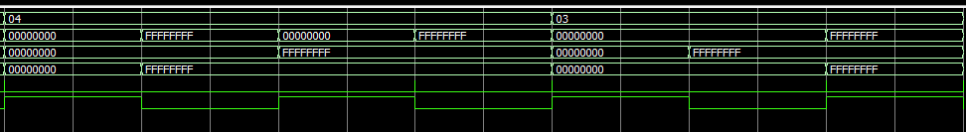

- [Part 3 (a)] Describe the difference between logical (srl) and arithmetic (sra) shifts. Why does MIPS not have a sla instruction?

SRL – Shift Right Logical, will shift each bit in binary number a binary number a specified amount, x, of bits right. It loads in 0’s into the most significant x bits. This instruction is synonymous with dividing an unsigned number by 2^x.

SLL – Shift Left Logical, will shift each bit in binary number a binary number a specified amount, x, of bits left. It loads in 0’s into the least significant x bits. This instruction is synonymous with multiplying a number by 2^x.

SRA – Shift Right Arithmetic, will shift each bit in binary number a binary number a specified amount, x, of bits right. It loads in 1’s into the most significant x bits. This instruction is synonymous with dividing a signed number by 2^x.

SLA – Shift Left Arithmetic is not supported because it is the same as SLL.

- [Part 3 (b)] In your writeup, briefly describe how your VHDL code implements both the arithmetic and logical shifting operations.

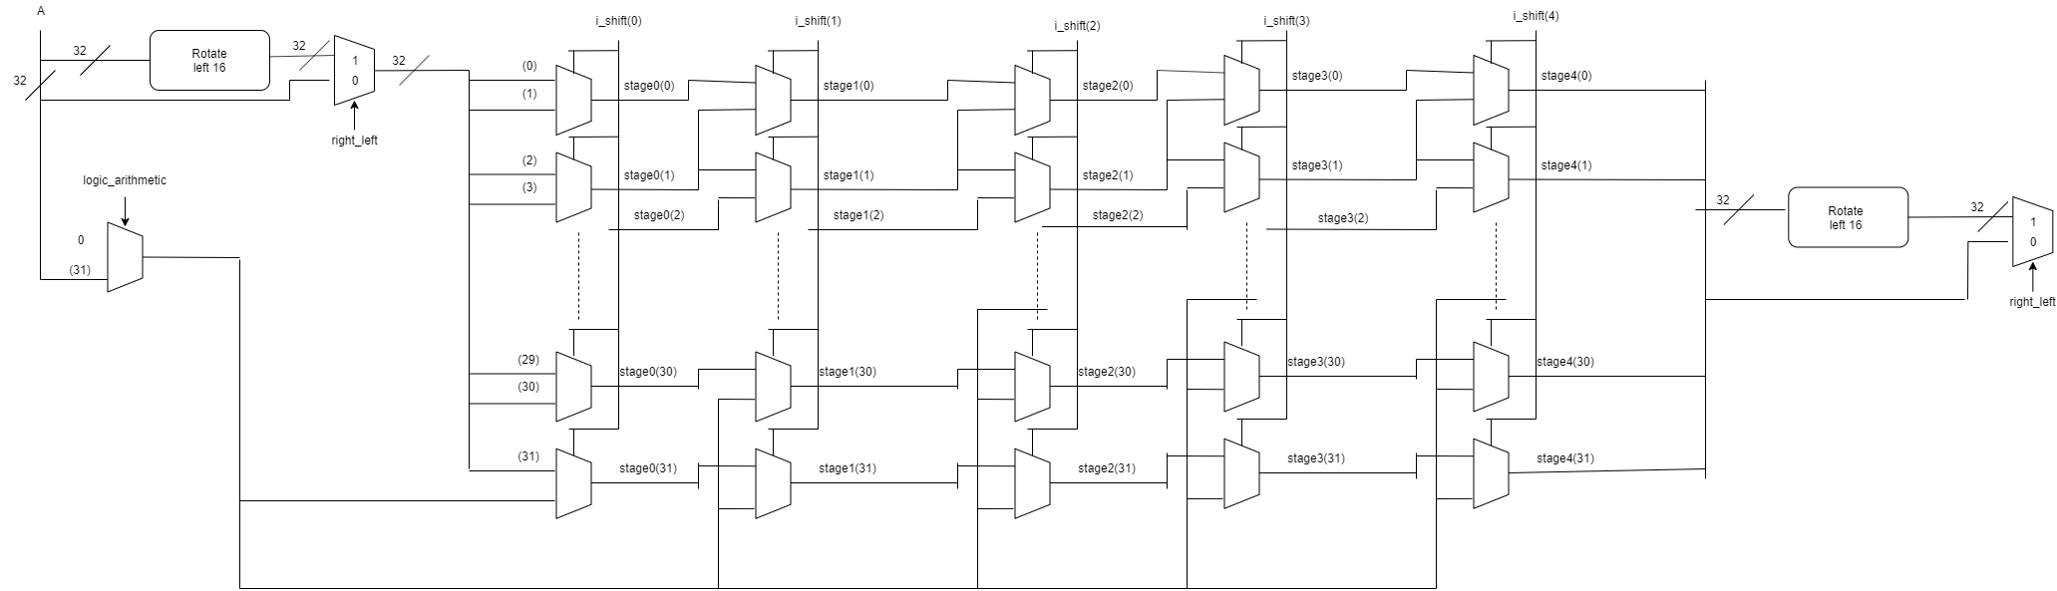

The VHDL code implements a right shifter, which accounts for logic and arithmetic shifts. There is a multiplexer which chooses the value, s_la, which is shifts into the new shifted value. If the instruction is logical, then 0 flows to s_la, otherwise the most significant bit of the base number flows into s_la. The mux tree then uses s_la to flow into the shifted value.

- [Part 3 (c)] In your writeup, explain how the right barrel shifter from part b) can be enhanced to also support left shifting operations.

If the instruction was to shift left, the base value bits are flipped with its ‘inverse’ bit. That is the value at bit 31 is swapped with the value at bit 0, bit 30 is swapped with bit 1, for all bits 0 to 31.

- [Part 3 (d)] Describe how the execution of the different shifting operations corresponds to the Modelsim waveforms in your writeup.
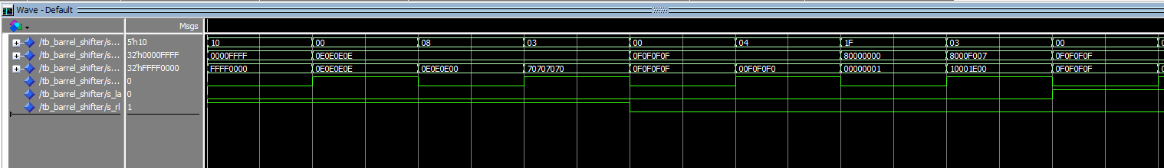

- [Part 4(b)] Justify why your test plan is comprehensive. Include waveforms that demonstrate your test program is functioning.

Up to this point, every function has been tested thoroughly and works. This test is meant to confirm that the ALU interfaces with the processor designed in lab 4.
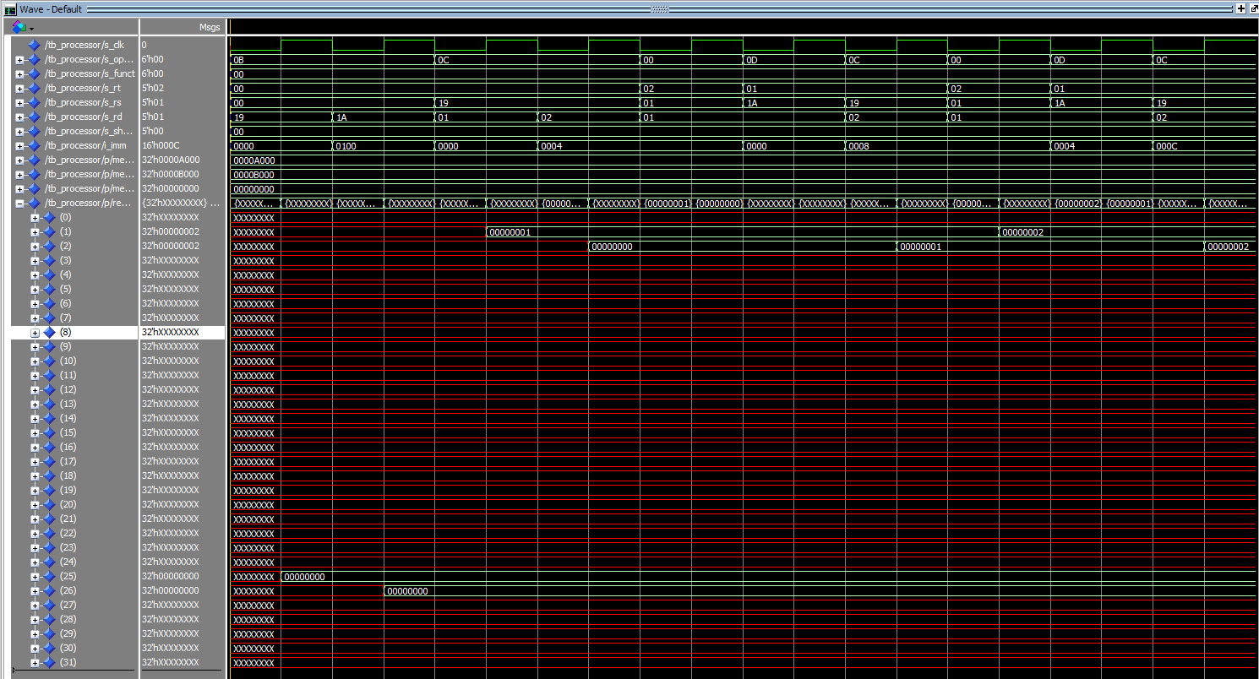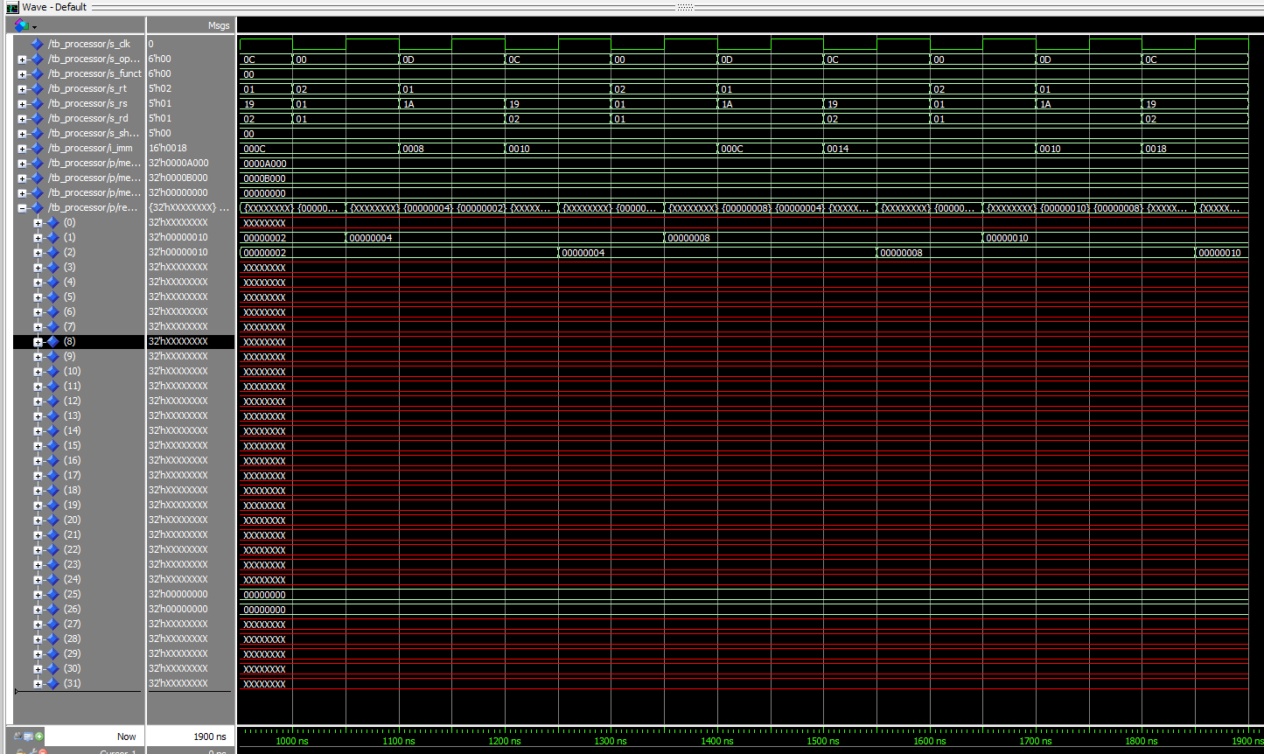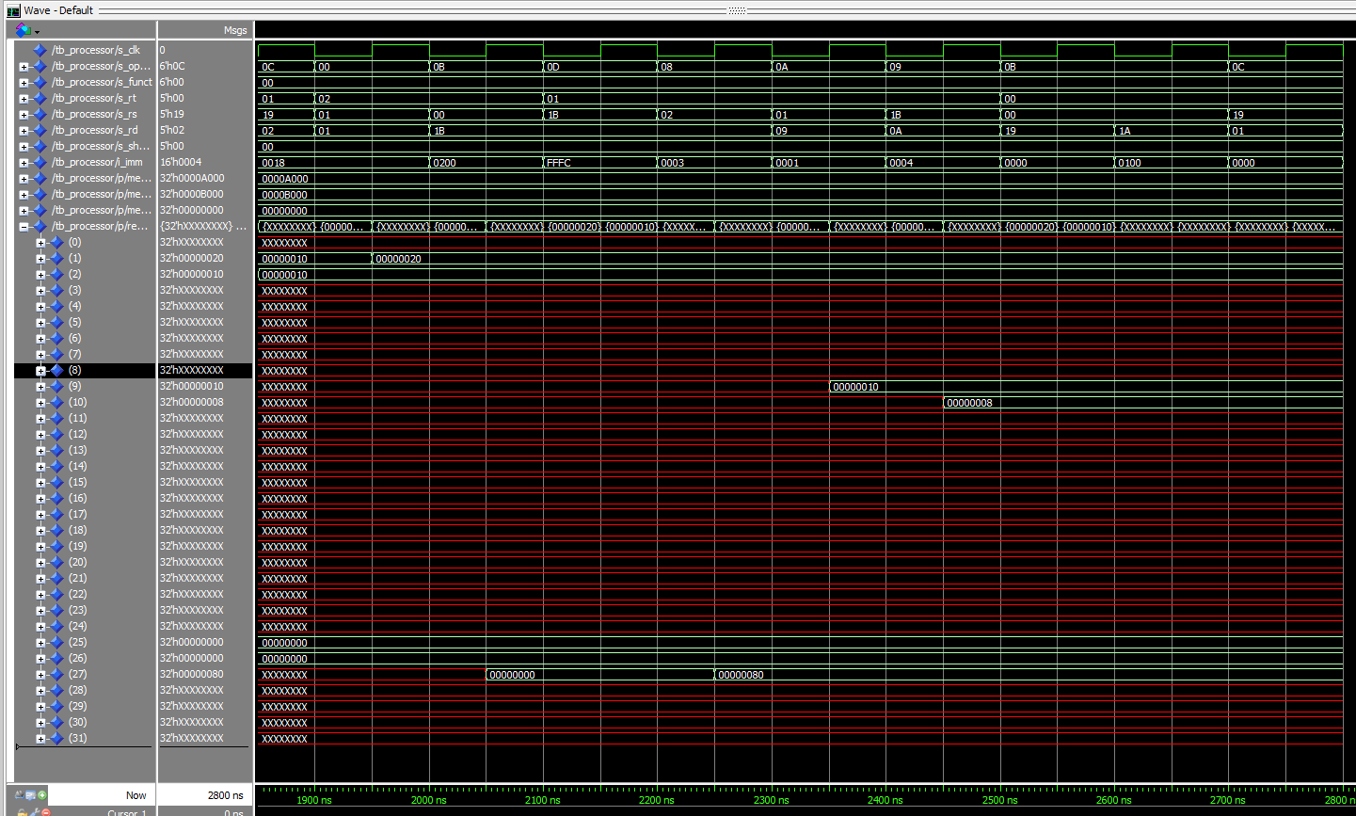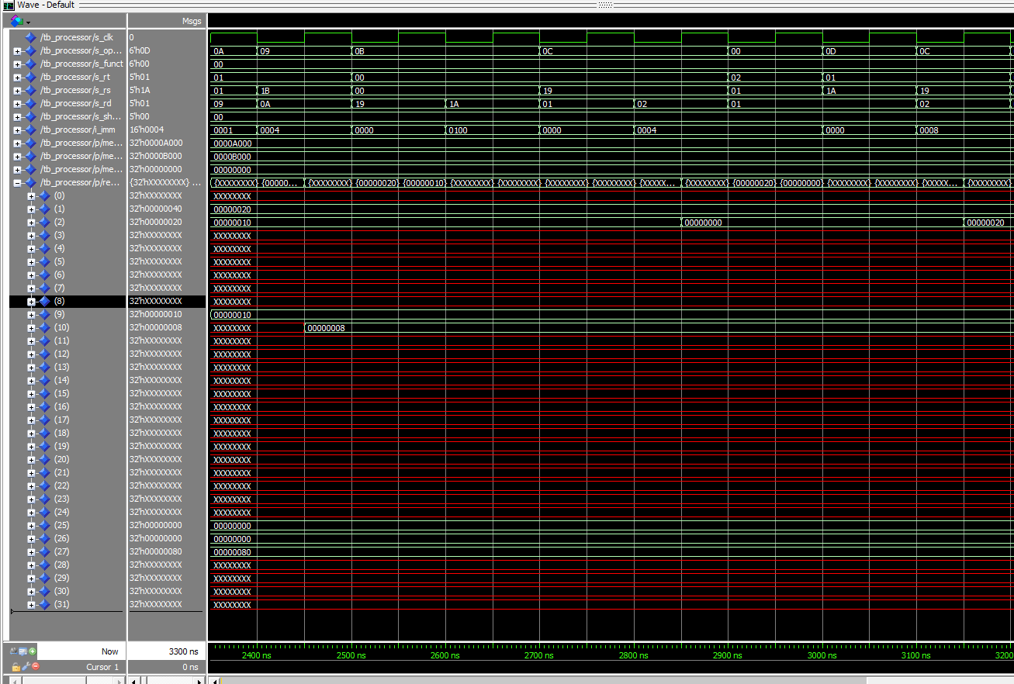

- [Part 5(c) BONUS] Justify why your test plan is comprehensive. Include waveforms that demonstrate your test program is functioning.

I used the testing program from Lab04. I then added tests for the shifting instructions since these were the last ones left untested from the base.

- [Feedback] You must complete this section for your lab to be graded. Please complete each column separately for each team member; I expect it to take roughly 10 minutes (do not take more than 20 minutes).

  - How many hours did you spend on this lab?

Task | During lab time |  |  | Outside of lab time
Team Initials | CM | TD | JS | CM | TD | JS
Reading lab | 15 min | 15 min | 15 min | 0 | 0 | 0
Pencil/paper design | 1 hr | 0 | 1 hr | 30 min | 0 | 1 hr
VHDL design | 1 hr | 2 hr | 1 hr | 6 hr | 3 hr | 3 hr
Assembly coding | 0 | 0 | 0 | 0 | 0 | 0
Simulation | 0 | 0 | 1 hr | 1 hr | 0 | 1 hr
Debugging | 2 hr | 2 hr | 1 hr | 5 hr | 3 hr | 1 hr
Report writing | 0 | 0 | 0 | 2 hr | 0 | 0
Other:
Total | 4 hr 15 min | 4 hr 15 min | 4 hr 15 min | 14.5 hr | 6 hr | 6 hr

  - If you could change one thing about the lab experience, what would it be? Why?

It would be helpful if I was given the components input and output pins for the given final project. Even if the pins are not going to be used this week, understanding how MIPS handles these would help drive my final design.

  - What was the most interesting part of the lab?

Getting the single bit ALU to work concurrently with 31 other single bit ALUs was interesting design choice.

