This is a report documenting this project’s class relationships and its core game loop. In the first part, we explained the main mechanism of your code project and what classes are used in each step. In the second part, we included detailed documents on what functions and attributes each class has.

A. Introduction of Mechanisms and Classes

Game Manager are responsible for storing the global information of the game. It represents a global class instance, storing the players and the boards. At the start of main.py, the game manager is initialised, generating players and the AI-generated boards. This object is accessed everywhere in the project, providing key game information such as players and questions.

Surface Manager are responsible for the key iterations of game mechanisms. It stores base surface objects in self.layers. At each iteration, it handles the click event and triggers Base_Surface.on_click(pos, player) on the top-most layer. It also calls the Base_Surface.draw() and Base_Surface.update() to update and render each element in the game. When a base surface is closed, the surface manager calls Base_Surface.on_close() to progress to the next stage of the game.

A base surface represents a block element which is shown on the main screen. It is an abstraction of all surfaces that will be added later to the game. It stores its dimension, its position (of the top-left corner) on the screen. It stores its alpha value and whether the user is able to click through it. It has several key functions for iterations, including self.draw(), self.update(). self.on_click() and self.on_close().

A player represents a player in the game, which can either be a human player or a robot. It contains a unique color, which is assigned randomly by Color.assign_colors() at the start of the game. It also contains a score.

A question represents a possible question which will appear in the game. It contains a problem string, list of options, and its value holded, which corresponds to its difficulties.

The StartScreen is a temporary screen which welcomes the player. It is here where the introduction music is played. After the player clicks it, it destroys itself, plays new music, initiates a Grid Surface.

The Grid Surface is the most central surface in the game, representing a jeopardy grid. It stores the current player in this round, and only allows the current player to click.

It stores the next bot action, which is a tuple of player, pos, and time. In Grid_Surface.update(), when the time reaches that for the robot to act, a click at the pos by the bot is initiated, simulating a robot opponent.

The Overlay class represents the score box which is on the top-right corner of the game. It shows what the current player is by holding a reference to the Grid Surface. It is accessed from the game manager to get how many scores are owned by each player.

When a cell in the Grid Surface is clicked, it first flashes for a while, and then initiates a Question Surface.

A Question Surface represents the answering of a question. There are two stages: Buzz and Answering. In buzz, any player who hasn’t previously answered this question can buzz. When a player buzzes, they have 5 seconds to answer it. After the five seconds, a sound effect is played, other players will be able to buzz in, although the current player can still answer it. Right and wrong answers also have their own sound effects.

This surface also overshades (self.overshade = true), meaning that the player cannot click any surfaces that are behind it (so that players cannot click a new cell).

This surface handles the bot action, and schedules bot actions during any time a robot can answer or buzz in. Based on the random result, a robot may have two actions while answering. If it hits (random > bot_skill), then the robot knows the correct answer. If it does not hit, the robots will try to randomly guess one, so that when there are less available options, the robots are more likely to answer correctly.

When a player buzzes, a flash is created using the class BorderFlash. BorderFlash just creates a flash in the border of the screen, corresponding to the current player’s color.

The Font and the Color class acts also as global instances, storing available fonts and colors for different modules to import and use accordingly.

The transition Screen is for the transition between stages, such as from welcoming to the normal jeopardy, or from normal jeopardy to the double jeopardy.

The LLM module automatically uses any cache that is already created. When there is no cache file (or they are removed), the LLM module generates new questions at run time.

B. Documentations

1. Surface_Manager
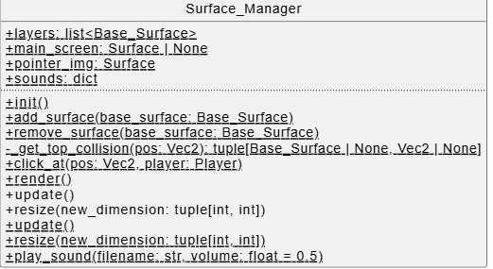
Surface_Manager.layers: list[Base_Surface]:
Stores the base surface objects in the order of their z-axis.

Surface_Manager.add_surface(Base_Surface):
It adds a base surface to self.layer.

Surface_Manager.main_screen: Surface:
It stores the main pygame display surface.

Surface_Manager.init():
Initializes the display window and loads the image of custom mouse pointer.

Surface_Manager.remove_surface(Base_Surface):
Calls the surface's on_close() to progress the game stage and removes it from the self.layers.

Surface_Manager.click_at(pos, player):
Finds the top surface that collides with the mouse click event and clicks it using on_click().

Surface_Manager.render():
Draws every surface in order of z-axis, draws the pointer, and flips the screen.

Surface_Manager.update():
Calls time_update() for all surfaces once per frame.

Surface_Manager.resize(new_dimension):
This method recreates the screen with a new size and calls resize() for all surfaces that support it.

Surface_Manager.play_sound(filename, volume=0.5):
Loads and plays a sound effect from the assets folder.

Surface_Manager._get_top_collision(pos):
Finds the top-most surface that collides with pos (used by click_at()).

2. Game_Manager
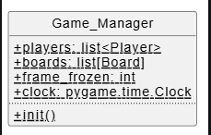
Game_Manager.players: list[Player]:
Stores all players in the current game.

Game_Manager.boards: list[Board]:
Stores AI-generated question boards (easy and double).

Game_Manager.frame_frozen: int:
Stores the frozen frame offset to pause timers when a cutscenes/transitions is present.

Game_Manager.clock:
Pygame.time.clock object. Stored in game manager for encapsulation.

Game_Manager.init():
Generates the boards and creates players.

3. Base_Surface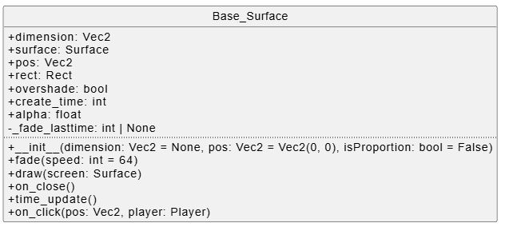

Base_Surface.dimension:
The size of the surface.

Base_Surface.pos:
The surface's top-left position on the main screen.

Base_Surface.rect:
The rect of the pygame surface.

Base_Surface.overshade: bool:
When it is true, block clicks from passing through surfaces behind it.

Base_Surface.alpha:
Stores the alpha value of the screen.

Base_Surface.__init__(dimension=None, pos=(0,0), isProportion=False):
Creates the surface buffer and sets up position, rect, and fade variables.

Base_Surface.draw(screen):
Render the surface to the main screen.

Base_Surface.on_click(pos, player):
Handles click events, called by the Game_Manager on each click.

Base_Surface.time_update():
Updates the surfaces on each frame.

Base_Surface.on_close():
Call the next surfaces to be initiated at the end of a surface’s life.

Base_Surface.fade(speed=64):
Reduces alpha over time and removes the surface when it becomes negative.

4. StartScreen
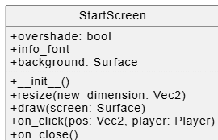
StartScreen.draw(screen):
Draws the static startscreen.

StartScreen.on_click(pos, player):
Removes the start screen.

StartScreen.on_close():
Spawns the Grid_Surface, ScoreOverlay, and a Transition_Surface.

StartScreen.resize(new_dimension):
Rescales the title screen background for window resizing.

5. Grid_Surface
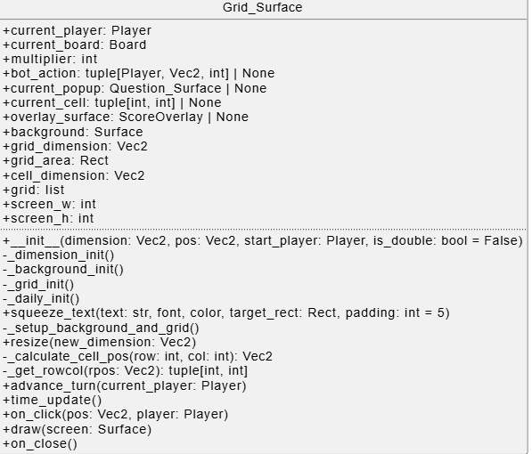
Grid_Surface.current_player: Player:
Store the current player in charge.

Grid_Surface.current_board:
Stores the current board.

Grid_Surface.current_popup:
Stores the reference to the current Question Surface in use.

Grid_Surface.grid:
Store the cells, and whether they are flashing or is already used.

Grid_Surface.draw(screen):
Draws the board background, categories, and the cells with their values.

Grid_Surface.on_click(pos, player):
Detects which cell is clicked and creates a Question_Surface for it. Only the current player can click.

Grid_Surface.time_update():
Runs bot actions, manages popup lifecycle, and checks if the board is finished.

Grid_Surface.advance_turn(current_player):
Switches the current player to the previous player who has correctly answered.

Grid_Surface.resize(new_dimension):
This method recalculates grid areas/cell rects when the window is resized.

Grid_Surface._get_rowcol(rpos):
Converts a click position into a grid in row, col.

6. Question_Surface
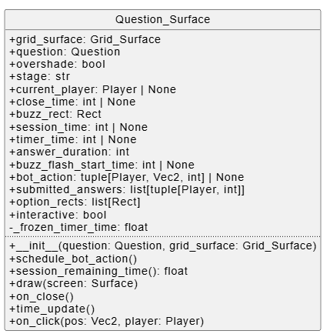
Question_Surface.question: Question:
Store the current question being displayed.

Question_Surface.stage:
Store the state machine stage (Buzz, Answering, Result, etc.).

Question_Surface.current_player:
Store the player who buzzed in and is answering.

Question_Surface.draw(screen):
Draw the clue, buzz button, timer, and answer options.

Question_Surface.on_click(pos, player):
Handles buzzing and option selection.

Question_Surface.time_update():
Updates timers, triggers bot actions, and closes the popup when finished.

Question_Surface.schedule_bot_action():
Schedules bot buzzing or bot answers depending on the stage the surface is in .

Question_Surface.session_remaining_time():
Returns the amount of remaining seconds for the current answering timer.

Question_Surface.on_close():
Tells the Grid_Surface to advance to the next player.

7. ScoreOverlay
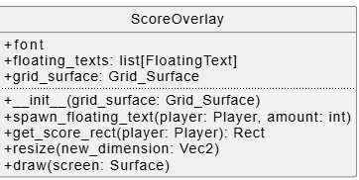
ScoreOverlay.draw(screen):
Draws each player name/score and the arrow for the current turn.

ScoreOverlay.spawn_floating_text(player, amount):
Creates FloatingText objects to animate score changes.

ScoreOverlay.resize(new_dimension):
Keep the overlay at the top-right after resizing.

ScoreOverlay.get_score_rect(player):
Returns the rect used to anchor FloatingText near a player's score.

8. FloatingText
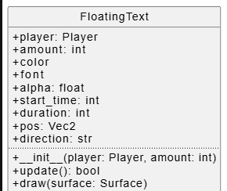
FloatingText.update():
Updates position and alpha and returns whether the surface is still alive.

FloatingText.draw(surface):
Draws the floating score text onto the overlay surface.

9. Transition_Surface

Transition_Surface.draw(screen):
Animates the transition image (drop/bounce/shake) and fades out.

Transition_Surface.time_update():
Freezes game time using Game_Manager.frame_frozen while active.

Transition_Surface.on_close():
Unfreezes the game time when the transition ends.

Transition_Surface.resize(new_dimension):
Rescales the transition image when the window is resized.

Transition_Surface._bounce(t):
Calculates a bounce offset for the animation.

10. Cutscene_Surface
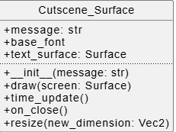
Cutscene_Surface.draw(screen):
Draws the overlay and animated message from small size to large size.

Cutscene_Surface.time_update():
Freezes the game timer while the cutscene is active.

Cutscene_Surface.on_close():
Unfreezes time when the cutscene is removed to allow for other surfaces to track time correctly.

Cutscene_Surface.resize(new_dimension):
Resizes the overlay surface for a new window size.

11. BorderFlash
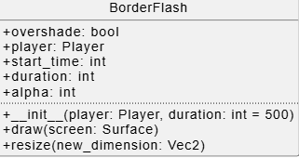
BorderFlash.draw(screen):
Draws the flash border and kill itself after the time.

BorderFlash.resize(new_dimension):
Resizes the flash surface when the window is resized.

12. FinalJeopardy
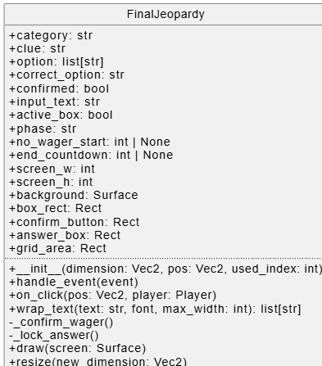
FinalJeopardy.handle_event(event):
Reads keyboard input and put into the wager/answer input field.

FinalJeopardy.on_click(pos, player):
Handles clicking input boxes and the confirm button.

FinalJeopardy.draw(screen):
Draws the final UI and reveals correct answers after time.

FinalJeopardy.resize(new_dimension):
Recalculates layout when the window is resized.

FinalJeopardy._confirm_wager():
Confirms the human wager and switches to answer phase.

FinalJeopardy._lock_answer():
Locks all answers, assigns bot answers, and applies scoring.

13. End_Surface
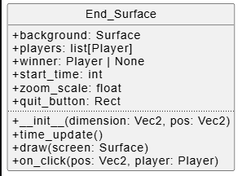
End_Surface.time_update():
Updates the zoom animation.

End_Surface.draw(screen):
Draws winner information and the quit button.

End_Surface.on_click(pos, player):
Quits the game if the quit button is clicked.

14. Player
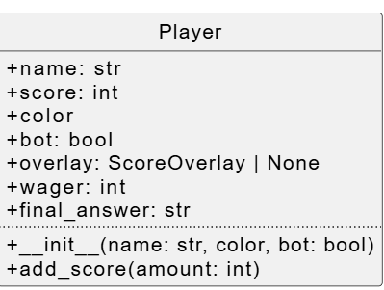
Player.name: str:
Stores the player's display name.

Player.score: int:
Stores the player's current score.

Player.bot: bool:
A boolean indicating whether the player is an AI bot.

Player.add_score(amount):
Adds points and triggers overlay floating text.

15. Question
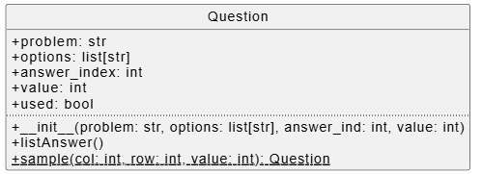
Question.problem: str:
Stores the clue text.

Question.options: list[str]:
Stores the options of answer.

Question.answer_index: int:
Stores the index of the correct option.

Question.value: int:
Stores the dollar value.

Question.listAnswer():
Prints the options to the console.

Question.sample(col, row, value):
Generates a sample question object.

16. LLMQuestionGenerator
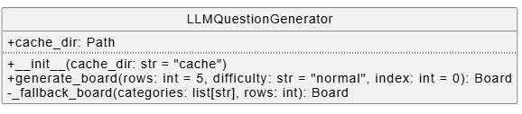
LLMQuestionGenerator.cache_dir:
Stores the cache folder path.

LLMQuestionGenerator.generate_board(rows=5, difficulty="normal", index=0):
Make a Jeopardy board, which is a list of questions.

LLMQuestionGenerator._fallback_board(categories, rows):
Returns simple dummy questions if the API fails.

17. Font
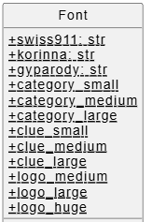
Font.category_small / Font.category_medium / Font.category_large:
These attributes store fonts used for category/value text.

Font.clue_small / Font.clue_medium / Font.clue_large:
These attributes store fonts used for clue text.

Font.logo_medium / Font.logo_large / Font.logo_huge:
These attributes store fonts used for logo/transition text.

18. Color
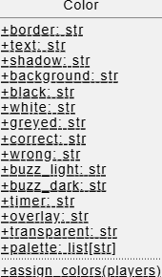
Color.palette:
This attribute stores a list of frequently called hex values. This includes color such as background, text, player assigned color and visual effects.

Color.assign_colors(players):
This method assigns a random distinct color from the palette to each player. This is done such that every game won’t look exactly the same and freshen the user experience.

Reference
all image comes from:
https://gameshows.fandom.com/wiki/Jeopardy!

all sound effect comes from:
https://www.myinstants.com/en/search/?name=jeopardy

