Goodness of fit diagnostics for Markov models
Cormac Monaghan
Idemauro Antonio Rodrigues de Lara
Rafael de Andrade Moral
Joanna McHugh Power
2025-11-27

Introduction
Dementia is a neurogenerative disease characterized by progressive deterioration in cognitive ability (Prince et al., 2013). Mathematically, this progression can be represented as a sequence of $K$ mutually exclusive states such that $S=\{1,2,…K\}$ beginning with a preclinical or asymptomatic period, transitioning through an intermediate stage such as mild cognitive impairment (MCI), and culminating in dementia (Sanz-Blasco et al., 2022). Understanding these transitions is central to epidemiological forecasting, intervention evaluation, and the design of health and social care services.
Because progression unfolds over time and involves movement between discrete, observable states, Markov models have become a widely used methodological tool for studying dementia trajectories (Costa et al., 2023; Salazar et al., 2007; Sanz-Blasco et al., 2022; Wei et al., 2014; Williams et al., 2020; Yu et al., 2013). Within these models, the cognitive state of individual $i$ at time $t$, denoted $Y_{i,t}∈S$, is represented as a stochastic process governed by the Markov property (Zhang et al., 2010):
$$P\left(Y_{i,t+1}=k |Y_{i,t}=j,Y_{i,t−1}=j_{t−1},…Y_{i0}=j_{0}\right)=P\left(Y_{i,t+1}=k | Y_{i,t}=j\right). \left(1\right)$$
This property asserts that the probability of transitioning from state $j$ to state $k$ depends only on the current state $Y_{i,t}$ and not on the full history of preceding states $\{Y_{i,t−1},…,Y_{i0}\}$. Under this assumption, Markov models offer a flexible framework for estimating transition probabilities $p_{jk}$, describing the likelihood of movement from state $j$ to state $k$ over a fixed time interval.
Despite their widespread use, several practical challenges arise when applying Markov models in dementia research. Firstly, Markov models can be formulated in either continuous or discrete time, but many longitudinal cohort studies collect observations at discrete intervals (e.g., annual or biennial assessments). Although R (R Core Team, 2025) provides a well-developed ecosystem for fitting continuous-time Markov models (Jackson, 2011; Ucar et al., 2019), dedicated tools for discrete-time Markov models are less developed. Existing packages such as DTMCPack (William, 2013) and markovchain (Spedicato, 2017) are useful but do not support covariate-dependent discrete-time transitions. Consequently, a common approach is to estimate the transition probabilities using a multinomial logistic regression model (see Spackman et al. (2012) as an example), treating the state at time $t+1$ as a categorical outcome conditional on the state at time $t$. Within this framework, the transition probabilities from state $j$ are modeled as:
$$log\left(\frac{p_{jk}\left(z_{i,t}\right)}{p_{j1}\left(z_{i,t}\right)}\right)=α_{jk}+z_{i,t}^{⊺}β_{jk} k=2,…,K, \left(2\right)$$
where $p_{j1}$ is the reference probability (e.g., remaining in state $j$), $α_{jk}$ is a state-pair specific intercept, and $β_{jk}$ is a vector of coefficients for covariates $z_{i,t}$ (of which $Y_{i,t}$ is inclusive).
However, while estimating covariate-dependent transition probabilities is straightforward using multinomial models, such that for a non-reference category,
$$p_{jk}\left(z_{i,t}\right)=\frac{exp\left(η_{i,t}^{\left(k\right)}\right)}{1+\sum_{ℓ=2}^{K}{exp}\left(η_{i,t}^{\left(ℓ\right)}\right)}, \text{for }k=2,3 \left(3\right)$$
and for the reference category,
$$p_{j1}\left(z_{i,t}\right)=\frac{1}{1−\sum_{j=1}^{J−1}{exp}\left(η_{i,t}^{\left(j\right)}\right)} \left(4\right)$$
where $η_{i,t}^{\left(k\right)}=α_{jk}+z_{i,t}^{⊤}β_{jk}$, diagnostic analysis and evaluating the goodness of fit of these Markov models remains an methodological challenge and is subject to ongoing research (Araripe et al., 2024). Unlike conventional regression frameworks, where a direct comparison is made between observed $\left(y\right)$ and predicted $\left(\hat{y}\right)$ values, the output of a Markov model is a set of transition probabilities. For a model with the $K$ states these probabilities are represented by a $K×K$ transition probability matrix $P$, where each element $p_{jk}$ is the probability of transitioning from state $j$ at time $t$ to state $k$ at time $t+1$:
$$P=\left(\begin{matrix}p_{11} & p_{12} & … & p_{1K} \\ p_{21} & p_{22} & … & p_{2K} \\ ⋮ & ⋮ & ⋱ & ⋮ \\ p_{K1} & p_{K2} & … & p_{KK}\end{matrix}\right).$$
Since an observed transition is a stochastic realization from this probability distribution, there is no direct analogue to prediction error or residuals that cleanly links observed transitions to model-implied transition mechanisms. Existing methods, such as likelihood-ratio tests, information criteria, or simulation envelopes, provide valuable but partial insights. They often fail to provide a comprehensive, quantitative measure of how well the aggregate transition structure of the fitted transition probability matrix replicates the empirical dynamics observed within the cohort data.

Distance metrics
To address this gap, a natural approach is to compare the empirical transition structure observed in the data with the model-implied transition structure produced by the fitted model. Let $P$ denote the empirical transition matrix estimated directly from the observed transitions, and let $\hat{P}$ denote the corresponding transition matrix estimated by fitting a Markov model. The central question then becomes: “How different is $\hat{P}$ from $P$?”. In univariate models, a simple way of measuring this difference is by calculating a residual, which typically relies on the signed unidimensional distance between an observation and a fitted value (e.g., $y−\hat{y}$). However, determining the best way to measure a distance between two matrices is less trivial.
Distance-based metrics provide a principled way to quantify discrepancies between two transition matrices. These metrics treat the transition matrix as a $K×K$ object whose structure can be assessed globally, rather than focusing on individual probabilities in isolation. Let $D=P−\hat{P}$ denote the matrix of element-wise differences. Several matrix norms and divergence measures can then be used to summarize the magnitude of discrepancy, each emphasizing different structural features of the transition process. For the purpose of this paper we focus on five of these distance measures which are summarized in Table 1. In addition, we compare these measures against current benchmark information criteria (AIC and BIC) within simulation studies whose complete setup is explained in the Methods section.
Table 1: Distance based metrics and information crietia used in study
Metric | Formula
Frobenius norm | $\left|\right|D{\left|\right|}_{F}=\sqrt{\sum_{j=1}^{K}{\sum_{k=1}^{K}{d_{j,k}^{2}}}}$
Manhattan distance | $\sum_{j=1}^{K}{\sum_{k=1}^{K}{\left|d_{j,k}\right|}}$
Maximum absolute error | $\max_{j,k}\left|d_{j,k}\right|$
Root mean squared error | $\sqrt{\frac{1}{K^{2}}\sum_{j=1}^{K}{\sum_{k=1}^{K}{d_{j,k}^{2}}}}$
Correlation dissimilarity | $1−\text{corr}\left(\text{vec}\left(P\right),\text{vec}\left(\hat{P}\right)\right)$
Akaike information criterion | $2k−2\text{ln}\left(\hat{ℓ}\right)$
Bayesian information criterion | $−2\text{ln}\left(\hat{ℓ}\right)+k\text{ln}\left(n\right)$
K represents the total number of categories; corr(x, y) = i​xi−xyi−yi​xi−x2(i​yi−y2 is the Pearson correlation function; vec(⋅) is an operator that converts a matrix into a vector by stacking its columns such that $\text{vec}={\left(a,b,c,d\right)}^{⊺}$; $θ$ is the number of model parameters; $ℓ$ is the model’s log-likelihood; $n$ is the sample size.

Methods

Simulation study aims
We designed a simulation study to evaluate the performance of different matrix-based distance metrics in assessing the goodness-of-fit of discrete-time Markov models for dementia progression. The primary aim was to determine whether these metrics can reliably detect misspecification in multinomial logistic regression models used to estimate transition probabilities. The study follows best practices for simulation reporting using the ADEMP framework (Morris et al., 2019; Siepe et al., 2024).

Data generating mechanisms

Markov process structure
We simulated data for $N=10,000$ individuals across $t=3$ waves. Consistent with typical dementia progression, the data was simulated for a process with $K=3$ mutually exclusive states such that $S∈\{1,2,3\}$, representing a pre-clinical state (1), mild cognitive impairment (2), and dementia (3). For each individual $i∈\{1,…,N\}$ and discrete time point $t∈\{1,…,T\}$, the true state at time $t$ is denoted as $Y_{i,t}∈S$. Under a first-order Markov process, transitions between states satisfy the Markov property (Equation 1).

Covariate specification
We generated a set of time-invariant and time-varying covariates designed to mimic plausible risk factors observed in ageing cohort studies (Sonnega et al., 2014). Each covariate was chosen to reflect either a common demographic factor, a behavioural or psychological construct, or generic background variability that may influence cognitive transitions (Monaghan et al., 2026).
- $x_{1}$: A binary covariate drawn from a Bernoulli distribution with probability of success $0.5$. Within the simulation, this variable represents a binary demographic attribute such as gender.
- $x_{2}$: A continuous covariate drawn from a normal distribution $x_{2}∼N\left(μ=70, σ^{2}=25\right)$ and then rounded to the nearest whole number. Within the simulation, this variable represents age.
- $x_{3}$: A continuous covariate from a normal distribution $x_{3}∼N\left(μ=25, σ^{2}=225\right)$, truncated to the interval $\left[0,60\right]$ such that $\tilde{x_{3}}=\left\{\begin{matrix}0 & x_{3}<0, \\ x_{3} & 0≤x_{3}≥60, \\ 60 & x_{3}>60\end{matrix}\right.$ and then rounded to the nearest whole number. Within the simulation, this variable represents psychological or behavioural assessments (e.g., memory tests or psychosocial scales) with fixed bounded scores.
- $x_{4},x_{5}$: Continuous noise variables, drawn from a uniform distribution $U\left(0,1\right)$.
Four of these covariates evolved over time to introduce time-varying confounding:
$$\begin{matrix}x_{2i,t} & =x_{2i0}+\left(t−1\right)×2 \\ x_{3i,t} & =min\left(60,max\left(0,x_{3i,\left(t−1\right)}+ϵ_{i,t}^{\left(3\right)}\right)\right) & & ϵ_{i,t}^{\left(3\right)}∼N\left(5,4\right) \\ x_{4i,t} & =min\left(1,max\left(0,x_{4i,t−1}+ϵ_{i,t}^{\left(4\right)}\right)\right) & & ϵ_{i,t}^{\left(4\right)}∼U\left(0,0.062\right) \\ x_{5i,t} & =min\left(1,max\left(0,x_{5i,t−1}+ϵ_{i,t}^{\left(5\right)}\right)\right) & & ϵ_{i,t}^{\left(5\right)}∼U\left(0,0.062\right),\end{matrix}$$
where $t∈\{1,2,3\}$ indexes follow-up waves. The full covariate vector for individual $i$ at time $t$ was $z_{i,t}=\left(x_{1i,t}, x_{2i,t}, x_{3i,t}, x_{4i,t}, x_{5i,t}\right)$.

Simulation scenarios
We evaluated three data-generating mechanisms (DGMs) of increasing complexity. In all scenarios, transition probabilities were governed by a multinomial logistic model (Equation 2) with state 1 as the reference category. The corresponding transition probability for each non-reference category was calculated using Equation 3 and for the reference category using Equation 4. Additionally, all true value parameters $\left(θ_{S1},θ_{S2},θ_{S3}\right)$ were derived from prior empirical research (Monaghan et al., 2026).
In scenario 1, transitions depended solely on a set of individual covariates $X_{i,t}=\left(x_{1it},x_{2it},x_{3it}\right)$, with no effect of the previous state. Within this scenario, the linear predictor was defined as:
$$η_{i,t}^{\left(k\right)}=α_{k}+X_{it}^{⊺}β_{k},$$
with true value parameters set as:
$$\begin{matrix}θ_{S1} & =\left(α_{k}, β_{1k}, β_{2k}, β_{3k}, :k=2,3\right) \\ α & =\left(−5.152,−5.402\right) \\ β & =\left(0.008,−0.034,0.036,0.017,0.028,0.045\right).\end{matrix}$$
In scenario 2, transitions depended additively on both the covariates $X_{i,t}=\left(x_{1it},x_{2it},x_{3it}\right)$ and the individual’s previous state $Y_{it}$. Within this scenario, the linear predictor was defined as:
$$\begin{matrix}η_{i,t}^{\left(k\right)} & =α_{k}+X_{it}^{⊺}β_{k}+S_{it}^{⊺}γ_{k},\end{matrix}$$
where $S_{it}$ is an indicator variable. The true value parameters were set as:
$$\begin{matrix}θ_{S2} & =\left(α_{k}, β_{1k}, β_{2k}, β_{3k},γ_{1k}, γ_{2k}, :k=2,3\right) \\ α & =\left(−5.370,−7.907\right) \\ β & =\left(0.02,−0.011,0.036,0.039,0.022,0.016,1.711,2.790\right) \\ γ & =\left(−0.776,20.914\right).\end{matrix}$$
Finally, in scenario 3, transitions depended both on the covariates $X_{i,t}=\left(x_{1it},x_{2it},x_{3it}\right)$ and the individual’s previous state $Y_{it}$ along with their corresponding interactions. Within this scenario, the linear predictor was defined as:
$$η_{i,t}^{\left(k\right)}=α_{k}+X_{it}^{⊺}β_{k}+S_{it}^{⊺}γ_{k}+{\left(X_{it}⊗S_{it}\right)}^{⊺}δ_{k},$$
with true value parameters defined as:
$$\begin{matrix}θ_{S3} & =\left(α_{k}, β_{1k}, β_{2k}, β_{3k},γ_{1k}, γ_{2k}, δ_{1k}, δ_{2k}, δ_{3k}, δ_{4k}, δ_{5k}, δ_{6k},:k=2,3\right) \\ α & =\left(−5.885,−10.613\right) \\ β & =\left(0.102,0.615,0.043,0.076,0.019,−0.002\right) \\ γ & =\left(3.845,7.901,−0.638,12.753\right) \\ δ & =\left(−0.292,−1.019,−0.474,−1.268,−0.031,−0.072,0.093,0.1,0.008,0.029,−0.082,−0.021\right).\end{matrix}$$

Estimation methods

Model fitting
For each simulated dataset, we fitted 15 multinomial logistic regression models using the nnet package (Venables & Ripley, 2002) across 4 different sample sizes $\{100,250,1000,5000\}$. These models were grouped into three “families”, corresponding to the level of model misspecification relative to the true DGM.
- Base Models (Ignoring Markov Property)
$$\begin{matrix}\text{Null:} & Y_{t+1}∼1 \\ \text{Reduced 1:} & Y_{t+1}∼x1 \\ \text{Reduced 2:} & Y_{t+1}∼x1+x2 \\ \text{True:} & Y_{t+1}∼x1+x2+x3 \text{(Exact DGM for Scenario 1)} \\ \text{Overfit:} & Y_{t+1}∼x1+x2+x3+x4+x5\end{matrix} \left(5\right)$$
- Additive Models (With State Dependence)
$$\begin{matrix}\text{Null:} & Y_{t+1}∼Y_{t} \\ \text{Reduced 1:} & Y_{t+1}∼x1+Y_{t} \\ \text{Reduced 2:} & Y_{t+1}∼x1+x2+Y_{t} \\ \text{True:} & Y_{t+1}∼x1+x2+x3+Y_{t} \text{(Exact DGM for Scenario 2)} \\ \text{Overfit:} & Y_{t+1}∼x1+x2+x3+x4+x5+Y_{t}\end{matrix} \left(6\right)$$
- Multiplicative Models (With Interactions)
$$\begin{matrix}\text{Null:} & Y_{t+1}∼Y_{t} \\ \text{Reduced 1:} & Y_{t+1}∼x1*Y_{t} \\ \text{Reduced 2:} & Y_{t+1}∼\left(x1+x2\right)*Y_{t} \\ \text{True:} & Y_{t+1}∼\left(x1+x2+x3\right)*Y_{t} \text{(Exact DGM for Scenario 3)} \\ \text{Overfit:} & Y_{t+1}∼\left(x1+x2+x3+x4+x5\right)*Y_{t}\end{matrix} \left(7\right)$$

Model-based transition probabilities
To evaluate how well each fitted model $M$ captured the underlying transition dynamics, we generated model-based transition probability matrices via a two step procedure. In the first step, an augmented dataset was created enabled the model to predict transitions from all possible previous states. For each individual $i$ at each time point $t$, three augmented rows were created corresponding to the three possible previous states $j∈\{1,2,3\}$. This ensured that the fitted model could generate predicted probabilities
$$P\left(Y_{t+1}=k | Y_{t}=j,z_{i,t}\right)$$
for every $j$, regardless of the individual’s actual previous state in the observed data.
In the second step, we derived the transition behaviour implied by each model by predicting next-state transitions using the model’s estimated parameters. For each model $M$, the estimated coefficients ${\hat{θ}}^{M}$ were extracted and treated them as the new “true” data-generating parameters. Using these parameters, we predicted next-state transitions ${\hat{Y}}_{i,t+1}$ for each individual and time point, conditional on their observed covariates. This produced predicted transition patterns implied by model $M$, rather than those realized in the original simulation.

Performance Measures
The core of our evaluation involved comparing the empirical transition matrix from the original simulated data to the model-implied transition matrix. Let $P_{i,t}$ be the empirical transition matrix for individual $i$ at time $t$ estimated by tabulating state transitions $\left(Y_{i,t},Y_{i,t+1}\right)$ from the original simulated data. Additionally, let ${\hat{P}}_{i,t}$ be the model-implied transition matrix. For individual $i$ at time $t$ with a covariate pattern $z_{i,t}$ this is a $K×K$ matrix where the entry $j,k$ is the model’s predicted probability $P\left(Y_{t+1}=k | Y_{t}=j,z_{i,t}\right)$. We defined the difference matrix as $D_{i,t}=P_{i,t}−{\hat{P}}_{i,t}$ and quantify the discrepancy using the distance metrics defined in Table 1.

Results
Initially we present an exploratory analysis of the data from each scenario using contingency tables. Table 2 summarizes the unconditional transitions and transition probabilities between each cognitive state across the scenarios.
Table 2: Unconditional transitions and transition probabilities across scenarios.
 | Current state (t)
Scenario 1 | Scenario 1 |  |  | Scenario 1
1
2 | 2155(0.11) | 498(0.02) | 204(0.01) | 2857
3 | 750(0.04) | 167(0.01) | 67(0.003) | 984
Scenario 2 | Scenario 2 | Scenario 2 | Scenario 2 | Scenario 2
1
2 | 1657(0.08) | 2606(0.04) | 162(0.01) | 2606
3 | 120(0.01) | 55(0.003) | 1214(0.06) | 1389
Scenario 3 | Scenario 3 | Scenario 3 | Scenario 3 | Scenario 3
1
2 | 1602(0.08) | 712(0.04) | 167(0.01) | 2481
3 | 102(0.01) | 61(0.003) | 1239(0.06) | 1402

To evaluate the ability of each distance metric to identify the true data-generating model, we examined the proportion of simulation repetitions in which each model $M$ was ranked as the best-fitting (Figure 1).

Small sample sizes
For the smallest sample size $\left(n=100\right)$ the Manhattan distance metric was able to identify the true model as often as and, when under increased model complexity, more often than the standard information criteria. The relative robustness in small samples suggests that the Manhattan distance metric is less sensitive to the sampling variability that destabilizes likelihood-based criteria. The remaining metrics (e.g., Frobenius norm, RMSE, correlation dissimilarity) showed mixed performance, often favoring overfitted or reduced models. Notably, for the $n=250$ repetitions, AIC improved modestly, but continued to misidentify the true model when under increased complexity, especially when interaction terms (Scenario 3) were present. BIC remained unreliable across all scenarios, strongly penalizing model complexity and frequently selecting the null model. In contrast, the Manhattan distance continued to show the most stable ability to detect the true model across repetition, outperforming AIC for the more complex generative scenarios.

Moderate sample sizes
With a moderate increase in sample size $\left(n=1000\right)$, AIC’s performance improved markedly, correctly identifying the true model in more than $90\%$ of repetitions across all scenarios. This reflects its well-known asymptotic behaviour in nested model comparisons. However, BIC continued to underfit, performing well only in Scenario 1 (the simplest generative mechanism) and frequently discarding key covariates or state-dependent terms in Scenarios 2 and 3.
The distance-based metrics showed a more gradual improvement. Most notably, the Manhattan distance consistently ranked the true model as best fitting in approximately half of all repetitions (substantially lower than AIC, but still meaningfully informative). Importantly, their accuracy did not collapse under model complexity, suggesting that these measures capture discrepancies in transition structure that are not always reflected in likelihood-based information criteria. The other metrics continued to show variable behaviour, with some leaning toward overfitted models and others exhibiting instability across replications.

Large sample sizes
At the largest sample size examined $\left(n=5000\right)$, both AIC and BIC demonstrated near-perfect performance, identifying the true model in essentially all simulation repetitions across all scenarios. This confirms that, when data are abundant, traditional likelihood-based criteria are sufficient for model recovery.
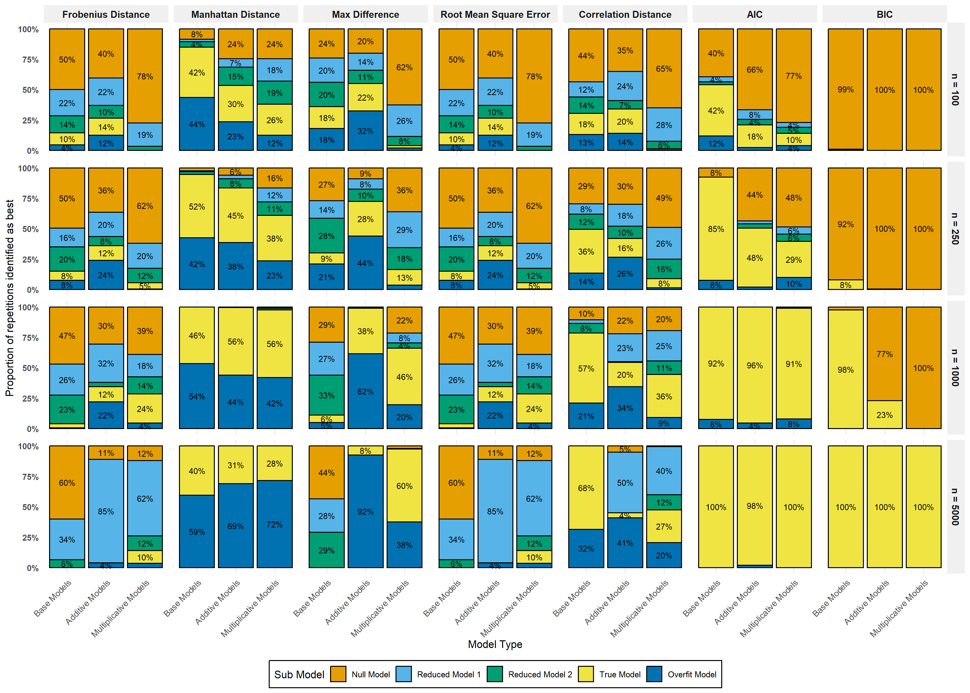
Figure 1: Proportion of times when each model was identified as the best. Each bar represents a different model type, with a longer coloured bar indicating that the associated model was selected as the ‘best fitting’ model more often.

Case study
We illustrate the proposed goodness-of-fit assessment framework using data from the United States Health and Retirement Study (HRS; Sonnega et al. (2014)). The HRS is a nationally representative longitudinal panel study administered by the Institute for Social Research at the University of Michigan, which follows American adults aged 50 years and older. Since its inception in 1992, the HRS has collected biennial data on participants’ health, socioeconomic circumstances, and cognitive functioning, making it a widely used resource for studying cognitive ageing and dementia trajectories. For the purpose of this illustration, we focus on three of these biennial waves from 2018 - 2022.
Cognitive function in the HRS is measured using a battery of assessments adapted from the Telephone Interview for Cognitive Status (TICS; Fong et al. (2009)). These assessments include immediate and delayed noun free-recall tasks to evaluate episodic memory, a serial sevens subtraction task to assess working memory, and a backward counting task to capture mental processing speed. Based on these assessments, Crimmins et al. (2011) developed a validated 27-point cognitive scale along with established cut-off points to classify respondents’ cognitive status. Following this classification scheme, respondents scoring between 12 and 27 were classified as having normal cognition, scores between 7 and 11 indicated mild cognitive impairment (MCI), and scores between 0 and 6 were classified as dementia.
From the available HRS covariates, we selected five predictors that are commonly examined in studies of cognitive decline (Livingston et al., 2024): sex ($x1$), age ($x2$), systolic blood pressure ($x3$), height ($x4$), and weight ($x5$). Sex, age, and systolic blood pressure were selected as primary predictors, as these variables have well-established associations with cognitive decline and dementia progression. In contrast, height and weight were included as weak or plausibly non-informative predictors, serving primarily to introduce additional covariate variation and to assess the ability of the proposed goodness-of-fit measures to distinguish meaningful signal from noise.
Using this covariate set, we fitted the 15 multinomial logistic regression models defined in Equation 5, Equation 6, and Equation 7 and compared $P_{i,t}$ to the resulting ${\hat{P}}_{i,t}$. Figure 2 summarizes the relative performance of each model across the distance metrics. Consistent with the simulation study, the Manhattan distance metric identified the true model for sample sizes $n∈\{250,1000,5000\}$, however, favored the over-fitted model for size $n=100$.
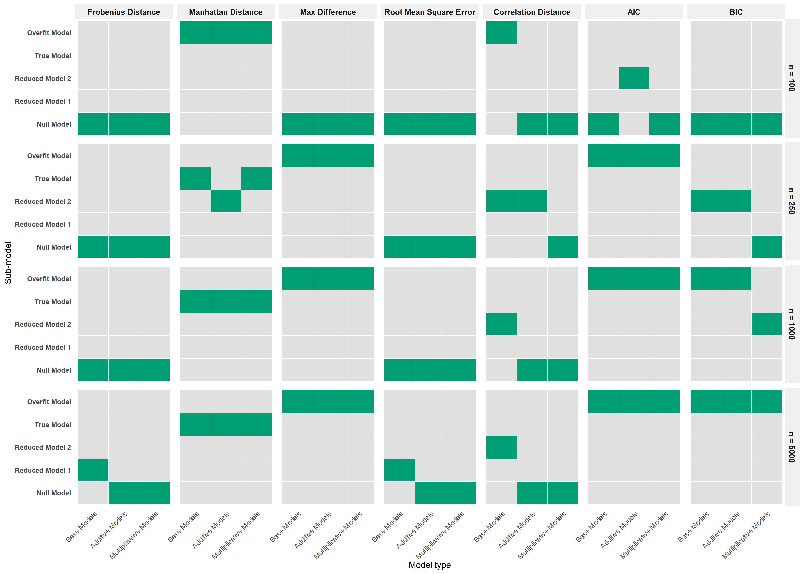
Figure 2: Relative model performance across distance metrics for the HRS case study. Green bars indicate the model identified as best-fitting under each distance metric.

Discussion
This study evaluated a set of matrix-based distance metrics as tools for assessing the goodness-of-fit of discrete-time Markov models estimated via multinomial logistic regression, with a particular focus on the usage of such models for dementia progression. Through a simulation study and an empirical case study using HRS data, the results show that distance-based comparisons of observed and model-implied transition matrices offer additional insights beyond traditional likelihood-based criteria.
In the simulation study, the Manhattan distance exhibited strong performance across a range of sample sizes and data-generating mechanisms. Notably, it outperformed AIC and BIC in small samples and under increased model complexity, especially when there were state dependence and interaction effects. This finding indicates that distance-based metrics may be less affected by sampling variability, which can make likelihood-based model selection unreliable in small samples (Emiliano et al., 2014). While AIC and BIC adjust indirectly with penalties on the likelihood, the Manhattan distance directly assesses model fitness by comparing the observed and implied transition structures. As a result, it seems more effective at catching structural errors in transition dynamics, even when likelihood-based criteria favor oversimplified or overly complex models.
As sample size increased, traditional information criteria improved substantially, with both AIC and BIC demonstrating near-perfect recovery of the true data-generating model in large samples. This behaviour is consistent with their known asymptotic properties and confirms that likelihood-based approaches remain appropriate when data are abundant. However, the more gradual improvement observed for the distance-based metrics highlights an important distinction: these metrics do not focus on maximizing predictive likelihood. Instead, they assess how well a fitted model reproduces the actual empirical transition structure. Consequently, their ongoing sensitivity to model misspecification in larger samples can be seen as a strength, especially in applied situations where structural realism matters.
The empirical case study further corroborated the simulation findings. Distance-based metrics, particularly the Manhattan distance, tended to favor models including established predictors of cognitive decline (i.e., sex, age, and systolic blood pressure), while remaining less sensitive to the inclusion of weak or non-informative covariates (i.e., height and weight). This behaviour aligns with the intended role of the distance metrics: to distinguish meaningful signal in transition dynamics from noise introduced by irrelevant predictors. Notably, at the smallest sample size $\left(n=100\right)$, some tendency toward overfitting was observed, mirroring patterns seen in the simulations and underscoring the continued importance of cautious model interpretation in limited data settings.
Taken together, these findings suggest that matrix-based distance metrics provide a valuable addition to the toolkit for evaluating discrete-time Markov models, particularly in contexts where researchers are interested in the accuracy of the implied transition structure rather than just the likelihood-based fit. As such, rather than serving as replacements for information criteria, these measures are best viewed as complementary diagnostics that can reveal forms of misspecification not readily detected by conventional approaches. In applied research on dementia progression and related longitudinal processes, incorporating such distance-based assessments may lead to more transparent and structurally sound model evaluation.

Limitations and future directions
Several limitations of the present study suggest directions for future research. First, although the proposed goodness-of-fit framework captures discrepancies in transition structure that are not reflected in likelihood-based criteria, the choice of distance metric remains application-dependent. Different metrics emphasize different aspects of the transition matrix (e.g., global versus state-specific discrepancies), and no single metric can be considered universally optimal. Future work could explore principled strategies for selecting or combining distance measures, potentially informed by substantive theory or decision-analytic considerations. Secondly, this simulation framework focuses on discrete-time, first-order Markov models. Extensions to higher-order Markov processes (e.g., continuous-time models, or hidden Markov models) represent promising avenues for future research (see Zeng et al. (2010) as example).

Conclusions
Matric-based distance metrics may serve as a complementary tool alongside likelihood-based criteria for assessing discrete-time Markov models. By comparing empirical transition matrices to those implied by fitted models, the approach provides diagnostic information that complements traditional likelihood-based criteria and is especially sensitive to forms of structural misspecification.

Araripe, P. P., Rodrigues De Lara, I. A., Rodrigues Palma, G., Cahill, N., & De Andrade Moral, R. (2024). Diagnostics for categorical response models based on quantile residuals and distance measures. Journal of Applied Statistics, 1–23. https://doi.org/10.1080/02664763.2024.2367150
Costa, L. M., Colaço, J., Carvalho, A. M., Vinga, S., & Teixeira, A. S. (2023). Using Markov chains and temporal alignment to identify clinical patterns in Dementia. Journal of Biomedical Informatics, 140, 104328. https://doi.org/10.1016/j.jbi.2023.104328
Crimmins, E. M., Kim, J. K., Langa, K. M., & Weir, D. R. (2011). Assessment of Cognition Using Surveys and Neuropsychological Assessment: The Health and Retirement Study and the Aging, Demographics, and Memory Study. The Journals of Gerontology: Series B, 66B, i162–i171. https://doi.org/10.1093/geronb/gbr048
Emiliano, P. C., Vivanco, M. J., & De Menezes, F. S. (2014). Information criteria: How do they behave in different models? Computational Statistics & Data Analysis, 69, 141–153. https://doi.org/10.1016/j.csda.2013.07.032
Fong, T. G., Fearing, M. A., Jones, R. N., Shi, P., Marcantonio, E. R., Rudolph, J. L., Yang, F. M., Dan Kiely, K., & Inouye, S. K. (2009). Telephone Interview for Cognitive Status: Creating a crosswalk with the Mini-Mental State Examination. Alzheimer’s & Dementia, 5(6), 492–497. https://doi.org/10.1016/j.jalz.2009.02.007
Jackson, C. H. (2011). Multi-state models for panel data: The msm package for R. Journal of Statistical Software, 38(8), 1–29. https://doi.org/10.18637/jss.v038.i08
Livingston, G., Huntley, J., Liu, K. Y., Costafreda, S. G., Selbæk, G., Alladi, S., Ames, D., Banerjee, S., Burns, A., Brayne, C., Fox, N. C., Ferri, C. P., Gitlin, L. N., Howard, R., Kales, H. C., Kivimäki, M., Larson, E. B., Nakasujja, N., Rockwood, K., … Mukadam, N. (2024). Dementia prevention, intervention, and care: 2024 report of the Lancet standing Commission. The Lancet, 404(10452), 572–628. https://doi.org/10.1016/S0140-6736(24)01296-0
Monaghan, C., Andrade Moral, R. de, Kelly, M., & Power, J. M. (2026). Procrastination as a marker of cognitive decline: Evidence from longitudinal transitions in the older adult population. In Alzheimer’s & Dementia: Diagnosis, Assessment & Disease Monitoring (1; Vol. 18). https://doi.org/10.1002/dad2.70245
Morris, T. P., White, I. R., & Crowther, M. J. (2019). Using simulation studies to evaluate statistical methods. Statistics in Medicine, 38(11), 2074–2102. https://doi.org/10.1002/sim.8086
Prince, M., Bryce, R., Albanese, E., Wimo, A., Ribeiro, W., & Ferri, C. P. (2013). The global prevalence of dementia: A systematic review and metaanalysis. Alzheimer’s & Dementia, 9(1), 63. https://doi.org/10.1016/j.jalz.2012.11.007
R Core Team. (2025). R: A language and environment for statistical computing. R Foundation for Statistical Computing. https://www.R-project.org/
Salazar, J. C., Schmitt, F. A., Yu, L., Mendiondo, M. M., & Kryscio, R. J. (2007). Shared random effects analysis of multi-state Markov models: Application to a longitudinal study of transitions to dementia. Statistics in Medicine, 26(3), 568–580. https://doi.org/10.1002/sim.2437
Sanz-Blasco, R., Ruiz-Sánchez de León, J. M., Ávila-Villanueva, M., Valentí-Soler, M., Gómez-Ramírez, J., & Fernández-Blázquez, M. A. (2022). Transition from mild cognitive impairment to normal cognition: Determining the predictors of reversion with multi-state Markov models. Alzheimer’s & Dementia, 18(6), 1177–1185. https://doi.org/10.1002/alz.12448
Siepe, B. S., Bartoš, F., Morris, T. P., Boulesteix, A.-L., Heck, D. W., & Pawel, S. (2024). Simulation studies for methodological research in psychology: A standardized template for planning, preregistration, and reporting. Psychological Methods. https://doi.org/10.1037/met0000695
Sonnega, A., Faul, J. D., Ofstedal, M. B., Langa, K. M., Phillips, J. W., & Weir, D. R. (2014). Cohort profile: The health and retirement study (HRS). International Journal of Epidemiology, 43(2), 576–585. https://doi.org/10.1093/ije/dyu067
Spackman, D. E., Kadiyala, S., Neumann, P. J., Veenstra, D. L., & Sullivan, S. D. (2012). Measuring Alzheimer disease progression with transition probabilities: Estimates from NACC-UDS. Current Alzheimer Research, 9(9), 1050–1058. https://doi.org/10.2174/156720512803569046
Spedicato, G. A. (2017). Discrete time markov chains with r. The R Journal, 9, 84–104. https://doi.org/10.32614/RJ-2017-036
Ucar, I., Smeets, B., & Azcorra, A. (2019). simmer: Discrete-event simulation for R. Journal of Statistical Software, 90(2), 1–30. https://doi.org/10.18637/jss.v090.i02
Venables, W. N., & Ripley, B. D. (2002). Modern applied statistics with s (Fourth). Springer. https://www.stats.ox.ac.uk/pub/MASS4/
Wei, S., Xu, L., & Kryscio, R. J. (2014). Markov transition model to dementia with death as a competing event. Computational Statistics & Data Analysis, 80, 78–88. https://doi.org/10.1016/j.csda.2014.06.014
William, N. (2013). DTMCPack: Suite of functions related to discrete-time discrete-state markov chains. https://cran.r-project.org/web/packages/DTMCPack/index.html
Williams, J. P., Storlie, C. B., Therneau, T. M., Jr, C. R. J., & Hannig, J. (2020). A Bayesian Approach to Multistate Hidden Markov Models: Application to Dementia Progression. Journal of the American Statistical Association, 115(529), 16–31. https://doi.org/10.1080/01621459.2019.1594831
Yu, H., Yang, S., Gao, J., Zhou, L., Liang, R., & Qu, C. (2013). Multi-state Markov model in outcome of mild cognitive impairments among community elderly residents in Mainland China. International Psychogeriatrics, 25(5), 797–804. https://doi.org/10.1017/S1041610212002220
Zeng, J., Duan, J., & Wu, C. (2010). A new distance measure for hidden markov models. Expert Systems with Applications, 37(2), 1550–1555. https://doi.org/10.1016/j.eswa.2009.06.063
Zhang, Y. F., Zhang, Q. F., & Yu, R. H. (2010). Markov property of Markov chains and its test. 2010 International Conference on Machine Learning and Cybernetics, 4, 1864–1867. https://doi.org/10.1109/icmlc.2010.5580952

