|  |  |
| --- | --- |
| **NAME** | **NIROSHA.C** |
| **DEPT** | **ECE-III YEAR** |
| **REG NO** | **420121106025** |
| **COLLEGE CODE** | **4201** |
| **GROUP** | **IBM-GROUP 5** |

**PROJECT:SMART WATER SYSTEM**

**Phase 1: Project Definition and Design Thinking**

**Project Definition:** The project involves implementing IoT sensors to monitor water consumption in public places such as parks and gardens. The objective is to promote water conservation by making real-time water consumption data publicly available. This project includes defining objectives, designing the IoT sensor system, developing the data-sharing platform, and integrating them using IoT technology and Python.

**Design Thinking:**

1. **Project Objectives:** Define objectives such as real-time water consumption monitoring, public awareness, water conservation, and sustainable resource management.
2. **.IoT Sensor Design:** Plan the design and deployment of IoT sensors to monitor water consumption in public places.
3. **Real-Time Transit Information Platform:** Design a mobile app interface that displays real-time parking availability to users.
4. **Integration Approach:** Determine how IoT sensors will send data to the data-sharing platform.
5. **Steps Involved:**
6. **Design:** Develop a IOT for website/apps to provide instant customer service.
7. **Applicability:** Enhance user experience by offering immediate assistance.
8. **Technology:** Use microcontrollers and sensors such as ultrasonic sensors,flow sensors, temperature,salinity,conductivity and quality of the water in real time.
9. **Language:** Java script,python,C are used to build the IOT.
10. **Transformation:** manipulate is an IOT Central data export that manipulate the format and structure of device data before exported to a destination.
11. **Real-World Analogy:** A knowledgeable hotel concierge offerings guidance at any time.

**Module 1:**

**INTRODUCTION IoT:**

**IoT stands for Internet of Things. It refers to the interconnectedness of physical devices, such as appliances and vehicles, that are embedded with software, sensors, and connectivity which enables these objects to connect and exchange data. This technology allows for the collection and sharing of data from a vast network of devices, creating opportunities for more efficient and automated systems.**

**Internet of Things (IoT) is the networking of physical objects that contain electronics embedded within their architecture in order to communicate and sense interactions amongst each other or with respect to the external environment. In the upcoming years, IoT-based technology will offer advanced levels of services and practically change the way people lead their daily lives. Advancements in medicine, power, gene therapies, agriculture, smart cities, and smart homes are just a very few of the categorical examples where IoT is strongly established.**

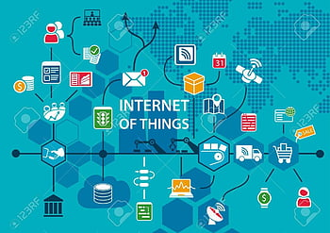

**Module 2:**

**ARDUINO UNO and Tinkercard:**

**Arduino and Tinkercad are two powerful tools that are gaining popularity in the world of electronics and engineering. While both of these tools are commonly used by hobbyists and professionals alike, many people may not have heard of them or may not fully understand what they are.**

**Arduino is an open-source electronics platform that is designed for building and programming electronic devices. It consists of a programmable microcontroller, or computer chip, that can be used to control electronic components such as LEDs, motors, sensors, and more. Arduino boards come in a variety of sizes and shapes, and they can be programmed using a variety of programming languages, including C and C++. Arduino is often used by hobbyists, artists, and designers to create interactive art installations, wearable technology, and other innovative projects.**

**Tinkercad is an online platform that allows users to design and simulate 3D models. It is a free and easy-to-use tool that is designed for beginners and experts alike. With Tinkercad, users can create 3D models of objects, buildings, and more, and then export them for 3D printing or use in other projects. Tinkercad also has a range of features that make it ideal for educational use, such as lesson plans, tutorials, and project ideas.**

**One of the most exciting things about Arduino and Tinkercad is that they can be used together. Tinkercad has a range of electronic components that can be used to build circuits and control devices, and it also has a built-in Arduino simulator that allows users to program and test their circuits in a virtual environment. This makes it easy to prototype and test new ideas before building them in the real world.**

**Overall, Arduino and Tinkercad are two powerful tools that are transforming the world of electronics and engineering. Whether you are a hobbyist, artist, designer, or educator, these tools offer endless possibilities for creating and innovating.**

**How to make smart water system using ARDUINO UNO:**

Now a days IOT plays most important role in our life.For smart water system first we have to shortlist the components thar are required to build the circuit.

* **Arduino**
* **Moisture sensor**
* **5V relay module**
* **6v Mini water pump with small pipe**
* **Connecting wires**
* **Resisters**
* **DC power input**
* **Electrode**

The image below shows the circuit designed using the components listed above:

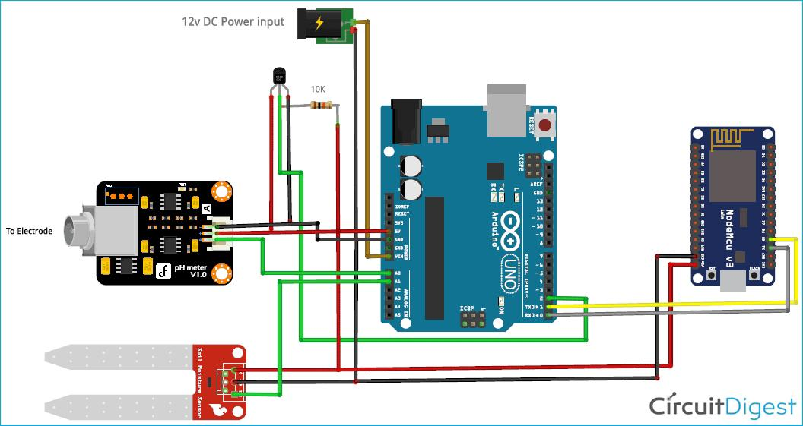**Hardware assembly for smart water system using moisture sensor and Arduino UNO**

**Fig: Smart water system for quality monitoring of water**