Colton Sellers

CSS 430 Operating Systems

Assignment 3 Report

# Part 1

Part 1 required changes to Kernel.java to use queues to handle process synchronization. Now each parent thread is assigned a QueueNode that contains the child thread IDs in a vector.

The tests described in the assignment requirements were all successful.

Figure 1: Test 2

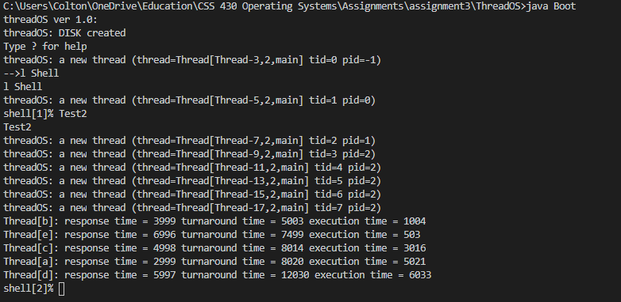

# Part 2

This part required another update to the kernel so that Disk I/O is assigned to another queue. This alleviates the current situation in which the threads were using a spin lock, just waiting to work. In this new implementation the threads were able to be entered into a queue to wait for notification instead of continuously checking.

Figure 2.1: Test 3 Kernel Old

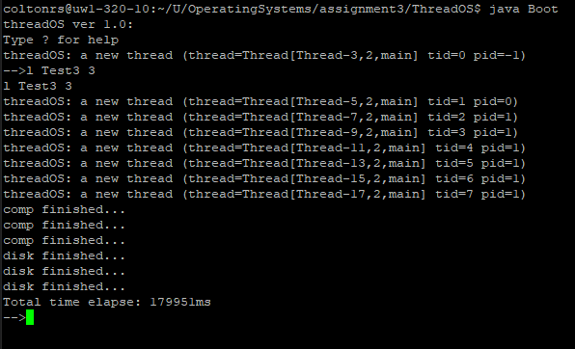

Figure 2.2 Test 3 Kernel New

