ALU CAMPUS
Murals in Motion
Immersive and Interactive AR Murals: Experience Design Document
Item | Detail
Course assignment | Creating Immersive and Interactive AR Murals (Group)
Group leader | Chibueze
Members | Chibueze, Eseosa, Thierry Gusenga, Rugamba
Repository | https://github.com/C-ifegwu/Immersive-and-Interactive-AR-Murals
Submission date | 11 October 2026

Contents
1. Overview
2. Mural Selection
M1: The Stone Head
M2: The Caravan
M3: Convention Centre
M4: The Floating Figure
M5: Living Paint
3. Experience Concept
M1: The Stone Head (Awakening)
M2: The Caravan (Journey)
M3: Convention Centre (Light)
M4: The Floating Figure (Levitation)
M5: Living Paint (Living Paint (animation))
4. AR Transformation
M1: The Stone Head
M2: The Caravan
M3: Convention Centre
M4: The Floating Figure
M5: Living Paint
5. UI Design
5.1 User flow
5.2 Screens
5.3 Visual style
6. Technical Approach
6.1 AR SDK and platform
6.2 Image tracking
6.3 Image preparation
6.4 Architecture
6.5 Assets
6.6 Animation system
6.7 Interaction system
6.8 UI implementation
6.9 Audio
7. Deliverables and Links
8. Group Attribution

Right-click the contents and choose Update Field in Word to fill in page numbers before exporting the PDF.

1. Overview
Murals in Motion is a single Android AR app that brings five murals on the ALU campus to life. Point a phone at a mural and the artwork itself starts to move: a stone head opens its eyes, a camel caravan walks on, a dome lights up, a figure's ornaments float into the room, and a portrait's jewellery swings in the wind.
Every effect is built from the mural's own photograph. The parts that move are cut out of the actual paint, so what the viewer sees is the artwork moving rather than a 3D model placed on top of it.
One rule for every mural: the painted wall dims before anything digital appears. That moment of dimming is what makes the movement read as coming out of the painting.
Mural | Title | Approach | What happens
M1 | The Stone Head | Awakening | The head blinks on its own every few seconds and its eyes follow the viewer as they move.
M2 | The Caravan | Journey | The caravans walk slowly along the dunes with a soft step, fade at the end of their stretch and start again from where they were painted.
M3 | Convention Centre | Light | A slow chase of light in Rwanda's blue, yellow and green runs up the dome while riders of the Tour du Rwanda cycle round its base, in front of the wall.
M4 | The Floating Figure | Levitation | The pieces drift in front of the figure, bobbing and turning slowly.
M5 | Living Paint | Living Paint (animation) | The earrings swing like real pendulums, a glint of light runs down the gold neck rings every few seconds, and the trees sway in a breeze.

2. Mural Selection
Murals were chosen for strong visual detail and contrast (reliable image tracking), a flat surface, and a subject that offers something to bring to life.

M1: The Stone Head
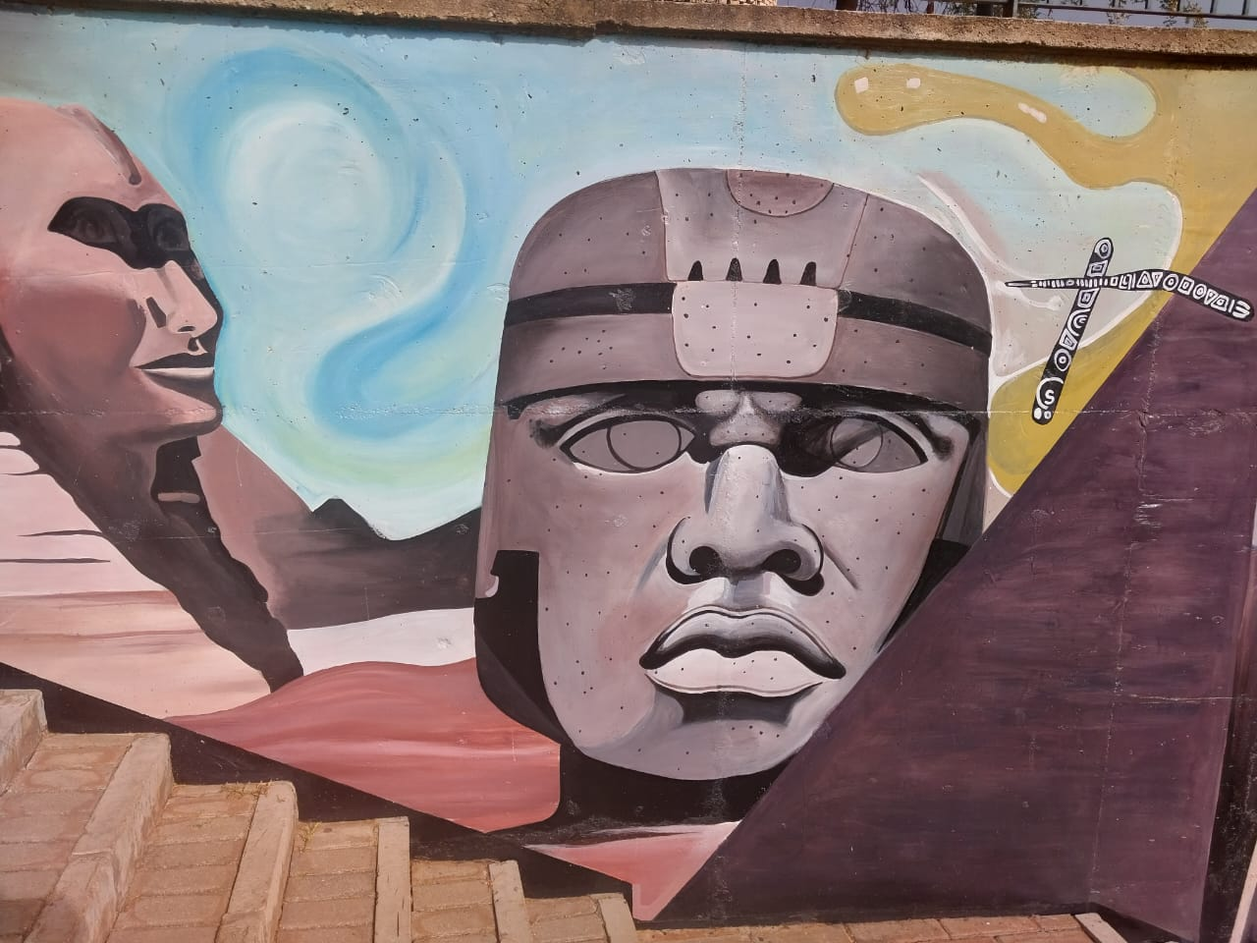
M1: The Stone Head. This photograph is also the image the app tracks.
Mural title / artist: [TO FILL: name of the mural and the artist, if known]
Location on campus: [TO FILL: building and wall, e.g. 'ground floor, outside the main hall']
Physical size: [TO FILL: width x height in metres, from a tape measure]
What it depicts: A giant carved stone head, echoing the colossal heads of ancient civilisations, set beside a sphinx-like face and a pyramid under a swirling sky.
Why we selected it: The head is large, central and full of high-contrast detail (dark headband, speckled stone, deep shadows), which tracks well. Its blank, unpainted eyes invite the idea that the statue could open them.

M2: The Caravan
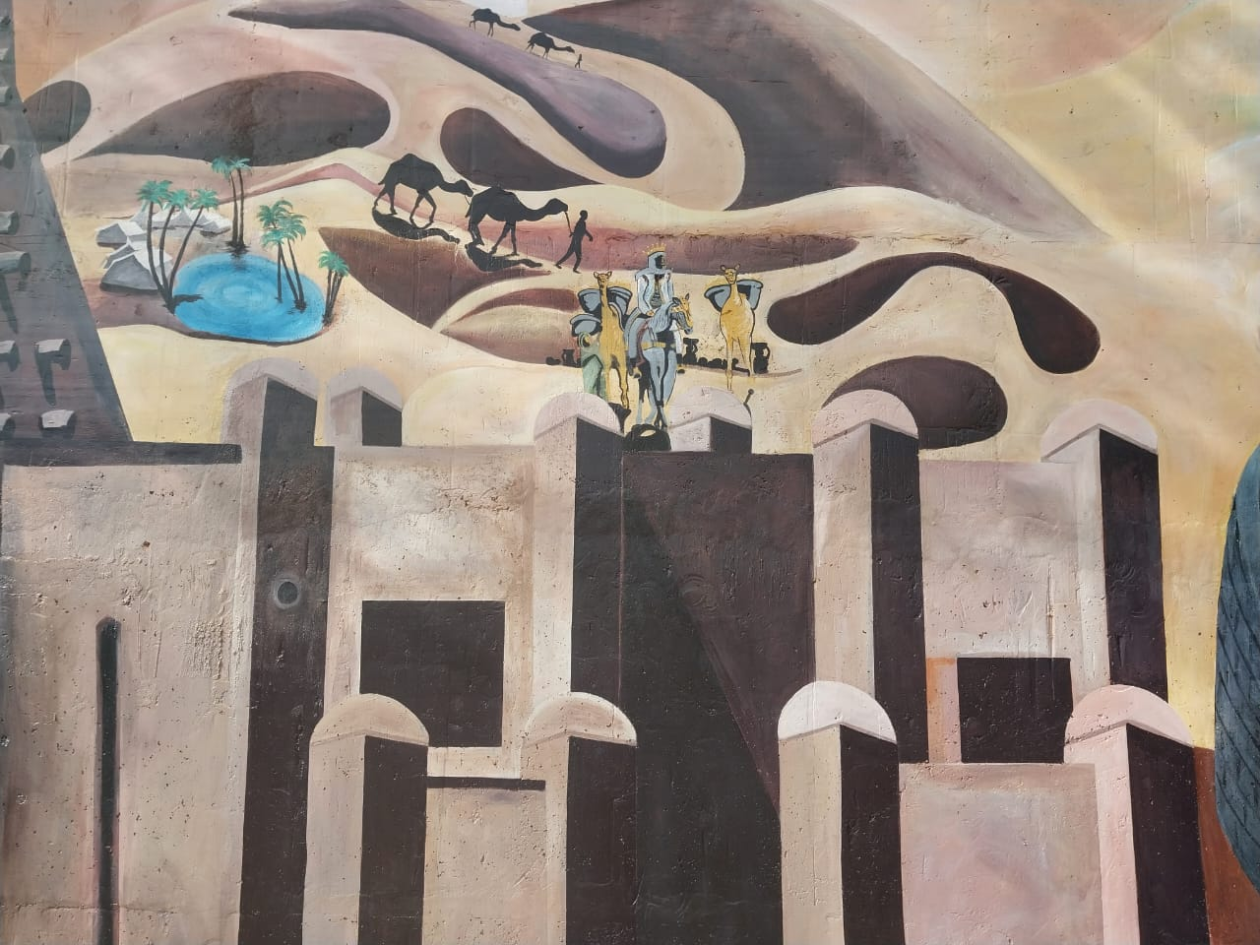
M2: The Caravan. This photograph is also the image the app tracks.
Mural title / artist: [TO FILL: name of the mural and the artist, if known]
Location on campus: [TO FILL: building and wall, e.g. 'ground floor, outside the main hall']
Physical size: [TO FILL: width x height in metres, from a tape measure]
What it depicts: A desert scene: camel caravans crossing the dunes past a palm oasis, above the towers of a walled desert city.
Why we selected it: Strong shapes and tonal contrast between the dark dunes, pale sand and the city walls give reliable tracking. The caravan is already painted mid-journey, so it is natural to let it move.

M3: Convention Centre
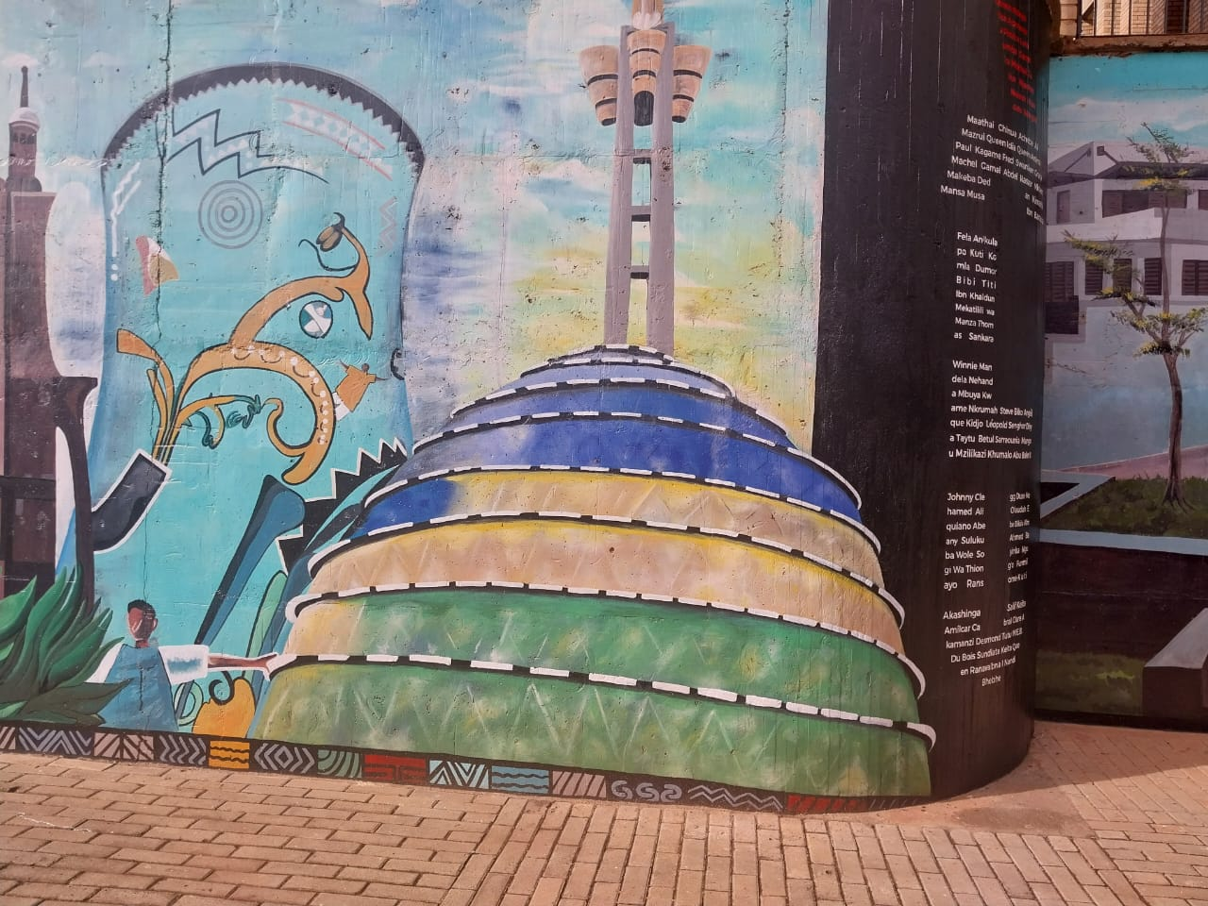
M3: Convention Centre. This photograph is also the image the app tracks.
Mural title / artist: [TO FILL: name of the mural and the artist, if known]
Location on campus: [TO FILL: building and wall, e.g. 'ground floor, outside the main hall']
Physical size: [TO FILL: width x height in metres, from a tape measure]
What it depicts: The Kigali Convention Centre's banded dome and tower against a painted sky, beside a column of names of people who shaped Africa's story.
Why we selected it: The dome is a bold, instantly recognisable shape with strong colour bands, which tracks well, and it is Kigali's best-known night-time light display.

M4: The Floating Figure
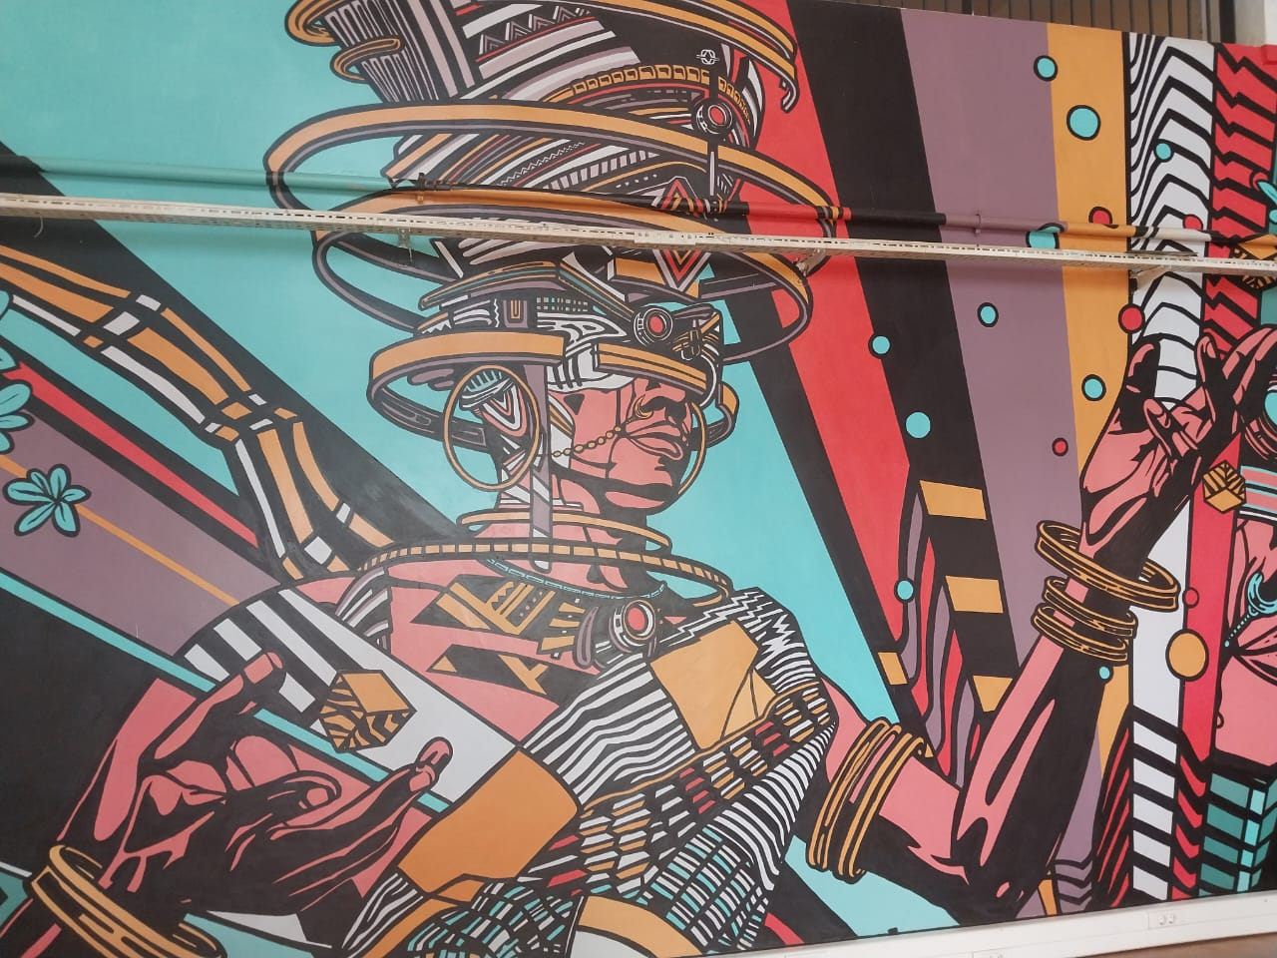
M4: The Floating Figure. This photograph is also the image the app tracks.
Mural title / artist: [TO FILL: name of the mural and the artist, if known]
Location on campus: [TO FILL: building and wall, e.g. 'ground floor, outside the main hall']
Physical size: [TO FILL: width x height in metres, from a tape measure]
What it depicts: A giant figure in traditional attire, crowned with rings and wearing gold bangles, painted in bold Afrofuturist colour with floating rings, cubes and dots around them.
Why we selected it: Very high colour contrast and dense line work make it one of the most trackable murals. The figure already floats among painted objects, which suggests lifting them into the room.

M5: Living Paint
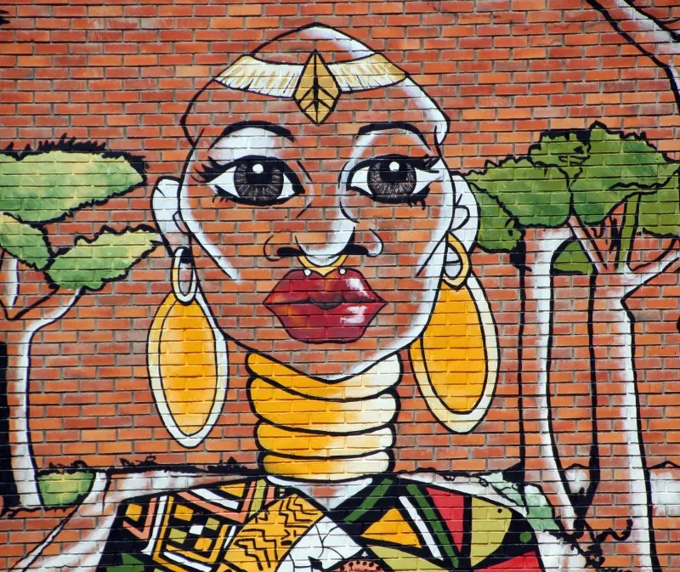
M5: Living Paint. This photograph is also the image the app tracks.
Mural title / artist: [TO FILL: name of the mural and the artist, if known]
Location on campus: [TO FILL: building and wall, e.g. 'ground floor, outside the main hall']
Physical size: [TO FILL: width x height in metres, from a tape measure]
What it depicts: A portrait of a woman in gold hoop earrings, neck rings and a beaded headband, framed by acacia trees, painted directly onto brick.
Why we selected it: A clear face, strong outlines and bright gold on red brick track well, and the jewellery and trees are natural things to set moving.

3. Experience Concept
What happens when the user scans each mural. Every experience follows the same three beats: the wall dims, the transformation plays, then the mural stays alive and responds to the viewer.

M1: The Stone Head (Awakening)

Sequence when the mural is scanned
- The paint dims. The painted wall darkens so that the parts about to move stand out.
- Transformation. The painted wall dims, leaving the head lit. The head lifts slightly out of the wall, eyelids settle over its blank stone eyes, then slowly open on pupils that were never painted.
- Experience. The head blinks on its own every few seconds and its eyes follow the viewer as they move.

Interactions
- Interaction 1: Tap the face: the head winks and the information panel opens with its story.
- Interaction 2: Move the phone (or drag): the eyes follow you, so the statue appears to watch the viewer.

Story connection
The mural is about how old Africa's history is. Making the statue look back at the viewer turns ancient history into something present and personal.

M2: The Caravan (Journey)

Sequence when the mural is scanned
- The paint dims. The painted wall darkens so that the parts about to move stand out.
- Transformation. The wall dims and the painted camel caravans lift off the dunes. Sand begins to drift across the desert.
- Experience. The caravans walk slowly along the dunes with a soft step, fade at the end of their stretch and start again from where they were painted.

Interactions
- Interaction 1: Tap the caravan: it stops to rest and the information panel opens; tap again and it walks on.
- Interaction 2: Drag left or right: the wind picks up, the sand blows harder and the caravans hurry along.

Story connection
Trans-Saharan trade routes carried salt, gold and ideas across Africa. Setting the caravan moving shows the journey the mural only implies.

M3: Convention Centre (Light)

Sequence when the mural is scanned
- The paint dims. The painted wall darkens so that the parts about to move stand out.
- Transformation. The wall and the dome go dark together. Then the dome lights up band by band from the ground, the tower last, with a warm glow behind it.
- Experience. A slow chase of light in Rwanda's blue, yellow and green runs up the dome while riders of the Tour du Rwanda cycle round its base, in front of the wall.

Interactions
- Interaction 1: Tap the dome: a fast light show plays and the information panel opens.
- Interaction 2: Drag left or right: the riders sprint, then ease back to their pace.

Story connection
The Convention Centre lights Kigali at night and the Tour du Rwanda brings the country onto its hills: two images of Rwanda today, side by side.

M4: The Floating Figure (Levitation)

Sequence when the mural is scanned
- The paint dims. The painted wall darkens so that the parts about to move stand out.
- Transformation. The wall dims and the gold bangles and cubes lift out of the paint, joined by the painted coloured dots appearing in the air.
- Experience. The pieces drift in front of the figure, bobbing and turning slowly.

Interactions
- Interaction 1: Tap a floating piece: it spins and the information panel opens.
- Interaction 2: Drag left or right: the pieces swing round the figure toward the viewer.

Story connection
The mural joins heritage and the future in one body. Lifting the ornaments into the viewer's space makes that weightlessness something they can stand inside.

M5: Living Paint (Living Paint (animation))

Sequence when the mural is scanned
- The paint dims. The painted wall darkens so that the parts about to move stand out.
- Transformation. The wall dims and the painting itself starts to move while staying painted: the earrings begin to swing from their hooks and the acacia leaves stir.
- Experience. The earrings swing like real pendulums, a glint of light runs down the gold neck rings every few seconds, and the trees sway in a breeze.

Interactions
- Interaction 1: Tap an earring: it swings hard and settles slowly, and the information panel opens.
- Interaction 2: Drag left or right: a gust of wind bends the trees and swings both earrings the way it blows.

Story connection
The portrait celebrates African beauty and adornment. Bringing the jewellery and the landscape to life keeps the portrait in the artist's style while making it feel present.

4. AR Transformation
Screenshots taken on a phone at the physical mural, showing the digital content attached to the artwork.

M1: The Stone Head
[TO FILL: screenshot from the phone at the real M1 wall, mid-effect]
Caption: [TO FILL: one line describing the moment shown]

M2: The Caravan
[TO FILL: screenshot from the phone at the real M2 wall, mid-effect]
Caption: [TO FILL: one line describing the moment shown]

M3: Convention Centre
[TO FILL: screenshot from the phone at the real M3 wall, mid-effect]
Caption: [TO FILL: one line describing the moment shown]

M4: The Floating Figure
[TO FILL: screenshot from the phone at the real M4 wall, mid-effect]
Caption: [TO FILL: one line describing the moment shown]

M5: Living Paint
[TO FILL: screenshot from the phone at the real M5 wall, mid-effect]
Caption: [TO FILL: one line describing the moment shown]

5. UI Design
The interface supports the AR experience without becoming it. All five murals share one set of screens, so the app feels like one product.

5.1 User flow
Splash → Start (campus map) → pick a mural → Scanning → mural detected → AR experience ⇄ Information → Completion → back to the map. From the AR screen, < SCAN returns straight to scanning for the next mural.
If tracking is lost, the digital content hides within half a second and scanning resumes. Pointing back at the mural continues the experience where it left off instead of restarting it.

5.2 Screens
Screen | Purpose and content
Splash | First screen on launch: viewfinder icon, "MURALS, IN MOTION", one line of explanation and a Start button, with the number of murals and levels.
Start (campus map) | "Find a mural": a progress pill (e.g. 2 / 5 found), level tabs (All, Lv1, Lv2...), a campus map with one numbered pin per mural, a legend, and SCAN ANY MURAL. Tapping a pin opens a card with the mural's photo, location, story and Scan this mural. Found murals turn green.
Scanning | Camera view with a frame, a faded photo of the chosen mural as a hint and "Hold steady and fill the frame with the artwork". < MAP returns to the map.
AR experience | Minimal UI so the mural stays the focus: < SCAN in the corner, and a bottom bar with INFO, REPLAY and DONE.
Information | A card over the AR view with the mural's title and two or three sentences of its story. Opened from INFO or by tapping inside the mural.
Completion | Confirms the mural is complete and invites the user to find the next one, with BACK TO MAP.
[TO FILL: screenshots of each screen from the phone]

5.3 Visual style
Token | Colour | Use
Ink / background | #000000, #10121C | Screen backgrounds, text on accent buttons
Surface | #161616 | Pills, tab bar, cards, map panel
Paper | #F2F1EC | Primary text
Accent | #FCBC40 | Primary buttons, pins, active tab
Found | #66D18C | Found pins and the progress dot
Typography: one sans-serif typeface; bold for titles and buttons, sentence case for body text. Layouts are designed at 1080 × 1920 and anchored to the top and bottom edges so they fit tall phones.

6. Technical Approach

6.1 AR SDK and platform
- Unity 6 with the Universal Render Pipeline.
- AR Foundation with Google ARCore on Android (the ARKit provider is included, so the project can also target iOS).
- Android build: ARM64, IL2CPP, OpenGL ES 3, minimum Android 8.0 (API level 26).

6.2 Image tracking
- ARTrackedImageManager on the XR Origin, with one reference image library holding all five murals, each named for its slot (M1 to M5).
- ARMuralManager matches each detected image to its experience by slot name and parents the experience to the tracked image, so content sits at the mural's real position and orientation.
- Content is scaled to the size ARCore actually measures, so the same experience fits the real wall, a poster or a photo on a laptop screen, and nothing pops out further than intended.
- Tracking loss: a 0.5 second grace period ignores momentary wobble; then the content hides, scanning returns, and the state is kept so the experience resumes.

6.3 Image preparation
- Each mural photographed as straight-on as possible, then used both as the tracking image and as the source of every moving layer.
- Trackability checked with Google's arcoreimg tool (target score 75 or above): [TO FILL: score per mural]

6.4 Architecture
Component | Responsibility
MuralExperienceBase | The contract every mural implements: OnTrackingFound (begin or resume), OnTrackingLost (hide, keep state), OnReset. Also the named audio slots and debug keys (F found, L lost, R reset) for testing without a camera.
LayeredMuralExperience | Shared base for photo-layer murals: rotates content onto the wall, dims the painted wall first, reads taps and drags, opens the story, resumes after tracking loss. Each mural only writes its reveal, its live loop and its two interactions.
M1 ... M5 experiences | M1BlinkExperience, M2CaravanExperience, M3ExpansionExperience, M4FloatExperience, M5LivingPaintExperience: one small class and one prefab per mural.
ARMuralManager | The only shared runtime component: binds detected images to experiences, fits them to the measured size, handles tracking loss.
UIShellController + CampusMapController | The five UI states through a fixed API, plus the splash, campus map, cards, progress and < SCAN.
MuralDirectory | One data asset with each mural's title, level, location, story, pin position and photo.

6.5 Assets
All visual assets come from the murals themselves: each moving part is cut from the mural photograph with a feathered alpha mask (by outline or by colour), so it matches the paint exactly. The only drawn assets are simple sprites (eyelids, pupils, cyclists, glints, glow) made to sit in the painted style.
Mural | Assets | Source / licence
M1 | Head cut-out; drawn eyelids and pupils | Cut from our own photo; drawn by the team
M2 | Caravan silhouettes; sand particle | Cut from our own photo; drawn by the team
M3 | Seven dome band layers; cyclist sprites; glow | Cut from our own photo; drawn by the team
M4 | Gold bangles and cubes; coloured dots | Cut from our own photo; drawn by the team
M5 | Earrings and acacia canopies; glint | Cut from our own photo; drawn by the team

6.6 Animation system
- Coroutine-driven reveal sequences (dim, then transform) with eased interpolation, so nothing appears instantly.
- Procedural animation for continuous behaviour: blinking timers, gaze following, walk cycles, light chases, bobbing and orbiting, and damped-pendulum earrings.
- Fades and tints applied with MaterialPropertyBlocks on unlit transparent URP materials, so shared materials are never modified at runtime.
- A particle system for the drifting sand in M2.
- M1: Head cut-out lifted on its own layer; eyelids are quads on a pivot at the top of each eye, scaled to blink; pupils are positioned each frame from the camera's position in wall space.
- M2: Camel silhouettes cut by colour threshold; position, step bob and fade animated per walker; sand is a particle system whose speed and emission follow the wind.
- M3: Dome split into seven band layers whose colour is driven per frame; riders are drawn sprites moving on a loop in front of the wall and billboarded to face the camera.
- M4: Gold pieces cut by colour threshold; each floats to its own depth with its own delay, bob and spin, and the group rotates round a vertical axis through the figure.
- M5: Earrings hang from pivots at their hooks and are driven by a damped pendulum; canopies rotate from pivots at their base; the glint is a soft sprite swept down the neck.

6.7 Interaction system
- Unity Input System pointer API: one code path for touch on the phone and mouse in the editor.
- Taps and drags are told apart by distance travelled; taps raycast against generous colliders sized as phone tap targets.
- Every mural has a tap interaction and a drag (or device-movement) interaction; each tap also opens that mural's story.

6.8 UI implementation
- uGUI screen-space canvas with a CanvasScaler (1080 × 1920 reference) so layouts hold on any phone.
- Five named panels switched by UIShellController; mural experiences talk to the UI only through its public methods.
- Campus map pins generated at runtime from the MuralDirectory asset.

6.9 Audio
- Every mural plays shared detect, lost and confirm sounds, so feedback is consistent across the app.
- Each mural has its own looping ambient bed, paused on tracking loss and resumed on re-acquire: a deep stone drone (M1), desert wind with camel bells (M2), a warm night pad with bicycle bells (M3), shimmering chimes (M4), and a breeze with jingling earrings (M5).
- Ambient beds were synthesised by the team; the detect, lost and confirm sounds are the project's placeholder effects.

7. Deliverables and Links
Deliverable | Link
Project repository | https://github.com/C-ifegwu/Immersive-and-Interactive-AR-Murals
Android build (APK) | [TO FILL: shared Drive link, set to 'anyone with the link']
Demonstration video | [TO FILL: link]
Technical walkthrough video | [TO FILL: link]

8. Group Attribution
Member | Role | Contribution
Chibueze (group leader) | [TO FILL: role] | [TO FILL: contribution]
Eseosa | [TO FILL: role] | [TO FILL: contribution]
Thierry Gusenga | Experiences, UI, document | All five mural experiences, detection, shared screens and campus map, audio, design document
Rugamba | [TO FILL: role] | [TO FILL: contribution]

