
DMI - 2025/2026
Master’s in Information Management – Business Intelligence
Margarida Sardinha
20221959
WalSmart Targeted Marketing
Data Mining I Project Report

Contents
1. Problem Statement 1
1.1. Repository structure 1
2. Data Exploration and Preprocessing 2
2.2. Missing Values 5
2.3. Outliers and Scaling 5
3. Clustering 6
3.1. Noise removal – PCA & DBSCAN 6
3.2. Perspective clustering 6
3.2.1. Value clustering – RFM 6
3.2.2. Purchase behavior clustering – K-Means 7
3.2.3. Result aggregation 7
3.3. Optimized full dataset clustering – HDBSCAN 7
3.4. Clustering Results 8
4. Cluster Analysis 10
4.1. Cluster Descriptions 10
5. Conclusion 13
5.1. Further Work 13
Annex 1: Disclaimer on Generative AI use 14

1. Problem Statement
The supermarket chain WalSmart is transitioning from broad mass‑marketing to a more data‑driven approach, with the goals of better understanding the diversity within its customer base and designing targeted marketing strategies. To support this shift, the company provided a random sample of roughly 120,000 active customers from 2023. Using this dataset, this project aims to develop customer segmentations that capture both value contribution and buying behavior for a targeted marketing strategy.
This report documents the full analytical process behind that segmentation: data exploration, preprocessing, modelling choices, and the final clustering results. Two clustering methods were developed: a perspective clustering solution with RFM and customer basket clustering, which were later merged into a consolidated set of interpretable clusters, and an optimized HDBSCAN pipeline. Throughout the entire process, the focus was on methodological clarity, justified assumptions, and producing clusters that are both coherent and actionable for effective marketing strategy development.

Repository structure
This project is documented in the following GitHub repository: C-ph3r/walsmart-targeted-marketing: Course project for Data Mining I in my Master's in Business Intelligence.
This repository is composed of:
- Project information: a README file, the PDF with the project’s description, the source dataset, and this very report
- Jupyter Notebooks for each of the project phases
  - WalSmart_DataExploration
  - WalSmart_Preprocessing
  - WalSmart_Modelling
  - WalSmart_TestModelling
- Python files with support functions (in folder ‘src’)
- The csv files with the final clustering results (in folder ‘outputs’)

Data Exploration and Preprocessing
The first step in the development of the model is analyzing what data we have and what treatment it needs to be useful to the question in study. This section was conducted in a separate jupyter notebook, WalSmart_DataExploration, and its findings were taken into consideration for the following steps. Below are some of the key outcomes of this analysis:
The dataset given shows a total of 31 variables, and 123683 entries, each entry corresponding to a unique customer.
The primary identifier in this dataset is the ID_Client variable. However, despite the dataset having 123683 entries, there are only 122803 unique values. Thus, I will consider this as the true dimension of the dataset and eliminate all rows with empty or repeated ID_Client.
In the latitude/longitude columns, we see two separate groups of points. However, one of these groups seems to be in the middle of the sea, so I will assume that this is an error. This would leave us with only 41% of data being correct, so these variables should be dropped. Luckily we have ZIP_Code we can use instead for location. Since this variable is heavily imbalanced, I will instead encode its values into ZIP_0, ZIP_4, ZIP_8 (the 3 by far most common values), ZIP_others (for all other existing codes) and ZIP_missing (for the case that the missing values are not at random). I will also make the assumption that these codes represent areas in a metropolitan area for cluster interpretation further on.
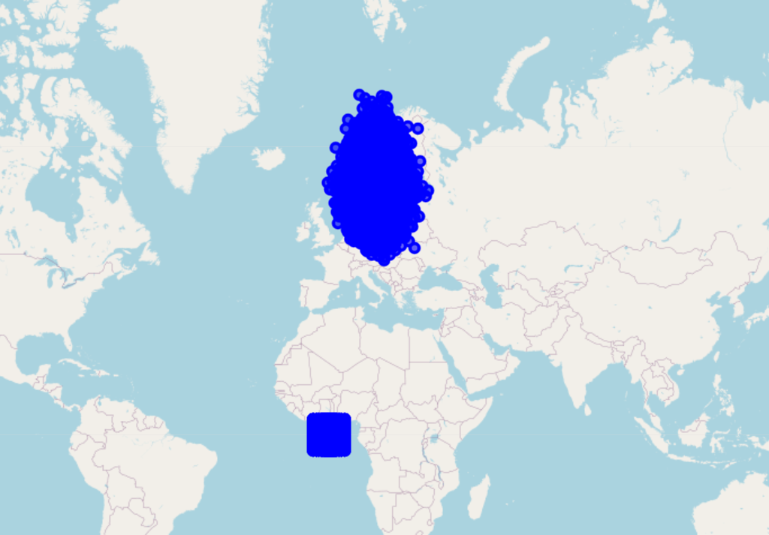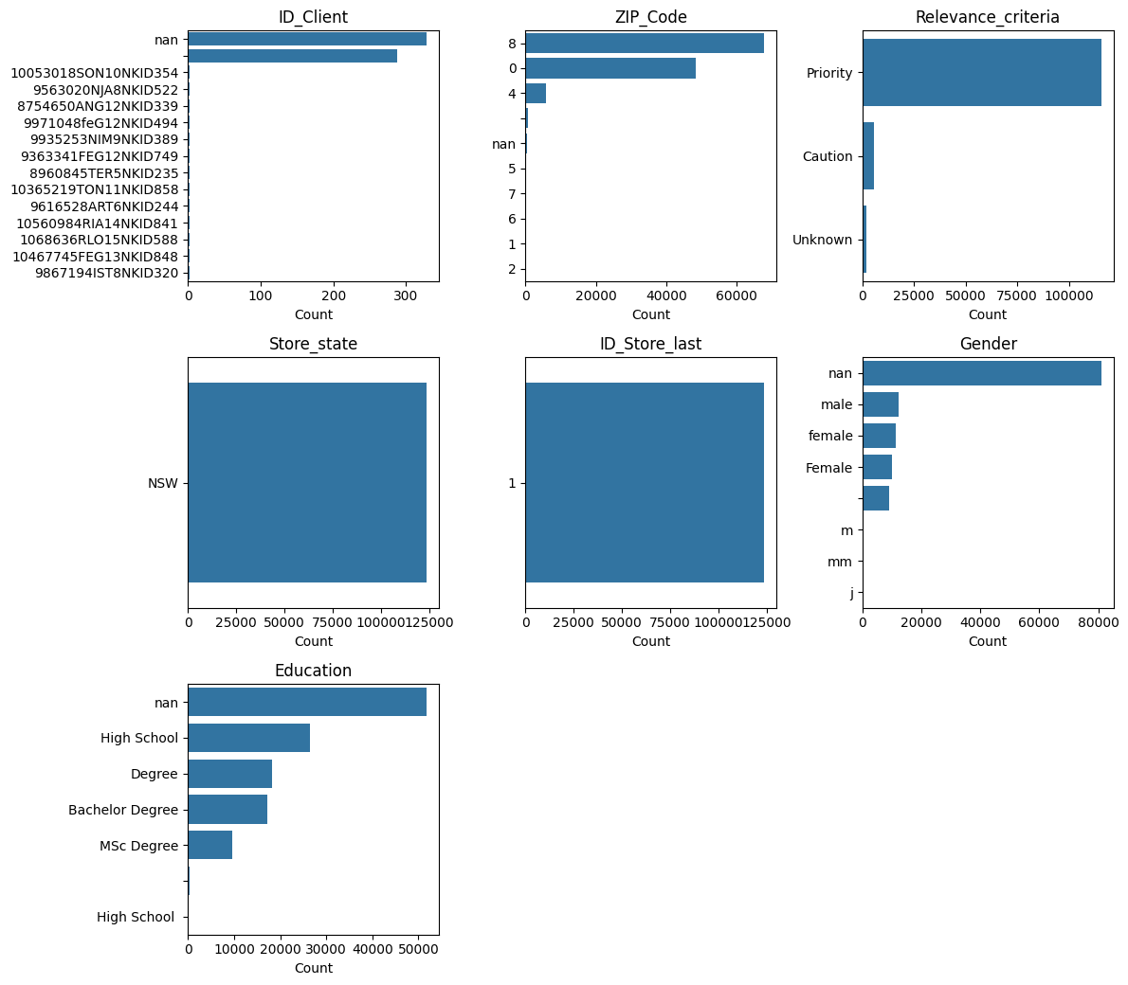
Fig. 1: Map visualization of Latitude and Longitude; Fig.2: Distribution of ZIP_Code
In the Gender column, there are 7 unique values, which could be easily corrected though normalizing all to “male” or “female”. However, this column has 65% of values missing. Imputation could be a possible solution, but this column seems to add very little information to the model, so I will be removing it instead.
In Education, although this is currently displayed as a categorical variable of different degrees, the most efficient option for proper interpretation by the model would be “Years of education” instead. I will create this column, assuming “degree” refers to a bachelor’s degree, and that missing values are at least the minimum required education of high school.
The variables Store_state, ID_Store_last and Checked_ok add no useful information to the clustering due to only having 1 unique value. Thus they will be dropped.
There are a significant number of negative values in the item category columns. For this, I present the following possible explanations:
- The store may be selling these categories at a loss.
- The customers are returning a certain amount of the items bought.
- There has been an error in data processing.
For this case study, I will assume the 1st option to be true, and leave these values as is.
Finally, addressing the variables Potential_Score and Credit_factor, these should not be used in clustering since they are calculated based on other models and, assumedly, the same data. Including these variables would mean biasing the clustering results to the model structures used to produce them.
Considering all the above, this dataset requires thorough preprocessing before being able to be used in modelling. As such, for each of the variables, the following processes must be completed:
Field | Issue | Preprocessing
ID_Client | Missing and null values at random | Remove all missing and null rows
Frequency_items | No issue | -
Potential_Score | Computed based on the same data | Remove from dataset
ZIP_Code | Very imbalanced, missing data | Create ZIP_Missing, ZIP_Others, and one-hot encode the 3 most common values
Longevity_months | Negative values at random | Replace negative values with 0 (First purchase on 31/12/2023)
Latitude | Error cluster around [-5,5] | Remove from dataset
Longitude | Error cluster around [-5,5] | Remove from dataset
Credit_factor | Computed based on the same data | Remove from dataset
Relevance_criteria | Very imbalanced | Replace with a Relevance_Priority column
Store_state | Adds no information | Remove from dataset
Recency_in_weeks | Negative values at random | Replace negative values with 0 (Last purchase on 31/12/2023)
Returns | Has 94% null values | Replace with a Has_Returns column
ID_Store_last | Adds no information | Remove from dataset
Gender | Low density, only 27% valid inputs | Remove from dataset
Flagged | False boolean | Replace “2” with “1” and make boolean
Promotional_percentage | False percentage | Make absolute and clip to scale to [0, 100]
Education | Non-normalized labels, missing values (41%) | Replacing with a “Education_Years” column, assuming null values equate to minimum education of High School
Checked_ok | Adds no information | Remove from dataset
Beer | Very skewed | Apply log transformation
Bottled_Water | Very skewed | Apply log transformation
Bread | Very skewed | Apply log transformation
Meat | Very skewed | Apply log transformation
Dairy | Wrong data type, very skewed | Correct data type, apply log transformation
Fresh_Foods | Pronounced outliers, very skewed | Apply log transformation, windsorize
Frozen_Foods | Missing values, very skewed | Apply log transformation, fill missing values through imputation
Fruit_Beverages | Very skewed | Apply log transformation
Pastry | Very skewed | Apply log transformation
Sodas | Scaling only | Apply log transformation
Toiletries | Very skewed | Apply log transformation
Veggies | Pronounced outliers, very skewed | Apply log transformation
Wines | Very skewed | Apply log transformation
Table 1: Preprocessing steps per variable

2.2. Missing Values
In general, a variable should be removed if it includes so many missing values such that it adds little information to the final result (rule of thumb being around 40%). However, if these values are meaningful, we may instead choose to fill them manually or impute with a specific function.
In this case study, the following methods were used:
- Removed rows with missing data: ID_Client
- Filled missing data with meaningful values: Education
- Filled missing data by imputation: Frozen_Foods
- Transformed the column: ZIP_Code, Relavance_criteria, Returns

Outliers and Scaling
This dataset is mostly composed of numeric columns, but most of them have some outlier values. While these could be identified and removed by methods such as interquartile range or analyzing box plots, I have chosen not to remove the entire row for this project. In clustering, there is value in including the extremes. These are not errors, they are real customer behaviors that should be noted and included in the final model, which should recognize them as an ”elite” cluster that should be treated as any other. These are often the best clients, and customized marketing strategies for them can be more beneficial than having slightly more accurate overall cluster results.
However, since we are using distance-based algorithms such as K-Means, the values need to be scaled to be comparable to each other. As such, windsorization (clipping to the 99th percentile) was applied to the product columns to handle outliers in scaling, and a Standard Scaler was applied to all numeric columns. Despite being sensitive to outliers, this is still the best choice of scaler since we want to preserve as much of the original structure and distributions as possible since we want to use PCA further on.

Clustering
For this case study, the main priority is the creation of effective marketing strategies. For this, our priority in clustering is to create loyal groups wherein we can make sure that our marketing will be effective. Two strategies will be used:
- Perspective clustering + Merging results
- Full pipeline including all variables
The goal with this method is to both apply the contents learned in class, but to also leave room for research, creativity and a final solution with much more quality than the simple models can offer. The final cluster interpretation will be based on the method that returns the best results.

Noise removal – PCA & DBSCAN
The dataset in this case study is extremely noisy. Even after feature engineering, windsorization and scaling, the cluster results were still too messy to be interpretable. As such, a step was added to try to reduce the impact of the noise rows (non-representative data points that deviate from the patterns in data) by removing the rows identified by DBSCAN as “noisy”. For this, PCA was used to reduce dimensionality, so DBSCAN works at its best. Around 8% of rows were removed by this method.

Perspective clustering
In perspective clustering, the goal is to join different views on the patterns found in data from different models and sets of variables. This is an interesting approach to clustering given it attempts to have the last model bias possible, while at the same time allowing for choosing the most appropriate model for each of the sets of variables.
In this case study, the perspectives in question are Value clustering, through simple RFM (Recency, Frequency, Monetary); and Basket/Purchase behavior clustering, through K-Means.

Value clustering – RFM
RFM does not need scaled variables since we are grouping them individually, by percentiles, and not comparing the raw variables with each other. This is a simple process wherein we create 3x3x3 clusters based only on each customer’s Recency, Frequency and total spent on the store. The cluster 333 would be the best new customers, 133 the best old customers, 313 big but rare spenders, and 331 old and frequent but cheap customers.
A simple function was applied to the unscaled variables Recency_in_weeks, Frequency_items and Total_profit to create these clusters, whose labels were concatenated and stored in the dataframe cluster_results for later visualization.

Purchase behavior clustering – K-Means
K-Means clustering is one of the simplest, most interpretable clustering models. Due to its versatility, it easily works in most clustering cases. Its implementation includes the following steps:
- Determining the optimal number of clusters through the elbow plot method + silhouette score to confirm
- Initializing the KMeans model, with random state for reproducibility
- Fitting the model to the scaled, cleaned data
- Getting cluster labels
- Extracting results: inertia, cluster centers and labels
- Evaluating with silhouette score (how similar samples are within clusters vs. to other clusters) and inertia (within-cluster sum of squares)
The cluster labels are added to the previously mentioned cluster_results dataframe for future use.

Result aggregation
Having concluded the clustering of both perspectives, joining them is a simple task. Taking the class notebooks as a template for this, the steps are the following:
- Joining the clean (no noise) preprocessed data with the cluster labels;
- Using the hc_merge_clusters function to use agglomerative clustering (ward-linkage) on the cluster centroids of each (RFM_Segment, Buying_Behaviour_Segment) pair, creating new cluster labels;
Note: The number of clusters to create here is customizable and was manually changed until the resulting clusters were sufficiently different and interpretable.
- Mapping those labels to the preprocessed data and profiling them with the averages of the columns in this dataset.
Through this process, we were able to use effective modelling on specific variables to arrive at a satisfying clustering solution, even with a dataset as complex as this one.

Optimized full dataset clustering – HDBSCAN
The second clustering solution presented is a full optimized pipeline including noise removal and clustering based on PCA and HDBSCAN. The goal with this was to attempt a more efficient solution for such a noisy dataset through dynamic dimensionality reduction and a naturally more effective clustering algorithm in HDBSCAN.
The pipeline created can be summarized as a two-stage parameter optimization approach:
- Stage 1: Grid search on sample data
  - Data preparation
  - Sampling to 5000 random points for speed
  - Grid test of combinations of: PCA variance retention, minimum cluster size, minimum number of samples per cluster
  - Scoring through silhouette score computed on the PCA-reduced space, including a penalty for excessive fragmentation (over 20 clusters)
- Stage 2: Validation on full data
- Re-runs PCA on the complete dataset with the best parameters
- Applies HDBSCAN with the best parameters
- Generates t-SNE visualization of the final clusters
- Outputs a dictionary with: result dataframe, best parameters found, best silhouette score, PCA-reduced feature space, t-SNE visualization, and the fitted PCA and HDBSCAN models
This pipeline would in theory be an objective way to check for the best possible clustering solution given the dataset, with flexibility in adjusting parameter ranges, somewhat efficient search with the sampling, and silhouette scoring in the PCA space. The original idea was to also include UMAP for further dimensionality reduction, but silhouette scoring in such a distorted space was not a very intelligent idea, as it would just create too many micro-clusters.
A solution for this that gave pretty good results was clustering the micro-clusters resulting from the original PCA > UMAP > HDBSCAN pipeline into macro-clusters. I will leave this solution in a separate notebook for future reference as it was quite an interesting solution.
In the end, this approach did not return the best results, but it was still interesting as a pipeline development challenge.

Clustering Results
Below are the results of both clustering approaches. It is clear that the merged clusters from perspective clustering show more variance between them and more balanced cluster sizes, indicating that they are more well defined and would have clearer interpretations. This is particularly the case with the purchase behavior variables; they are particularly cleanly defined in the merged clusters while nearly no variance is noted in the HDBSCAN clusters.
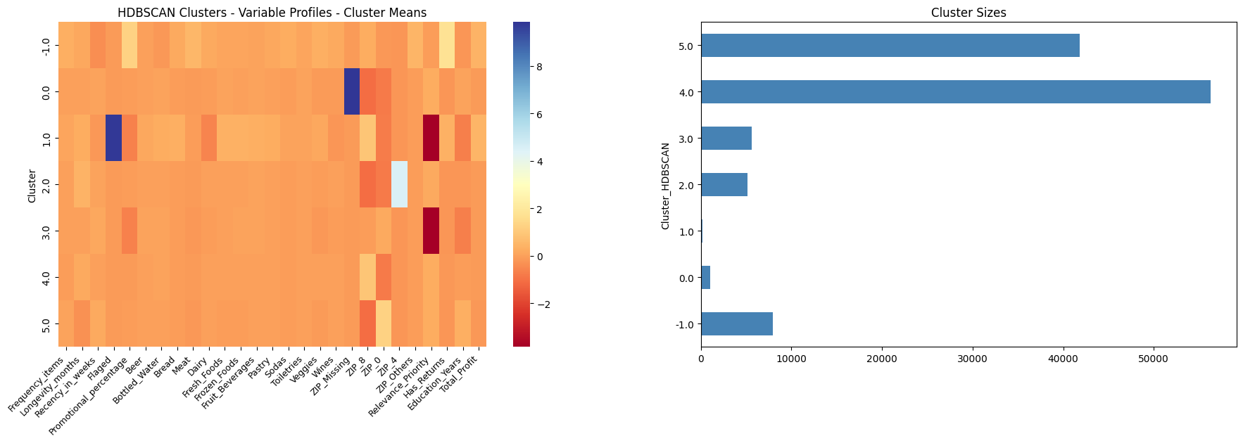
Fig. 3: HDBSCAN cluster results
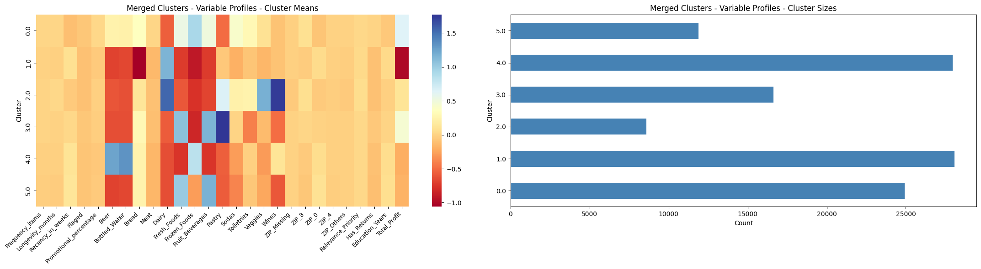
Fig 4: Merged (RFM+Kmeans) cluster results

Cluster Analysis
For each cluster, here is a short, somewhat speculative description on who these people might be based on the averages of their cluster. The description includes a summary, a persona based on the data including what likely drives them to purchase, and a suggestion of marketing strategies that could work for them. I will not be including cluster -1 since those represent noise and outliers, so their values are not representative.
Note: This analysis was done based on the merged_cluster_profiles.csv document, exported from the results of the Perspective Clustering method.

Cluster Descriptions
Cluster 0: The Ferreiras
Summary: Routine‑driven suburban households anchored by Frozen + Fresh spending.
Persona: The Ferreiras show very high Frozen Foods (83.65) and strong Fresh Foods (34.38), a classic signature of families who plan their week in advance. Their Fruit Beverages (68.08) and Bottled Water (61.93) reinforce a lifestyle full of school lunches, gym routines, and constant movement. Their ZIP distribution is dominated by ZIP_8 (59%), suggesting suburban or semi‑rural families with cars, commutes, and structured weekly rhythms. They have almost no returns (Has_Returns = 0.04), indicating low friction and high satisfaction — they buy what they know works. Their motivation is efficiency: predictable meals, hydration for active routines, and shopping that fits into a busy schedule.
Strategy: Promote “Week Sorted” bundles, Frozen + Fresh meal kits, and stable pricing. They respond to anything that reduces planning effort: pre‑planned menus, auto‑refill options, and time‑saving recommendations.

Cluster 1: The Costas
Summary: Small households with narrow baskets and low value contribution.
Persona: The Costas have the lowest Total_Profit (386.9) and the lowest category breadth. Their standout category is Dairy (73.93), while Fresh (30.89), Frozen (29.62), and Meat (0.39) remain minimal. This is the behavior of students, young adults, or single professionals who buy only what they need. Their ZIP pattern is again dominated by ZIP_8 (53%), but with a slightly higher share of ZIP_0 (42%), hinting at urban apartments or small suburban rentals. Their Education_Years (13.32) is slightly above average, consistent with younger, educated individuals living independently. Their motivation is control: avoiding waste, sticking to a tight budget, and keeping shopping simple and predictable.
Strategy: Offer micro‑bundles like “Breakfast Basics”, compact essentials, and low‑commitment add‑ons. Encourage small category expansions by linking Dairy to Bread or Fresh items. Avoid heavy promotions, they’re not particularly deal‑chasers.

Cluster 2: The Sousas
Summary: Practical family households anchored by Dairy + Fresh Foods.
Persona: The Sousas show very high Dairy (83.78) and strong Fresh Foods (36.12), the backbone of family meals. Their Pastry (21.84), Sodas (39.45), and Wines (43.3) are moderate, reinforcing a practical, essentials‑first mindset. Their ZIP distribution is again dominated by ZIP_8 (59%), consistent with suburban family neighborhoods. Returns are extremely low (0.02), suggesting they buy predictable staples with little experimentation. Their motivation is stability: predictable prices, reliable staples, and weekly routines that run smoothly.
Strategy: Offer family‑sized packs, Fresh + Dairy bundles, and “School Week Staples”. Promote recurring‑essentials subscriptions and stable everyday prices.

Cluster 3: The Amarais
Summary: High‑value, high‑variety shoppers who treat food as discovery and pleasure.
Persona: The Amarais have the highest Fresh Foods (104.35) and the highest Pastry (91.63) of all clusters. Their Fruit Beverages (91.63) are also extremely high. This is the behavior of food lovers: young couples, dual‑income professionals, or empty‑nesters who enjoy exploring flavors. Their ZIP distribution is again dominated by ZIP_8 (55%), but with a slightly higher share of ZIP_0 (39%), suggesting a mix of suburban comfort and urban curiosity. Their Returns (0.03) are low but slightly higher than other clusters, consistent with experimentation. Their motivation is pleasure: discovering new foods, elevating everyday meals, and indulging in high‑quality fresh items.
Strategy: Lean into curation: “Chef’s Picks”, seasonal boxes, gourmet pastries. Offer early access to new products and cross‑sell premium meats or wines to elevate their already high basket value.

Cluster 4: The Pintos
Summary: Beverage‑heavy, convenience‑oriented shoppers who buy for gatherings and easy meals.
Persona: The Pintos have the highest Beer (83.24) and Bottled Water (83.48) spending in the dataset. Their Frozen Foods (106.52) is also extremely high. This is the unmistakable signature of social households; people who host gatherings, stock up for events, or maintain a well‑supplied home. Their ZIP distribution is slightly more urban‑leaning: ZIP_0 (42%), ZIP_8 (52%). Their Education_Years (13.35) is the highest among clusters, suggesting more educated, socially active households. Their motivation is readiness: being prepared for guests, events, or spontaneous social moments.
Strategy: Promote party bundles, “Game Night Packs”, beverage + frozen combos, and event‑themed collections. Avoid unnecessary discounts as they already spend heavily.

Cluster 5: The Matos
Summary: Busy households mixing convenience with healthy choices.
Persona: The Matos show very high Frozen Foods (101.67) and strong Fresh Foods (57.2), a hybrid pattern of quick meals and healthier cooking. Their Pastry (92.01) is high, but their Wines (5.7) and Meat (0.32) are low, suggesting small families or professionals who enjoy treats but don’t cook elaborate meals. Their Education_Years (13.38) is the second‑highest, consistent with busy, educated professionals balancing health and convenience. Their motivation is balance: eating well without sacrificing time, mixing convenience with freshness, and keeping weeknight meals manageable.
Strategy: Promote hybrid meal kits, Fresh + Frozen bundles, and “Healthy Convenience” collections. Highlight time savings and balanced nutrition. A “Mix & Match Meal Builder” would resonate strongly.

Conclusion
This project set out to explore WalSmart’s customer data and develop segmentation models capable of supporting a more targeted marketing approach. The work involved extensive data exploration and preprocessing, and the design of two complementary clustering strategies. Perspective clustering (combining RFM value segmentation with K‑Means behavioral clustering) proved to be the most effective approach, producing well‑defined and interpretable groups. The alternative full‑pipeline PCA + HDBSCAN solution, while technically interesting and valuable as a modelling exercise, did not yield clusters with the same level of clarity or practical usefulness.
Overall, the project demonstrates that meaningful segmentation is achievable even in a noisy, heterogeneous dataset, if preprocessing is rigorous and modelling choices are tailored to the structure of the data. The resulting clusters offer a clear view of customer behavior and can support the development of effective marketing strategies to help WalSmart reach its business goals.

Further Work
There are several directions in which this project could be extended. The most immediate opportunity is refining the noise‑removal step, either by testing alternative dimensionality‑reduction techniques or by exploring adaptive methods that better preserve local structure. Improvement can also be done on behavioral segmentation by incorporating seasonality, basket diversity, or time-based patterns if we had that data too. From a modelling perspective, experimenting with soft‑clustering approaches or probabilistic assignments could provide a more nuanced view of customers who sit between the extremes.
Beyond the clustering itself, association rules could be applied within each cluster to find product combinations that are particularly characteristic of specific segments. This would allow for more precise cross‑selling strategies and a clearer understanding of how categories interact within different customer profiles. Also, once marketing strategies are deployed, a monitoring framework should be established to evaluate their effectiveness over time. This would ensure that the segmentation remains relevant and continues to support data‑driven decision‑making.

Annex 1: Disclaimer on Generative AI use
No generative AI tools were used in the production of this report, however the tools Microsoft Copilot and GitHub Copilot were used in some sections of the underlying code. AI tool use was restricted to research, definitions and basic code, never the overall structure, decision-making or interpretation.
No specific prompt engineering techniques were used, just simple prompts like:
- “Create python code for a multiplot of numeric column distributions of a dataframe”
- “Define, with references, the process of windsorization”
- “Give me the full list of parameters of the function HDBSCAN”
- “Join the following code together into a function with parameters XYZ and outputs XYZ: [code]”

