1. Problem Statement

2. Data Exploration and Preprocessing
The first step in the development of the model is analyzing what data we have and what treatment it needs to be useful to the question in study. This section was conducted in a separate jupyter notebook, WalSmart_DataExploration, and its findings were taken into consideration for the following steps. Below are some of the key outcomes of this analysis:
The dataset given shows a total of 31 variables, and 123683 entries, each entry corresponding to a unique customer.
The primary identifier in this dataset is the ID_Client variable. However, despite the dataset having 123683 entries, there are only 122803 unique values. Thus, I will consider this as the true dimension of the dataset and eliminate all rows with empty or repeated ID_Client.
In the latitude/longitude columns, we see two separate groups of points. However, one of these groups seems to be in the middle of the sea, so I will assume that this is an error. This would leave us with only 41% of data being correct, so these variables should be dropped. Luckily we have ZIP_Code we can use instead for location. Since this variable is heavily imbalanced, I will instead encode its values into ZIP_0, ZIP_4, ZIP_8 (the 3 by far most common values), ZIP_others (for all other existing codes) and ZIP_missing (for the case that the missing values are not at random). I will also make the assumption that these codes represent areas in a metropolitan area for cluster interpretation further on.
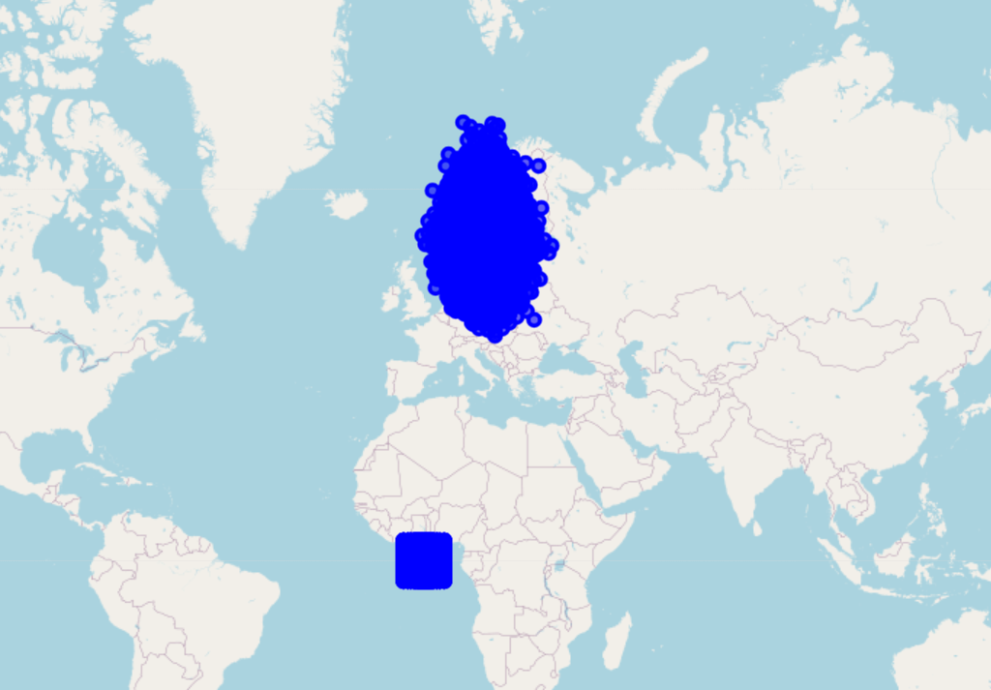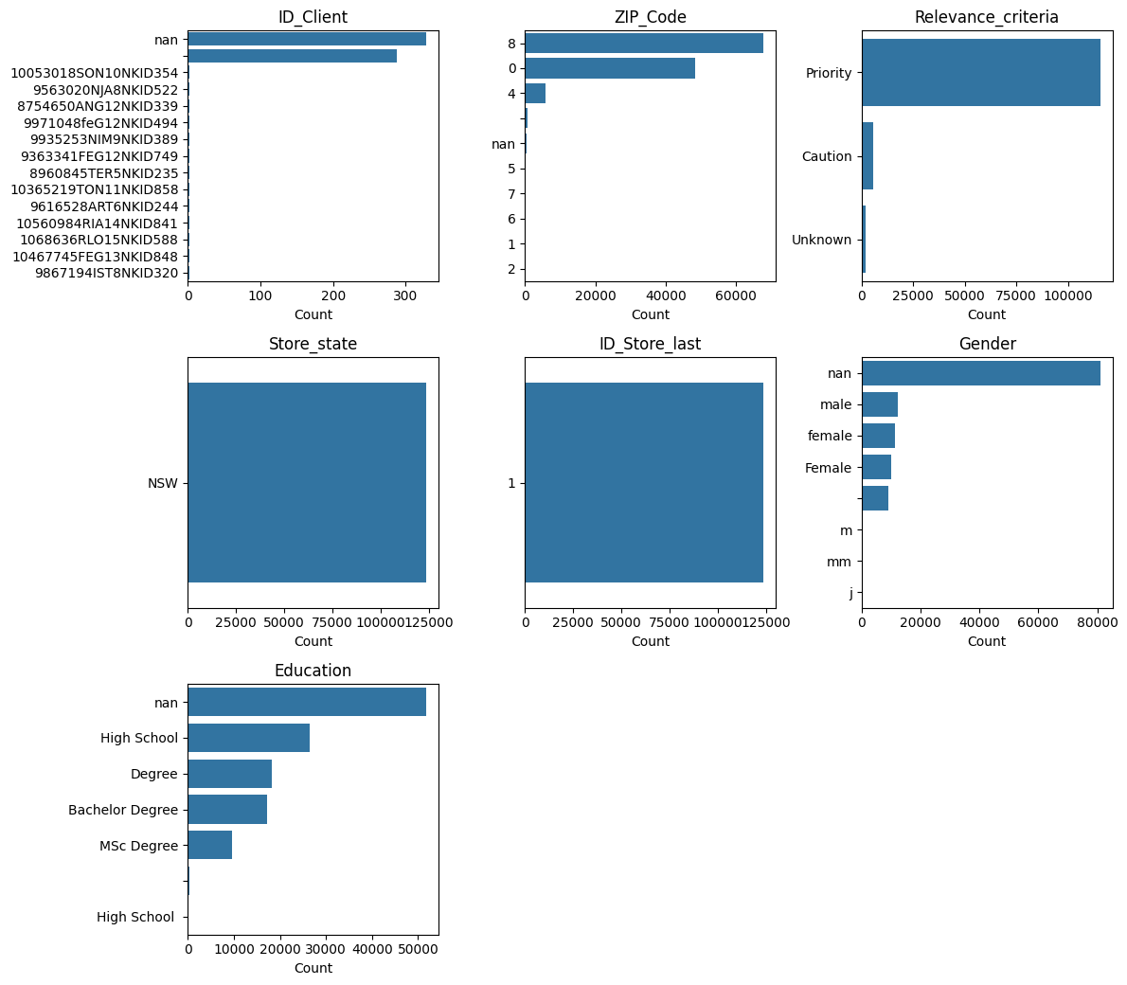
Fig. 1: Map visualization of Latitude and Longitude; Fig.2: Distribution of ZIP_Code
In the Gender column, there are 7 unique values, which could be easily corrected though normalizing all to “male” or “female”. However, this column has 65% of values missing. Imputation could be a possible solution, but this column seems to add very little information to the model, so I will be removing it instead.
In Education, although this is currently displayed as a categorical variable of different degrees, the most efficient option for proper interpretation by the model would be “Years of education” instead. I will create this column, assuming “degree” refers to a bachelor’s degree, and that missing values are at least the minimum required education of high school.
The variables Store_state, ID_Store_last and Checked_ok add no useful information to the clustering due to only having 1 unique value. Thus they will be dropped.
There are a significant number of negative values in the item category columns. For this, I present the following possible explanations:
- The store may be selling these categories at a loss.
- The customers are returning a certain amount of the items bought.
- There has been an error in data processing.
For this case study, I will assume the 1st option to be true, and leave these values as is.
Finally, addressing the variables Potential_Score and Credit_factor, these should not be used in clustering since they are calculated based on other models and, assumedly, the same data. Including these variables would mean biasing the clustering results to the model structures used to produce them.
Considering all the above, this dataset requires thorough preprocessing before being able to be used in modelling. As such, for each of the variables, the following processes must be completed:
Field | Issue | Preprocessing
ID_Client | Missing and null values at random | Remove all missing and null rows
Frequency_items | No issue | -
Potential_Score | Computed based on the same data | Remove from dataset
ZIP_Code | Very imbalanced, missing data | Create ZIP_Missing, ZIP_Others, and one-hot encode the 3 most common values
Longevity_months | Negative values at random | Replace negative values with 0 (First purchase on 31/12/2023)
Latitude | Error cluster around [-5,5] | Remove from dataset
Longitude | Error cluster around [-5,5] | Remove from dataset
Credit_factor | Computed based on the same data | Remove from dataset
Relevance_criteria | Very imbalanced | Replace with a Relevance_Priority column
Store_state | Adds no information | Remove from dataset
Recency_in_weeks | Negative values at random | Replace negative values with 0 (Last purchase on 31/12/2023)
Returns | Has 94% null values | Replace with a Has_Returns column
ID_Store_last | Adds no information | Remove from dataset
Gender | Low density, only 27% valid inputs | Remove from dataset
Flagged | False boolean | Replace “2” with “1” and make boolean
Promotional_percentage | False percentage | Make absolute and clip to scale to [0, 100]
Education | Non-normalized labels, missing values (41%) | Replacing with a “Education_Years” column, assuming null values equate to minimum education of High School
Checked_ok | Adds no information | Remove from dataset
Beer | Very skewed | Apply log transformation
Bottled_Water | Very skewed | Apply log transformation
Bread | Very skewed | Apply log transformation
Meat | Very skewed | Apply log transformation
Dairy | Wrong data type, very skewed | Correct data type, apply log transformation
Fresh_Foods | Pronounced outliers, very skewed | Apply log transformation, windsorize
Frozen_Foods | Missing values, very skewed | Apply log transformation, fill missing values through imputation
Fruit_Beverages | Very skewed | Apply log transformation
Pastry | Very skewed | Apply log transformation
Sodas | Scaling only | Apply log transformation
Toiletries | Very skewed | Apply log transformation
Veggies | Pronounced outliers, very skewed | Apply log transformation
Wines | Very skewed | Apply log transformation

2.2. Outliers and Scaling
This dataset is mostly composed of numeric columns, but most of them have some amount of outlier values. These were identified through the created function clean_outliers, through which for each numeric variable, identifies the outlier values through

3. Clustering
For this case study, the main priority is the creation of effective marketing strategies. For this, our priority in clustering is to create loyal groups wherein we can make sure that our marketing will be effective. Two strategies will be used:
- Perspective clustering + Merging
- Full pipeline including all variables
The goal with this method is to both apply the contents learned in class, but to also leave room for research, creativity and a final solution with much more quality than the simple models can offer. The final cluster interpretation will be based on the results from strategy b).

3.1. Noise removal – DBSCAN
The dataset in this case study is extremely noisy, even after feature engineering and scaling. It is thus essential to remove the rows that would negatively affect the clustering results (noise) and that do not represent the majority of the clients. For this, the best model to use is DBSCAN

3.2. Perspective clustering

3.2.1. Value clustering – RFM

3.2.2. Purchase behavior clustering – Agglomerative Hierarchical

3.2.3. Results

3.3. Optimized full dataset clustering – HDBSCAN

4. Cluster Analysis
For each cluster, here is a short, somewhat speculative description on who these people might be based on the averages of their cluster. The description includes a summary tagline, a persona based on the data, and a suggestion of marketing strategies that could work for them. I will not be including cluster -1 since those represent noise and outliers, so their values are not representative.
Note: an assumption was made that zip codes represent areas within a city or metropolitan area. This is the type of information one would in theory have if this project was with a real client, so there should not be an issue here.

4.1. Cluster Descriptions
Cluster 0: The Pereiras
Summary: Food lovers who fill their carts with fresh and frozen staples.
Persona: The Pereiras are families who cook often and value convenience. Their baskets are dominated by Fresh Foods, Frozen Foods, and Fruit Beverages, the classic “weekly shop.” They have long relationships with WalSmart, buy frequently, and generate high profits. They’re not heavy returners and not particularly promotion‑driven. They’re the high‑value, high‑engagement households who rely on WalSmart for most of their groceries.
Strategy: Promote meal‑planning kits, recipe‑based bundles, and cross‑category offers linking Fresh + Frozen + Fruit Beverages. They’re high‑value and loyal, so reward them with tiered loyalty perks and early access to seasonal products. They should respond to quality and convenience, not discounts.

Cluster 1: The Joanas
Summary: Quick-stop shoppers who grab what they need and go.
Persona: Joanas are young adults or busy workers who shop irregularly and lightly. Their baskets lean toward convenience: Sodas, Pastry, and small essentials. They rarely buy meat or wine, and their Fresh Foods spending is modest. They’re low‑longevity, low‑profit, and ZIP_0 concentrated (likely urban, living near a store, popping in for quick purchases). They’re the on‑the‑go, low-engagement customers.
Strategy: Use micro‑promotions and impulse‑friendly offers: “grab‑and‑go combos,” pastry + soda deals, and mobile push notifications triggered by proximity. They’re low‑engagement, so the goal is to increase visit frequency, not basket size. Highlight speed: express checkout, pickup lockers, and “5‑minute shop” messaging.

Cluster 2: The Sousas
Summary: Family-first shoppers focused on essentials and value.
Persona: The Sousas are budget-conscious families with strong spending in Dairy and Fresh Foods, staples of a household with kids. They buy fewer indulgences (Pastry, Sodas, Wines) and keep their baskets practical. They’re not promotion-obsessed but are consistent shoppers with moderate longevity. ZIP_8 dominates, suggesting suburban or semi-rural households. They’re practical, essentials-driven families.
Strategy: Offer family‑sized packs, dairy + fresh bundles, and stable everyday prices. They’re not promotion‑obsessed, so emphasize value consistency rather than flashy discounts. Promote school‑friendly snacks, weekly meal staples, and “family essentials” curated lists. A subscription for recurring essentials could work well.

Cluster 3: The Costas
Summary: Stock‑up shoppers who fill the freezer and pantry.
Persona: The Costas shop in bulk. Their Frozen Foods and Fruit Beverages spending is extremely high, and they buy large quantities of Beer and Bottled Water. They likely do fewer but larger trips. Their longevity is strong, and they’re moderately profitable. ZIP_8 presence suggests families living farther from stores, making fewer but bigger visits. They’re the bulk-buying, freezer-filling households.
Strategy: Push bulk deals, freezer‑friendly bundles, and beverage multipacks. They shop less often but spend more per trip, so use trip‑planning campaigns: “Stock up for the month,” “Freezer restock weekend,” or “Pantry power deals.” Highlight storage‑friendly promotions and large‑format products.

Cluster 4: The Almeidas
Summary: Quality-focused families who mix fresh, frozen, and indulgent items.
Persona: The Almeidas are middle-to-upper-income households who buy a lot of Fresh Foods, Frozen Foods, Pastry, and Wines. They enjoy cooking but also appreciate convenience. Their baskets show a taste for quality and variety. They’re loyal, profitable, and ZIP_0 concentrated — likely urban or suburban families with stable routines. They’re premium-leaning, food-loving loyalists.
Strategy: Position WalSmart as their quality partner: premium frozen meals, artisanal pastries, curated wine selections, and fresh‑produce highlights. Use taste‑driven campaigns, recipe inspiration, and “elevate your weeknight dinner” messaging. They respond to quality cues, not price cuts.

Cluster 5: The Silvas
Summary: Deal-seekers who shop smart and stretch their budget.
Persona: The Silvas are promotion-sensitive shoppers who mix categories but always look for value. Their promotional percentage is among the highest, and they show moderate returns. They buy across categories but without strong peaks. They’re the savvy, price-aware customers who respond well to targeted discounts and loyalty incentives.
Strategy: Lean into personalized promotions, digital coupons, and “smart shopper” challenges. They’re highly responsive to discounts, so use dynamic pricing, loyalty‑based rewards, and promotion‑stacking opportunities. Weekly “best deals for you” emails will drive engagement, they’re ideal for price‑sensitive retention campaigns.

Cluster 6: The Rochas
Summary: High-spending gourmets with complex, premium baskets.
Persona: The Rochas are the elite segment. Affluent, heavy spenders across every category. They buy premium meats, wines, fresh produce, frozen meals, toiletries, and more. Their profit contribution is massive. They also have higher returns and a higher flagged rate, typical of high-volume shoppers. They’re the top-tier, gourmet, everything-buying power customers.
Strategy: Introduce VIP experiences: exclusive wine tastings, gourmet product previews, and concierge‑style recommendations. Offer premium loyalty tiers, early access to limited‑edition items, and personalized cross‑category bundles (Meat + Wines + Fresh + Frozen). They’re the top profit drivers, treat them as elite customers.

Cluster 7: The Catarinas
Summary: Health-conscious shoppers who prioritize fresh and veggie-heavy baskets.
Persona: The Catarinas buy a lot of Fresh Foods, Veggies, and Frozen Foods, with moderate Sodas and Pastry. They’re balanced but lean toward healthier choices. They’re moderately loyal, moderately profitable, and ZIP_8 concentrated. They’re the health-leaning, balanced households who value fresh ingredients but still enjoy convenience.
Strategy: Promote healthy lifestyle bundles, veggie‑forward recipes, and “fresh picks of the week.” Highlight organic options, low‑sugar beverages, and balanced meal kits. Use nutrition‑focused messaging and seasonal produce campaigns. They respond to health, balance, and freshness.

Cluster 8: The Mouras
Summary: Weekend shoppers who enjoy wine, fresh foods, and easy meals.
Persona: The Mouras have a distinctive pattern: high Wines, strong Fresh and Frozen Foods, and moderate Pastry. They look like couples or small households who shop on weekends, enjoy cooking, and appreciate a good bottle of wine. ZIP_Others suggests geographic diversity. They’re lifestyle-oriented, weekend stock-up shoppers.
Strategy: Create weekend‑centric campaigns: wine + cheese bundles, “Friday night dinner kits,” and curated pairings. Promote frozen convenience meals for busy weeks and fresh ingredients for weekend cooking. Use lifestyle storytelling like “Make your weekend special.” They’re ideal for experience‑driven marketing.

Cluster 9: The Ferreiras
Summary: Traditional households with strong dairy and fresh staples.
Persona: The Ferreiras buy a lot of Dairy and Fresh Foods, with low Meat, Pastry, and Sodas. They’re traditional, essentials-focused, and ZIP_0 concentrated. Their profit is lower, but they’re consistent. They’re the routine-driven, staple-focused families who stick to what they know.
Summary: Focus on staple‑based loyalty: dairy discounts, fresh produce guarantees, and “your weekly essentials” lists. They’re predictable and routine‑driven, so use habit reinforcement: recurring baskets, reminders, and stable pricing. Promote trusted brands and family‑friendly basics.

4.2. Strategy x Cluster Mapping table
Marketing Strategy | Target Clusters | Why This Works
Routine Essentials Bundles | Martins (−1), Ferreiras (9) | Stable, predictable shoppers who value consistency and weekly staples.
Meal-Planning Kits & Recipe Bundles | Pereiras (0), Almeidas (4) | High spends in Fresh + Frozen; enjoy cooking and structured meal planning.
Express / Grab-and-Go Offers | Joanas (1) | Low-engagement, convenience-driven shoppers who make quick trips.
Family-Sized Packs & Essentials Subscriptions | Sousas (2), Martins (−1) | Family-oriented, essentials-heavy baskets with predictable needs.
Bulk Stock-Up Promotions | Costas (3), Pereiras (0) | Large basket sizes, high Frozen + Beverages, infrequent but heavy trips.
Premium Product Highlights & Quality Messaging | Almeidas (4), Rochas (6) | Quality-focused, high-spending customers who respond to premium cues.
Personalized Promotions & Digital Coupons | Silvas (5), Joanas (1) | Price-sensitive shoppers with high promotional responsiveness.
VIP / Elite Loyalty Tier | Rochas (6) | Highest spenders across all categories; ideal for premium loyalty programs.
Healthy Lifestyle Campaigns | Catarinas (7), Mouras (8) | High Fresh + Veggies; health-leaning or lifestyle-oriented shoppers.
Weekend Wine & Dine Bundles | Mouras (8), Almeidas (4) | Strong Wine + Fresh + Frozen patterns; weekend cooking and lifestyle focus.
Replenishment Reminders (“Your Usual Basket”) | Martins (−1), Ferreiras (9), Sousas (2) | Routine-driven shoppers with stable, predictable baskets.
Seasonal Fresh Produce Highlights | Pereiras (0), Catarinas (7), Ferreiras (9) | High Fresh Foods spend; respond to freshness and seasonality.
Impulse Micro-Promotions (Pastry + Soda, etc.) | Joanas (1), Silvas (5) | Convenience-driven or deal-driven shoppers with small baskets.
Cross-Category Gourmet Pairings (Meat + Wine + Fresh) | Rochas (6), Almeidas (4) | High spend across premium categories; respond to curated experiences.
Stable Everyday Low Prices | Sousas (2), Ferreiras (9) | Value-oriented households who prefer predictability over promotions.

