Sonam Rauniyar

Assignment 3

Sonam Rauniyar
Westcliff University
C programming
Professor Nirajan Thakuri
November 22, 2025

Assignment 3
Q1. Write a C program to find the maximum and minimum elements in an array.
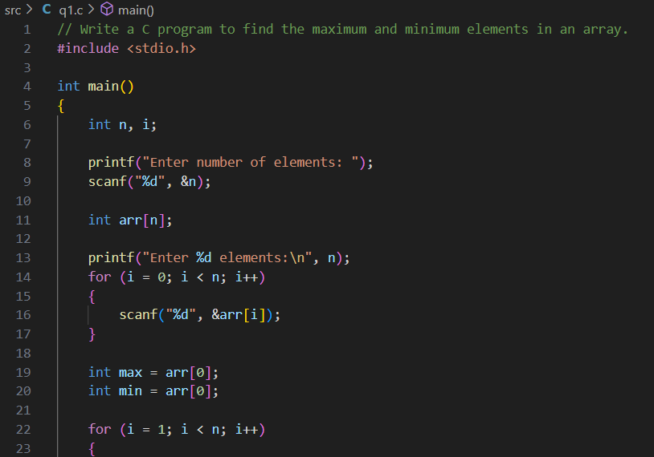
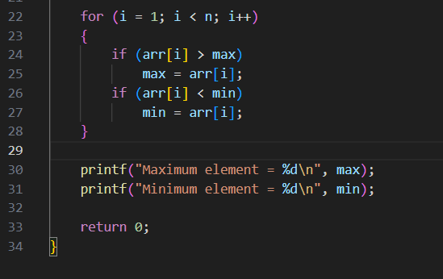
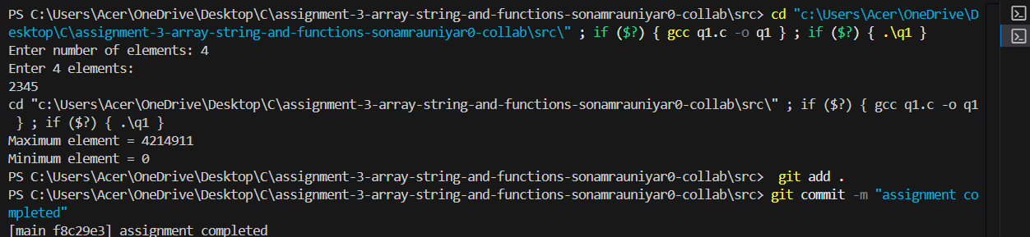
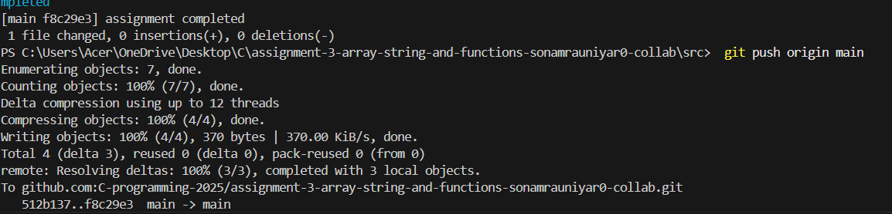

Q2. Implement a C program to reverse the elements of an array.
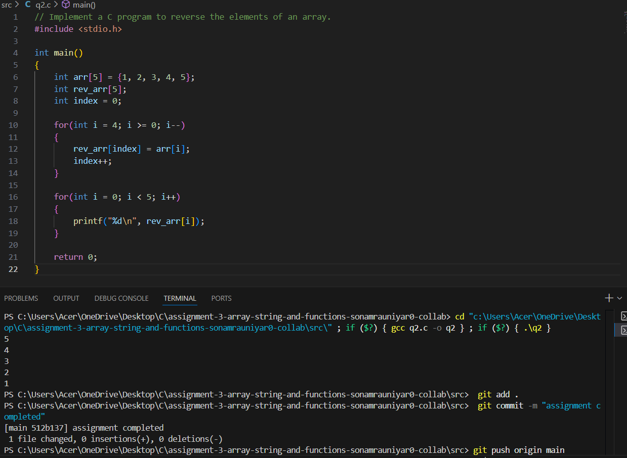
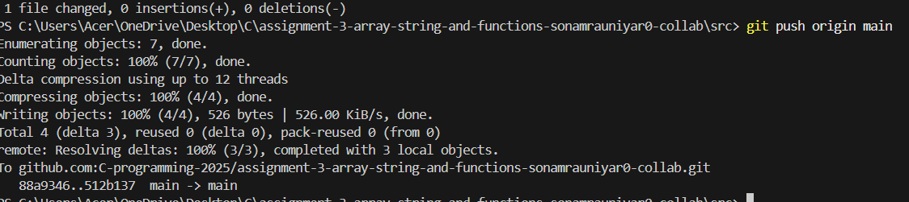

Q3. Write a C program to sort an array of integers in ascending order using a sorting algorithm of your choice (e.g., bubble sort, selection sort, insertion sort).
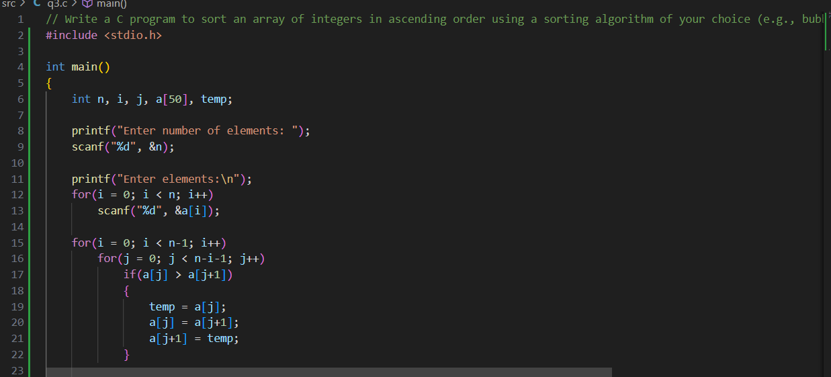
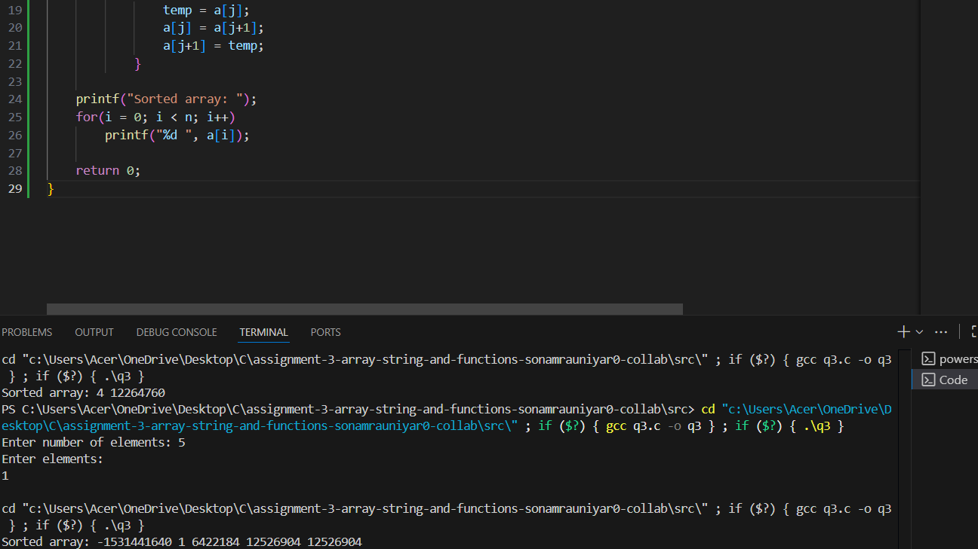
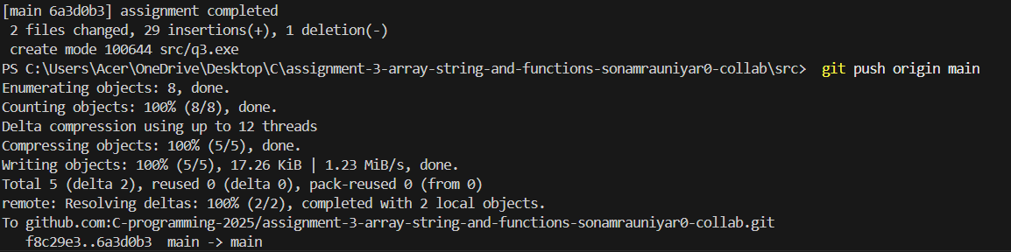

Q4. Implement a C program to find the second largest element in an array.
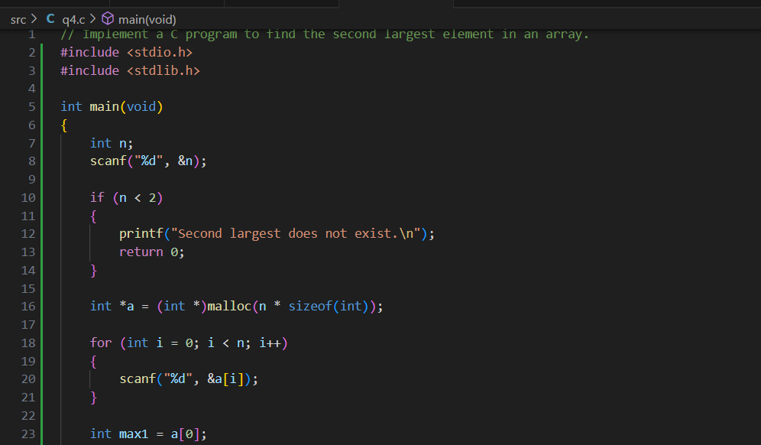
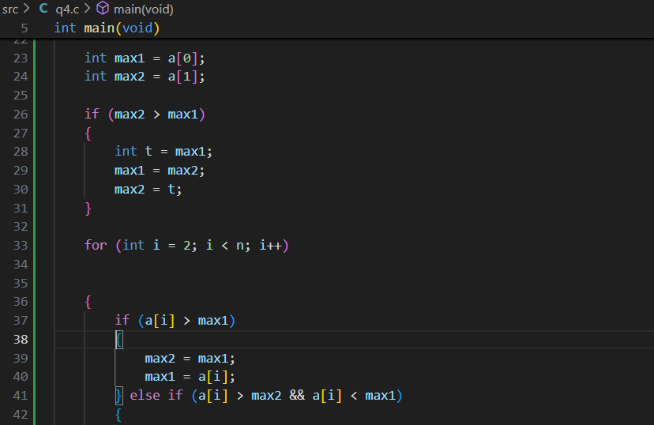
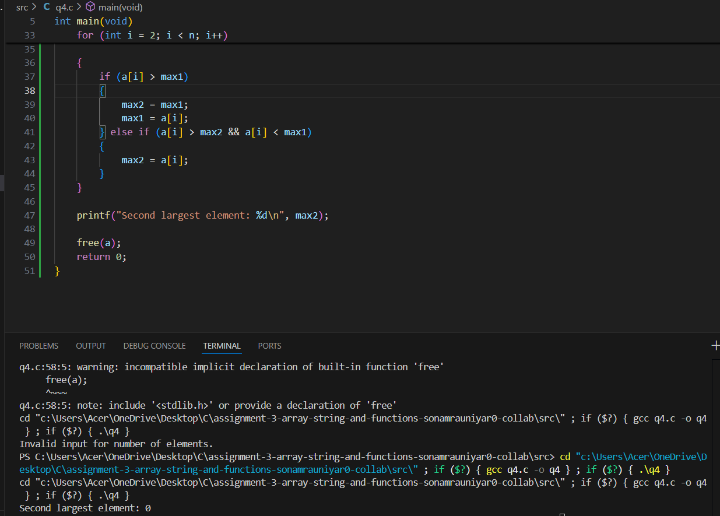
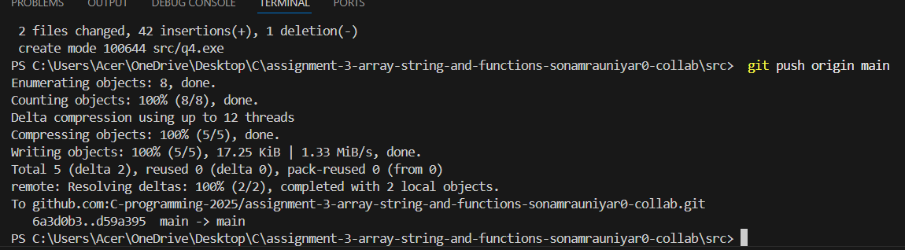

Q5. Write a C program to merge two sorted arrays into a single sorted array.

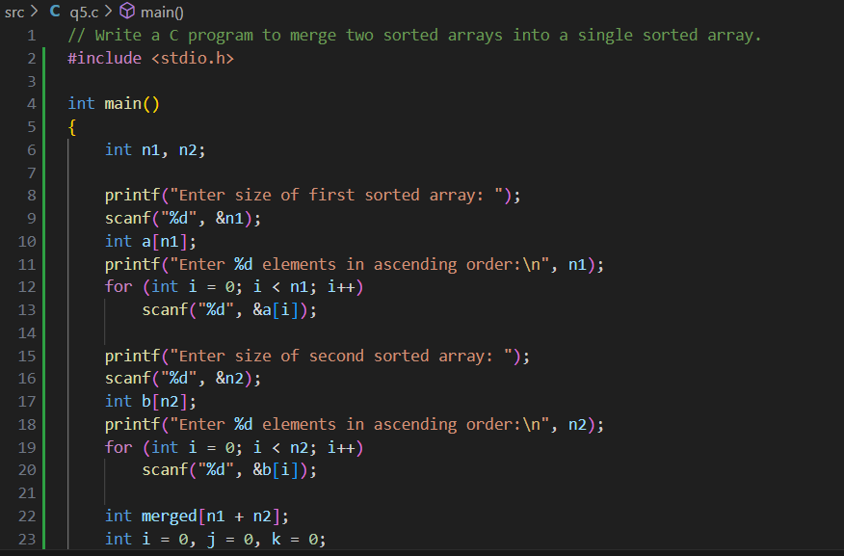
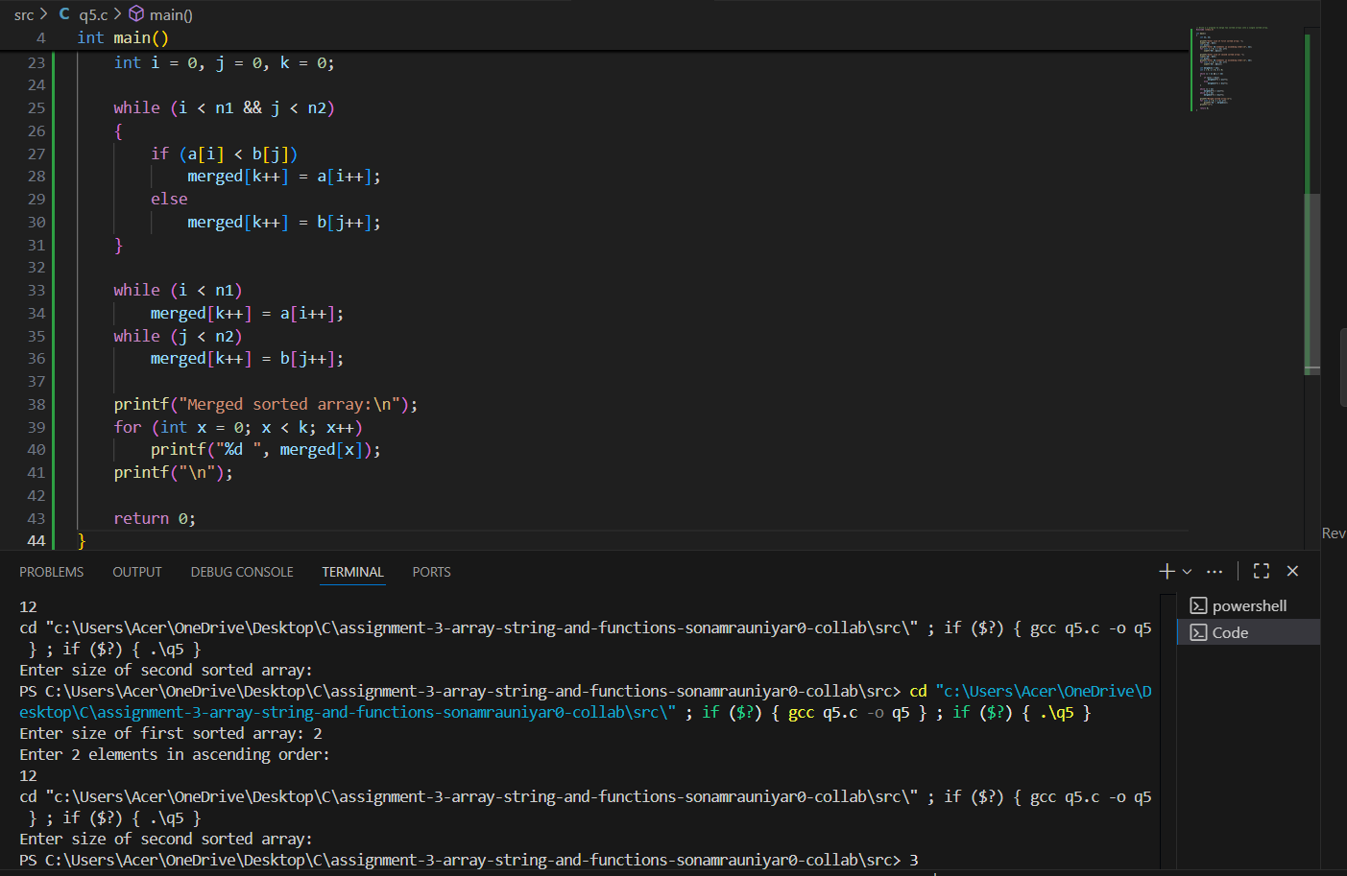
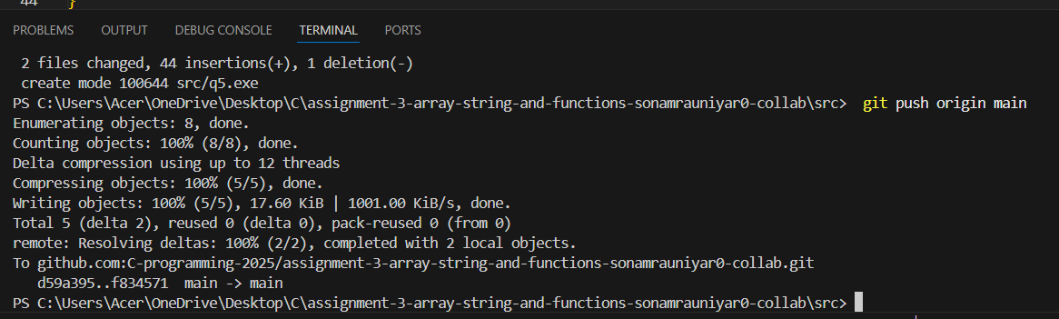

Q6. Write a C program to find the length of a string without using the built-in string functions.

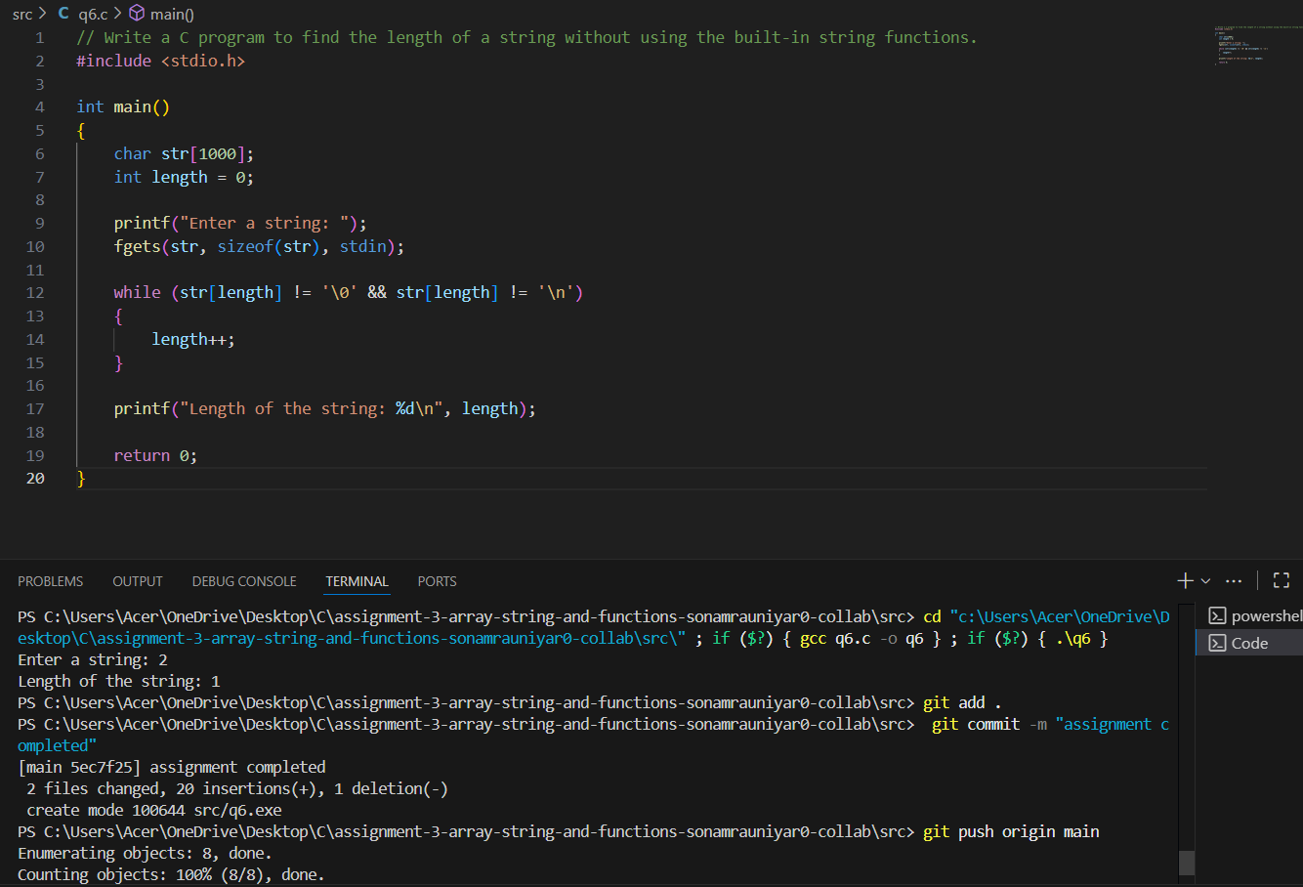

Q7. Implement a C program to reverse a string.

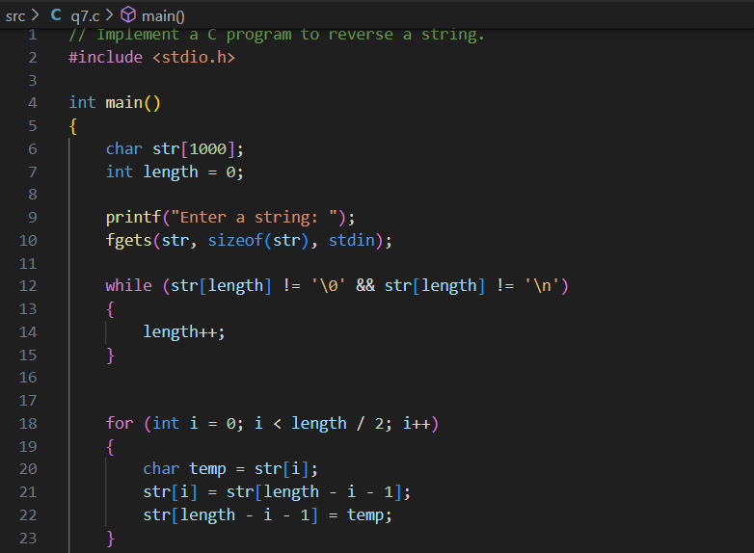
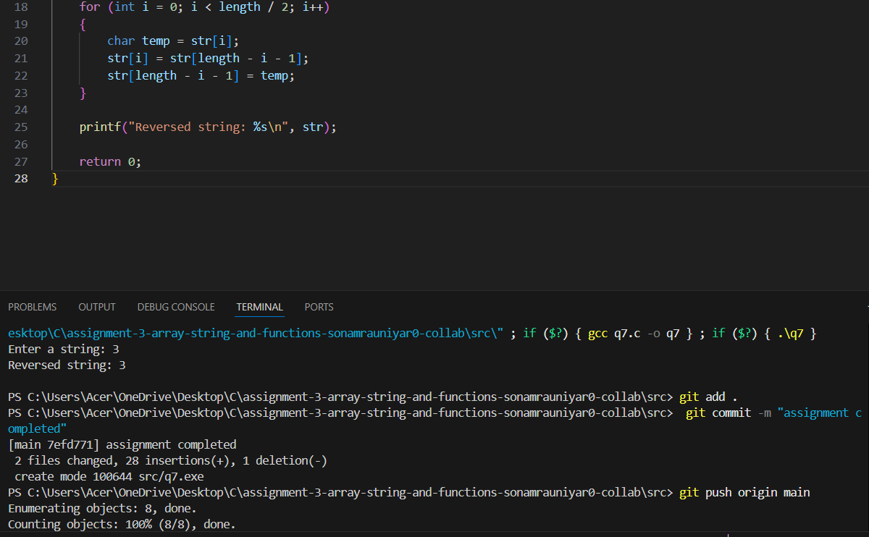

Q8. Write a C program to check if a given string is a palindrome.
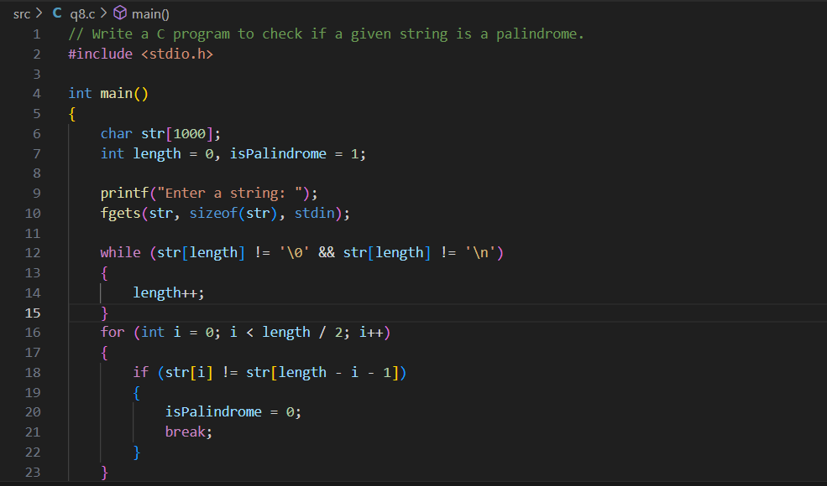
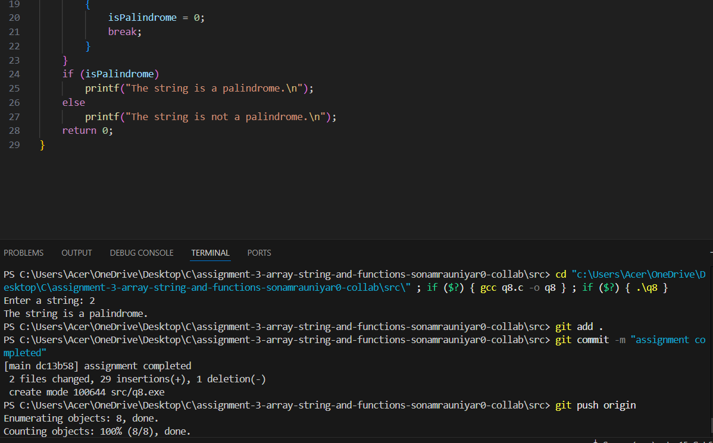

Q9. Implement a C program to count the occurrence of a specific character in a string.
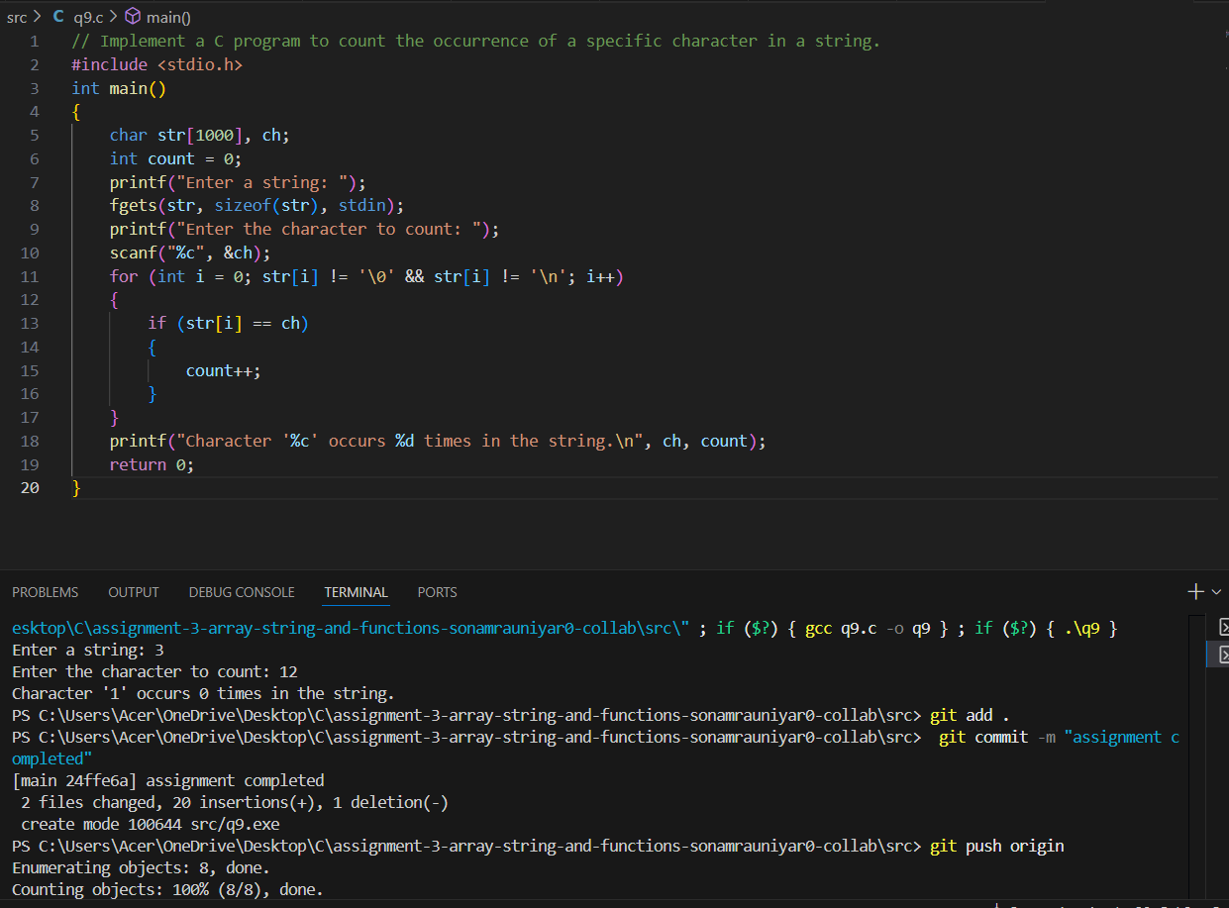

Q10. Write a C program to concatenate two strings without using the built-in string functions.
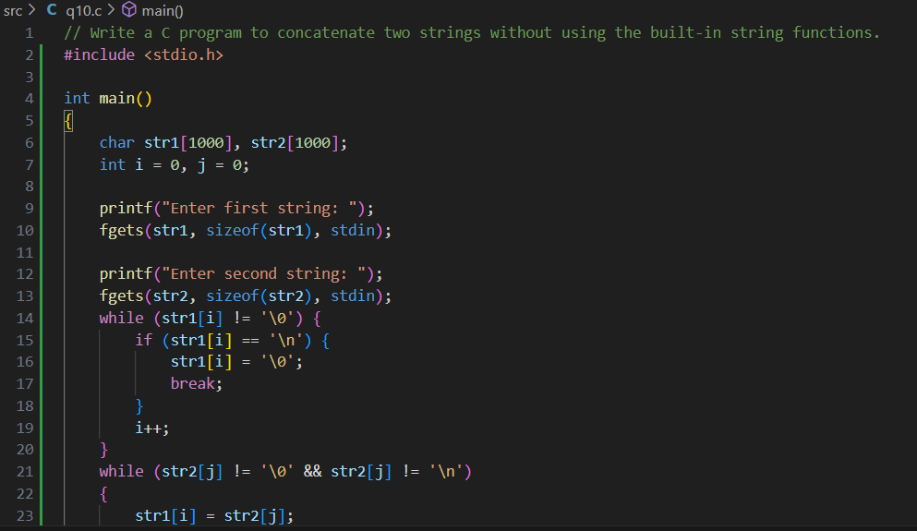
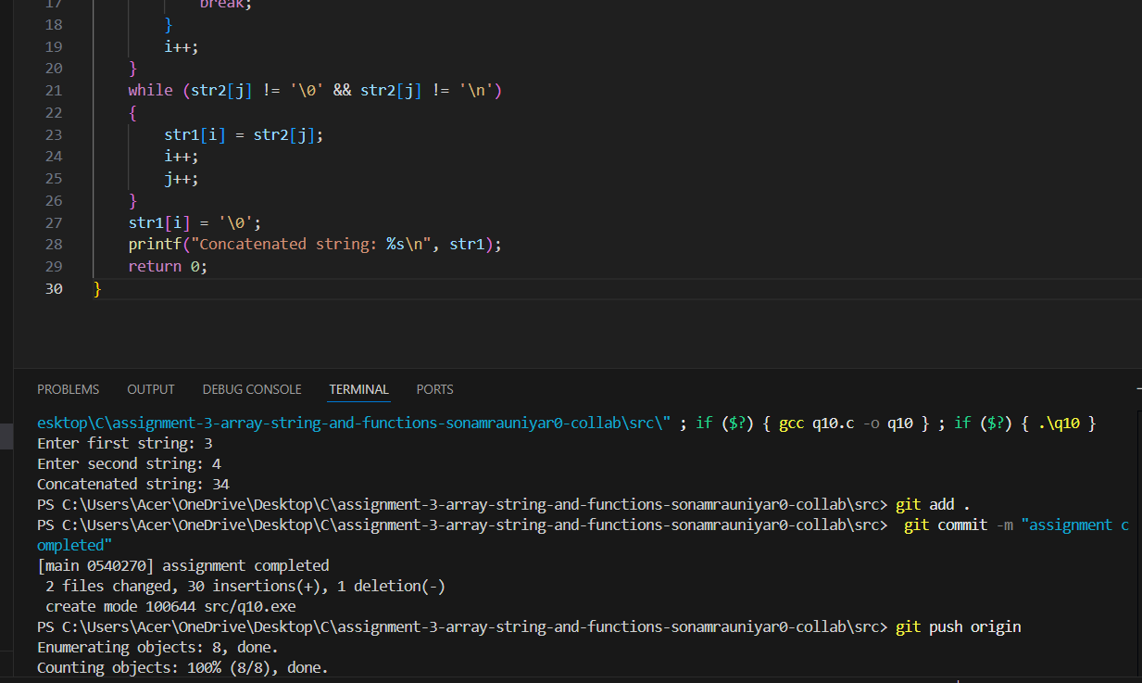
Q11. Write a function named calculate Average that takes an array of integers as input and returns the average of the numbers.
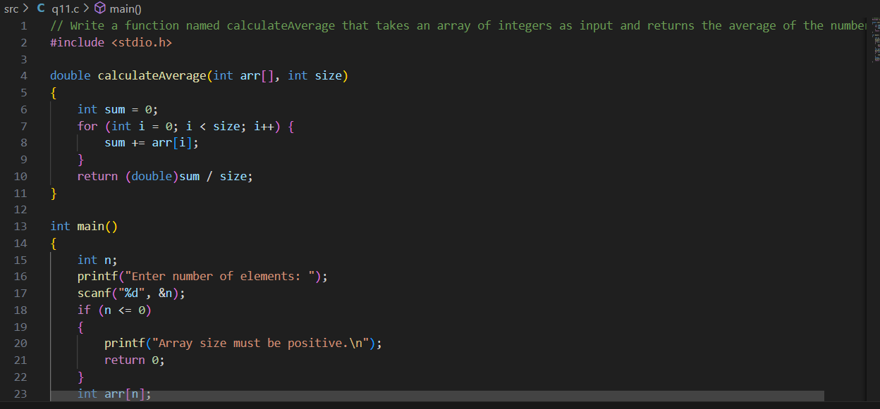
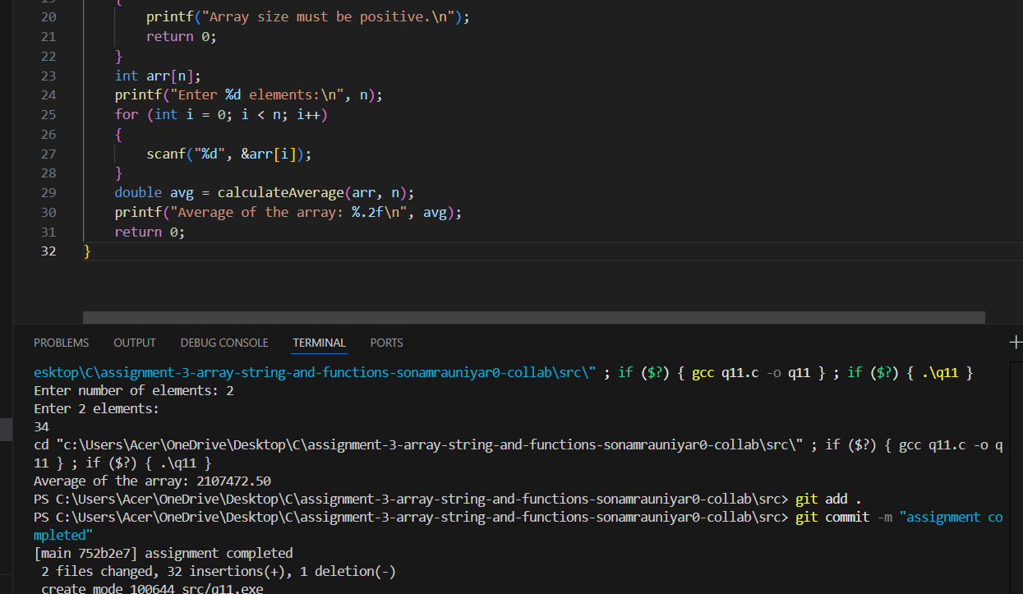
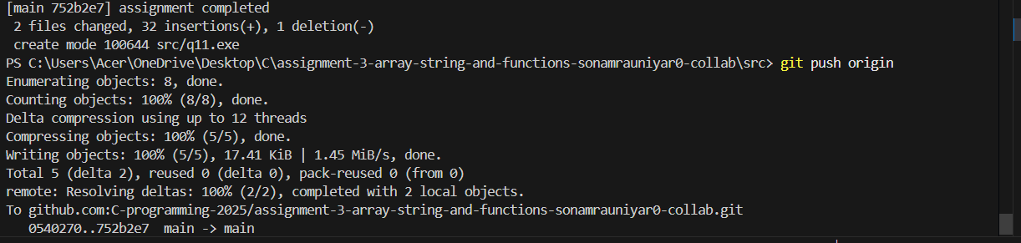
Q12. Write a function named is Palindrome that takes a string as input and returns 1 if it is a palindrome (reads the same forwards and backwards), and 0 otherwise.
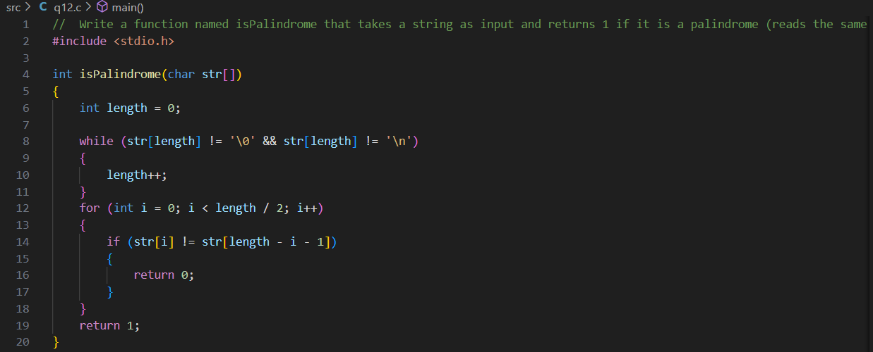

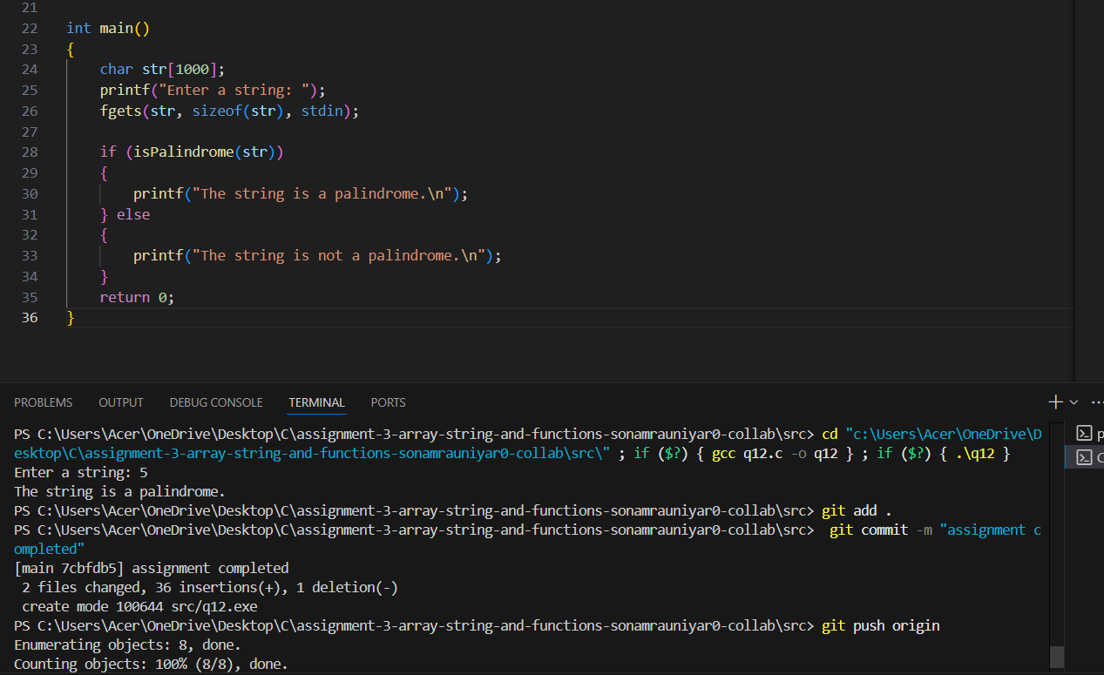

Q13. Write a function named find Factorial that takes an integer as input and returns its factorial.
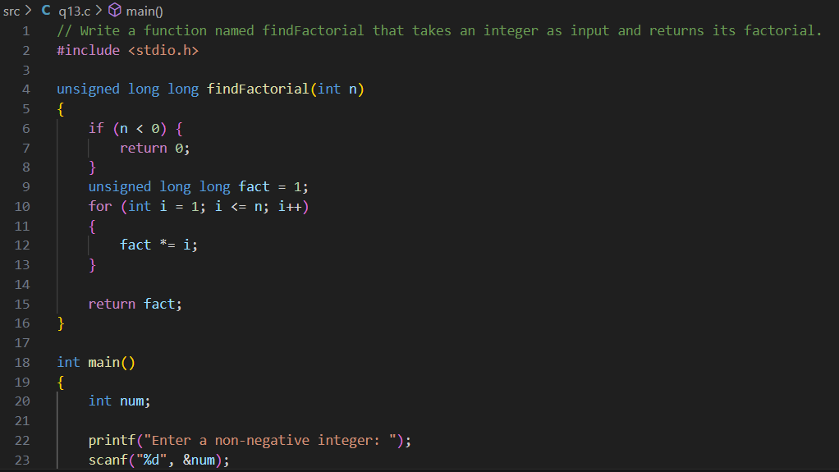
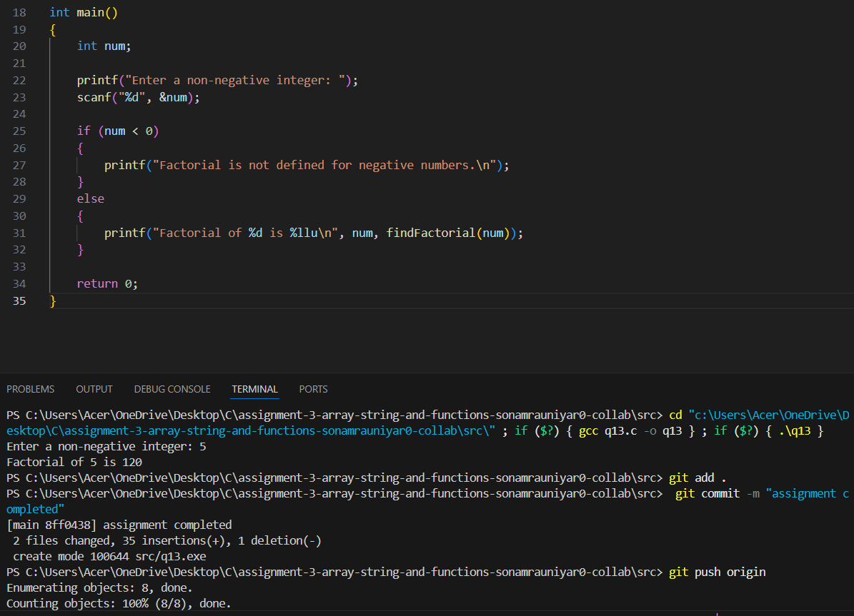

Q14. Write a function named convert Temperature that takes a temperature value in Celsius and converts it to Fahrenheit. The function should return the converted temperature.
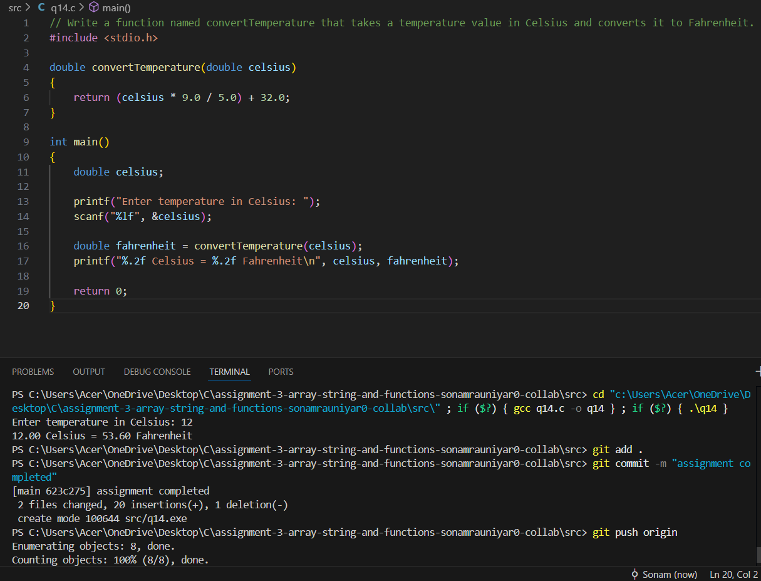

Q15. Write a function named count Occurrences that takes a string and a character as input and returns the number of times the character appears in the string.
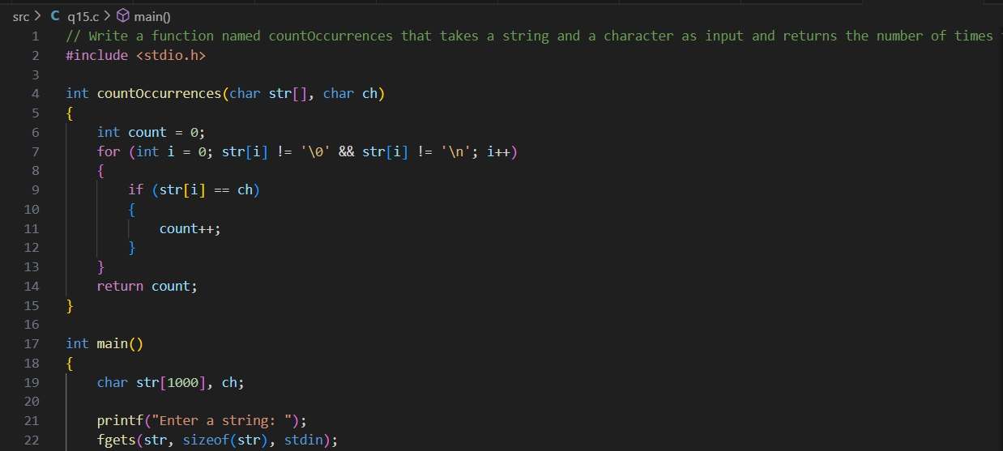
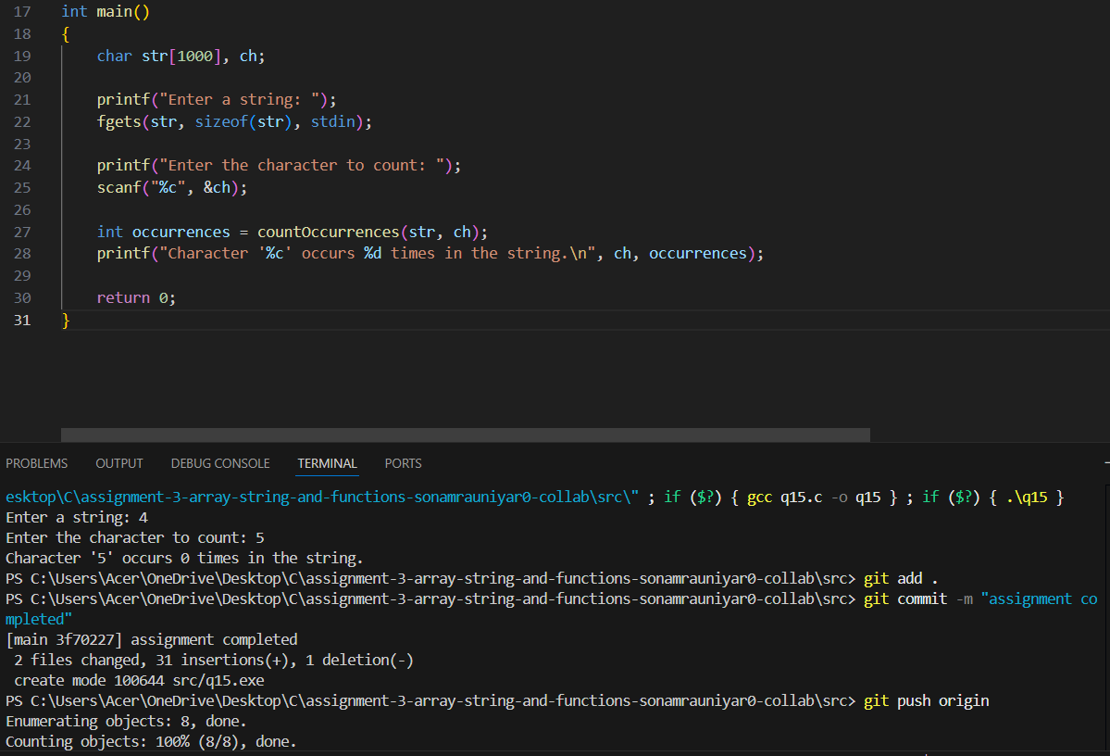

Q16. Write a function named reverse Array that takes an array of integers as input and reverses the order of the elements in the array.
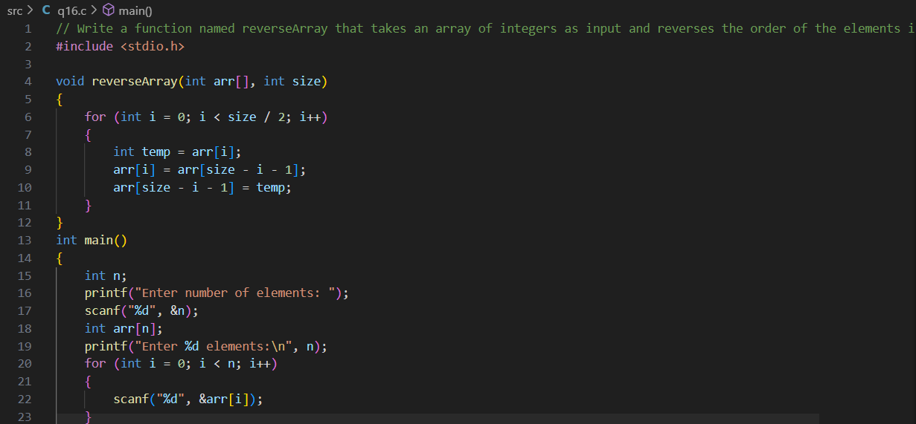
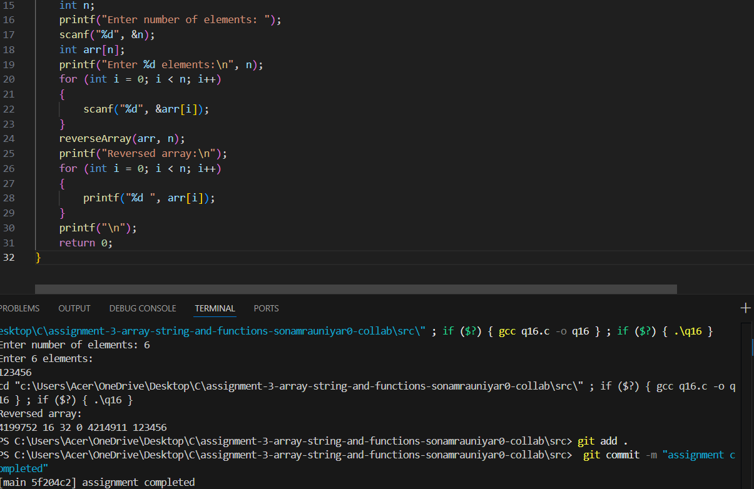
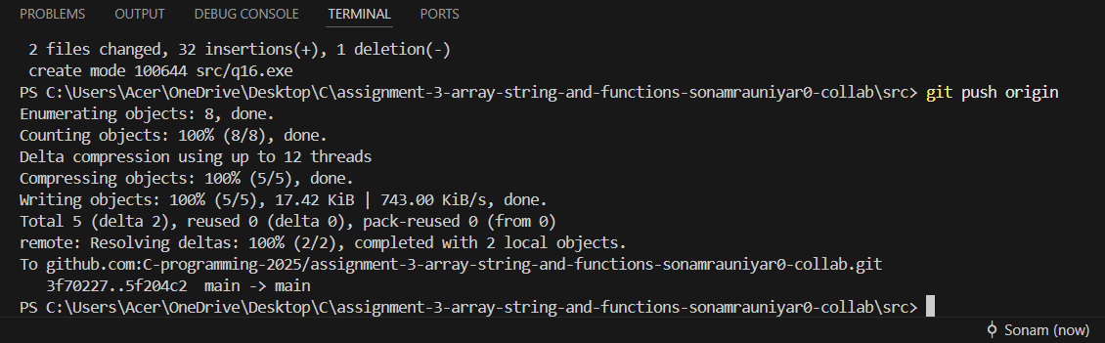
Q17. Write a function named calculate Power that takes two integers, base and exponent, as input and returns the result of raising the base to the exponent.
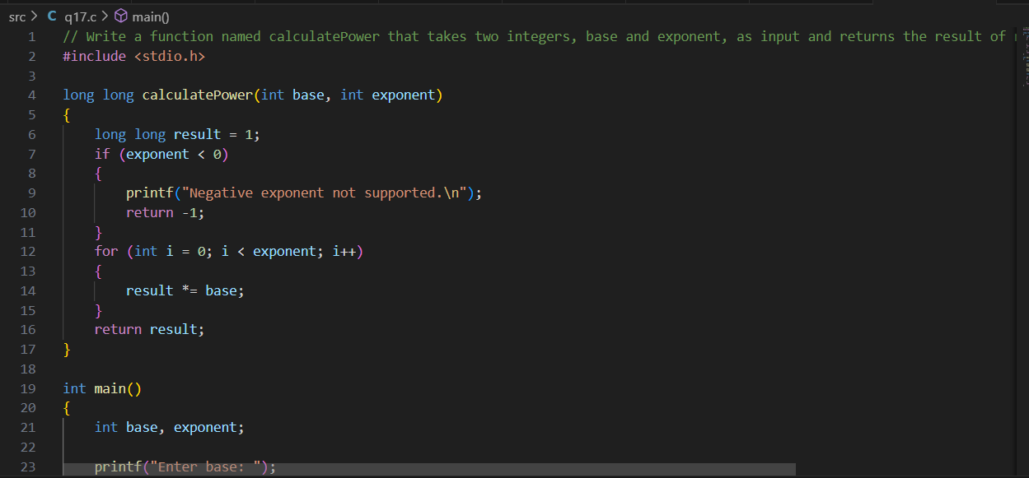
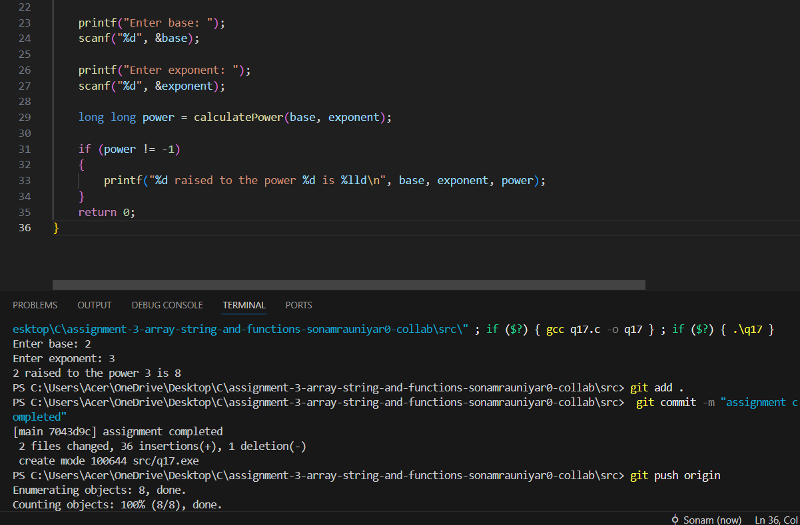
Q18. Write a function named findPrimeNumbers that takes an integer n as input and prints all prime numbers from 1 to n.
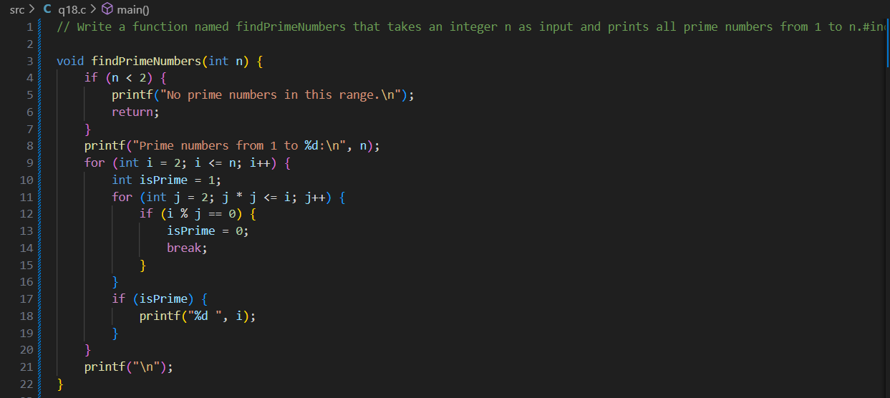
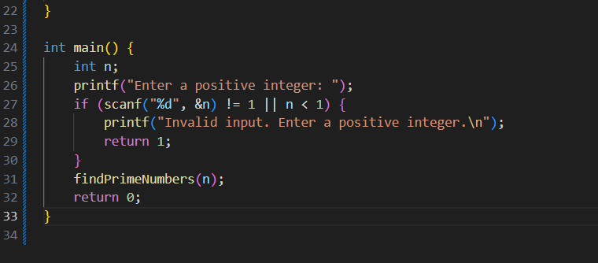
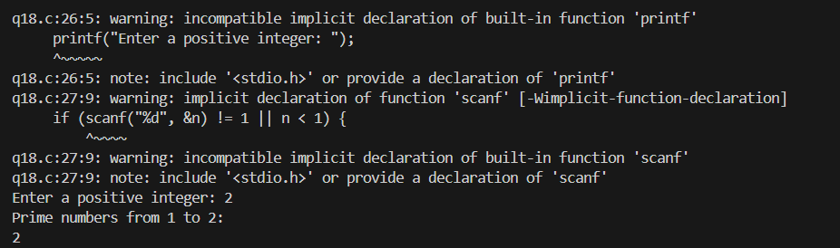
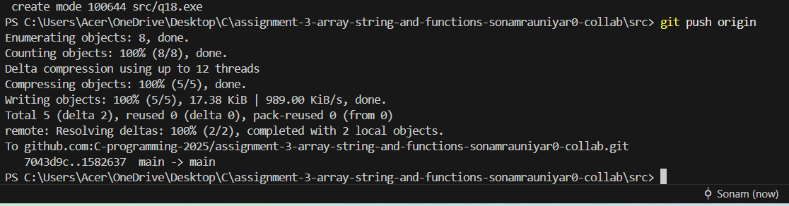

Q19. Write a function named calculateFactorialSeries that takes an integer n as input and prints the factorial series up to n.
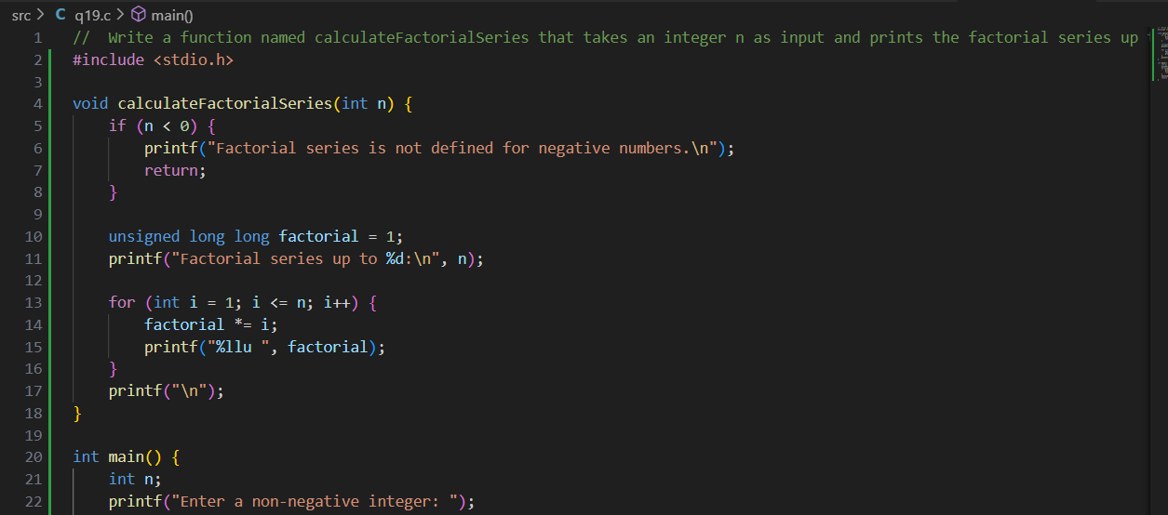
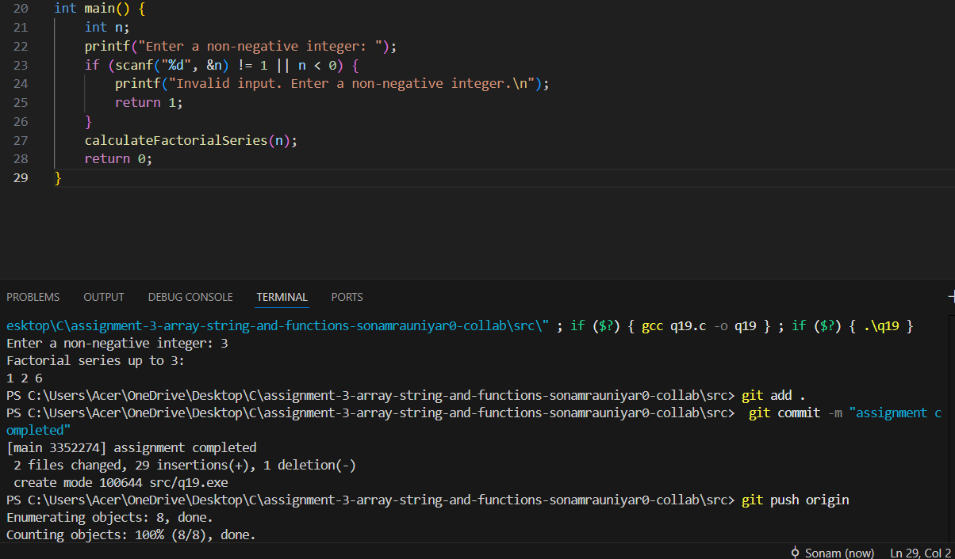

Q20. Write a function named calculateGCD that takes two integers as input and returns their greatest common divisor (GCD).
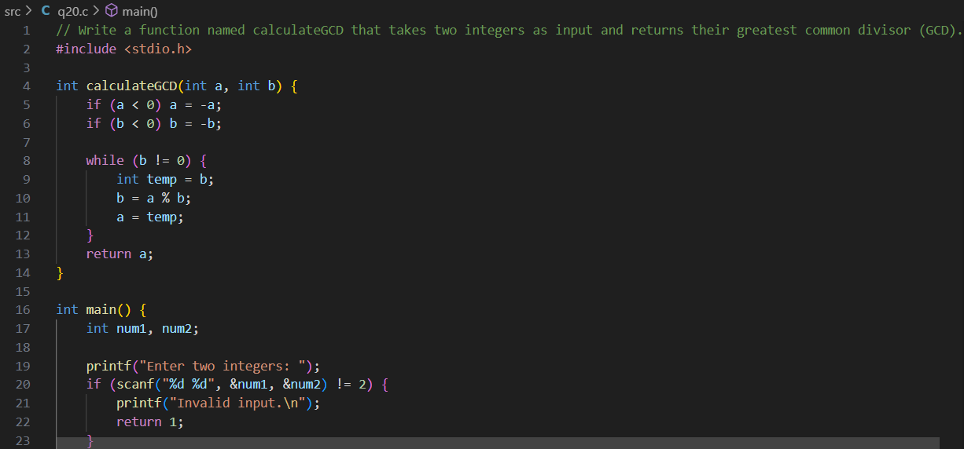
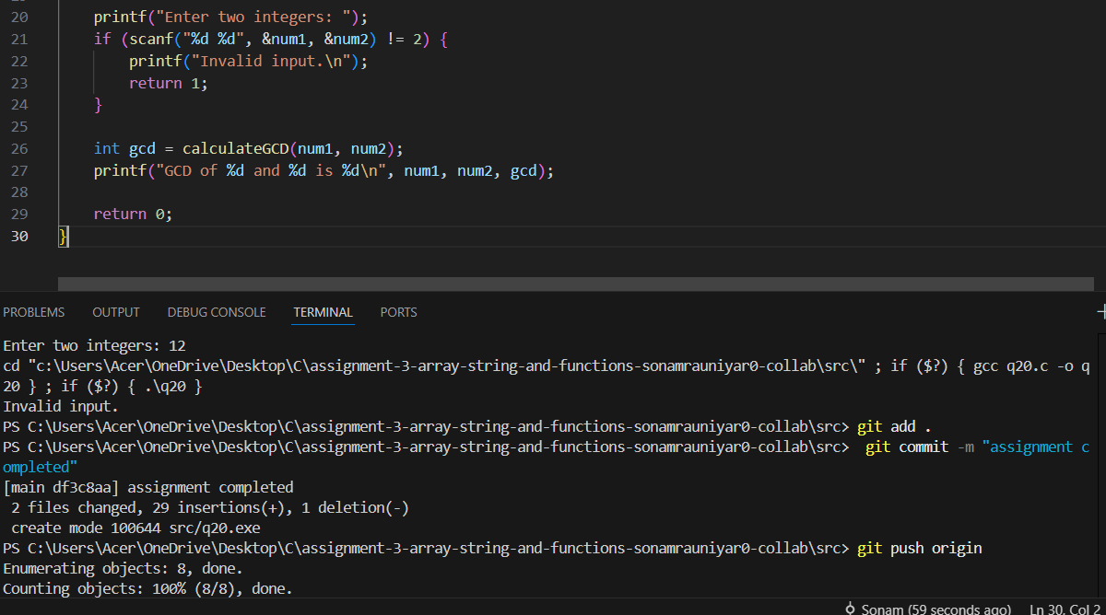

Q21. Write a recursive function named calculate Factorial that takes an integer n as input and returns its factorial.
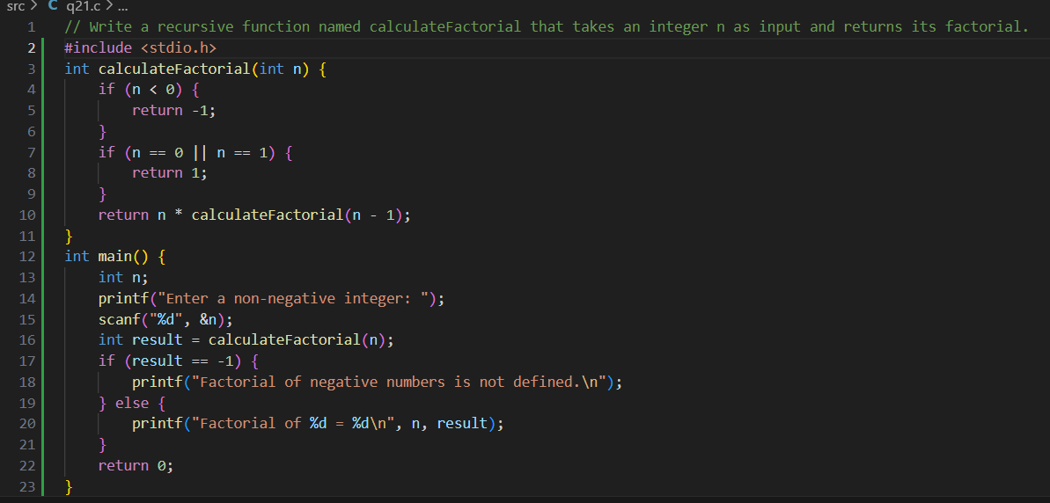
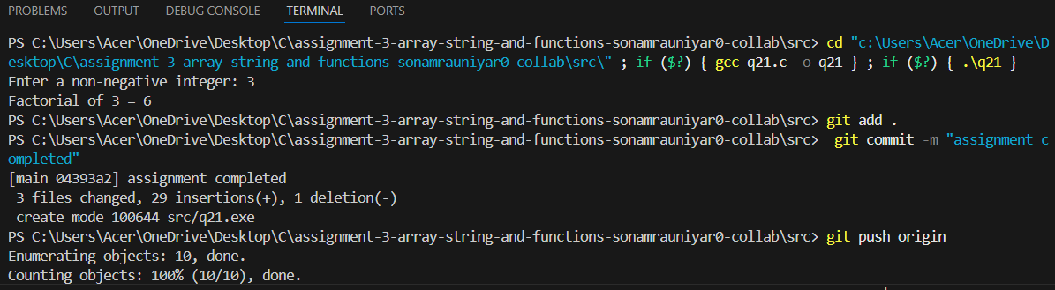

Q22. Write a recursive function named calculate Fibonacci that takes an integer n as input and returns the nth Fibonacci number. The Fibonacci sequence starts with 0 and 1, and each subsequent number is the sum of the two preceding numbers.
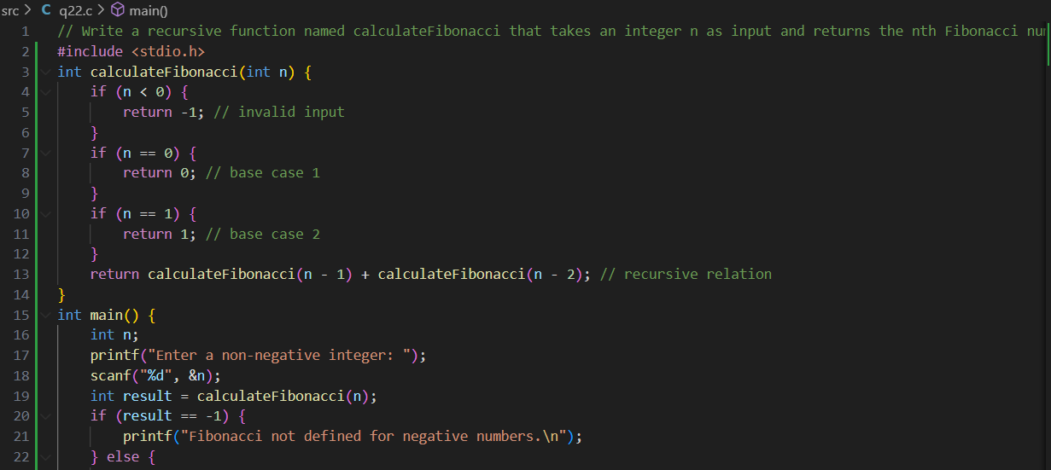
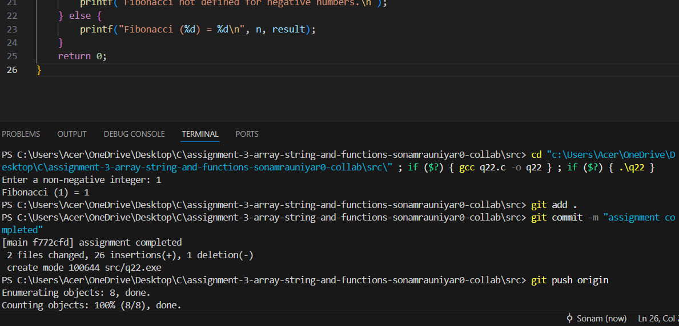

Q23. Write a recursive function named calculateGCD that takes two integers a and b as input and returns their greatest common divisor (GCD).
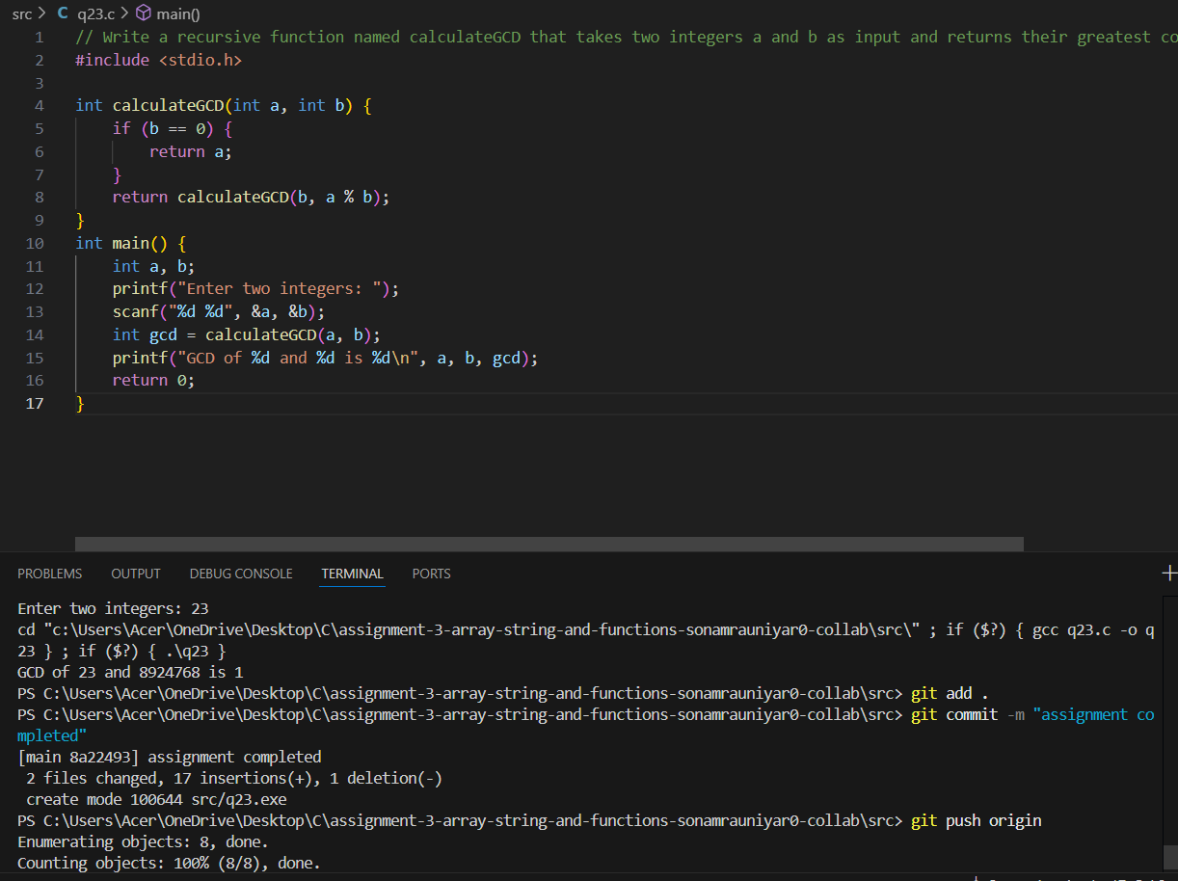

Q24. Write a recursive function named calculate Power that takes two integers base and exponent as input and returns the result of raising the base to the exponent.
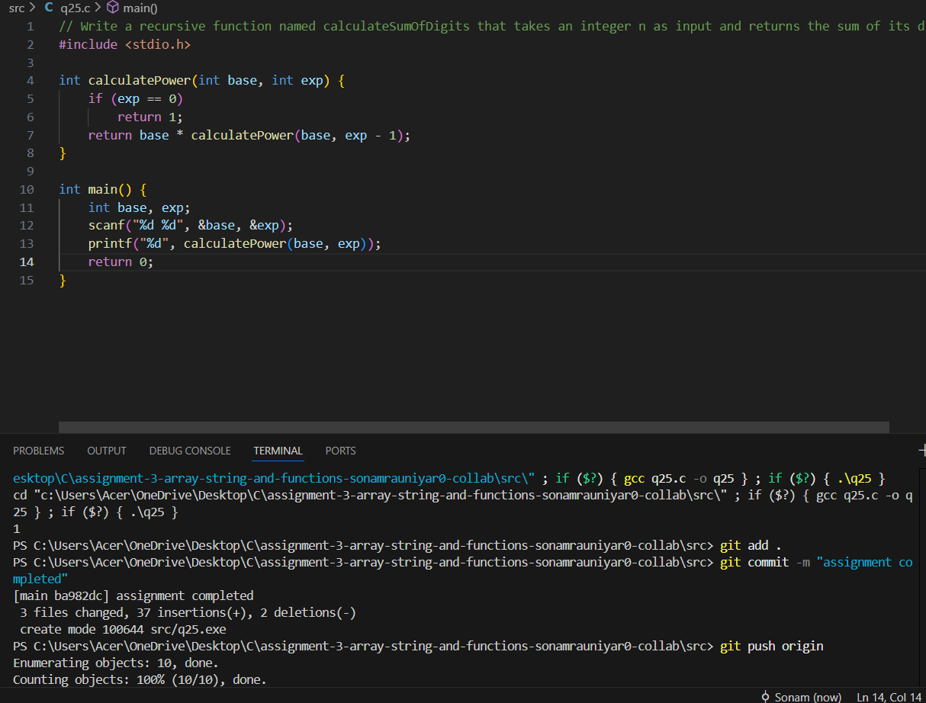

Q25. Write a recursive function named calculateSumOfDigits that takes an integer n as input and returns the sum of its digits.
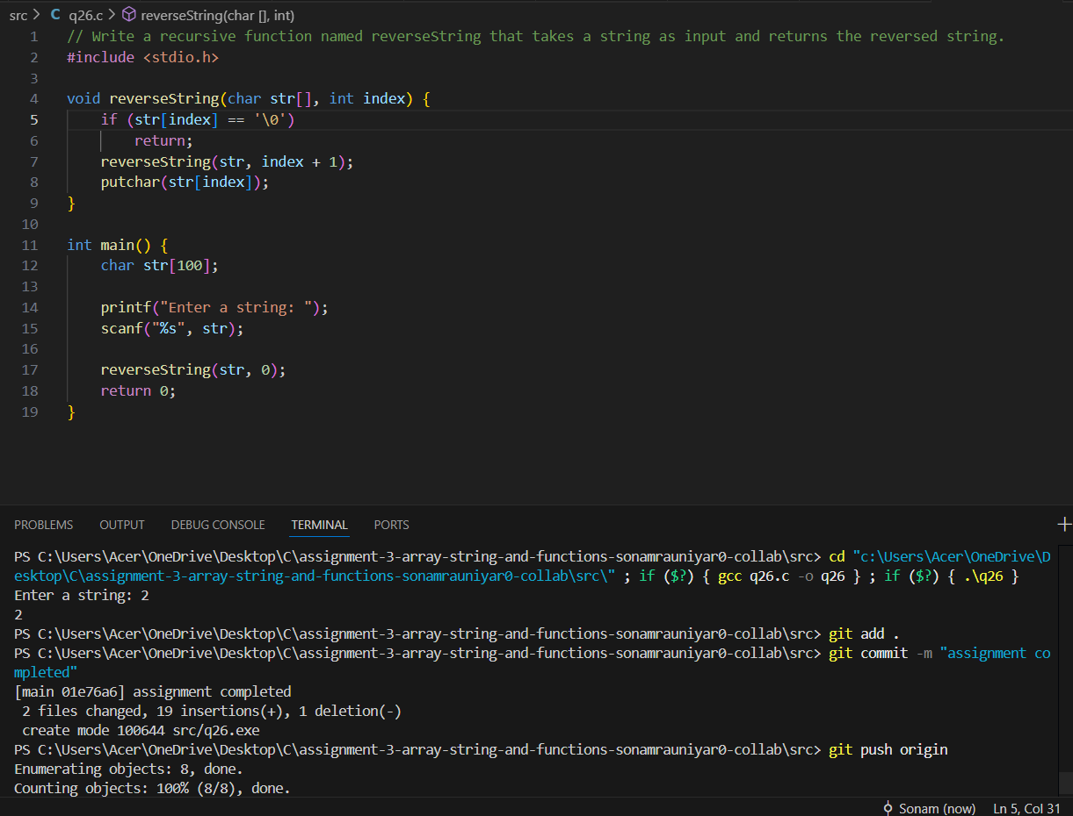

Q26. Write a recursive function named reverse String that takes a string as input and returns the reversed string.
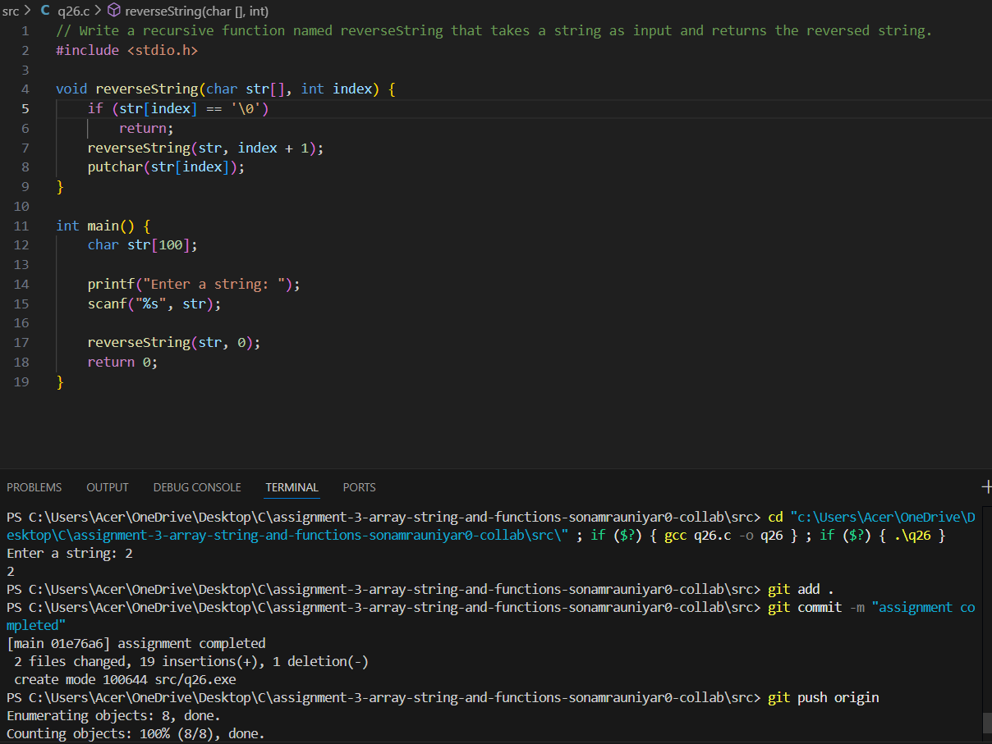

Q27. Write a recursive function named print Triangle that takes an integer n as input and prints a triangle of asterisks (*) with n rows.
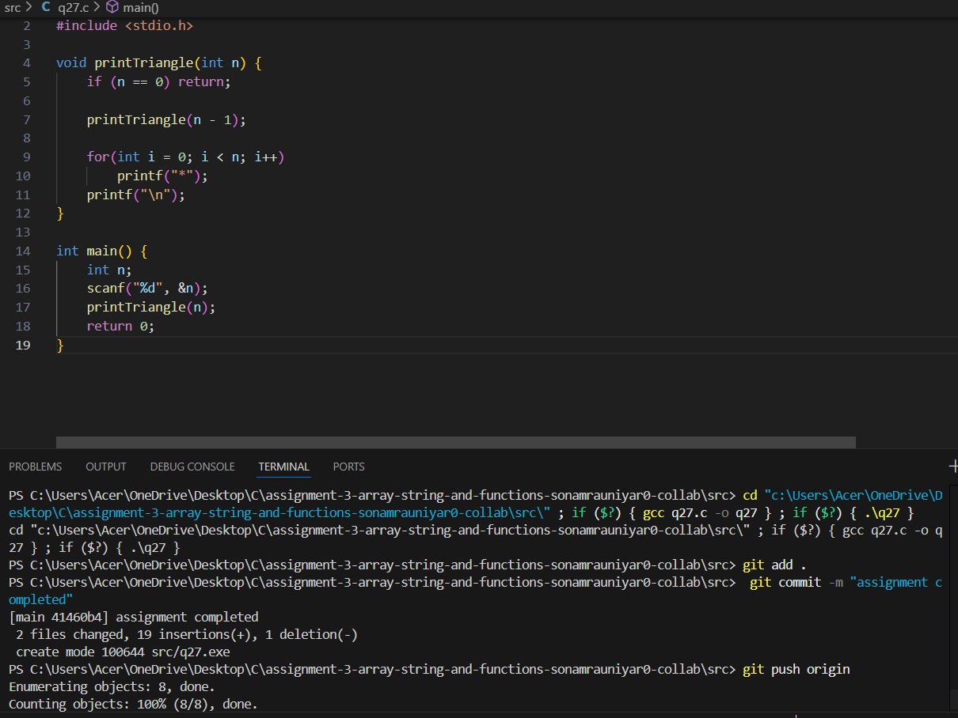

Q28. Write a recursive function named calculate Binary that takes an integer n as input and returns its binary representation as a string.
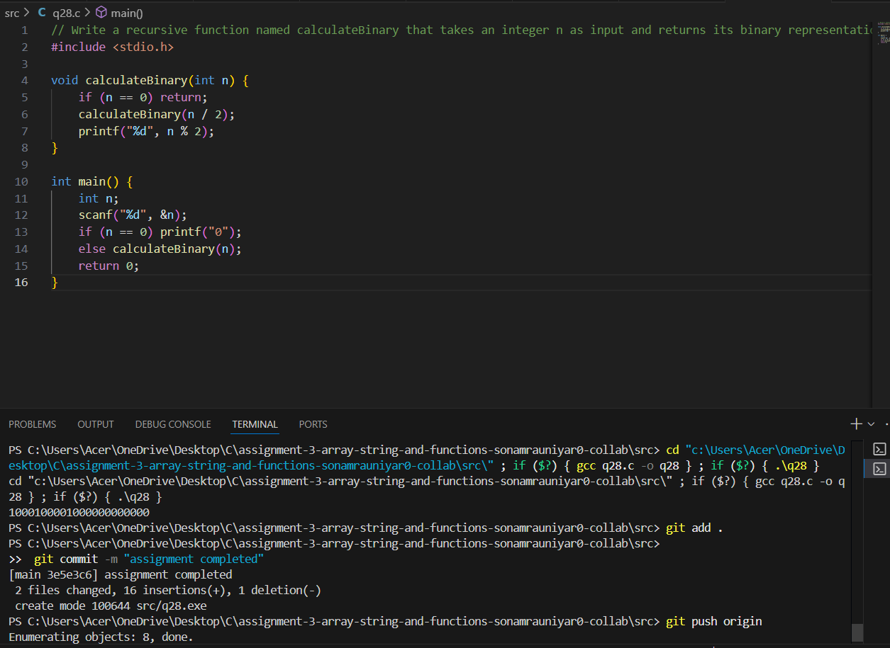

Q30. Write a recursive function named count Occurrences that takes a string and a character as input and returns the number of times the character appears in the string.
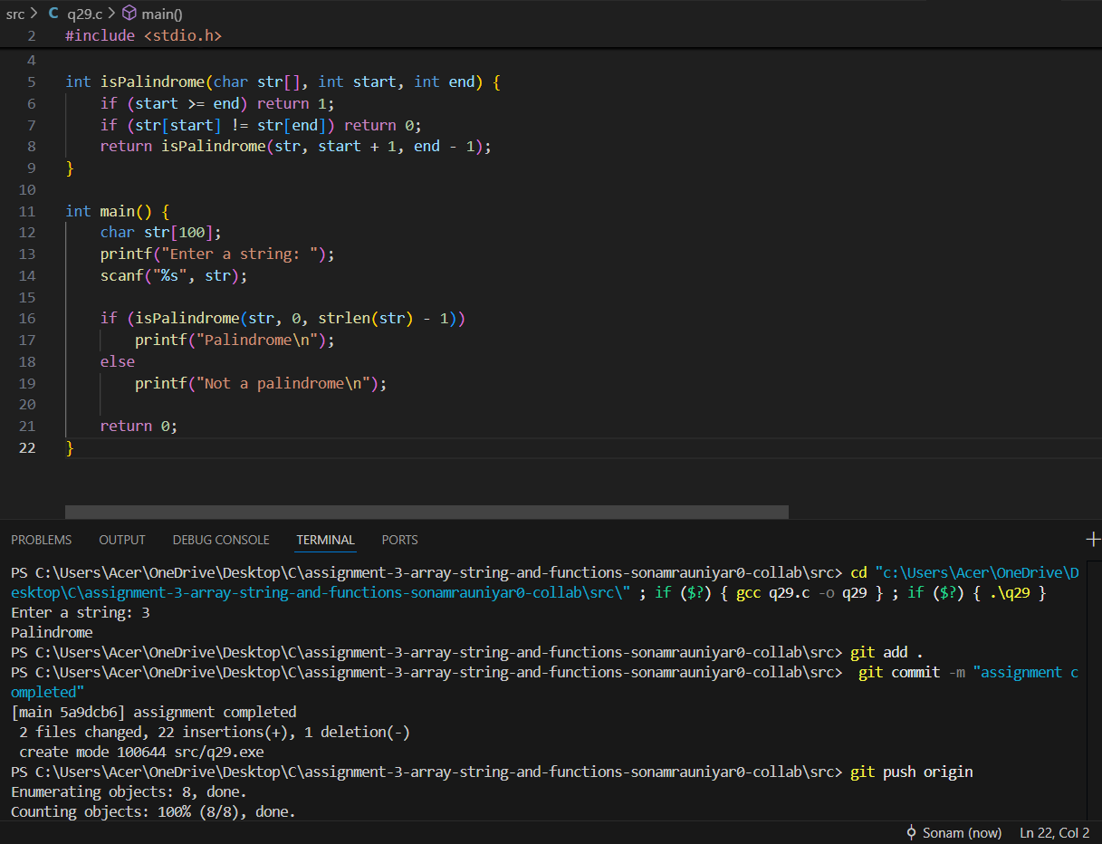

Q30. Write a recursive function named count Occurrences that takes a string and a character as input and returns the number of times the character appears in the string.
