# Database Tables

## CustomerPayment Structure

(**)Tomas Smitas

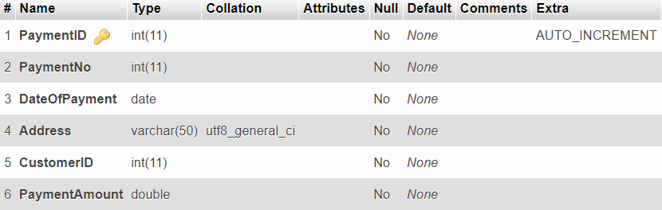

## CustomerPayment Sample Data

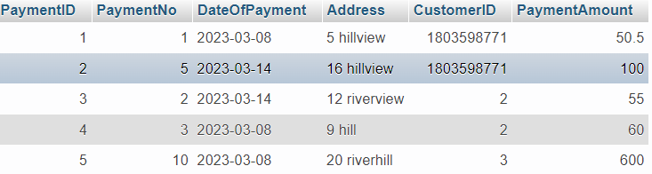

## Customer Structure

(**)Tomas Smitas

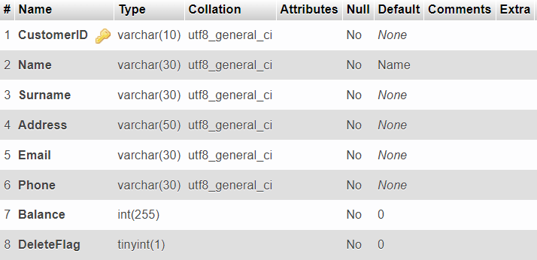

## Customer Sample Data

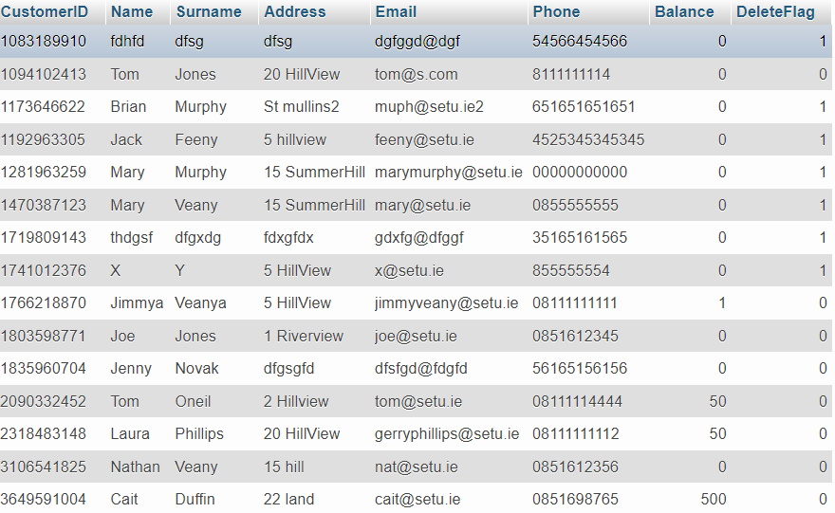

## Sales Item Structure

(**)Tomas Smitas

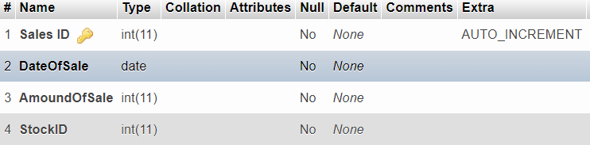

## Sales Item Sample Data

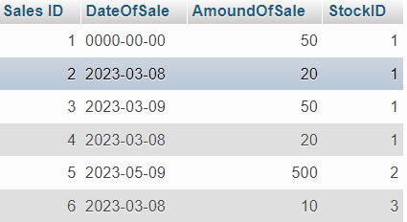

## Orders Structure

(**)Tomas Smitas

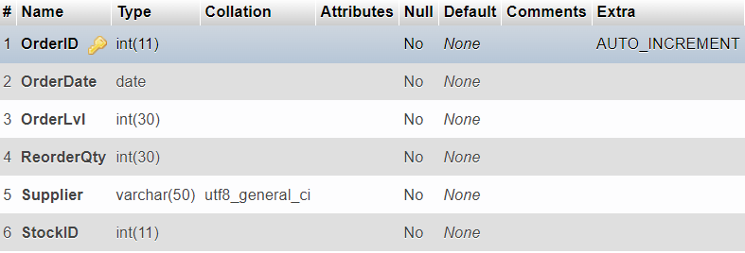

## Orders Sample Data

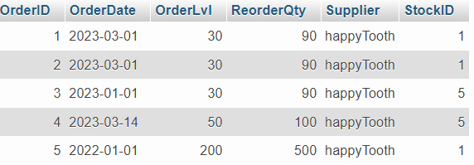

Employee Structure

(**)Edward Omorusi

Employee Sample Data

Funeral Details Structure

(**) Edward Omorusi

Funerals Details Sample Data

Supplier Structure

(**) Matthew Ufumeli

Supplier Sample Data

Supplier Invoice Structure

(**) Matthew Ufumeli

Supplier Invoice Sample Data

Order Item Structure

(**) Matthew Ufumeli

Order Item Sample Data

Counter Sales Structure

(**) Matthew Ufumeli

Counter Sale Sample Data

