Lab6 Notes/Findings

Step1: Install kn:
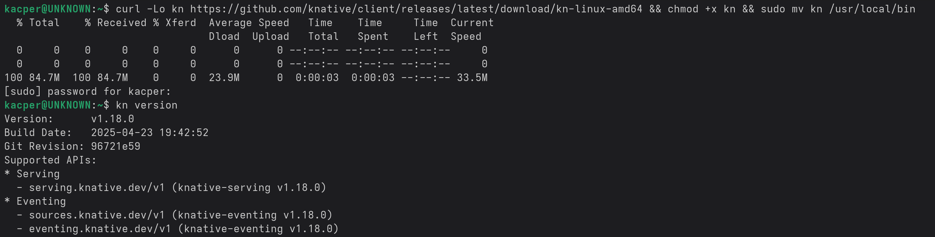
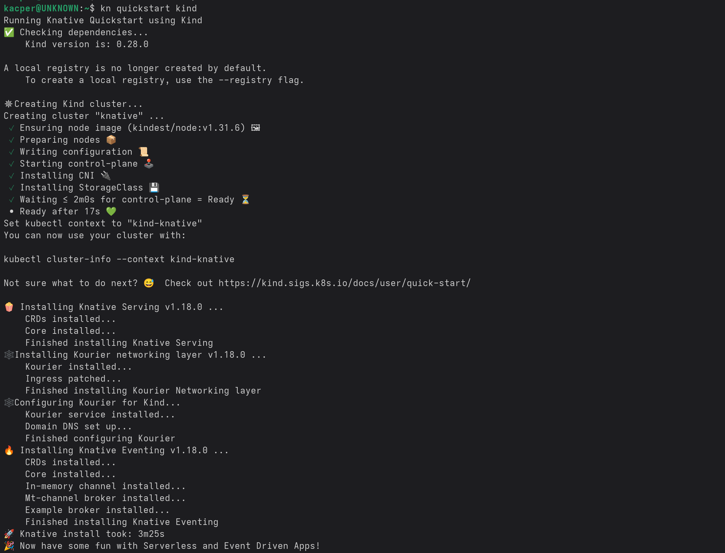

Step2:Build into the local registry:
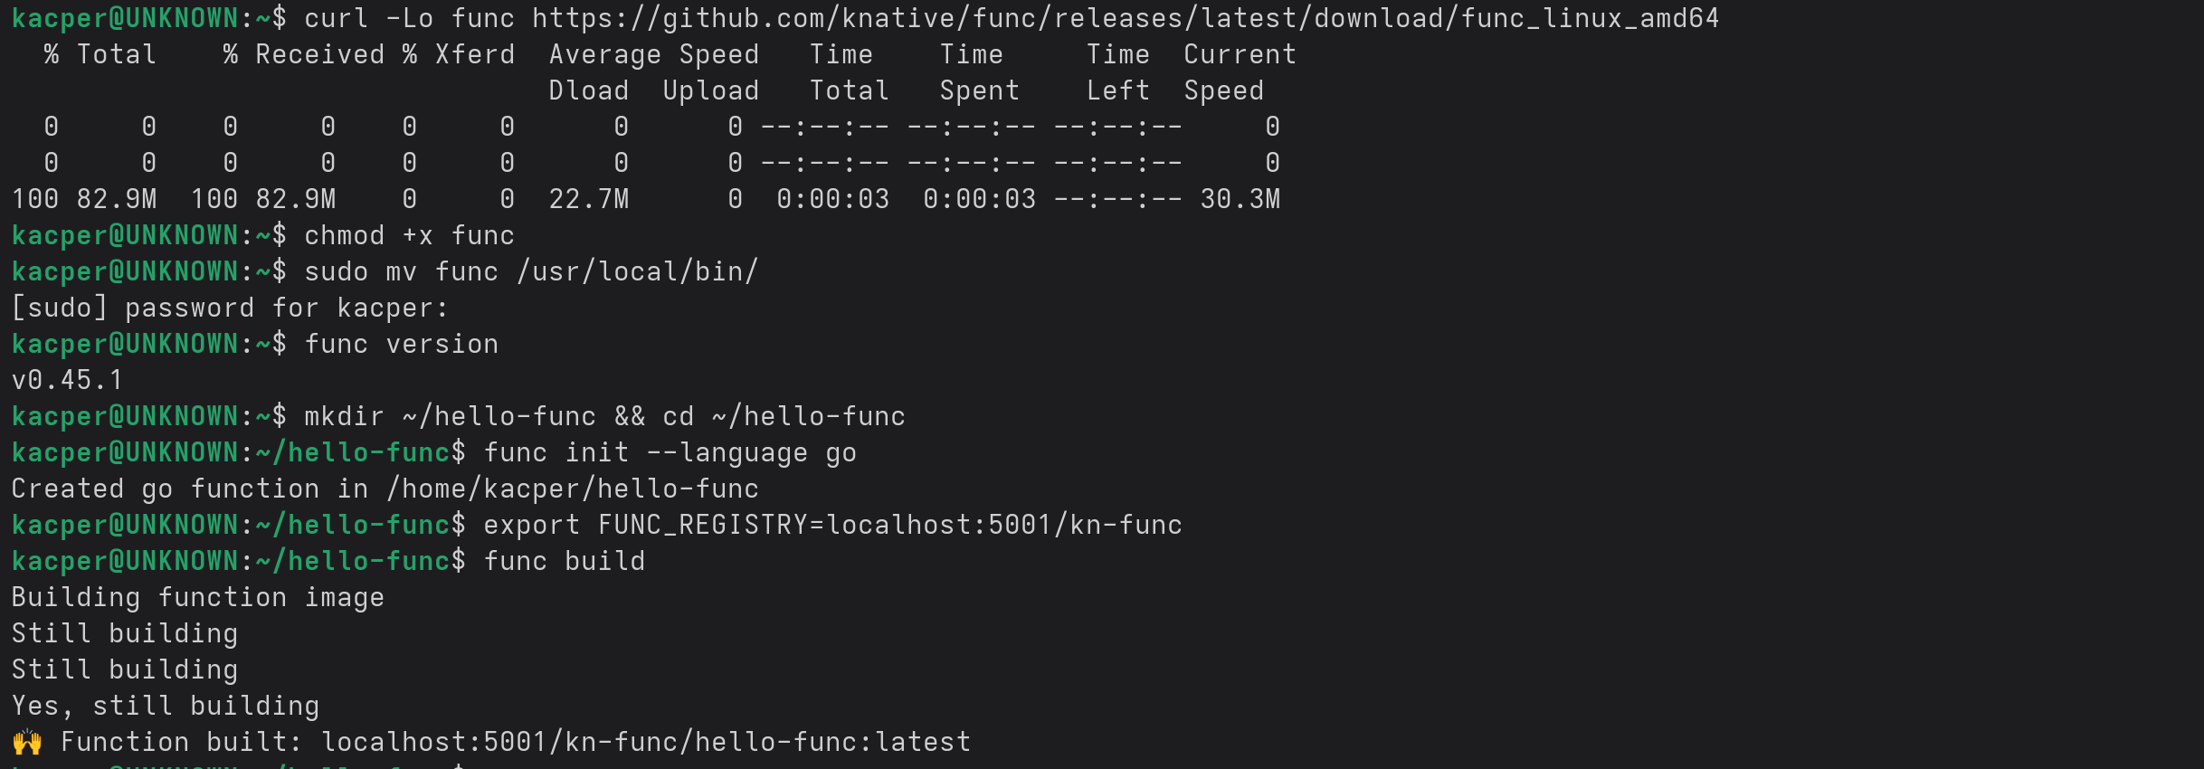
Step3: Create a Knative Service:
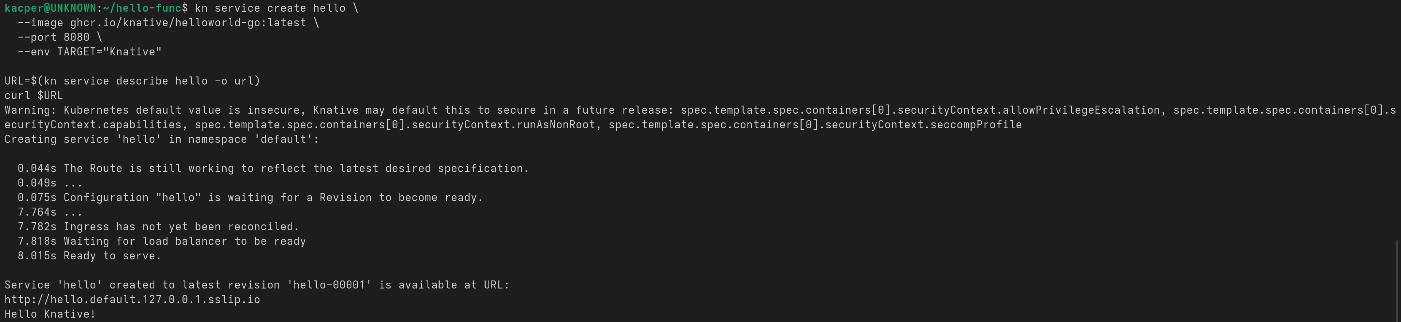
Step4: Autoscale Demo:
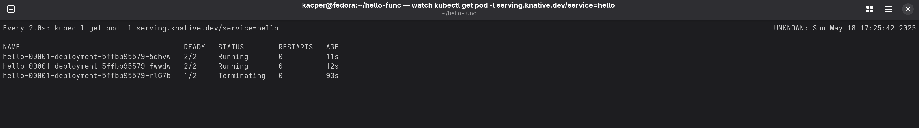

Step5: Knative Event:
