Lab2 Notes/Findings

Step 1: Install Docker Engine

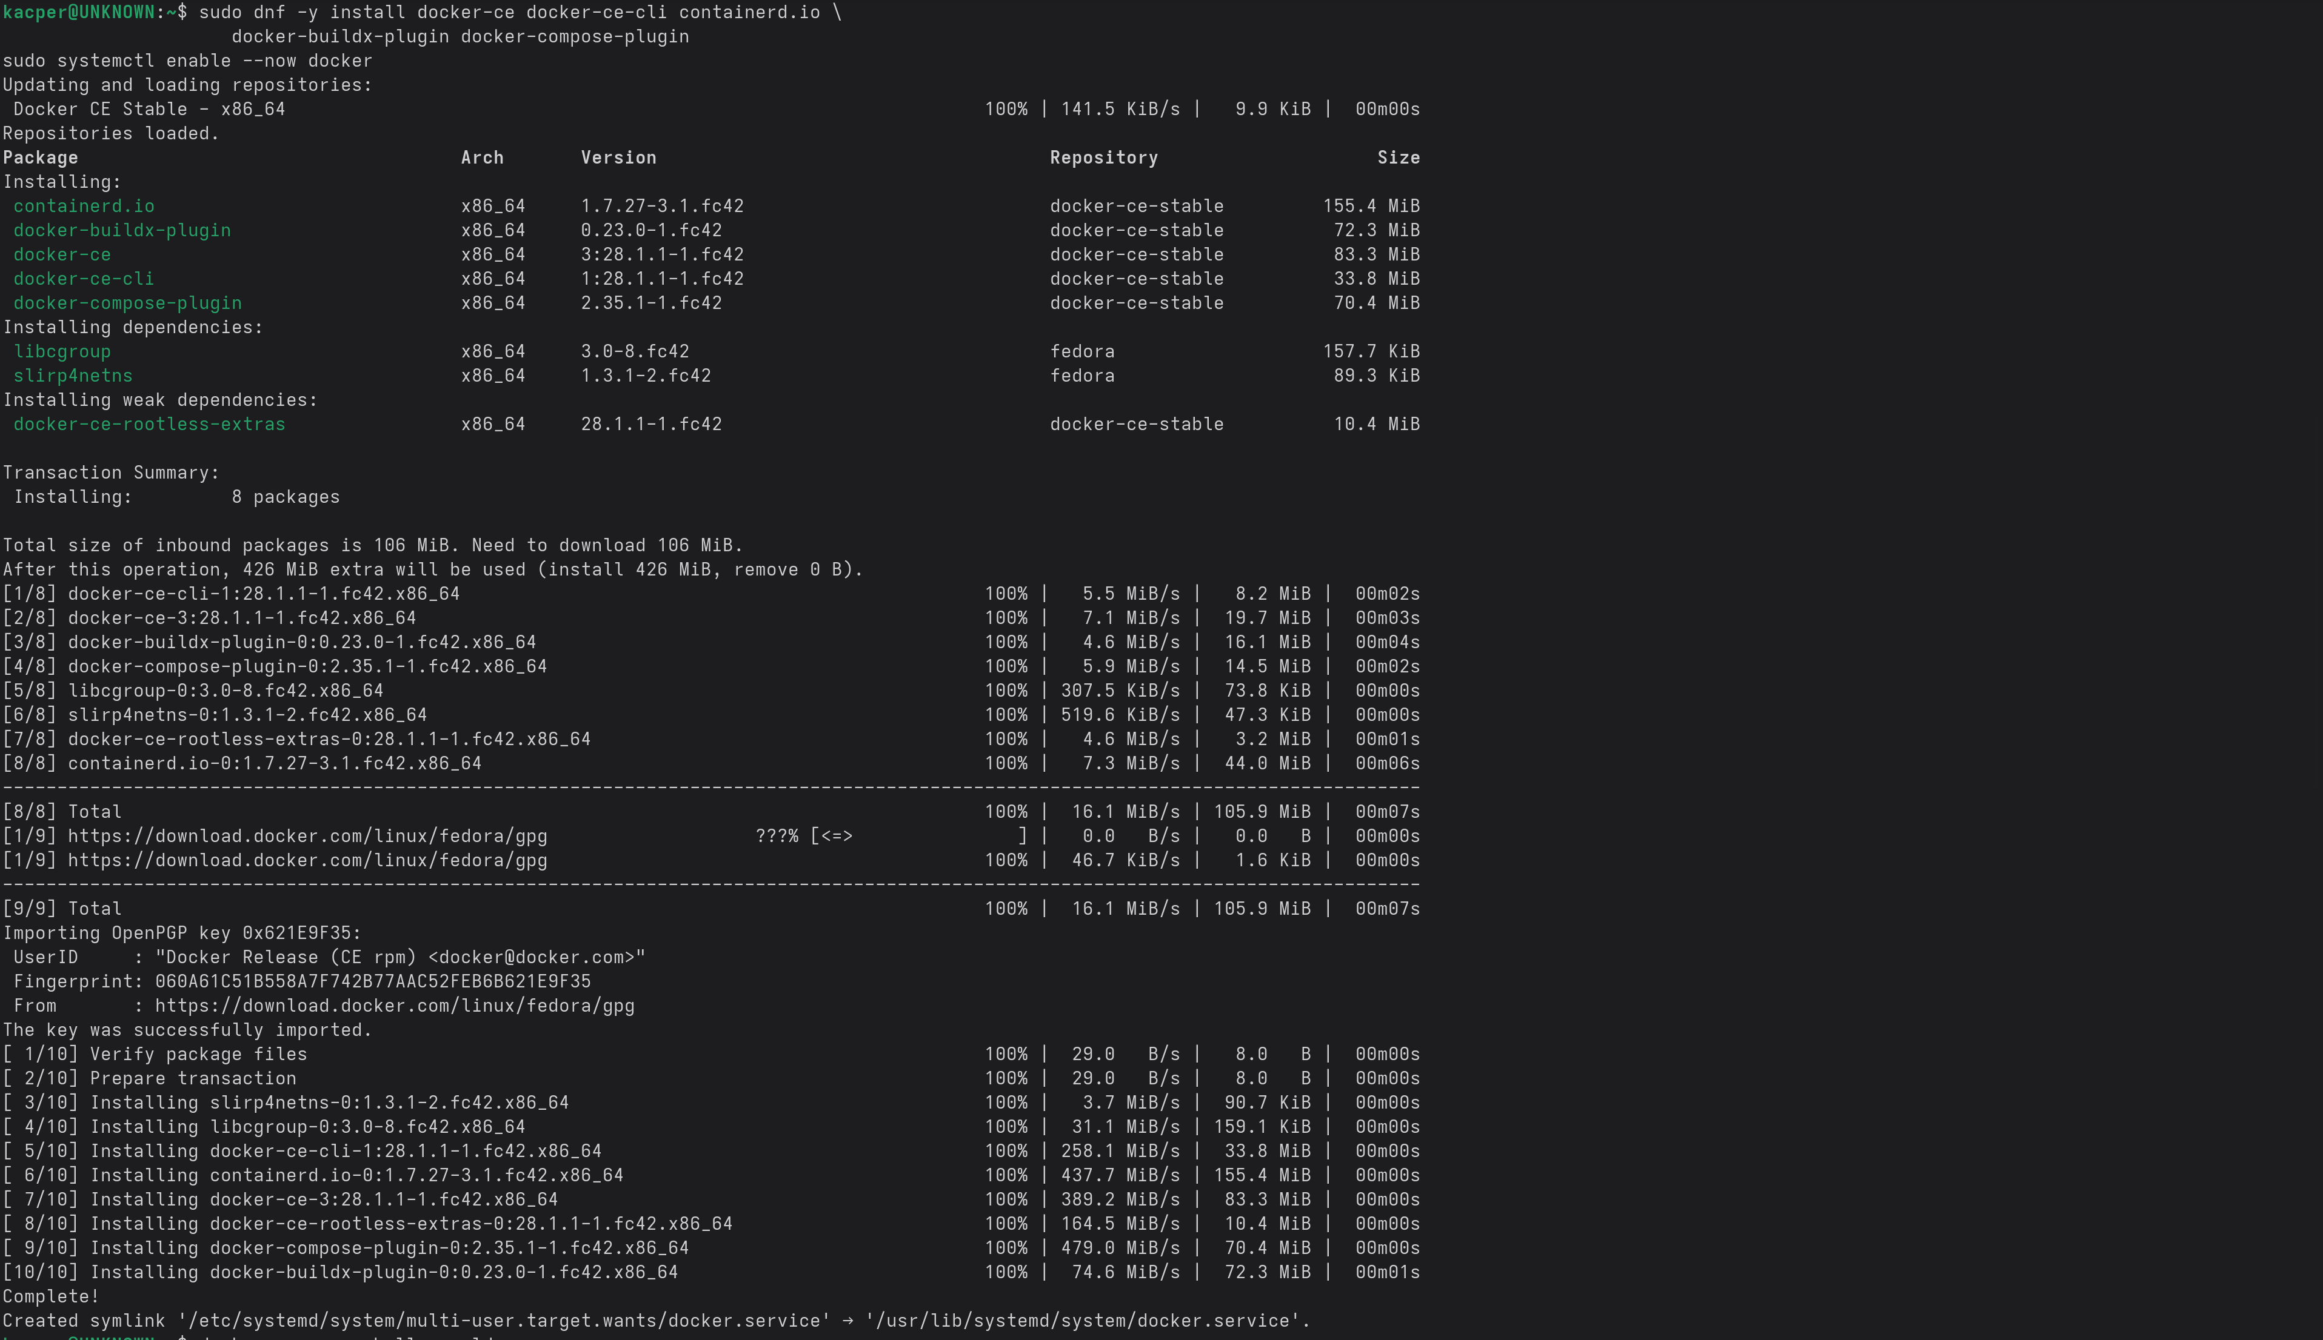
For Context, attempting to install and run docker on a Linux Fedora System for this section.

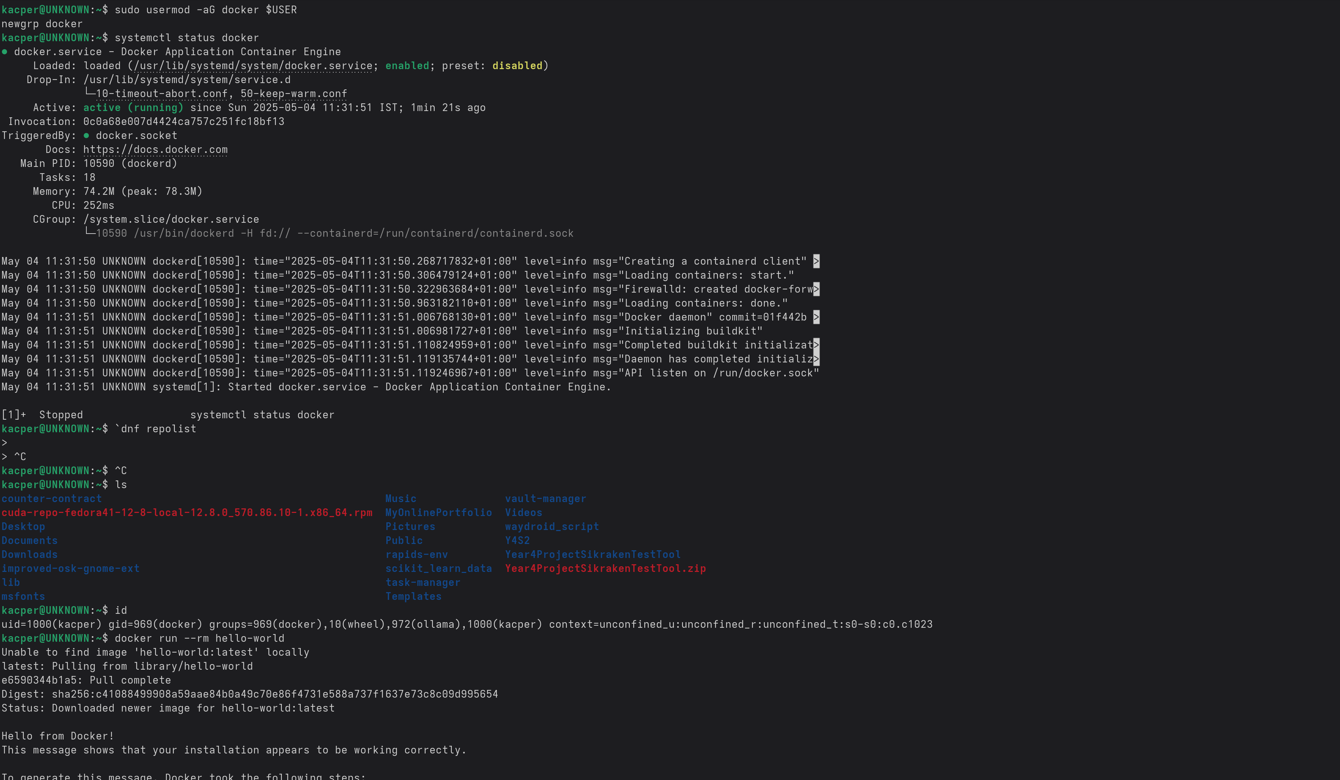
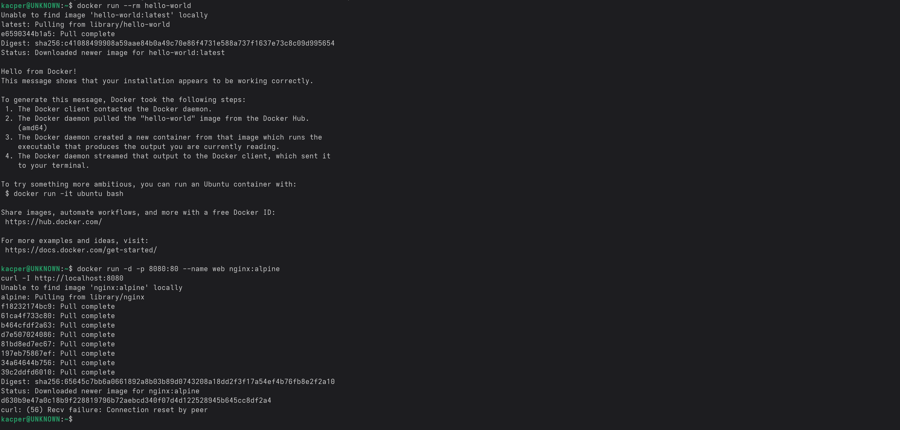

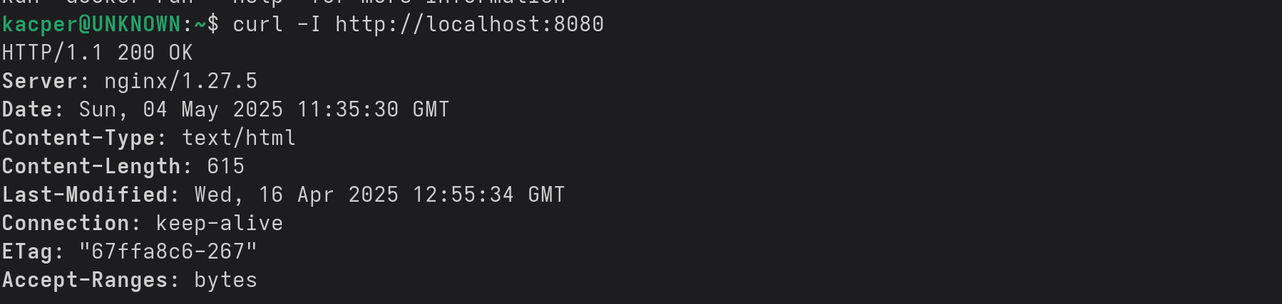
Step 2: Publish Container Ports:
Step 3: Override Container Defaults:
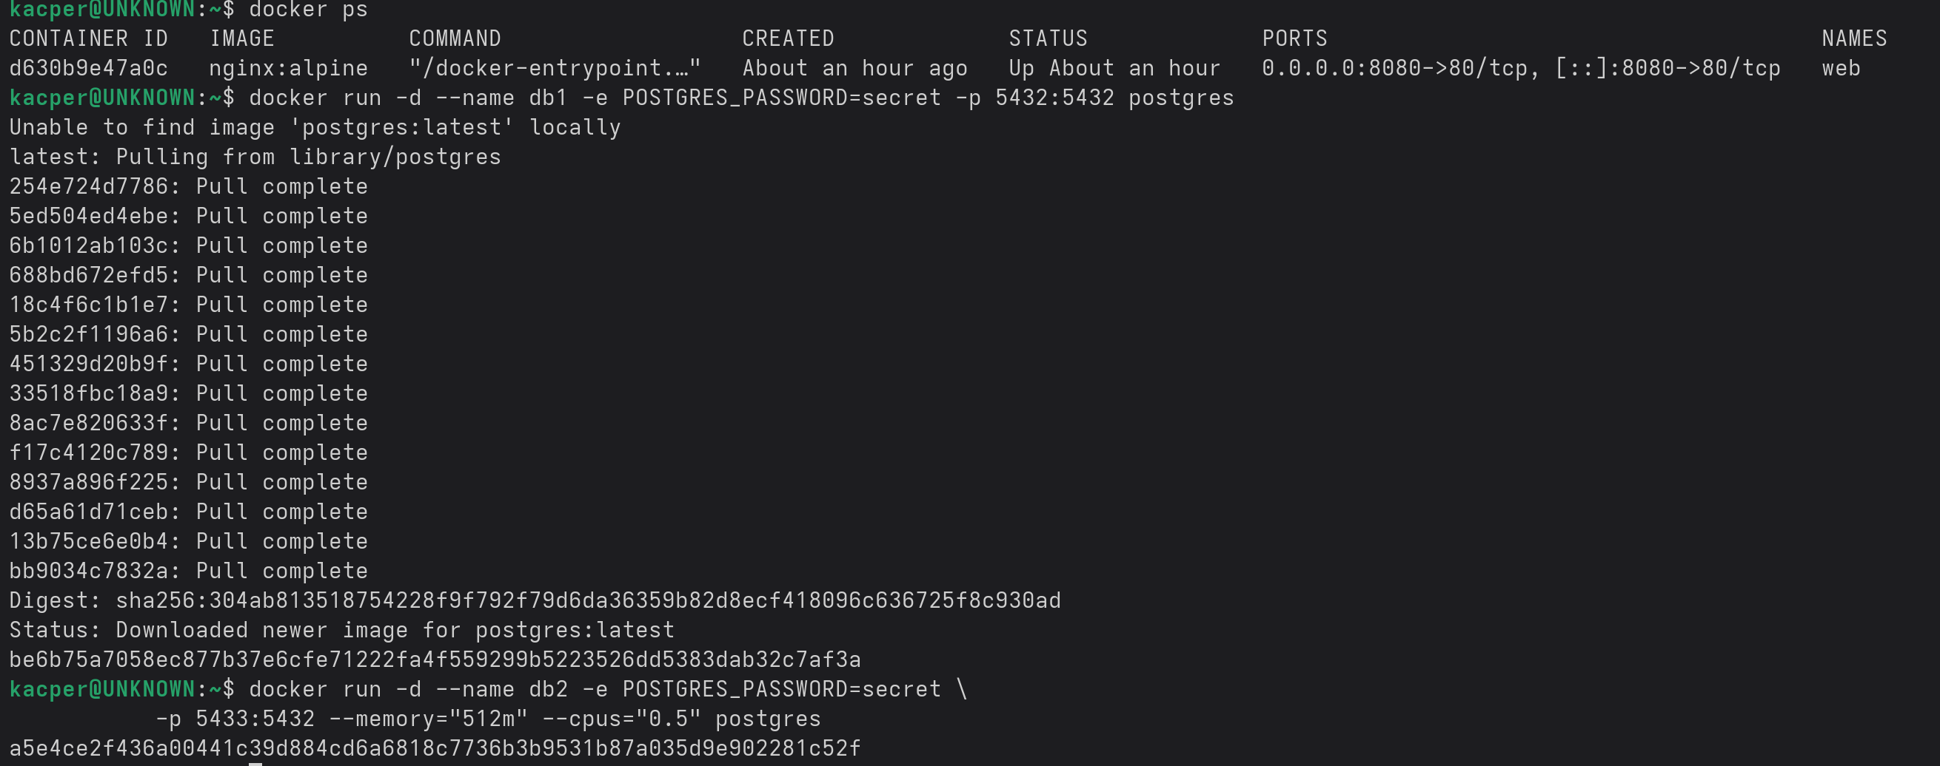
db1runs Postgres with default resources on the standard host port 5432
- db2 demonstrates overrides:
-p 5433:5432` → shifts the host port to 5433
`--memory="512m" --cpus="0.5"` → limits RAM to 512 MiB and CPU to half a core
`-e POSTGRES_PASSWORD=secret` → passes an environment variable at runtime
Step 4: Persisting Container Data:

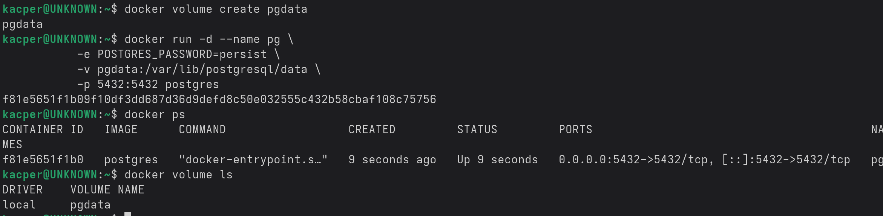
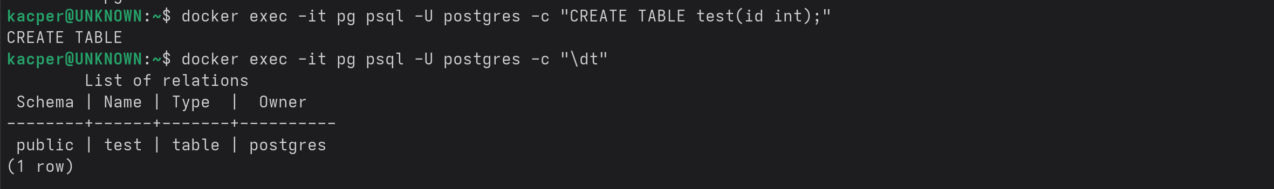
Now delete container pg (but the volume will be kept)
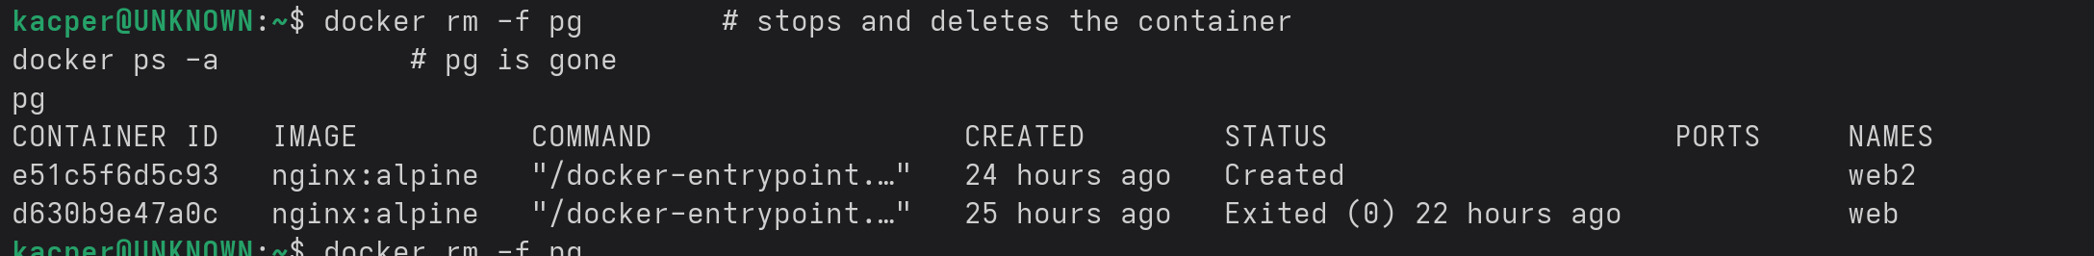
Start a new postgres pointing to the same volume and the test table will persist in the new postgre (showing that data can persist outside of previous containers)
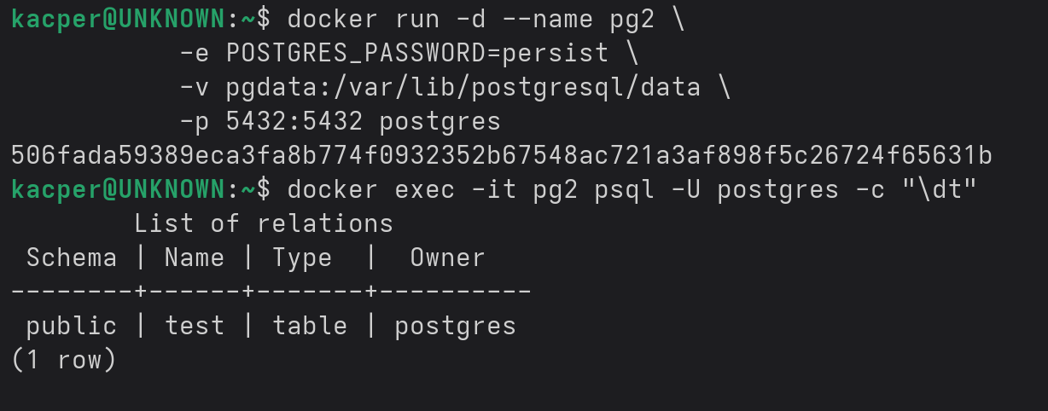

Step 5: Sharing Host Files with a Container:

Make a test directory and a mock html file, which will be hosted by docker.
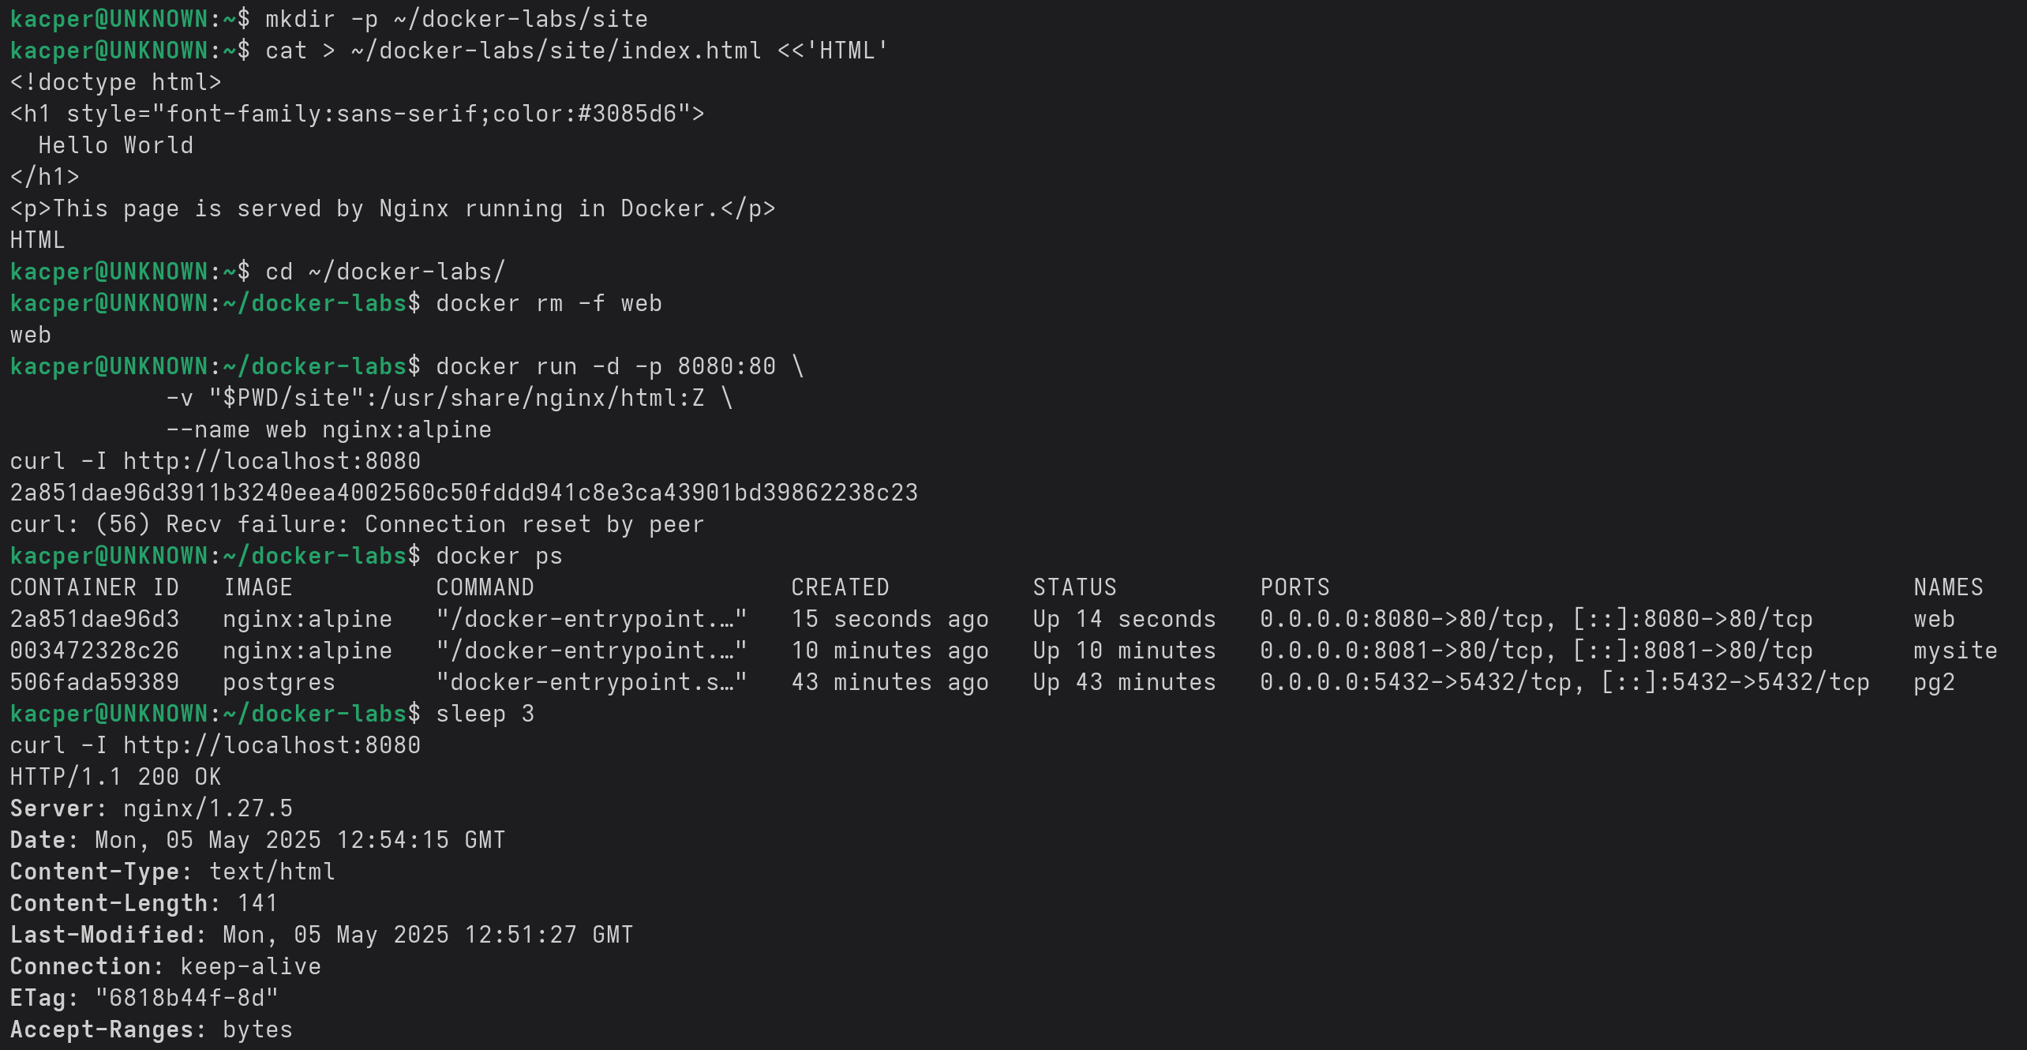

Step 6: Running a multi-container application with Docker Compose:
