Lab3 Notes/Findings

Step 1: Install kubectl and minikube:
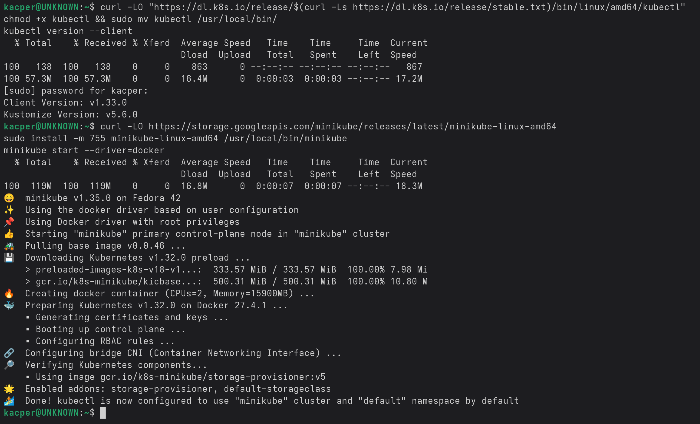
Step 2: Create a Cluster:
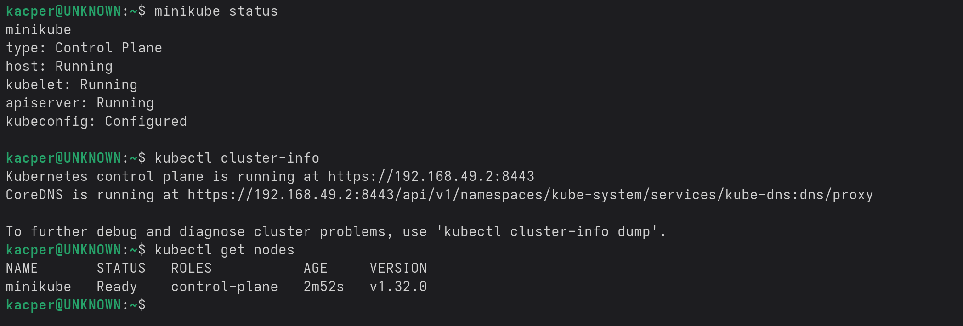

Step 3: Deploy an App:
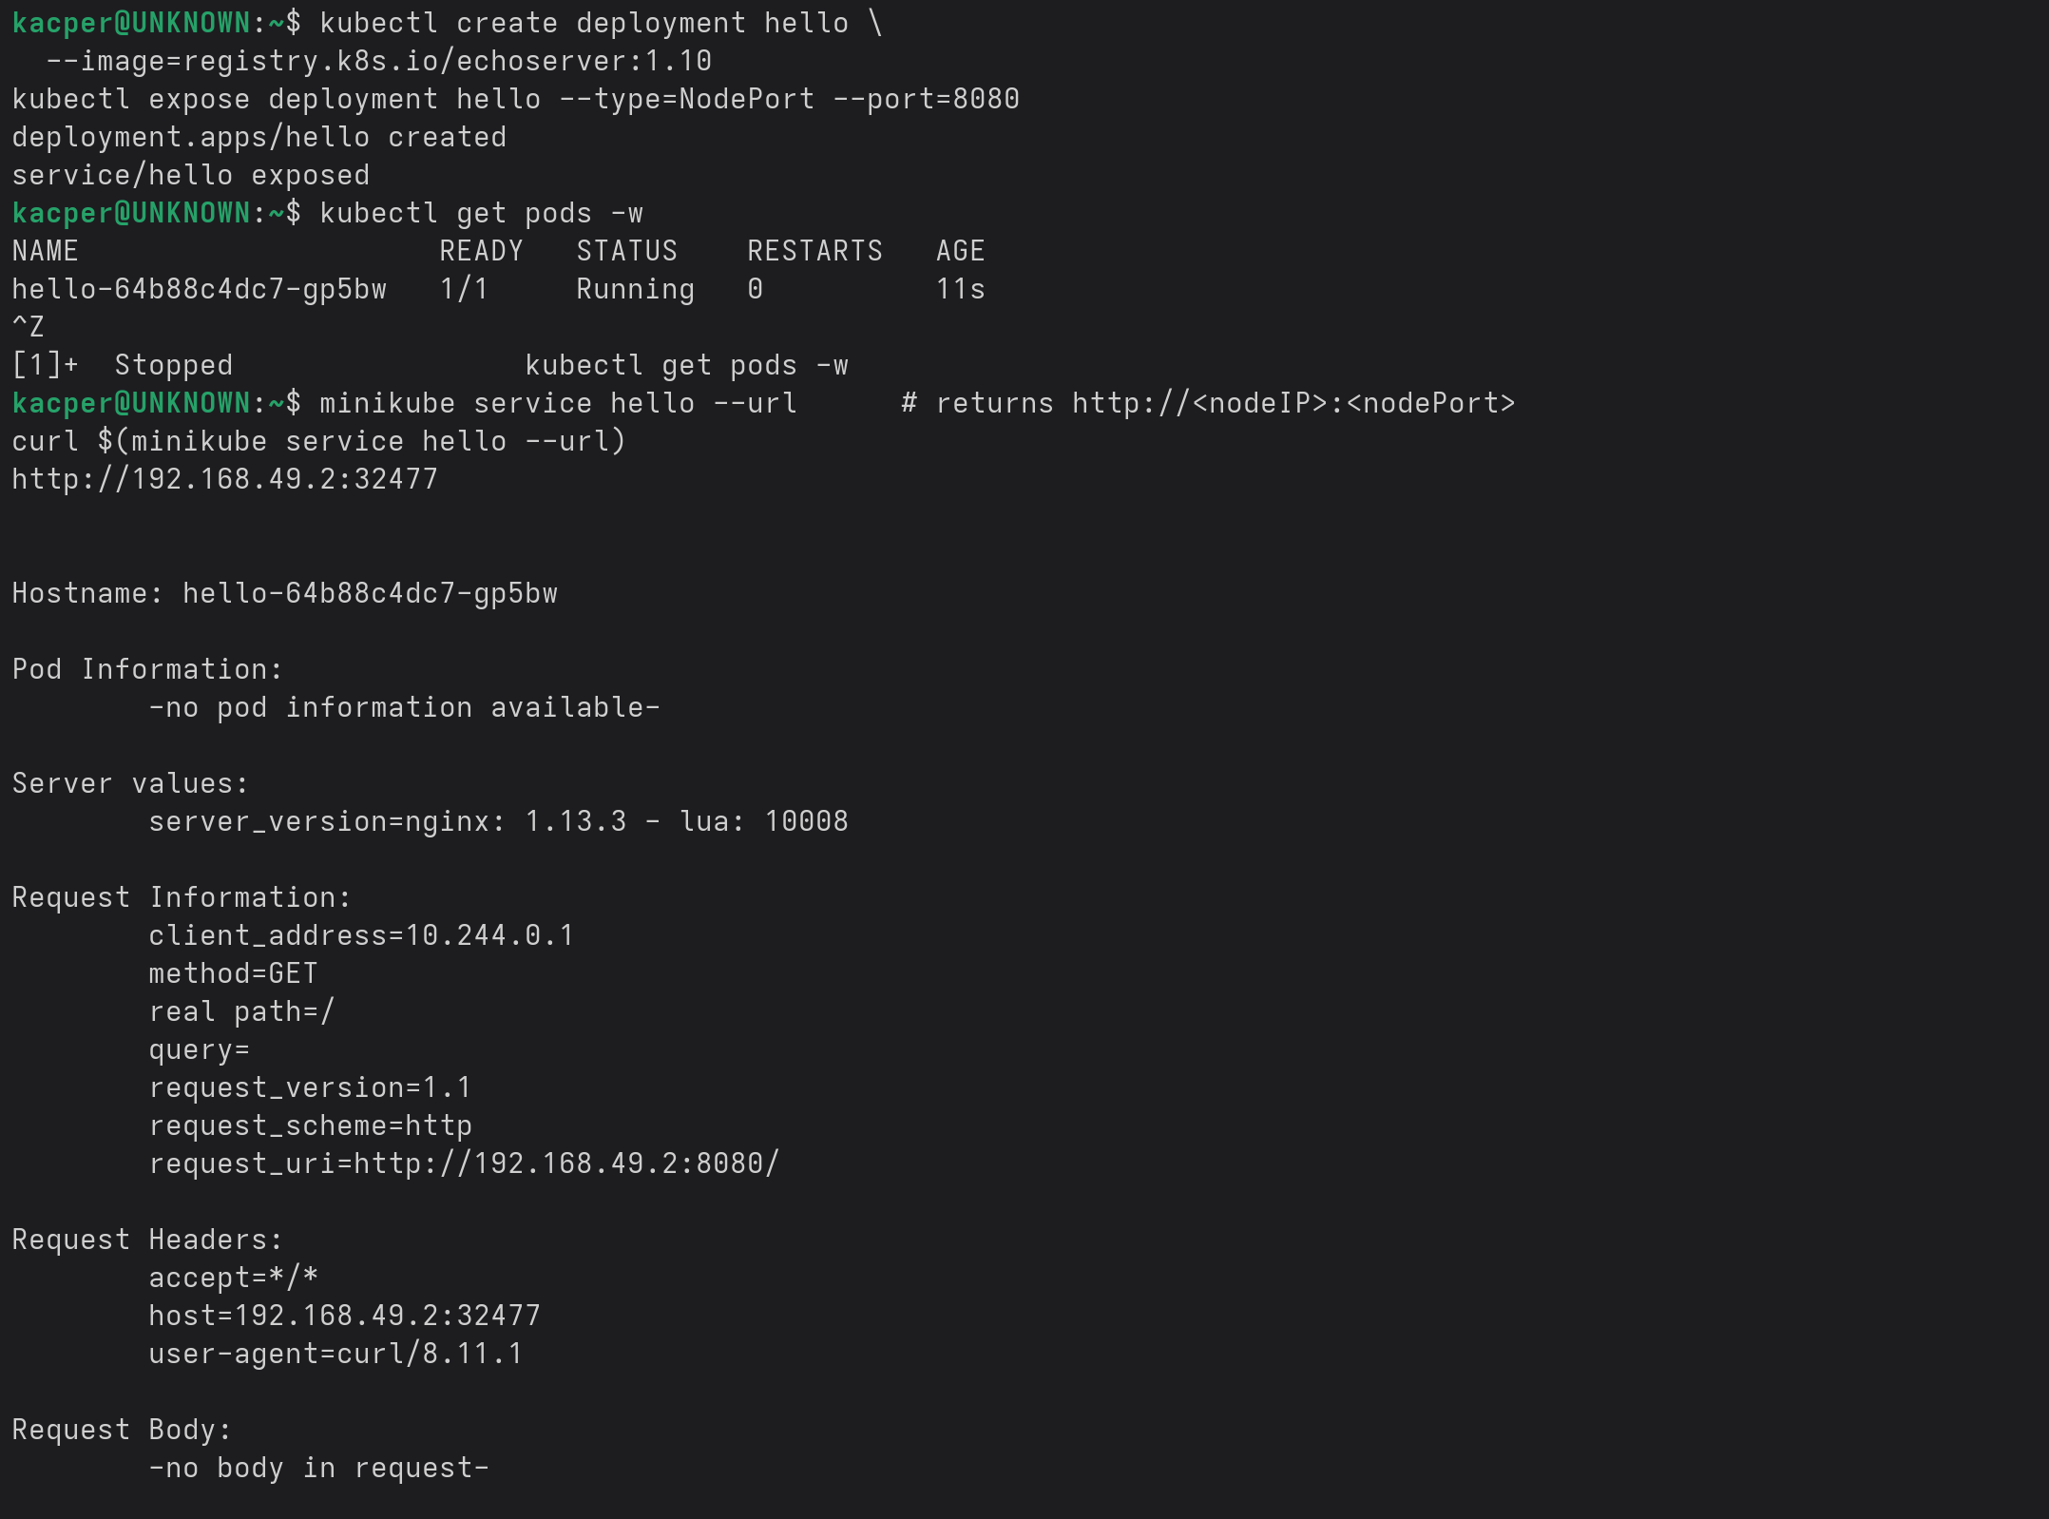

Step 4: Explore the App:
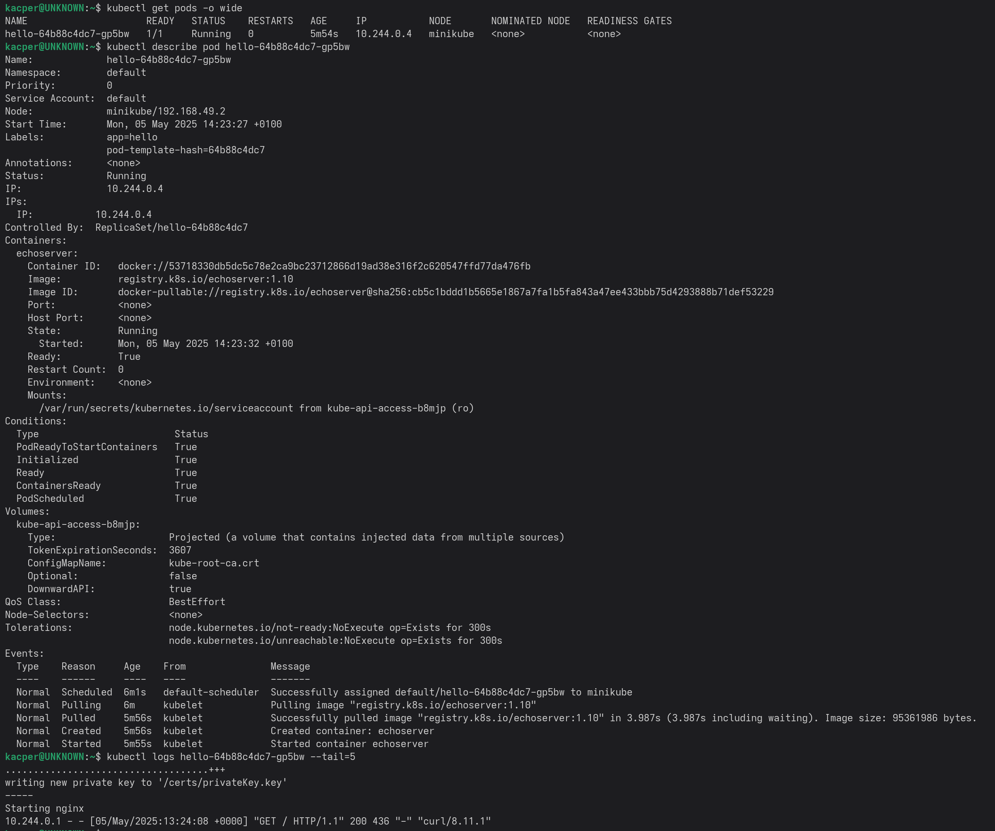
App own shell

Step 5: Scale the App:
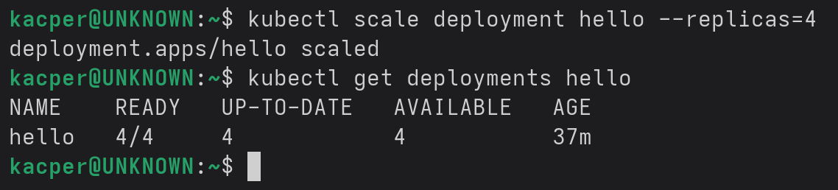
Scaling adjusts the ReplicaSet size; Kubernetes schedules new Pods across nodes and keeps the requested number running.
Check load-balancing:
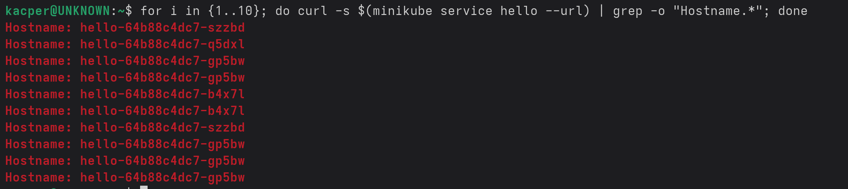
Step 6: Update the App:
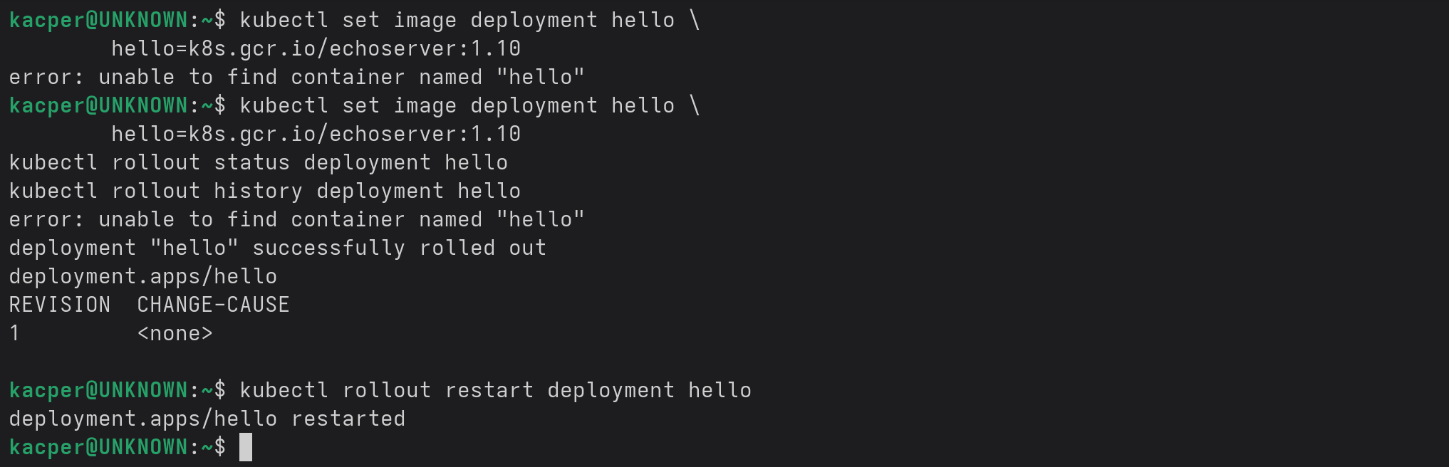
Step 7: (Extra) Cleanup:
