Lab5 Notes/Findings

Step1: Initial Setup for a clean Kubernetes Cluster:
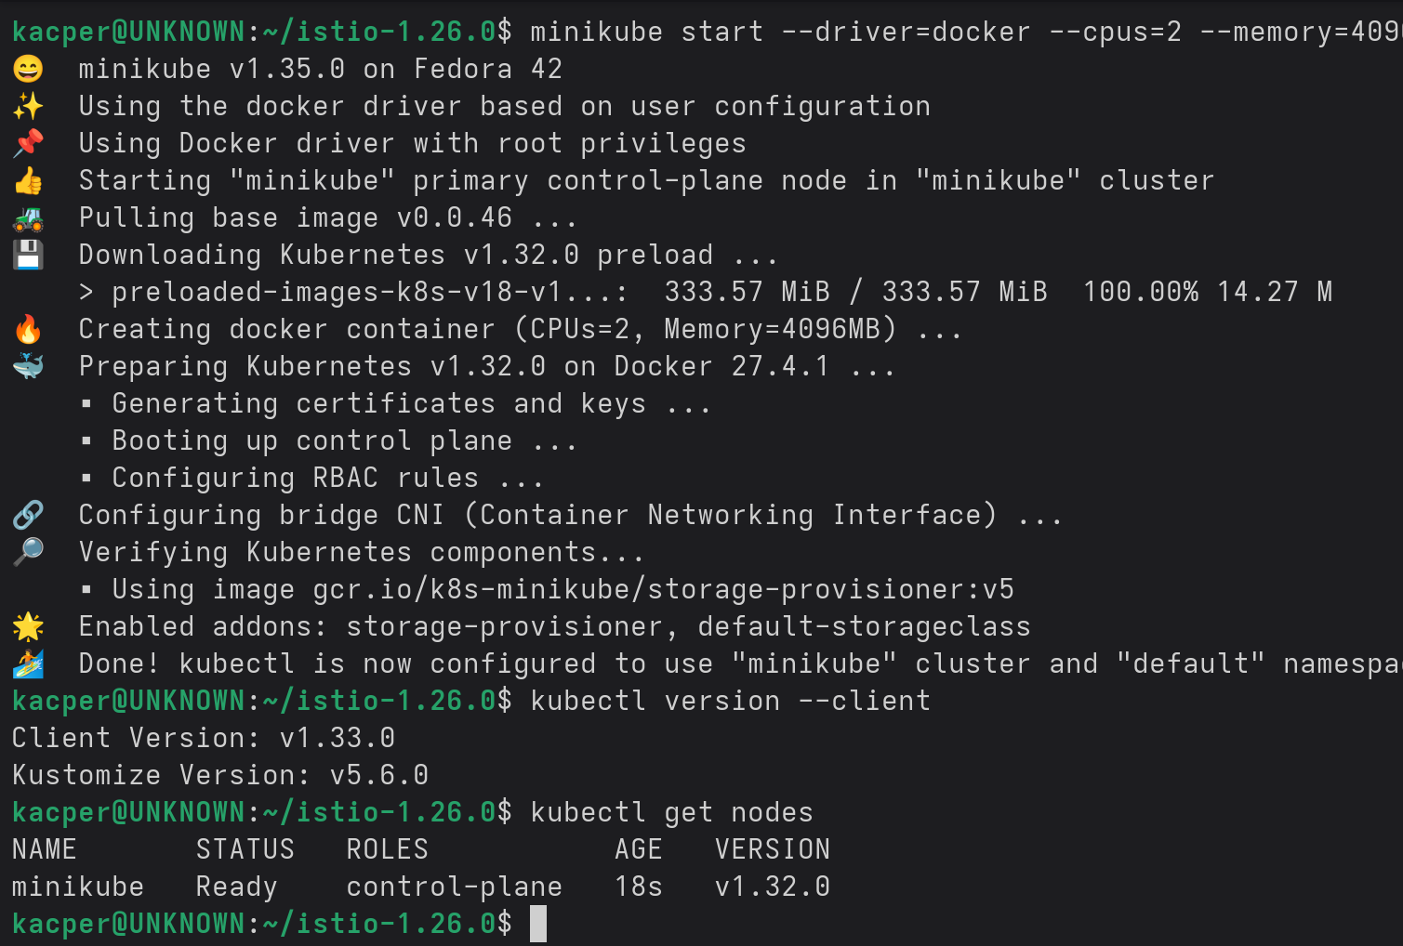
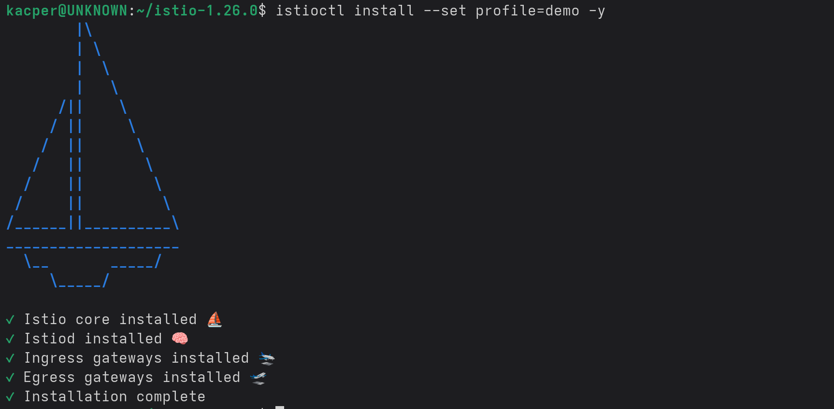

Step2: Minikube instance set:
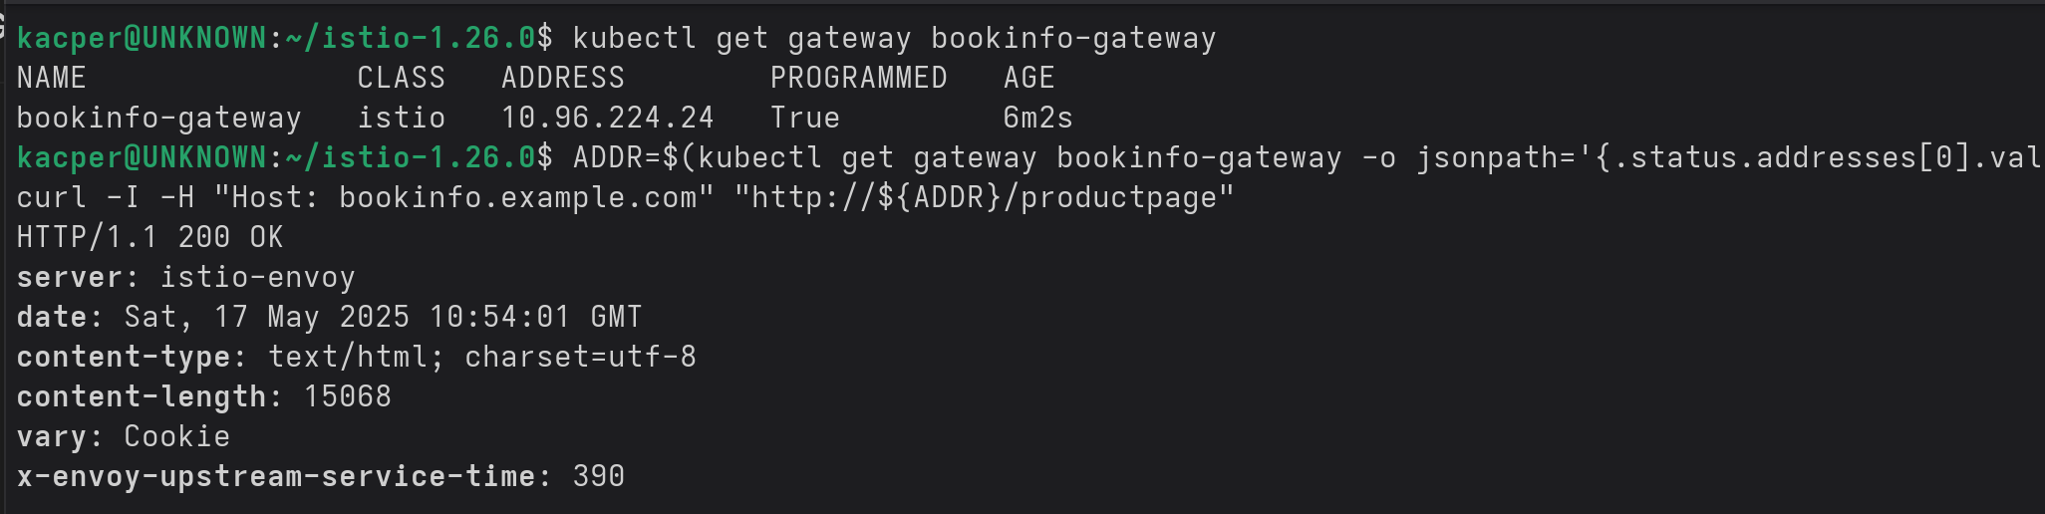
Step3: Kiali Dashboard Setup:
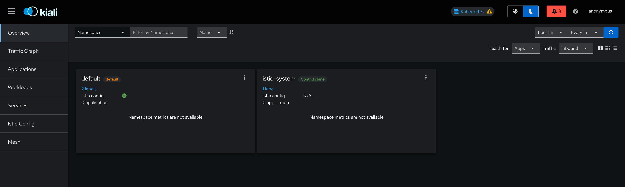
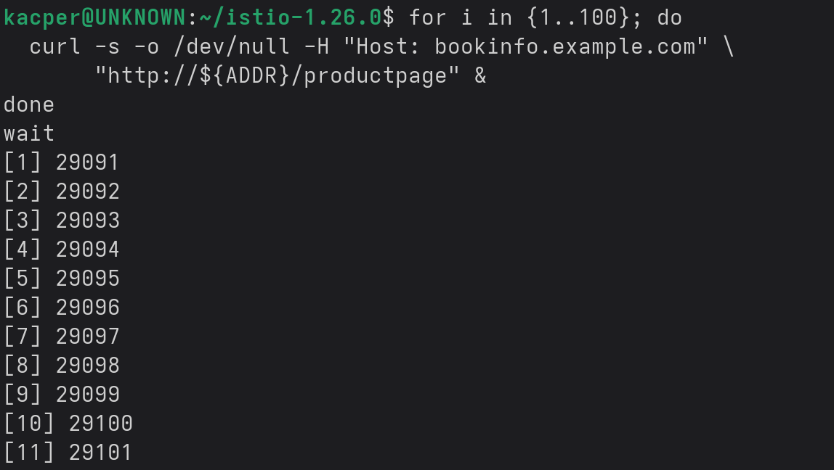
Step4 Generate some traffic:

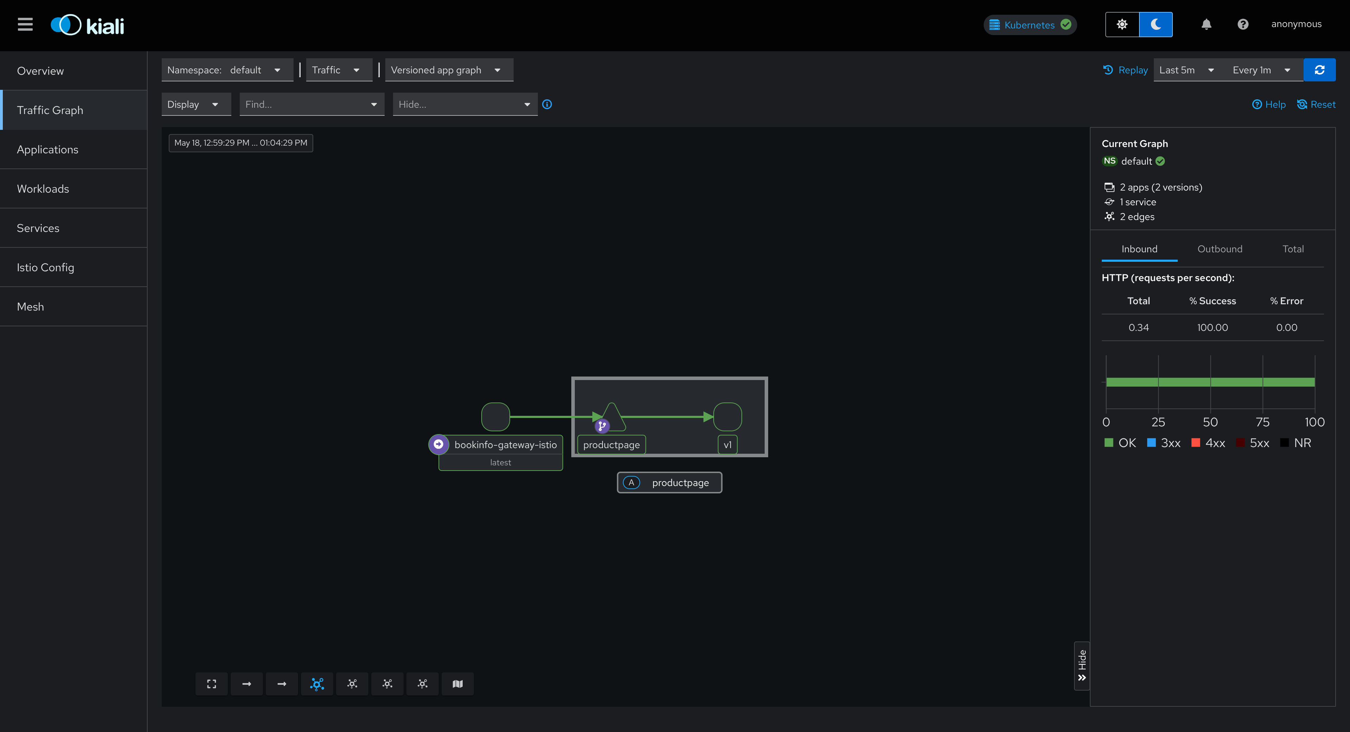

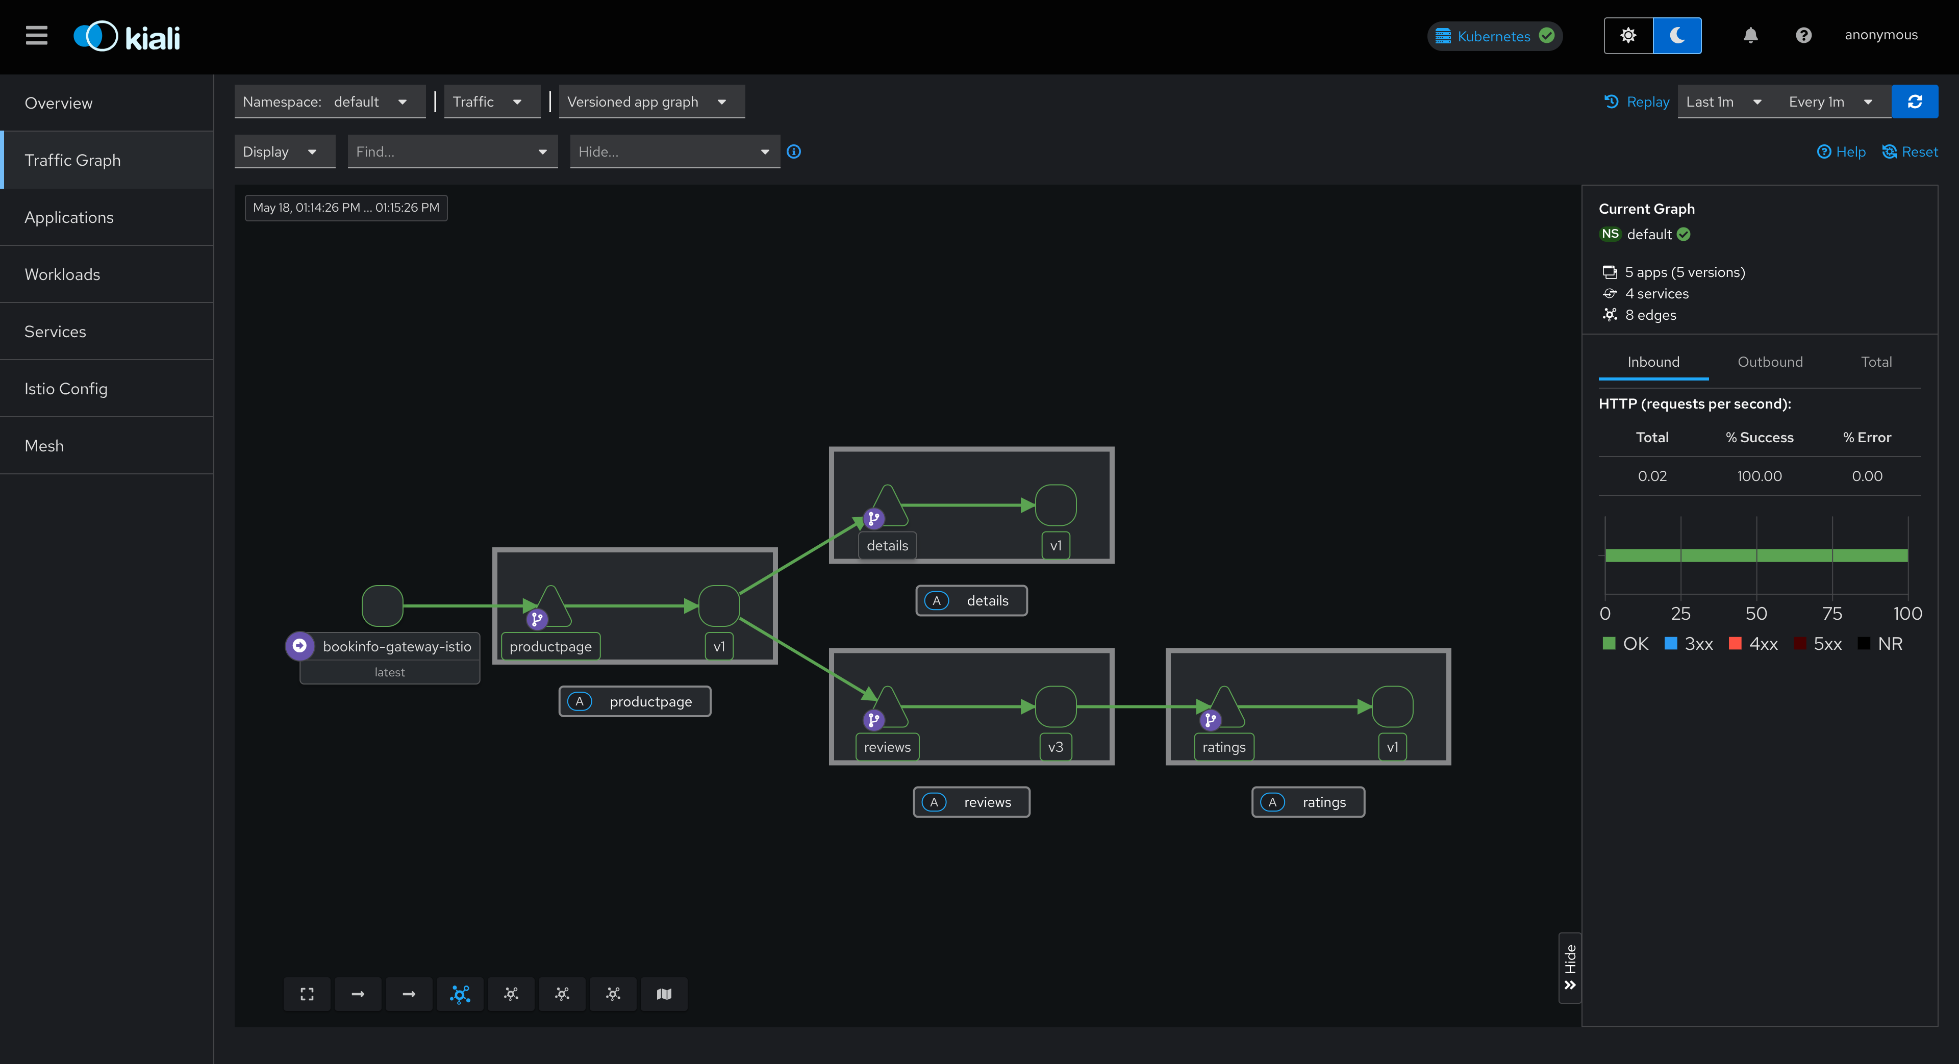

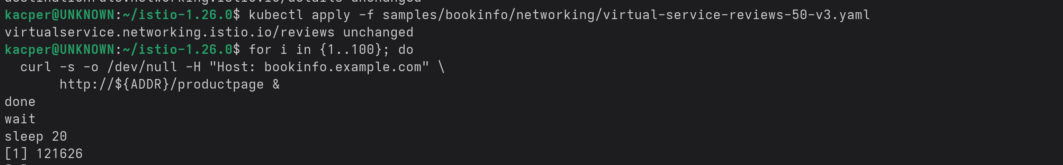

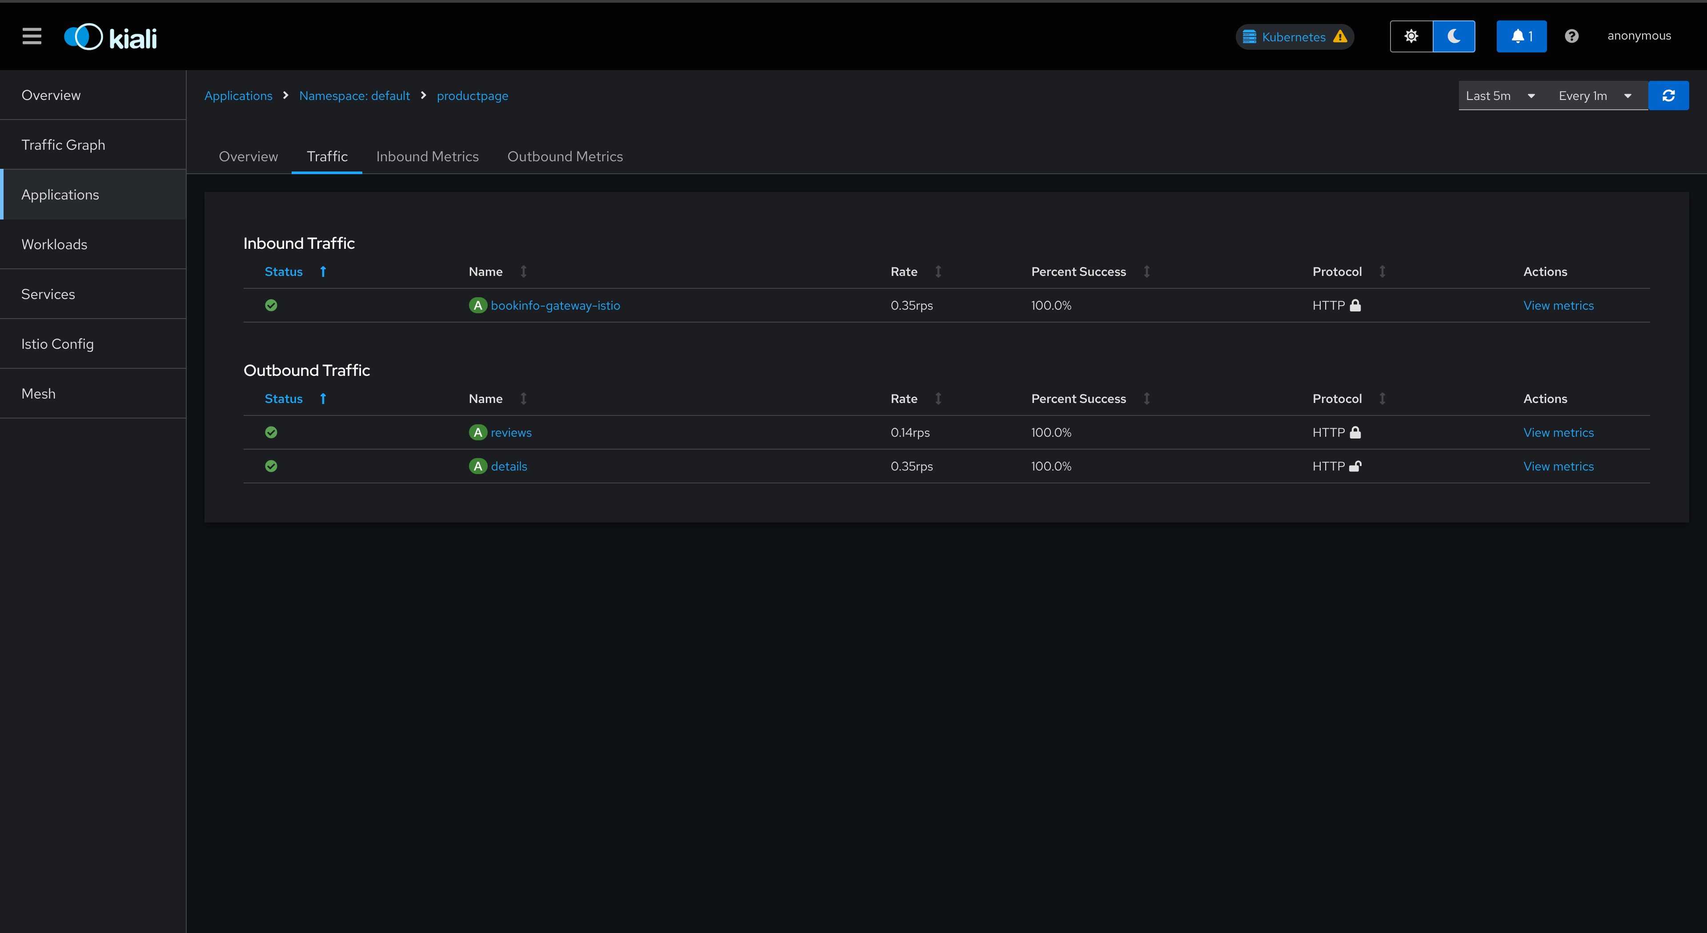

Step5: Fault Injection:
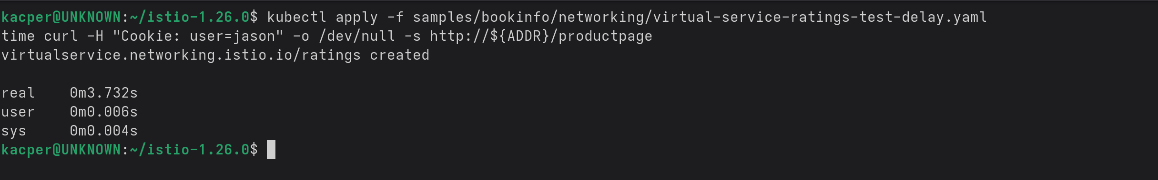
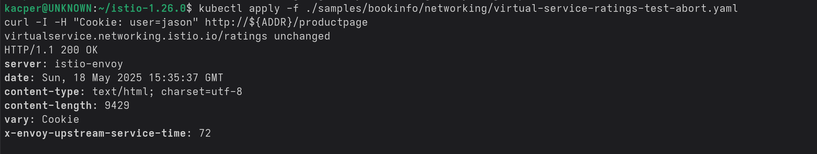
Step6: Abort with HTTP 500 for jason:
Step7: Circuit Breaking:
