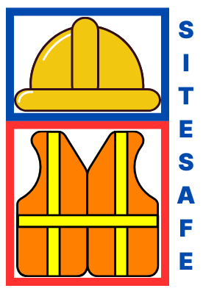
TITLE: SiteSafeAI

  - Project Description:
  - This project aims to enhance safety and compliance on construction sites by using AI to monitor workers and ensure they are always wearing helmets. The system leverages real-time video feeds, which are processed by an object detection model based on YOLOv11 (You Only Look Once), a high-performance deep learning model for image recognition and object detection.
  - The solution is designed to automatically detect personnel within the camera’s view and assess whether they are wearing helmets. If any individual is detected without a helmet, the system can immediately alert site supervisors to address the safety violation by recording the detection in the detection tab and sending an automatic email notification.

CONTACT DETIALS:
Name: Tomas Smitas
Personal Email: tomassmitas@yahoo.com
Student Email: C00276177@setu.ie
c00276177tomas.github.io/MachineLearningPortfolio

