

Software Development Year 4

Project

Functional Specifications

Project Title: SiteSafe AI



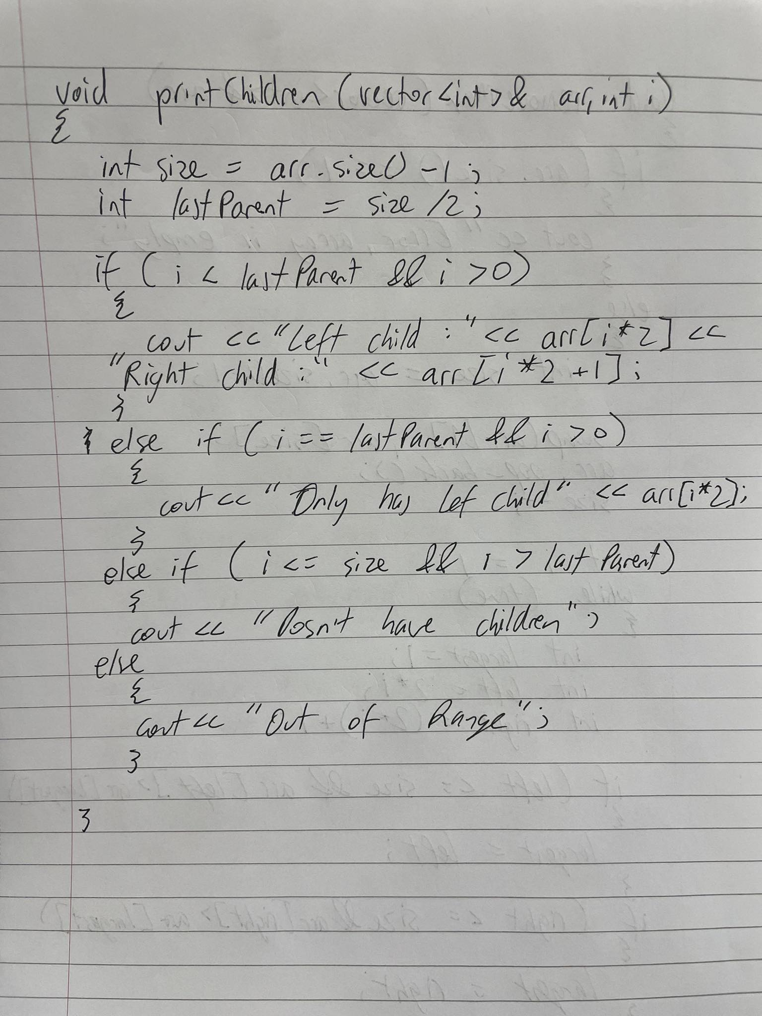
By: Tomas Smitas

Student No: C00276177

Date: 2024

Supervisor: Oisin Cawley

Introduction

This is a functional specification for a proposed object detection product demonstration that will use Machine Learning technology to detect people, high visibility jackets and helmets on safety critical construction sites. Once a person is detected to not have either a helmet or a high visibility jacket on a safety critical site an appropriate person will be automatically notified with an incident report through an email and/or phone message.

The key idea of this functional specification is to outline the path needed to follow to complete this project. It will include technologies used and why that technology was used, product overview that will describe in detail what the project is about, Mandatory, Discretionary and Exceptional features that need to be completed to reach each milestone.

Technologies

For the technology section extensive research has been carried out to try and predict the best technologies to use for this project. Most of these technologies that have been chosen to use have similar alternatives. I will outline these technologies and why they were chosen over their counterparts.
The main technologies that will be used are:

- Python

Description: Python is a programming language that is being used because it has great support for machine learning and AI both of which are going to be implemented in the project. Has great integration with other technologies that will be mentioned. Easy language to understand and develop with. Has great real-time data handling which will be crucial in my project.

Alternative: R was a programming language that is also commonly used in machine learning projects. The main reason for not using this language over python was because it didn’t have as much integration with other technologies like OpenCV and You Only Look Once.

- YOLOv10

Description: You Only Look Once is a real-time object detection system that identifies and classifies multiple objects in images or video frames in a single pass, hence the name. Unlike traditional object detection methods that apply a classifier to various parts of an image, YOLO divides the image into a grid and predicting bounding boxes and class probabilities directly from the grid cells. This approach enables YOLO to achieve high speeds while maintaining good accuracy, making it particularly suitable for this project that requires real-time processing for the video surveillance.

Alternative: Real-Time DEtection TRansformer (RT-DETR) unlike YOLO this object detection tool is not designed for real-time object detection, there might have been issues implementing this with live video surveillance. YOLO provides detection in a single pass while RT-DETR uses the two-stage approach which makes the latency slower.
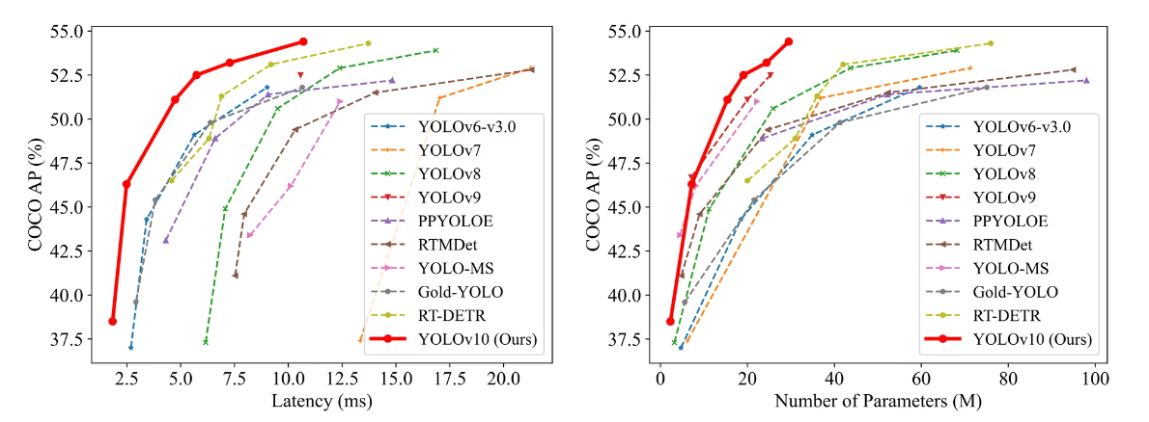

- JavaScript

Description: Python is a programming language that is being used because it has great support for machine learning and AI both of which are going to be implemented in the project. Has great integration with other technologies that will be mentioned. Easy language to understand and develop with. Has great real-time data handling which will be crucial in my project.

Alternative: R was a programming language that is also commonly used in machine learning projects. The main reason for not using this language over python was because it didn’t have as much integration with other technologies like OpenCV and You Only Look Once.

- HTML & CSS
- GitHub

Portfolio Layout

The general layout of the portfolio will be a grey header with a profile picture with the role

