

Fig. 1 SETU logo

Software Development Year 4

Project

Design Document

Project Title: SiteSafeAI

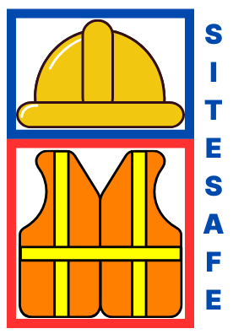

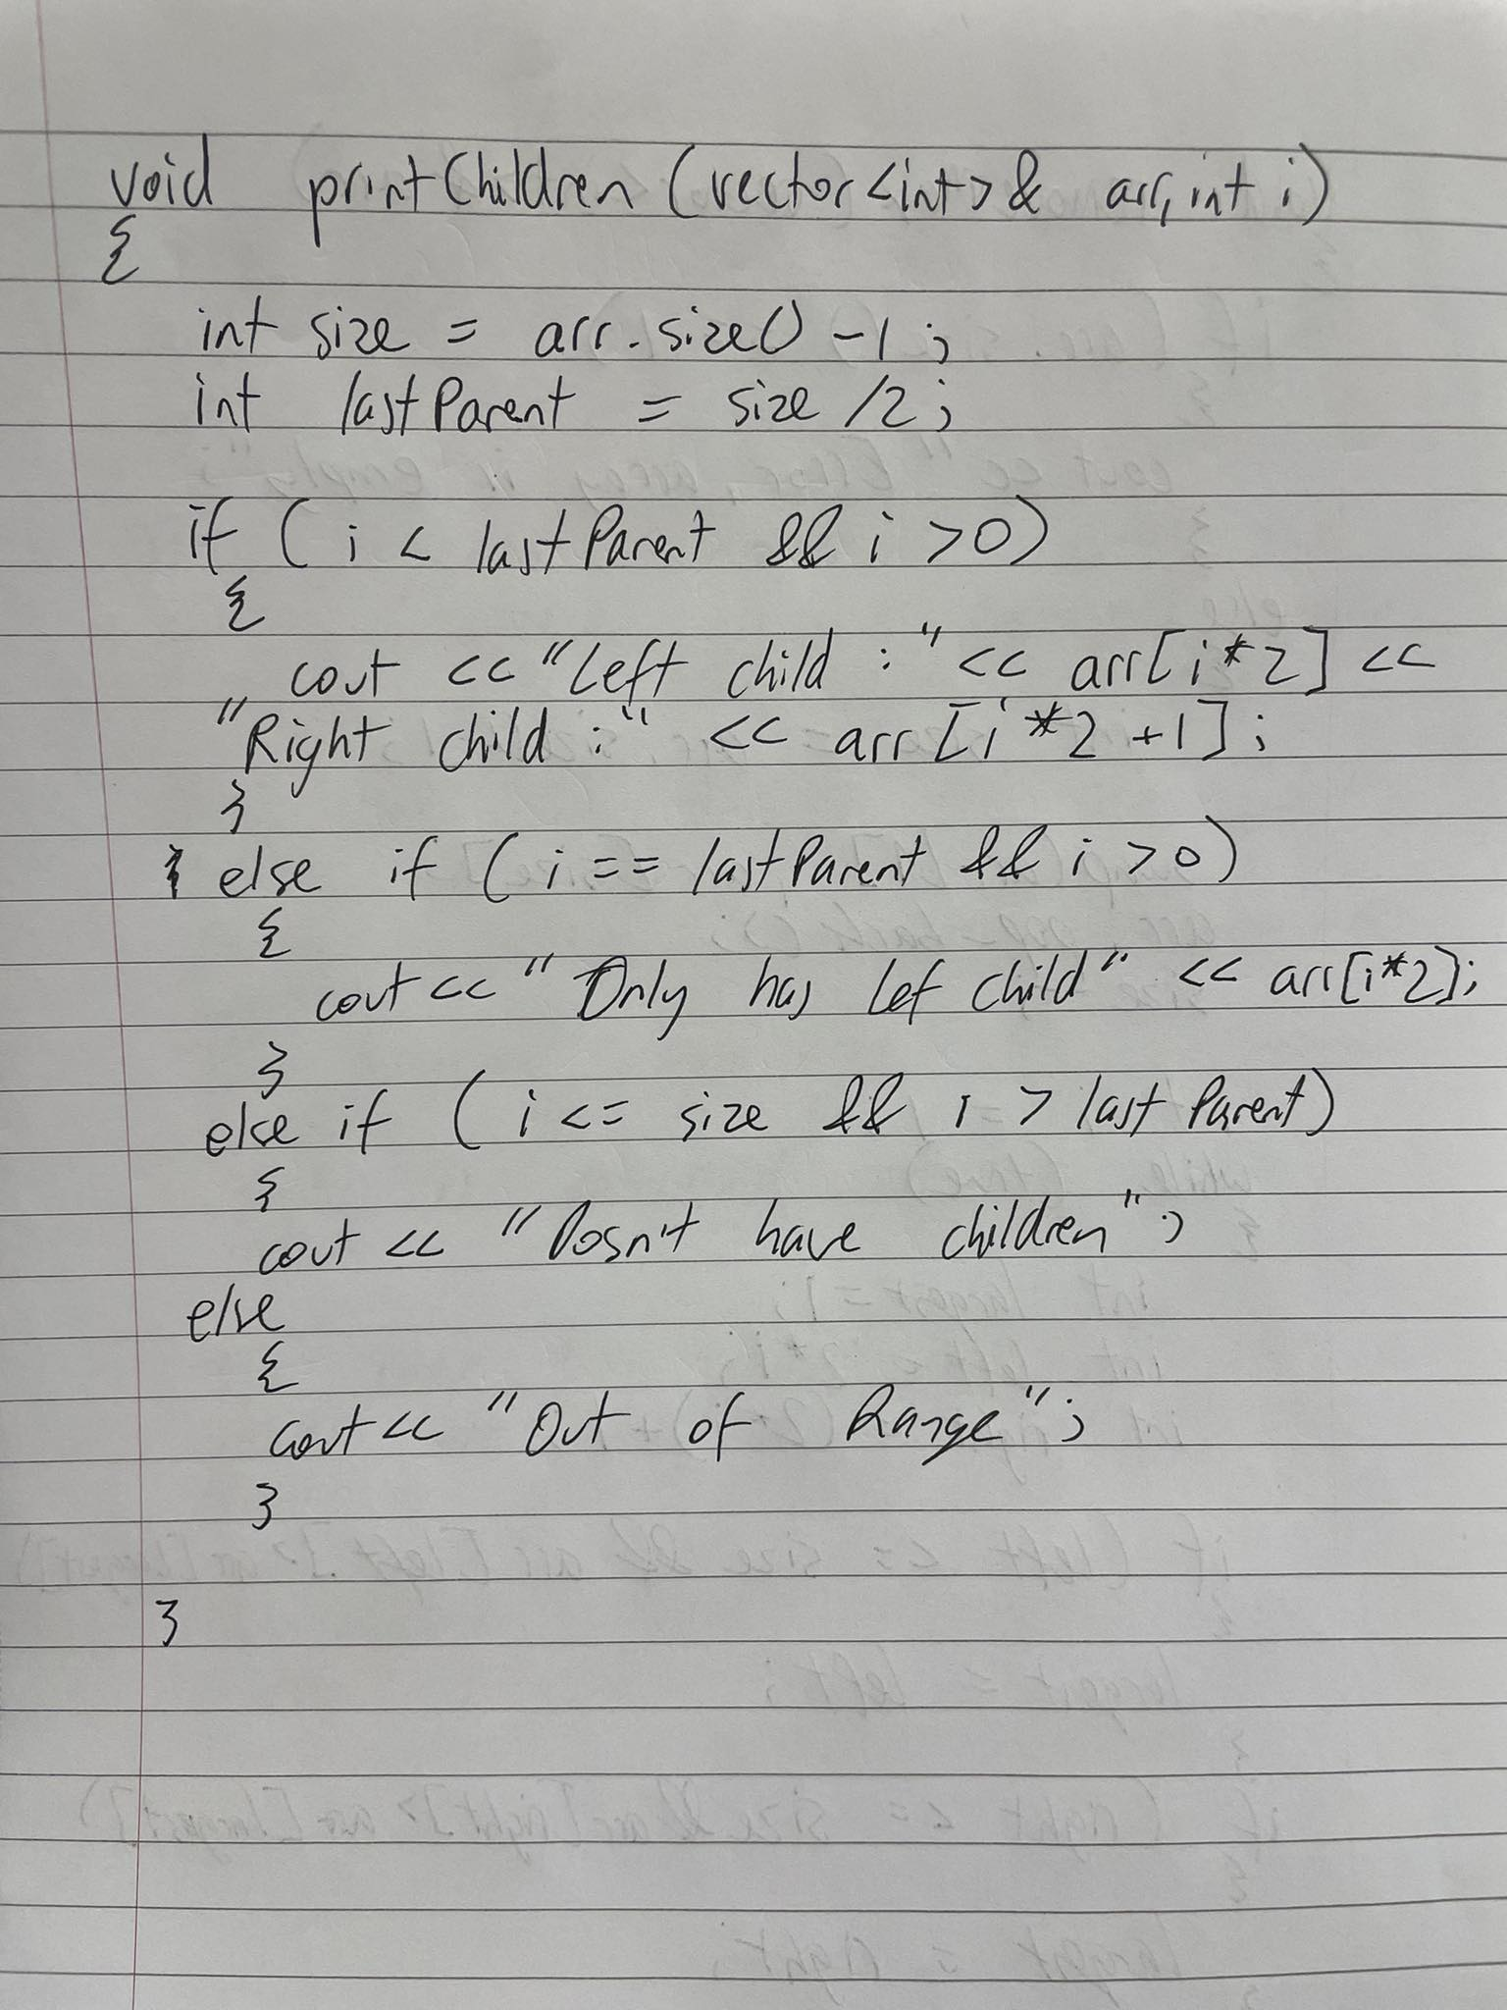
By: Tomas Smitas

Student No: C00276177

Date: 2024

Supervisor: Dr Oisin Cawley

Fig. 2 Site Safe Logo

Introduction

This design document provides a detailed plan for how the AI construction monitoring application will meet its outlined requirements. Building on the functional specification, this document shifts the focus toward the technical approaches and high-level design choices that will shape the implementation process.
The application’s primary objective is to enhance construction site safety by detecting personal protective equipment (PPE), specifically helmets and high-visibility jackets, using machine learning.
Following the implementation of the core detection functionality, the application will include additional features such as real-time alerts, data logging, and reporting. These secondary functions are essential to providing actionable insights and ensuring comprehensive safety monitoring on construction sites. It is a way to set this project from others who just detect the safety equipment and then do nothing with it. The design of these supplementary features will be discussed in detail.
Subsequent sections will outline the technological stack selected for this project, including the reasoning behind these choices and their role in the development process. Key elements such as the machine learning model architecture, front-end and back-end frameworks, and supporting tools will be described to provide a clear vision of how the application will be constructed.
Finally, this document will present the interaction flow between the system’s components through sequence diagrams and provide a user interface overview. This includes a navigation flowchart and prototype screenshots to demonstrate the application’s functionality and user experience.

Personal Protective Equipment Detection

Helmet Detection

Ensuring workers on construction sites wear helmets is critical for reducing the risk of head injuries caused by accidents or falling objects. The effectiveness of helmet detection using AI is one of the key features of this project, aligning with its objective of improving construction site safety. As such, selecting the most effective methodology for implementing helmet detection is a crucial design decision.
Recent advancements in machine learning provide a strong foundation for this system’s design. Helmet detection primarily involves analysing visual input to identify key features of helmets on individuals in a live video feed. Techniques such as object detection using convolutional neural networks (CNNs) have proven effective in similar applications.
Focusing on helmets allows for a more streamlined and accurate first iteration. For this reason, the initial implementation will prioritize helmet detection based on trained object detection models, such as YOLO (You Only Look Once), due to its speed and precision in real-time environments.
Subsequent iterations of the system will expand to include high-visibility jackets alongside helmets. Research has shown that combining multiple safety indicators can significantly enhance the overall reliability of site safety systems. By starting with helmets as the primary focus, this project aims to deliver high accuracy and responsiveness, laying the groundwork for broader functionality in future updates.

High-Visibility Jacket Detection

The detection of high-visibility jackets is a vital component of ensuring worker compliance with safety regulations on construction sites. The chosen methodology for identifying high-visibility jackets relies on leveraging object detection models trained to recognise the unique colour, shape and reflective properties of such jackets.
Object detection libraries and frameworks provide the foundation for this functionality. Pretrained models like YOLO (You Only Look Once) have been evaluated for their suitability in identifying helmets, transitioning this to high-visibility jackets should be achievable. YOLO is particularly advantageous due to its ability to process frames in real-time, a crucial feature for live video monitoring.
For initial implementation, YOLO will be employed for its speed and compatibility with a range of camera sources. The system will be trained using datasets containing diverse examples of high-visibility jackets across varying lighting and weather conditions to ensure robustness. One limitation of YOLO, however, is that its accuracy may decrease when distinguishing between jackets and similarly coloured or reflective objects, which will be addressed through iterative model refinement.

Evaluation

The evaluation of detection models for helmets and high-visibility jackets will focus on key performance metrics to ensure the system meets safety monitoring standards. Metrics such as precision, recall, and the F1-score will be used to assess the balance between the model's accuracy and its ability to minimize false positives and false negatives. A confusion matrix will provide a detailed breakdown of true positives, false positives, true negatives, and false negatives, offering insights into areas of improvement for the model.
In addition to these metrics, the Precision-Recall (PR) curve will be utilized to analyse the trade-off between precision and recall across different confidence thresholds. This evaluation will help optimize the model's detection threshold for specific scenarios, such as ensuring that all workers wearing PPE are identified while minimizing false alarms. High recall will be prioritized for detecting helmets and jackets, as missed detections pose significant safety risks.
These evaluations will be conducted on a diverse test dataset to account for variations in lighting, camera angles, and occlusions, ensuring the robustness of the detection system in real-world construction site environments. By iteratively refining the models based on these evaluation metrics, the system will achieve high reliability and efficiency in monitoring safety compliance.

