Title: Sales System
Module: Object Oriented Software Development
Lecturer: Jason Barron
Department: Department Of Computing
Course: Software Development
Student Numbers:
C00294564 - Mantas Bielevicius
C00300283 - Szymon Stepniak

Description
The Sales System project is a desktop application built in Java to manage information on customers, staff, equipment, orders, order returns, customer feedback, deliveries, reports and faulty items. The application uses a graphical user interface (GUI) to allow non-technical users to easily perform CRUD (create, read, update, delete) operations.

Functional Requirements

Customer management
Add Customer
Insert new customer records with fields for first name, last name, address, email and phone number.
Update Customer
Update an existing customer using CustomerId
Delete Customer
Remove a customer record

Staff Administration
Add Staff
Insert new staff member records with first name, last name, role, email and phone number.
Update Staff
Update a staff record using staffId

Equipment Inventory
Add Equipment
Insert new equipment records with values for equipmentName, equipmentType, purchaseDate and status.
Update Equipment
Update equipment details using equipmentId

Faulty Items Reporting
Add Faulty Item
Insert details of a faulty item including itemName, description, quantity and reportDate
Update Faulty Item
Update details of a faulty item by its itemId.

Order Processing
Add Order
Insert a new order that stores customerId, orderDate, totalAmount and orderStatus.
Update Order
Modify details of an existing order.

Other Tables
Tables such as OrderReturns, OrderAnd Equipment, CustomerFeedback, Delivery and Reports are planned to support additional reporting and administrative needs. These operations are planned features and may receive further testing and refinement.

Non-Functional Requirements
Database Connectivity
The application uses JDBC to connect to a MySQL database running on a localhost. The SalesSystem schema is used to store all application data.

Build Environment
Java 17 is used for compiling the application and Maven manages dependencies and builds.

User Interface
The application features a GUI that enables the user to interact with the application with error messages and success notifications being provided throughout the interface.

Security
Basic input validation and SQL exception handling are implemented to prevent errors and prevent SQL injection attacks.

Testing
JUnit tests are written to verify that each CRUD operation functions as expected.
Tests document current successes and highlight areas that are still in development.

Current Implementation Status & future work

While the core functionality (adding, updating and deleting customers, orders, equipment, faulty items and staff) are functioning, some operations are still under development and require further integration with the GUI

Fully Working
Customer, Equipment, Orders, Faulty Items and Staff add, update, delete and view operations have been implemented and are covered by JUnit tests.

Planned/Under Development
Additional Functions (OrderReturn, OrderAndEquipment, CustomerFeedback, Delivery and Reports): These tables have been defined and future versions of the application will include full implementation of these functionalities.

Database Tables (Structure & Data)

Table: Customer
customerId INT AUTO_INCREMENT PRIMARY KEY,
firstName VARCHAR(50) NOT NULL,
lastName VARCHAR(50) NOT NULL,
address VARCHAR(100) NOT NULL,
email VARCHAR(50) NOT NULL,
phoneNumber VARCHAR(10) NOT NULL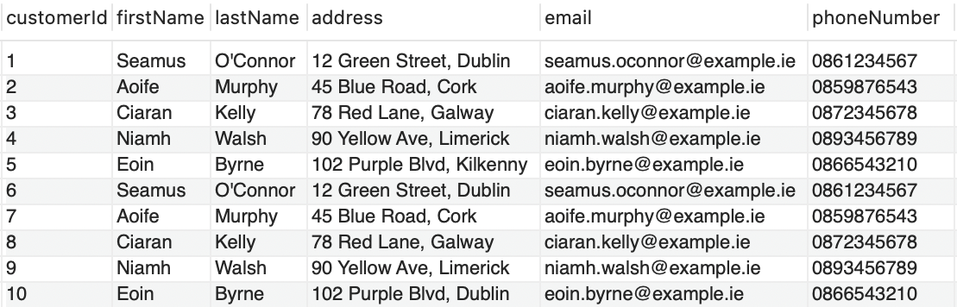

Table: Staff
staffId INT AUTO_INCREMENT PRIMARY KEY,
firstName VARCHAR(50) NOT NULL,
lastName VARCHAR(50) NOT NULL,
staffRole VARCHAR(50) NOT NULL,
email VARCHAR(50) NOT NULL,
phoneNumber VARCHAR(50) NOT NULL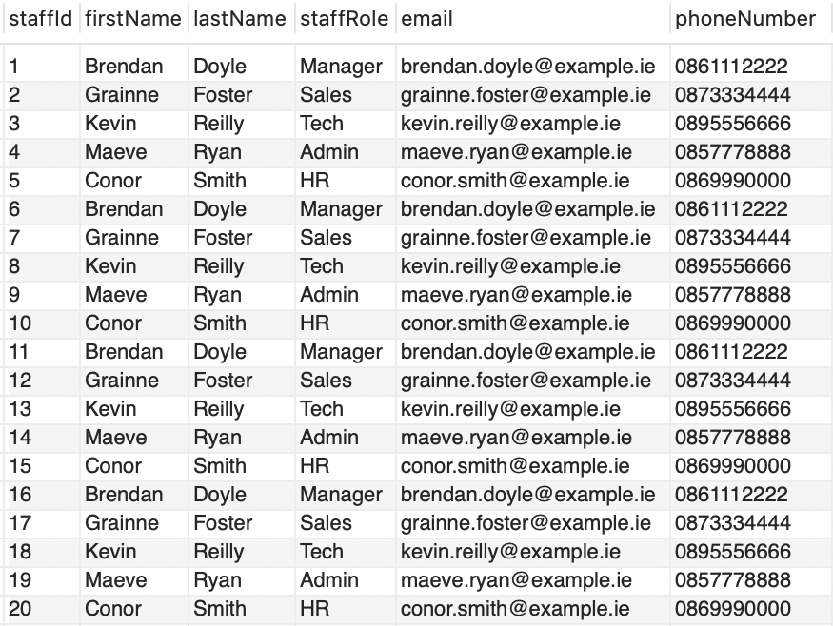

Table: Equipment
equipmentId INT AUTO_INCREMENT PRIMARY KEY,
equipmentName VARCHAR(50) NOT NULL,
equipmentType VARCHAR(50) NOT NULL,
equipmentSpecifications TEXT NOT NULL,
quantityAvailable INT NOT NULL,
equipmentPrice DECIMAL(10, 2) NOT NULL
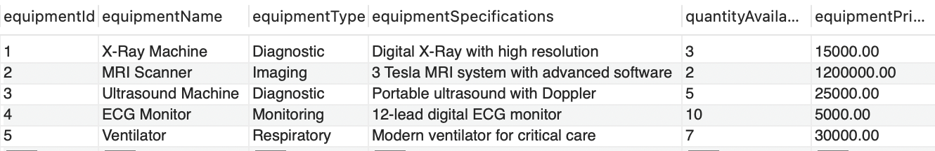

Table: Orders
orderId INT AUTO_INCREMENT PRIMARY KEY,
customerId INT NOT NULL,
orderDate DATETIME NOT NULL,
totalAmount DECIMAL(10, 2),
orderStatus VARCHAR(50) NOT NULL,
FOREIGN KEY (customerId) REFERENCES customer(customerId)
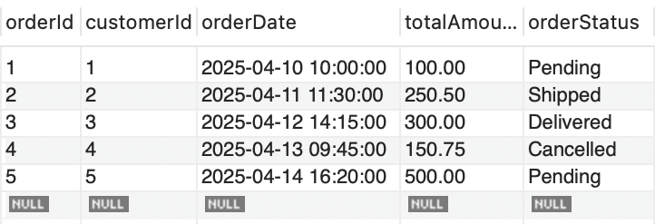

Table: OrderReturns
returnId INT AUTO_INCREMENT PRIMARY KEY,
orderId INT NOT NULL,
equipmentId INT NOT NULL,
reason TEXT NOT NULL,
orderReturnStatus VARCHAR(50) NOT NULL,
replacementRequested BOOLEAN,
FOREIGN KEY (orderId) REFERENCES Orders(orderId),
FOREIGN KEY (equipmentId) REFERENCES Equipment(equipmentId)
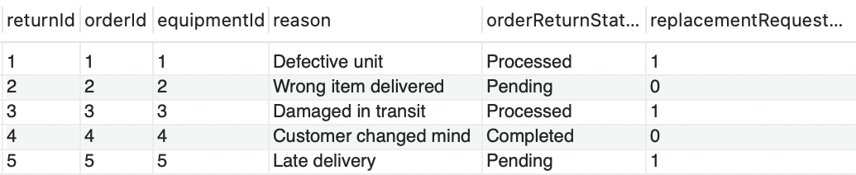

Table: OrderAndEquipment
orderId INT NOT NULL,
equipmentId INT NOT NULL,
PRIMARY KEY (orderId, equipmentId),
FOREIGN KEY (orderId) REFERENCES Orders(orderId),
FOREIGN KEY (equipmentId) REFERENCES Equipment(equipmentId)
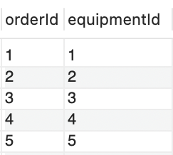

Table: CustomerFeedback
feedbackId INT AUTO_INCREMENT PRIMARY KEY,
customerId INT NOT NULL,
orderId INT,
comments TEXT NOT NULL,
rating INT CHECK (rating BETWEEN 1 AND 5),
FOREIGN KEY (customerId) REFERENCES customer(customerId),
FOREIGN KEY (orderId) REFERENCES Orders(orderId)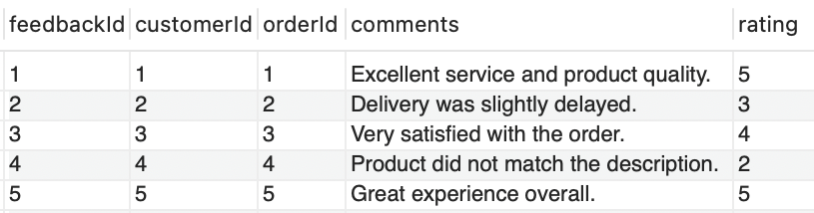

Table: Delivery
deliveryId INT AUTO_INCREMENT PRIMARY KEY,
orderId INT NOT NULL,
estimatedDeliveryTime DATETIME NOT NULL,
trackingStatus VARCHAR(50) NOT NULL,
FOREIGN KEY (orderId) REFERENCES Orders(orderId)
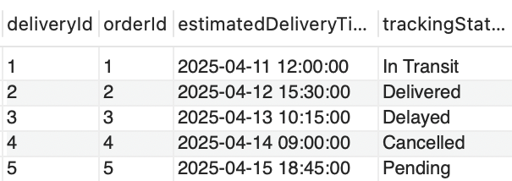

Table: Reports
reportId INT AUTO_INCREMENT PRIMARY KEY,
reportType VARCHAR(50) NOT NULL,
reportData TEXT NOT NULL,
reportDate DATETIME NOT NULL
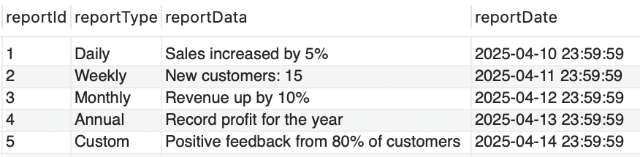

Table: FaultyItems
faultId INT AUTO_INCREMENT PRIMARY KEY,
equipmentId INT NOT NULL,
batchNumber INT NOT NULL,
faultDescription TEXT NOT NULL,
reportedDate DATETIME NOT NULL,
FOREIGN KEY (equipmentId) REFERENCES Equipment(equipmentId)

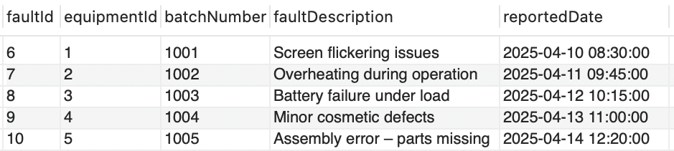

ER Diagram

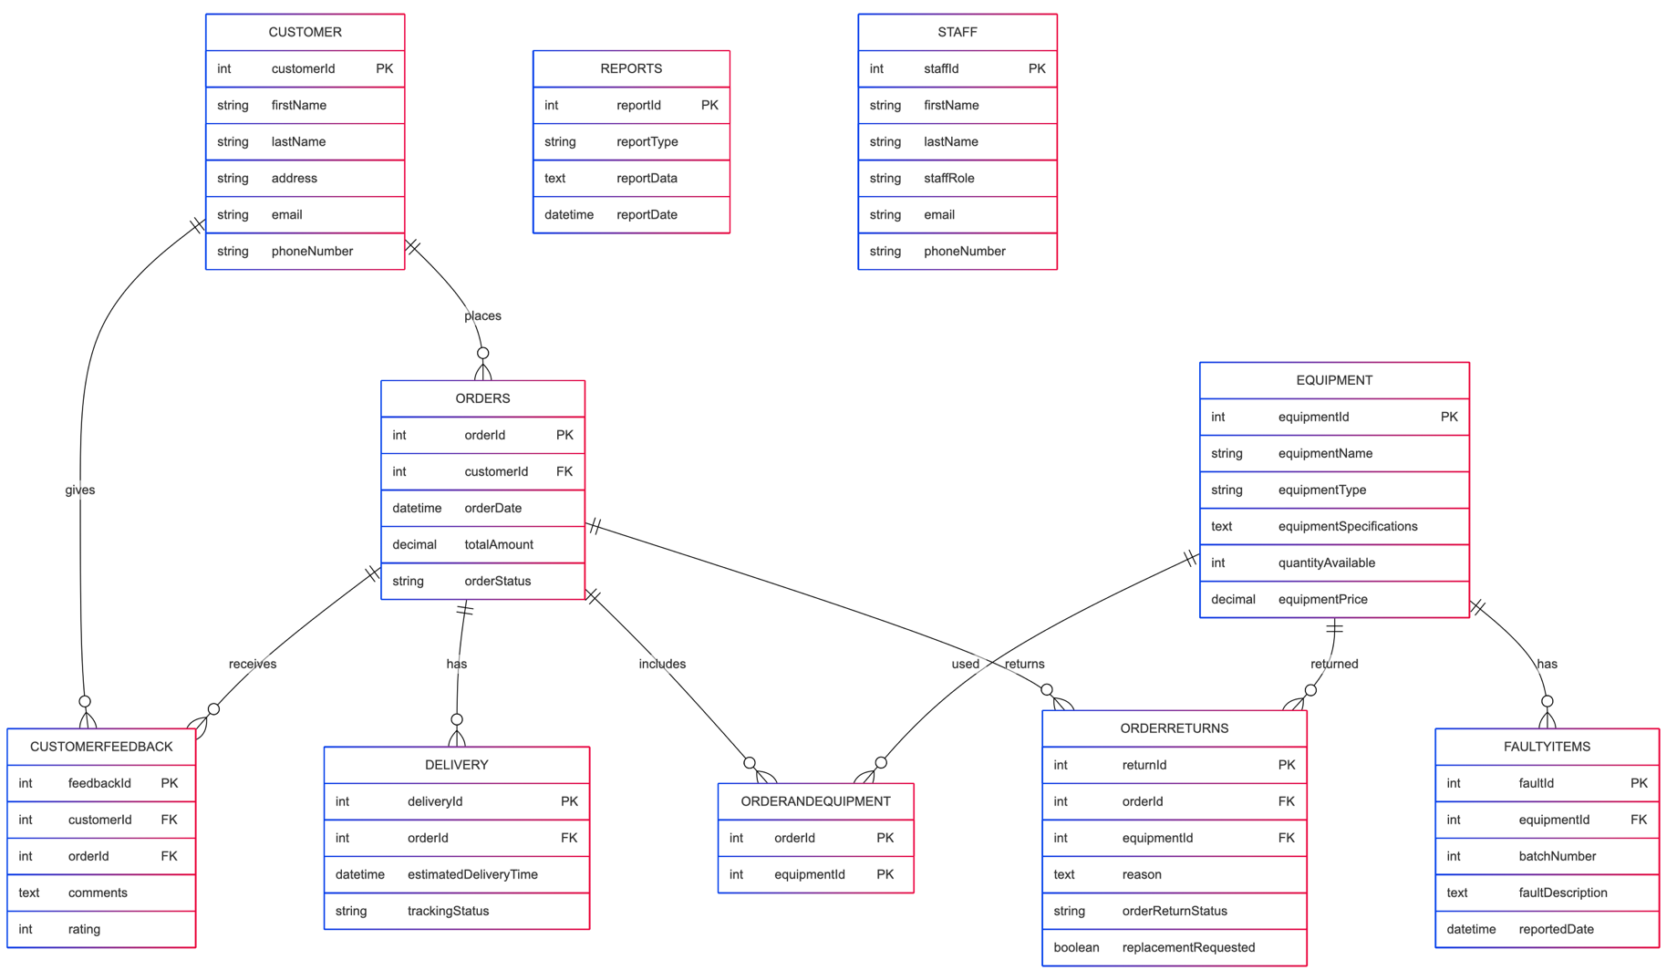

Interesting Source Code Snippets

GUI Form for Adding an Order
This snippet shows how the GUI for adding an order is built. Using a JPanel with a GridLayout, the code creates labeled fields for a Customer ID, total amount and order status. The order date is pre-populated with the current date. and time and made read-only. Utility methods like "createNumbersOnlyField()" and "createDecimalField() are used to restrict input types. Buttons for adding or cancelling are also included.

private void openAddOrderWindow() {
JPanel panel = new JPanel(new GridLayout(5, 2, 10, 10));
panel.add(new JLabel("Customer ID:"));
JTextField customerIdField = createNumbersOnlyField();
panel.add(customerIdField);
panel.add(new JLabel("Order Date (YYYY-MM-DD HH:MM:SS):"));
// Order Date is set automatically and cannot be changed.
JTextField orderDateField = new JTextField(getCurrentDateTime());
orderDateField.setEditable(false);
panel.add(orderDateField);
panel.add(new JLabel("Total Amount:"));
JTextField totalAmountField = createDecimalField();
panel.add(totalAmountField);
panel.add(new JLabel("Order Status:"));
JTextField orderStatusField = createLettersOnlyField();
panel.add(orderStatusField);
JButton addButton = new JButton("Add");
addButton.setPreferredSize(BUTTON_SIZE);
panel.add(addButton);
JButton cancelButton = new JButton("Cancel");
panel.add(cancelButton);
setCenterPanel(panel);

Maven Dependencies Configuration

This snippet from pom.xm1 shows the dependencies required for unit testing using JUnit 5 (JUnit Jupiter API and Engine) and the MySQL Connector/J for database connectivity. These depenencies allows you to write tests for database operations and to make sure there is communication with your MySQL server.

<dependencies>
<!-- JUnit Jupiter API for writing tests -->
<dependency>
<groupId>org.junit.jupiter</groupId>
<artifactId>junit-jupiter-api</artifactId>
<version>5.8.2</version>
<scope>test</scope>
</dependency>
<!-- JUnit Jupiter Engine for running tests -->
<dependency>
<groupId>org.junit.jupiter</groupId>
<artifactId>junit-jupiter-engine</artifactId>
<version>5.8.2</version>
<scope>test</scope>
</dependency>
<dependency>
<groupId>mysql</groupId>
<artifactId>mysql-connector-java</artifactId>
<version>8.0.33</version>
</dependency>
</dependencies>

Generic Insert Method

This generic method simplifies inserting data into any table in the database. It dynamically builds an INSERT SQL statement based on the keys (column names) of the provided map and uses prepared statments to execute the query. This approach reduces redundancy by centralizing the insert functionality. This method is reused in the other insert methods such as addCustomer and addEquipment. This helps maintain consistency and reduce code duplication.

// ---------------- Generic Insert Method ----------------
public static int insertRecord(String tableName, Map<String, Object> data) {
int rowsAffected = 0;
if (data.isEmpty()) {
System.out.println("No data provided to insert.");
return 0;
}
String columns = String.join(", ", data.keySet());
String placeholders = String.join(", ", Collections.nCopies(data.size(), "?"));
String query = "INSERT INTO " + tableName + " (" + columns + ") VALUES (" + placeholders + ")";
try (Connection connection = DriverManager.getConnection(DATABASE_URL, USERNAME, PASSWORD);
PreparedStatement pstat = connection.prepareStatement(query)) {
int index = 1;
for (Object value : data.values()) {
pstat.setObject(index++, value);
}
rowsAffected = pstat.executeUpdate();
System.out.println(rowsAffected + " record(s) successfully added to " + tableName);
} catch (SQLException e) {
e.printStackTrace();
}
return rowsAffected;
}

Tests

Overview
The Pharmacy Sales System project includes unit tests to verify that the application CRUD operations work correctly. The tests are written in JUnit 5 (JUnit Jupiter) and are executed using Maven's Surefire Plugin. The aim of that test were to make sure that:

1. Insert/Add Methods work correctly by ensuring valid data is inserted and the correct number of records is affected.

2. Update methods modify the data in the selected table correctly and that the appropiate error conditions are triggered in the event there is invalid data inputted.

3. Deletion methods delete records as expected while handling related dependencies.

Test Strategy

Unit Tests:
Each operation in the Operations class (e.g addCustomer, updateStaff) has it's own unit test. These tests use a real database connection to insert, update and delete data. This verifies that each method does what's it is expected.

2. Boundary and Negative Testing

The unit tests also confirm that attempting an operation with invalid data (or on records that don't exist returns 0 affected rows or the appropiate error message and help ensure that the applicaltion handles invalid input correctly.

3. Integration Testing:
By using a real MySQL database (in a test environment), integration tests verify that the all methods work and are able to connect to the database and execute the SQL statements. These tests also show the relationships defined in the SalesSystem schema and foreign keys.

Example Test Cases

Add Customer Test
This test ensures that a customer record is corrrectly addd to the database by verifying that the addCustomer method returns 1.

@Test
public void testAddCustomer() {
Map<String, Object> customerData = new HashMap<>();
customerData.put("firstName", "Alice");
customerData.put("lastName", "Brown");
customerData.put("address", "123 Main St");
customerData.put("email", "alice.brown@example.com");
customerData.put("phoneNumber", "0861234567");

int result = Operations.addCustomer(customerData);
assertEquals(1, result, "Adding a customer should affect 1 row");
}

Update Staff Test (for a non-existent record)
This test attempts to update a staff record using a staffId that does not exist. It is expected that the result will be that 0 rows will be affected.

@Test
public void testUpdateStaffNonExistent() {
int result = Operations.updateStaff(-1, "John", "Doe", "Manager", "john.doe@example.com", "0861112222");
assertEquals(0, result, "Updating non-existent staff should affect 0 rows");
}

Delete Faulty Item Test
Tests that a faulty item record is deleted successfully using it's primary key. Negative test scenarios check if non-existant records were deleted.

@Test
public void testDeleteFaultyItemNonExistent() {
int result = Operations.deleteFaultyItem(-1);
assertEquals(0, result, "Deleting a non-existent faulty item should affect 0 rows");
}

Running the Tests

Using Maven
The tests are executed via Maven. In a terminal if you run the commad "mvn test" inside the project directory. The command with find all unit tests and run them. The Maven Surefire Plugin generates reports in the target/surefire-reports directory. These reports summarize the results of all tests and provide detailed logs for any errors or failures.

