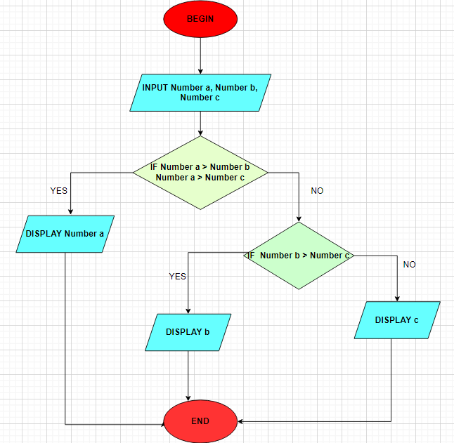**Begin**

Input Number a, Number b, Number c

**IF** Number a > Number b and Number a > Number c

Display Number a

**END IF**

IF Number b > Number c

Display Number b

**ELSE**

Display Number c

**END IF**

**End**