Name: Anmolpreet Kaur

Student Id: C0727060

Assignment:2, G-3, T-3, CPCM

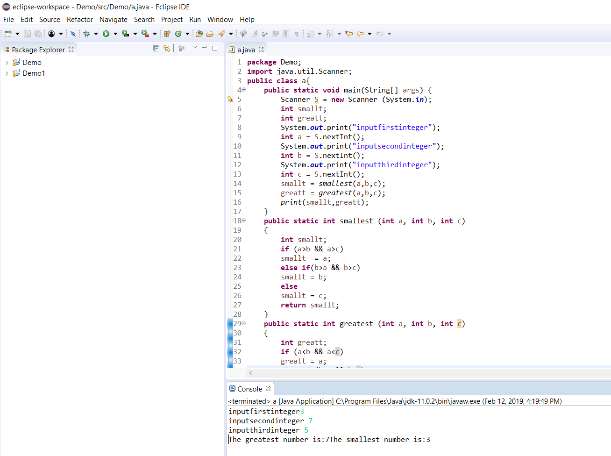

**package** Demo;

**import** java.util.Scanner;

**public** **class** a{

**public** **static** **void** main(String[] args) {

Scanner S = **new** Scanner (System.***in***);

**int** smallt, bbb;

**int** greatt;

System.***out***.print("inputfirstinteger");

**int** a = S.nextInt();

System.***out***.print("inputsecondinteger");

**int** b = S.nextInt();

System.***out***.print("inputthirdinteger");

**int** c = S.nextInt();

smallt = *smallest*(a,b,c);

greatt = *greatest*(a,b,c);

*print*(smallt,greatt);

}

**public** **static** **int** smallest (**int** a, **int** b, **int** c)

{

**int** smallt;

**if** (a>b && a>c)

smallt = a;

**else** **if**(b>a && b>c)

smallt = b;

**else**

smallt = c;

**return** smallt;

}

**public** **static** **int** greatest (**int** a, **int** b, **int** c)

{

**int** greatt;

**if** (a<b && a<c)

greatt = a;

**else** **if** (b<a && b<c)

greatt = b;

**else**

greatt = c;

**return** greatt;

}

**public** **static** **void** print (**int** greatt, **int** smallt)

{

System.***out***.print("The greatest number is:"+greatt);

System.***out***.print("The smallest number is:"+smallt);

}

}