2020



GAMER MANAGEMENT

Submitted to:

William Pourmajidi

Date:05/03/2020

aMANDEEP KAUR c0744703

GURPREET CHAHAL C0742780

NAvNEET SINGH c0749303

KARANVIR SINGH C0745204

1. **Profile Page Function.**

In Image -1. User will login into her account by filling her Login id and Password.

Image – 1.

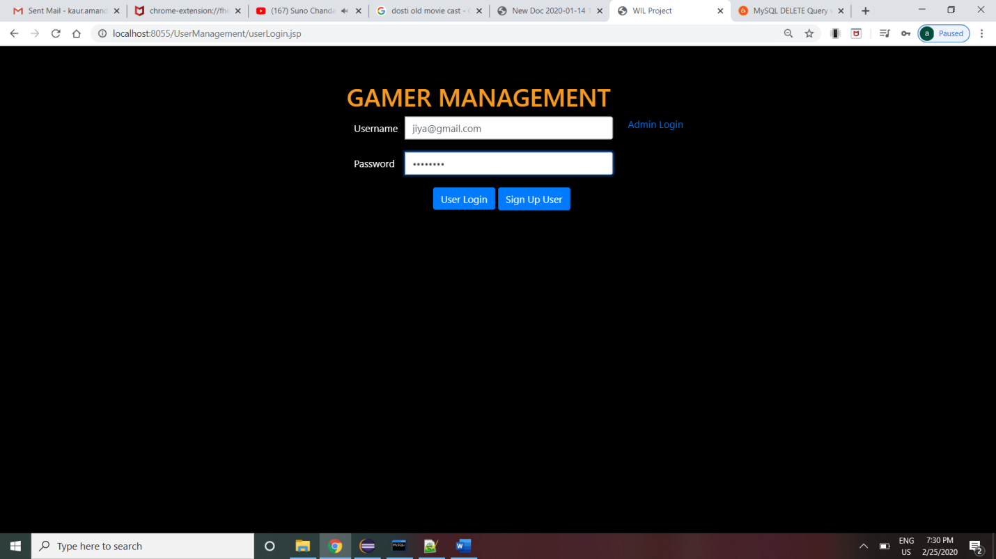

In Image -2. User will see Welcome Message “Welcome Regular Access User” as she is already added into this app by the Admin.

Image – 2.

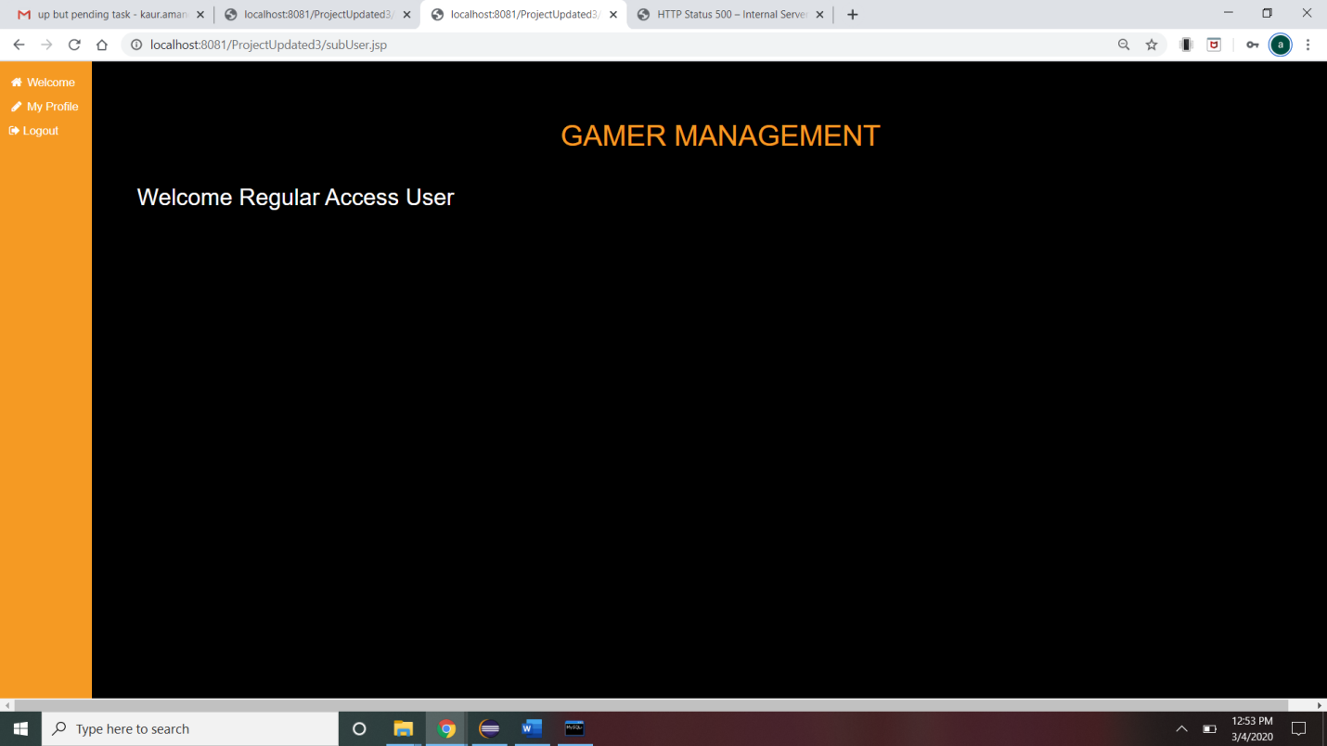

In Image -4. Now Admin will login to his account.

Image – 4

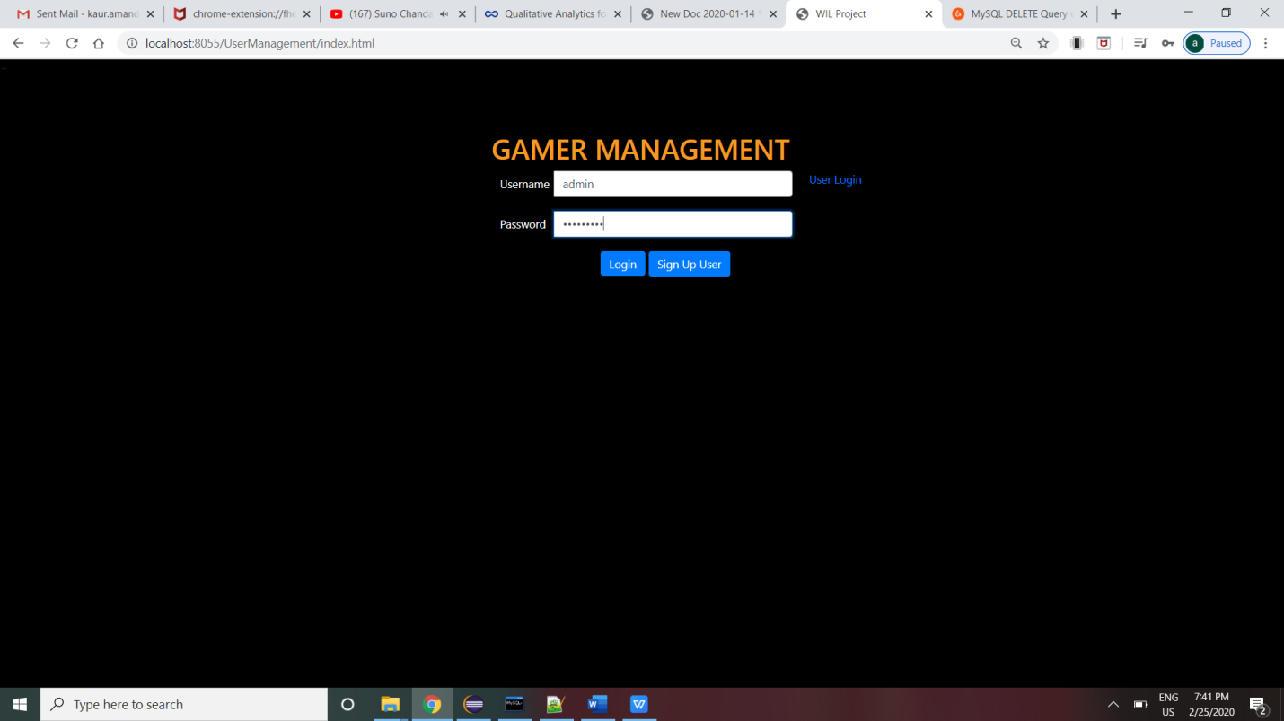In Image – 4.1. Admin will see welcome message “Welcome Administrator”.

Image – 4.1

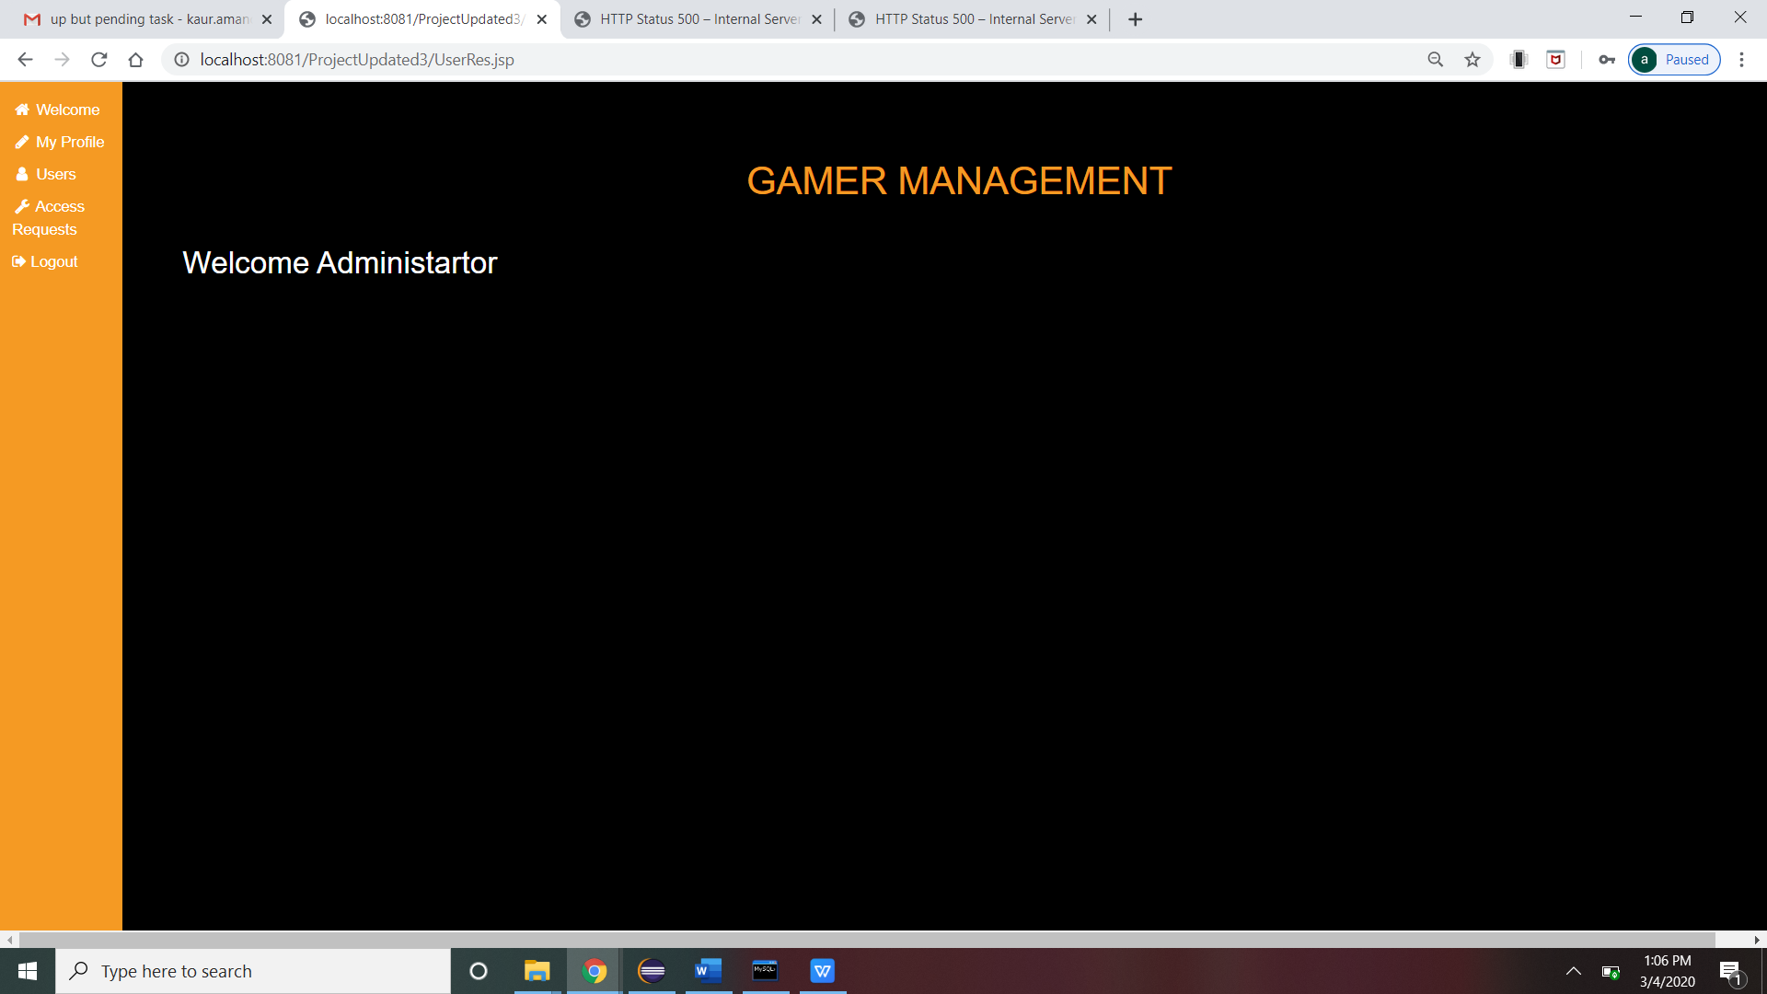

In Image – 5 , Admin will click on Users tab and click on View button where, Admin will see the profile of all other Users.

Image -5.

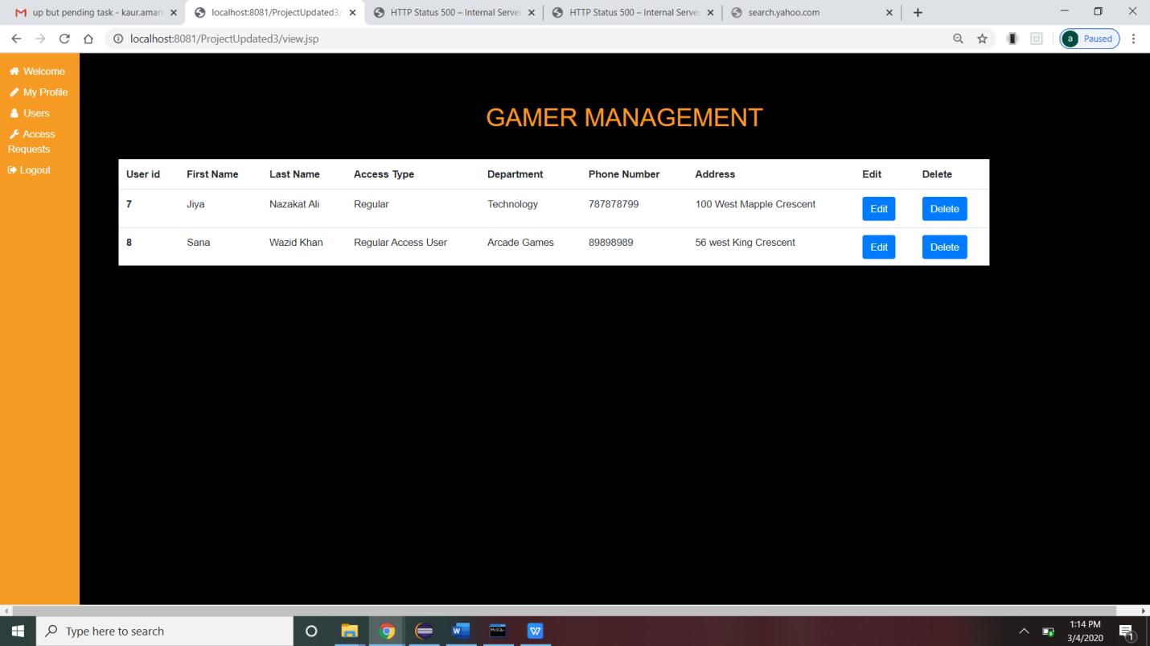

1. **Request Access Function**

Image – 6. User Will Login to her account by filling credentials.

Image – 6.



In Image – 7. Admin will see welcome message “Welcome Administrator”.

Image-7



In Image – 8 . User will click on My Profile tab where she will see Request Elevated Access button on the right side of the screen.

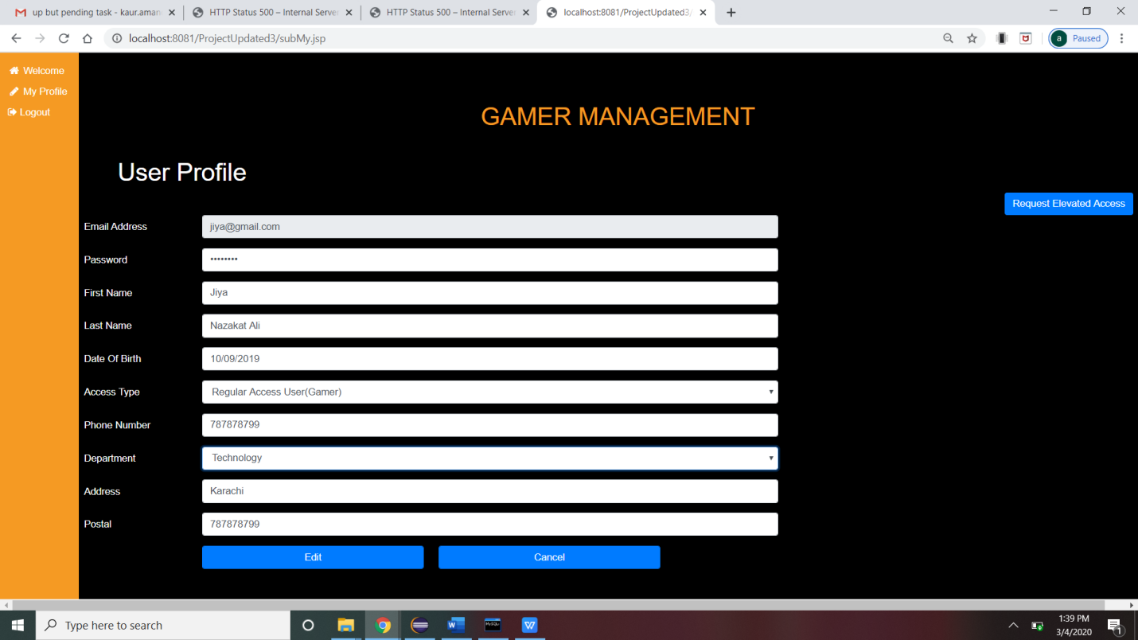

In Image – 9. User will click on Request Elevated Access button to raise the request for getting Elevated Access.

Image – 9.

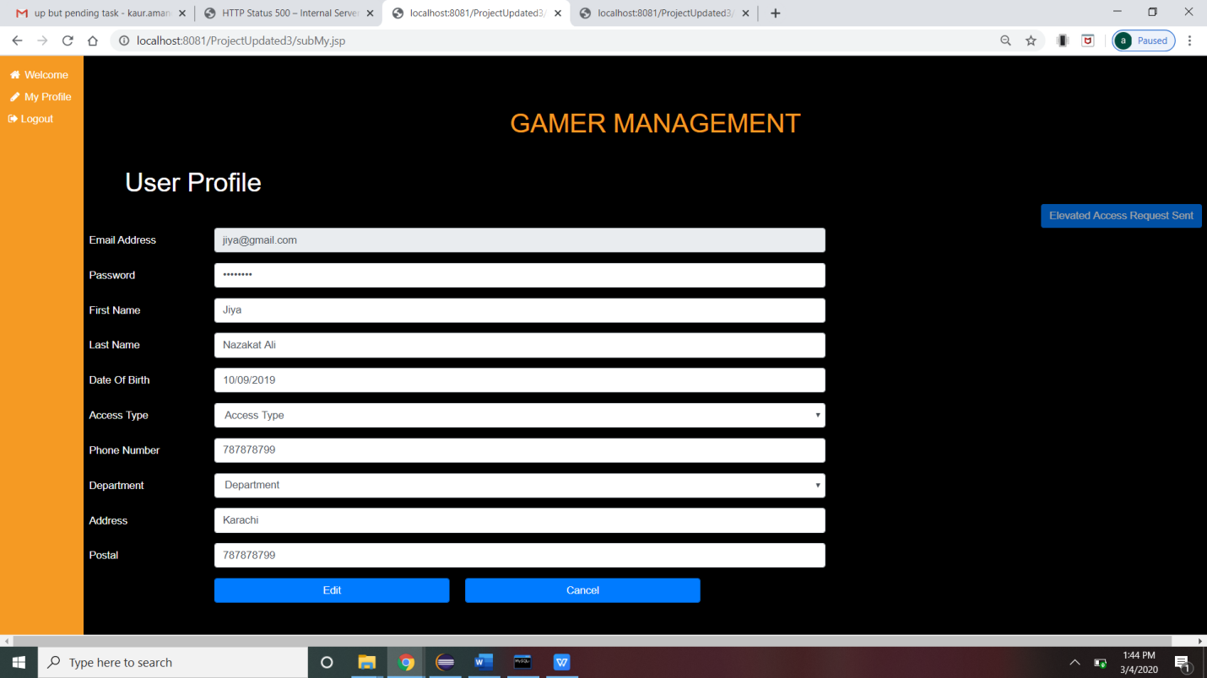

In Image – 10. Admin will Login to his account and click on Access Request tab. Here, Admin will see Requests sent by the other User. In this Image, Request sent by ‘Jiya’ is pending so the status is “Active”.

Image – 10.

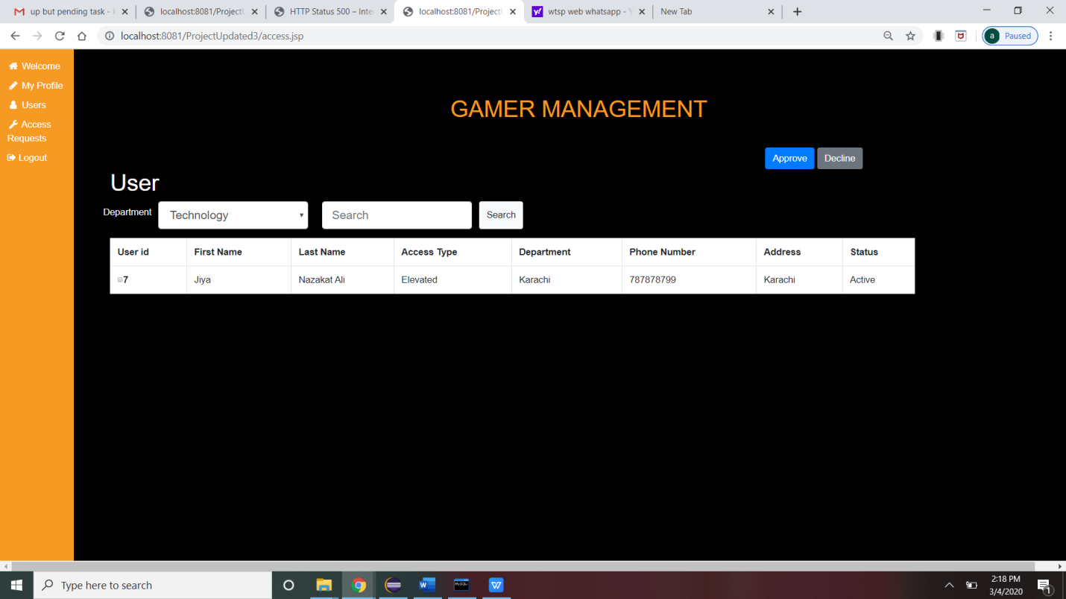

In Image – 11. Here admin will Approve the request, then there will be a pop-up message “Request Approved” on the screen to confirm the changes.

Image - 11.

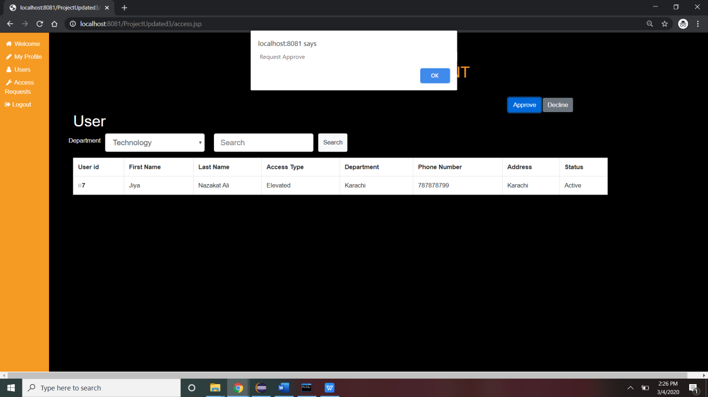

In Image – 12. Here Press OK on pop-up message , then the Status will be updated as “Approved”.

Image – 12.

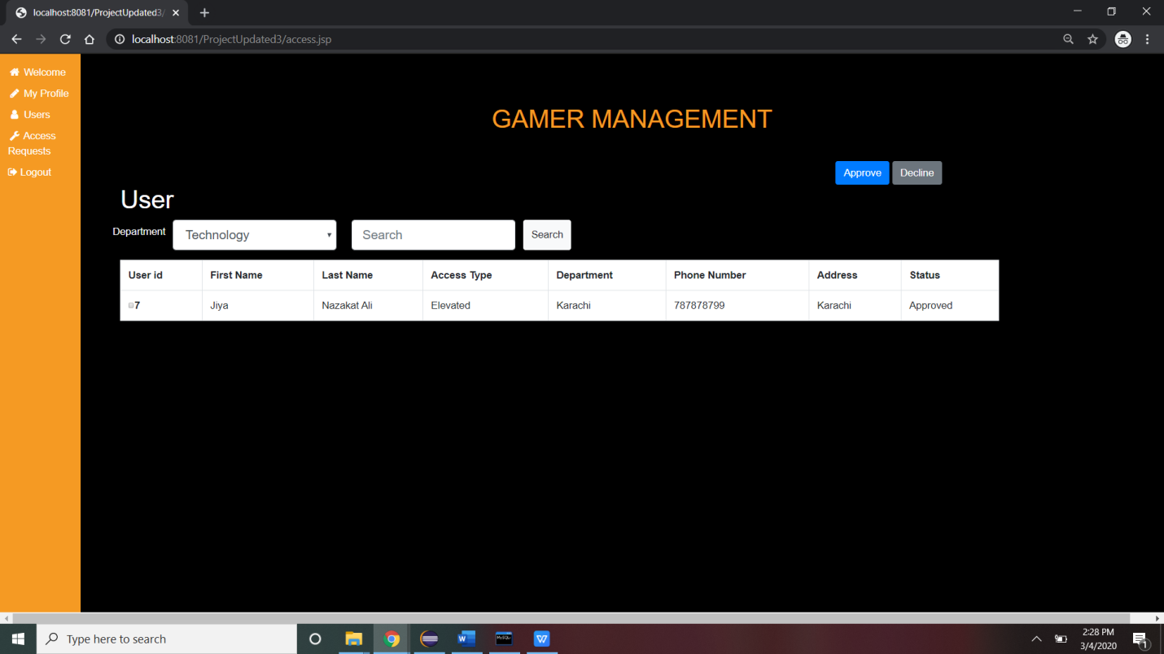

1. **Search Function.**

In Image - 13, Admin will login to his account and go to Users tab and click on View button.

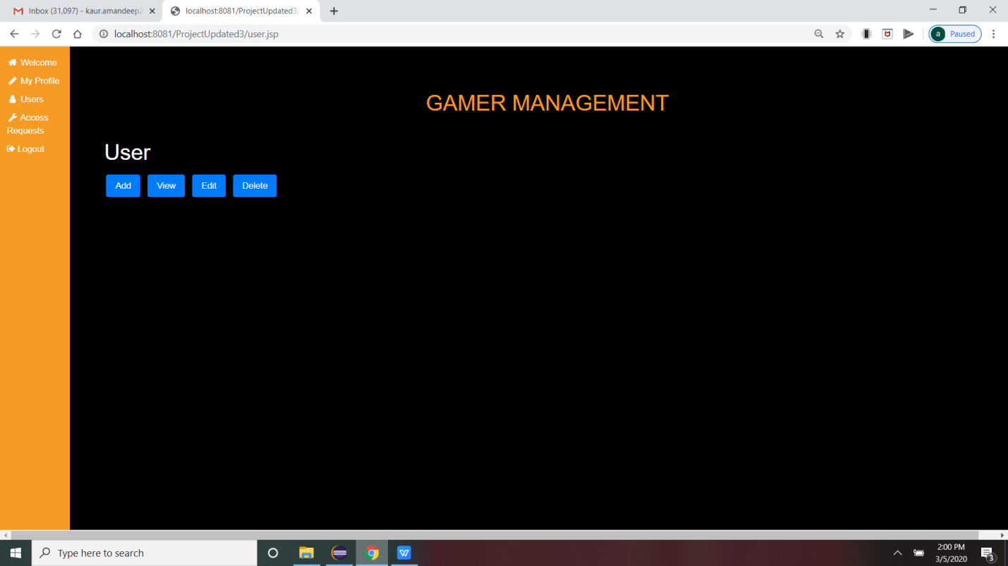

In Image - 14. After he click on View button, he will see this window in which there is one drop-down list to choose user according to the *Department* and *Search* box to search for other users.

Image -14.

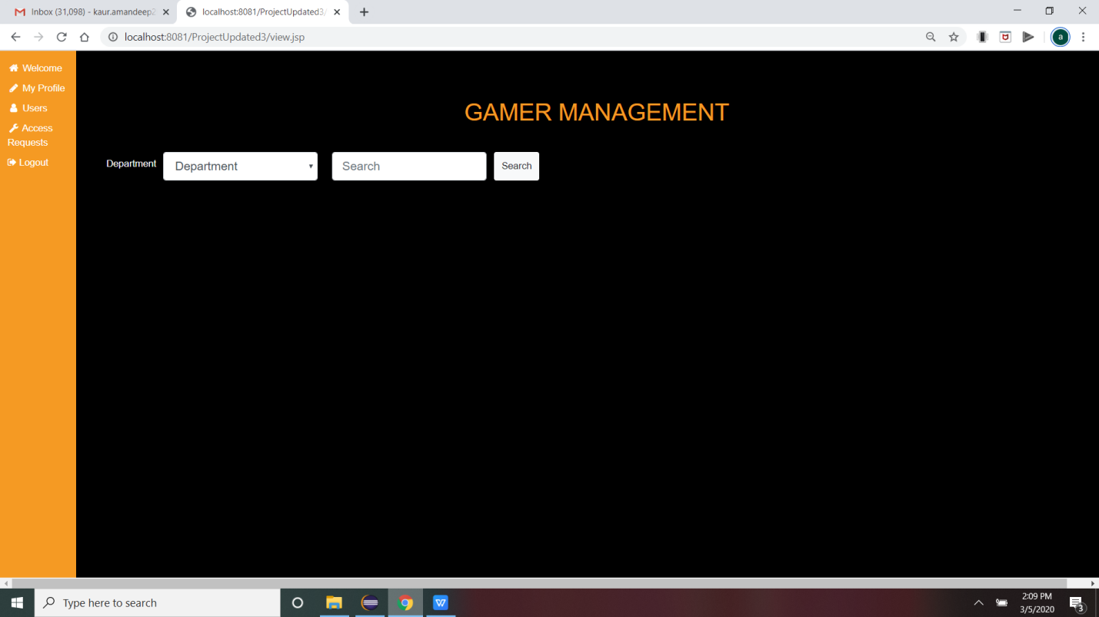

In Image - 15, Admin will select the Department from drop-down list to search user sorting by the Department and click on Search button.

Image - 15.

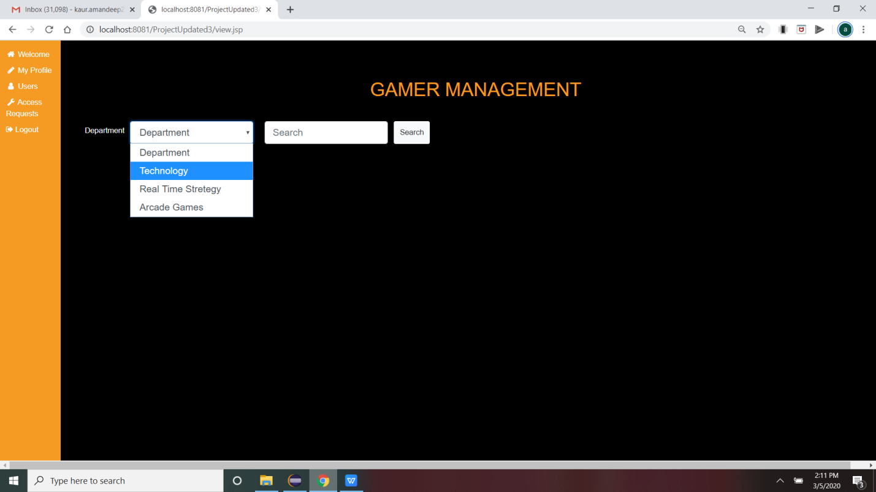

In Image - 16, After clicking on Search button, the result will be like this. Those users, who has the same *Department* as selected in the drop-down list will be displayed.

In this window, Admin selected department as Technology so information of user named ‘jiya’ is displayed.

Image - 16.

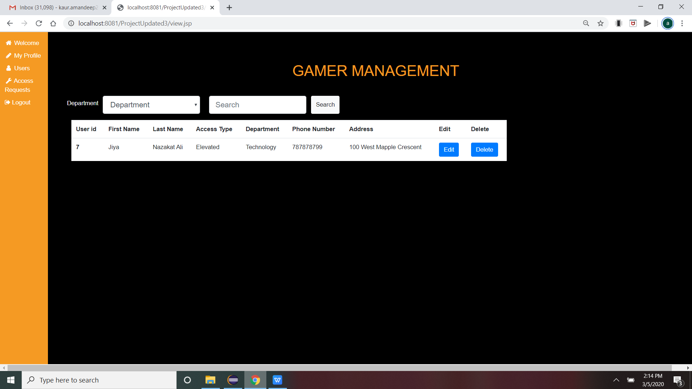

In Image - 17, Admin is using Search box to search for other users.

Admin searched for user named ‘Sana’. the result will be like this.

Image - 17.

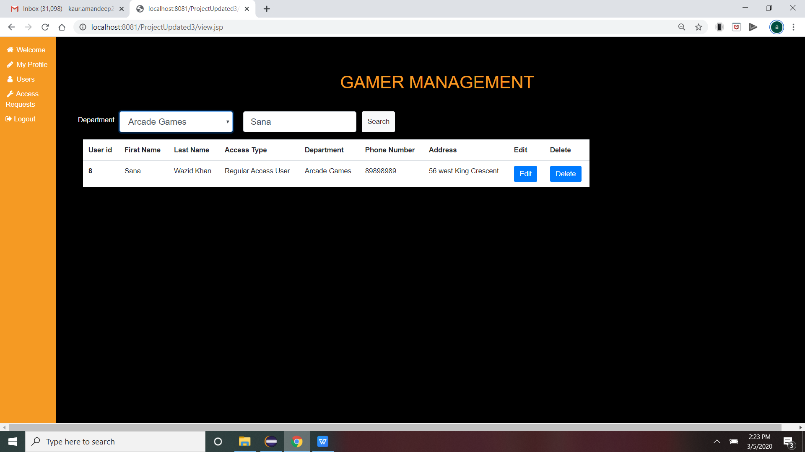

In Image - 18, Admin can sort the users in Request Access tab also. Here, he select Technology Department from drop-down list and click on Search button. The result will be like this.

Image - 18

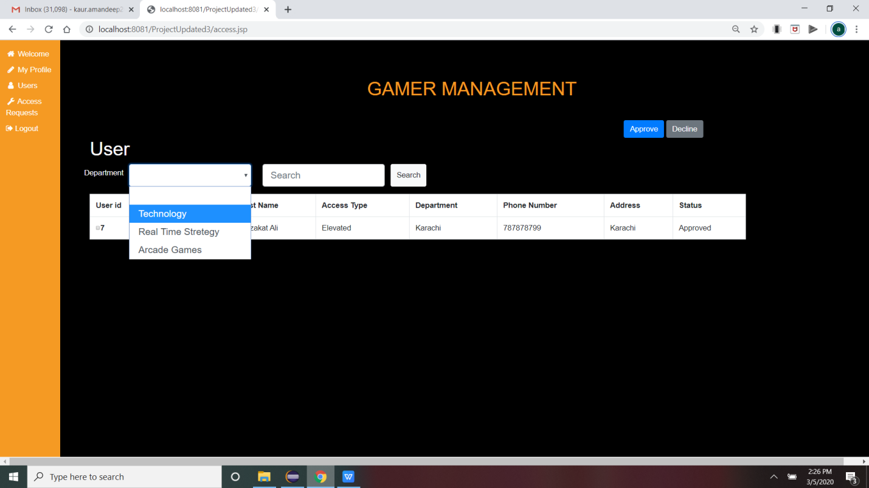

In Image - 19 ,Here , Admin uses Search box to see the details of users request. He Enter ‘jiya’, in Search box and press Search button. The result will be like this.

Image - 19.

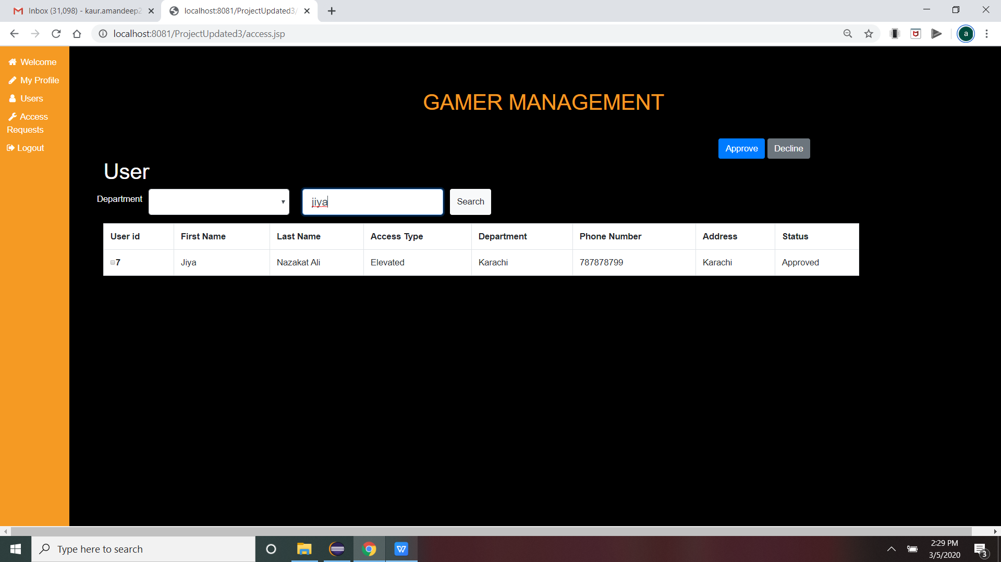

In Image - 20 , user jiya logged in to her account and see welcome message “Welcome Elevated User” as her Elevated Access Request is approved by the Admin so she is Elevated Access User now.

Image - 20.

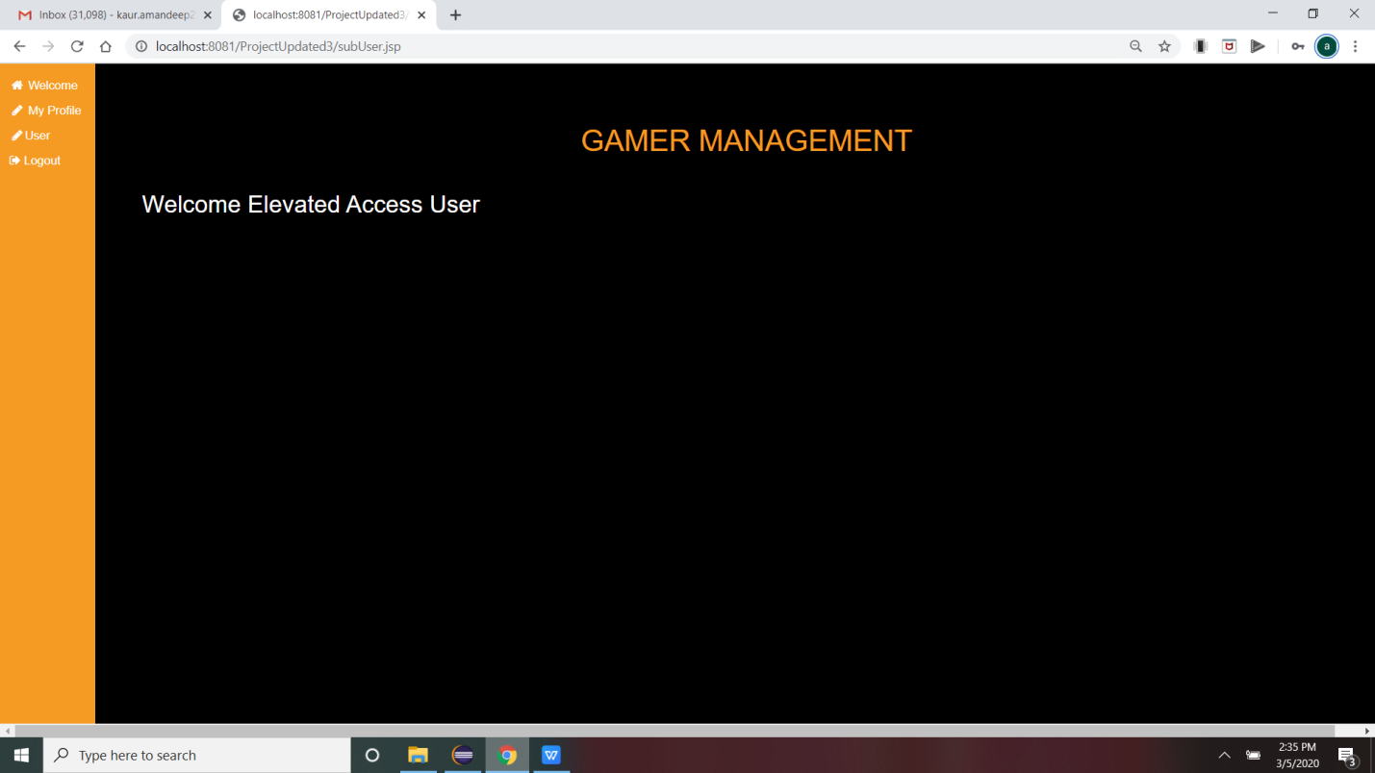

In Image - 20.1 Moreover, she can search for the users to view their information as she has Elevated Access now. User will go to User tab, where she will select the Department as *“Technology”* from drop-down list and click on Search button.

Image - 20.1.

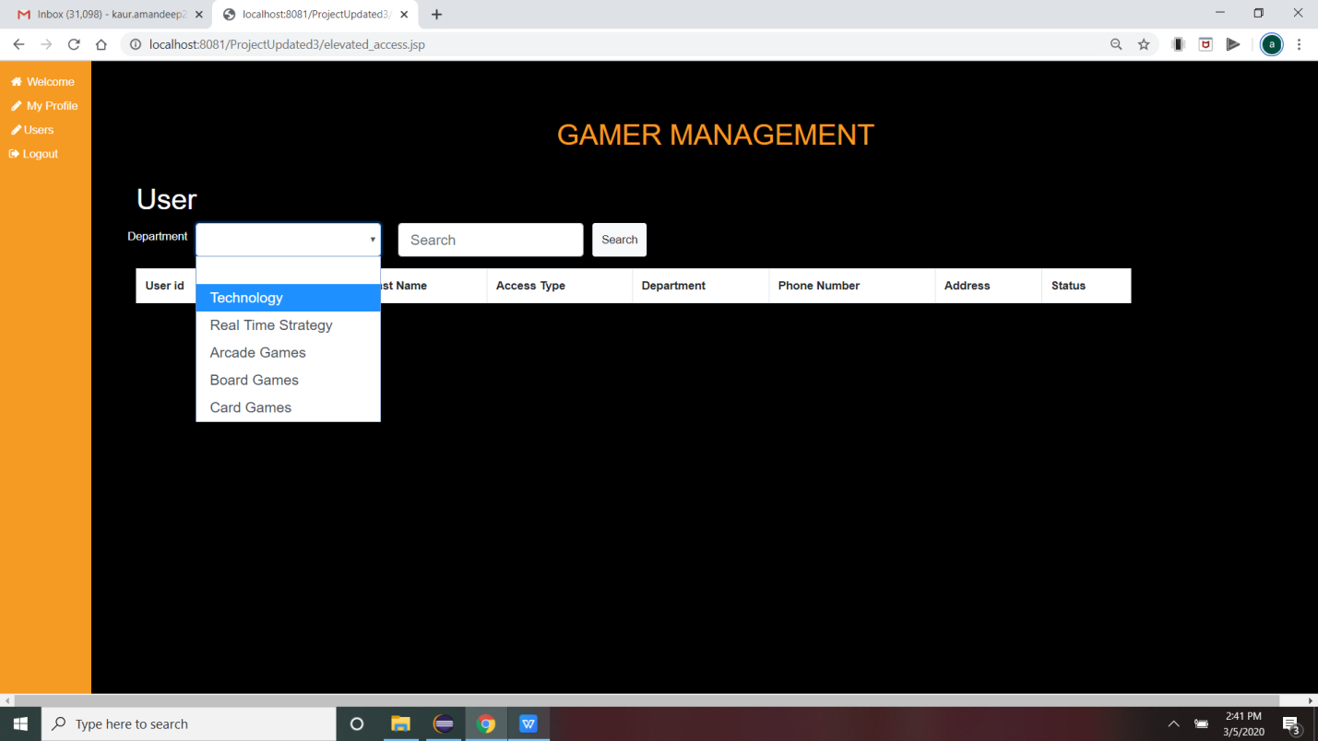

In Image - 21, after selecting department as Technology and clock on Search button, the result will be display below.

Image - 21.

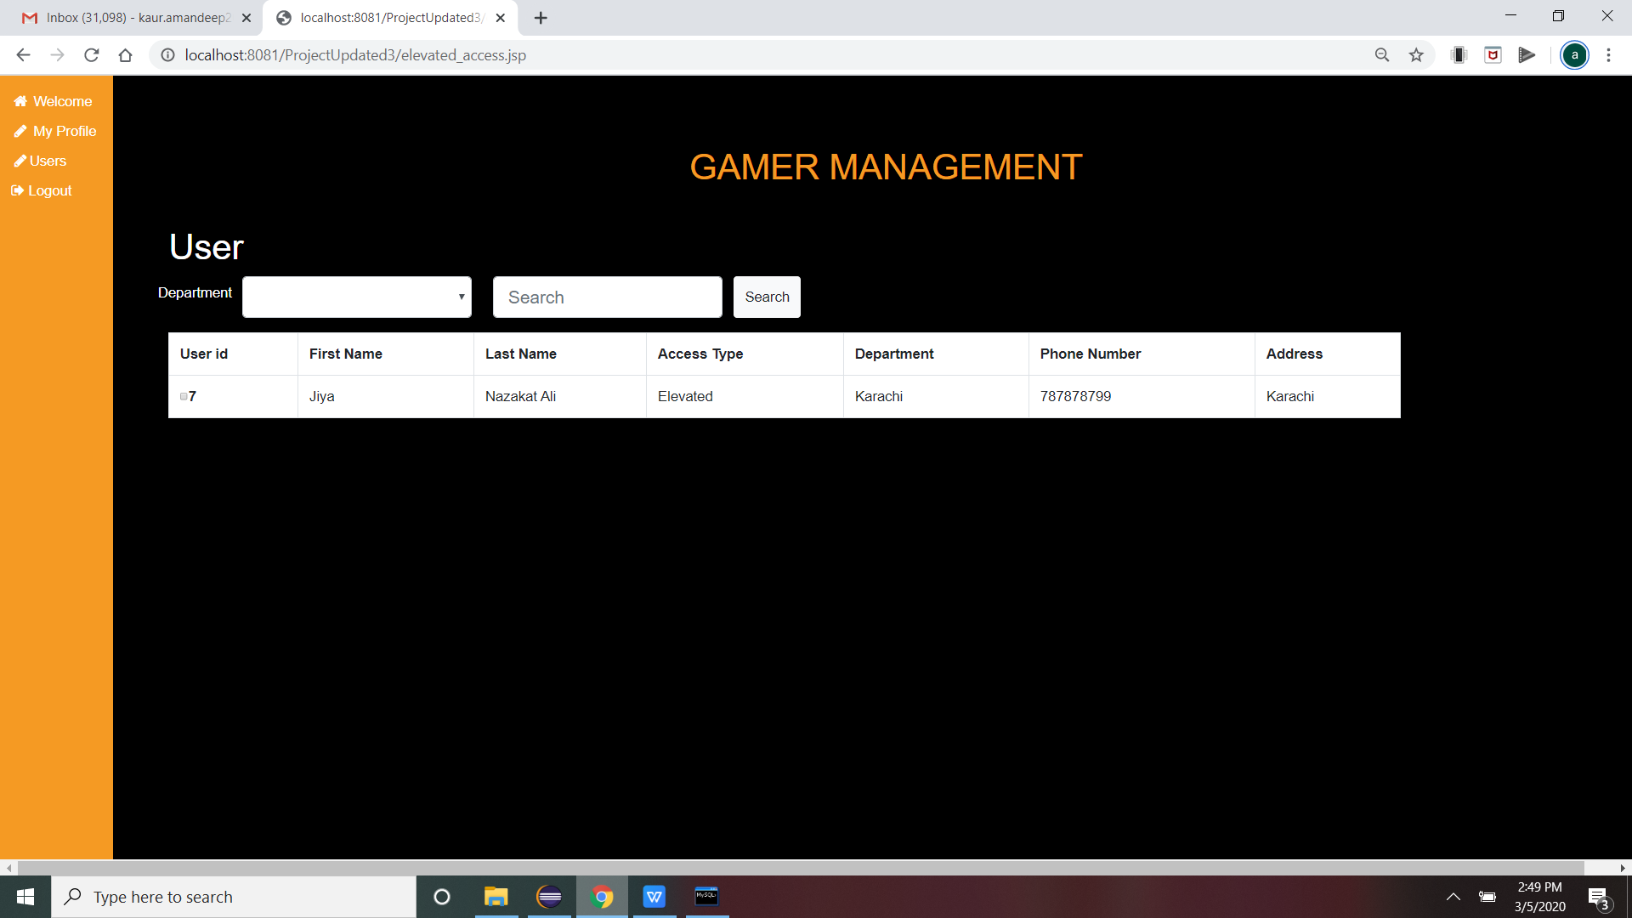

In Image - 22, Here, User can view other users by using Search box.

User has typed ‘jiya; and click on Search button. The result will be in Image - 23.

Image - 22.

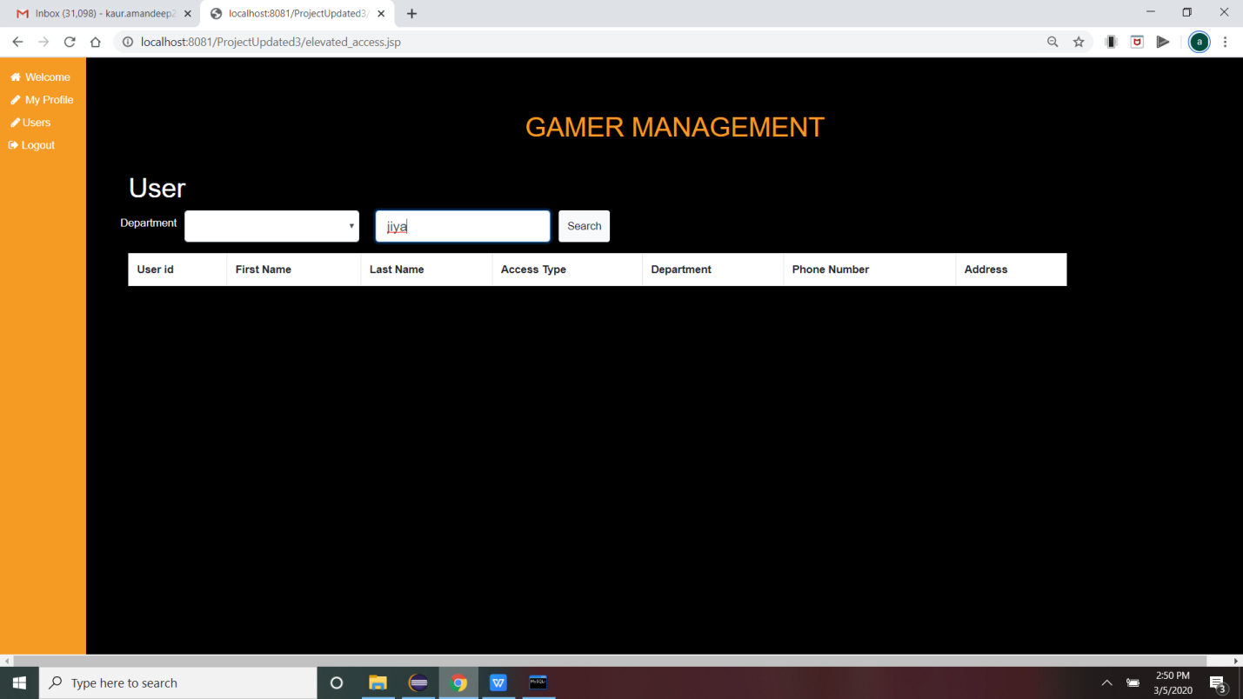

Image -23.



