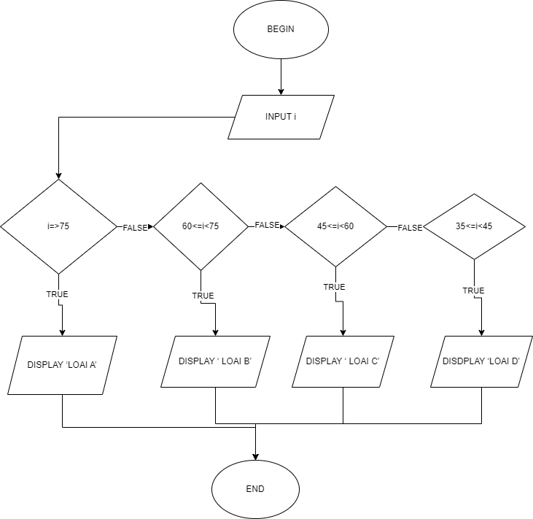BEGIN

INPUT i

If (i>=75)

DISPLAY ‘LOAI A’

eIse if (60<= i <75)

DISPLAY ‘ LOAI B’

ELSE IF (45<= i < 60)

DISPLAY ‘ LOAI C’

ELSE IF ( 35<= i <45)

DISDPLAY ‘LOAI D’

ELSE IF ( i< 35)

DISPLAY ‘ LOAI E’

END