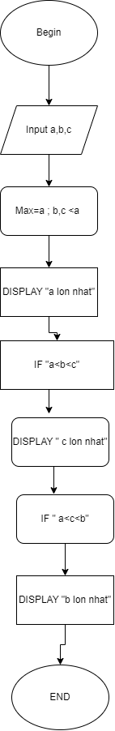BEGIN

INPUT a,b,c

Max=a ; b,c <a

DISPLAY “a lon nhat”

IF “a<b<c”

DISPLAY “ c lon nhat”

IF “a<c<b”

DISPLAY “ b lon nhat”

END