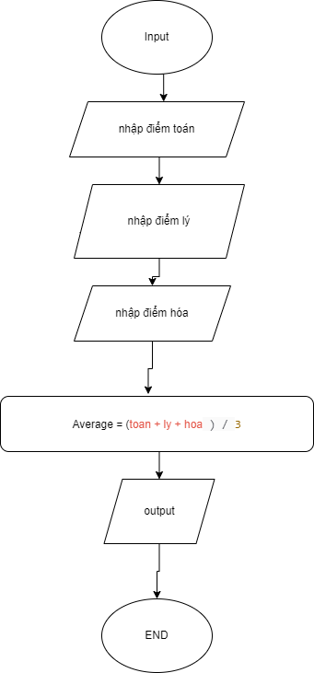BEGIN

INPUT toan,ly,hoa

Average = (toan + ly + hoa)/3

DISPLAY Average

END