# 2. Methods

## 2.1 Participants

For the experiment Thirteen healthy, right-handed medicine students from the University of Marburg (7 males and 6 females) were recruited. Each of them took part in an MRI introduction course to familiarize themselves method and to experience having an MRI scan performed on themselves. Subjects were additionally offered to participate in an fMRI experiment. If they agreed, subjects were asked permission to have an EEG recording added to the experiment. In exchange, they were provided an anatomical scan of their brain. Subjects were excluded from the experiment if they were not between 18 and 35 years old, reported impaired vision, left-handedness, prior experience with the task, current use of prescription drugs and acute or a history of neurological or psychiatric disorders. All subjects were between 18 and 32 years old (M = 23.23, SD = 4.28). Participants provided informed consent after they were given a summary of the risks and requirements involved as well as a rough outlet of the experimental procedure. A summary of all subject information can be found in Table 1. This study was approved by the local ethics committee at the Department of Psychology.

Table 1

## 2.2 Experimental Design and Setup

### 2.2.1 General Procedure

All experiments were performed on the premises of the section for brainimaging located at the clinic for psychiatry and psychotherapy at the Department of Medicine in Marburg. When subjects arrived at the clinic, they were greeted and asked to take a seat in front of a desk in a comfortable office chair in a light-attenuated room. The desk was empty, except for a few sheets of paper, a stop watch and a pen. Starting from this point, all experimental procedures were documented on the standardized protocol (see Appendix 1).

Next, subjects were provided an oral overview of the following proceedings (i.e., conditions for participation, informed consent, etc.) and the study’s background. Then, they were handed the written version of the informed consent as well as a metal anamnesis to assess risk factors for the application of fMRI and to ensure the subject’s safety (see Appendix 2 and 3). The latter was used to ensure that there were no pieces of metal or electrical devices permanently attached to the subject’s body. On request subjects could receive a written report, describing the study’s background, risks and conditions of participation in detail.

If the subject had filled out all forms and had no further questions, the interviewer conducted pre-experimental interview (see Appendix 4), in order to assess demographic and personal data (i.e., age, highest academic degree, average grades). Further, to control for the influence of stable capacities for informational load, the Digit Symbol Coding Test from the German version of the Wechsler Intelligence Scale for Adults (WAIS-IV, fourth eidition; Petermann, 2012) was administered as a pretest (see Appendix 5). This measure was also included to enrich the battery of behavioral and self-report variables, which should be predictable by brain activation, with a cognitive test.

Afterwards, subjects were brought into the MRI control room, where they could change into a hospital gown. This was offered to prevent soiling the participants’ private clothing with gel from the EEG and ECG electrodes at the head and upper back. While subjects sat in a chair in front of the computer running the EEG and ECG recording software, the experimenter could check the signal quality (i.e., electrical impedance, voltage at each electrode). Two sizes of EEG caps were available (size 56 cm and 58 cm) with mounts for 31 ring electrodes plus one grounding (AFz) and one reference channel (FCz) on the fronto-anterior and fronto-central scalp positions, respecitvely.

Before the EEG cap was put on, skin portions that would be covered were cleaned with Isopropanol (70%), followed by measuring the subject’s head circumference. By assessing the distances between the left and right preauricular points as well as between the nasion below the forehead and the inion at the back of the head, the central vertex point (Cz) was marked as the intersection of the two axes (Klem, Lüders, Jasper, & Elger, 1999). The EEG cap was then put on at this central position. An elastic chin band prevented the cap from sliding.

Electrical impedances were reduced with a conductive electrolyte gel, containing pumice, as this gel component aids roughening the skin and removes detrimental elements to the electrical conductance such as callus skin or fat. The gel was distributed across the electrode sites, starting with the reference and grounding electrodes. For this purpose blunt plastic syringes were used, after slightly roughening the skin with cotton swabs. These were also applied for pushing away hair blocking the contact of the electrodes to the scalp. All impedances were kept at or below 5 kΩ. At last, the ECG electrode integrated in the EEG system was placed on the upper back. Before the electrode was attached and the impedance was optimized, subjects were asked if they preferred a person of the same sex to execute this step.

When the EEG and ECG signal were optimal, subjects were lead into the scanning room to the MRI bore. Here, several measures, as can be read in protocols from Ritter and Villringer (2006) or Mullinger, Castellone, & Bowtell (2013), were met to achieve optimal data quality. For a detailed description on these measures specific for simultaneous recordings, see section 2.3.2. During the entire time in the scanner, subjects were able to communicate with the experimenter via a two-way intercom system connecting the two adjacent rooms.

Following an anatomical T1-weighted scan, subjects were introduced to the DPX (see section 2.2.2) on ten slides with written instructions. When they felt confident, they could start with 18 practice trials. As opposed to the subsequent four experimental blocks, subjects received feedback on their performance (‘correct’, ‘incorrect’, ‘too slow’, ‘too early, please wait for the probe’). The feedback was initially given to make sure subjects had properly understood the task. Before the experiment and the functional data acquisition was started, subjects were asked one last time if they were well and ready to begin. From that point on, not counting practice trials and instructions, the experiment lasted approximately 32 minutes.

Finally, when the task was over, subjects were moved out of the scanner, freed of all EEG equipment and provided the opportunity to wash their hair and back. When they had cleaned themselves, all subjects participated in a post-experimental interview (see Appendix 6). Among other questions, they were asked how they rated their task performance on a scale of one to ten and which ideas they had on the purpose of the task. Concluding the experiment, subjects were informed about the background of the task and the complete purposes of the study (i.e., psychological mechanisms involved in DPX, clinical applications). In case they were interested, subjects could indicate if they wanted to be notified of the results of the study.

### 2.2.2 DPX Paradigm

The DPX paradigm is a continuous performance task with four different trialtypes (AX, BX, AY, BY) repeated across experimental blocks. Each block consisted of 52 trials. Blocks were separated by fixed one minute breaks and preceded by 18 practice trials. Every trial entailed the successive presentation of two stimulus types: one cue, which provided predicitive information about which of two possible goal responses would be required, and one probe, signaling when to show a goal response. Therefore, the DPX task allows for the assessment of early predictions based on goal-related information locked to the cue as well as updating behavioral responses with the onset of the probe.

All stimuli were made of dot patterns highlighted within a square of nine equidistant blue dots. The first dot pattern (i.e., the cue) was presented in light blue for 100 ms on a white background, followed by a jittered interstimulus interval of 3 to 5 seconds. The second dot pattern (i.e., the probe) was presented in grey. As soon as the probe appeared, subjects had a time window of 800 ms to respond. After 300 ms the probe disappeared. A jittered intertrialinterval of 2.5 to 4.5 seconds separated the probe from the next cue. Thus, the minimum duration of each trial was 6.4 s and the maximum duration 10.4 s.

Subjects were instructed to respond with a right button push after a correct cue-probe combination and with a left button push after an incorrect combination. In the correct combination (AX) in the vertical midline three blue dots light up as a cue. During the maintenance interval subjects fixated the square of nine dark blue dots as a mask. The corresponding probe had the two upper dots of the vertical midline and one on the right in the middle in grey. Any deviation in the cue, probe or in both patterns was considered incorrect. All patterns were constructed starting with nine equidistant dots arranged in a square. Further, all colors were checked for equiluminance to control for contrast effects. They were each tested in the configurations in which they were pesented in the experiment.

ISI 3 to 5 s

maintenance interval

**Right button**

Correct cue-probe combination **AX**

**BX**

**AY**

**BY**

Incorrect cue-probe combinations

**Left button**

**Figure 4** Illustration of the DPX task adapted for simultaneous EEG-fMRI recordings. One trial consists of a cue lighting up within in the square, followed by a mask and then the probe appearing in grey (left side of the figure). A correct combination is presented on the left and all incorrect combinations on the right side.

Across the four blocks 208 trials were presented with 136 AX (65%) and 24 trials (11.6%) for BX, AY and BY respectively. However, due to a programming error in the pseudo-randomized stimulus list, the fourth block contained 33 AX and 8 BX trials. Therefore, the actual amount is 135 AX, 25 BX and 24 AY and BY trials. An overview of the paradigm is given in **Figure 4**.

As often found in EEG paradigms, this design was intentionally unbalanced. For the paradigm to work, the correct trialtype AX had to have the highest frequency of occurance. Of the 52 trials per block, 33 were AX (65%) and 8 trials were each of the remaining trialtypes (11.6%). Thus, subjects developed a dominant response tendency towards AX to push the right button. However, in a small amount of trials (i.e., AY trials) the expectation to see a correct probe after a correct cue was violated. An AY trial required subjects to correct their behavioral planning by updating WM in a reactive control style. They had to integrate the unexpected information, since the last stimulus and not the context was imperative to their behavior.

By contrast, when subjects saw a wrong cue (B), a strong proactivity was triggered. Regardless of the probe, in a trial starting with a wrong cue there is only one possible response, since both cue and probe have to be correct in order for the trial to be correct. The wrong cue has to be maintained in WM, because in this case it is the imperative stimulus. As soon as subjects saw the correct probe, they had to inhibit the dominant response tendency to push the right button by having the context direct their behaviour. The last combination BY was a control condition and presumably did not require noteworthy cognitive control efforts.

Across the four blocks 564 trials were presented with 384 AX and 60 trials for BX, AY and BY respectively. Both the baseline and the dual demand blocks with cognitive reappraisal consisted of 282 trials. Hence, both conditions had 192 AX and 30 BX, AY and BY trials.

## 2.3 Data acquisition

### 2.3.1 Materials and software

For electrophysiological recordings inside the MRI scanner, the BrainAmp MR (Brain Products GmbH, Gilching, Germany), an fMRI compatible 32-channel EEG system including an integrated ECG channel, was used. This system amplifies the recorded electrical signal with a shielded amplifier connected via a fiber optic cable to the USB interface in the control room. As a result, there are no artefacts caused by data transmission and the amount of electrical wiring inside the MRI room is minimized. All EEG and ECG channels were recorded using silver/silver chloride (Ag/AgCl) ring electrodes. Imaging data were collected in a 3 Tesla MRI scanner (Trio Tim System, Siemens, Erlangen, Germany), using a 12 channel head matrix receive coil for data acquisition.

Unlike in common EEG systems, short cables connect the electrode cap to the amplifier. This quality prevents safety risks for the subject and potential sources of artefacts due to free moving wires inside the MRI. Another characteristic of the BrainAmp MR system is that it is clocked by the USB interface at the other end of the fiber optic cable. In many more sophisticated setups, for instance involving more than 32 channels, using an external system for temporal alignment can safe electric connections in the MRI. On top of that, implementing an external clock serves another essential purpose. There is virtually no approach for the correction of artefacts from simultaneous recordings in the EEG that does not rely on temporal synchronization. This task is very demanding, since the EEG has to be acquired with a much higher sampling rate than technically feasible for any MRI scanner and both have to be precisely aligned. Achieving this feat on a data level after the recording is more than likely insufficient for optimal data quality. Hence, a SyncBox (Brain Products GmbH, Gilching, Germany) is used as intermediary between the MRI and the EEG. The scanner clock is connected to the SyncBox Scanner Interface, which in turn is coupled to the SyncBox main unit. The latter contains all the circuitry necessary for detecting inputs from the clock and for downsampling the input. Lastly, the SyncBox puts out a clock signal to the USB interface, thereby enabling markers for events timed by the scanner clock (i.e., volume acquisition) to be set in the EEG. A schematic illustration of this setup can be seen in **Figure 5**.

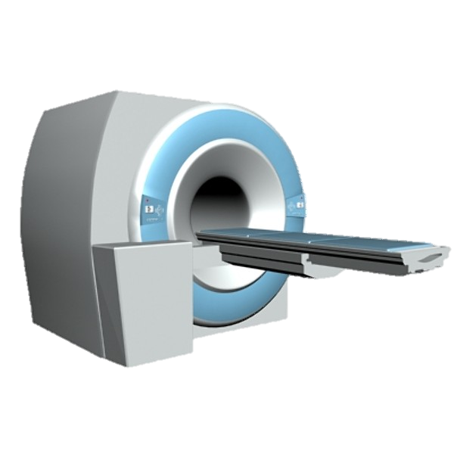

MRI console and control equipment

Computer for EEG acquisition

MRI scanner

EEG amplifier positioned inside the MRI bore

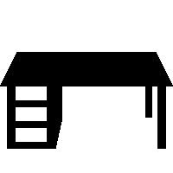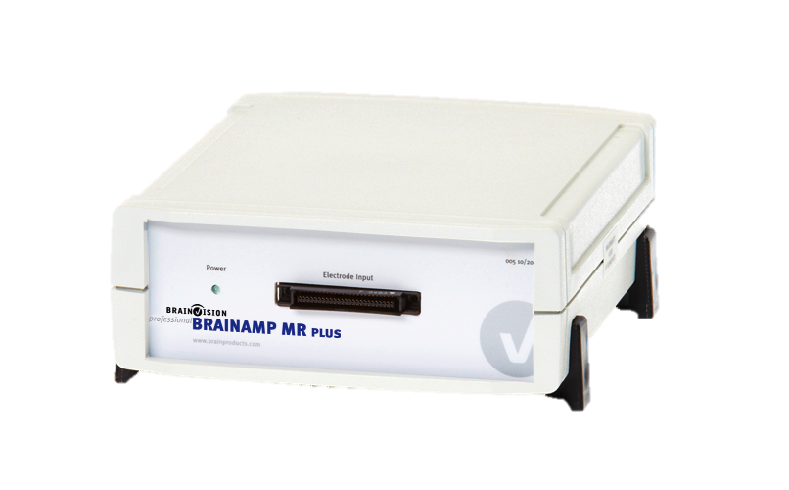

MRI and EEG control room

Computer for stimulus presentation

MRI room

Online clock synchronization of EEG and MRI via SyncBox

Scanner Master Clock Output

SyncBox Scanner Interface

**Figure 5** Schematic illustration of the experimental setup for simultaneous EEG-fMRI recordings adapted from Ullsperger & Debener (2010). EEG and fMRI acquisition is performed with a SyncBox synchronizing data acquisition of the two methods to ensure that TR markers are set precisely in the EEG data.

During the experiment EEG data was recorded and observed with BrainVision Recorder (Version 1.21, Brain Products GmbH, Gilching, Germany). The DPX task, as described above, was programmed and presented using Presentation (Neurobehavioral Systems, Albany, USA) on a screen behind the MRI scanner. Subjects were able to view the stimuli through a mirror above them, which reflected the images on the screen.

For subsequent pre-processing of the EEG data, the MNE-python software (Gramfort et al., 2013), the Bergen plug-in for EEGLAB (Delorme & Makeig, 2004), provided by the fMRI group of the University of Bergen, Norway, as well as the Fusion ICA Toolbox, provided by the Medical Image Analysis Lab of the University of New Mexico, USA, for Matlab (Release 2014b, The MathWorks, Inc., Natick, Massachusetts, United States) were used. Pre-processing of the fMRI data was performed with processing pipelines build in Nipype (Gorgolewski et al., 2011). For this purpose, software packages containing functions from FSL (Smith et al., 2004) and SPM (Friston et al., 1995) were integrated in the pipeline. Behavioral data analysis and the multilevel model were written and performed in the R Programming Environment (R Development Core Team, 2016) as well as the scikit-learn package for machine learning in python (Pedregosa et al., 2012) to implement the N-PLS regression.

### 2.3.2 Experimental protocol for simultaneous recordings

Besides the aformentioned aspects of the experimental setup, a number of additional measures were taken to follow a sensible protocol for the concurrent assessment of electrophysiological and imaging data.

Even with MRI-compatible materials, performing an EEG recording inside the MRI scanner causes the electrodes and other materials to heat up, posing a potential safety risk to the subject (Yeung et al., 2002). As a preventive measure, it is essential to assess how intensively materials of the EEG system (most importantly the electrodes) heat while using the planned EPI sequence. During the test run over the entire experiment all electrodes showed temperatures equal to or below 28 °C.

Another preventive measure taken before running an experiment, was to switch off the helium pump. With subtle vibrations caused by the pump’s compressor (Rothlübbers et al., 2014) cables and other materials are moved inside the magnetic field. This leads to serious artefacts impacting the quality of the EEG data.

During the experiment, when subjects first entered the MRI room, they were once more instructed about how to behave during the experiment. They were asked to abstain from any unnecessary movements of the head, torso or shoulders and to avoid crossing their limbs, as this would cause severe artefacts for both the EEG and fMRI. Furthermore, they were given a brief oral explanation of the experimental task. The participant’s head was then placed on a pressure-insensitive cushion and further stabilized with foam pads to minimize head movements.

Electrode leads were passed through the head coil above the subject. Before moving the subject into the scanner bore, they were given an emergency control to be able to abort the experiment at any time they felt in danger. Inside the bore electrode leads were connected to the amplifier positioned behind the subject’s head. All cables between the electrodes and the amplifier were fastened firmly with adhesive tape to prevent movement. As an additional measure, sandbag weights were put on electrode leads for stabilization.

### 2.3.3 Recording parameters for EEG and fMRI

A T1-weighted structural image was acquired for all subjects. Functional data were recorded with EPI parameters (echo time = 30 ms, TR = 1800 ms, 75° flip angle, voxel size 3 x 3 x 4.6 mm, matrix 64x64) based on previous adaptations of the DPX task for fMRI studies (D’Ardenne et al., 2012; Lopez-Garcia et al., 2016). For each volume data from 32 slices oriented to the AC-PC line were collected in ascending order.

EEG data for all 32 channels were collected with a sampling rate of 5 kHz. An online band-pass filter excluded data above 100 Hz and below 0.001 Hz. During the recording data were online referenced to FCz. As mentioned in section 2.2.1, all impedances were kept below 5 kΩ.

## 2.4 Unimodal data analysis

Before joining data features, behavioral, EEG and MRI data were first pre-processed and then analyzed independently from one another. This was done to achieve a baseline level of informational value and to validate unimodal results with existing literature. To achieve the most sensible approach, pre-processing started with behavioral data, followed by fMRI and at last EEG data. For both EEG and fMRI it was necessary to note which trials had correct responses. Furthermore, optimal EEG pre-processing required the realignment parameters resulting from realigning the raw functional data to the structural image of a subject. Thus, EEG pre-processing was performed last.

### 2.4.1 Behavioral Data

RT were assessed starting with the onset of the probe until the subject showed its first response. Button presses applied before, less than 100 ms after or 800 ms after the onset of the probe were categorized as invalid or miss, respectively. For all analyses performed with RT only valid, correct responses were included. The ER, as measure of accuracy, was specified as the relative amount of incorrect button presses to the total amount of trials.

Since reactive and proactive control strategies presumably balance each other, it is often more appropriate to enter values indexing the balance rather than a single trialtypes RT. For this reason, a proactive behavioral shift index (PSI) was computed (Braver, Paxton, & Locke, 2009), based on equation (2):

( 2 )

Equation (2) can be used for both RT and ER. However, in case subject values equaling zero would have to be entered, ER were corrected following equation (3):

( 3 )

The PSI indicates increasing or decreasing proactive control tendencies. A higher difference in performance for AY and BX trials was interpreted as a shift towards proactive control, as could be observed in case of improved BX and/or diminished AY performance. Therefore, a higher numerator, resulting in higher PSI values, hinted at elevated proactive control levels. Vice versa, a low BSI for RT or ER was interpreted as a stronger reactive control tendency.

### 2.4.2 fMRI pre-processing

### 2.4.3 EEG pre-processing

## 2.5 Multimodal data analysis

### 2.5.1 Asymmetric data integration

### 2.5.2 Joint and Parallel ICA

### 2.5.3 Multiway Partial Least Squares regression

### 2.5.4 Multilevel modeling