JavaScript Lab Assignment
Operators, Precedence, Ternary Logic, Type Coercion & Debugging
Name | Rishikesh Priyadarshi
Scholar ID | 2424370
Course | BCA
Semester | 5th

Part 0 — Quick Recap Warm-Up
Expression | Output | Reason
typeof (10 + "5") | "string" | 10 + "5" becomes "105"
5 === "5" | false | Number and string are different types
let x = 10; x += 5; x | 15 | x += 5 means x = x + 5
true && false || true | true | && is evaluated before ||
10 % 3 | 1 | Remainder after 10 / 3 is 1
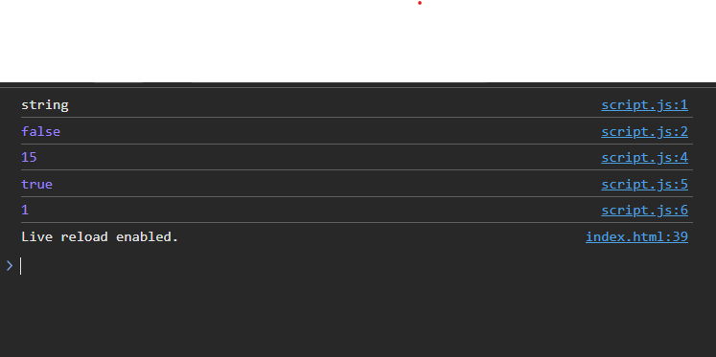

Part 1 — Operator Precedence

Task 1.1
let val = 4 + 3 * 2 ** 2 - 6 / 3;
console.log(val);

Step-by-step:
1. Exponent: 2 ** 2 = 4
2. Multiplication: 3 * 4 = 12
3. Division: 6 / 3 = 2
4. Add/Subtract: 4 + 12 - 2 = 14

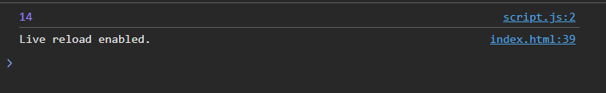
Answer: 14

Task 1.2 — Comparison Chaining
console.log(1 < 2 < 3);
console.log(3 > 2 > 1);

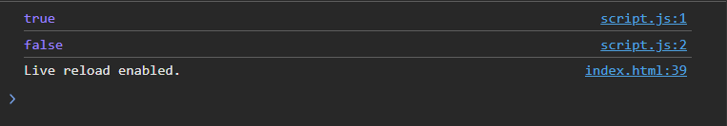
First expression: 1 < 2 → true; then true < 3 → 1 < 3 → true. Output: true
Second expression: 3 > 2 → true; then true > 1 → 1 > 1 → false. Output: false
Explanation: JavaScript does not treat these as mathematical chained comparisons — it evaluates left to right. The Boolean true is converted to 1 when compared with a number, so true > 1 becomes 1 > 1, which is false.

Task 1.3 — Expression with 4+ Operators
let answer = (10 + 5) * 2 > 20 && 30 % 4 === 2;
console.log(answer);

10 + 5 = 15
15 * 2 = 30
30 > 20 = true

30 % 4 = 2
2 === 2 = true

true && true = true

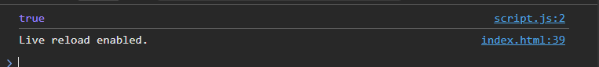
Final answer: true
Operators used: +, *, >, %, ===, &&

Part 2 — Nested Ternary Logic

Task 2.1 — Movie Ticket Pricing
function ticketPrice(age) {
let price = age < 5 ? "Free"
: age < 12 ? "₹100"
: age < 60 ? "₹250"
: "₹150";

console.log("Age:", age, "Ticket:", price);
}

ticketPrice(3);
ticketPrice(8);
ticketPrice(25);
ticketPrice(60);
ticketPrice(70);

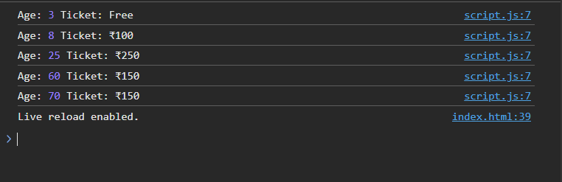
Test results:
Age | Ticket
3 | Free
8 | ₹100
25 | ₹250
60 | ₹150
70 | ₹150

Task 2.2 — Shipping Cost Calculator
function shippingCost(cartTotal) {
let shipping = cartTotal >= 2000 ? "Free Shipping"
: cartTotal >= 1000 ? "₹50"
: "₹100";

console.log("Cart Total:", cartTotal, "Shipping:", shipping);
}

shippingCost(2500);
shippingCost(1500);
shippingCost(500);

Cart Total: 2500 Shipping: Free Shipping
Cart Total: 1500 Shipping: ₹50
Cart Total: 500 Shipping: ₹100

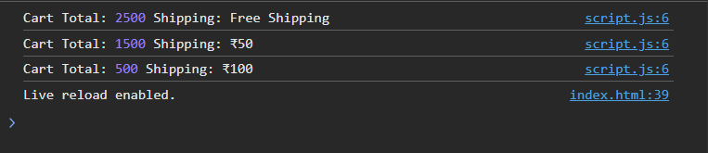

Task 2.3 — Ternary + Logical Operator
let isMember = true;
let totalSpent = 6000;

let discountType =
(isMember && totalSpent >= 5000)
? "VIP Discount"
: totalSpent >= 5000
? "Regular Discount"
: "No Discount";

console.log(discountType);

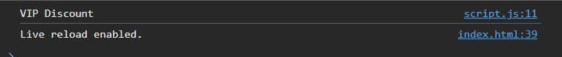
Output: VIP Discount
If isMember = false and totalSpent = 6000, the result changes to: Regular Discount

Part 3 — Manual Aggregation

Task 3.1 — Exam Scores
const scores = [65, 72, 80, 55, 68];

const sum = scores[0] + scores[1] + scores[2] + scores[3] + scores[4];
const average = sum / scores.length;

const result = average >= 40 ? "Pass" : "Fail";

console.log("Sum:", sum);
console.log("Average:", average);
console.log("Result:", result);

65 + 72 + 80 + 55 + 68 = 340

340 / 5 = 68

Sum: 340
Average: 68
Result: Pass

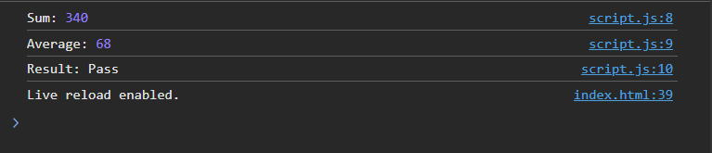

Task 3.2 — Fourth Product
const item1 = { name: "Notebook", price: 60, qty: 3 };
const item2 = { name: "Pen", price: 10, qty: 5 };
const item3 = { name: "Bag", price: 800, qty: 1 };
const item4 = { name: "Pencil", price: 5, qty: 4 };

const subtotal1 = item1.price * item1.qty;
const subtotal2 = item2.price * item2.qty;
const subtotal3 = item3.price * item3.qty;
const subtotal4 = item4.price * item4.qty;

const grandTotal = subtotal1 + subtotal2 + subtotal3 + subtotal4;

console.log("Subtotal 1:", subtotal1);
console.log("Subtotal 2:", subtotal2);
console.log("Subtotal 3:", subtotal3);
console.log("Subtotal 4:", subtotal4);
console.log("Grand Total:", grandTotal);

Notebook = ₹60 x 3 = ₹180
Pen = ₹10 x 5 = ₹50
Bag = ₹800 x 1 = ₹800
Pencil = ₹5 x 4 = ₹20

Grand Total = ₹180 + ₹50 + ₹800 + ₹20 = ₹1050

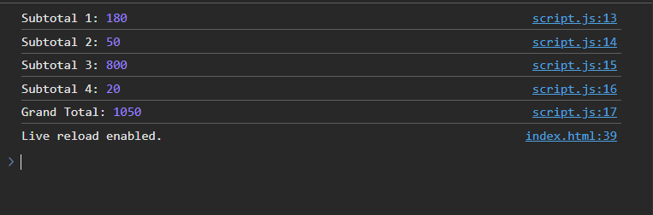

Part 4 — Tricky Type Coercion

Task 4.1
Expression | Output | Reason
"5" + 3 | "53" | + with a string performs string concatenation
"5" - 3 | 2 | - converts "5" to a number
"abc" * 2 | NaN | "abc" cannot be converted to a number
NaN === NaN | false | NaN is never equal to itself
[] == false | true | Both sides are coerced to comparable primitives
"10" == 10 | true | == allows type coercion
null + 1 | 1 | In numeric addition, null becomes 0

Most surprising example: [] == false
It is surprising because an empty array looks like an object, while false is a Boolean. With loose equality, JavaScript coerces the empty array to an empty string, then to 0; false is also coerced to 0, so the comparison is true.

Task 4.2 — typeof NaN
console.log(typeof NaN);

Output: number
NaN means Not-a-Number, but it is actually a special value within JavaScript's Number data type. It represents an invalid or undefined numerical result, such as "abc" * 2.

Part 5 — Mini Project: Smart Shopping Cart
A complete solution using the three products from the worksheet's sanity check.

index.html
<!DOCTYPE html>
<html>
<head>
<title>Smart Shopping Cart</title>
</head>
<body>

<h1>Smart Shopping Cart &amp; Billing System</h1>

<script src="script.js"></script>
</body>
</html>

script.js
// Three product objects
const item1 = {
name: "Notebook",
price: 60,
qty: 3
};

const item2 = {
name: "Pen",
price: 10,
qty: 5
};

const item3 = {
name: "Bag",
price: 800,
qty: 1
};

// Defensive type check
if (
typeof item1.price === "number" &&
typeof item2.price === "number" &&
typeof item3.price === "number"
) {

// Calculate individual subtotals
const subtotal1 = item1.price * item1.qty;
const subtotal2 = item2.price * item2.qty;
const subtotal3 = item3.price * item3.qty;

// Calculate grand total
const grandTotal = subtotal1 + subtotal2 + subtotal3;

// Tiered discount
const discountPercent =
grandTotal >= 5000 ? 20
: grandTotal >= 2000 ? 10
: grandTotal >= 1000 ? 5
: 0;

// Discount amount
const discountAmount = grandTotal * discountPercent / 100;

// Amount after discount
const afterDiscount = grandTotal - discountAmount;

// GST calculation
const gst = afterDiscount * 18 / 100;

// Final payable amount
const finalPayable = afterDiscount + gst;

// Free shipping condition
const freeShipping =
afterDiscount >= 1500 || 3 >= 3;

// Shipping status
const shippingStatus = freeShipping
? "FREE"
: "₹100 shipping charge";

// Optional loyalty points
const loyaltyPoints = finalPayable / 100;

// Receipt
console.log("========== RECEIPT ==========");
console.log(item1.name + " x " + item1.qty + " = ₹" + subtotal1);
console.log(item2.name + " x " + item2.qty + " = ₹" + subtotal2);
console.log(item3.name + " x " + item3.qty + " = ₹" + subtotal3);

console.log("-----------------------------");
console.log("Grand Total: ₹" + grandTotal);
console.log("Discount: " + discountPercent + "%");
console.log("Discount Amount: ₹" + discountAmount.toFixed(2));
console.log("After Discount: ₹" + afterDiscount.toFixed(2));
console.log("GST (18%): ₹" + gst.toFixed(2));
console.log("Final Payable: ₹" + finalPayable.toFixed(2));
console.log("Shipping: " + shippingStatus);
console.log("Loyalty Points: " + loyaltyPoints);
console.log("=============================");

} else {
console.log("Error: Product prices must be Numbers.");
}

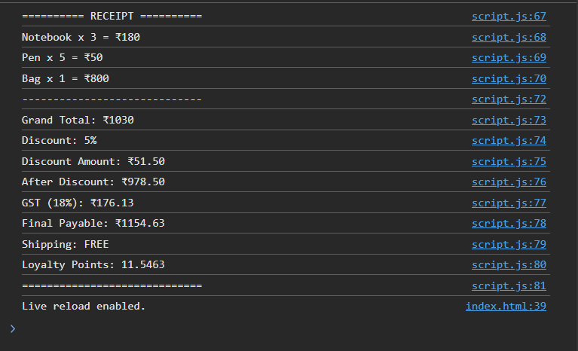

Expected Receipt
========== RECEIPT ==========
Notebook x 3 = ₹180
Pen x 5 = ₹50
Bag x 1 = ₹800
-----------------------------
Grand Total: ₹1030
Discount: 5%
Discount Amount: ₹51.50
After Discount: ₹978.50
GST (18%): ₹176.13
Final Payable: ₹1154.63
Shipping: FREE
Loyalty Points: 11.5463
=============================

Note: The freeShipping condition uses ||. Since there are exactly 3 distinct products, the second condition is true, so shipping is free even though the discounted amount is below ₹1500.

Part 6 — Debugging Challenge

Snippet 1
Original code:
let price = 500;
const discount = price * 0.1;
discount = discount + 5;
console.log("Final: " + fnal);

Two bugs:
1. discount is declared with const, so it cannot be reassigned.
2. fnal is misspelled; it should be discount.
Corrected code:
let price = 500;
let discount = price * 0.1;
discount = discount + 5;

console.log("Final: " + discount);

Output: Final: 55

Snippet 2 — Silent Bug
Original code:
let marks = "85";
let result = marks === 85 ? "Pass" : "Fail";
console.log(Result);

Two bugs:
1. marks is a string while 85 is a number, so marks === 85 is false.
2. Result should be lowercase result.
Corrected code:
let marks = 85;
let result = marks === 85 ? "Pass" : "Fail";

console.log(result);

Output: Pass
Why is the === bug silent? The comparison itself is valid JavaScript, so it produces no error. Because marks holds the string "85" and 85 is a number, strict equality returns false, causing the program to choose "Fail" even though the student's marks are 85.

Snippet 3
Original code:
const cartTotal = 1200;
cartTotal = cartTotal - 100;
let shipping = cartTotal >= 1500 ? "Free" "Paid";
console.log(shipping);

Two bugs:
1. A const variable cannot be reassigned.
2. The ternary expression needs a colon (:) between "Free" and "Paid".
Corrected code:
let cartTotal = 1200;

cartTotal = cartTotal - 100;

let shipping = cartTotal >= 1500 ? "Free" : "Paid";

console.log(shipping);

Output: Paid

Self-Check Questions

1. Trace 2 + 3 * 4 ** 2
4 ** 2 = 16
3 * 16 = 48
2 + 48 = 50

Answer: 50 — exponentiation happens first, followed by multiplication, then addition.

2. Why does 3 > 2 > 1 evaluate to false?
3 > 2 = true
true > 1 -> 1 > 1 = false

JavaScript evaluates the expression left to right. true is converted to 1 during the numeric comparison, so the final comparison becomes 1 > 1, which is false.

3. What happens when grandTotal is exactly 2000?
The condition grandTotal >= 2000 is true, so the customer gets a 10% discount. The order of the conditions matters because 2000 is not >= 5000, but it is >= 2000, so the discount ladder must be checked from the highest threshold down to the lowest.

4. Why is NaN === NaN false?
NaN represents an invalid numerical result and is a special value that is defined as not equal to itself, so NaN === NaN always returns false.

5. Why check typeof before calculating?
Checking that prices are actually Numbers before performing arithmetic helps prevent incorrect calculations caused by unexpected data, such as a price accidentally being stored as the string "800" instead of a number.

6. Why didn't Snippet 2 throw an error?
Because it is a logic error, not a syntax error. The expression "85" === 85 is valid JavaScript and simply evaluates to false, so JavaScript continues running instead of throwing an error. This is exactly why silent bugs are difficult to find.

Reflection

Which part of today's lab pushed you the most, and why?
The type coercion and debugging parts of today's lab pushed me the most because JavaScript sometimes produces results that are different from what I initially expect. Expressions such as "5" - 3, [] == false, and NaN === NaN helped me understand that JavaScript automatically converts values between different types. The debugging challenge was also useful because some errors were logic errors rather than syntax errors, so they did not immediately crash the program. Overall, this lab helped me understand the importance of checking data types, following operator precedence, and testing my code carefully.

