**Introduction**

An accurate prediction on the house price is important to prospective homeowners, developers, investors, appraisers, tax assessors and other real estate market participants, such as, mortgage lenders and insurers. Traditional house price prediction is based on cost and sale price comparison lacking an accepted standard and a certification process. Therefore, the availability of a house price prediction model helps fill up an important information gap and improve the efficiency of the real estate market.

Real estate market is booming in the United States, every person’s dreams is to have a perfect house. As house market in the USA is thriving house price becomes a crucial factor for a home seeker. Research shows that important factors that influence the house price are housing site, housing quality, geographical location and the environment.

**Client**

This analysis report can be an interest to any Real estate company, Real estate investors, Mortgage lenders and Home insurers. This report helps make decisions easy for the businesses and home seekers.

**Dataset**

Dataset consists of historical house prices of residential homes in Ames, Iowa. The dataset consists of 81 exploratory features with 1460 observations. The dataset is extracted from Kaggle <https://www.kaggle.com/c/house-prices-advanced-regression-techniques/data>

The data set contains every minute detail of the house. Some of the major features in this data set are:

1. Lot Area
2. Neighborhood
3. House Style
4. Quality of the house
5. Overall condition of the house
6. Year built
7. Year remodeled
8. Foundation
9. Basement Condition
10. Total basement square feet
11. 1st floor square feet
12. 2nd floor square feet
13. Above ground living area in square feet
14. Full bathrooms above ground
15. Bedrooms above grade
16. Total rooms above grade
17. Garage size in square feet
18. Garage quality

However, it is good idea to explore the data set from Kaggle to get good idea on the data.

**Data Wrangling**

Data Wrangling is an extremely important step for any data analysis. It is very crucial for data to be organized. This process typically includes manually converting/mapping data from one raw form into another format to allow for more convenient consumption and organization of the data.

Data Cleaning steps carried out in this project are:

1. Handling missing data
2. Handling inconsistent data in a few variables

House Prices data set information:

<class 'pandas.core.frame.DataFrame'>

RangeIndex: 1460 entries, 0 to 1459

Data columns (total 81 columns):

Id 1460 non-null int64

MSSubClass 1460 non-null int64

MSZoning 1460 non-null object

LotFrontage 1201 non-null float64

LotArea 1460 non-null int64

Street 1460 non-null object

Alley 91 non-null object

LotShape 1460 non-null object

LandContour 1460 non-null object

Utilities 1460 non-null object

LotConfig 1460 non-null object

LandSlope 1460 non-null object

Neighborhood 1460 non-null object

Condition1 1460 non-null object

Condition2 1460 non-null object

BldgType 1460 non-null object

HouseStyle 1460 non-null object

OverallQual 1460 non-null int64

OverallCond 1460 non-null int64

YearBuilt 1460 non-null int64

YearRemodAdd 1460 non-null int64

RoofStyle 1460 non-null object

RoofMatl 1460 non-null object

Exterior1st 1460 non-null object

Exterior2nd 1460 non-null object

MasVnrType 1452 non-null object

MasVnrArea 1452 non-null float64

ExterQual 1460 non-null object

ExterCond 1460 non-null object

Foundation 1460 non-null object

BsmtQual 1423 non-null object

BsmtCond 1423 non-null object

BsmtExposure 1422 non-null object

BsmtFinType1 1423 non-null object

BsmtFinSF1 1460 non-null int64

BsmtFinType2 1422 non-null object

BsmtFinSF2 1460 non-null int64

BsmtUnfSF 1460 non-null int64

TotalBsmtSF 1460 non-null int64

Heating 1460 non-null object

HeatingQC 1460 non-null object

CentralAir 1460 non-null object

Electrical 1459 non-null object

1stFlrSF 1460 non-null int64

2ndFlrSF 1460 non-null int64

LowQualFinSF 1460 non-null int64

GrLivArea 1460 non-null int64

BsmtFullBath 1460 non-null int64

BsmtHalfBath 1460 non-null int64

FullBath 1460 non-null int64

HalfBath 1460 non-null int64

BedroomAbvGr 1460 non-null int64

KitchenAbvGr 1460 non-null int64

KitchenQual 1460 non-null object

TotRmsAbvGrd 1460 non-null int64

Functional 1460 non-null object

Fireplaces 1460 non-null int64

FireplaceQu 770 non-null object

GarageType 1379 non-null object

GarageYrBlt 1379 non-null float64

GarageFinish 1379 non-null object

GarageCars 1460 non-null int64

GarageArea 1460 non-null int64

GarageQual 1379 non-null object

GarageCond 1379 non-null object

PavedDrive 1460 non-null object

WoodDeckSF 1460 non-null int64

OpenPorchSF 1460 non-null int64

EnclosedPorch 1460 non-null int64

3SsnPorch 1460 non-null int64

ScreenPorch 1460 non-null int64

PoolArea 1460 non-null int64

PoolQC 7 non-null object

Fence 281 non-null object

MiscFeature 54 non-null object

MiscVal 1460 non-null int64

MoSold 1460 non-null int64

YrSold 1460 non-null int64

SaleType 1460 non-null object

SaleCondition 1460 non-null object

SalePrice 1460 non-null int64

dtypes: float64(3), int64(35), object(43)

The output above is produced from **info()** function. There are a few categorical and numerical variables with missing values.

1. **Handling Missing Data:**

* **Categorical Data:** The categorical variables with missing values are ‘MasVnrType’ and ‘Electrical’. Python provides many methods like fillna, forward/ backward filling, dropna etc. for handling missing data. I introduced another category called ‘**missing**’ to all the null values. This way I am retaining the original information of the data and not guessing anything.
* **Numerical Data:** The most popular method to handle missing numerical data is **Mean Imputation**. I applied the same on my numerical data. Mean imputation is a method in which the missing value on a certain variable is replaced by the mean of the available cases. This is a reliable method for handling missing numerical data.

1. **Handling inconsistent data:**

There are a few null values in the data set which are not actually nulls but are entered wrongly as nulls. Referring to the actual data set description file (data_description.txt) from Kaggle, a few values were coded as ‘NA’ if a feature was not present in the house, but these NA values were entered as Nan in the .csv file. I decoded these misinterpreted values as ‘No feature_name’ (feature_name being name of the feature not present in the house).

**New Data Set**

The data is now clean without any null/ inconsistent values. I transferred this data into a new csv file ‘**house_prices_cleaned.csv’**. I will use this data set for data exploration.

**Data Exploration**

Data exploration is the first step in data analysis and typically involves summarizing the main characteristics of a dataset. It is commonly conducted using visual analytics tools. Data Visualization is best way to explore the data because it allows users to quickly and simply view most of the relevant features of the dataset. By displaying data graphically scatter plots/ bar charts to name a few – users can identify variables that are likely to have interesting observations and if they are helpful for further in-depth analysis.

I used seaborn library provided by Python for my visualizations. I divided the data frame into numerical and categorical – containing quantitative and qualitative data respectively for the ease of analysis.

1. **Multicollinearity:** Multicollinearityexists when two or more of the predictors highly correlated, this might lead to an increase in the variance of the coefficient estimates and make the estimates very sensitive to minor changes in the model. I used Heat map to find out highly correlated independent variables. From the graph, we can see that features like:

* 'GarageCars' and 'GarageArea',
* 'Total Basement square footage' and '1st floor square footage',
* 'Above grade(ground) area' and 'Total no. of rooms above grade(ground) are highly correlated with each other.

The issue with Multicollinearity can be addressed through Machine Learning algorithms such as Ridge and Lasso Regression.

Other than that the highly correlated independent variables with the target variable Sale Price are Overall Quality, Above Ground Living area and Garage cars.

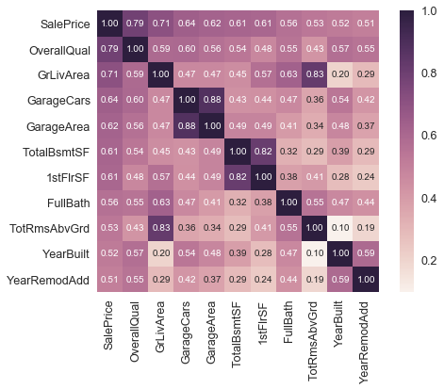

1. 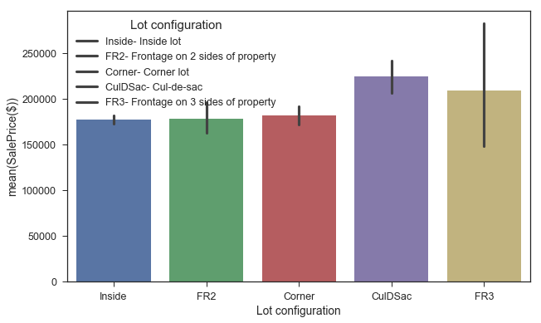**What type of lots tend to have higher prices?**

Cul-de-Sac lots tend to have higher prices followed by houses that have frontage on 3 sides of property. Cul-de-sac houses usually have more lot area, this might be a reason for a spike in a Cul-de-Sac site.

1. **Which neighborhoods are most and least expensive?**

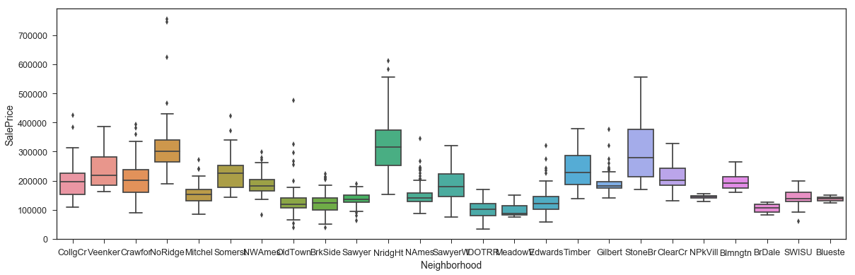

Northridge Heights and Stone Brook have the most expensive houses and Old Town, Brook Side, Sawyer, North Ames, Edwards, Iowa DOT and Rail Road, Meadow Village and Briardale are least priced houses among all the neighborhoods.

1. **Does external look of the house effect Sale Price?**

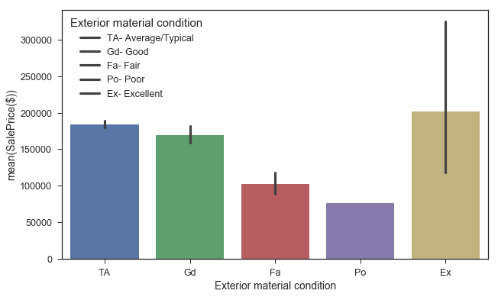

Looks like the exterior of the house is as important as the interior. The better the exterior quality the higher the house price is.

1. **What effect does Basement Condition have on house price?**

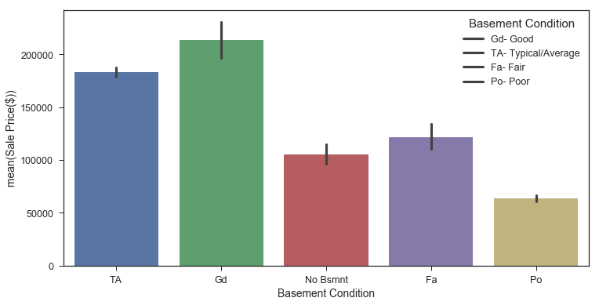

Basement condition has a linear effect on Sale Price, the better the quality of basement the more the price of the house.

1. **What is the relationship between HVAC system and Sale Price?**

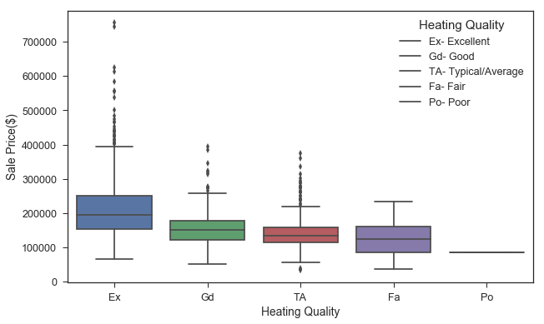

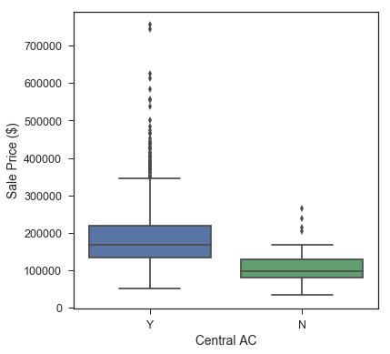

HVAC is one of the major component every house owner should consider before buying the house. HVAC has a positive correlation with Sale Price.

1. **How does Kitchen Quality effect the final Sale price of a house?**

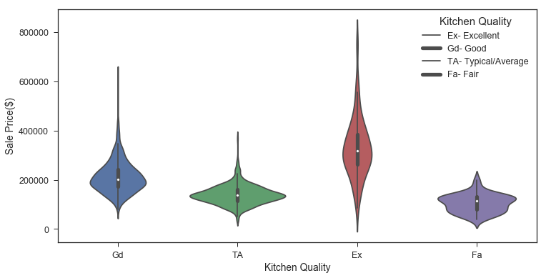

Kitchen is the heart of the house. It is evident from the graph that an improvised kitchen doesn’t come cheap.

**Conclusion**

From the exploratory analysis, we can conclude that the Overall Quality of the house effects the house price. Other important features that every home owner considers are Garage capacity, Square footage of the house, Neighborhood, Exterior condition, HVAC system, Basement and Kitchen quality.

Some more additional information on Neighborhood like schools in the neighborhood, access to shopping, transport and details about traffic around the area would have been more helpful in making the model.