CPU SCHEDULER:

CPU scheduling is the process of deciding which process will be executed by the CPU at any given time. The main goal of CPU scheduling is to make the most efficient use of the CPU and ensure that all processes are executed fairly.
Whenever the CPU becomes idle, the operating system must select one of the processes in the line ready for launch(i.e. from the processes stored in ready queue for execution). The selection process is done by a temporary (CPU) scheduler. The Scheduler selects between memory processes ready to launch and assigns the CPU to one of them.

Importance of CPU Scheduling:

1) Efficient CPU Utilization: The primary goal of CPU scheduling is to maximize the utilization of the CPU by keeping it as busy as possible. CPU scheduling algorithms aim to minimize CPU idle time and ensure that the CPU is utilized to its full potential.
2) Fairness: CPU scheduling algorithms ensure that all processes are executed fairly and no process is starved or neglected. This prevents some processes from monopolizing the CPU while others wait indefinitely.
3)Improved Throughput: By efficiently scheduling processes, CPU scheduling algorithms can maximize the number of processes that complete execution in a given time period, thereby improving overall system throughput.
4) Scheduling ensures quick response to the user inputs, enhancing the user experience by reducing the response time.
5) It enables multiple processes to run concurrently, making multitasking possible.

Conditions when CPU Scheduling is done:

1)When a process switches from the running state to the waiting state: This can occur when a process requests I/O operations or invokes a system call that blocks the process. In this case, the CPU scheduler selects another process from the ready queue to run next.
2)When a process switches from the running state to the ready state: This can happen when a process is interrupted by an interrupt, such as a timer interrupt, or when a process completes I/O operations and becomes ready to run again. In this case, the CPU scheduler has a choice to either continue running the current process or select a different one.
3)When a process switches from the waiting state to the ready state: This can occur when a process completes I/O operations or when a process is released from a wait state. In this case, the CPU scheduler also has a choice to either continue running the current process or select a different one.
4)When a process terminates: When a process completes its execution, the CPU scheduler selects another process from the ready queue to run next.

Scheduling Criteria:

Scheduling criteria is crucial for selecting or designing an appropriate scheduling algorithm that meets the specific needs of a computing environment:

1) Maximize CPU utilization to ensure that the CPU is not idle.
2) Maximize throughput to handle more processes in less time.
3) Minimize turnaround time [i.e. total time a process takes to execute, from the time of submission to the time of completion] to ensure processes are completed quickly.
4) Minimize waiting time(i.e. the amount of time a process spends waiting in the ready queue before being allocated the CPU).
5) Minimize response time (i.e. time that process takes from the submission of a process to the generation of its first response).

Some terms related to CPU Scheduling:

1) Throughput: A measure of the work done by the CPU. It is the the number of processes being executed and completed per unit of time.

2) Turnaround Time: The time elapsed from the time of submission of a process to the time of completion is known as the turnaround time. Turn-around time is the sum of times spent waiting to get into memory, waiting in the ready queue, executing in CPU, and waiting for I/O.
Turn Around Time = Completion Time – Arrival Time.

3) Burst Time: It refers to the amount of time a process requires to execute its CPU-bound workload without interruption. It represents the time a process spends actively using the CPU to perform its tasks.

4) Waiting Time: A scheduling algorithm does not affect the time required to complete the process once it starts execution. It only affects the waiting time of a process i.e. time spent by a process waiting in the ready queue.
Waiting Time = Turnaround Time – Burst Time.

5) Response Time: In an interactive system, turn-around time is not the best criterion. A process may produce some output fairly early and continue computing new results while previous results are being output to the user. Thus another criterion is the time taken from submission of the process of the request until the first response is produced. This measure is called response time.
Response Time = CPU Allocation Time( when the CPU was allocated for the first time) –Arrival Time.

6) Completion Time: The completion time is the time when the process stops executing, which means that the process has completed its burst time and is completely executed.

7) Priority: If the operating system assigns priorities to processes, the scheduling mechanism should favor the higher-priority processes.

8) Preemptive scheduling: It is a method where tasks are assigned based on their priorities. Higher-priority tasks are executed before lower-priority tasks, even if the lower-priority task is already running.

9) Non-Preemptive Scheduling: Non-preemptive scheduling is a method where a process takes control of a resource and retains it until the process is terminated or transitions to a waiting state.

Different Types of Scheduling Algorithms:

1) First Come First Served (FCFS)
2) Shortest Job First (SJF)
3) Longest Job First (LJF)
4) Priority Scheduling
5) Round Robin (RR)
6) Shortest Remaining Time First (SRTF)
7) Longest Remaining Time First (LRTF)

1) First Come First Served (FCFS):
- This is the simplest scheduling algorithm.
- This algorithm that executes processes in the order they arrive in the ready queue
i.e. the process which arrives first in the ready queue will be executed first. A process from ready queue will be picked up for execution when the process before it which has entered in running queue has been executed completely.
- It is implemented by using the FIFO queue.
- It is non Preemptive type algorithm i.e., once a process starts executing, it runs to
completion without being preempted.

Implementation:

void FCFS_scheduling(vector<process> &processes, const int &num_processes)
{
// Sort processes by arrival time
sort(processes.begin(), processes.end(), [](const process &a, const process &b)
{ return a.arrival_time < b.arrival_time; });

//Above line of code sorts the processes vector based on the arrival time in ascending //order.This ensures that the processes which has entered first in waiting queue gets //executated first.

int start[num_processes], end[num_processes], waiting[num_processes], turnaround[num_processes];

//Arrays are initialised to store the start and end times of execution (start and end); waiting time(waiting) and turn_around time(turnaround)for each processes.

cout << "\nFCFS Scheduling:\n\n";
int current_time = 0;
int total_turnaround_time = 0;
int total_waiting_time = 0;

for (const process &task : processes)
{
// Wait if the task hasn't arrived yet
if (current_time < task.arrival_time)
{
current_time = task.arrival_time;
}

/*The current time is tracked with current_time.
For each process:
1)If the current time<processe’s arrival time then current time is updated to process arrival time
2)The process is then executed marking start and end the start and end of tasks respectively.
Execute the process*/
start[task.id - 1] = current_time;
current_time += task.burst_time;
end[task.id - 1] = current_time;
turnaround[task.id - 1] = current_time - task.arrival_time;
waiting[task.id - 1] = turnaround[task.id - 1] - task.burst_time;
total_turnaround_time += turnaround[task.id - 1];
total_waiting_time += waiting[task.id - 1];
}

sort(processes.begin(), processes.end(), [](const process &a, const process &b)
{ return a.id < b.id; });

// Above line of code sorts the processes again on the basis of ID so that they can be shown
// in order of how they reach in the waiting queue;

for (const process &task : processes)
{
cout << "Task " << task.id << " executed during time " << execution_lower[task.id -1];
cout << " to " << execution_higher[task.id - 1] << " unit" << endl;
cout << "Turn Around Time for Task " << task.id << " is " << turnaround[task.id - 1] << " unit" << endl;
cout << "Waiting Time for Task " << task.id << " is " << waiting[task.id - 1]
<< " unit" << endl;
}

A.second = static_cast<double>(total_waiting_time) / num_processes;
A.first = static_cast<double>(total_turnaround_time) / num_processes;

A.second = static_cast<double>(total_waiting_time) / num_processes;
A.first = static_cast<double>(total_turnaround_time) / num_processes;

}

/*Above part of code prints all the necessary information like Turn_around time, execution time, aaverage waiting and turnaround time etc.*/

Limitations:

a) Convoy Effect: This occurs when a long process arrives early and occupies the CPU for a significant duration. Shorter processes arriving later are forced to wait in the queue, leading to increased waiting time and potentially starvation (where a low-priority process waits indefinitely).

b) Low CPU Utilization: FCFS doesn't consider the burst time of processes. A short process might arrive behind a long one, resulting in the CPU being idle for a relatively long period while the short process waits. This can lead to underutilized CPU resources.

c) No Consideration for I/O Bound Processes: FCFS doesn't differentiate between CPU-bound and I/O-bound processes. An I/O-bound process spends a lot of time waiting for I/O operations. If such a process is at the front of the queue, the CPU might remain idle while waiting for the I/O, further reducing overall efficiency.

2) Shortest Job First Scheduling:

- It is a CPU scheduling algorithm that selects the waiting process with the smallest execution time(Burst Time) to execute next.
- This is both Preemptive and Non-Preemptive type of algorithms. In case of preemptive if a new process starts with a shorter remaining time than the current process then the current process is interrupted and it is again sent to ready queue for execution and the new process is executed.

Implementation:

void SJF_scheduling(vector<process> &processes, const int &num_processes)
{
// Considering this algo to be Preemptive
int bursttime[num_processes];
for (int i = 0; i < num_processes; i++)
{
bursttime[processes[i].id - 1] = processes[i].burst_time;
}

// A burstTime array is initialised to store the original bursttimes of each task.
// Sort processes primarily by arrival time, secondarily by burst time

sort(processes.begin(), processes.end(), [](const process &a, const process &b)
{
if (a.arrival_time == b.arrival_time) {
return a.burst_time < b.burst_time;
}
return a.arrival_time < b.arrival_time; });

// Above lines of code sorts the processes primarily by their arrival time and //secondarily by their burst time (if arrival times are the same). This ensures that //when multiple tasks arrive at the same time, the task with the shorter burst time
//is considered first.

vector<vector<int>> execution(num_processes);
cout << "\nSJF Scheduling:\n"<< endl;
int current_time = 0;
int total_turnaround_time = 0;
int total_waiting_time = 0;
int processes_completed = 0;

/*execution: A 2D vector to store the execution timeline of each task.
current_time: Keeps track of current time in the schedule.
total_turnaround_time and total_waiting_time: Accumulators for calculating the average times.
processes_completed:Counter to track the number of completed tasks.*/

while (processes_completed < num_processes)
{
int shortest_job_index = -1;
for (int i = 0; i < num_processes; ++i)
{
if (processes[i].arrival_time <= current_time && processes[i].burst_time > 0)
{
if (shortest_job_index == -1 || processes[i].burst_time<
processes[shortest_job_index].burst_time)
{
shortest_job_index = i;
}
}
}

if (shortest_job_index == -1)
{
// No task is ready to execute, move to the next available task's arrival time
current_time++;
continue;
}

process &task = processes[shortest_job_index];
task.burst_time--;
execution[task.id - 1].push_back(current_time);

if (task.burst_time == 0)
{
processes_completed++;
}

current_time++;
}

/*The main loop runs untill all tasks are completed.
It finds the shortest job that is ready to execute by iterating through tasks and selecting the one with the shortest burst time that has arrived (arrival_time<=current_time).
If no task is ready, it increments the current_time.
If a task is selected, it decrements its burst time,logs its execution time, and if a task is completed i.e. remaining burst time is 0 then processes_completed is incremented.*/

// Sort processes by their ID for reading the output.

sort(processes.begin(), processes.end(), [](const process &a, const process &b)
{ return a.id < b.id; });

// Print the execution times for each task

for (const process &task : processes)
{
cout << "Task " << task.id << " executed during time ";
if (execution[task.id - 1].empty())
{
cout << "no time";
}
else
{
int start = execution[task.id - 1][0], end = execution[task.id - 1][0];
for (size_t i = 1; i < execution[task.id - 1].size(); ++i)
{
if (execution[task.id - 1][i] == execution[task.id - 1][i - 1] + 1)
{
end = execution[task.id - 1][i];
}
else
{
if (start == end)
{
cout << start << " to " << start + 1;
}
else
{
cout << start << " to " << end + 1;
}
cout << ", ";
start = end = execution[task.id - 1][i];
}
}
int completion_time = 0;
if (start == end)
{
cout << start << " to " << start + 1 << " unit";
completion_time = start + 1;
}
else
{
cout << start << " to " << end + 1 << " unit";
completion_time = end + 1;
}
int turnaroundtime = completion_time - task.arrival_time;
int waitingtime = turnaroundtime - bursttime[task.id - 1];
cout << "\nTurn Around Time for Task " << task.id << " is " << turnaroundtime << " unit" << endl;
cout << "Waiting Time for Task " << task.id << " is " << waitingtime << " unit"
<< endl;
total_waiting_time += waitingtime;
total_turnaround_time += turnaroundtime;
}
cout << endl;
}

A.second = static_cast<double>(total_waiting_time) / num_processes;
A.first = static_cast<double>(total_turnaround_time) / num_processes;

A.second = static_cast<double>(total_waiting_time) / num_processes;
A.first = static_cast<double>(total_turnaround_time) / num_processes;
}

/*Above lines of code calculates the necessary terms to be outputed like waiting time, turnaround time etc. */

Advantages:
- Minimizes Average Waiting Time: SJF scheduling aims to execute the shortest jobs first, which tends to reduce the average waiting time for processes in the ready queue. This can lead to better system performance and higher throughput.
- Optimal for Certain Workloads: SJF is optimal in scenarios where the burst times of processes are known in advance and do not change dynamically during execution. In such cases, it can achieve the minimum average waiting time among all scheduling algorithms.
- Fairness: SJF scheduling ensures fairness by giving preference to shorter jobs. Shorter jobs get executed sooner, which can lead to better response times for interactive applications or users.
Disadvantages:

- Predicting Burst Times: SJF requires accurate predictions or estimates of process burst times, which may not always be available. In real-world scenarios, burst times may vary due to factors such as I/O operations, making it challenging to implement SJF effectively.
- Starvation: Longer jobs may suffer from starvation if a continuous stream of shorter jobs keeps arriving. These longer jobs may never get a chance to execute if shorter jobs consistently arrive, leading to unfairness and decreased system performance.
- High Variability in Response Time: SJF can result in high variability in response times, especially if there is a mix of short and long jobs. While short jobs may experience low response times, long jobs may face significant delays, leading to inconsistent user experience.
3) Priority Scheduling:

Priority Scheduling is a CPU scheduling algorithm where each process is assigned a priority. The CPU is allocated to the process with the highest priority (smallest numerical value in priority scheduling) among all the processes in the ready queue at any given time. If two processes have the same priority, they are scheduled according to their arrival order.
This is both Preemptive as well as Non-Preemptive type algorithm.
For implementation purpose I have considered it as Preemptive.

Implementation:

void P_scheduling(vector<process> &processes, const int &num_processes)
{
// Considering this algo to be Preemptive
int bursttime[num_processes];
for (int i = 0; i < num_processes; i++)
{
bursttime[processes[i].id - 1] = processes[i].burst_time;
}
// Sort processes primarily by arrival time, secondarily by burst time
sort(processes.begin(), processes.end(), [](const process &a, const process &b)
{
if (a.arrival_time == b.arrival_time) {
return a.priority > b.priority;
}
return a.arrival_time < b.arrival_time; });

/*After initializing bursttime, the function sorts the tasks vector primarily on the basis of arrival time and secondarily by priority.*/

vector<vector<int>> execution(num_processes);
cout << "\nPriority Scheduling:\n"
<< endl;
int current_time = 0;
int total_turnaround_time = 0;
int total_waiting_time = 0;
int processes_completed = 0;

while (processes_completed < num_processes)
{
int index = -1;
for (int i = 0; i < num_processes; ++i)
{
if (processes[i].arrival_time <= current_time && processes[i].burst_time > 0)
{
if (index == -1 || processes[i].priority > processes[index].priority)
{
index = i;
}
}
}

/* The above loop iterates untill all tasks are completed. Inside the loop it continuously selects the task with the highest priority among those that have arrived and are ready to execute.*/

if (index == -1)
{
// No task is ready to execute, move to the next available task's arrival time
current_time++;
continue;
}

process &task = processes[index];
task.burst_time--;
execution[task.id - 1].push_back(current_time);

if (task.burst_time == 0)
{
processes_completed++;
}

current_time++;
}

// Sort processes back by their IDs for output consistency
sort(processes.begin(), processes.end(), [](const process &a, const process &b)
{ return a.id < b.id; });

// Print the execution times for each task
for (const process &task : processes)
{
cout << "Task " << task.id << " executed during time ";
if (execution[task.id - 1].empty())
{
cout << "no time";
}
else
{
int start = execution[task.id - 1][0], end = execution[task.id - 1][0];
for (size_t i = 1; i < execution[task.id - 1].size(); ++i)
{
if (execution[task.id - 1][i] == execution[task.id - 1][i - 1] + 1)
{
end = execution[task.id - 1][i];
}
else
{
if (start == end)
{
cout << start << " to " << start + 1;
}
else
{
cout << start << " to " << end + 1;
}
cout << ", ";
start = end = execution[task.id - 1][i];
}
}
int completion_time = 0;
if (start == end)
{
cout << start << " to " << start + 1 << " unit";
completion_time = start + 1;
}
else
{
cout << start << " to " << end + 1 << " unit";
completion_time = end + 1;
}
int turnaroundtime = completion_time - task.arrival_time;
int waitingtime = turnaroundtime - bursttime[task.id - 1];
cout << "\nTurn Around Time for Task " << task.id << " is " << turnaroundtime << " unit" << endl;
cout << "Waiting Time for Task " << task.id << " is " << waitingtime << " unit"
<< endl;
total_waiting_time += waitingtime;
total_turnaround_time += turnaroundtime;
}
cout << endl;
}

A.second = static_cast<double>(total_waiting_time) / num_processes;
A.first = static_cast<double>(total_turnaround_time) / num_processes;

A.second = static_cast<double>(total_waiting_time) / num_processes;
A.first = static_cast<double>(total_turnaround_time) / num_processes;
}

Advantages:

- Resource Allocation: Priority Scheduling enables efficient resource allocation by allocating CPU time to the most important or time-sensitive tasks first, potentially improving overall system throughput and performance.
- It can assign priorities based on importance, urgency or other criteria.
- It is efficient for critical tasks, it ensures that high-priority tasks are executed first.

Disadvantages:

- Starvation: Lower-priority processes may suffer from starvation if higher-priority processes continuously monopolize system resources. This can lead to unfairness and decreased performance for less critical tasks.
- Priority Inversion: Priority inversion occurs when a low-priority task holds a resource needed by a higher-priority task, causing the higher-priority task to wait longer than expected. This can lead to unexpected delays and degraded system performance.
- Priority Aging: Without proper mechanisms in place, low-priority processes may wait indefinitely if high-priority processes continuously arrive, leading to aging and potential performance issues.

4) Round Robin Scheduling:

It is a CPU scheduling algorithm that allocates CPU time to each process in equal portions and in a circular order, handling all processes without prioritization. It's a pre-emptive scheduling algorithm, meaning that the CPU scheduler interrupts the currently executing process after a fixed time interval (known as the time quantum or time slice) and then schedules the next process in the ready queue for execution.
The time quantum represents the maximum amount of CPU time a process can have before being preempted.
It allocates process to the CPU for execution based on the arrival time of the process.

Implementation:

void RR_scheduling(vector<process> &processes, const int &num_processes, const int &time_quantum)
{
queue<process *> task_queue;
int current_time = 0;
int total_turnaround_time = 0;
int total_waiting_time = 0;
int processes_completed = 0;
cout << "\nRound Robin Scheduling:\n"
<< endl;

vector<pair<int, int>> execution[num_processes];

// Sort processes by arrival time
sort(processes.begin(), processes.end(), [](const process &a, const process &b)
{ return a.arrival_time < b.arrival_time; });

// Add initial processes to the queue
auto task_it = processes.begin();
while (task_it != processes.end() && task_it->arrival_time <= current_time)
{
task_queue.push(&(*task_it));
task_it++;
}

while (processes_completed < num_processes)
{
if (!task_queue.empty())
{
process *task = task_queue.front();
task_queue.pop();

int exec_time = min(time_quantum, task->remaining_time);

execution[task->id - 1].emplace_back(current_time, current_time + exec_time);
task->remaining_time -= exec_time;
current_time += exec_time;

// Add new processes to the queue that have arrived
while (task_it != processes.end() && task_it->arrival_time <= current_time)
{
task_queue.push(&(*task_it));
task_it++;
}

if (task->remaining_time > 0)
{
task_queue.push(task);
}
else
{
int turnaround_time = current_time - task->arrival_time;
int waiting_time = turnaround_time - task->burst_time;

total_turnaround_time += turnaround_time;
total_waiting_time += waiting_time;
processes_completed++;
}
}
else
{
current_time++;
}
}
sort(processes.begin(), processes.end(), [](const process &a, const process &b)
{ return a.id < b.id; });

for (const process &task : processes)
{
cout << "Task " << task.id << " executed during time ";
for (const auto &period : execution[task.id - 1])
{
cout << period.first << " to " << period.second << (period == execution[task.id - 1].back() ? " unit" : ", ");
}
cout << endl;
int turnaround_time = execution[task.id - 1].back().second - task.arrival_time;
int waiting_time = turnaround_time - task.burst_time;
cout << "Turn Around Time for Task " << task.id << " is " << turnaround_time << " unit" << endl;
cout << "Waiting Time for Task " << task.id << " is " << waiting_time << " unit\n"
<< endl;
}

A.second = static_cast<double>(total_waiting_time) / num_processes;
A.first = static_cast<double>(total_turnaround_time) / num_processes;

A.second = static_cast<double>(total_waiting_time) / num_processes;
A.first = static_cast<double>(total_turnaround_time) / num_processes;
}

Advantages:

Fairness: Round Robin scheduling provides fairness by allocating CPU time equally among all processes in the ready queue. Each process gets an equal share of CPU time during each time quantum, preventing any single process from monopolizing the CPU for an extended period.
Responsive: Round Robin scheduling ensures responsive system behavior by allowing all processes to have regular access to the CPU. This can lead to better user experience in interactive systems and applications, as users do not have to wait excessively for CPU time.
Efficient for Time-Sharing Systems: This algorithm is suitable for time-sharing systems where multiple users require quick responses.
Disadvantages:

Overhead: Round Robin scheduling can incur overhead due to frequent context switches, especially if the time quantum is too small. Context switching overhead can reduce CPU efficiency and increase system overhead, particularly in environments with a large number of processes.
Inefficient for Long-Burst Processes: Round Robin scheduling may be inefficient for processes with long CPU bursts, as they may be interrupted frequently by the scheduler. This can lead to decreased CPU utilization and increased overhead, as processes spend more time in context switching than executing useful work.
Performance Sensitivity to Time Quantum: The performance of Round Robin scheduling is sensitive to the choice of the time quantum. If the time quantum is too short, the system may experience high context switching overhead and reduced CPU efficiency. If the time quantum is too long, the system may become less responsive, especially for interactive tasks.
Not Suitable for Real-Time Systems: While Round Robin scheduling provides fairness and predictability, it may not be suitable for real-time systems or environments with strict timing requirements. Processes may experience variable response times, depending on their position in the ready queue and the length of the time quantum.
Test Run of Main Code:

For FCFS Scheduling:
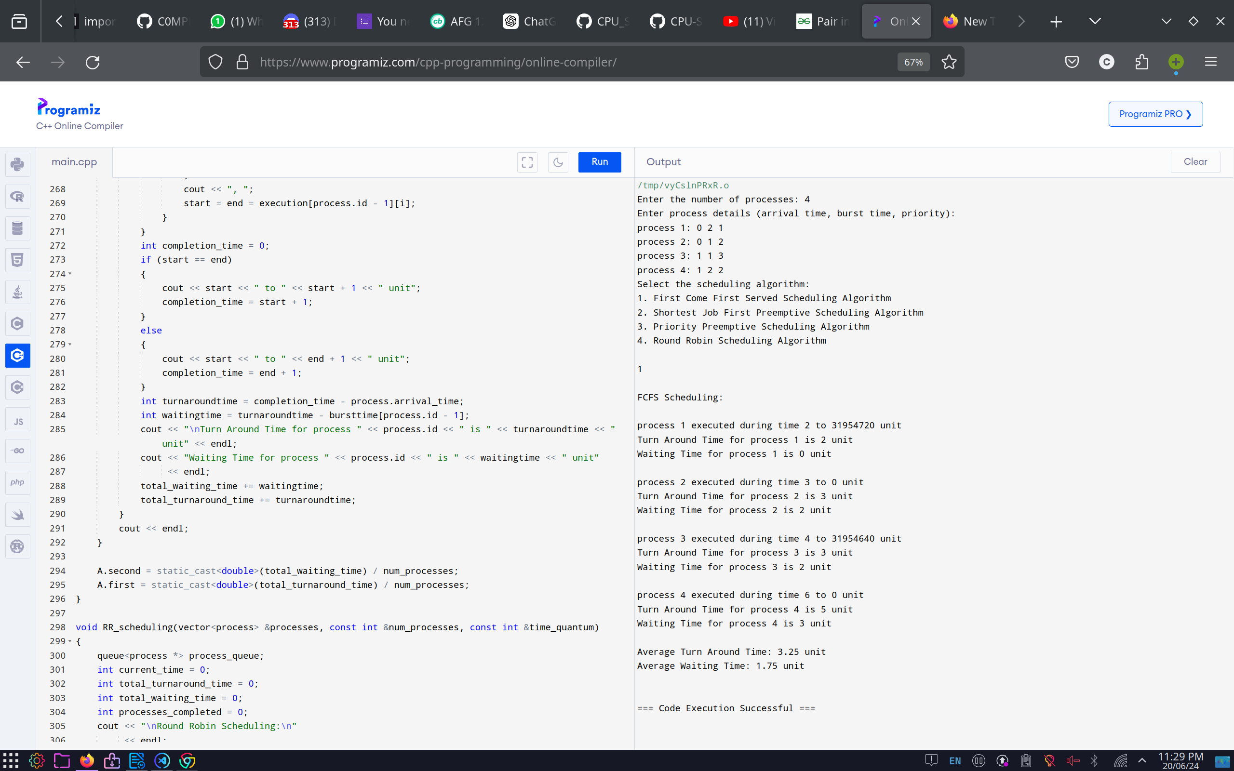

For Preemptive SJF scheduling:
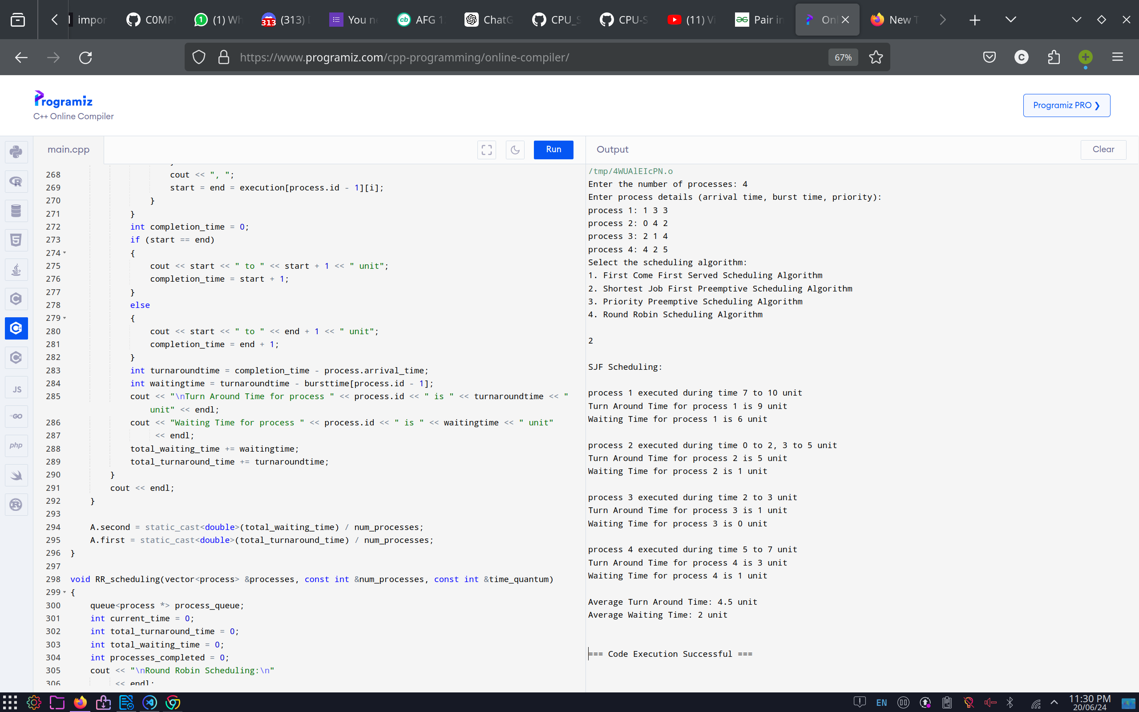

For Preemptive Priority Scheduling:

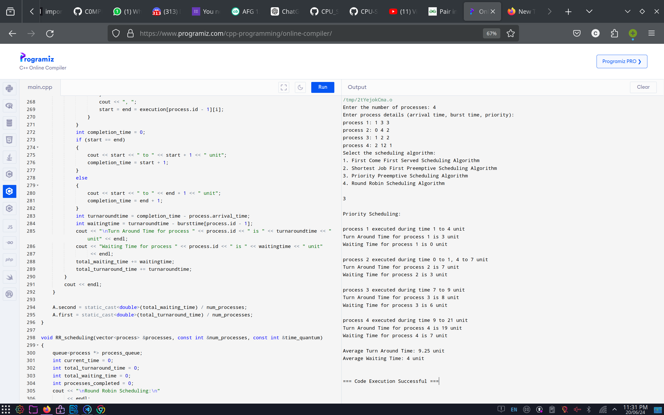
For Round Robin Scheduling:

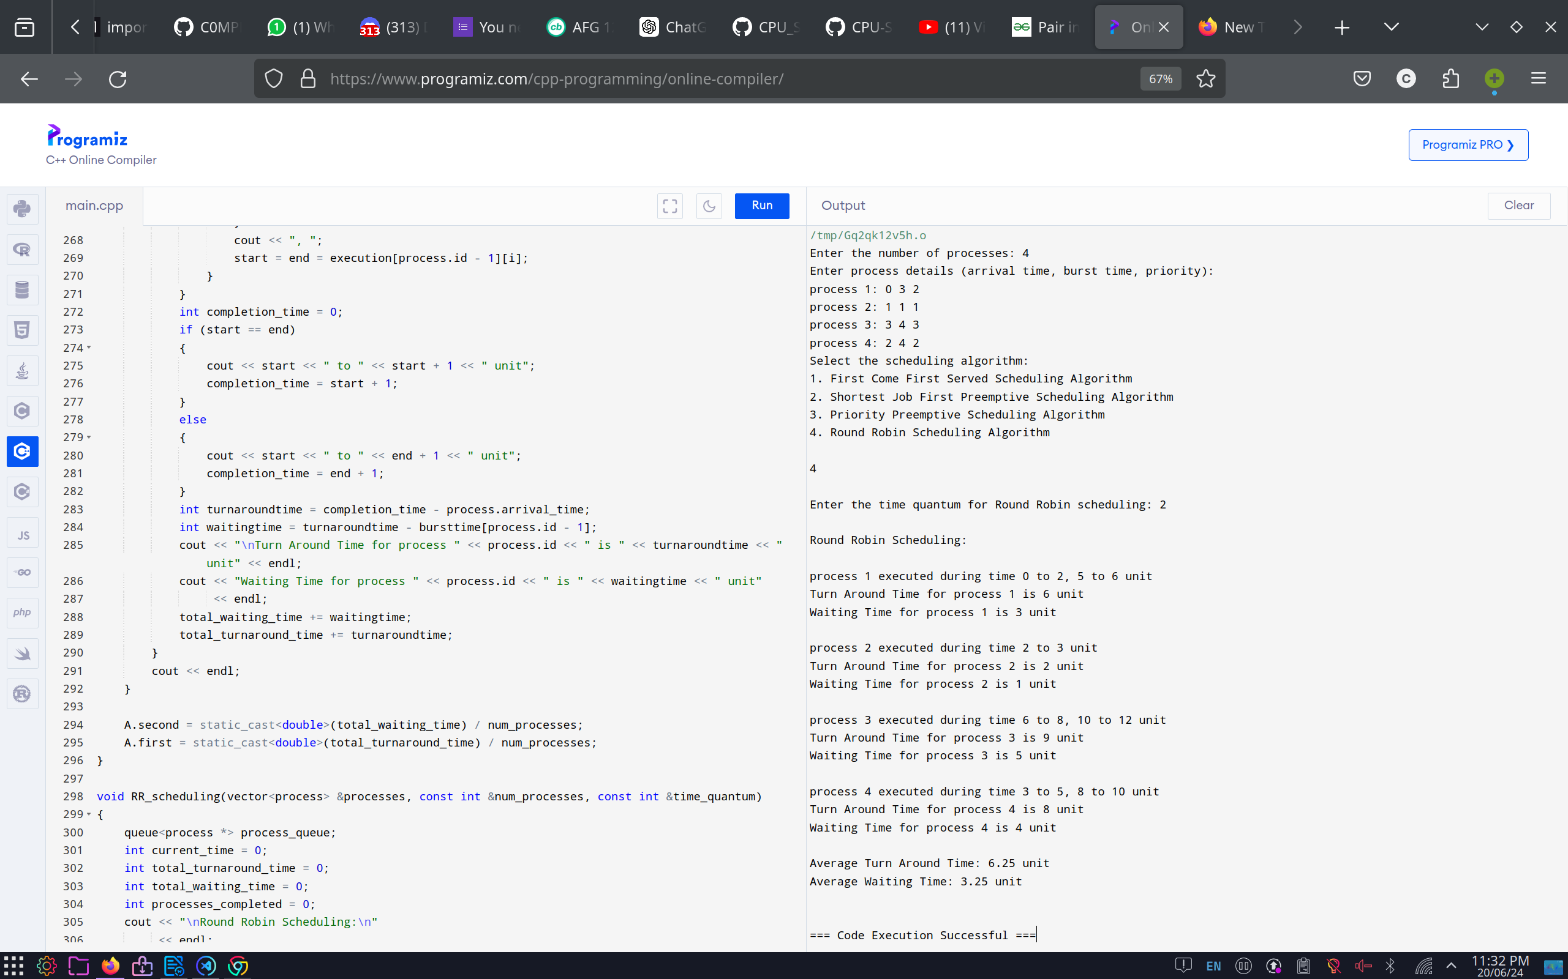

Conclusion:

In this project, I explored various CPU scheduling algorithms including First come first served (FCFS) ,Shortest Job First (SJF), Priority Scheduling and Round robin(RR) etc. Each algorithm offers unique advantages and challenges, making them suitable for different system requirements and workloads.

FCFS is straightforward but can lead to inefficiencies for shorter tasks. SJF optimises waiting time but can starve longer processes. Priority Scheduling allows flexibility in process handling but requires careful management to preventstarvation. Round Robin ensures fairness and responsiveness, ideal for interactive systems , but requires an appropriately chosen time quantum.

Understanding these algorithms and their trade-offs is crucial for designing effective CPU schedulers that balance performance, fairness, and complexity. This project provides a comprehensive overview of CPU scheduling, enabling more informed decisions in process management and system optimization.

