PA 3
David Greni and Haskell Cappers
Introduction
The two algorithms that we will analyze in this report are bubble sort and quick sort. David implemented quick sort and Haskell implemented bubble sort. Our hypothesis was that quick sort would be faster for both randomized and reverse order arrays, but slower for sorted arrays.
Complexity Analysis
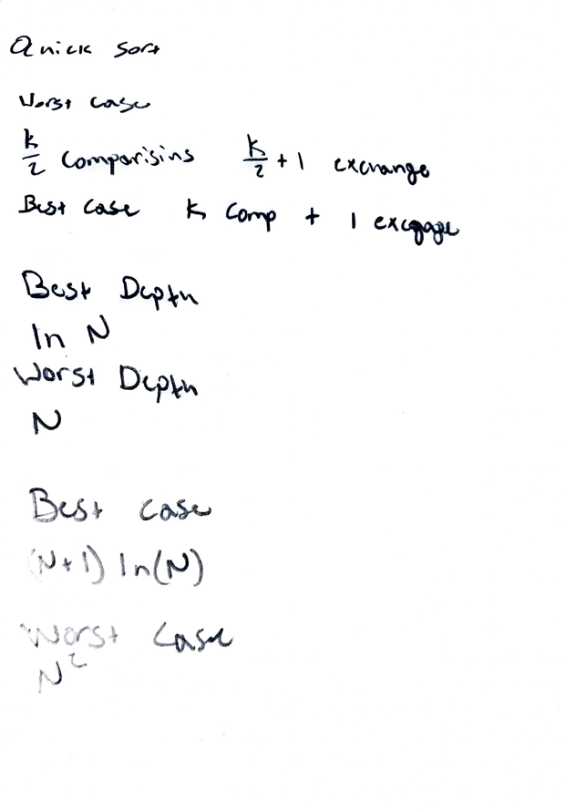

Experimental Plan
We decided that our experiment would be to test both algorithms in three different ways. First being that we would test the algorithms with random data, second with already sorted data, and third with reverse sorted data. These tests were done three times with each algorithm. One with the array size being 2000, second with 4000, and third with 8000. We implemented these test by creating a test client that had methods to test the algorithms. First it would test the algorithms with known arrays to ensure the sorting algorithms were implemented correctly. Then they would call the experiment method that would send the large arrays through the algorithms.
Experimental Results
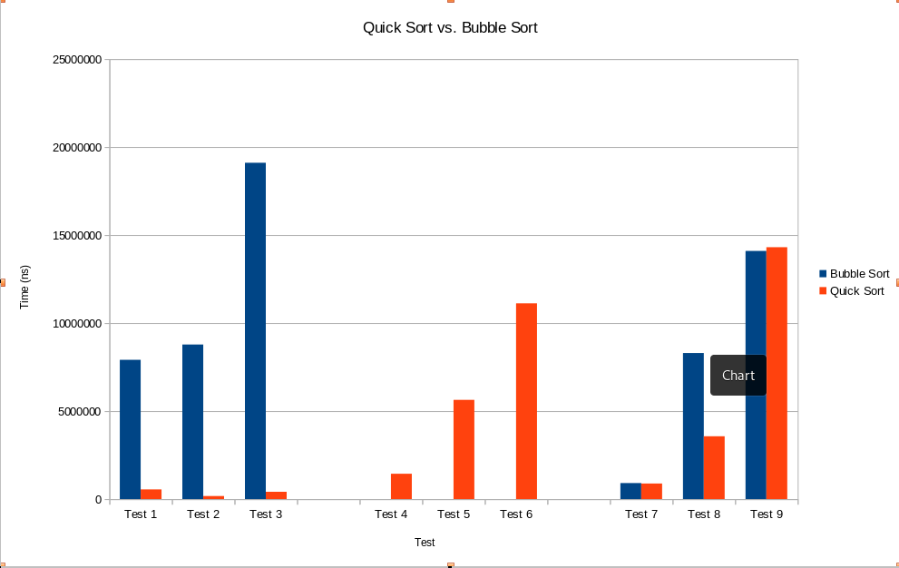
Figure 1: This graph depicts the time difference between quick sort and bubble sort.

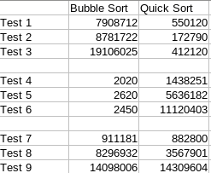

Table 1: This table represents the data that was collected from the
program when running the data through the algorithms.
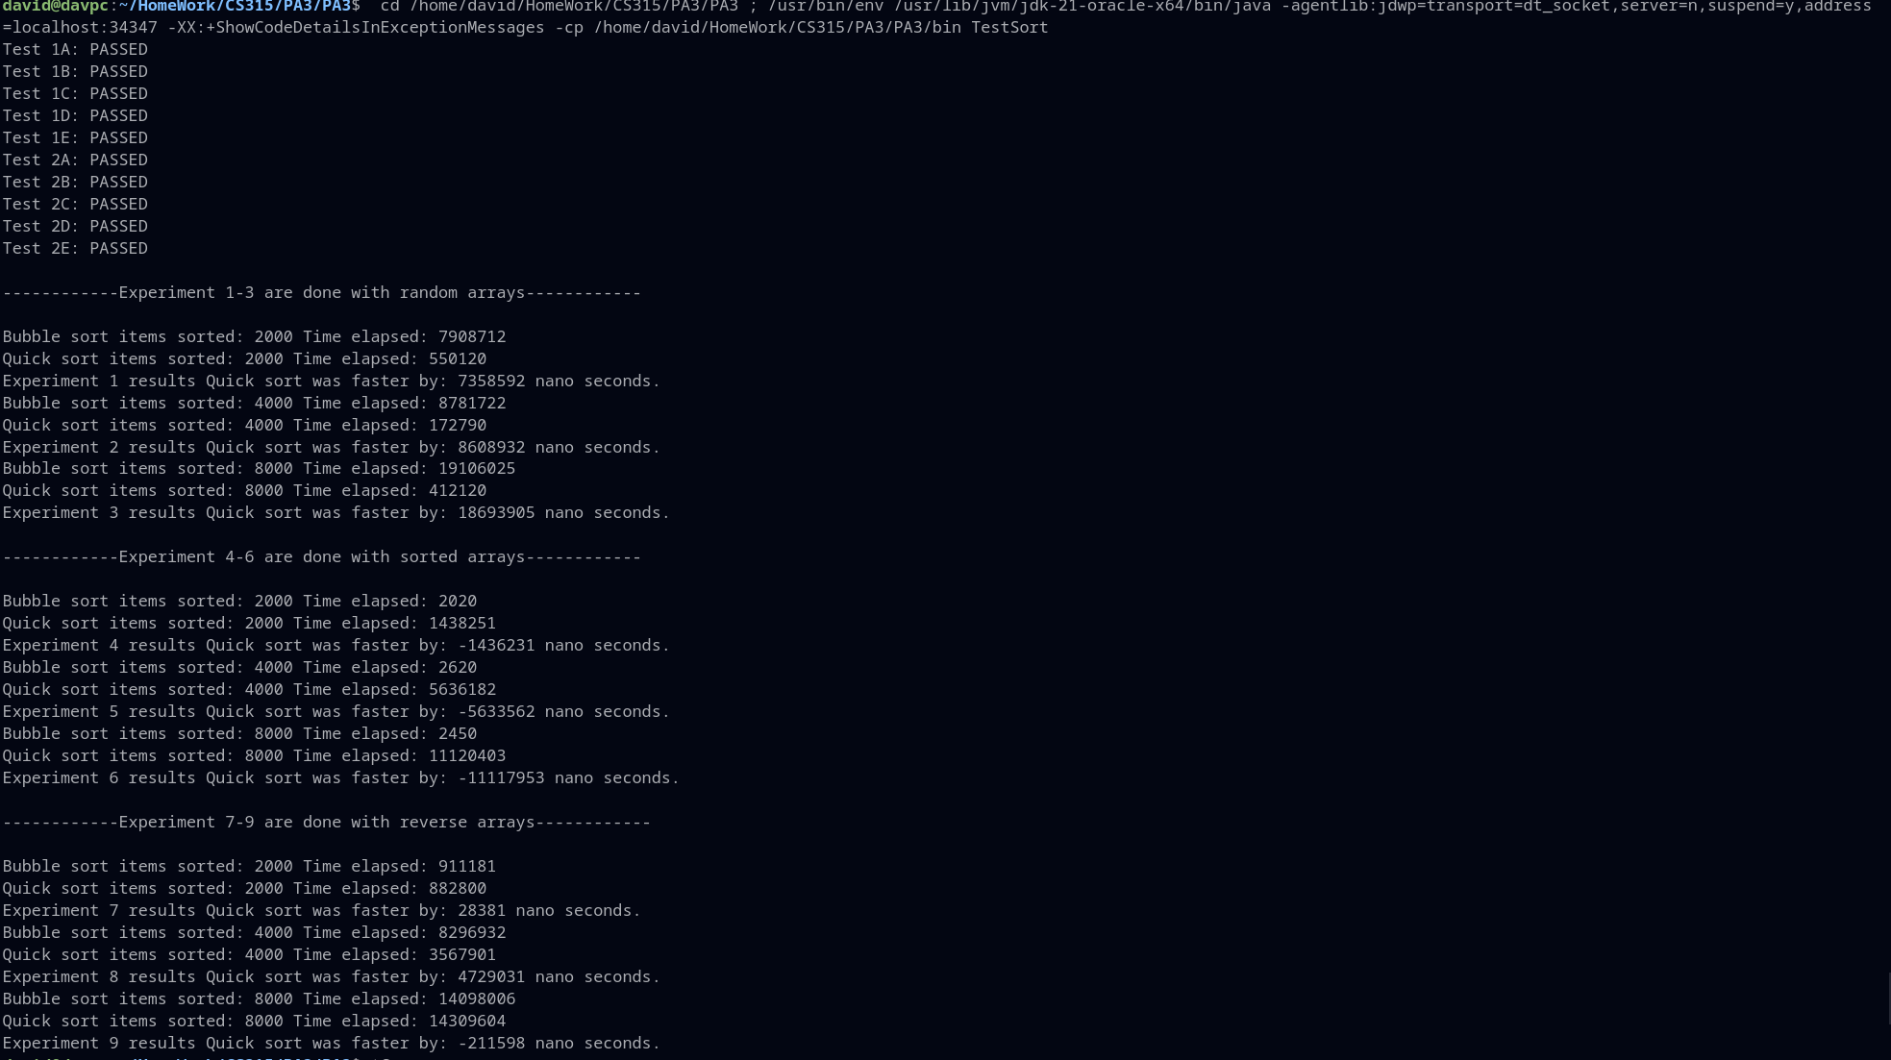
Image 1: This image is the raw output from the program.
Results Analysis
The results followed the hypothesis closely. In experiments 1-3 quick sort was much faster than bubble sort. This was because the data was randomized and there quick sort is much better at handling that data. Experiments 4-6 bubble sort was incredibly fast. This was because the data was already sorted and there was no need for the bubble sort to make any changes. Experiments 7-9 the algorithms were close to taking the same amount of time. There were a few unexpected deviations from the hypothesis. First quick sort would unexpectedly get faster when it was handling an array of size 4000 over size 2000. This was unexpected because the array is double the size of the first one. This can be seen in experiments 2 and 8. Second the initial hypothesis was that quick sort would be much faster than bubble sort on reverse order arrays. This was proven false by the data.
Lessons Learned
Implementing the algorithms was very easy but ensuring that they were correct and implementing the test clients was difficult. Initially there were a few issues with the test client but that was quickly handled. Overall it was very interesting to learn how these algorithms handle these data sets and how efficient quick sort was at handling the large randomized data. It was also very interesting to see how quick sort worked when the worst case scenario was forced into quick sort with tests 4-6.
Overview of Source Code
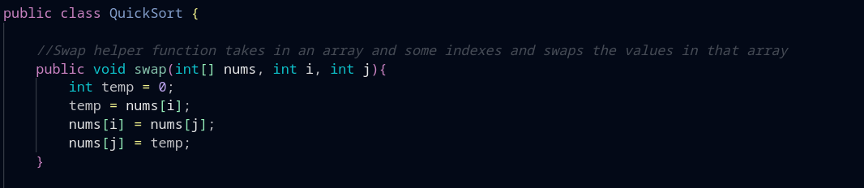
This is the beginning of the quick sort algorithm. I implemented a helper function to assist the algorithm. This helper function takes in an array of integers, and two indexes. Then the function swaps the two values given in those indexes.
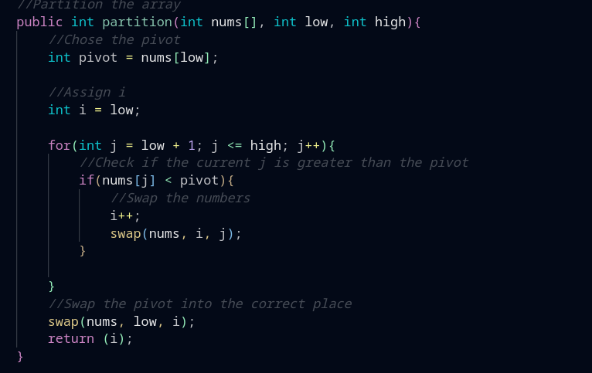
This is the partitioning function. It takes in a array of ints a high and a low. The pivot is decided based on the first value in that sub array. Then the I and J values are created to evaluate all values within that sub array and swap them when necessary. It then swaps the pivot value into the correct position after sorting the sub array.

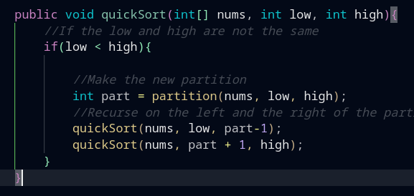
This is the quick sort algorithm. It takes in an array of ints a high and a low. It first partitions the array into two sub arrays then recursively calls on itself with the right and left sub array.
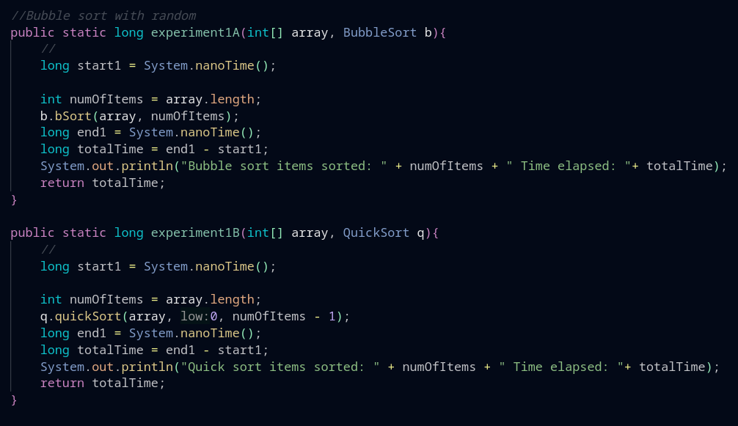
These are the experiment functions. They are responsible for running the tests. They first start by getting the time at the beginning of the function. Then they call the sort algorithm. After the sort algorithm has finished they record the time. Then they output a println statement that tells the user how many items were sorted and how long it took for each. It then returns the time for later use.
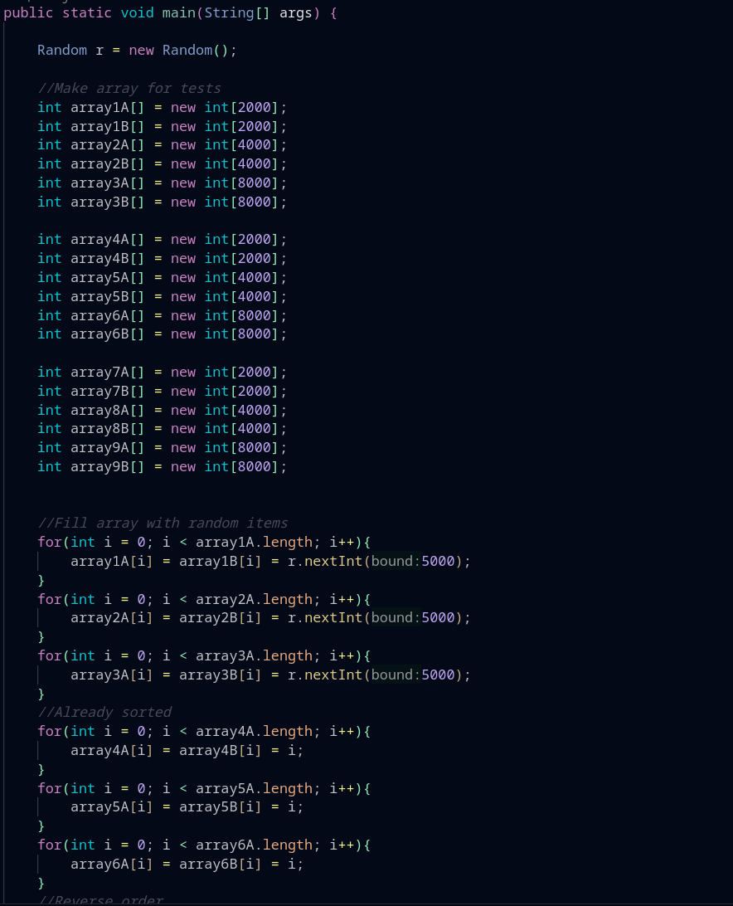
This is the code that is responsible for running the tests. It first initializes all of the arrays to the correct length. Then it fills them with data through the for loops. The first three for loops fills them with randomized data. The next three fill them with sorted data. The last three fill them with reverse sorted data.
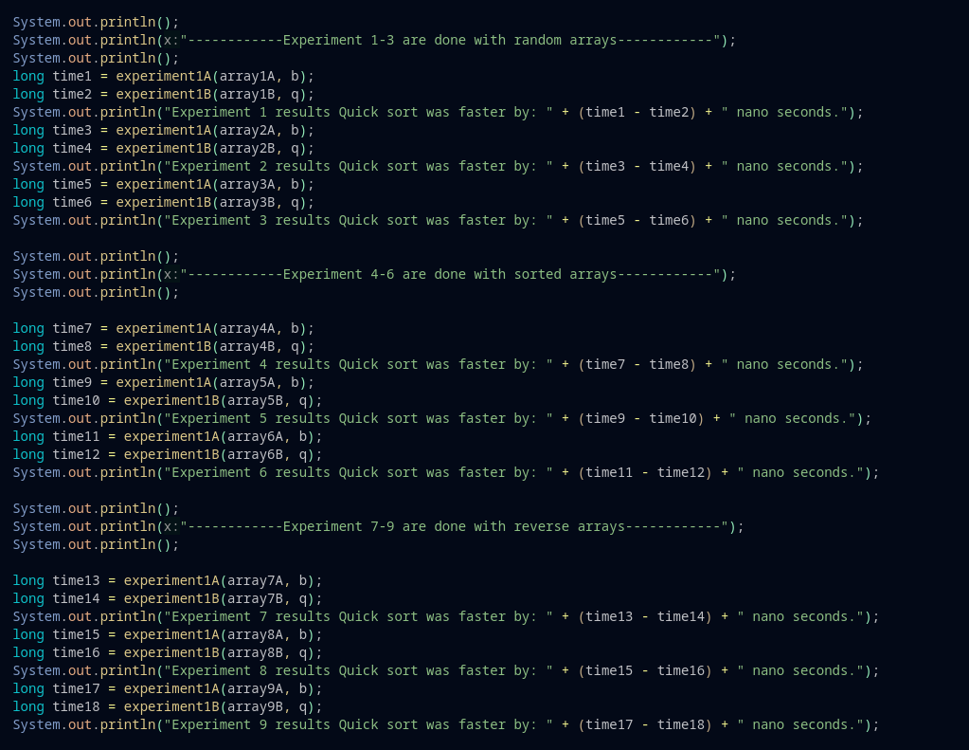
This is the running of the experiments. First there are a few println statements for readability then the experiments are ran and the time is saved for later use. Then the time difference is outputted to the user.
Conclusion
In conclusion this was a fun assignment and brought a lot of understanding to how these algorithms work. This also made me understand how to implement these algorithms. The hypothesis was mostly correct and I now understand why the hypothesis was incorrect.
References

[1] “Quicksort - data structure and algorithm tutorials,” GeeksforGeeks, https://www.geeksforgeeks.org/quick-sort/ (accessed Oct. 30, 2023).
[2] Tono NamTono Nam, “Order of growth of specific recursive function,” Stack Overflow, https://stackoverflow.com/questions/9509038/order-of-growth-of-specific-recursive-function (accessed Oct. 30, 2023).

