Notes on AWS Certified Developer Associate
Skip IAM
SKIP EC2
Skip parts of chapter 5 – serverless websites and Aws skill

Exam Blueprint
- Deployment – 22%
- Security = 26%
- Development with AWS Services – 30%
- REFACTORING – 10%
- monitoring and troubleshooting – 12%

multiple choice
multiple response
Need 720/1000 to pass the exam
130 minutes in length
65 questions in total
qualfication is valid for 2 years

If you have an amazon echo, you can use a skill. Alexa, open cloudguru

More on RDS

Backups – backups have a retention database, store a daily snapshot, recovery can be down to a second
- Backup storage space = size of DB (ex. 10Gb of backup storage to 10gb of rds instance size)
Snapshots
- done manually and will be stored even after RDS instance is deleted
- a db restored from a snapshot will have a new endpoint

Encryption for RDS DB’s are supported at rest and in transit (KMS) .
- To encrypt a current instance, make a snapshot, restore the snapshot and create an encrypted RDS from it.
Read replicas
- DR Strategy only
- synchronized data among central DB and slave nodes
- by default, AWS will change hostname to the read replica during an outage or destruction of the central DB.
- 5 maximum read replicas
- You can have read-replicas- for read-replicas. Useful for spreading traffic among availability zones
- ASYNCHRONOUS REPLICATION
- used for scaling and not DR

More on Elasticache
- provides Memcache or redis ot provide in-memory cache for DBs and web applications
- memcached – memory object caching system, no persistencen, manages memcaches nodes as a pool, SIMPLE CACHE TOOL, useful for large cache notes with multithreaded performance
- redis – in-memory key-value store, supports master-slave replication and multi-az, manages redis more like a relational DB, supports more advanced data types, sorting and ranking datasets such as Leaderboards, persistence important, run in multiple AZ’s

Amazon Neptune – fast,reliable graph database, useful for network security, knowledge graphs,
THESE ARE USED TO STORE AND NAVIGATE RELATIONSHIPS

More on S3

- Max storage is 5Tbs
- Buckets need to enable CORS to access files in another bucket
- Transfer acceleration – S3 Transfer acceleration – improve transfer speed for S3 upload
- amazon durability – 11 9s
- amazon availability – 2 9s
- S3 intelligent tiering – useful for unknown and unpredictable access patterns
  - frequent access – automatically moves your data to most effective tier based on how frequently you access each object, more costly
  - infrequent access - lower cost,
- Costs
  - storage per GB
  - requests
  - use of cloudfront
  - data management pricing
    - cost to transfer data out of buckets, NO COST TO TRANSFER DATA IN
    - transfer acceleration
  - storage management pricing
    - inventory
    - analytics
    - object tags

S3 Security
- all buckets are private by default
- enable cors to allow 1 resource to allow another resource

S3 Policies
- SSE-S3 - server side encryption that will use AWS managed keys
- SSE-KMS – server side encryption that will use aws kms-managed keys
- SSE-C – server side encryption that will use customer provided keys
- Client side encryption – you encrypt the files before you upload them
- Enforcing encryption on S3 buckets – when PUT requests are received. Create a bucket policy which denies any s3 put requests which doesnt include the following parameter.
  - use the x-amz-server-side-encryption-parameter to encrypt at upload time
    - options:
  - x-amz-server-side-encryption: AES256 - s3 managed keys
  - x-amz-server-side-encryption:ams:kms – aws kms managed keys

Use signed URLS and signed cookies to have premium users to view the paidfor content
Use origin access identity to limit s3 content to just the cloudfront link.

S3 performance optimizations
Use cloudfront to minimize latency from various sources, also to cache these requests
MIXED_Requests – use random-prefix to key names to force s3 to distribute your keys across multiple partitions which distributes the I/O workload
ex.
mybucket/jasd/photo1.jpg
mybucket/jasd/photo2.jpg
mybucket/jasd/photo3.jpg

USE THIS INSTEAD
mybucket/u213u-jasd/photo1.jpg
mybucket/duasii-jasd/photo1.jpg
mybucket/2u92-jasd/photo1.jpg

S3 now can handle 3500 PUT requests per second
5500 GETrequests per second
Max file for s3 on PUT requests is 5gb

More on Serverless Computing

More on API Gateway
Types of API
- RESTFul API – uses JSON for transferring database
- SOAP API – Simple object access protocol – uses XML( similar to HTML)

What Amazon API Gateway is?
Managed service to run APIs
- it can expose https endpoints to your Lambda function
- serverless connect to services like lambda and dynamo db
- send each API endpoint to a different target
- run efficiently with no cost
- track and control usage by api key
- throttle requests to prevent attacks
- use cloudwatch to monitoring
- can use multiple versions of apI

Setting up an API gateway
- Define an API
- Define resources and nested resources
- For each resources
  - select supported http methods
  - set security
  - choose target
  - set request and response transformations
- deploy api to stage
  - use API gateway domain
  - use AWS certificate manager for free ssl/tls certs

API Caching – caches responses from your endpoint to a specified TTL
Same origin policy – web browser permits scripts contained in first web page to access data ina second web page if both have the same origins.
THIS IS DONE TO PREVENT CROSS-SITE-XCRIPTING
CORS IS USED TO RELAX this policy.

Lambda Triggers
- SQS
- SNS
- S3
- Kinesis
- Dynamo DB
- Cognito Sync Triggers
- Code Commit
- Cloudwatch logs
- cloudwatch events
- application load balancer
- api gateway
- AWS IoT

Using Version Control with Lambda
Lambda functions can have different versions
AWS lamda maints your latest function code with the $LATEST versions
2 types of ARNS
- qualfied ARN – function arn with the version suffic
  - arn:aws:lamnbda:aws-region:acct-id:function:helloworld:$latest
- unqualified ARN – no version suffix
  - arn:aws:lamnbda:aws-region:acct-id:function:helloworld
With versioning, we can create an alias!!

We use prod Alias to invoke version 1 of the Lambda Function
For any new improvements, push version 2 then point prod alias to version 2
Use version and aliases to split traffic among many versions

More on Step Functions
Allws you visualize and test your serverless applications.
Graphical console to arrange and visualize the components of your applications as a series of steps
One lambda function can trigger 1+ lambda functions.

More on Amazon X-RAY
You can see where errors, bottlenecks are in your serverless code
- X-RAY SDK- SDK that runs your code, installed on ec2, interce[ts add ot your code to trace http requests
- X-RAY Daemon – runs on ec2 pcs, listening on udp, takes json and send it to XRAY API
- XRAY API
- XRAY Console – takes data from API and visualizes it
- CAN BE USED WITH: lambda, ec2, api gateway, elastic beanwalk
- Esupported languages: go java ruby node.js,
- Traces are just events that have happened

You can import API gateway to an API from a definition file. It supports swagger v2.0 definition files.
- API limits to 10000 requests per second.
- Max request is 5000 concurrently!
- SOAP Webservice – YOU CAN USE AMAZON API GATEWAY

Notes on DynamoDB
- flexible noSQL database for applications
- supports both document and key-value data models
- useful for mobile,web,gaming,ad-techIoT
- backed by ssds
- spread across 3 distint data centers
- has eventual consistent reads or strongly consistent reads
- made of tables – items, attributes, key and value
  - can be written in JSON,HTML
- Stores 2 types of primary keys:
  - partition key – unique attribute – user ID
    - its value is put into a hash function and that determines the physical location of where it will be stored
    - NO 2 PARTITION KEYS WILL BE THE SAME
  - composite key – combination of partition key and sort key
    - useful where partition key isn’t unique
    - ex forum posts – partition key – userID, sort key – timestamp of the post
      - items with the same partition key are stored together and they sorted according to the sort key

- Security is managed by IAM – create users to access and create DynamoDB tables, also create a role or use IAM condition to restrict user access to their own records
  - ex. mobile game with users and scoreboard

Example of an IAM condition

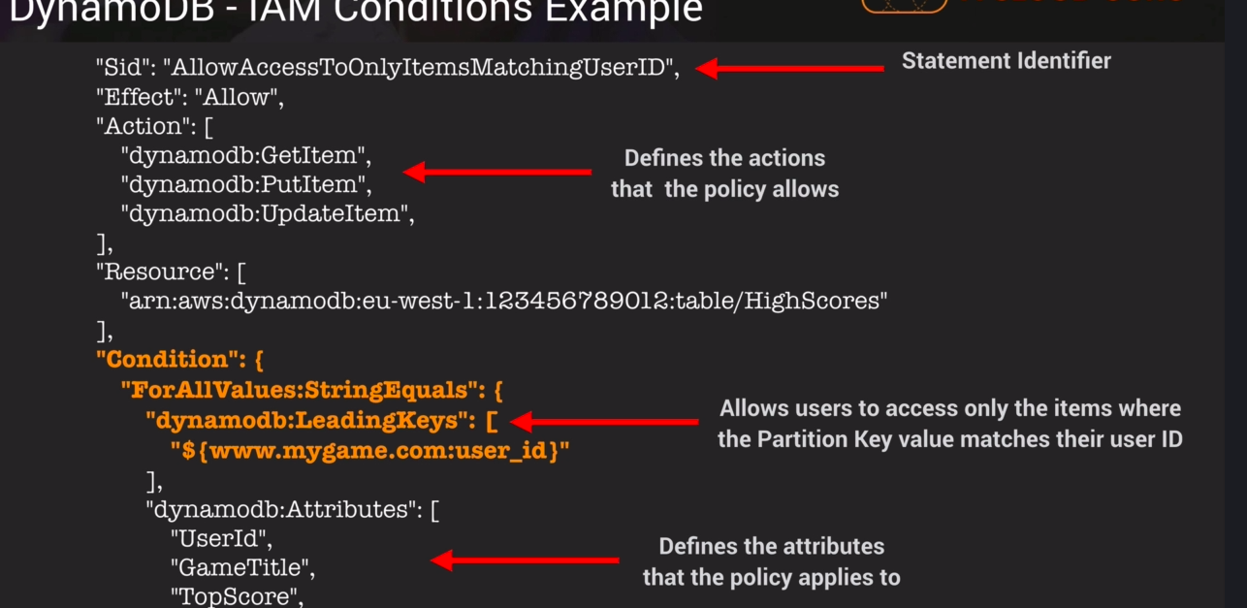
Example of a dynamo db query
aws dynamodb get-item --table-name ProductCatalog --region eu-west-2 --key '{"Id":{"N":"205"}}'

More on Dynamo DB Indexes
Index – data structure that allows you to perform fast queries on specific columns in a table
2 types:
- local secondary index -
  - can only be created when created your table
  - same partition key as original table but different sort key
  - any queries based on this sorty key are much faster using the index than the main table
  - ex. partition key – userID, sort key – account creation date
- global secondary index -
  - create this index when you like
  - you can choose a different partition key and different sort key
  - speeds up queries according to these alternate partition and sort keys
  - ex. partition key – email address, sort key – last login-date

More on Scan vs Query API
Query – finds items in a tabled based on primary key and a distinct value and returns all items that match that query
- uses an optional sort key name and value to refine the results
  - ex. query items with a timestamp of the last 7 days where sort key is a timestamp
- use the ProjectionExpression parameter to only return the specific attributes you want
  - ex you only want to see an email addresses, no other attributes
- results are sorted by the sort key
- numeric order
- ASCII character code values
- reverse the order with ScanIndexForwardparameter to false
- Queries are eventually consistent
  - they can be specified to be strongly consistent

Scan – exames every item in the table
- returns all data attributes by default
- use the ProjectionExpression parameter to only return the specific attributes you want

Query is much more efficient than a scan.
Scan is useful for removing unwanted data you dont want.
Improving performance:
- reduce impact of query by setting a small page size which uses fewer read operations
- set page size to return 40 items
- larger number of smaller operations will allow other requests to succeed
- avoid using scan operations if you can – design tables in way that you can use query,get,batchgetitem APIs
- know scans process data sequentially returning 1MB incremements. It can only scan 1 partition at a time
- dynamoDB can be configured for parallel scans – divides table into segments and scans each segment in parallel. AVOID PARALLEL SCANS TO HEAVY WORKLOADS

More on DynamoDB provision throughput
1 write capacity unit = 1 x 1kb write per second
1 x read capacity unit = 1 strongly consistent read of 4kb per second or 2 x eventual consistency reads of 4kb per second
Example
table with 5 read capacity and 5 write capacity unites
can perform 5x4kb reads = 20kb/sec or 40kb eventually consistent
5x1kb writes = 5kb/sec

Example*****
Your application needs to read 80 items per second
each item is 3kb in size
you need strongly consistent reads
Read-capacity-units-needed = size of each unit/4kb=.75
You will need 80 capacity units in total
For eventual consistent reads
You will need only 40 capacity units

Example 2 *******
You want to write 100 items per second
each item 512 bytes in size
512 / 1000 = .5 writers per second – need 1 unit
Need 100 units total

More on DynamoDB on-demand capacity
charged for read,write,storing data
pay for only what you use
on-demand vs provisioned capacity
unpredictable workloads, unpredictable traffic, and pay per use model, use on-demand
More on DynamoDB Accelerator(DAX)
- Managed, clustered in-memory cache for DynamoDB
- delivers up to 10x read performance
- microsecond performance
- ideal for read-heavy and bursty workloads
- ex use during black-friday

DAX is writes data to the cache and to the back-end store (uses write-through cache)
ex. adding a new item
Allows you to point DynamoDB API calls to the DAX cluster first.
DAX performs eventual consistent getitem operation on DynamoDB for miss, if hit, it will get query from cache
HELPS TO REDUCE PROVISIONED READ CAPACITY
DO NOT USE FOR STRONGLY CONSISTENT READS, OR WRITE-INTENSIVE APPLICATIONS OR APPS THAT DON’T READ TOO MANY READ OPERATIONS

More on Elasticache
in-memory cache in the cloud
sits between your application and DB
ex. e-commerce site
good for read-heavy databases (social-networking, gaming media, Q&A portals)
good for compute heavy workloads (recommendation engines)

Lazy loading
- ADVANTAGES
  - loads data into the cache only when necessary
  - elasticache returns data if in cache or returns null if not found, data is written in cache next time
  - node failures are not fatal,
- DISADVANTAGES
  - more cache miss penalties
  - stale data – data only updated when there is a miss
Add a TTL until cache expires. Removes stale data

Write-through
- Advantages
  - data in cache is never stale
  - users dont care if it takes few seconds to update data
- Disadvantages
  - write penalties!
  - Node failures are fatal, data has to be repopulated
  - lost of wasted resources(means it cost more)

More on DynamoDB Transactions
- ACID Transactions(atomic,consistent,isolated,durable)
- durable – written in the DB for good
  - read/write multiple items across multiple tables as an all or nothing opertaion
  - check for prerequ before writing to table

More on DynamoDB TTL
- Great for removing irrelevant data like session data, event logs, temp data
- reduces costs by removing cache and data no longer needed
- data will removed after the ttl (expressed in epoch time) is equal to or greater than epoch time
- Can modify these in the table, select item under action

More on DynamoDB Streams
- time ordered sequence oF item level modifications, insert, delete, update
- logs encrypted and stored for 1 day
- accessed using a dedicated endpoint
- primary key is recorded
- before/after iamges can be captured
- USEFUL FOR SERVERLESS ARCHITECTURES
- A DynamoDB stream is an ordered flow of information about changes to items in an Amazon DynamoDB table.
- Events are recored in near real-time
- event source for lambda, can trigger lambda basically!
- ex. payments entry enters SQS, SNS triggers lambda, which triggers dynamoDB streams endpoint, to store transaction into DYnamoDB

Provisioned throughput exceeded and exponential backoff
ERROR – PROVISIONEDHTHROUGHPUTEXCEEDEDERROR
What to do?
- if request rate is too high for read/write capacity unit, manually reduce request frequency
- use exponential backoff – all aws sdks use exponential baackoff, app will wait longer before retrying again. First 50 ms, then 100 ms, then 200 ms,
- EXPONTIAL BACKOFF APPLIES TO MANY AWS SERVICES (s3, CLOUDFORMATION, e.g.)

BatchGetItem – API call to fetch multiple items from DynamoDB
DynamoDB query uses primary partition key to search for the items

Notes on KMS and Encryption
KMS makes it easy to create and control the encryption keys
KMS keys are regional!
CloudHSM – dedicated hardware, cloud-based hardware security module

More on KMS API Calls
Commands for CLI commands to KMS API
aws kms encrypt --key-id 6f393361-777e-4ee0-b47f-17d475c47949 --plaintext fileb://hi.txt --output text --query CiphertextBlob | base64 --decode > encrypted.txt

aws kms decrypt --ciphertext-blob fileb://encrypted.txt --output text --query Plaintext | base64 --decode > decrypted.txt

aws kms re-encrypt --destination-key-id 6f393361-777e-4ee0-b47f-17d475c47949 --ciphertext-blob fileb://encrypted.txt | base64 > newencrypted.txt

aws kms enable-key-rotation --key-id 6f393361-777e-4ee0-b47f-17d475c47949

More on KMS Envelope encryption
Envelope encryption – key used to unencrypt your data
Take your master key to encrypt envelope key, and envelope key is used to encrypt data
With decryption, we have our envelope key, we take master key to decrypt envelope key which gives us our plain text data key and use it to decrypt our data.

More notes on other AWS Services

More notes on SQS
- web service message queue service that can be used to store messages until a computer can process them
- distributed queue system
- short polling – keep polling the queue for more work
- long polling – respond when messages are finally in the queue, maximum long poll time is 20 seconds
- useful for decoupling components and easing message management between these components
- standard – standard queues are delivered at least once , no ordering
  - you need to provide another application to help with ordering
- FIFO – first in, first processed, liit to 300 transactions per secondary
- messages are 256kb in size
- kept from 1 min to 14 days in the queue
- default retention period is 4 days
- SQS visibility timeout – time amessage is invisible in the sqs queue after a reader picks it up,
  - message is deleted after processed
  - message becomes visible if no computer processes it
  - timeout can range from 30 seconds to 12 hrs
  - ChangeMessageVisibility – time to process the message

More on SNS
amazon’s managed notification service
- flexible, scalable, cost-efficient
- push notifications to numerous devices
- make a topic – access point where devices subscribe, group of devices to receive these messages
- all messages are stored redundantly across multiple AZ’s
- push-based deliver
- payasyougo
  - .50 per 1 million requests
  - .06 per 100000 per http requests
  - .75 per 100 notifications over SMS
  - 2.00 per 100000 notifications over email
You can use SNS to send 1 message to multiple SQS queues

SES vs SNS
SES – simple email service
scalable email service to help with marketing services (think mailchimp for AWS)
- automated emails
- purchase confirmations
- shipping notifications
- order status updates
- online retail business that needs customers about sales promotions and discounts

More on Elastic Beanstalk 101
service for scaling web applications in many languages
Developers focus on writing code. Elastic beanstalk handles the rest
- you upload the code
- it configures the environment
- elastic beanstalk is using zip folder while cloudformation are templates in JSON
- you have full admin control over the resources
- all updates are applied by elastic beanstalk (such as updates for dependencies)
- integrates with cloudwatch and x-ray
- updates, monitoring, metrics, and health-checks all included

More on deployment policies
- all at once
  - deploys all new version to all instances
  - all instances out of service while new code is deployed
  - DO NOT USE FOR MISSION-CRITICAL CHANGES
  - LONGER TIME FOR ROLLING BACK CHANGES
  - Use only in DEV Environments
- rolling
  - deploy new version in batches
  - some instances are taken out during the new version being pushed
  - NOT IDEAL FOR PERFORMANCE SENSITIVE SYSTEMS

- rolling with additional batch
  - launches an additional batch of instances
  - deploys new version in batches
  - doesn’t affect environment
  - USEFUL FOR SYSTEMS THAT NEED FULL PERFORMANCE
- immutable
  - deploys new version to fresh group of instances
  - when instances with new version pass health checks, they are put into your autoscaling group and older instances are terminated
  - B EST OPTION FOR MISSION CRITICAL SYSTEMS
  - fallback option is to terminate the new auto-scaling group

More on Elastic Beanstalk
Use elastic beanstalk configuration files to specify elastic beanstalk configuration
Written in YAML or JSON, must have .config and saved in folder .ebextensions
elasticbeanstalk.config → .ebextensions/
it supports:
- apache tomcat for java applications
- apache http server for php applications
- passenger for ruby applications

RDS and Elastic Beanstalk
- you can launch RDS from within Elastic Beanstalk
  - useful for dev and test environments
  - not ideal for production environments because once elastic beanstalk environment is terminated, RDS is terminated, DECOUPLE THEM
- decouple the RDS and Elastic beanstalk environments.
  - Launch RDS seperately then couple it with elastic beanstalk
  - modify security group in elastic beanstalk to talk to RDS via MySQl connection port 3306
  - provide connection data to application servers in Elastic beanstalk environment (endpoint, password,)

Notes on Kinesis
- AWS service to manage streaming services
- Ex. can be purchases, video streaming, music streaming, e.g., stock prices, game data , social network data , geospatial data, IoT sensor Data
- easiest way to load and analyze these database
- 3 types of kinesis products
- Kinesis streams
  - uses shards – individual streams to feed into your analysis tools, these hold data, stored for 24 hours – 7 days
  - ec2 instances(data consumers) process the shards and return analytic insights into it
  - ex. predict the stock market
  - After calculations are done, they are sent to storage services
  - Shards – 5 transactions per second with max read size of2MB per second, write 1000 records per second up to max size of 1MB per second
  - stream – sum of all capacities with shards grouped together
- Kinesis Firehouse
  - producers send data over
  - Firehouse doesn’t need shards, streams, e.g. It is automated
  - Data can be collected and analyzed , then stored into s3 buckets
  - No automatic data retention policy, NO DATA THAT IS STORED WILL BE DROPPED
  - You can send data over to elasticsearch cluster
Elasticsearch – search and analytics engine able to process vast amounts of data (useful for analytics)
- Kinesis analytics – Analysis service to analyze streams or firehouse
  - Allows you to run sql queries as it exists on firehouse and streams and then store that data in s3, redshift,
  - ANALYZE DATA WHILE ITS IN KINESIS USING SQL QUERY LANGUAGES

Notes on Developer theory
Notes on Continuous Integration and Continuous Improvement (CI/DI)
CI/CD are best practices for software development and deployment
enable you to push changes faster to production code
- Example of a workflow
- 1.Code Repo → 2.build management system → 3.Test framework → 4. make an exe out of code → 5.package the code and deploy to instances running the exe
- push your code
- it gets built
- then it gets tested (integration, functional, unit tests)
- an exe is made
- code is pushed to computers(or mobile devices ) for running

CI – continuous integration is about integrating/merging the code changes frequently
Contuous delivery is about automating the build,test,and deployment functions
Continous deployment is automating the entire release process, deploying code into production as soon as it passes the release proceess

types of products to run in AWS
- CodePipeline – all stages for create, deploying, and reintegrating code is this pipeline, continuous deployment service
- Codecommit – github repo
- Codebuild – build the code – compile source code
- code deploy – make an exe out of it, deploy it to ec2, on premise and lambda
- Codepipeline – CI/CD workflow tool, automate entire release process

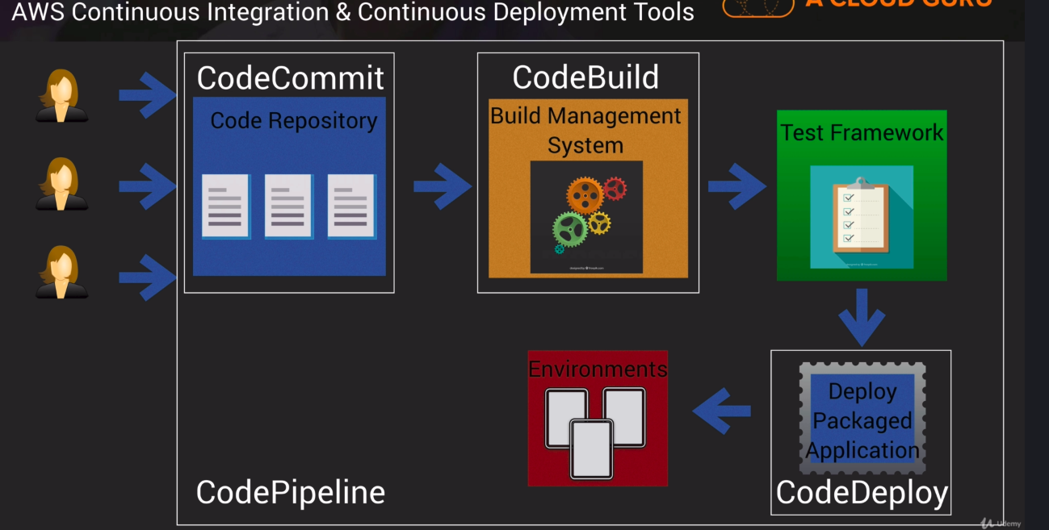

Amazon Lightsail – service tailored to new users to spin up virtual private servers
Notes on CodeCommit
host open source source control system
- just think git
- code is encrypted in transit and at rest

Notes on CodeDeploy
- deployment service to on-premise or cloud resources
- keeps standard configuraitons across those resources
- integrates with ansible, puppet, chef
- 2 deployment approaches
  - in-place
    - application is stopped on each instance, latest revision is installed
    - instance is out of service so capacity is reduced
    - Note: configure load balancer to stop sending requests to instances that go down
    - Rolling update – only for ec2 and on-premise systems, no lambda
    - Manual reverting changes
  - blue/green
    - blue instances are active deployment
    - green instances are running newest version
    - after passing tests, ELB will route traffic ot green instances and terminate old instances
    - Faster recovery time for development

- Deployment group – ec2 instances or lambda functions that has newest code version
- deployment – process to apply new revisions
- deployment configuration – deployment rules and success/fail conditions used during deployment
- AppSpec File – defines deployment actions you want AWS CodeDeploy to execute
- Revision – evertyhign needed to deploy new version – AppSpec file, app files, exes
- Application – id for app you are deploying
CodeDeploy agents must be installed on Ec2 instances to control them

More notes on CodePipeline
Fully managed CI and CD service
you can orchestrate the build,test, and deployment of your application everytime
simple workflow
- CODE UPDATE
  - code updated in codecommit
- BUILD
  - builtcode with codebuild
- TEST

- DEPLOY

- CodePipeline will stop if one of the stages fails
- Issues are caught while they are still easy to fix.

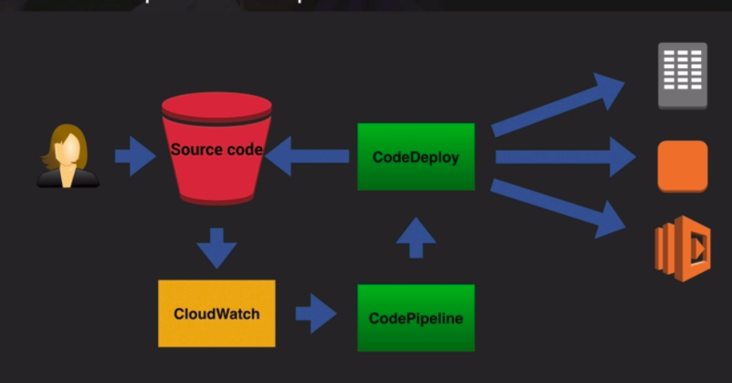
Example
developer pushes new code
cloudwatch detects new change, and triggers codepipeline to launch
codepipeline has codedeploy get the new code and run it in new instances

Notes on Advanced CodeDeploy
AppSpecFile – define parameters that will be used for a codedeploy deployment
it is written in YAML or JSON

version – reserved for future use
resources – name and properties of lambda function to deploy

hooks – specifies functions/scripts/lambda functions to run at set points in the deployment lifecycle to validate the deployment , these are basically validation tests

Appspec.yml File – lambda example
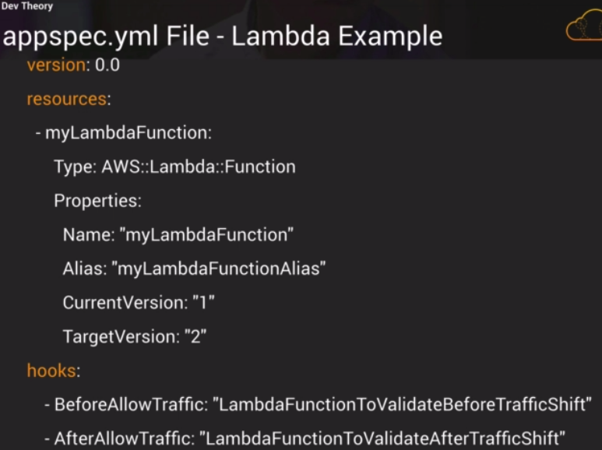

hooks for lambda
beforeallowtraffic – used to specify tasks or functions you want to run before traffic is routed to newly deployed lambda function
afterallowtraffic – specify tasks/functions you want to run after the traffic has been routed to new instances

Appspec file hooks for ec2 and on premises
HOOKS -
includes:
- OS
- version
- files
  - location of files that need ot be copied and where to
- hooks
  - tasks/functions to run at set points in the deployment lifecycle
Appspec File must be placed in the root directory of your revision
Ex.
/mywebFolder
---appspec.yml
-----/scripts
----------/config
--------/source
ex.
version: 0.0
os: linux
files:
- source: /index.html
destination: /var/www/html/
hooks:
BeforeInstall:
- location: scripts/install_dependencies.sh
timeout: 300
runas: root
- location: scripts/start_server.sh
timeout: 300
runas: root
ApplicationStop:
- location: scripts/stop_server.sh
timeout: 300
runas: root

Supported hooks for EC2 and on premises
beforeblocktraffic – run tasks on instances before they are deregistered from a load balancer
blocktraffic – deregister instances from a load balancer
afterblocktraffic – run tasks on instances after they are deregistered from a load balancer
Useful for testing web application traffic from 1 group to another. This ensures traffic isnt being routed to servers off the load balancer

Hooks for EC2 and On-premise when upgrading any applicationb
- applicationStop – stop application
- downloadBundle – copies app revision files into temp location
- BeforeInstall – scripts that are run before new version install (backup scripts, version files.e.g)
- Install – copes revision files from temp location to correct location
- AfterInstall – details any post installation scripts (config tasks, change file permissions)
- ApplicationStart – restarts any services stopped during applicationStop
- ValidateService – details any tests to validate service

Final hooks to reregister instances to load balancer
- BeforeAllowTraffic – run taks before instances are registered with LB
- allowtraffic – register instances with LB
- afterallowtraffic – run tasks on instances after they are registered with LB

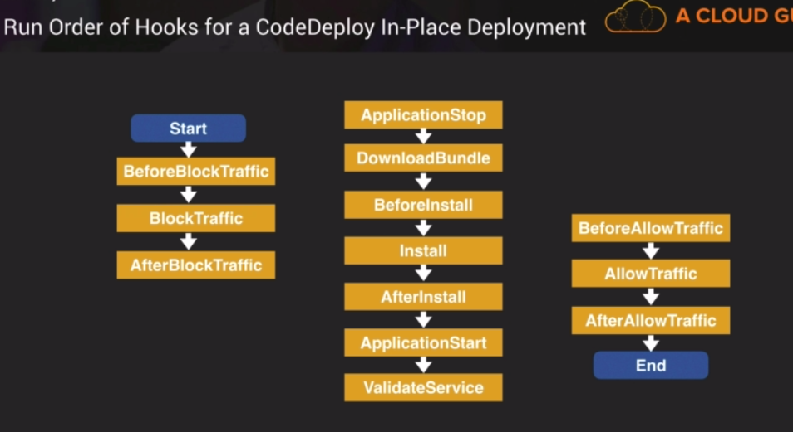
The hooks for a codedeploy inplace deployment
hooks are tasks run after removing instances frrom LB
hooks are run on instances
hooks are tasks run after adding instances to LB

Notes on Docker and CodeBuild
Docker – open source technology which allows you to create applications based on containers
containers contain everything the software needs to run
ECS – elastic container service – AWS service for managing containers

AWS Codebuild – managed build service which runs a set of commands you define
builds artifacts that are ready to deploy

ECR – Elastic container registry – these store your docker images
Error – ecr:GetAuthorizationToken
This is due to IAM policy. Fix it with IAM and add policy – ec2containerregistrypoweruser

docker build -t mydockerrepo .
Build docker image based on dockerfile. In this example, the docker image is mydockerrepo

docker tag mydockerrepo:latest 516088461745.dkr.ecr.us-east-1.amazonaws.com/mydockerrepo:latest
This is to tag your new docker image mydockerrepo. Its a long tag with latest build andincludes the region

docker push 516088461745.dkr.ecr.us-east-1.amazonaws.com/mydockerrepo:latest
This will push new image into docker registry

Task placement – customize how tasks are placed on instances within your cluster
Types of placement templates:
- az balanced spread – spread tasks evenly across AZ’s
- az balanced binpack – spread tasks across Azs then bin pack tasks based on memory
- binpack – place tasks based on the last available amount of CPU or memory, used to minimize # of instances in use
- onetask per host
- random – place tasks randomly
- spread – place tasks evenly based on the specified value , ex based on the instanceID
- memory – tasks spread due to memory
- custom

Notes on Cloudformation
build infrastructure using code
- easier way to manage infrastructure with changes
- version control and peer review templates
- free to use but resources are costly
- YAML or JSON format
- You can upload template to S3 and have cloudformation look at it
- resources must be required
- optional stuff in a template:
  - metadata – environment metadata
  - description – description of the template and environment
  - parameters, - data you have to provide
  - conditions – take action based on condition
  - mappings – set values based on a region
  - transform – include snippets of code outside the main template
  - resources – resources to be deployed
Example of a template (YAML)
######################################################
AWSTemplateFormatVersion:2019-09-09
Description: Template to create an EC2 instance
MetaData:
instances:
Description: Web Server Instance
Parameters: #input values
EnvType:
Description: Environment Type
Type: String
AllowedValues:
prod
test

Conditions:
CreateProdResources: !Equals [!ref EnvType,prod]
#create prod resources if input parameters is prod

# region for infrastructure to be deployed, RegionMap = primary key,
ami = secondary key , specify ami
Mappings
RegionMap:
us-east-1:
“ami”: “instanceID”

Transform:
Name:’AWS:Include’
Parameters:
location:s3://bucket/myfile.yaml

Resources:
ec2instance:
type:aws::ec2:instance
properties:
instancetype:t2.micro
imageid:ami..

Outputs:
InstanceID:
Description: theinstanceID
Value:!refec2instance

#######################################################

Notes on Serverless Application Moddel (SAM)
Extension to cloudformation to define serverless applications
simplified syntax to define APIS, lambda functions, dynamoDBS
use sam CLI to package deployment code, upload to s3, then deploy using cloudformation
Example of commands
#command to package up your code
sam package\
– template-file ./mytemplate.yml\
--output-template-file sam-template.yml\
--s3-bucket s3-bucket-name

#command to deploy code to, CAPABILITIES create an IAM role to allow the function to execute
sam deploy\
--template-file sam-template.yml\
--stack-name mystack\
capabilities capability_IAM

Lab with SAM

Notes on Nested Cloudformation stacks
Nested stacks – allow re-use of cloudformation code for common use cases
Use cloudformation to launch a cloudformation template for a load balancer, web application server, or other services

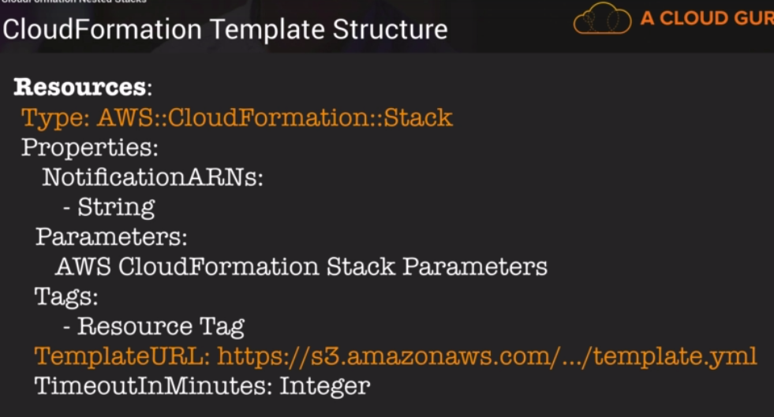
Resources
Type – aws:cloudfornatio:stack
TemplateURL – location of cloudformation template to be used

Notes on Advanced IAM
Web Identity Federation lets you give your users access to AWS with AWS, facebook, other identity providers
user receives an authenitcaiton code, which is traded for an aws security credential
Amazon cognito – provides identity federation, stores temp credentials for many users, acts as an identity broker
Recommended for web identity federation
Cognito brokers between the app and Facebook
Cognito User Pools
- user pools – user directories used to manage sign up and sign in functionality for mobile and web apps
- users sign in to the user pool. They generate jsob web tokens (JWTs) upon successful authentication
- identity pools – create unique identites for your users and authenticate them with identity providers, you obtain temp, limited privilege credentials to access other aws services
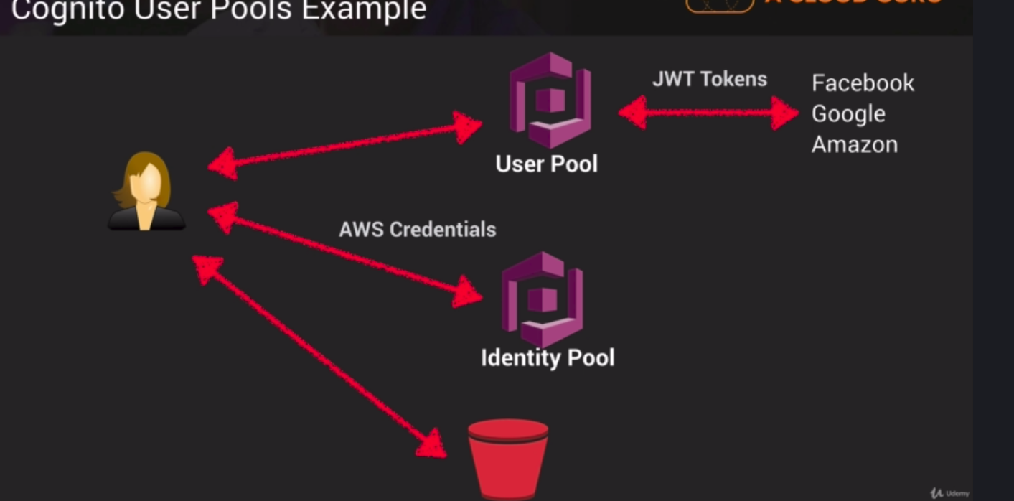
User logs in to userpool via FB and gets JWT token.
Cognito identity pool exchanges jwt token with aws credentials
She can now use s3 bucket service.

Cognito uses Push Synchronization – pushes updates and synchronize user data across multiple devices,
Amazon SNS is used to send silent push notification to all devices associated with a given user identity whenever data in the cloud changes

Different types of IAM policies
- inline policies
  - apply to only a singer user, group or role
  - policy that is EMBEDDED within a user,group,role it is applied.
  - 1:1 relatoinship,
  - the policy is deleted with the user,group,role is deleted
- AWS managed policies
  - IAM policy created and administered by AWS
    - ex. AWSDynamoDBFullAccess
    - AWSCodeCommitPowerUser
    - policies managed by AWS you don’t have to write yourself
- customer managedpolicies
  - customer created policy
  - it is adminstered by you and applied to users,groups,roles within your own account
  - Just copy aws managed policies and customize it

AWS Sign in portal is https://signin.aws.amazon.com/saml

More on CloudWatch

Custom metrics must be installed as an agent on EC2 instances, then feed back data to cloudwatch
Use getmetricstatistics API to retrieve data
store log data in cloudwatch logs
You can also recover data from terminated instances to cloudwatch
Custom metrics- min granularity is 1 min
many services are set to update every minute,some 3 or 5 minutes

Cloudwatch alarms – monitor cloudwatch metrics in account and then setup an action to be taken

AWS Config records state of AWS environment and notify you of changes

