Laboratory Work N1
Web Application Development Tools
Orbit Atlas is a one-page solar system website built with Node.js and Express. The project includes custom CSS, interactive planet exploration and an animated orbital illustration.

Task 1 Node js and npm
A portable Node.js installation is stored in the project on drive D. The verified versions are Node.js v24.22.1 and npm 11.19.1. The command output below was recorded on Windows and displayed in a local verification page.

Task 2 Create the application
The project contains package.json, server.js and express/index.html. Running npm install created node_modules and package-lock.json. The installed direct dependency is Express 4.22.3.
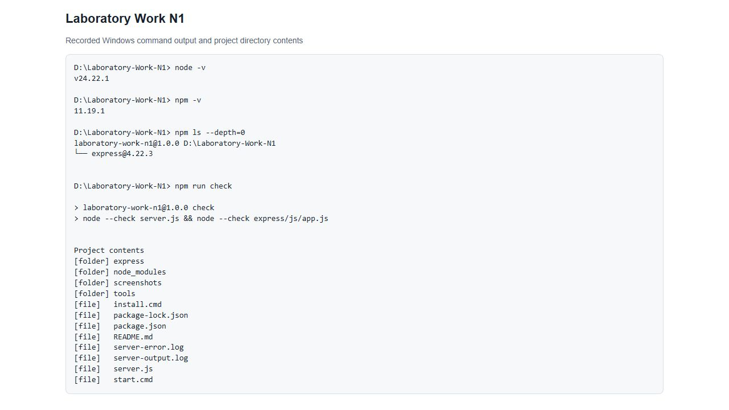
Figure 1. Recorded version checks, installed dependency, syntax checks and directory contents.

Task 3 Add a design template
A custom template was created for Orbit Atlas. The single HTML page contains the overview, planet catalogue and observatory. Styles are stored in express/css/style.css; browser effects are stored in express/js/app.js. Planet images are stored locally in express/images.
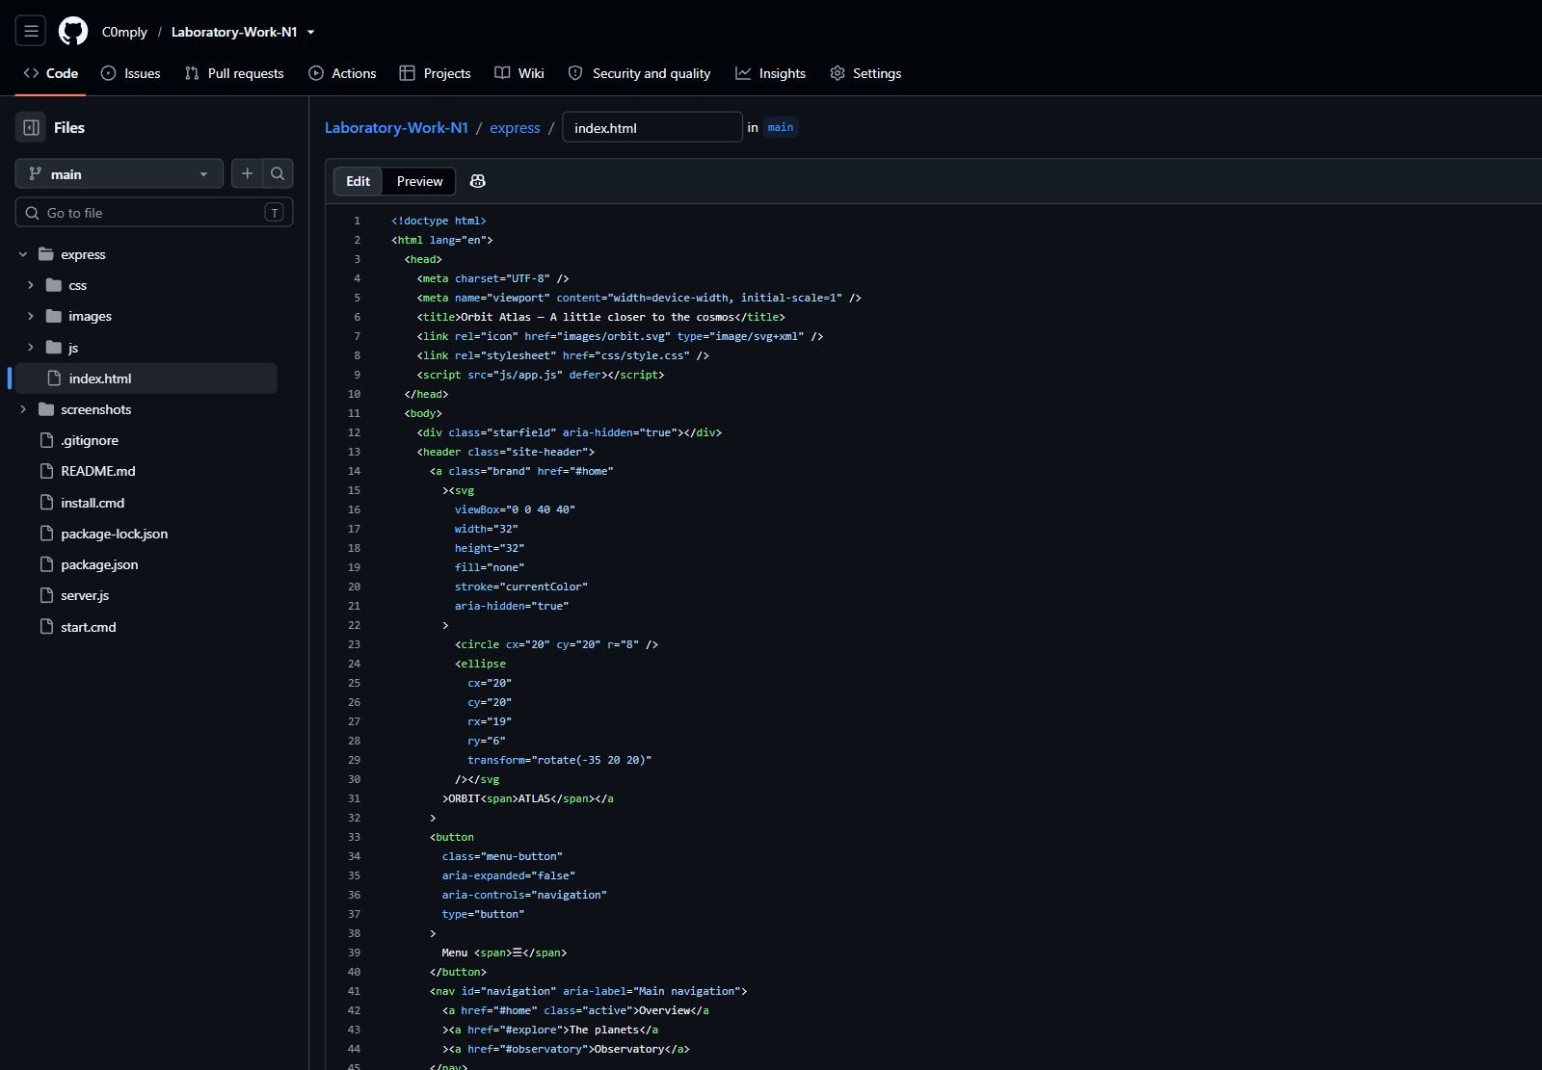
Figure 2. express/index.html open in the GitHub code editor with the project tree visible.
The template uses semantic header, nav, main, section and footer elements. The planet details use a native dialog element. Images have alternative text, and the search field has an accessible label.

Task 4 Run the project
Start the application with npm start, then open http://localhost:3000. The local start.cmd file also runs the project using the portable Node.js installation. Express serves the express folder using an absolute path, so static resources do not depend on the terminal working directory.
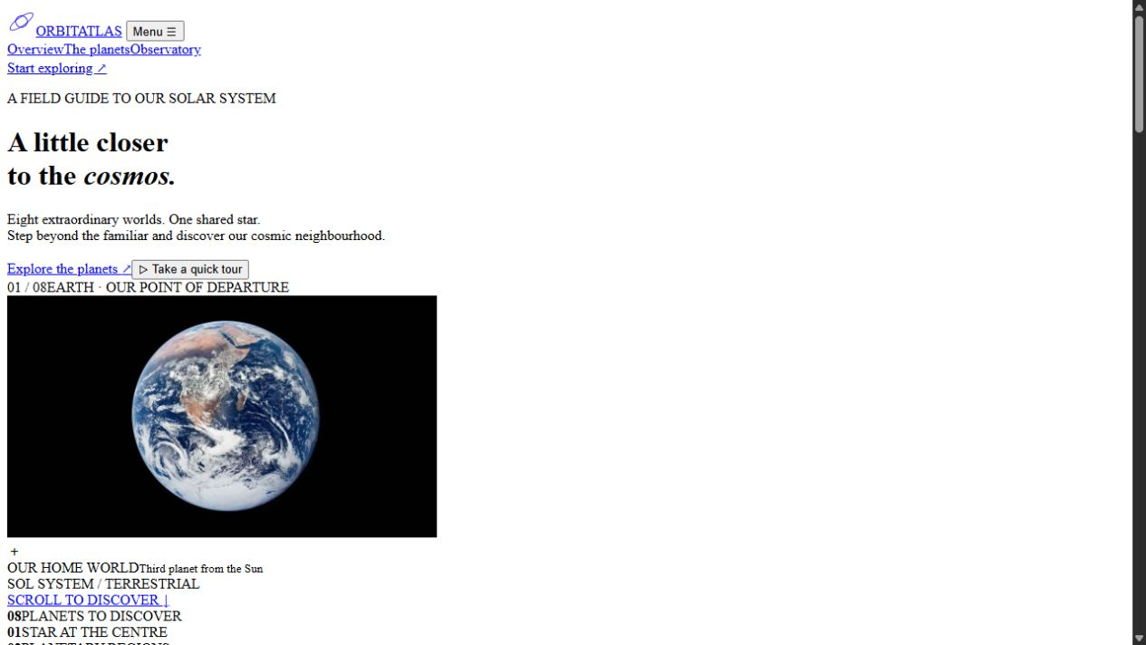
Figure 3. The HTML template before the custom stylesheet and JavaScript are applied.
The final application is also available at the same local address. GET /health returns a JSON response with status set to ok.

Task 5 Add custom CSS
Paragraphs use a custom font size, line height and muted colour. Headings use a separate type scale. Image styles control sizing and cropping; planet cards have borders, rounded corners and hover transitions. The grid changes from four columns on desktop to two columns on mobile.

Task 5 Custom CSS result
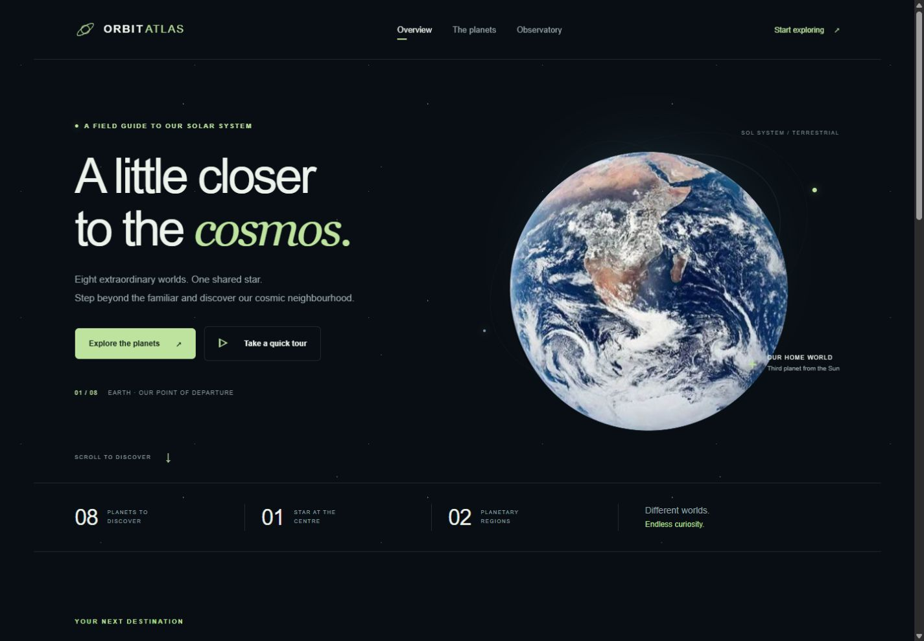
Figure 4. The styled page with the Earth overview, navigation and solar system facts.
The stylesheet also defines the star background, orbital rings and green accent colour. Media queries adapt spacing, navigation and image sizes. The prefers-reduced-motion media query disables CSS animation and smooth scrolling when reduced motion is requested.

Task 6 Add JavaScript effects
The page implements more than three JavaScript effects: region filters, live name search, planet detail dialogs, pause and resume controls, the mobile menu and a conditional back-to-top button.

Task 6 Filtering and planet details
Clicking a filter changes the active region. The filter and search are combined using a condition: a card is shown only when its region and name both match. A separate condition displays an empty-state message when no planets match.
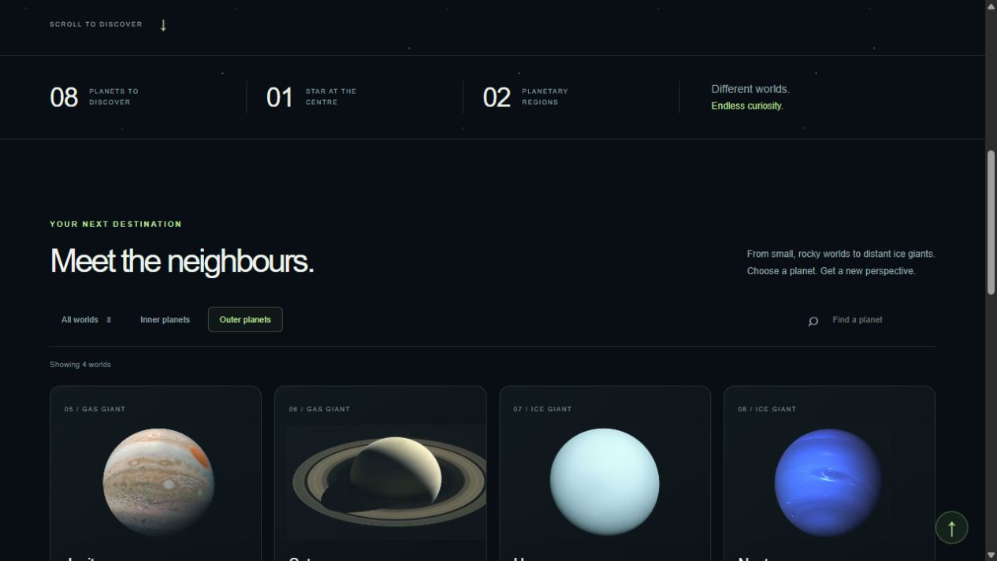
Figure 5. The Outer planets filter displays Jupiter, Saturn, Uranus and Neptune.
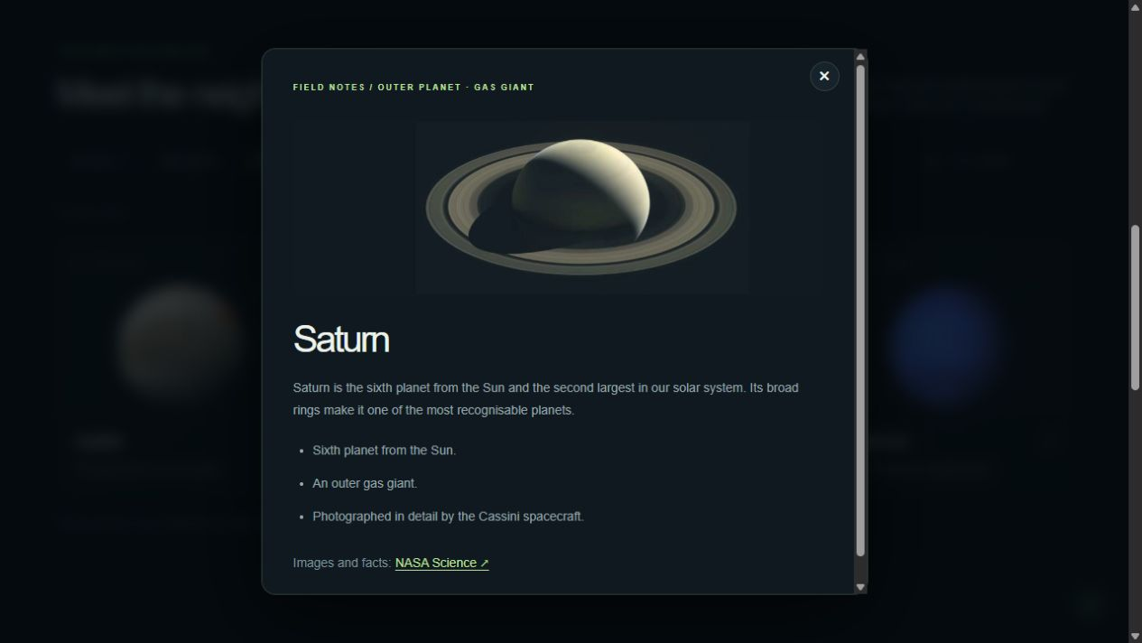
Figure 6. Selecting Saturn opens its field notes. Escape, the close button or a click outside closes the dialog.

Task 6 Search and animation
The input event updates the search results immediately. The example below shows one matching world after entering Mars. The observatory uses CSS keyframes for orbit animation; the click event toggles the paused state.
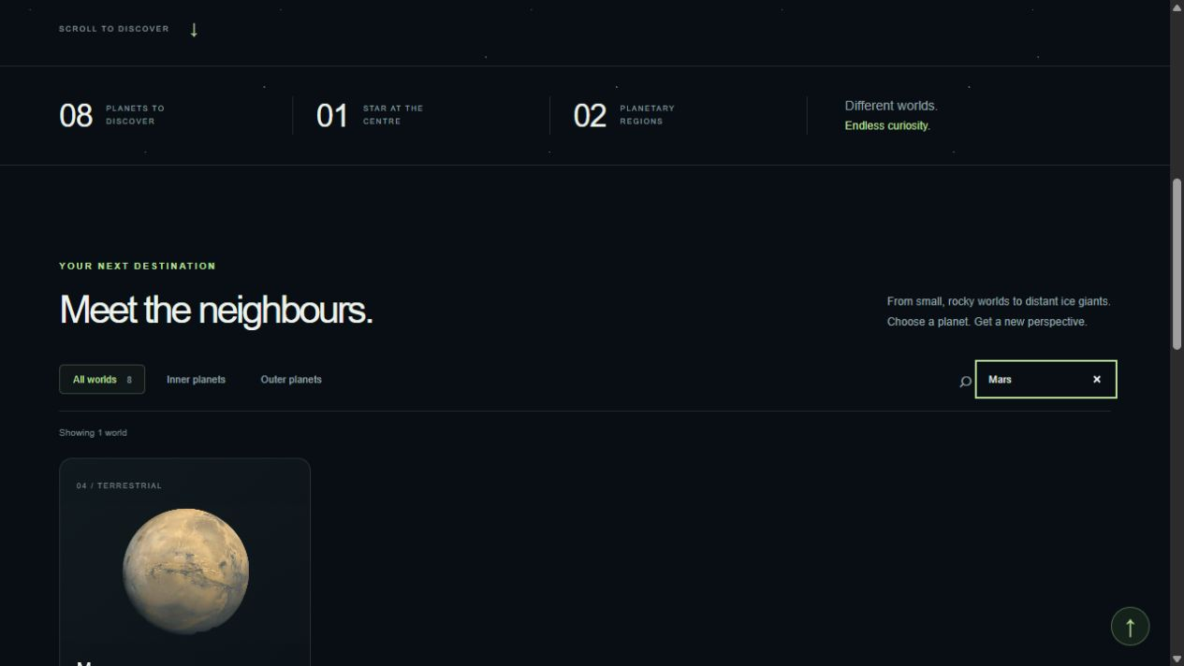
Figure 7. Live search narrows the catalogue to Mars.
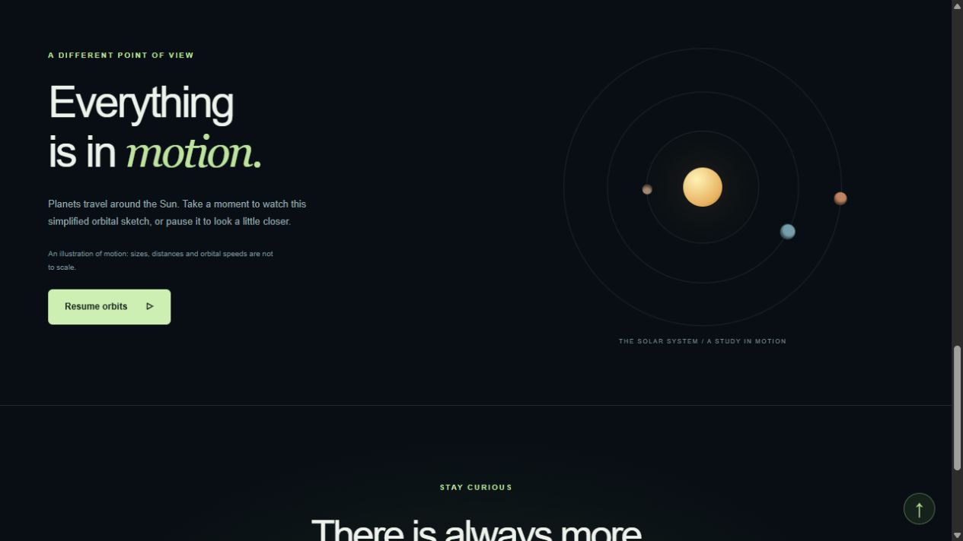
Figure 8. Paused orbital animation with the Resume orbits control visible.

Task 7 Debugging and validation
The first image selection matched a NASA news image about Earth rather than the planet photograph. It was replaced with the Apollo 17 Blue Marble image. The initial hero image also extended beyond the page; its sizing and clipping were adjusted, and the page was checked again for horizontal overflow.
The server serves static files from an absolute path. A port-in-use error is handled with a clear message. JavaScript syntax checks passed for server.js and app.js.
Browser checks verified region filtering, live search, no-result feedback, planet dialogs, Escape, pause and resume, and the mobile menu. No JavaScript errors were observed in the checked browser session. At 390 pixels wide, the menu opened and the page had no horizontal overflow.
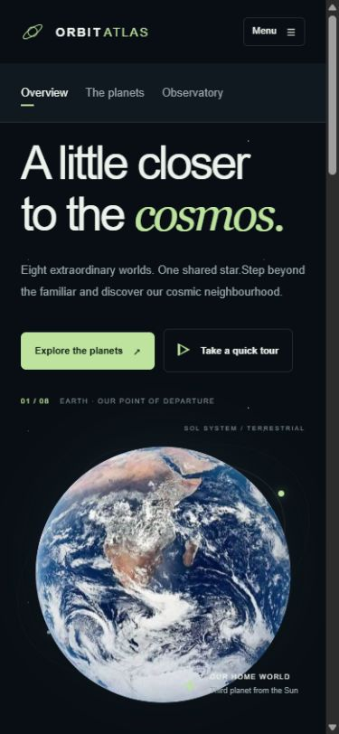
Figure 9. Mobile layout and expanded navigation.

Task 8 Commit the final code
The project is committed to the main branch of the public student repository:
https://github.com/C0mply/Laboratory-Work-N1
The repository contains the website source, package lockfile, screenshots and this report. node_modules, the npm cache and portable tools are excluded by .gitignore.
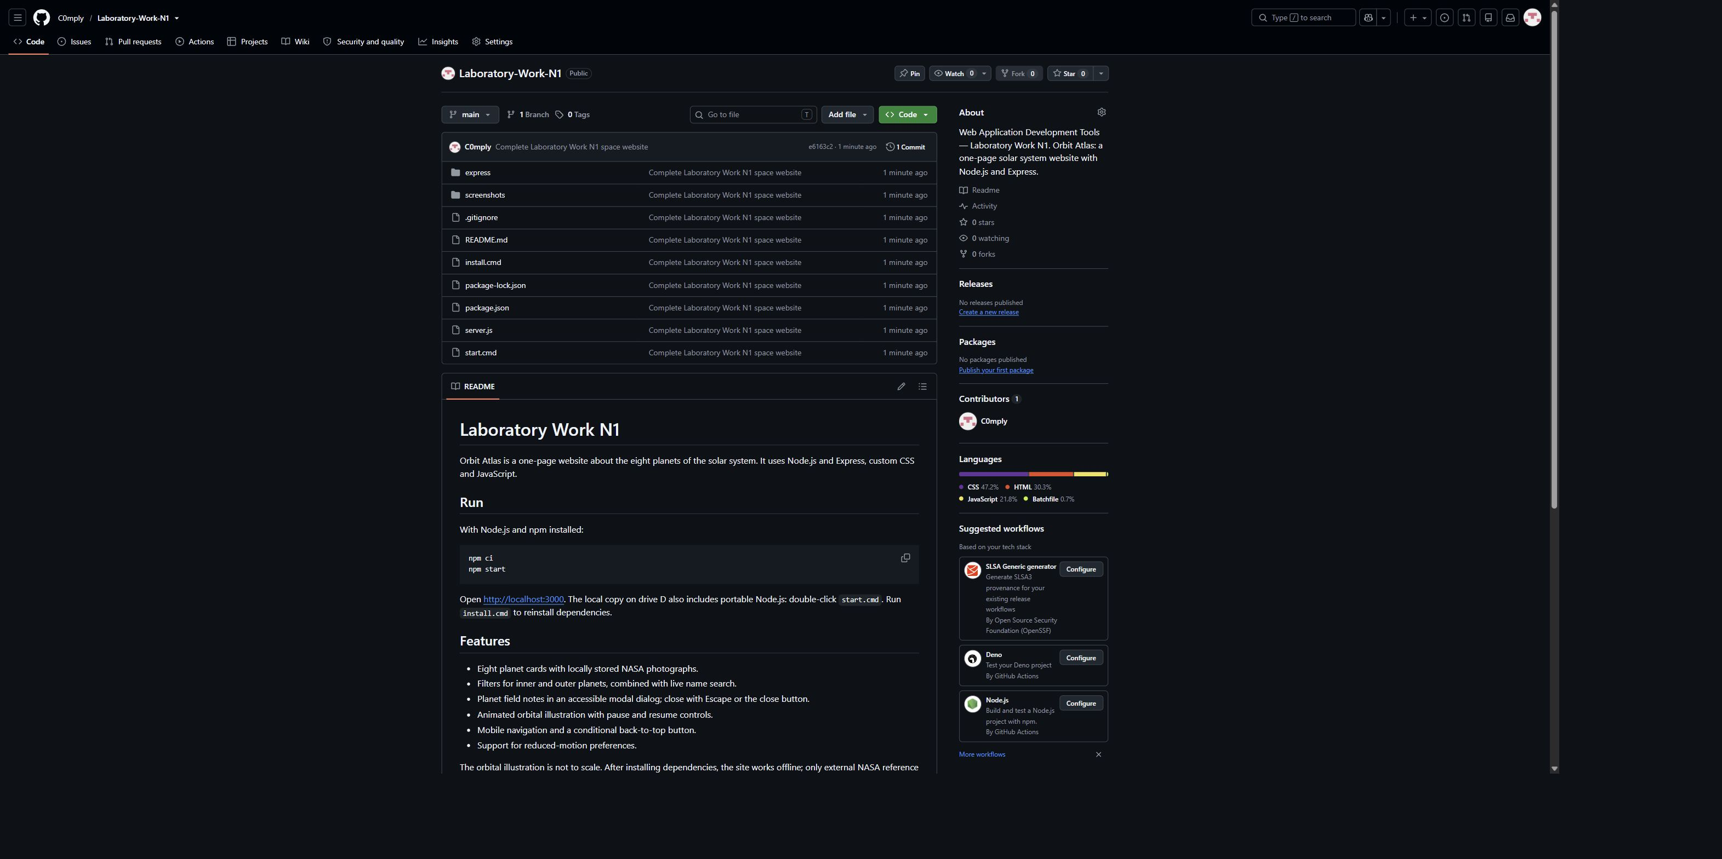
Figure 10. Public repository with the committed project files.

Sources
Planet facts and photographs: NASA Science, About the Planets. https://science.nasa.gov/solar-system/planets/
The orbital illustration is explanatory: sizes, distances and orbital speeds are not to scale.

