TỔNG LIÊN ĐOÀN LAO ĐỘNG VIỆT NAM
TRƯỜNG ĐẠI HỌC TÔN ĐỨC THẮNG
KHOA CÔNG NGHỆ THÔNG TIN


BÁO CÁO BÀI TẬP
MÔN CÔNG NGHỆ PHẦN MỀM

Assignment Report
Kindergarten Management System

Người hướng dẫn: GV ĐẶNG MINH THẮNG
Người thực hiện: PHẠM CÔNG - 517H0039
HOÀNG TUẤN HUY - 517H0054
Lớp: CÔNG NGHỆ PHẦN MỀM- NHÓM 06
Khoá: 21

THÀNH PHỐ HỒ CHÍ MINH, NĂM 2019
ĐỒ ÁN ĐƯỢC HOÀN THÀNH
TẠI TRƯỜNG ĐẠI HỌC TÔN ĐỨC THẮNG

Tôi xin cam đoan đây là sản phẩm đồ án của riêng của tôi và được sự hướng dẫn của GV Đặng Minh Thắng. Các nội dung nghiên cứu, kết quả trong đề tài này là trung thực và chưa công bố dưới bất kỳ hình thức nào trước đây. Những số liệu trong các bảng biểu phục vụ cho việc phân tích, nhận xét, đánh giá được chính tác giả thu thập từ các nguồn khác nhau có ghi rõ trong phần tài liệu tham khảo.
Ngoài ra, trong đồ án còn sử dụng một số nhận xét, đánh giá cũng như số liệu của các tác giả khác, cơ quan tổ chức khác đều có trích dẫn và chú thích nguồn gốc.
Nếu phát hiện có bất kỳ sự gian lận nào tôi xin hoàn toàn chịu trách nhiệm về nội dung đồ án của mình. Trường đại học Tôn Đức Thắng không liên quan đến những vi phạm tác quyền, bản quyền do tôi gây ra trong quá trình thực hiện (nếu có).
TP. Hồ Chí Minh, ngày tháng năm
Tác giả
(ký tên và ghi rõ họ tên)

Phạm Công Hoàng Tuấn Huy

PHẦN XÁC NHẬN VÀ ĐÁNH GIÁ CỦA GIẢNG VIÊN
Phần xác nhận của GV hướng dẫn
_______________________________________________________________________________________________________________________________________________________________________________________________________________________________________________________________________________________________________________________________________________________________________________________________________________
Tp. Hồ Chí Minh, ngày tháng năm
(kí và ghi họ tên)

Phần đánh giá của GV chấm bài
_______________________________________________________________________________________________________________________________________________________________________________________________________________________________________________________________________________________________________________________________________________________________________________________________________________
Tp. Hồ Chí Minh, ngày tháng năm
(kí và ghi họ tên)

Intellectual Property
Copyright 2019 Team Pham Cong – Hoang Tuan Huy.

The following documentation, the content therein and/or the presentation of its information is proprietary to and embodies the confidential processes, designs, technologies and otherwise of Team CongVan. All copyright, trademarks, trade names, patents, industrial designs, and other intellectual property rights contained herein are, unless otherwise specified, the exclusive property of Team CongVan.

The ideas, concepts and/or their application, embodied within this documentation remain and constitute items of intellectual property which nevertheless belong to Team CongVan.

The information (including, but by no means limited to, data, drawings, specification, documentation, software listings, source and/or object code) shall not be disclosed, manipulated, disseminated or otherwise in any manner inconsistent with the nature and/or conditions under which this documentation has been issued.

The information contained herein is believed to be accurate and reliable. Team CongVan accepts no responsibility for its use in any way whatsoever. Team Five shall not be liable for any expenses, damages and/or related costs which may result from the use of the information contained herein.
The information contained herein is subject to change without notice.

All Rights Reserved. Copyright herein is expressly protected at common law, statute and under various International and Multi-National Treatises (including, but by no means limited to, the Berne Convention for the Protection of Literary and Artistic Works).

Table of Contents

Table of Contents 5
Executive Summary 6
I. Introduction 6
II. Analysis Presentation 7
1. Actors 7
2. Use Case Diagram 8
3. List of Use Cases 9
4. Collaboration Diagram 10
5. Activity Diagram 11
6. Class Diagram 12
7. State Chart Diagram 13
8. Use case detailed description 13
III. Design Presentation 24
1. Design Class Diagram 24
2. Implement ER Diagram from Class Diagram 25
3. Modifying Sequence Diagrams 26
4. Design A Demo Website 26
IV. References 29

Executive Summary
The purpose of this document is to provide an overview of the proposed of kindergarten Management topic.

Introduction
Our team have discussed and do researched to find the best way to apply technology in school management include several criteria as fast, convenient, friendly, easy to use and able to do, so we can change the traditional way of kindergarten school management to become better.
The system design will be release under the title of Kindergarten Management System and the initial release is expected to be 1.0 (though this is subject to change). Further iterations of the application are bound to occur and thus this first system should be considered as the base model with room to grow and evolve as the end customer’s requirements change.
Parents can view their kids learning assessment faster so they don’t need to wait for them kids to tell them how they learn or how their score. They can view the health care information faster to know is there something wrong with their kids and have solution instantly to avoid the unexpected situation on their kid’s health. The system will help managers collect the information easy and fast in manage on student’s data, then they can make better decision to provide best service in school.
It is expected that the relevant test and development plan documents will be created based on the information provided within this document and should be referenced accordingly.
The Kindergarten Management System workflow will be in three deliverables
- Use case model survey: Use case model survey includes a list of actors and use case diagrams. (Section II.1, II.2, II3)
- Domain object model (optional): The deliverables of this activity are collaboration, sequence and class diagrams for each use case. (Section II.4, II.5, II.6, II.7)
- Detailed use case description for every use case: These documents drive the development in of future phases of developing a software system. (Section II.8)
- ……

Assumption
- School provide each parent an account that can access their student information.
- School provide each teacher an account that can manage their teaching student.
- School provide manager an account that have all access to the system.
- School provide the health care service permission to update all student health care data.
- Each account has a unique id/value.

Analysis Presentation
The theories in this document with the main intent are:
- A Model would be a complete description of a system from a particular perspective

Use Case Diagrams
Class Diagrams

Sequence Diagrams

Deployment Diagrams

Models
Collaboration Diagrams

Activity Diagrams

State-Chart Diagrams

- An Actor would be someone or something that must interact with the system under development.
- A use case would be a pattern of behavior the system exhibits that each use case is a sequence of related transactions performed by an actor and the system in a dialogue. A flow of events document would be created for each use cases.
- A use case diagram would present an outside view of the system.
- A sequence diagram display would object interactions arranged in a time sequence.
- A class diagram would show the existence of classes and their relationships in the logical view of a system.
- An activity diagram would be a variant of state-chart diagrams organized according to actions, and mainly targeted towards representing the internal behavior of a method.

The following is to present for Kindergarten Management System

Actors
- Parent: Parent can overview their kid(s) on system to get updated info about learning assessment, health care diary, school activities and student attendance.
- Teacher: Is who contract with the system to manage their teaching classes, students, check attendance, update health care diary, learning assessment.
- Administration: Is a manager of the school, they manage teacher and parent account, update school activities, school announcement and system database.
- Healthcare service: Is a services work with the school to check student health monthly. They will collect health data then update it to the system

Use Case Diagram
The use case diagram of Kindergarten Management System can be draw-able as the following
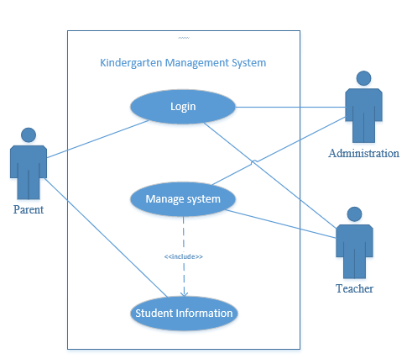
Diagram 2.1: Kindergarten Management System Use Case

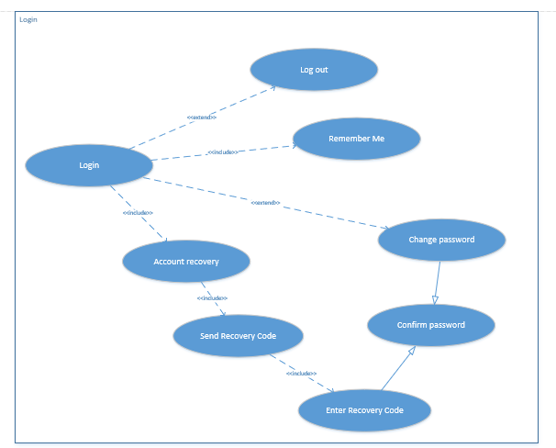

Diagram 2.2: Subsystem - Login Use Case

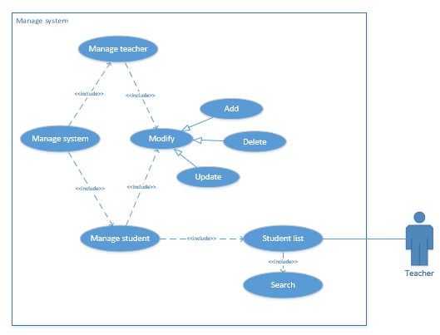
Diagram 2.3: Subsystem – Manage System Use Case

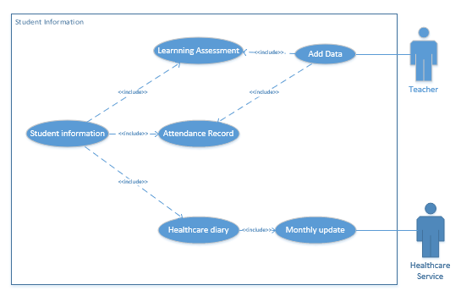
Diagram 2.4: Subsystem – Student Information Use Case

List of Use Cases
Login: Each user will use their account to log in to the system.
Log out: User can log off their account.
Change Password: After login success, user can change their password.
Confirm Password: After User change them password, the password will be updated in database.
Account Recovery: In case user have problem with their account, they can choose this option to recovery.
Send Recovery Code: System send recovery code to user contact (text phone and email).
Enter Recovery Code: User receive recovery code, then enter it, system will check the recovery code, if it’s right with the send code, then let them change new password.
Remember Me: User can choose to remember account to skip login step in next time.
Manage System: This use case let administration access to all the student data.
Manage Teacher: Provide administration several option to manage teacher list.
Manage Student: Provide administration several option to manage student list.
Modify: This use case allow administration modify teacher and parent account data include add, delete or update.
Add: Administration can add new teacher account or parent account.
Delete: Administration can delete teacher or parent account.
Update: Administration can update the student or teacher information, include all the basic information and class class.
Student list: Teacher log in to their account can see the list of students in their class.
Search: Administration can search teacher or student using their id or name. Teacher can search their teaching student using their id or name.
Student information: Parent, teacher and administration can overview student information, include name, date of birth, contact, address, class, teacher teaching.
Learning assessment: Provide student learning assessment quality, achievement, teacher comment updated weekly by teacher.
Attendance record: Provide student attendance data and number of days off, updated daily by teacher.
Add data: Teacher can add new data on learning assessment data and comment weekly, teacher can also use this option to check attendance on student daily.
Health care diary: Provide health care check data from healthcare services, doctor recommend, updated monthly by health care service.
Monthly update: Health care services can use this option to up date health care diary on student monthly.

Collaboration Diagram
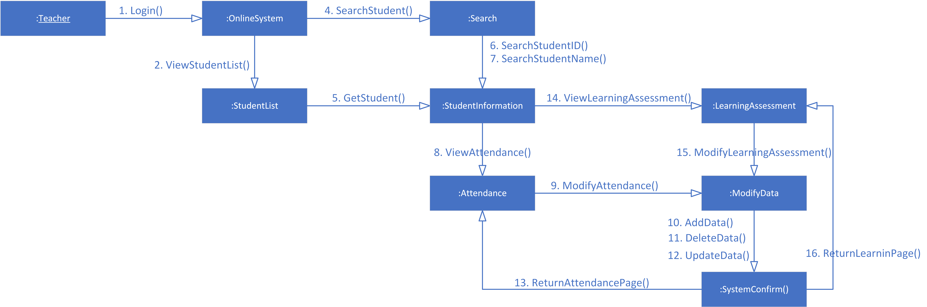
Diagram 2.5: Collaboration diagram for teacher

Activity Diagram
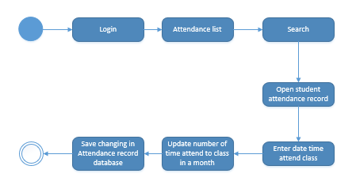Diagram 2.6: Activity diagram for view attendance record

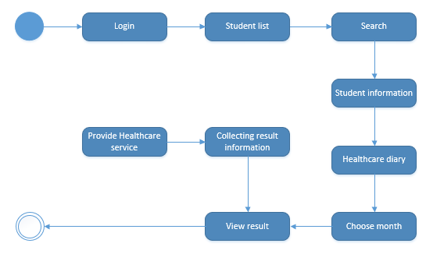 Diagram 2.7: Activity diagram for Healthcare Service

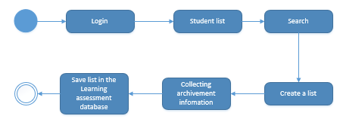
Diagram 2.8: Activity diagram for Learning Assessment Diary

Class Diagram

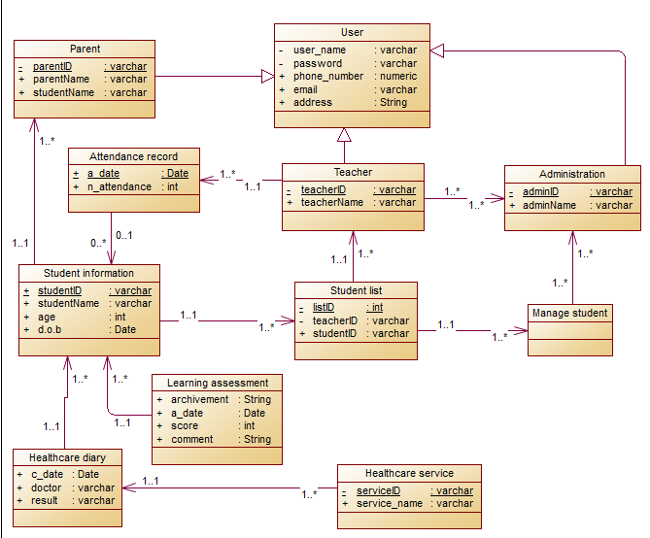
Diagram 2.9: Class diagram for Kindergarten Management System

State Chart Diagram
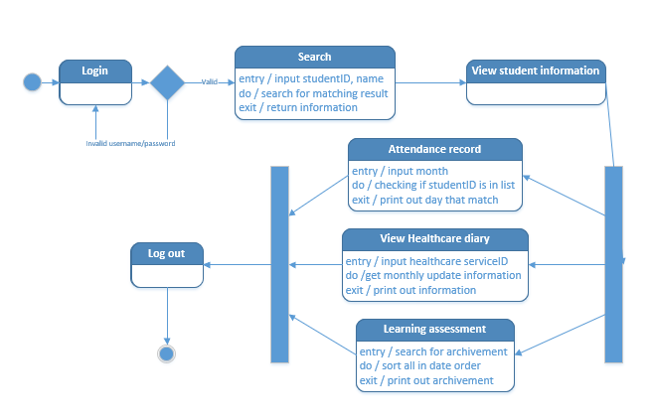
Diagram 2.10: State Chart Diagram for teacher

Use case detailed description
The following is to document by using ‘use case report’ for the development in of future phases of developing a software system for Kindergarten Management System.

7.1 Login
7.1.1 Description
  - This use case allows user enter their account to login to the website.
  - The main actor of this use case are Parent, Administration and Teacher.
7.1.2. Flow of Evens
This use case starts with school homepage and require to input username and password.
i) Basic Flows
  - User enter username and password
  - System check username and password in database.
  - System confirm match account with database.
  - User logged and go to user homepage
ii) Alternative Flows
If user account is incorrect -> System require to enter and the use case repeats.
7.1.3. Special Requirement
There is no special requirement for this use case.
7.1.4 Preconditions
User account created in database.
7.1.5 Post-Conditions
User logged into the website.
7.1.6 Extension points
Recovery Account: In case User can’t login to the website when system can’t find User account data, website display the message advice for recovery option.

7.2 Remember Me
7.2.1 Description
  - This use case allows the system remember user to skip login step in next time.
  - The main actor of this use case are Parent, Administration and Teacher.
7.2.2. Flow of Evens
This use case starts after user login successful into the system by Manipulating functions needs to be confirmed.
i) Basic Flows
  - System start a function to ask user if they want to skip input account step next time.
  - User confirms.
  - System identify user account with device by Cookie.
ii) Alternative Flows
There is no alternative flow for this use case.
7.2.3. Special Requirement
There is no special requirement for this use case.
7.2.4 Preconditions
User login success to the website.
7.2.5 Post-Conditions
User can skip enter account step next time.
7.2.6 Extension points
There is no extension point for this use case.

7.3 Change password
7.3.1 Description
  - This use case allows user make an update account password request.
  - Current password is required to check user identity.
  - The main actor of this use case are Parent and Teacher.
7.3.2. Flow of Evens
This use case can start with the Change Password option in homepage of user account.
i) Basic Flows
  - User requires to make a change password.
  - System require user enter current password.
  - User enter current account password.
  - System check the account password with database.
  - System confirm correct password.
ii) Alternative Flows
If user current password is incorrect -> system ask to re-enter current password, repeats from step 2.
7.3.3. Special Requirement
There is no special requirement for this use case.
7.3.4 Preconditions
User logged in the website.
7.3.5 Post-Conditions
System confirm change password request and user identity.
7.3.6 Extension points
Recovery password: if user enter incorrect current password, system start a function suggest to recovery

7.4 Account Recovery
7.4.1 Description
  - This use case allows user request to recovery their password in case they have problem with their account.
  - The main actor of this use case are Parent and Teacher.
7.4.2. Flow of Evens
This use case can start with the recovery account option in school homepage or in user homepage.
i) Basic Flows
  - User choose “Recovery Account” function to request recovery account.
  - User required to enter account username, teacher ID or student ID.
  - System checks data in database if there is account match with collected info.
  - System found account data.
  - System confirm recovery request.
ii) Alternative Flows
If username, teacher id or student id cannot found by system -> system ask to re-enter and suggest to make a call for school administration if they can’t remember all. The use case repeats from step 2.
7.4.3. Special Requirement
There is no special requirement for this use case.
7.4.4 Preconditions
Account activated in database.
7.4.5 Post-Conditions
System confirmed recovery request.
7.4.6 Extension points
There is no extension point for this use case.

7.5 Send Recovery Code
7.5.1 Description
  - This use case will help system to send recovery code, which is key to update their accounts.
  - Random recovery code will be created and send to owner contact.
  - The main actor of this use case are Parent and Teacher.
7.5.2. Flow of Evens
This use case starts after recovery request confirmed.
i) Basic Flows
  - System creates a random recovery code with 4 digits.
  - System stores recovery code with account id in “Recovery Requested List”.
  - System gets user email and phone number from account id..
  - System sends recovery code to user email and phone number.
  - System announces to user to check text message or email.
ii) Alternative Flows
If user can’t receive code -> after 60 second, user can choose to send recovery code again, the process of use case will repeat from step 1.
If user neither access their email and phone number -> System will suggest to call administration.
7.5.3. Special Requirement
There is no special requirement for this use case.
7.5.4 Preconditions
System confirmed recovery request.
User email and phone number stored in account basic information.
7.5.5 Post-Conditions
User receive recovery code by email or text message.
7.5.6 Extension points
There is no extension point for this use case.

7.6. Enter Recovery Code
7.6.1 Description
  - This use case requests user to enter recovery code so the system can confirm user identity who are trying to recovery their account.
  - The main actor of this use case are Parent and Teacher.
7.6.2. Flow of Evens
This use case starts after recovery code send.
i) Basic Flows
  - User required to enter recovery code.
  - User enters recovery code.
  - System check recovery code in “Recovery Requested List” if its match to the account id.
  - System checked recovery code is correct.
  - System confirm user identity.
ii) Alternative Flows
If entered recovery code is incorrect -> System announce incorrect code and repeat the use case from step 1.
7.6.3. Special Requirement
There is no special requirement for this use case.
7.6.4 Preconditions
User received Recovery Code.
7.6.5 Post-Conditions
System confirm user identity.
7.6.6 Extension points
There is no extension point for this use case.

7.7 Confirm password
7.7.1 Description
  - This use case allows user updates account password.
  - The main actor of this use case are Parent and Techer.
7.7.2. Flow of Evens
This use case just can start after system confirm change password requests or recovery request and user identity confirmed.
i) Basic Flows
  - User required new password 2 times.
  - User enter new password 2 times.
  - System entered passwords are same.
  - System confirm new password.
  - System update account password in database.
ii) Alternative Flows
If two entered passwords are different -> System announces error different password and request to re-enter, the use case repeats from step 1.
7.7.3. Special Requirement
There is no special requirement for this use case.
7.7.4 Preconditions
User identity confirmed, change password or recover password confirmed.
7.7.5 Post-Conditions
User password update successfully.
7.7.6 Extension points
There is no extension point for this use case.

7.8. Manage System
7.8.1 Description
  - This use case allows school manager which actor is Administration to manage the system data.
  - The man actor of this use case is administration.
7.8.2. Flow of Evens
This use case can start with Administration after they logged in to their account
i) Basic Flows
  - Administration manage list of account.
ii) Alternative Flows
There is no alternative flow for this use case.
7.8.3. Special Requirement
There is no special requirement for this use case.
7.8.4 Preconditions
Administration must be login before start this use case.
7.8.5 Post-Conditions
Administration can manage all parent and teacher account.
7.8.6 Extension points
Search: administration can search for specific account in the list using their ID or full name.

7.9 Manage Teacher
7.9.1 Description
  - This use case allows Administration to manage list of teacher account.
  - The main actor of this use case is Administration.
7.9.2. Flow of Evens
This use case can start with Manage Teacher option from administration homepage
i) Basic Flows
  - Administration choose Mange Teacher option.
  - System show the list of teacher account with name, id, class.
ii) Alternative Flows
There is no alternative flow for this use case.
7.9.3. Special Requirement
There is no special requirement for this use case.
7.9.4 Preconditions
Administration must be logged in to choose this use case.
7.9.5 Post-Conditions
Administration can manage all the teacher account.
7.9.6 Extension points
Search: administration can search for specific account in the list using their ID or full name.

7.10 Manage Student
7.10.1 Description
  - This use case allows Administration to manage list of parent account, which is stored student’s information.
  - The main actor of this use case is Administration.
7.10.2. Flow of Evens
This use case can start with Manage Student option from administration homepage
i) Basic Flows
  - Administration choose Mange Student option.
  - System show the list of teacher account with name, id, class.
ii) Alternative Flows
There is no alternative flow for this use case.
7.10.3. Special Requirement
There is no special requirement for this use case.
7.10.4 Preconditions
Administration must be logged in to choose this use case.
7.10.5 Post-Conditions
Administration can manage all the parent account (all the student information).
7.10.6 Extension points
Search: administration can search for specific account in the list using their ID or full name.
Student Information: Administration can view the student information from the list.

7.11 Modify
7.11.1 Description
  - This use case allows Administration to modify teacher and parent account.
  - The main actor of this use case is Administration.
7.11.2. Flow of Evens
This use case can start with Modify option in student list or teacher list management.
i) Basic Flows
  - Administration require Modify option.
ii) Alternative Flows
There is no alternative flow for this use case.
7.11.3. Special Requirement
There is no special requirement for this use case.
7.11.4 Preconditions
There is no preconditions for this use case.
7.11.5 Post-Conditions
User password update successfully.
7.11.6 Extension points
Search: administration can search for specific account in the list using their ID or full name.

7.12. Add
7.12.1 Description
  - This use case allows Administration to add new parent account or teacher account to database.
  - New account will include type account (parent or teacher), id, full name, user, password,… and all basic account information.
  - The main actor of this use case is Administration.
7.12.2. Flow of Evens
This use case can start when Administration choose this option from Modify option.
i) Basic Flows
  - Administration require add option.
  - Administration required account information.
  - Administration input information for new account.
  - System add new account.
ii) Alternative Flows
If admin input same ID with existing ID account in system database -> system announce error and require to edit input information, repeat step 2.
7.12.3. Special Requirement
There is no special requirement for this use case.
7.12.4 Preconditions
Administration require to modify system data.
7.12.5 Post-Conditions
New account added to system data base.
7.12.6 Extension points
There is no extension point for this use case.
7.13. Delete
7.13.1 Description
  - This use case allows Administration to delete existing parent account or teacher account in data base.
  - The main actor of this use case is Administration.
7.13.2. Flow of Evens
This use case can start when Administration choose this option from Modify option.
i) Basic Flows
  - Administration require delete option.
  - Administration required account ID.
  - Administration input account ID want to delete.
  - System delete account.
ii) Alternative Flows
If admin input an ID don’t existing in system database -> system announce error and require re-input ID, repeat step 2.
7.13.3. Special Requirement
There is no special requirement for this use case.
7.13.4 Preconditions
Administration require to modify system data.
7.13.5 Post-Conditions
Account deleted from system data base.
7.13.6 Extension points
There is no extension point for this use case.

7.14. Update
7.14.1 Description
  - This use case allows Administration to update information for existing parent account or teacher account in database.
  - Administration can update any data relate to account except ID and username.
  - The main actor of this use case is Administration.
7.14.2. Flow of Evens
This use case can start when Administration choose this option from Modify option.
i) Basic Flows
  - Administration require update option.
  - Administration required account ID to update.
  - Administration input update data.
  - System update data for required account.
ii) Alternative Flows
If admin input an ID don’t existing in system database -> system announce error and require re-input ID, repeat step 2.
7.14.3. Special Requirement
There is no special requirement for this use case.
7.14.4 Preconditions
Administration require to modify system data.
7.14.5 Post-Conditions
New account added to system data base.
7.14.6 Extension points
There is no extension point for this use case.

7.15. Student list
7.15.1 Description
  - This use case allows teacher to manage list of students in their class.
  - The list contains each student information.
  - The main actor of this use case are Teacher.
  - One teacher can only have one Student List, one class can have up to two teachers.
7.15.2. Flow of Evens
This use case
i) Basic Flows
  - Teacher login to their account.
  - System show the list of students in their class at homepage.
ii) Alternative Flows
There is no alternative flow for this use case.
7.15.3. Special Requirement
There is no special requirement for this use case.
7.15.4 Preconditions
Teacher must be logged in to see this use case.
7.15.5 Post-Conditions
Teacher can manage students in their class.
7.15.6 Extension points
Search: Teacher can search for specific student in the list using their ID or full name.
Student Information: Teacher can view the student information from the list.

7.16. Search
7.16.1 Description
  - This use case allows Administration to search student and teacher using their ID, name, to view them information.
  - This use case allows Teacher to search student in their student list using their ID, or name to view them information.
  - The main actor of this use case is Administration and Teacher.
7.16.2. Flow of Evens
This use case can start with Search option from Teacher and Admin homepage
i) Basic Flows
  - User require search option.
  - User required to input ID or full name.
  - System search required account ID or name in database.
  - System return information search result.
ii) Alternative Flows
If user input name or ID don’t existing -> System return
There is no alternative flow for this use case.
7.16.3. Special Requirement
There is no special requirement for this use case.
7.16.4 Preconditions
There is no preconditions for this use case.
7.16.5 Post-Conditions
User receive account information from search result.
7.16.6 Extension points
Student Information: Teacher and Administration can view the student information from search result.

7.17. Student Information
7.17.1 Description
  - This use case allows user to get the basic information of student (include identity, contact to parent, address, class…)
  - The main actor of this use case are Administration, Teacher and Parent.
7.17.2. Flow of Evens
This use case can start with view Student Information option in parent account homepage.
Administration can access this use case from manage student, search result.
Teacher can access this option from list of teaching student, search result.
i) Basic Flows
  - User require student information.
  - System check required ID with database.
  - System return basic ID.
ii) Alternative Flows
There is no alternative flow for this use case.
7.17.3. Special Requirement
There is no special requirement for this use case.
7.17.4 Preconditions
Student information stored in database.
7.17.5 Post-Conditions
Student basic information.
7.17.6 Extension points
There is no extension point for this use case.

7.18. Learning Assessment
7.18.1 Description
  - This use case allows user view the learning assessment of student.
  - Learning assessment include score, date, teacher comment and achievement, update weekly by teacher who teach them.
  - The main actor of this use case are Administration, Teacher and Parent.
7.18.2. Flow of Evens
This use case can start with Learning Assessment option from Student Information.
i) Basic Flows
  - User choose Learning Assessment option.
  - System confirm student ID.
  - System return Learning Assessment from database.
ii) Alternative Flows
There is no alternative flow for this use case.
7.18.3. Special Requirement
There is no special requirement for this use case.
7.18.4 Preconditions
Learning assessment added by teacher.
7.18.5 Post-Conditions
User get learning assessment information.
7.18.6 Extension points
Add Data: Teacher can choose this option to add new learning assessment of student.

7.19. Attendance Record
7.19.1 Description
  - This use case allows user view the attendance record of student.
  - Attendance record include date, number of day off, and attendance record update daily by teacher.
  - The main actor of this use case are Administration, Teacher and Parent.
7.19.2. Flow of Evens
This use case can start with Attendance Record option from Student Information.
i) Basic Flows
  - User choose Attendance Record option.
  - System confirm student ID.
  - System return Attendance Record of database.
ii) Alternative Flows
There is no alternative flow for this use case.
7.19.3. Special Requirement
There is no special requirement for this use case.
7.19.4 Preconditions
Teacher check attendance daily.
7.19.5 Post-Conditions
User get attendance record information.
7.19.6 Extension points
Add Data: Teacher can choose this option to check attendance daily.

7.20. Healthcare Diary
7.20.1 Description
  - This use case allows user view the healthcare diary of student.
  - healthcare diary include date, result, service, doctor, comment, update monthly by health care services.
  - The main actor of this use case are Administration, Teacher and Parent.
7.20.2. Flow of Evens
This use case can start with Healthcare Diary option from Student Information.
i) Basic Flows
  - User choose Healthcare Diary option.
  - System confirm student ID.
  - System return healthcare from database.
ii) Alternative Flows
There is no alternative flow for this use case.
7.20.3. Special Requirement
There is no special requirement for this use case.
7.20.4 Preconditions
Healthcare diary update by healthcare services.
7.20.5 Post-Conditions
User get healthcare diary information.
7.20.6 Extension points
There is no extension point for this use case.

7.21. Add Data
7..1 Description
  - This use case allows Teacher to add new data for list of student in their class. student learning assessment and check attendance.
  - Teacher will input new attendance record daily (as check attendance) or learning assessment follow week.
  - The main actor of this use case is Teacher.
7.21.2. Flow of Evens
This use case can start with Add Data option in teacher account homepage or access through specific student.
i) Basic Flows
  - Teacher require Add Data option.
  - System require data to add on list.
  - Teacher choose on student they want to add in student list.
  - Teacher input new data.
  - System confirm new data, add to database.
ii) Alternative Flows
There is no alternative flow for this use case.
7.21.3. Special Requirement
There is no special requirement for this use case.
7.21.4 Preconditions
Teacher decides to add learning assessment or attendance data.
7.21.5 Post-Conditions
learning assessment or attendance data of student update successfully.
7.21.6 Extension points
There is no extension point for this use case.

7.22 Monthly Update
7.22.1 Description
  - This use case allows healthcare service update new healthcare data for students.
  - School provide healthcare services permission to update healthcare diary without account.
  - The main actor of this use case is Healthcare Service.
7.22.2. Flow of Evens
This use case can start by Monthly Update option of system.
i) Basic Flows
  - Healthcare service require Monthly Update.
  - System require input student ID and new healthcare diary
  - Healthcare service input required info.
  - System add new data or student in database
ii) Alternative Flows
There is no alternative flow for this use case.
7.22.3. Special Requirement
Only Healthcare Service has permission to access this use case.
7.22.4 Preconditions
Healthcare Service collets data after each health care monthly check.
7.22.5 Post-Conditions
Healthcare diary update successfully to database.
7.22.6 Extension points
There is no extension point for this use case.

Design Presentation

Design Class Diagram
Diagram 3.1: Class diagram for Kindergarten Management System

Implement ER Diagram from Class Diagram
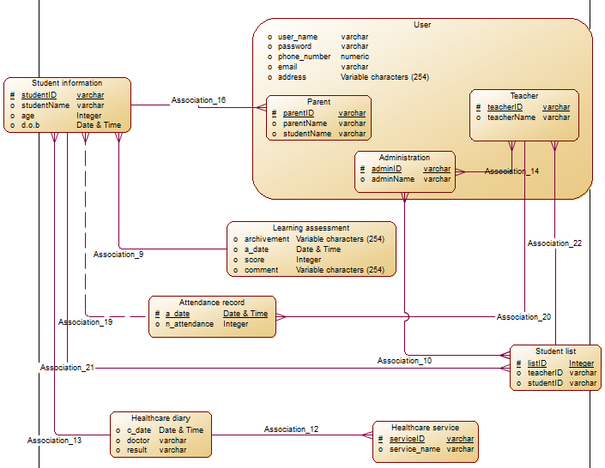

Diagram 3.2: ER diagram implemented from class diagram

Modifying Sequence Diagrams
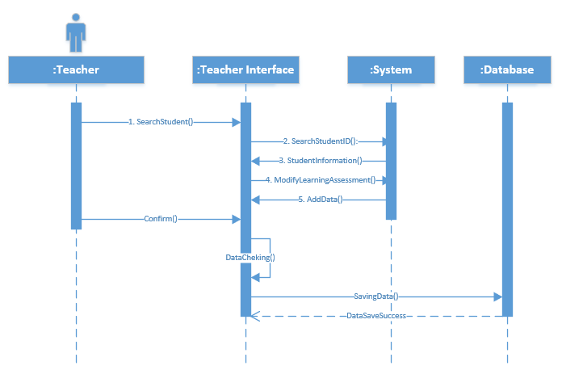

Diagram 3.3: Sequence diagram for teacher to update student Learning Assessment

Design A Demo Website

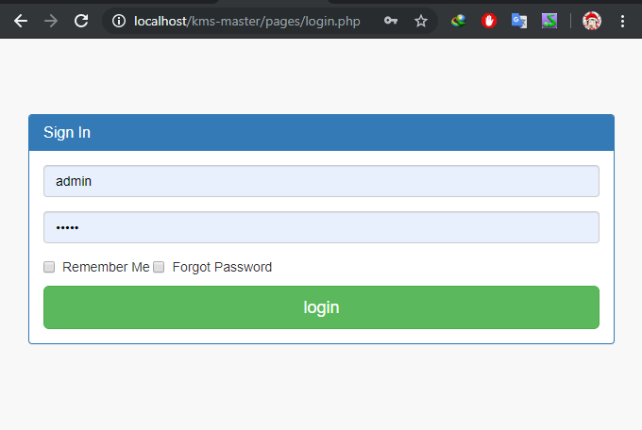
Image 3.4: Login page
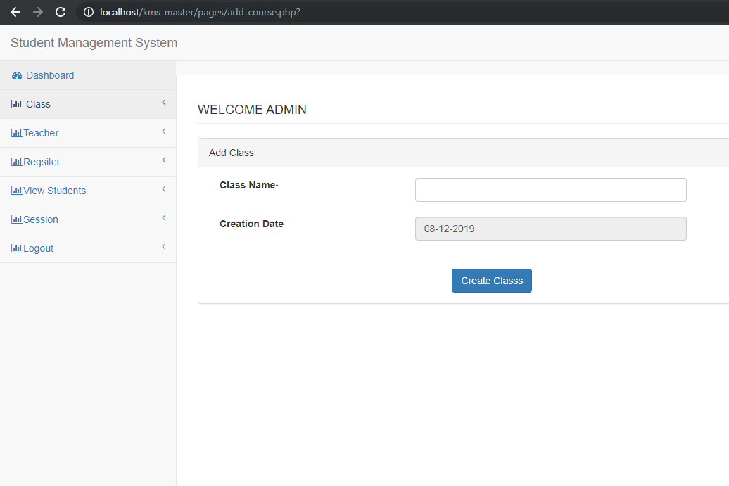
Image 3.5: Login with admin
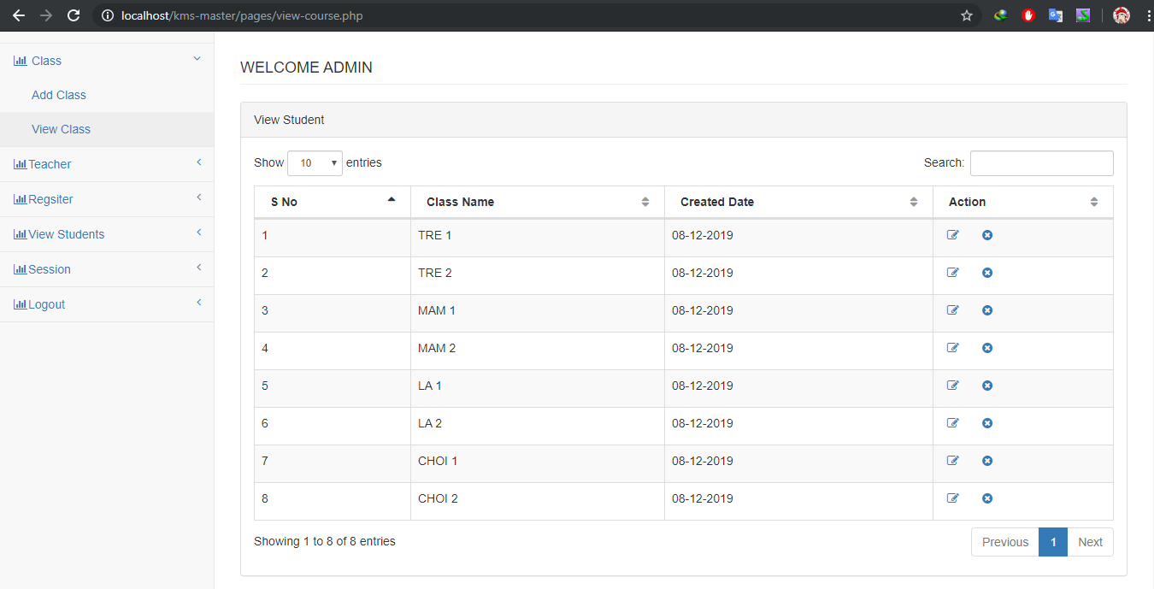
Image 3.6: Class management
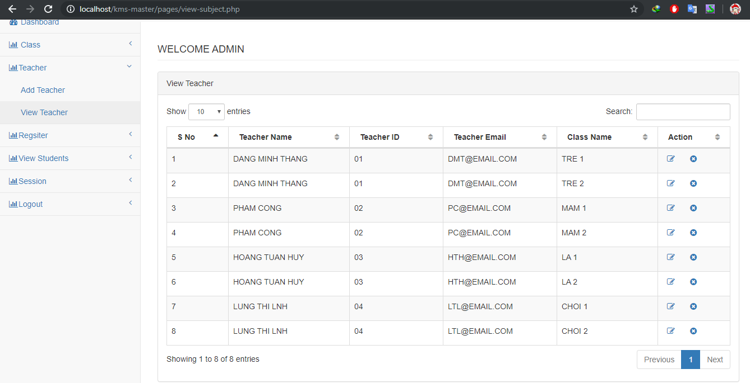
Image 3.7: Managing teacher list

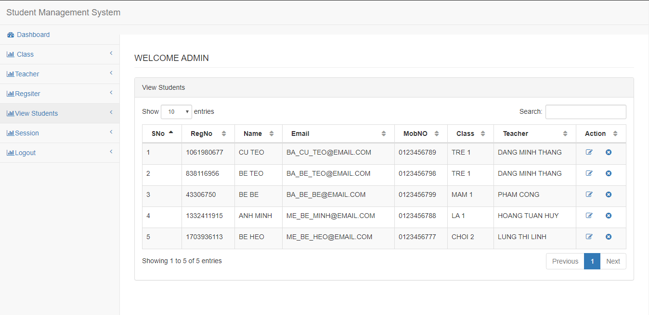
Image 3.8: Managing student list

Conclusions/ Recommendations
This kindergarten system is implemented to replace the currently used system.
This development system goals to raise for the need to change the system
The identified actors play an important role to the full functioning of the system development.

References
1. Slide Requirements Modelling
2. Book-MultiAuthor, Gra
3. Slide OnlineShopping_UMLSamples, Mr. P.T.K.Trung
4. Internet link:
- https://kipalog.com/posts/Design-bi-kip--Hoi-3---Sequence-than-cong
- https://iviettech.vn/viettech/1351-sequence-diagram-ban-ve-tuan-tu.html
- https://iviettech.vn/blog/1066-activity-diagram-ban-ve-hoat-dong.html
- https://iviettech.vn/blog/543-ban-ve-use-case-use-case-diagram.html
- https://iviettech.vn/blog/813-classs-diagarm-ban-ve-ve-classlop.html
-https://viblo.asia/p/phan-tich-thiet-ke-he-thong-thong-tin-su-dung-bieu-do-uml-phan-1-PjxMe6yNG4YL

