Searching for the image using “yondermakers/” as it was the only way to find the image.

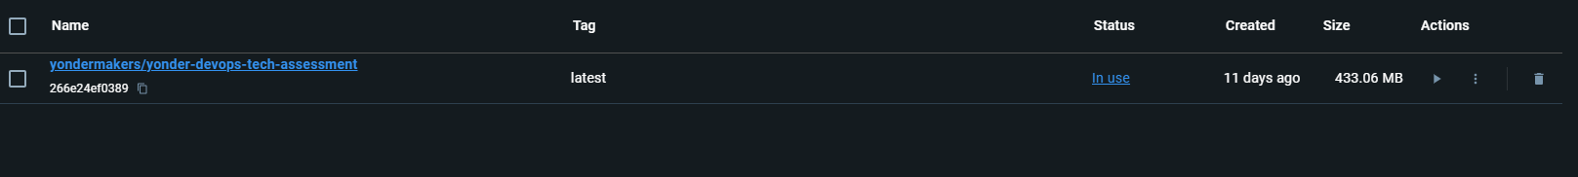

Loading the image and run it

Searching on youtube for docker tutorials so I can access the port 30000.

Link: <https://www.youtube.com/watch?v=6by0pCRQdsI>

Using Visual studio code. I have created the following 2 wrong containers

Created the correct container

Access the site.