Knowledge Management Project - Progress Report
La Nube Supermarket
Felix Yael
Student ID: AL07003384
Universidad Tecmilenio

1. Description of the Fictional Company
La Nube is a small neighborhood supermarket in Mexico that sells groceries, convenience products and fresh meat by the kilo at its own butcher counter. It operates two checkout registers, one butcher counter with a label scale and one local server inside the store. The store keeps selling even when the internet is down, and the owner checks sales from a phone. The organization is based on our team's GitHub repository insfra-super-la-nube, the point-of-sale system we are building for this store.
Element | Description
Type of organization | Retail - supermarket (mini super) with butcher counter
Core activities | Selling products at two registers, selling meat by weight, buying from suppliers, managing inventory and meat breakdown, customer credit, daily cash cut
Knowledge / documents handled | Manuals (cashier, owner, installation), reports (daily sales, margins, shrinkage, audit), sales documents (tickets, invoices, promotions, credit), inventory records (purchase orders, receipts, counts, kardex) and policies
People | Owner, manager, cashiers, butcher, technician, suppliers and customers

2. Knowledge Lifecycle Map
The map follows how knowledge moves through La Nube. It is a cycle: what the store learns in each round (reports, audit, incidents) feeds the next round of creation.
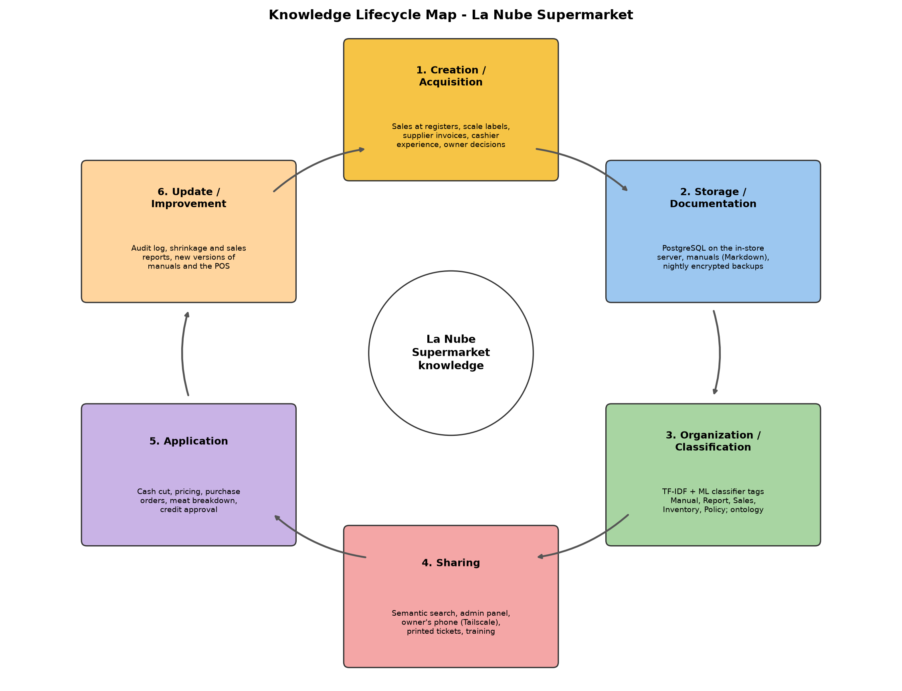
Figure 1. Knowledge lifecycle map of La Nube (diagrams/lifecycle_map.png).
Stage | How it happens at La Nube
Creation / acquisition | Each sale, scale label, supplier invoice and cash cut creates data; cashiers and the owner create experience (tacit knowledge) that is written into manuals.
Storage / documentation | PostgreSQL database on the in-store server; manuals in Markdown in the repository; nightly encrypted backups to a USB disk and cloud storage.
Organization / classification | Documents are tagged as Manual, Report, Sales, Inventory or Policy by the automatic classifier and linked to concepts through the ontology.
Sharing | Semantic search over documents, admin panel, owner's phone through Tailscale, printed tickets and training of new cashiers with the manuals.
Application | Knowledge is used in daily decisions: cash cut, pricing, purchase orders, meat breakdown and credit approval.
Update / improvement | Audit log, shrinkage and sales reports and incident reports show what to change; manuals and the POS get new versions.

3. Ontology / Conceptual Graph
The ontology (diagrams/la-nube-ontology.ttl, OWL in Turtle format, 96 triples) represents how knowledge is structured in the store. It has 12 main domain concepts, 5 document types under the class Document, 4 subclasses and 17 object properties. Example individuals link real documents of the corpus to concepts, e.g. D04 (Manual) describes the process CashClosing.
Element | Content
Main concepts | Employee, Customer, Product, Department, Supplier, Sale, Payment, CashRegister, CashCut, InventoryMovement, Process, Document
Subclasses | Cashier, Manager, Butcher (is-a Employee); MeatCut (is-a Product)
Document types | Manual, Report, SalesDocument, InventoryRecord, Policy (is-a Document)
Concept-concept relations | buys, contains, paidWith, recordedAt, operates, closes, belongsTo, supplies, changesStock, executes, authors
Document-concept relations | Manual describes Process; Policy regulates Process; Report summarizes Sale and cites CashCut; SalesDocument records Sale; InventoryRecord registers InventoryMovement
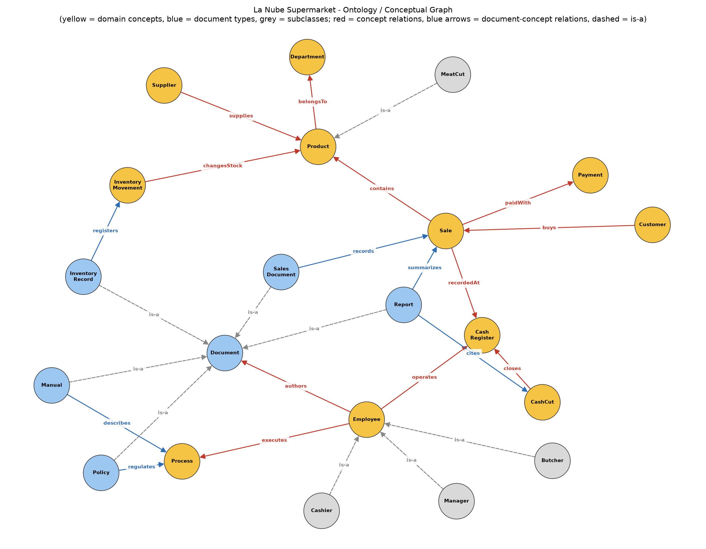
Figure 2. Conceptual graph of organizational knowledge (diagrams/ontology_graph.png).

4. How the Prototype Works
The corpus (data/documents.csv) has 50 sample documents written from the real processes of the POS repository, 10 for each category: Manual, Report, Sales, Inventory and Policy. Each document has an id, title, category and text.

4.1 Automated classification (prototype/classifier.py)
- Loads the 50 documents from the CSV file and joins title + text.
- Splits them into 70% training and 30% test, stratified by category (seed 42).
- Vectorizes the text with TF-IDF (English stop words removed, sublinear term frequency).
- Trains two simple models: Multinomial Naive Bayes (alpha=0.5) and Logistic Regression (C=10). The settings were selected with 5-fold cross-validation (practice exercise 2).
- Reports accuracy, precision, recall, F1 and a confusion matrix, and classifies 5 new documents.

4.2 Semantic search (prototype/semantic_search.py)
- Receives a natural-language query (command-line argument or demo queries).
- Converts the query into a TF-IDF vector with the vectorizer fitted on the documents (unigrams and bigrams).
- Calculates the cosine similarity between the query vector and every document vector.
- Shows the 3 most relevant documents with their similarity score and category.
Limitation: TF-IDF matches shared words, not meaning, so synonyms are missed ("debt" does not match "balance"). A next step is to use sentence embeddings for real semantic similarity.

5. Evidence of Prototype Development
All results below were produced by running make_doc.py, which executes each script. Images are captures of the console output.

5.1 Classification results
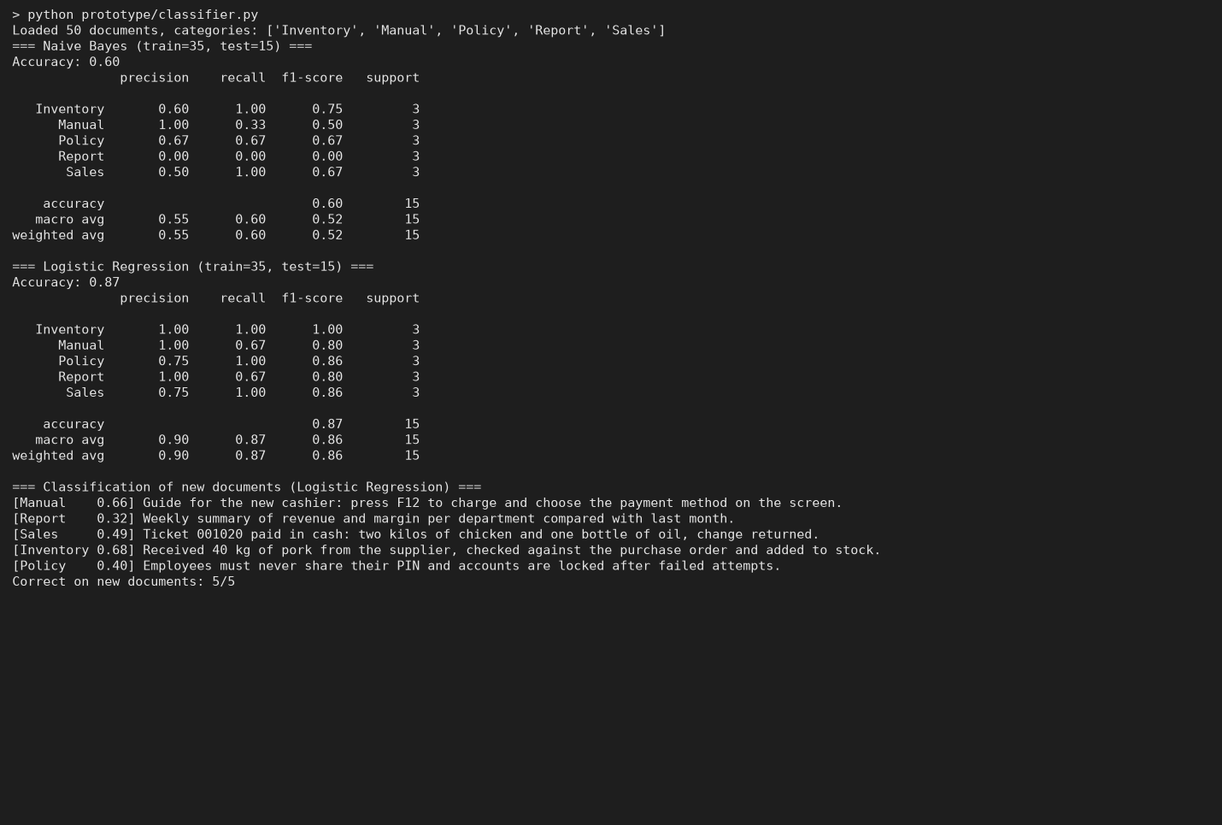
Figure 3. Console output of classifier.py.
Model | Hold-out accuracy (15 docs) | 5-fold CV accuracy
Naive Bayes | 0.60 | 0.78 +/- 0.15
Logistic Regression | 0.87 | 0.86 +/- 0.08
Logistic Regression is the better model: 0.87 accuracy on the test set and 5 of 5 new documents classified correctly. Naive Bayes confuses Reports with Sales because both talk about sales and registers. With only 35 training documents the scores vary a lot between splits, so the CV value is the more reliable estimate.
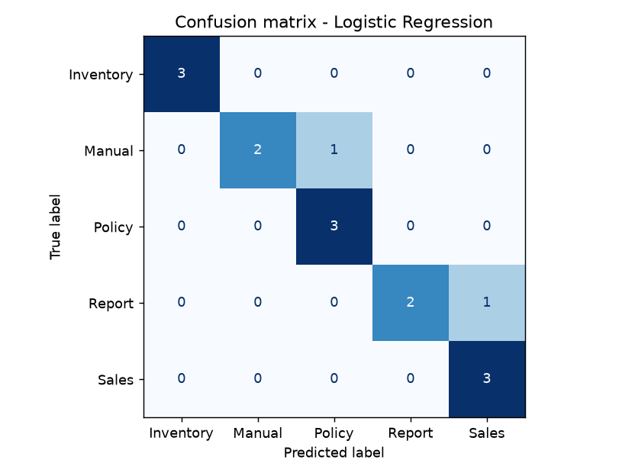
Figure 4. Confusion matrix - Logistic Regression.
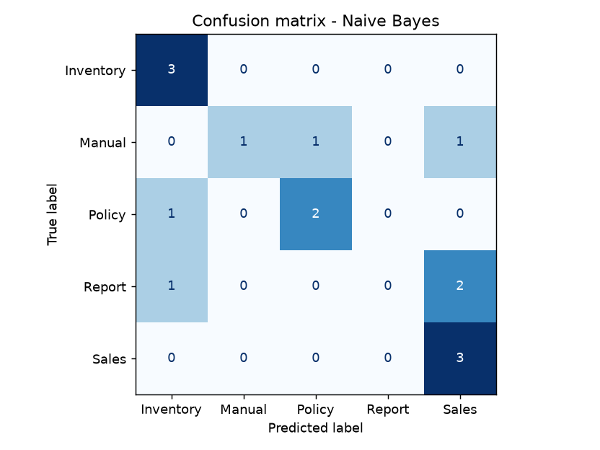
Figure 5. Confusion matrix - Naive Bayes.

5.2 Semantic search examples

Figure 6. Console output of semantic_search.py with the demo queries.

Figure 7. Free query typed by the user.
The query "how do I close the register at the end of my shift" returns the cash-cut manual (D04) first with a clear margin (0.44 vs 0.06). For "what happens if the internet goes down" it finds the offline policy and the troubleshooting manual, which use the words internet and selling.

6. Practical Exercises (Topics 1 to 6)
These exercises were done while building the project and shaped its decisions (practice/practice_exercises.py).
Topic | Activity and evidence
Topics 1-2: knowledge and its lifecycle | Identification of the knowledge and document types of La Nube and the lifecycle map (Figure 1).
Topic 3: conceptual representation | Ontology / conceptual graph in OWL (Figure 2); earlier ontology exercise for IT technical support used as a model.
Topic 4: text representation | Exercise 1: bag of words vs TF-IDF top terms per category.
Topic 5: classification tests | Exercise 2: 5-fold CV of Naive Bayes and Logistic Regression with unigrams vs bigrams; selected the prototype settings.
Topic 6: information retrieval | Exercise 3: precision@3 and MRR of the search on 8 queries with known relevant documents (mean P@3 = 0.71, MRR = 1.00).
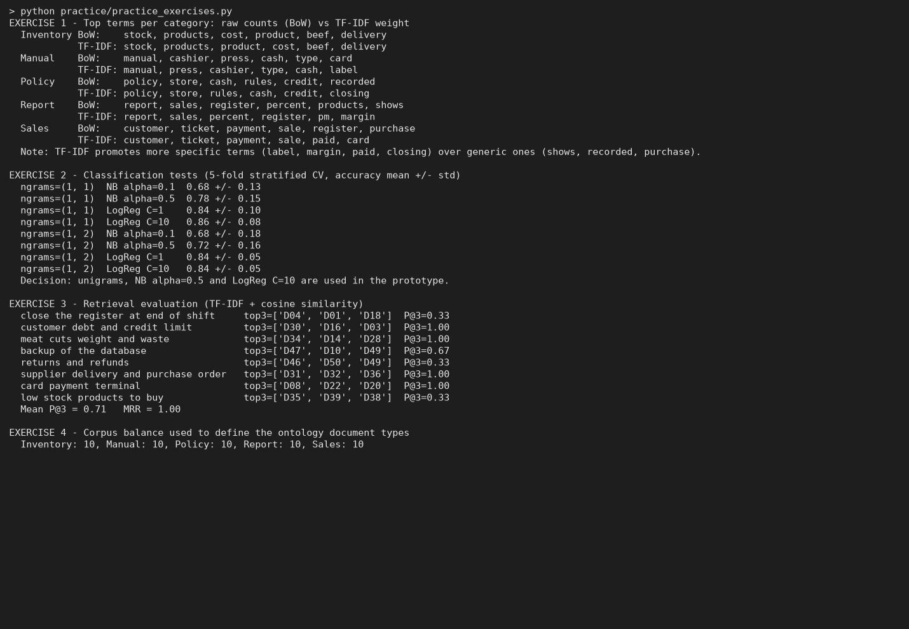
Figure 8. Console output of the practice exercises.
Exercise 3 shows that the first result is always relevant (MRR = 1.00) but some lists contain unrelated documents in positions 2-3, e.g. "returns and refunds" also returns the offline and pricing policies. This supports the planned move to embeddings and adding more documents per category.

7. Next Steps
- Grow the corpus with the real manuals and reports of the POS (Spanish) and retrain.
- Replace TF-IDF search with sentence embeddings for true semantic similarity.
- Use the ontology to expand queries (e.g. a search for "cash cut" also returns documents about CashRegister).
- Connect the classifier to the admin panel so new documents are tagged automatically.

