**A**

**PARTIAL**

**PROJECT REPORT**

**ON**

**“INTERACTIVE EDUCATION”**

Submitted By:

CHIRAAG PATIL

YUKTA YADAV

KAVERI CHAVAN

YURAJ GUND

**Fourth Year of Engineering**

**(Computer Engineering)**

Kavayitri Bahinabai Chaudhari

North Maharashtra University Jalgaon (M.S.)



Department of Computer Engineering

**Shri Gulabrao Deokar College of Engineering, Jalgaon**

[2022 – 2023]

**Shri Gulabrao Deokar College of Engineering, Jalgaon.**

**Department of Computer Engineering**

****

**“INTERACTIVE EDUCATION”**

Submitted By:

CHIRAAG PATIL

YUKTA YADAV

KAVERI CHAVAN

YURAJ GUND

In fulfillment of

**Fourth Year of Engineering**

**(Computer Engineering)**

Guided By:-

**Ms. Soniya P. Chaudhari**

[2022 – 2023]

**CERTIFICATE**

This is to certify that, Project submitted by,

CHIRAAG PATIL

YUKTA YADAV

KAVERI CHAVAN

YURAJ GUND

Is a bonafide work completed under my supervision and guidance in partial fulfillment of third year Engineering(Computer) of Kavayatri Bahinabai Chaudhari North Maharashtra University,Jalgaon.

**Place:** Jalgaon

**Date: / /**

**Mr. Hariom C. Agnihotri Ms. Soniya P. Chaudhari**

**HOD GUIDE**

**Dr. C. S. PATIL**

**PRINCIPAL**

**Shri Gulabrao Deokar College of Engineering, Jalgaoan**

**ACKNOWLEDGEMENT**

The successful completion of any task would not be complete without expression of

gratitude to all those who helped in doing that task. we hereby take this opportunity to express our heartfelt gratitude towards the people whose help proved useful to complete my partial project work on **“INTERACTIVE EDUCATION ”.**

First we wish to express our gratitude and sincere thanks to our principal **Dr. C. S. Patil;** who gives us opportunity to completing this project report.

Our special thanks to **Ms. Soniya P. Chaudhari** for her valuable suggestions in project

topic. She always helps in every difficulty. In particular, we are thankful to all our staff members of Computer Engineering Department for their whole hearted Co-operation. We are thankful to our parents for their blessings and their valuable moral support. Without their support we cannot do anything.

Last but not least. We are very much thankful to our friends for supporting us in development of this project.

CHIRAAG PATIL

YUKTA YADAV

KAVERI CHAVAN

YURAJ GUND

(BE Computer)

**ABSTRACT**

Learning methods play an important role and receive special attentions in our life. We live in digital era, where everyone wants something efficient, effective, dynamic, fast and interactive. The term ‘interactive’ appears in two distinct strands of educational research discourse: one concerning pedagogy and the other concerning new technologies in education. Teaching students with traditional method where there is only one way of communication is no longer effective. The word interactive is the key to have an effective and efficient teaching and learning process where the teacher can grab students’ attention and students can learn more in comparison to that of the traditional method.

**Interactive Learning** is a [pedagogical](https://en.wikipedia.org/wiki/Pedagogy" \o "Pedagogy) approach that incorporates [social networking](https://en.wikipedia.org/wiki/Social_networking" \o "Social networking) and [urban computing](https://en.wikipedia.org/wiki/Urban_computing" \o "Urban computing) into course design and delivery. Interactive Learning has evolved out of the hyper-growth in the use of digital technology and virtual communication, particularly by students. Beginning around 2000, students entering institutes of higher education have expected that interactive learning will be an integral part of their education. The use of interactive technology in learning for these students is as natural as using a pencil and paper was to past generations.

The use of technology can be a key element in strengthening the art of independent learning. The proposed system discusses the issues in creating an interactive educational environment, most suited to children. We introduce the features of the interactive learning; a software which is an integration of teaching, training, testing, learning, analyzing, and mastering; with a high level of interactivity. We have in the course defined a simulation of video lectures, notes and uses Augmented reality for the learning process.

The term ‘interactive’ appears in two distinct strands of educational research discourse: one concerning pedagogy and the other concerning new technologies in education. Teaching students with traditional method where there is only one way of communication is no longer effective. The word interactive is the key to have an effective and efficient teaching and learning process where the teacher can grab students’ attention and students can learn more in comparison to that of the traditional method.

# In order to be effective, learning institutions must see computers and associated technology as an essential part of the student. In other words, technology must be seen as cognitive prosthetics. The core concept of [distance education](https://en.wikipedia.org/wiki/Distance_education" \o "Distance education) is that the real world becomes the learning environment; in this environment, the purpose of the instructor is to help facilitate the absorption of knowledge through both real-world and virtual learning experiences.

# Index

|  |  |  |  |  |
| --- | --- | --- | --- | --- |
| Sr.no | | | Contents | Page No |
|  |  |  | Acknowledgement | iv |
|  |  |  | Abstract | v |
| 1 |  |  | Introduction | 8 |
|  | 1.1 |  | Background | 9 |
|  | 1.2 |  | Motivation | 9 |
|  | 1.3 |  | Problems with Online Learning Envirnoments | 9 |
|  | 1.4 |  | Scope | 12 |
|  | 1.5 |  | Objective | 12 |
| 2 |  |  | Project Planning and Management | 14 |
|  | 2.1 |  | Existing System | 14 |
|  | 2.2 |  | Proposed System | 14 |
|  | 2.3 |  | **Analysis model** | 15 |
|  | 2.4 |  | Feasibility Study | 16 |
|  |  | 2.4.1 | Technical Feasibility | 17 |
|  |  | 2.4.2 | Economic Feasibility | 17 |
|  |  | 2.4.3 | Operational Feasibility | 17 |
|  | 2.5 |  | Risk Analysis | 18 |
|  | 2.6 |  | Project Planning And Scheduling | 21 |
|  | 2.7 |  | Cost Estimation | 23 |
| 3 |  |  | Analysis | 25 |
|  | 3.1 |  | Software Requirements Specification | 27 |
|  | 3.2 |  | Functional Requirements | 28 |
|  | 3.3 |  | Non-Functional Requirements | 29 |
|  | 3.4 |  | Requirements analysis | 31 |
|  | 3.5 |  | Requirements Specification | 32 |
|  | 3.6 |  | Software Requirements | 32 |
|  | 3.7 |  | Hardware Requirements | 33 |
| 4. |  |  | Design | 34 |
|  | 4.1 |  | Introduction | 34 |
|  | 4.2 |  | Object oriented analysis | 36 |
|  | 4.3 |  | Uml model | 39 |
|  |  | 4.3.1 | Data flow diagram | 40 |
|  |  | 4.3.4 | Class diagram | 43 |
| 5 |  |  | Conclusion | 44 |
| 6 |  |  | Future work | 45 |
| 7 |  |  | appendix | 46 |
|  | 7.1 |  | Software description(technical description) | 46 |
| 8 |  |  | Reference | 51 |

# INTRODUCTION

Learning methods play an important role and receive special attentions in our life. We live in digital era, where everyone wants something efficient, effective, dynamic, fast and interactive. The term ‘interactive’ appears in two distinct strands of educational research discourse: one concerning pedagogy and the other concerning new technologies in education. Teaching students with traditional method where there is only one way of communication is no longer effective. The word interactive is the key to have an effective and efficient teaching and learning process where the teacher can grab students’ attention and students can learn more in comparison to that of the traditional method.

Online learning is the use of digital tools for learning. Learning management systems and distance education are among the most prevalent tools. However, hybrid experiences and collaborations are changing the online -learning landscape. Recent developments include the advent of social networking and online learning communities, the ubiquitous presence of smart phones, and an increased recognition of the potential for computer games to transform learning.

the application is reduced as much as possible to avoid errors while entering the data.it also provide error message while entering invalid data.no formal knowledge is needed for the user to use this system. thus by this it proves it is user -friendly .

In order to be effective, learning institutions must see computers and associated technology as an essential part of the student. In other words, technology must be seen as cognitive prosthetics. The core concept of [distance education](https://en.wikipedia.org/wiki/Distance_education" \o "Distance education) is that the real world becomes the learning environment; in this environment, the purpose of the instructor is to help facilitate the absorption of knowledge through both real-world and virtual learning experiences. Historically, one of the obstacles to [distance education](https://en.wikipedia.org/wiki/Distance_education" \o "Distance education) is the lack of face to face contact. The use of technology as an integral part of course design has attempted to compensate in both synchronous and asynchronous settings.

For delivery of synchronous content, technologies such as [videoconferencing](https://en.wikipedia.org/wiki/Videoconferencing" \o "Videoconferencing) and [web conferencing](https://en.wikipedia.org/wiki/Web_conferencing" \o "Web conferencing) are typically used. An example of this is the growing use of [Skype](https://en.wikipedia.org/wiki/Skype" \o "Skype) and [GoToMeeting](https://en.wikipedia.org/wiki/GoToMeeting" \o "GoToMeeting) for virtual class discussions and lectures.

For asynchronous content delivery, course designers use a variety of software suites that include various types of interactive elements. Programs such as [WebCT](https://en.wikipedia.org/wiki/WebCT" \o "WebCT), [Knowledge Forum](https://en.wikipedia.org/wiki/Knowledge_Forum" \o "Knowledge Forum), [First Class](https://en.wikipedia.org/wiki/FirstClass" \o "FirstClass) and [Blackboard Learning System](https://en.wikipedia.org/wiki/Blackboard_Learning_System" \o "Blackboard Learning System) attempt to ameliorate the lack of contact with online discussion forums and bulletin boards.

* 1. **Background**

Interactive learning is a technique that seeks to get students actively engaged in the learning process, often through the use of technology. This is in contrast to more passive techniques like the traditional lecture.

While the technological part of interactive learning can be intimidating to some, it is important to remember that technology exists to support pedagogy, not the other way around. With that in mind, instructors should evaluate educational technology with an eye toward tools that open up exciting possibilities for their lessons and enhance learning for their students.

## **1.2 Motivation**

Education seems to be constantly changing. Students are no longer expected to sit at a desk and take notes on a lecture. Lessons are much more engaging and interactive.

Interactive learning is a hands-on, real-world approach to education. According to Stanford University School of Medicine, 'Interactive learning actively engages the students in wrestling with the material. It reinvigorates the classroom for both students and faculty. Lectures are changed into discussions, and students and teachers become partners in the journey of knowledge acquisition.

Interactive learning can take many different forms. Students strengthen their critical thinking and problem-solving skills using a much more holistic approach to learning.

## **1.3 Problems with Online Learning Environments**

**1. Lack of Motivation in Students**

It was thought that online learning would be the new interactive and immersive method to teach the new generation of students. Though, the results speak on the contrary. Endless oceans of texts, quizzes, frequent learning assignments and MCQ’s have led to students losing motivation to keep revisiting the learning portal.

Students complain of lacking motivation due to a lack of interpersonal touch between the students and the teacher in the online classes. The need for physical interaction between the students is also a necessity for maintaining engagement which the online learning methodology has no answers for yet. Institutions need to [deliver interactive lessons](https://www.hurix.com/how-to-develop-and-deliver-interactive-lessons-for-higher-education/" \t "https://www.hurix.com/what-are-the-biggest-challenges-facing-online-education-today/_blank) to students.

**2. Infrastructural Problems**

Though online learning doesn’t require huge buildings, big classrooms, chairs, tables, blackboards, chalk doesn’t mean there are no infrastructural requirements. The need for a computer, adequate software, constant electricity and high-bandwidth internet is quite a big demand.

In most developed nations, this infrastructure is available to the public through public libraries if they cannot personally afford it. But for developing countries such as India, Pakistan, Bangladesh and many others, this quality of infrastructure is only available to a select few percent of the population.

**3. Digital Literacy and Technical Issues**

Though the new generation is proficient in working with computers doesn’t necessarily translate to Digital Literacy. To proficiently learn through an online system requires understanding the workings of multiple software, which presents a huge learning curve. Also, students need to understand online communication etiquette and know student rights and responsibilities in an online learning environment.

A bigger problem is with constant technical issues faced by both teachers and students on these platforms. These problems often require technical support to rectify, causing frequent disruption in the learning flow.

**4. Lack of In-person Interaction**

Humans are social animals. The growth of the internet hinged on the principle that humans will always be curious to interact and know more about one another. That said, on a psychological level, virtual interaction cannot mimic that of a physical one.

The physical presence inside a classroom with a teacher and fellow peers often leads to an atmosphere that can’t be replicated through virtual means. The physical model also ensures discipline as students cannot switch off webcams and doze off. Physical classrooms also allow for teachers to provide more personal attention to each student’s needs. However, [interactive eLearning modules](https://www.hurix.com/interactive-elearning-modules-user-engagement/" \t "https://www.hurix.com/what-are-the-biggest-challenges-facing-online-education-today/_blank)can help improve student engagement.

**6. Lack of EdTech and Online Learning Options for Special Needs of Students**

The segment of students who have been completely ignored in the evolution of online learning is students with special needs. Special needs students need a more personalized and hands-on method of teaching.

Though technology has improved drastically, it is still heavily dependent on the need for an expert or a teacher to be there full-time to guide the student through the tasks. These problems have caused special needs students to fall behind others in their academic pursuits.

**7. Course Structure and Quality**

The shift to online learning and other modern teaching tools was thought to bring about a modernization even in the course curriculum and structure. Sadly, that hasn’t been the case. Institutions have retained their obsolete [course curriculum and structure](https://www.hurix.com/role-of-technology-in-higher-education-curriculum-development/" \t "https://www.hurix.com/what-are-the-biggest-challenges-facing-online-education-today/_blank)even after shifting online. With companies such as Google and Tesla choosing to forego college as a prerequisite for employment, students are reconsidering college as a whole.

Online resources such as YouTube, Goggle, Skillshare, Udemy and others offer better content on these subjects for cheaper or even free. These platforms also let them pick and choose their subjects, making the learning structure highly flexible. This should cause Educational Institutions to rethink their approach to teaching as a whole.

**8.  Lack of Accredited Degrees From Top Universities**

 Education has more to do about branding than learning. It matters more from where you studied than what you studied. In such a market where the brand is a huge factor, the online learning sphere is yet to convince prestigious higher learning institutions to offer their courses through online/ distance learning modes.

The online courses for degrees are often not accredited and mostly not recognized by the job market or other institutions. Though schools have embraced the online learning system, the higher educational institutions and the governments have yet to recognize them as legitimate methods of obtaining a professional degree.

**9. Abundant Distractions, Lack of Discipline**

With recurrent technical issues, bandwidth problems and monotonous lectures, online attendance has seen a drastic dip. Most students find learning online boring and often complain of lacking the motivation to make it through a class. Even teachers often complain of a lack of tools to make the classes engaging, leading to a loss of interest from both parties.

With the lack of any accountability in the online teaching method, education quality often becomes compromised. Coupled with the free use of laptops and mobile phones during classes, distractions have become countless, often coming at the cost of focusing during class.

**Conclusion**

Where there is a problem,  there is always a solution. The current Edu Tech system in the online learning segment has many shortcomings not limited to the list above. That said, the segment is relatively young and even so has improved leaps and bounds. The online education world has multiple upsides and will make education cheaper and more widely available. Gone are the days of fixed curriculums and rigid subject choices as the new generation of students demands greater freedom in their education. Yet, the biggest hurdle that EdTech has to overcome is replicating the charm of in-person learning and making the experience more immersive as technical difficulties often get smoothened out over time.

## **1.4 Scope**

* Online learning a wide platform to help students get more education
* With interactive learning the concept of learning become easier.
* Students are highly enthusiastic about the concept of online learning .they get a chance to showcase their skills and capabilities in an interactive and advanced environment.
* It satisfy the user requirement.
* Be easy to understand by the user and operator.
* Be easy to operate.
* Have a good user interface.

## 

## **1.5 Objective:**

Our aprroch to solving this problem is that we create a applications that is both educational and fun to use. One that will reward and punish based on your performance.

Step 1 -

Create a 3d interactable envirnment which student can roam around in.

Step 2 -

Integrate lectures ,3d models and various academic stuff with in the envirnoment.

Step 3 -

Create a Augmented reality experience so students can learn through interactive learning.

Step 4 -

Create a testing and rewards based system.

Step 5 -

Polish the experience.

What will this do??

This approch will solve the problem related to boredom and obselete knowledge as students will be engaged thanks to the way mechanics are done and they will also intreact with 3d real life models thanks to AR.

Also as smartphones are much more widely avaliable than laptops this will solve the hardwware issue as well.

# **2.Project Planning and Management**

## **2.1 Existing System**

An existing software system is any software application that is currently in use. It includes everything from newly released software to those that have existed for years.

The present system the student cant directly interact with the system.

The existing system is-

* As Current System is Window base So It’s Very Difficult.
* Time-consuming Problem.
* Only One Person is work at a time.
* Difficult to Work For E-Learning Time Duration.
* Student can't interact with the syetem.

## 

## **2.2 Proposed System**

The aim of proposed system is to develop a system is to develop a system which can help the students to learn and understand the concept without getting bored.

* Better service.
* Minimum time required.
* User friendliness and interactive.
* Greater efficiency
* Minimum time needed for the various processing.

## **2.3 Analysis model**

Analysis Model is a technical representation of the system. It acts as a link between system description and design model. In Analysis Modelling, information, behavior, and functions of the system are defined and translated into the architecture, component, and interface level design in the design modeling.

Objectives of Analysis Modelling:

* It must establish a way of creating software design.
* It must describe the requirements of the customer.
* It must define a set of requirements that can be validated, once the software is built.

The goal of system design is to produce a model or representation that exhibit,

commodity and delight. It provides information about the application domain for the software to be built. It fully describes the internal details of each software.

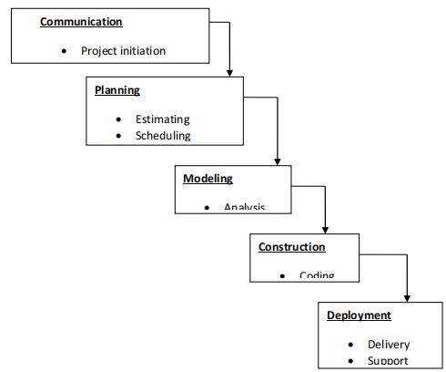

**Communication**

The first and foremost step is to know thoroughly about the demands of customers and other stakeholders. It is to assure all the necessary information is gathered. The client is also made aware of the [Software Development Process](https://blog.wadic.net/agile-software-development-limitations/). Penning down all requirements decides about the specific development process.

**Planning**

This development step contains the making of the idea, gathering suggestions, deciding timelines, technical procedures and working schedules. It demands the proper research about the product value, the targeted audience of the product, and its symmetry to your client’s business requirements. Linear sequential model of **Software Development** is the best option for smaller projects. Thorough planning is the demand of waterfall methodology. If the issue raises, there might be chances of restarting the development process from scratch.

**Modeling**

At this step, there is a need for a proper map to **Project Development**. Having all requirements, info, and ingredients to construct the product, then it’s time for you to have a timeline to better understand the demands and design to achieve these requirements. This stage will help you to choose the employment of the technologies and services you will be needing in the development process.

The central focus behind this road map is to have the understanding to build a robust infrastructure and user-friendly application. A mock-up model of the project will guide you with the vision about the inner structure and the user interface of the product. It will also help you in choosing the user-friendly and attractive design the application to target the maximum relative audience. Effective and healthy planning is an essential step to plan out how time and money is going to be spent on the project.

**Construction**

The entire process is broken into sequential stages. It’s vital to finish each phase successfully as a way to move onto the next one. All kinds of testing methods are essentially carried out during the validation approach.

**Deployment**

Once the functional and non-functional testing is done; the product is deployed in the customer environment or released into the market

## **2.4 feasibility study**

It is the high level capsule version of the entire requirement analysis

process. The objective of feasibility study is to determine whether the proposed system can be developed with available resources.

A feasibility study is an analysis that considers all of a project's relevant factors—including economic, technical, legal, and scheduling considerations—to ascertain the likelihood of completing the project successfully.

Whether a project is feasible or not can depend on several factors, including the project's cost and [return on investment](https://www.investopedia.com/terms/r/returnoninvestment.asp), meaning whether the project generated enough [revenue](https://www.investopedia.com/terms/r/revenue.asp) or sales from consumers.

However, a feasibility study isn't only used for projects looking to measure and forecast financial gains. In other words, feasible can mean something different, depending on the industry and the project's goal. For example, a feasibility study could help determine whether a hospital can generate enough donations and investment dollars to expand and build a new cancer center.

Although feasibility studies can help project managers determine the risk and return of pursuing a plan of action, several steps and best practices should be considered before moving forward.

There are three steps to be followed for determining feasibility study of proposed systems.

➢Technical feasibility

➢Operational feasibility

➢Economical feasibility

#### **Technical Feasibility**-

A large part of determining resources has to do with assessing technical feasibility. It considers the technical requirements of the proposed project. The technical requirements are then compared to the technical capability of the organization. The systems project is considered technically feasible if the internal technical capability is sufficient to support the project requirements.  
The analyst must find out whether current technical resources can be upgraded or added to in a manner that fulfills the request under consideration.  This is where the expertise of system analysts is beneficial, since using their own experience and their contact with vendors they will be able to answer the question of technical feasibility.

The proposed system included the study of complete functionality to be provided in the system, as described in the system requirement specification (SRS) .

#### **Operational Feasibility-**

Operational feasibility is a measure of how well a proposed system solves the problems, and takes advantage of the opportunities identified during scope definition and how it satisfies the requirements identified in the requirements analysis phase of system development.  
Operational feasibility reviews the willingness of the organization to support the proposed system. This is probably the most difficult of the feasibilities to gauge. In order to determine this feasibility, it is important to understand the management commitment to the proposed project.

No doubt the proposed system is fully 3d based that is very user friendly and all inputs to be taken all self-explanatory .besides, a proper training has been conducted to let know the essence of the system to the users so that they feel comfortable with new system.

#### **Economic Feasibility-**

This includes an evaluation of all incremental costs and benefits expected if proposed

system is implemented. Costs-benefit analysis which is to be done during economical

feasibility delineates costs for project development and weighs them against system

benefits. The system adds information of colleges and companies for which colleges

and companies pays as it provides their information as well as company jobs. So

developing this system is economically feasible.

Economic analysis could also be referred to as cost/benefit analysis. It is the most frequently used method for evaluating the effectiveness of a new system. In economic analysis the procedure is to determine the benefits and savings that are expected from a candidate system and compare them with costs. If benefits outweigh costs, then the decision is made to design and implement the system. An entrepreneur must accurately weigh the cost versus benefits before taking an action.

This is very important aspect to be considered while developing a project. We decided the technology based on minimum possible cost factor.

* All the hardware and software cost has to be borne by the organization.
* Overall we have estimated that the benefits the organization is going to receive from the proposed will surely overcome the initial coats and the later on running cost for system.

## 

## **2.5 Risk Analysis**

## Risk Analysis-

Risk analysis is the process of assessing the likelihood of an [adverse event](https://www.investopedia.com/terms/m/maximum-foreseeable-loss.asp) occurring within the corporate, government, or environmental sector. Risk analysis is the study of the underlying uncertainty of a given course of action and refers to the uncertainty of forecasted [cash flow](https://www.investopedia.com/terms/c/cashflow.asp) streams, the variance of portfolio or stock returns, the probability of a project's success or failure, and possible future economic states.

Risk analysts often work in tandem with forecasting professionals to minimize future negative unforeseen effects. All firms and individuals face certain [risks](https://www.investopedia.com/terms/r/risk.asp); without risk, rewards are less likely. The problem is that too much risk can lead to failure. Risk analysis allows a balance to be struck between taking risks and reducing them.

Risk assessment enables corporations, governments, and investors to assess the probability that an adverse event might negatively impact a business, economy, project, or [investment](https://www.investopedia.com/terms/i/investment.asp).  Assessing risk is essential for determining how worthwhile a specific project or investment is and the best process(es) to mitigate those risks. Risk analysis provides different approaches that can be used to assess the [risk and reward tradeoff](https://www.investopedia.com/terms/r/riskreturntradeoff.asp) of a potential investment opportunity.

A risk analyst starts by identifying what could potentially go wrong. These negatives must be weighed against a probability metric that measures the likelihood of the event occurring.

Finally, risk analysis attempts to estimate the extent of the impact that will be made if the event happens. Many risks that are identified, such as [market risk](https://www.investopedia.com/terms/m/marketrisk.asp), credit risk, currency risk, and so on, can be reduced through [hedging](https://www.investopedia.com/trading/hedging-beginners-guide/) or by purchasing insurance.

Almost all sorts of large businesses require a minimum sort of risk analysis. For example, commercial banks need to properly hedge foreign exchange exposure of overseas loans, while large department stores must factor in the possibility of reduced revenues due to a global [recession](https://www.investopedia.com/terms/r/recession.asp). It is important to know that risk analysis allows professionals to identify and mitigate risks, but not avoid them completely.

**RISK IDENTIFICATION-:** Risk management involves Risk Identification, Risk

Analysis and Risk Prioritization; while Risk protection involves Risk Management Planning, Risk Resolution and Risk Monitoring

R1: Illiterate to project management skills

R2: Unfamiliar to the programming language, e.g. Advanced Java

R3: Unfamiliar to concept of project.

R4: Unfamiliar to software tools.

R5: Given that the technical experience among project members is limited,

there is concern that the size estimate may drift considerably resulting in schedule overruns.

R6: N/W Hardware cannot integrated easily, requiring redesign and rework.

## Risk Management-

Risk management is the process of identifying, assessing and controlling threats to an organization's capital and earnings. These risks stem from a variety of sources including financial uncertainties, legal liabilities, technology issues, strategic management errors, accidents and natural disasters.

A successful risk management program helps an organization consider the full range of risks it faces. Risk management also examines the relationship between risks and the cascading impact they could have on an organization's strategic goals.

**RISK IDENTIFICATION** Risk management involves Risk Identification, Risk

Analysis and Risk Prioritization; while Risk protection involves Risk Management Planning, Risk Resolution and Risk Monitoring

R1: Illiterate to project management skills

R2: Unfamiliar to the programming language, e.g. Advanced Java

R3: Unfamiliar to concept of project.

R4: Unfamiliar to software tools.

R5: Given that the technical experience among project members is limited,

there is concern that the size estimate may drift considerably resulting in schedule overruns.

R6: N/W Hardware cannot integrated easily, requiring redesign and rework

## Risk Projection-

Risk Projection involves Risk Management Planning, Risk Resolution and Risk

Monitoring

**Preparing risk table -**

•**ST:** Staff related size and experience

• **TE**: Technology to be built related

• **DE**: Development Environment

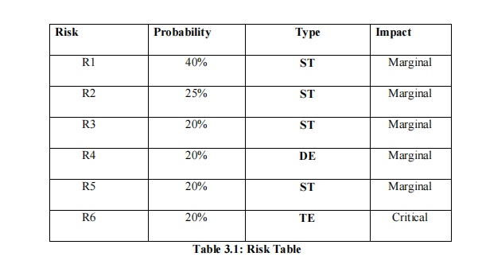

**Risk table along with RMMM plan-**

This Risk Mitigation Monitoring and Management Plan identify and documents the

risks associated with Project. In addition to project risks and technical risks, business risks are also identified, analyzed and documented.

**Risk Management and Risk Mitigation** is the process of identifying, assessing, and mitigating risks to scope, schedule, cost and quality on a project.  Risks come in the form of opportunities and threats and are scored on probability of occurrence and impact on project.

A defined and documented process agreed upon by project stakeholders for how risks will be identified, assessed, a decision made on mitigation (or if the risks will be accepted), how a response plan will be developed and what controls will be put in place to monitor risks over the duration of the project.

**Risk management** is the identification, evaluation, and prioritization of [risks](https://en.wikipedia.org/wiki/Risk" \o "Risk) (defined in [ISO 31000](https://en.wikipedia.org/wiki/ISO_31000" \o "ISO 31000) as the effect of uncertainty on objectives) followed by coordinated and economical application of resources to minimize, monitor, and control the probability or impact of unfortunate events[[1]](https://en.wikipedia.org/wiki/Risk_management" \l "cite_note-Risk_Management_pg._46-1) or to maximize the realization of opportunities.

Risks can come from various sources including uncertainty in [international markets](https://en.wikipedia.org/wiki/Market_environment" \o "Market environment), threats from project failures (at any phase in design, development, production, or sustaining of life-cycles), legal liabilities, credit risk, accidents, [natural causes and disasters](https://en.wikipedia.org/wiki/Natural_disaster" \o "Natural disaster), deliberate attack from an adversary, or events of uncertain or unpredictable [root-cause](https://en.wikipedia.org/wiki/Root_cause_analysis" \o "Root cause analysis).

Both generic and product-specific risks have been considered. In addition to identification, this document outlines the proactive strategy that is adopted to avoid these risks.

A contingency plan is also prepared for each risk, in case it becomes a reality. Only those risks have been treated whose probability and impact are relatively high, i.e. above a referent level.

**2.6 Project Planning And Scheduling**

Project planning:

Software project plan can be viewed as the following:

1. Within the organization: how the project is the be implemented? What are various constraints (Time, cost, staff)?
2. With respect to the customer: Weekly or timely meeting with the customer with presentation on status reports. customers feedback is also taken and further modification and developments are done.

For a successful software project, the following steps can be followed:

* Select a project

1. Identifying projects aims and objective
2. Understanding requirements and specification
3. Methods of analysis, design and implementation
4. Testing techniques
5. Documentation

* Project milestone and deliverables
* Budget allocation

1. Exceeding limits within control

* Project estimates

1. Cost
2. Time
3. Size of code
4. Duration

* Resource allocation

1. Hardware
2. Software
3. Previous relevant project information
4. Digital library

**Project scheduling**

An elementary gantt chart or timeline chart for the development plan is given below.

The plan explains the tasks versus the time ( in weeks) they will take to complete.

## 

|  |  |  |  |  |  |  |  |  |  |  |  |  |
| --- | --- | --- | --- | --- | --- | --- | --- | --- | --- | --- | --- | --- |
|  | **August** | | | | **September** | | | | **October** | | | |
| **Requirement**   **gathering** |  | | | |  | | | |  | | | |
| **Analysis** |  | | | |  | | | |  | | | |
| **Design** |  | | | |  | | | |  | | | |
|  | W1 | W2 | W3 | W4 | W1 | W2 | W3 | W4 | W1 | W2 | W3 | W4 |

## **2.7 Cost Estimation**

Effective software project estimation is one of the challenging and important activities

in software development. Proper project planning and control is not possible without sound and reliable estimate.

The four basic steps in software project estimation are:

a. Estimate the size of development product. The units of measure are lines of code (LOC) and function point (FP).

b. Estimate the effort in person-months or person-hours.

c. Estimate the schedule in calendar months.

d. Estimate the project cost in rupees.

Estimated Cost For Development

This system comes under “Object Oriented” approach, because Python is used which is an object oriented language and also it is used as front end.

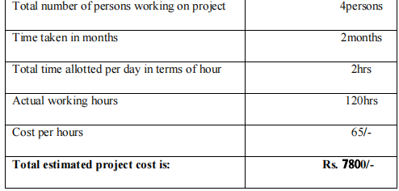

**Basic COCOMO**

Basic COCOMO computes software development effort (and cost) as a function of

program size. Program size is expressed in estimated thousands of source lines of code (SLOC) COCOMO applies to three classes of software projects:

• Organic projects - "small" teams with "good" experience working with "less than rigid" requirements.

• Semi-detached projects - "medium" teams with mixed experience working with a mix of rigid and less than rigid requirements.

• Embedded projects - developed within a set of "tight" constraints. It is also combination of organic and semi-detached projects.(hardware, software, operational, ...)

The basic COCOMO equations take the form

1. Effort Applied (E) = ab (KLOC)bb [ man-months ]

2. Development Time (D) = cb (Effort Applied)db [months]

3. Average staff = ( Effort)/(development time )

4. productivity = ( kloc) /Effort

where, KLOC is the estimated number of delivered lines (expressed in thousands ) of code for project. The coefficients ab, bb, cb and db are given in the following table:

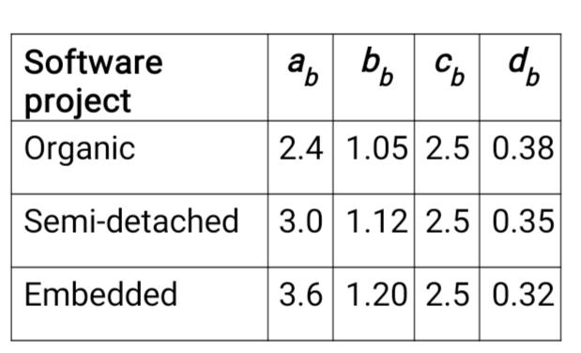

Basic COCOMO is good for quick estimate of software costs. However it does not account for differences in hardware constraints, personnel quality and experience, use of modern tools and techniques, and so on.

**Temporary Estimations using COCOMO model:**

1) Efforts:

Effort=a(kloc)b

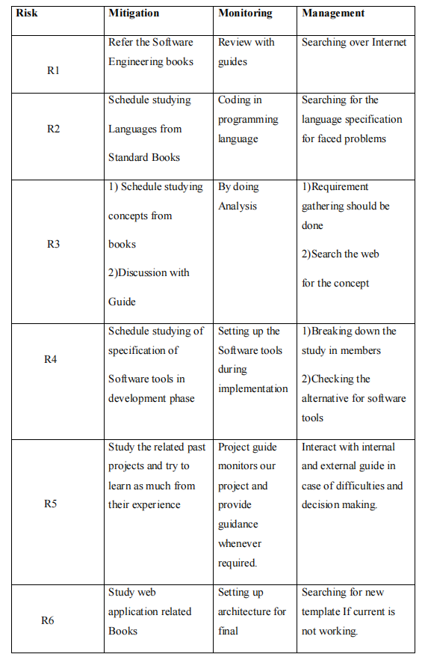

**Analysis**

## **3.1 Software Requirements Specification**

A Software Requirements specification (SRS) – a requirements specification for a software system is a complete description of behavior of a system to be developed. It includes a set of cases that describe all the interactions users will have with the software. In addition to use cases, the SRS also contains non-functional requirements. Non- functional requirements are requirements which impose constraints on the design or implementation (such as performance engineering requirements, quality standards, or design constraints). System Requirements Specification It is a collection of information that embodies the requirements of a system. A business analyst, sometimes titled system analyst, is responsible for analyzing the business needs of their clients and stakeholders to help identify business problems and propose solutions. Projects are subject to three sorts of require elements.

* Business requirements describe in business terms what must be delivered or accomplished to provide value.
* Product requirements describe properties of a system or product (which could be one of several ways to accomplish a set of business requirements.)
* Process requirements describe activities performed by the developing organization. For instance, process requirements could specify methodologies that must be followed, and constraints that the organization must obey.

Product and process requirements are closely linked. Process requirements often specify the activities that will be performed to satisfy a product requirement. For example, a maximum development cost requirement (a process requirement) may be imposed to help achieve a maximum sales price requirement (a product requirement) a requirement that the product be maintainable (a product requirement) often is addressed by imposing requirements to follow development styles.

A system engineering, a requirement can be a description of what a system must do, referred to as Functional Requirement. This type of requirement specifies something that the delivered system must be able to do. Another type of requirement specifies something about the system itself, and how well it performs its functions. Such requirements are often called Non-functional requirements, or ‘Performance requirements’ or ‘Quality of service requirements. Examples of such requirements include usability, availability, reliability, supportability, testability and maintainability. A collection of requirements defines the characteristics or features of the desired system. A ‘good’ list of requirements as far as possible avoids saying how the system should implement the requirements, leaving such decisions to the system designer. Specifying how the system should be implemented is called “implementation bias” or “solution engineering”. However, implementation constraints on the solution may validly be expressed by the future owner, for example for required interfaces to external systems; for interoperability with other systems; and for commonality with other owned products.

## **3.2 FUNCTIONAL REQUIREMENTS:**

In software engineering, a functional requirement defines a function of a software system or its component. A function is described as a set of inputs, the behaviour, and outputs (see also software). Functional requirements may be calculations, technical details, data manipulation and processing and other specific functionality that define what a system is supposed to accomplish. Behavioral requirements describing all the cases where the system uses the functional requirements are captured in use cases. Generally, functional requirements are expressed in the form “system shall do <requirement>”. The plan for implementing functional requirements is detailed in the system design. In requirements engineering, functional requirements specify particular results of a system. A requirements analyst generates use cases after gathering and validating a set of functional requirements. The hierarchy of functional requirements is: user/stakeholder request -> feature -> use case -> business rule.Functional requirements drive the application architecture of a system. A requirements analyst generates use cases after gathering and validating a set of functional Functional requirements drive the application architecture of a system.

requirements. Functional requirements may be technical details, data manipulation and other specific functionality of the project is to provide the information to the user.

The following are the Functional requirements of our systenctional requirements as mentioned in Objectives.

* It should meet the functional requirements as mentioned in objectives.
* Student can play different video.
* Student can read notes.
* Student can move in 3D environment.
* They can use augumented reality to experience the model.

## 

## **3.3 NON-FUNCTIONAL REQUIREMENTS:**

In systems engineering and requirements engineering, a **non-functional requirement** is a requirement that specifies criteria that can be used to judge the operation of a system, rather than specific behaviors.

**Availability:** A system’s “availability” or “uptime” is the amount of time that is operational and available for use. It’s related to the server providing the service to the users in displaying images. As our system will be used by thousands of users at any time our system must be available always. If there are any cases of updates, they must be performed in a short interval of time without interrupting the normal services made available to the users.

**Efficiency:** Specifies how well the software utilizes scarce resources: CPU cycles, disk space, memory, bandwidth etc. All of the above-mentioned resources can be effectively used by performing most of the validations at client

side and reducing the workload on server by using JSP instead of CGI which is being implemented now.

**Flexibility:** If the organization intends to increase or extend the functionality of the software after it is deployed, that should be planned from the beginning; it influences choices made during the design, development, testing and deployment of the system. New modules can be easily integrated to our system without disturbing the existing modules or modifying the logical database schema of the existing applications.

**Portability:** Portability specifies the ease with which the software can be installed on all necessary platforms, and the platforms on which it is expected to run. By using appropriate server versions released for different platforms our project can be easily operated on any operating system, hence can be said highly portable.

**Scalability:** Software that is scalable can handle a wide variety of system configuration sizes. The nonfunctional requirements should specify the ways in which the system may be expected to scale up (by increasing hardware capacity, adding machines etc.). Our system can be easily expandable. Any additional requirements such as hardware or software which increase the performance of the system can be easily added. An additional server would be useful to speed up the application.

**Integrity:** Integrity requirements define the security attributes of the system, restricting access to features or data to certain users and protecting the privacy of data entered into the software. Certain features access must be disabled to normal users such as adding the details of files, searching etc which is the sole responsibility of the server. Access can be disabled by providing appropriate logins to the users for only access.

**Usability:** Ease-of-use requirements address the factors that constitute the capacity of the software to be understood, learned, and used by its intended users. Hyperlinks will be provided for each service the system provides through which navigation will be easier. A system that has high usability coefficient makes the work of the user easier.

The proposed system have the following non -functional requirements:

* System must be easy to use so that a person with basic knowledge of computer and with internet connection can understand the working in 5,10 minutes.
* Language should be English.
* The minimum requirements for the system are:

1. Snapdragon680 or above processor
2. Smart phones with at least 8.0.0 android version.
3. Shader 3.0
4. Vulcan/ openGL support.
5. Functional camera.

## **3.4 Requirement Analysis**

Requirement analysis help the software engineer to better understand the problem

they will work to solve. It includes the set of tasks that lead to an understanding:-

1. What customer wants exactly?

2. What is the information proposed by the system?

3. What function the systems perform?

1. What is the behavior of the system?

## **3.5 REQUIREMENT SPECIFICATION:**

**Normal Requirements**

**N1**. Compatibility

**N2**. Ease of access

**N3**. Light & fast

**Expected Requirements**

**Exp1.** Simple look & feel.

**Exp2.** Fast response time.

**Exp3**. Security to user accounts.

**Exp4**. Easy enhancement.

## **3.6 SOFTWARE REQUIREMENTS:**

* Operating System : Windows/Linux
* Software : Unity ,Augmented reality, Artificial intelligence
* Language : C#

## 

## **3.7 HARDWARE REQUIREMENTS:**

1 .Processor - i3 (min)

2 .RAM - 2GB (min)

3 .Hard Disk – 1.8 GB

# 

# **4. Design**

## 

## **4.1 INTRODUCTION**

**Definition**- Design is a mechanism to transform user requirements into some suitable form, which helps the programmer in software coding and implementation. It deals with representing the client's requirement, as described in SRS (Software Requirement Specification) document, into a form, i.e., easily implementable using programming language.

Objectives of Software Design

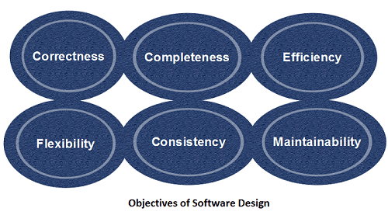

1. **Correctness:** Software design should be correct as per requirement.
2. **Completeness:** The design should have all components like data structures, modules, and external interfaces, etc.
3. **Efficiency:** Resources should be used efficiently by the program.
4. **Flexibility:** Able to modify on changing needs.
5. **Consistency:** There should not be any inconsistency in the design.
6. **Maintainability:** The design should be so simple so that it can be easily maintainable by other designers.

**Software Design Principles**

Software design principles are concerned with providing means to handle the complexity of the design process effectively. Effectively managing the complexity will not only reduce the effort needed for design but can also reduce the scope of introducing errors during design.

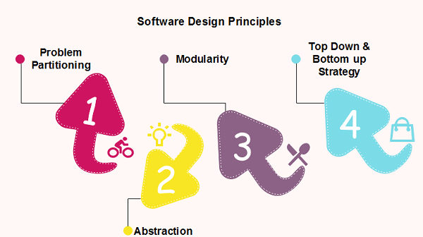

**Problem Partitioning -:**For small problem, we can handle the entire problem at once but for the significant problem, divide the problems and conquer the problem it means to divide the problem into smaller pieces so that each piece can be captured separately.

Benefits of Problem Partitioning

1. Software is easy to understand
2. Software becomes simple
3. Software is easy to test
4. Software is easy to modify
5. Software is easy to maintain
6. Software is easy to expand

These pieces cannot be entirely independent of each other as they together form the system. They have to cooperate and communicate to solve the problem. This communication adds complexity.

## Problem Partitioning-For small problem, we can handle the entire problem at once but for the significant problem, divide the problems and conquer the problem it means to divide the problem into smaller pieces so that each piece can be captured separately.

These pieces cannot be entirely independent of each other as they together form the system. They have to cooperate and communicate to solve the problem. This communication adds complexity.

**Abstraction-**An abstraction is a tool that enables a designer to consider a component at an abstract level without bothering about the internal details of the implementation. Abstraction can be used for existing element as well as the component being designed.

Here, there are two common abstraction mechanisms

1. Functional Abstraction
2. Data Abstraction

### Functional Abstraction

1. A module is specified by the method it performs.
2. The details of the algorithm to accomplish the functions are not visible to the user of the function.

Functional abstraction forms the basis for **Function oriented design approaches**.

### Data Abstraction

Details of the data elements are not visible to the users of data. Data Abstraction forms the basis for **Object Oriented design approaches**.

## **4.2 OBJECT ORIENTED ANALYSIS OVERVIEW:**

The object-oriented approach to software development is decidedly a part of the

mainstream simply because it has proven to be of value in building systems in all sorts of problem domains and encompassing all degrees of size and complexity. Furthermore, most contemporary languages, operating systems, and tools are object-oriented in some fashion, giving greater cause to view the world in terms of objects. Object-oriented development provides the conceptual foundation for assembling systems out of components using technology such as Java Beans or COM+.

An analysis model created using object oriented analysis is transformed by object oriented design into a design model that works as a plan for software creation. OOD results in a design having several different levels of modularity i.e., The major system components are partitioned into subsystems (a system level “modular”), and data their manipulation operations are encapsulated into objects (a modular form that is the building block of an OO system.).

In addition, OOD must specify some data organization of attributes and a procedural description of each operation

## **Why we model?**

• A model is a simplification of reality.

• We build models so that we can better understand the system we are developing

• Models help us to visualize a system as it is or as we want it to be.

• Models permit us to specify the structure or behavior of a system.

• Models give us a template that guides us in constructing a system.

• Models document the decisions we have mad.

**Using Objects**

The problem can be partitioned with respects to its objects. During analysis the

object represents some entity, which can be some concept in the problem domain. An

object contains some state information and provides some services to entities outside

objects. The state can be accessed (or) modified only through the service it provides.

## **Advantages:**

• Easier to build and maintain.

• Transition from object oriented analysis to object oriented design will be easy.

• OOA is more immune to change because objects are more stable than function.

• Objects are likely to stay the same even if the exact nature of the problem changes

**Basic concepts:**

• Object contain attributes that define the state of the object.

• Objects of similar type are grouped together to form an object class (or class).

• An object also provides some services or operations which are used to view or modify the state of an object from outside with the help of messages sent to that object.

Modularity

Modularity specifies to the division of software into separate modules which are differently named and addressed and are integrated later on in to obtain the completely functional software. It is the only property that allows a program to be intellectually manageable. Single large programs are difficult to understand and read due to a large number of reference variables, control paths, global variables, etc.

**The desirable properties of a modular system are:**

* Each module is a well-defined system that can be used with other applications.
* Each module has single specified objectives.
* Modules can be separately compiled and saved in the library.
* Modules should be easier to use than to build.
* Modules are simpler from outside than inside

Strategy of Design

A good system design strategy is to organize the program modules in such a method that are easy to develop and latter too, change. Structured design methods help developers to deal with the size and complexity of programs. Analysts generate instructions for the developers about how code should be composed and how pieces of code should fit together to form a program.

To design a system, there are two possible approaches:

1. Top-down Approach
2. Bottom-up Approach

**1. Top-down Approach:** This approach starts with the identification of the main components and then decomposing them into their more detailed sub-components.

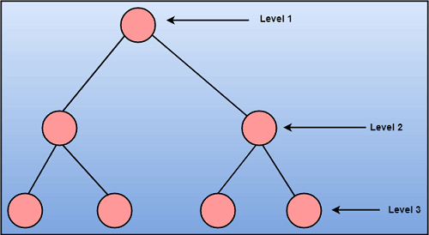

**2. Bottom-up Approach:** A bottom-up approach begins with the lower details and moves towards up the hierarchy, as shown in fig. This approach is suitable in case of an existing system.

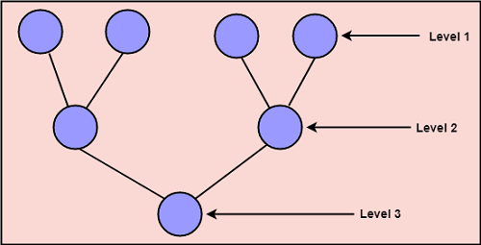

**4.3 UML MODELING:**

Uml is a method for describing the system architecture in detail using the blueprint. UML represents a collection of best engineering practice that has proven successful in the modeling of large and complex systems. The UML is very important parts of developing object-oriented software and the software development process. The UML uses mostly graphical notations to express the design of software projects. Using the helps UML helps project teams communicate explore potential designs and validate the architectural design of the software

# 

4.3.1 Data Flow Diagrams

A Data Flow Diagram (DFD) is a traditional visual representation of the information flows within a system. A neat and clear DFD can depict the right amount of the system requirement graphically. It can be manual, automated, or a combination of both.

It shows how data enters and leaves the system, what changes the information, and where data is stored.

The objective of a DFD is to show the scope and boundaries of a system as a whole. It may be used as a communication tool between a system analyst and any person who plays a part in the order that acts as a starting point for redesigning a system. The DFD is also called as a data flow graph or bubble chart

### 

### DATA FLOW DIAGRAM Data flow diagram for partial project

**Class diagram-:**

Class diagram is a static diagram. It represents the static view of an application. Class diagram is not only used for visualizing, describing, and documenting different aspects of a system but also for constructing executable code of the software application.

Class diagram describes the attributes and operations of a class and also the constraints imposed on the system. The class diagrams are widely used in the modeling of object oriented systems because they are the only UML diagrams, which can be mapped directly with object-oriented languages.

Class diagram shows a collection of classes, interfaces, associations, collaborations, and constraints.

**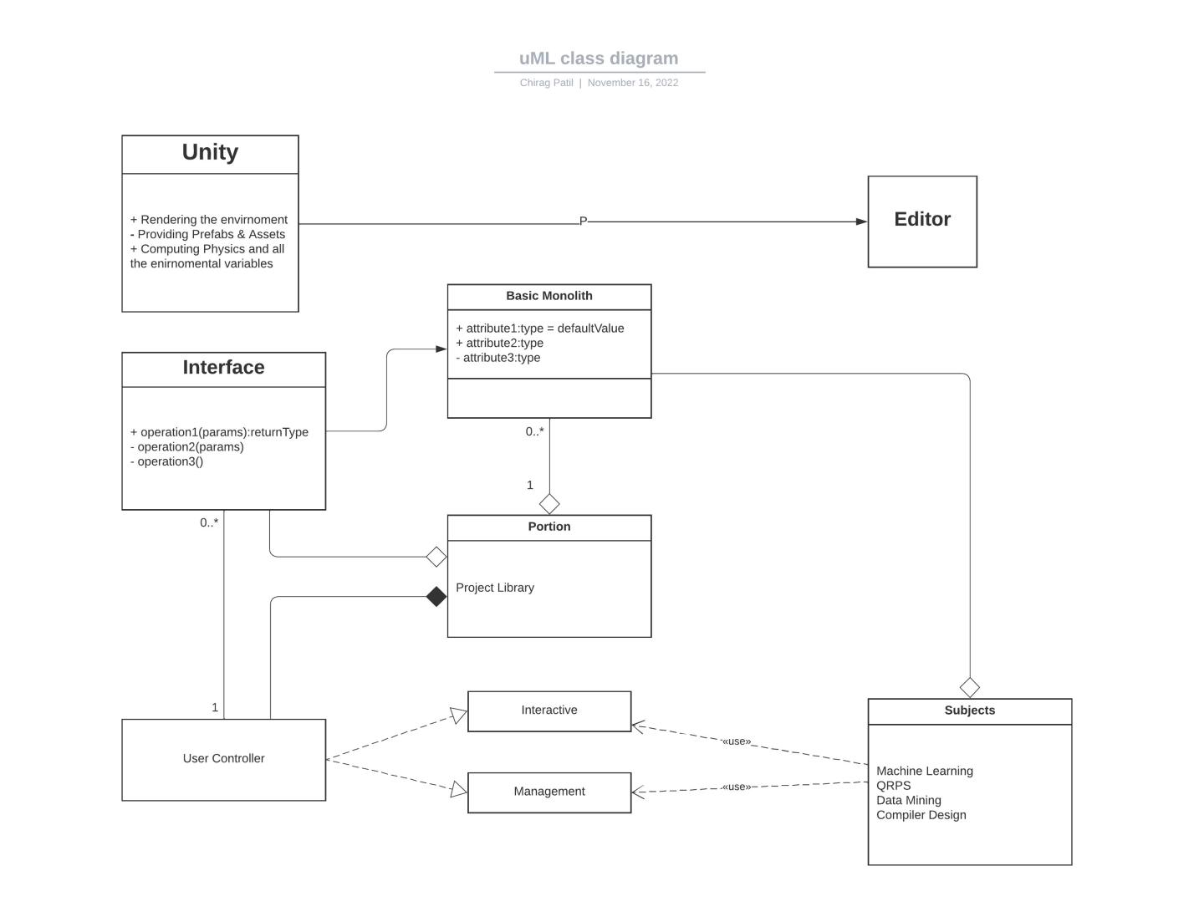**

# 

# **Conclusion**

The main aim of the project is to make interactive learning platform. Education seems to be constantly changing. Students are no longer expected to sit at a desk and take notes on a lecture. Lessons are much more engaging and interactive.

 Interactive Learning has evolved out of the hyper-growth in the use of digital technology and virtual communication, particularly by students. Interactive learning cannot be successful if it is very convenient for learners to study .it is very effective to provide good result of learning to a learner which is main function of an learning system

Interactive learning has gives education a new dimension, taking classroom learning to the next level. it is more than distance education where resources are simply put online.it could improve the flexibility, quality and focus of education.

The current generation who are digitally native and active require a new approach of teaching and learning because the traditional method has been provide to be not effective and efficient. To support the need, we have developed an interactive learning method to increase the current generation learning experiment. the new approach increases the visual spatial skills, memory skills, and multitasking ability.

**Future Scope**

As computer ownership grows across the globe interactive -learning becomes increasingly viable and accessible. Internet connection speeds are increasing, and with that, opportunities for more multimedia training methods arise.

With the immense improvement of mobile networks in the past few years and the increase in telecommuting, taking all the awesome features of e-learning on the road is a reality with smartphones and other portable devices. Technologies such as social media are also transforming education constantly.

Interactive learning has rapidly evolved from a thing of the future to a practical approach towards education. It will continue to be an extremely useful classroom teaching tool as well as self-study platform. With the rise of artificial intelligence and augment reality solutions, experimental subjects, skill-based learning a will come to depend more heavily on Interactive-learning solutions. Various education technology providers are also hinting towards the rise of mobile learning solutions (also known as m-learning) as the advanced stage of education technology in future.

# **Appendix**

**Technology Used -**

## **Unity**

**Unity** is a [cross-platform](https://en.wikipedia.org/wiki/Cross-platform" \o "Cross-platform) [game engine](https://en.wikipedia.org/wiki/Game_engine" \o "Game engine) developed by [Unity Technologies](https://en.wikipedia.org/wiki/Unity_Technologies" \o "Unity Technologies), first announced and released in June 2005 at [Apple Worldwide Developers Conference](https://en.wikipedia.org/wiki/Apple_Worldwide_Developers_Conference" \o "Apple Worldwide Developers Conference) as a [Mac OS X](https://en.wikipedia.org/wiki/MacOS" \o "MacOS) game engine. The engine has since been gradually extended to support a variety of [desktop](https://en.wikipedia.org/wiki/Desktop_computer" \o "Desktop computer), [mobile](https://en.wikipedia.org/wiki/Mobile_phone" \o "Mobile phone), [console](https://en.wikipedia.org/wiki/Video_game_console" \o "Video game console) and [virtual reality](https://en.wikipedia.org/wiki/Virtual_reality" \o "Virtual reality) platforms. It is particularly popular for [iOS](https://en.wikipedia.org/wiki/IOS" \o "IOS) and [Android](https://en.wikipedia.org/wiki/Android_(operating_system)" \o "Android (operating system)) mobile game development and is considered easy to use for beginner developers and is popular for [indie game](https://en.wikipedia.org/wiki/Indie_game" \o "Indie game) development.

The engine can be used to create [three-dimensional](https://en.wikipedia.org/wiki/Three-dimensional_space" \o "Three-dimensional space) (3D) and [two-dimensional](https://en.wikipedia.org/wiki/Two-dimensional_space" \o "Two-dimensional space) (2D) games, as well as interactive [simulations](https://en.wikipedia.org/wiki/Computer_simulation" \o "Computer simulation) and other experiences.The engine has been adopted by industries outside video gaming, such as [film](https://en.wikipedia.org/wiki/Film_industry" \o "Film industry), [automotive](https://en.wikipedia.org/wiki/Automotive_industry" \o "Automotive industry), [architecture](https://en.wikipedia.org/wiki/Architecture" \o "Architecture), [engineering](https://en.wikipedia.org/wiki/Engineering" \o "Engineering), [construction](https://en.wikipedia.org/wiki/Construction" \o "Construction), and the [United States Armed Forces](https://en.wikipedia.org/wiki/United_States_Armed_Forces" \o "United States Armed Forces).

The Unity game engine launched in 2005, aiming to "democratize" game development by making it accessible to more developers.The next year, Unity was named runner-up in the Best Use of Mac OS X Graphics category in [Apple Inc.](https://en.wikipedia.org/wiki/Apple_Inc." \o "Apple Inc.)'s Apple Design Awards. Unity was initially released for Mac OS X, later adding support for Microsoft Windows and Web browsers.

In December 2016, Unity Technologies announced that they would change the [versioning numbering system](https://en.wikipedia.org/wiki/Software_versioning" \o "Software versioning) for Unity from [sequence-based identifiers](https://en.wikipedia.org/wiki/Software_versioning" \l "Sequence-based_identifiers" \o "Software versioning) to [year of release](https://en.wikipedia.org/wiki/Software_versioning" \l "Date_of_release" \o "Software versioning) to align the versioning with their more frequent release cadence; Unity 5.6 was therefore followed by Unity 2017. Unity 2017 tools featured a real-time graphics rendering engine, color grading and worldbuilding, live operations analytics and performance reporting. Unity 2017.2 underscored Unity Technologies' plans beyond video games. This included new tools such as Timeline, which allowed developers to drag-and-drop animations into games, and Cinemachine, a smart camera system within games. Unity 2017.2 also integrated [Autodesk](https://en.wikipedia.org/wiki/Autodesk" \o "Autodesk)'s 3DS Max and Maya tools into the Unity engine for a streamlined asset sharing in-game iteration process.

Unity 2018 featured the Scriptable Render Pipeline for developers to create high-end graphics.This included the High-Definition Rendering Pipeline for console and PC experiences, and the Lightweight Rendering Pipeline for mobile, virtual reality, and augmented reality.Unity 2018 also included [machine learning](https://en.wikipedia.org/wiki/Machine_learning" \o "Machine learning) tools, such as Imitation Learning, whereby games learn from real player habits, support for Magic Leap, and templates for new developers.

The C# [source code](https://en.wikipedia.org/wiki/Source_code" \o "Source code) of Unity was published under a "reference-only" license in March 2018, which prohibits reuse and modification.

As of 2020, software built with Unity's game engine was running on more than 1.5 billion devices. According to Unity, apps made with their game engine account for 50 percent of all mobile games, and are downloaded more than 3 billion times per month, and approximately 15,000 new projects are started daily with its software.Financial Times reported that Unity's engine "powers some of the world's most lucrative mobile games", such as [Pokémon Go](https://en.wikipedia.org/wiki/Pok%C3%A9mon_Go" \o "Pokémon Go) and [Activision](https://en.wikipedia.org/wiki/Activision" \o "Activision)'s [Call of Duty Mobile](https://en.wikipedia.org/wiki/Call_of_Duty_Mobile" \o "Call of Duty Mobile).

In June 2020, Unity introduced the Mixed and Augmented Reality Studio (MARS), which provides developers with additional functionality for rules-based generation of augmented reality (AR) applications. Unity released Unity Forma, an automotive and retail solution tool, on December 9, 2020.

Unity acquired Finger Food Advanced Technology Group in 2020, as it aimed to bolster its non-video game uses and offer additional design help to customers.The company went public in September 2020, to further expand use of its game engine into industries outside of gaming.

Unity 2021 brought multiple new features such as Bolt, Unity's Visual Scripting system, a new multiplayer library to support multiplayer games, improved Il2cpp runtime performance, Volumetric clouds for the High Definition Render pipeline. Shadow caching and Screen Space Global Illumination for HDRP. For the Universal Render Pipeline it added new features such as point light shadows, Deferred renderer and general core engine improvements and fixes.

Unity gives users the ability to create games and experiences in both [2D](https://en.wikipedia.org/wiki/2D_computer_graphics" \o "2D computer graphics) and [3D](https://en.wikipedia.org/wiki/3D_computer_graphics" \o "3D computer graphics), and the engine offers a primary scripting API in [C#](https://en.wikipedia.org/wiki/C_Sharp_(programming_language)" \o "C Sharp (programming language)) using [Mono](https://en.wikipedia.org/wiki/Mono_(software)" \o "Mono (software)), for both the Unity editor in the form of plugins, and games themselves, as well as [drag and drop](https://en.wikipedia.org/wiki/Drag_and_drop" \o "Drag and drop) functionality.Prior to C# being the primary programming language used for the engine, it previously supported [Boo](https://en.wikipedia.org/wiki/Boo_(programming_language)" \o "Boo (programming language)), which was removed with the release of Unity 5,and a [Boo](https://en.wikipedia.org/wiki/Boo_(programming_language)" \o "Boo (programming language))-based implementation of [JavaScript](https://en.wikipedia.org/wiki/JavaScript" \o "JavaScript) called UnityScript, which was deprecated in August 2017, after the release of Unity 2017.1, in favor of C#.

Within 2D games, Unity allows importation of sprites and an advanced 2D world renderer. For 3D games, Unity allows specification of [texture compression](https://en.wikipedia.org/wiki/Texture_compression" \o "Texture compression), [mipmaps](https://en.wikipedia.org/wiki/Mipmap" \o "Mipmap), and resolution settings for each platform that the game engine supports, and provides support for [bump mapping](https://en.wikipedia.org/wiki/Bump_mapping" \o "Bump mapping), [reflection mapping](https://en.wikipedia.org/wiki/Reflection_mapping" \o "Reflection mapping), [parallax mapping](https://en.wikipedia.org/wiki/Parallax_mapping" \o "Parallax mapping), [screen space ambient occlusion](https://en.wikipedia.org/wiki/Screen_space_ambient_occlusion" \o "Screen space ambient occlusion) (SSAO), dynamic shadows using [shadow maps](https://en.wikipedia.org/wiki/Shadow_map" \o "Shadow map), [render-to-texture](https://en.wikipedia.org/wiki/Framebuffer_object" \o "Framebuffer object) and full-screen post-processing effects.

## **Augmented Reality**

Augmented reality (AR) is the integration of digital information with the user's environment in [real time](https://www.techtarget.com/whatis/definition/real-time). Unlike virtual reality ([VR](https://www.techtarget.com/whatis/definition/virtual-reality)), which creates a totally artificial environment, AR users experience a real-world environment with generated perceptual information overlaid on top of it. Augmented

Augmented reality is used to either visually change natural environments in some way or to provide additional information to users. The primary benefit of AR is that it manages to blend digital and three-dimensional ([3D](https://www.techtarget.com/whatis/definition/3-D-three-dimensions-or-three-dimensional)) components with an individual's perception of the real world. AR has a variety of uses, from helping in decision-making to entertainment.

AR delivers visual elements, sound and other sensory information to the user through a device like a smartphone or glasses. This information is overlaid onto the device to create an interwoven experience where digital information alters the user's perception of the real world. The overlaid information can be added to an environment or mask part of the natural environment.

Boeing Computer Services Research employee Thomas Caudell coined the term augmented reality in 1990 to describe how the head-mounted displays that electricians use when assembling complicated wiring harnesses worked. One of the first commercial applications of augmented reality technology was the yellow first down marker that began appearing in televised football games sometime in 1998. Today, [Google Glass](https://www.techtarget.com/iotagenda/definition/Google-Glass), smartphone games and heads-up displays ([HUDs](https://www.techtarget.com/whatis/definition/heads-up-display-HUD)) in car windshields are the most well-known consumer AR products. But the technology is also used in many industries, including healthcare, public safety, gas and oil, tourism and marketing.

### How does augmented reality work?

Augmented reality can be delivered in a variety of formats, including within smartphones, tablets and glasses. AR delivered through contact lenses is also being developed. The technology requires hardware components, such as a processor, sensors, a display and input devices. Mobile devices already typically have this hardware available, with sensors including cameras, [accelerometers](https://www.techtarget.com/whatis/definition/accelerometer), Global Positioning System (GPS) and solid-state compasses. This helps make AR more accessible to the everyday user. A GPS is used to pinpoint the user's location, and its compass is used to detect device orientation, for example.

Sophisticated AR programs used by the military for training can also include [machine vision](https://www.techtarget.com/searchenterpriseai/definition/machine-vision-computer-vision), object recognition and [gesture recognition](https://www.techtarget.com/whatis/definition/gesture-recognition). AR can be computationally intensive, so if a device lacks processing power, data processing can be offloaded to a different machine.

Augmented reality apps are written in special 3D programs that enable developers to tie animation or contextual digital information in the computer program to an augmented reality marker in the real world. When a computing device's AR app or browser [plugin](https://www.techtarget.com/whatis/definition/plug-in) receives digital information from a known marker, it begins to execute the marker's code and layer the correct image or images.

### 

### Top AR use cases:

AR can be used in the following ways:

* **Retail.** Consumers can use a store's online app to see how products, such as furniture, will look in their own homes before buying.
* **Entertainment and gaming.** AR can be used to overlay a virtual game in the real world or enable users to animate their faces in different and creative ways on social media.
* **Navigation.** AR can be used to overlay a route to the user's destination over a live view of a road. AR used for navigation can also display information about local businesses in the user's immediate surroundings.
* **Tools and measurement.** Mobile devices can use AR to measure different 3D points in the user's environment.
* **Architecture.** AR can help architects visualize a building project.
* **Military.** Data can be displayed on a vehicle's windshield that indicates destination directions, distances, weather and road conditions.
* **Archaeology.** AR has aided archaeological research by helping archeologists reconstruct sites. 3D models help museum visitors and future archeologists experience an excavation site as if they were there.

### 

### Examples of AR

Examples of AR include the following:

* **Target app.**The Target retail app feature called [See it in Your Space](https://www.target.com/c/see-it-in-your-space/-/N-9ciy7" \t "https://www.techtarget.com/whatis/definition/_blank) enables users to take a photo of a space in their home and digitally view an object, like a picture on the wall or a chair,to see how it will look there.
* **Apple Measure app.** The Measure app on Apple iOS acts like a tape measure by enabling users to select two or more points in their environment and measure the distance between them.
* **Snapchat.** Snapchat filters use AR to overlay a filter or mask over the user's Snap or picture.
* **Pokemon Go.** Pokemon Go is a popular mobile AR game that uses the player's GPS to detect where Pokemon creatures appear in the user's surrounding environment for them to catch.
* **Google Glass.** Google Glass is Google's first commercial attempt at a glasses-based AR system. This small wearable computer enables users to work hands-free. Companies such as DHL and DB Schenker use Google Glass and third-party software to enable frontline workers to be more efficient when it comes to global supply chain logistics and customized shipping. Google is also [working on another pair of glasses](https://www.theverge.com/2022/5/13/23068759/google-io-2022-ar-glasses-translation-concept-challenges-vaporware" \t "https://www.techtarget.com/whatis/definition/_blank) in 2022 that's designed to overlay a live transcription or translation of what another person says in text.
* **U.S. Army.** The U.S. Army uses AR in an eyepiece called Tactical Augmented Reality (TAR). TAR mounts onto the soldier's helmet and aids in locating another soldier's position.

### 

### Future of AR technology

AR technology continues to grow as the popularity and familiarization of apps and games like Pokemon Go or retail store AR apps increase. The expansion of [5G](https://www.techtarget.com/searchnetworking/definition/5G) networks may make it easier to support cloud-based augmented reality experiences, for example, by providing AR applications with higher data speeds and lower latency.

The Android equivalent of ARKit, ARCore, also continues to grow and improve. For example, ARCore uses a [geospatial](https://www.techtarget.com/searchbusinessanalytics/news/252486088/Geospatial-data-a-means-for-deeper-understanding) API that sources data from Google Earth 3D models and Street View image data from Google Maps. Similar to ARKit's Depth API, ARCore has improved its Depth API, optimizing it for longer-range depth sensing.

Apple continues to develop and update its open source mobile augmented reality development tool set, [ARKit](https://www.techtarget.com/whatis/definition/ARKit). Companies, including Target and Ikea, use ARKit in their flagship AR shopping apps for iPhone and iPad. ARKit 6 enables users to render AR in 4K high-dynamic range, or HDR, and improves image and video capture. ARKit 6 also provides a Depth API, which uses per-pixel depth information to enable a device's camera to understand the size and shape of an object and includes scene geometry that creates a topological map of a space along with other improvements.

The Android equivalent of ARKit, ARCore, also continues to grow and improve. For example, ARCore uses a [geospatial](https://www.techtarget.com/searchbusinessanalytics/news/252486088/Geospatial-data-a-means-for-deeper-understanding) API that sources data from Google Earth 3D models and Street View image data from Google Maps. Similar to ARKit's Depth API, ARCore has improved its Depth API, optimizing it for longer-range depth sensing.

Modern advances under development, such as Google's smart glasses that live translate audio to text, will revolutionize how people who speak different languages communicate. Because AR uses immersive technology, more opportunities and experiences across different platforms and media types are on the horizon.

Google Glass is Google's first commercial attempt at a glasses-based AR system. This small wearable computer enables users to work hands-free. Companies such as DHL and DB Schenker use Google Glass and third-party software to enable frontline workers to be more efficient when it comes to global supply chain logistics and customized shipping. Google is also [working on another pair of glasses](https://www.theverge.com/2022/5/13/23068759/google-io-2022-ar-glasses-translation-concept-challenges-vaporware" \t "https://www.techtarget.com/whatis/definition/_blank) in 2022 that's designed to overlay a live transcription or translation of what another person says in text.

## **Artificial Intelligence (AI)**

In the simplest terms, AI which stands for artificial intelligence refers to systems or machines that mimic human intelligence to perform tasks and can iteratively improve themselves based on the information they collect. AI manifests in a number of forms. A few examples are:

* Chatbots use AI to understand customer problems faster and provide more efficient answers
* Intelligent assistants use AI to parse critical information from large free-text datasets to improve scheduling
* Recommendation engines can provide automated recommendations for TV shows based on users’ viewing habits

AI is much more about the process and the capability for superpowered thinking and data analysis than it is about any particular format or function. Although AI brings up images of high-functioning, human-like robots taking over the world, AI isn’t intended to replace humans. It’s intended to significantly enhance human capabilities and contributions. That makes it a very valuable business asset.

AI has become a catchall term for applications that perform complex tasks that once required human input such as communicating with customers online or playing chess. The term is often used interchangeably with its subfields, which include [machine learning](https://www.oracle.com/data-science/machine-learning/what-is-machine-learning/) and [deep learning](https://www.oracle.com/artificial-intelligence/machine-learning/what-is-deep-learning/).

There are differences, however. For example, machine learning is focused on building systems that learn or improve their performance based on the data they consume. It’s important to note that although all machine learning is AI, not all AI is machine learning.

To get the full value from AI, many companies are making significant investments in data science teams. Data science, an interdisciplinary field that uses scientific and other methods to extract value from data, combines skills from fields such as statistics and computer science with business knowledge to analyze data collected from multiple sources.

**References**

* Akyol, Z., & Garrison, D. R. (2011). Understanding cognitive presence in an online and blended community of inquiry: Assessing outcomes and processes for deep approaches to learning. British Journal of Educational Technology, 42(2), 233-250.
* Bates, A. W. & Poole, G. (2003). Effective teaching with technology in higher education: Foundations for success.  Indianapolis, IN: Jossey-Bass.
* Bonk, C. J. & Graham, C. R. (Eds.). (2005). Handbook of blended learning: Global Perspectives, local designs. San  Francisco, CA: Pfeiffer Publishing.
* Conceição, S. C. O., & Lehman, R. M. (2011). Managing online instructor workload: Strategies for finding balance and success. San Francisco, CA: Jossey-Bass.
* Duffy, T. M. & Kirkley, J. (2004). Learner-centered theory and practice in distance education: Cases for higher education. Mahwah, NJ: Lawrence Erblaum Associates.
* <http://unity3d.com>
* <http://fourm.unity3d.com>
* <http://google.com>