**The correlation between the stock price with the public attention on ‘ESG’ search fields: Evidence from Baidu search index**

Jinliang Xu, Zixuan Zhang, Biru Zhao, Yujia Yang, Xinyi Li, Xiaoxiao Zheng,

**Abstract:**  ​​In this paper, we study the relationship between the baidu search indexes of keywords in environmental, social, and governance and the stock prices of different industries, and construct a matrix of the importance of different keywords for each industry. Meanwhile, we construct our portfolio by screening stocks using 113 indicators that affect the ESG ratings of companies, and trade with specific baidu search trends as a trading signal to obtain positive returns.

**Keywords:** ESG, Baidu searches trend, ESG index, classification tree, panel regression

1. **Introduction**

Nowadays, only analyzing corporations by financial data can’t fit the more information demand of investors. Investors are seeking for more tools and data to evaluate their assets and developing more effective trading strategies. One of the most popular new topics that just jumps into investors’ horizons is ESG. Environmental, Social and Governance (ESG) focuses on the sustainability of the company and screens out investment assets with social awareness and sustainable development. In our paper, we utilized the Baidu trend to evaluate public attention and investor sentiment on environmental, social and governance related topics. Then we developed a trading strategy to find out how ESG related keywords can be used in portfolio investment.

Search engines are a reliable source for alternative ESG data. Relevant search engine indices can reflect investor sentiment about the future of the stock market.(Fang, J., Gozgor, G., Lau, C. K. M., & Lu, Z., 2020)) For example, China's largest search engine, Baidu, captures 73.5% of China's market and reaches 97.5% of China's Internet users. Baidu provides Chinese investors with a convenient and cost-free way to learn about the ESG sectors they are interested in. Therefore, ESG keywords such as green finance (Niyazbekova, S., Jazykbayeva, B., Mottaeva, A., Beloussova, E., Suleimenova, B., & Zueva, A. ,2021)). , pollution (Tarmuji, I., Maelah, R., & Tarmuji, N. H. ,2016))and privacy protection (Miller, D., 2017) can be used as one of the potential indicators for stock price prediction using the search index. Through studying the impact of investor sentiment on the Chinese stock market through alternative data of ESG search indices. Our findings can help scholars studying the link between Chinese ESG alternative data and the Chinese stock market and provide relevant investors with effective investment measurement categories.

To start our research, we first looked at how to construct an ESG index and based on the ESG index, we selected a range of stocks that perform well as compared to their peers using classification tree. To take a deeper understanding of what indicators we should choose and why we should choose these indicators to construct the ESG index, we have considered the following:

1. Environmental indicators include the company's energy use, energy waste, environmental pollution, protection of natural resources and animal treatment. Environmental factors are used to assess any environmental risks that the company may face and how to manage these risks.
2. Society focuses on the business relationship of the company. Including the company's upstream and downstream business situation and employee situation, such as supplier level, customer's ability and employee satisfaction. (Jang, G. Y., Kang, H. G., Lee, J. Y., & Bae, K. (2020)). The society also considers the contribution of the company to the local community, the evaluation of employees' working environment and the interests of other stakeholders. (Sahut, J. M., & Pasquini-Descomps, H. (2015)).
3. Governance factors involve investors' requirements for corporate governance, including the allocation of rights and responsibilities from sovereign decision-making to different participants, including board of directors, managers, shareholders and stakeholders. Among them, investors are most concerned about the purpose of the company, the role and composition of the board of directors, and the salary and supervision of senior managers. (Filbeck, A., Filbeck, G., & Zhao, X. (2019))

The rest of this paper is as follows. The second section introduces the literature review. The third section introduces our sample, data and descriptive analysis. The fourth section introduces the panel data regression results. The fifth section we will explain how we construct the portfolio and discuss the performance of our trading strategies. And in the last section, we will conclude and discuss our future work.

1. **Literature Review**

Sentimental analysis has been applied for investments in the stock market, especially sentiment that has a huge impact under COVID-19 pandemic. Hee Soo (2020) used Daily News Sentiment Index (DNSI) and Google Trends data on coronavirus-related searches discovered excess returns by applying the Fama-French three factor model through 11 selected factors in the time range of January 21, 2020 to May 20, 2020. What strategic investment he suggested is to take time lag difference into consideration. In our research, we accepted this suggestion and used the data in Baidu Trends since we focused on China’s market.

Sentiment indicators could be combined with ESG ratings to effectively improve stock screening. By overlaying these two elements, alpha would be increased by 300 bp, and reduce half of the maximum drawdown when compared with random market portfolio (Peter, 2019).

However, the existence of fake news could not be ignored. Jonathan, Hailing, Ding and Jeffrey (2021) used the U.S. Securities and Exchange Commission (SEC) suppressed stock advertisements to examine investors’ reaction and stock performance. While Seeking Alpha editors have limited ability to detect fake news, they figured out how to build machine learning methods to identify fake news, and believe the stock market has the correct reaction when dealing with fake news in terms of volume and price change.

According to Kim, Lee, and Shin (2020), recall can have a significant impact on a company's image and reputation, and it is one of the most common consumer complaints. The influence of a recall on business stock prices is examined using the Event Study method in this study. Previous studies reached varied outcomes based on the recall case and data collection process. They use data as a more objective Google Trends to address such challenges. We investigate the impact of product recalls on stock prices from a variety of perspectives, including Google Trend search volume, recall type, industry category, and nation. Despite the fact that recall has no statistically meaningful impact on stock prices, they discovered that recalls of businesses with a high search traffic have a bigger impact than those with a low search volume. Involuntary recalls have a bigger impact than voluntary recalls, and non-car industries have a greater impact than the automobile industry, according to their findings. This research looked at all of the data mentioned on the Internet, with the exception of countries that could not access Google owing to a lack of government restrictions or IT infrastructure.

Mozaffar, George and Aaron (2016) developed a dataset by using sustainability topics on materiality classifications manually to get sustainability ratings at firm-level. Under time regression and company panel regression, they came to the conclusion that in sustainability investments, good rating firms performed better than poor ratings. The idea of integration of sustainability factors is worth thinking about when we construct our evaluation model.

Portfolio managers and amateur investors alike are looking for asset allocation models that incorporate environmental, social, and governance (ESG) factors as well as investor behavioral biases. In the current work, a novel strategy to optimize the behavioral portfolio management model in the context of investor biases for ESG sustainability, loss aversion, and cognitive dissonance is presented. They add to the literature on factor pricing by using a factor extraction approach to uncover three distinct and widespread ESG factors. Machine learning methods are applied to a production-theoretic six-factor Fama and French model to forecast individual asset returns after studying the interconnection of the elements. A hierarchical multiobjective portfolio optimization model is used to identify efficient asset allocations. Simulation results from different layered specifications being solved (Gordon & Nina, 2021).

1. **Data**

**Data Source**

1. **Stock data**

In this paper, we select Chinese A-share listed companies from 2017-to 2021 as a sample, and refer to relevant research studies in various countries to screen the sample, and screen out 6467 companies, then, we classify the companies, according to the 2012 industry classification of China Securities Regulatory Commission into 19 industries, in which, there are 3783 companies belonging to manufacturing industry, 584 companies in information transmission, software and information technology service industry There are 183 companies in the financial sector, 139 companies in the mining sector, and so on.

We obtain the daily stock prices of target companies from CSMAR for 2017-2021 for a total of n sample points. "CSMAR database is a professional economic and financial data platform. The database covers several research series including China stock market, China-listed companies, China fund market, China bond market, China derivatives, China economy, China money market, thematic research, etc. The content includes structured financial statements and trading quotes as well as unstructured news and information, research reports, company announcement data, etc. It is one of the most comprehensive economic and financial research databases available. "

We compare the current day to the previous day's stock price and log the result to get the log return, which is used as the main indicator of return.

The corresponding daily stock turnover rates are collected from the CSMAR database and merged with the calculated log return of daily stock price.

1. **Focus measurement**

Based on the actual situation in China, this paper selects the widely used search engine Baidu in China, and searches fields in the Baidu index, which are derived from the CSR reports disclosed by listed companies, and manually selects twenty search fields based on the frequency of mentions in the reports, combined with the widely used search engine Baidu in China, and refers to the Global Reporting Initiative ( GRI) ESG rating system, which is issued by the Global Sustainability Standards Board (GSSB).

The GRI Reporting Principles, in the chapter "Reporting Principles for Defining Report Content", mention that the following four points should be grasped in analyzing reports: Stakeholder Inclusiveness, Sustainability Context, Materiality, and Completeness. Completeness helps organizations decide what to include in a report.

In the GRI Reporting Principles chapter, the following six points should be grasped: Accuracy, Balance, Clarity, Comparability, Reliability, and Timeliness, this guides the organization in ensuring the quality of the information in sustainability reports.

Selected Search fields are shown as follows：

| **Pillars** | **Search Fields** |
| --- | --- |
| Environmental (7) | Green Finance, Carbon Neutral, PM2.5, Haze,  Global Warming, Low Carbon, low carbon environment-friendly |
| Social  (9) | Microfinance, Rural revitalization, Anti-addiction, Poverty relief, 404, public benefit, Inclusive Finance, Donation, Smart City |
| Governance  (8) | Baby break, product recall, 996, consumer right protection,  privacy protection, Data security, customer data,  intellectual property protection (IPR) |

***Figure 1： Environmental Search Fields Focus***

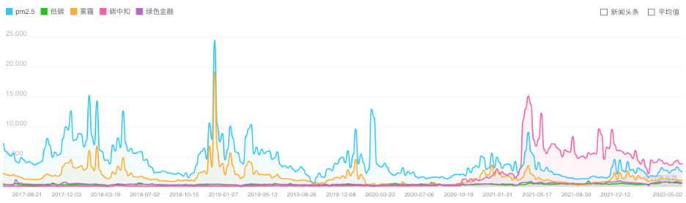

***Figure 2:Governance Search Fields Focus***

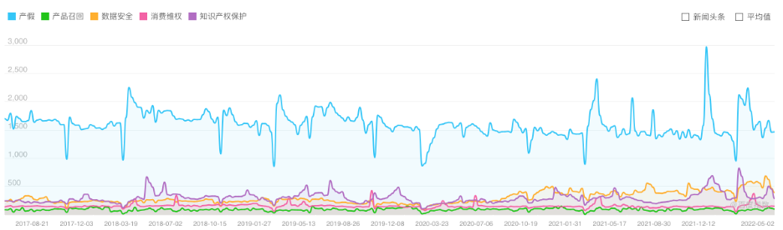

***Figure 3: Social Search Fields Focus***

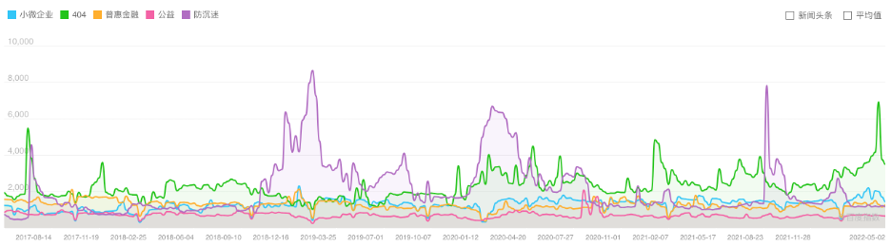

1. ESG index construction

All indicators come from the CSMAR database, covering basic information of listed companies, regional environmental pollution such as waste gas and wastewater emissions, poverty alleviation, etc. According to the GRI reporting principles already introduced above, they are divided into the following categories, with a brief enumeration of each category. Of these, environmental and governance indicators each accounted for 38% and social indicators accounted for 24%. And in terms of data type, ratio indicator accounts for 73%, nominal indicator accounts for 1%, lodistic indicator accounts for 16%, and ordinal indicator accounts for 10%.

***Table 1:***

| **Environmental** |  | **Social** |  | **Governance** |
| --- | --- | --- | --- | --- |
| Greenhouse Gas Emissions |  | Help poor disabled people |  | Major Omission |
| Environmental protection tax |  | Number of poor students funded |  | Delay Disclosure |
| Wastewater discharge |  | Material depreciation |  | Illegal stock trading |
| … |  | … |  | … |

113 metrics are constructed for each company whereby we measure the overall quality of a company's management of ESG issues.

**Summary Statistics**

We performed descriptive statistics on the concern indicators separately according to the different pillars of ESG, and the results are as follows.

***Table 2:*** *Summary for Environmental Pillar*

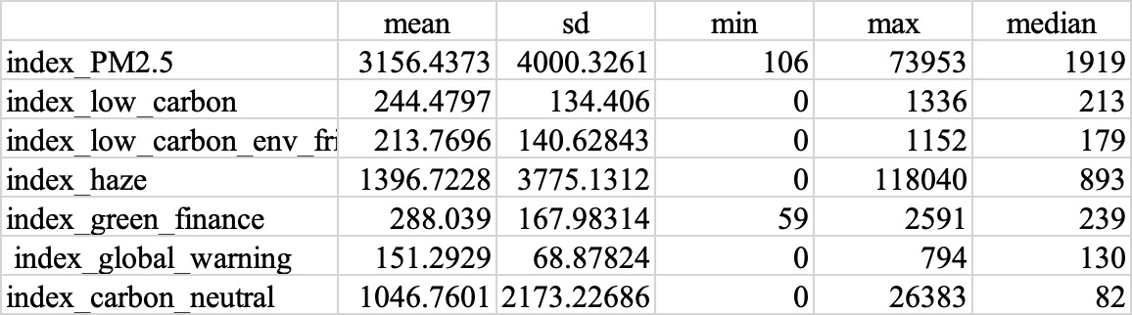

*Table 3: Summary for Social Pillar*

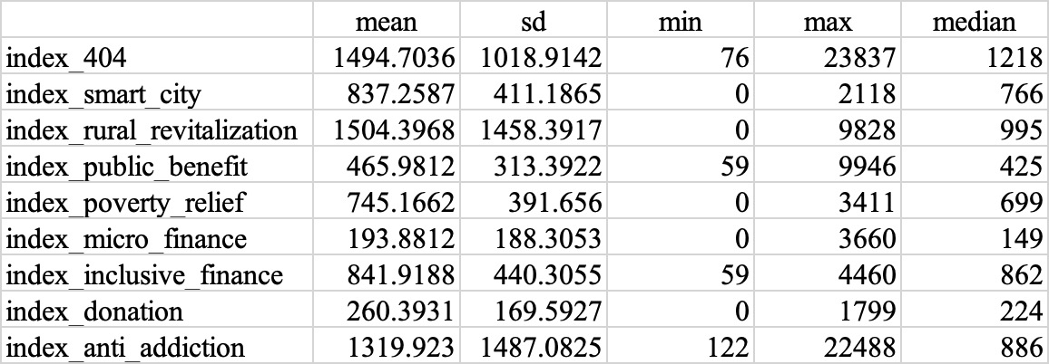

*Table 4: Summary for Governance Pillar*

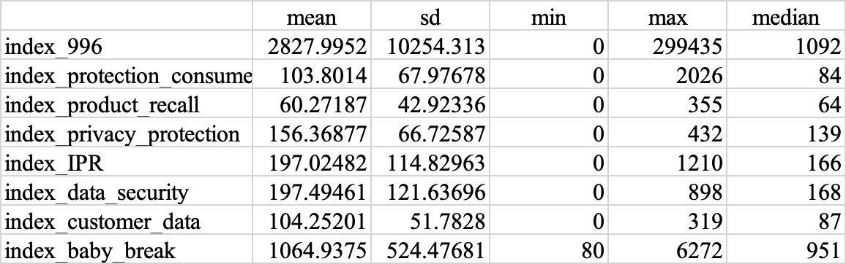

1. **Results**

Regression of daily stock returns on the baidu search index of certain ESG related phrases：

1. We use the baidu search index of each word to predict the next day stock returns using panel regressions. We found that among all 24 search fields,18 of them have a significant influence on the stock returns. Examples for “global warming”,”macro finance” are shown as follows:

***Figure 4: Regression result***

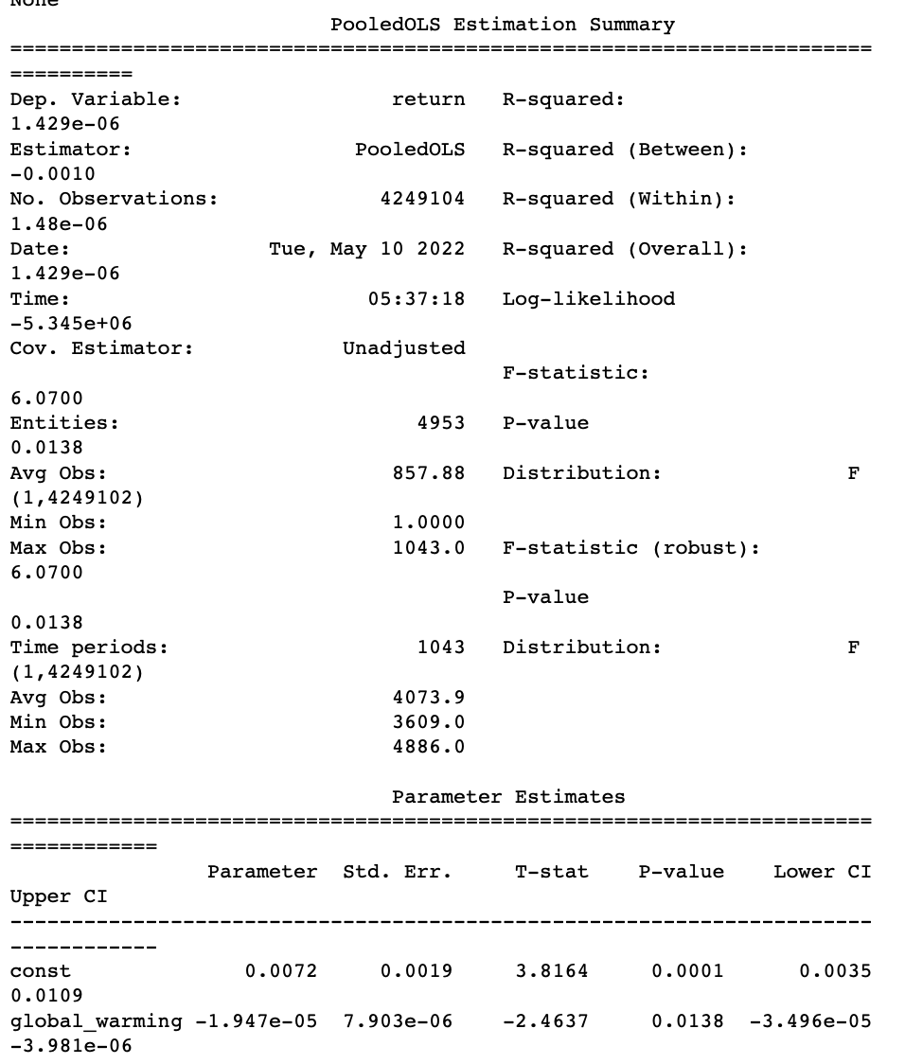

***Figure 5: Regression result***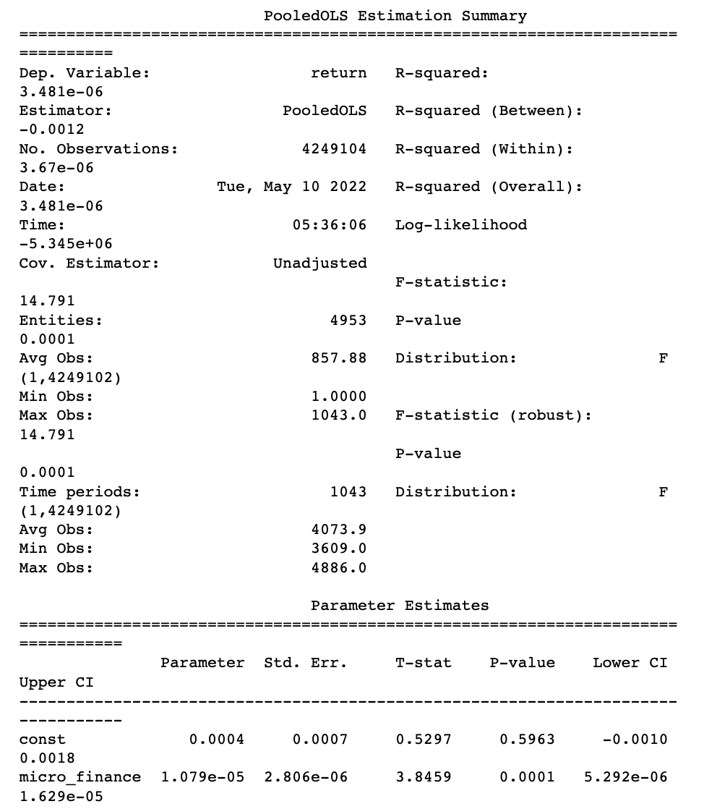

Although in the regression analysis, more than half of search fields show significant relationship with stock return. However,no matter if it is significant or not, the coefficient is nearly zero, supported by bad performance of R-Square. Such regression analysis does not present a clear relationship between variables.

2.Regression of daily stock turnover rate changes on the baidu search index of certain ESG related search fields is conducted to take a further insight into the relationship. Specifically, we make the difference between log return and then combine it with the baidu index for the correlation test. The results show that most search fields have shown a significant relationship with first-order difference of stock return.

***Figure 6: Regression result***

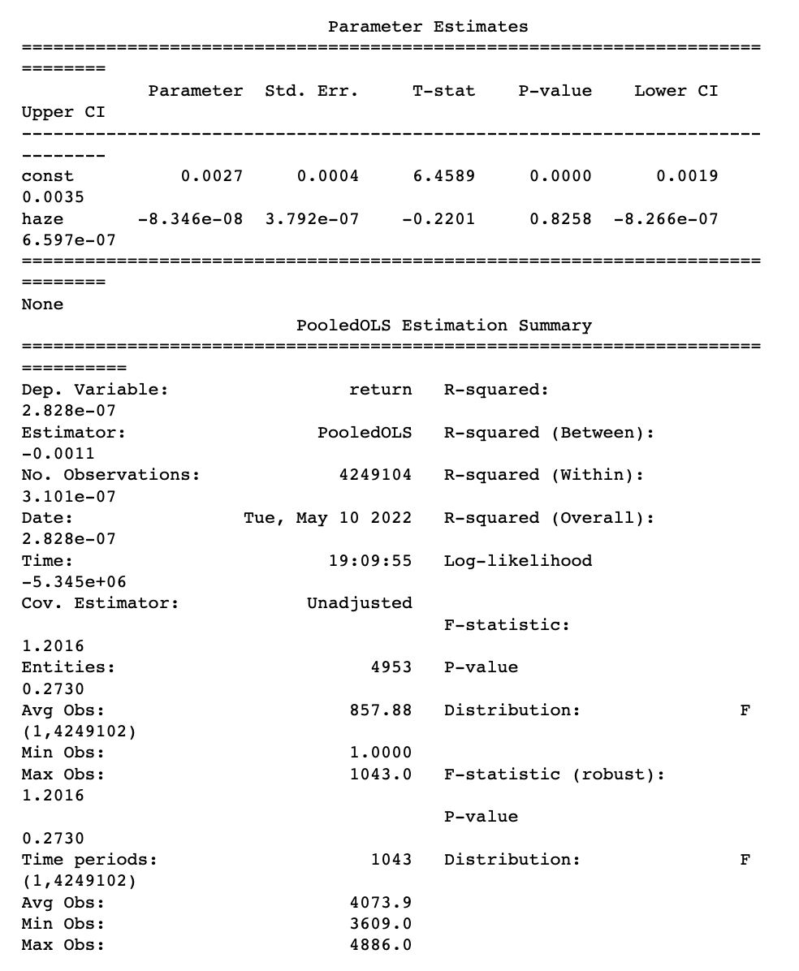

Taking ”haze” as an example,the coefficient is significantly negative, which shows negative correlation between haze focus and stock return, significantly at level of 0.001. since most results have significant regression coefficients, it is possible to estimate relatively stable correlation coefficients.

And in the term of economic significance, the negative sign conforms to intuitive, when people have more concentration on haze, which is a negative word, the image of companies in a particular industry will be affected worsley, and thus the share price will be harmed..

3.Regression of daily stock returns on the baidu search index change signal of certain ESG related search fields. In this step, we have finer analysis and procession for our stock return. Specifically,we convert stock return into a binary variable, specifically, signal is defined as 1 when stock return > 0, i.e., when the stock is rising, and signal is defined as 0 when stock returns < 0, when the stock is falling. One instance about “low carbon” is presented below:

***Figure 7: Regression result***

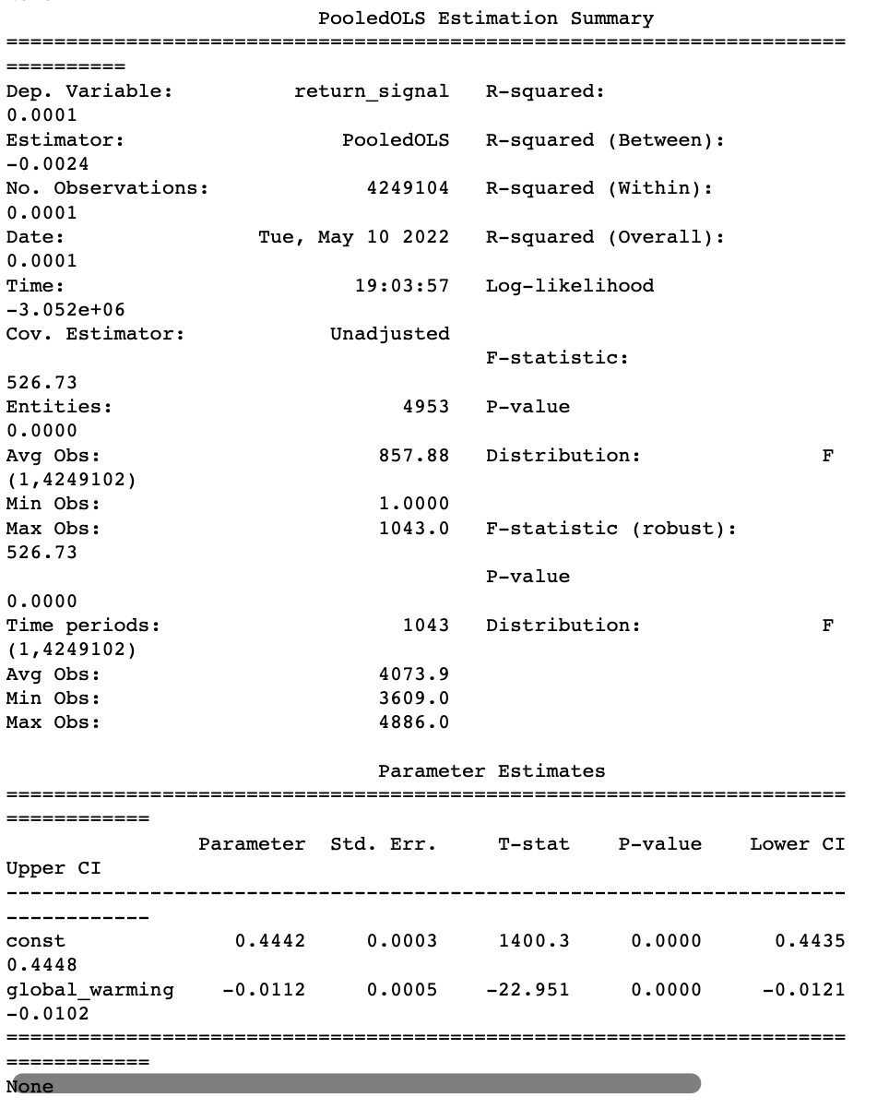

The coefficients of most search fields are significantly higher than the previous regression results. The correlation coefficient of -0.0112 shows that ceteris paribus, when search frequency for “low carbon” increases by 1 unit, the probability of increase in stock price rises by -0.0112 unit.

4. Regression of daily stock turnover rate on the baidu search index of certain ESG related search fields are conducted to take a further analysis.

***Figure 8: Regression result***

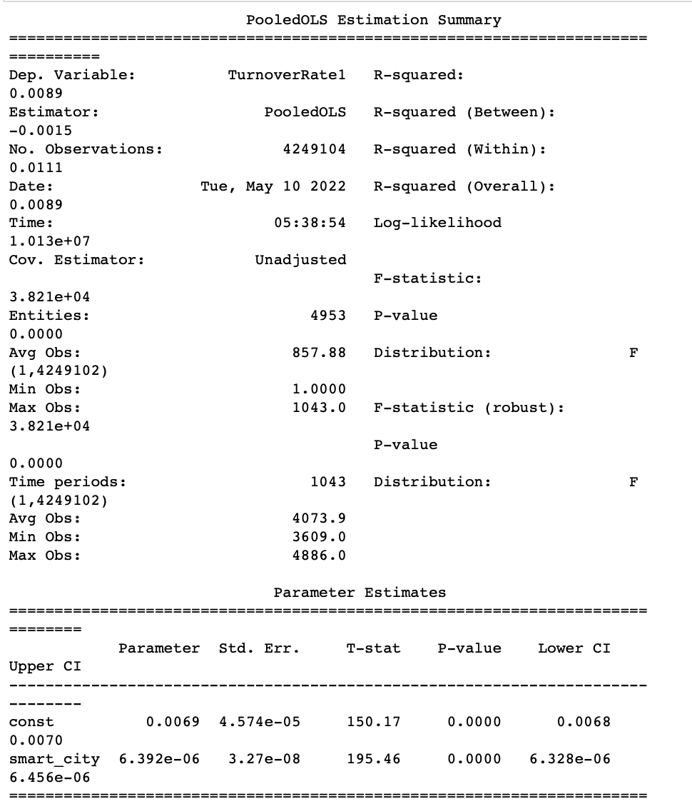

The regression result is similar to the regression analysis between stock return and baidu search fields frequency. there is significantly, however, nearly zero correlation between variables.

By comparison, the regression of stock return signals and search fields perform best among these, which seems to show that the rise or decline is more important than the precise amount of increase and decrease in.

Moreover, instead of using the whole 4930 stocks to do the panel regression, we extend our model result to different keywords in specific industries. We use the Baidu search indexes as the explanatory variables respectively and stock return in one specific industry as the explained variable to do the regression. And the p-values of the coefficient result for different keywords and industries are listed below.

***Figure 9: p-values of the regression***

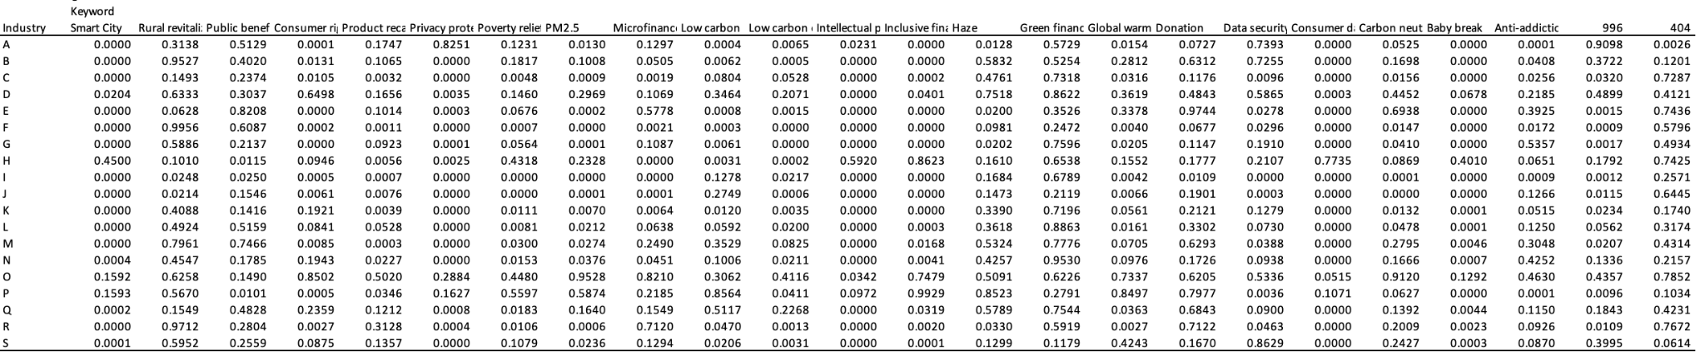

From the regression result, we find that among 456 p-values generated by the 24 keywords and 19 industries, 221 p-values are below 0.05, which means that 221 regressions have significant results.

Figure 10 shows the importance matrix of the search index for each ESG-related search term for different industries. In the figure, 1 means that the change in search index is significantly correlated with the change in stocks in that industry, and 0 means that it is not significant. And the last column (row) gives the total number of significant p-values in the industry (keyword).

***Figure 10: The importance matrix of the search index for each ESG-related search term for different industries***

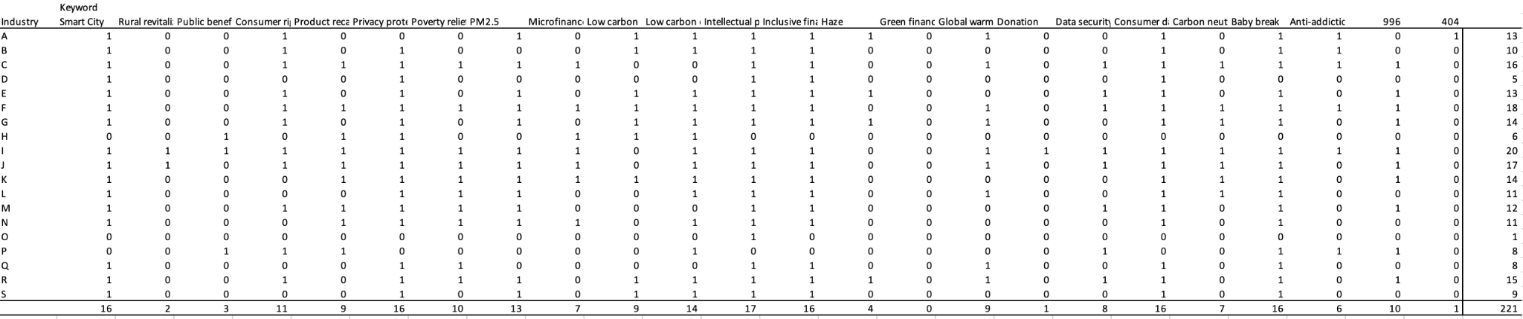

Among all the 24 keywords, “Smart City”, “Privacy protection”, “Intellectual property”, “protection(IPR)”, “Inclusive finance ”, “Consumer data”, “Baby break” have the best performance that works for over 15 industries.

1. **Strategy**

Our strategy consists of two parts. First, we use the firm-level ESG data to predict the stock returns based on the classification tree model. We obtain some rules from the classification tree model results. Then according to the panel regression part results, we use the baidu search index of ESG relevant keywords as another indicator to guide our trading strategy.

In the first part, we divided the stocks into two categories according to its yearly rate of return. And then we respectively use the E, S, and G firm-level data in the last year to fit the classification tree. We choose the classification tree with a two-level dependent variable instead of the regression tree or the classification tree with more levels to avoid overfitting.

In the second part, we regress stock returns on the daily baidu search index of ESG relevant keywords. Also, we do it classified by industries. Using the results here, we derive signals according to some keywords index and choose the industry with better performance.

Using the 2019 year as an example to illustrate our strategy:

First, we get the fitted classification tree model of E, S and G based on 2018 firm-level ESG data. Then we integrate three rules to get the high rate of returns. The following are the confusion matrix of our prediction results.

***Figure 11: Confusion matrix***

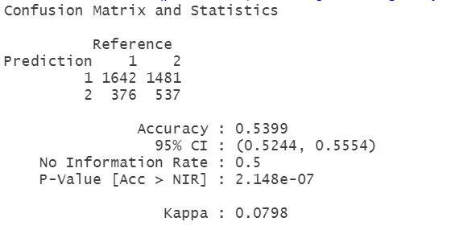

***Figure 12: Confusion matrix***

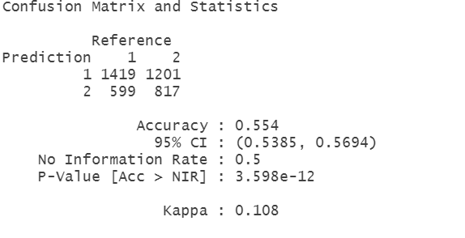

***Figure 13: Confusion matrix***

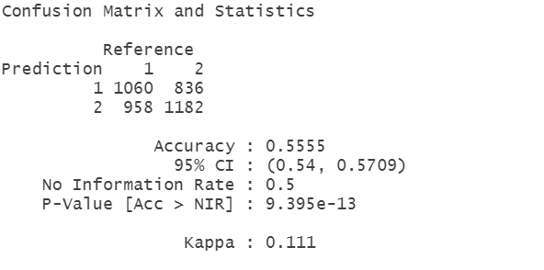

We get 111 stocks to invest using the rules above.

Then according to the statistics summary of the predictability of 26 keywords index on stock returns classified by industries. We pick 6 keywords indexes (Smart City, Privacy protection, Intellectual property protection(IPR), Inclusive finance, Consumer data, Baby break) as our signals to build the portfolios.

The performance of each keyword is as the following:

return, cost adjusted return

Smart City: -11.53%, 13.36%

Privacy protection: 7.91%,5.24%

Intellectual property protection(IPR): -14.98%,-15.90%

Inclusive finance: 4.81%, 2.21%

Consumer data: 41.65%, 38.11%

Baby break: 9.02%, 6.31%

We use the mean rate of return of the stock pool as our baseline. And the return of the baseline is 3.31%. From the result shown above, we better perform the baseline return.

1. **Conclusion and Discussion**
2. For the correlation result between the stock price and the baidu trend, we use the panel data regression. The regression results show different relationships between stock data of different industries and Baidu search indexes of different ESG domain keywords. The trend of the Baidu index for specific keywords in specific industries shows a significant correlation with stock prices.
3. Although the Baidu search index of specific keywords show significant correlation with the stock price, the coefficient and the R-squared are small, meaning that the search index cannot explain most of the price change. Thus, the model may not be a good prediction on the stock price.
4. For the ESG indicators we used to conduct portfolios, we use the classification tree to divide the stock into 2 portfolios, the one that we predict to better perform the market and the one we predict that has lower return than the market average. Our accuracy of classification beat the no information rate significantly, which means that using the indicators, we can choose the portfolio better.
5. In this strategy, machine learning does most of the work of conducting portfolios. After the data were collected, organized, and cleaned, the only work we did on the indicator was to classify the indicator for the three broad categories of environment, society, and governance, without considering the importance of the indicators in advance. And this means that the classification work is in balck box. For future work, we need to select out the material indicators manually in the guidance of literature before putting all the indicators into the decision tree.

**Reference**

Alessandrini, F., & Jondeau, E. (2020). ESG investing: From sin stocks to smart beta. *The Journal of Portfolio Management, 46*(3), 75-94.

Amel-Zadeh, A., & Serafeim, G. (2018). Why and how investors use ESG information: Evidence from a global survey. *Financial Analysts Journal*, *74*(3), 87-103.

Bauer, R., Koedijk, K., & Otten, R. (2005). International evidence on ethical mutual fund performance and investment style. *Journal of Banking and Finance, 29*(7), 1751–1767.

Bello, Z.Y. (2005). Socially responsible investing and portfolio diversification. *Journal of Financial Research*, *28*(1), 41–57.

Berg, F., Koelbel, J. F., & Rigobon, R. (2019). *Aggregate confusion: The divergence of ESG ratings* (pp. 1-42). Cambridge, MA, USA: MIT Sloan School of Management.

Cappucci, M. (2018). The ESG integration paradox. *Journal of Applied Corporate Finance, 30*(2), 22-28.

Chen, J., H. Hong, M. Huang, and J. D. Kubik. 2004. “Does Fund Size Erode Mutual Fund Performance? The Role of Liquidity and Organization.” *American Economic Review,94* (5): 1276–302.

Chong, J., & Phillips, G. M. (2016). ESG investing: A simple approach. *The Journal of Wealth Management*, *19*(2), 73-88.

Dyck, A., Lins, K. V., Roth, L., & Wagner, H. F. (2019). Do institutional investors drive corporate social responsibility? International evidence. *Journal of Financial Economics*, *131*(3), 693-714.

Fatemi, A., Glaum, M., & Kaiser, S. (2018). ESG performance and firm value: The moderating role of disclosure. *Global Finance Journal*, *38*, 45-64.

Friede, G., Busch, T., & Bassen, A. (2015). ESG and financial performance: aggregated evidence from more than 2000 empirical studies. *Journal of Sustainable Finance & Investment*, *5*(4), 210-233.

Giese, G., Ossen, A., & Bacon, S. (2016). Esg as a performance factor for smart beta indexes. *The Journal of Index Investing*, *7*(3), 7-20.

Halbritter, G., & Dorfleitner, G. (2015). The wages of social responsibility—Where are they? A critical review of ESG investing. *Review of Financial Economics*, *26*, 25-35.

Hamilton, S., Jo, H., & Statman, M. (1993). Doing well while doing good? The investment performance of socially responsible mutual funds. *Financial Analysts Journal, 49*(6), 62–66.

Ioannou, I., & Serafeim, G. (2010, August). THE IMPACT OF CORPORATE SOCIAL RESPONSIBILITY ON INVESTMENT RECOMMENDATIONS. In *Academy of Management Proceedings* (Vol. 2010, No. 1, pp. 1-6). Briarcliff Manor, NY 10510: Academy of Management.

Knox, S., & Maklan, S. (2004). Corporate social responsibility:: Moving beyond investment towards measuring outcomes. *European Management Journal*, *22*(5), 508-516.

Kreander, N., Gray, R., Power, D., & Sinclair, C. (2005). Evaluating the performance of ethical and non-ethical funds: A matched pair analysis. *Journal of Business Finance and Accounting, 32*(7/8), 1465–1493.

Krishnamachari, R. T. (2017). Big Data and AI Strategies.

Krueger, P., Sautner, Z., & Starks, L. T. (2020). The importance of climate risks for institutional investors. *The Review of Financial Studies*, *33*(3), 1067-1111.

Nagy, Z., Kassam, A., & Lee, L. E. (2016). Can ESG add alpha? An analysis of ESG tilt and momentum strategies. *The Journal of Investing*, *25*(2), 113-124.

Sauer, D. A. (1997). The impact of social-responsibility screens on investment performance: Evidence from the Domini 400 Social Index and Domini Equity Mutual Fund. *Review of Financial Economics*, *6*(2), 137-149.

Sparkes, R., & Cowton, C. J. (2004). The maturing of socially responsible investment: A review of the developing link with corporate social responsibility. *Journal of business ethics*, *52*(1), 45-57.

Statman, M. (2000). Socially responsible mutual funds. *Financial Analysts Journal, 56(*3),30–39.

Utz, S., & Wimmer, M. (2014). Are they any good at all? A financial and ethical analysis of socially responsible mutual funds. *Journal of Asset Management, 15*(1), 72–82.

Van Duuren, E., Plantinga, A., & Scholtens, B. (2016). ESG integration and the investment management process: Fundamental investing reinvented. *Journal of Business Ethics*, *138*(3), 525-533.

Siew, R. Y., Balatbat, M. C., & Carmichael, D. G. (2013). The relationship between sustainability practices and financial performance of construction companies. *Smart and Sustainable Built Environment*.

Hee Soo, L. (2020). *Exploring the Initial Impact of COVID-19 Sentiment on US Stock Market Using Big Data*. Sustainability 2020, 12, 6648; doi:10.3390/su12166648

Peter, H. (2019). *Socially Responsible Investing: Combining ESG Ratings with News Sentiment Generates Alpha.* Retrieved at: https://ssrn.com/abstract=3782432

Mozaffar, K. George, S. and Aaron, Y. (2016). *Corporate Sustainability: First Evidence on Materiality. American Accounting Association.* DOI: 10.2308/accr-51383

Jonathan, C., Hailiang, C. Ding D., Yu J. H. (2018). F*ake News, Investor Attention, and Market Reaction. Information Systems Research*. Vol. 32, No. 1, March 2021, pp. 35–52.

Gordon H, D., Nina, K. (2021). *Behavioral Portfolio Management with Layered ESG Goals and AI Estimation of Asset Returns.* Retrieved at: <https://ssrn.com/abstract=3953440>

Kim, A., Lee, S., and Shin, D. (2020). *An Analysis of the Impact of product Recall on Stock Price Based on Google Search Trend Counts*. Global Business & Finance Review (GBFR) [ISSN:] 2384-1648 [Volume:] 25 [Year:] 2020 [Issue:] 4 [Pages:] 33-50

**Appendix**

*Panel B: Frequency by Sector*

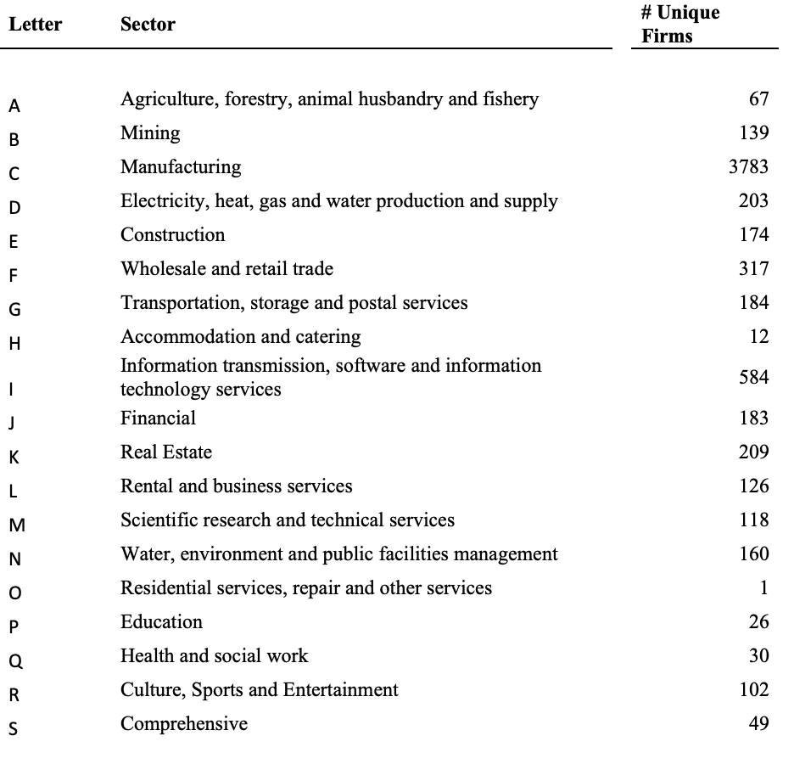

*Panel C : Chinese and English Comparison Table*

| Environment | | Social | | Governance | |
| --- | --- | --- | --- | --- | --- |
| English | Chinese | English | Chinese | English | Chinese |
| Green Finance | 绿色金融 | Microfinance | 小微金融 | Baby break | 产假 |
| Carbon Neutral | 碳中和 | Rural revitalization | 乡村振兴 | product recall | 产品召回 |
| PM2.5 | PM2.5 | Anti-addiction | 防沉迷 | 996 | 996 |
| Haze | 雾霾 | Poverty relief | 扶贫 | consumer right protection, | 消费维权 |
| Global Warming | 气候变暖 | 404 | 404 | privacy protection | 隐私保护 |
| Low Carbon | 低碳 | public benefit | 公益 | Data security | 数据安全 |
| low carbon environment-friendly | 低碳环保 | Inclusive Finance | 普惠金融 | customer data | 客户资料 |
|  |  | Donation, | 捐赠 | intellectual property protection (IPR) | 知识产权保护 |
|  |  | Smart City | 智慧城市 |  |  |

*Panel D: Explanation for indicators*

| MedNHealResInvest | The amount of medical and health resources invested in poor areas |
| --- | --- |
| EcoProInvest | Investment in ecological protection |
| ind_helpoor_ProjectNum | Number of poverty alleviation projects for industrial development |
| ind_helpoor_ProjType | Industrial development poverty alleviation projects |
| ind_helpoor_ProjectInvestAmount | Amount invested in poverty alleviation projects for industrial development |
| RearPopInvest | Investment amount of "three left-behind" personnel |
| RearPop | Number of "three left-behind" people assisted |
| PovAndDisabInvest | Poor disabled people input amount |
| HelpPovAndDisabPop | Help poor disabled people |
| TPAcoopInvest | Investment in poverty alleviation cooperation between east and West |
| FixTPAInvest | Amount invested in designated poverty alleviation work |
| TPAWelfFundInvest | The amount invested in the public welfare fund for poverty alleviation |
| isEmisskey | Whether it is a major emission company- 1: Yes, 0: No |
| GHGEmissRed | Greenhouse Gas Emission Reduction |
| CEmissRed | Carbon emission reduction |
| COEmissRed | Carbon monoxide emission reduction |
| GHGEmission | Greenhouse Gas Emissions |
| CEmission | Carbon emission |
| CO2Emission | Carbon dioxide emissions |
| COEmissRed | carbon monoxide reduction |
| tax_BeginningAmount | Beginning amount of environmental protection tax |
| tax_EndingAmount | Ending amount of environmental protection tax |
| env_Amount | Listed company environmental management fees |
| LowCarbonCreditCardnum | Cumulative issuance of low-carbon credit cards |
| TotalPurchaseVERs | Cumulative purchase of voluntary emission reductions |
| NeutralCarbonEmi | Neutral carbon emissions |
| donation_expenditure | Charitable donations |
| SupPovStudInvest | Amount invested in subsidizing poor students |
| SupPovStudPop | Number of poor students funded |
| EduResourceInvest | Amount of investment in improving educational resources in poverty-stricken areas |
| epinvest | Environmental investment |
| wastewateremiss | Wastewater discharge |
| CODemiss | [COD emissions] - 0=no description; 1=qualitative description; 2=quantitative description (currency/numerical description) (chemical oxygen demand) |
| SO2emiss | [SO2 emissions] - 0=no description; 1=qualitative description; 2=quantitative description (currency/numerical description) |
| CO2emiss | [CO2 emissions] - 0=no description; 1=qualitative description; 2=quantitative description (monetary/numerical description) (main components of greenhouse gases) |
| smokeduskemiss | [Smoke and dust emissions] - 0=no description; 1=qualitative description; 2=quantitative description (currency/numerical description) |
| indsolwastepro | [Industrial Solid Waste Generation] - 0=no description; 1=qualitative description; 2=quantitative description (currency/numerical description) |
| EPtConcept | Environmental Protection Concept] - Disclose the company's environmental protection concept, environmental policy, environmental management organizational structure, circular economy development model, green development, etc. The value is 1, otherwise it is 0 |
| EPGoal | [Environmental protection goals] - Disclose the company's past environmental protection goals and future environmental protection goals, and assign a value of 1, otherwise it will be 0 |
| EPManSysSchema | [Environmental management system system] - Disclose a series of management systems such as the relevant environmental management system, system, regulations, responsibilities, etc. formulated by the company, and the value is 1, otherwise it is 0 |
| EPEduTrain | [Environmental protection education and training] - Disclose the environmental protection-related education and training that the company participated in, and assign a value of 1, otherwise it is 0 |
| EPSpecialAct | [Environmental protection special action] - Disclose the environmental protection special activities, environmental protection and other social welfare activities that the company participated in, and assign a value of 1, otherwise it is 0 |
| EnvEventEmergMech | [Environmental incident emergency mechanism] - Disclose the company's establishment of an emergency response mechanism for major environmental-related emergencies, the emergency measures taken, the treatment of pollutants, etc., and the value is 1, otherwise it is 0 |
| EPHonorReward | [Environmental protection honors or awards] - Disclose the honors or awards the company has received in environmental protection, with a value of 1, otherwise 0 |
| ThreeSimultaneity | ["Three Simultaneous" System] - Disclose the company's implementation of the "Three Simultaneous" system, the value is 1, otherwise it is 0 |
| WasteGasEmissRed | [Exhaust gas emission reduction treatment] - 0=no description; 1=qualitative description; 2=quantitative description (currency/numerical description) |
| WasteWaterEmissRed | [Wastewater Emission Reduction Treatment] - 0=no description; 1=qualitative description; 2=quantitative description (currency/numerical description) |
| SootDustRed | [Dust and soot control] - 0=no description; 1=qualitative description; 2=quantitative description (currency/numerical description) |
| SolidWasteDispUtil | [Solid waste utilization and disposal] - 0=no description; 1=qualitative description; 2=quantitative description (currency/numerical description) |
| NoiseLightRadGovern | [Noise, light pollution, radiation, etc. governance] - 0=no description; 1=qualitative description; 2=quantitative description (currency/numerical description) |
| ClearProdImplement | [Cleaner production implementation] - 0=no description; 1=qualitative description; 2=quantitative description |
| KeyPollMonUnit | [Key pollution monitoring unit] - If the company disclosed in the report is a key monitoring unit, the value is 1, otherwise it is 0 |
| PollEmissStandard | [Pollutant discharge compliance] - The value is 1 if the pollutant discharge reaches the standard, otherwise it is 0 |
| SuddenEnvAccident | [Sudden Environmental Accident] - If there is a sudden major environmental pollution incident, the value is 1, otherwise it is 0 |
| EnvViolation | [Environmental violation event] - If there is an environmental violation event, the value is 1, otherwise it is 0 |
| EnvPetLetterCase | [Environmental petition case] - If there is an environmental petition incident, the value is 1, otherwise it is 0 |
| IsPassISO14001 | [Whether it has passed ISO14001 certification] - passed the ISO14001 audit, the value is 1, otherwise it is 0 |
| IsPassISO9001 | [Whether it has passed ISO9001 certification] - passed the ISO9001 audit, the value is 1, otherwise it is 0 |
| RearPopInvest | Amount invested by "three left-behind" personnel |
| RearPop | Number of "three left-behind" people helped |
| PovAndDisabInvest | Amount invested by poor disabled people |
| HelpPovAndDisabPop | Help the poor and disabled |
| TPAcoopInvest | Amount of investment in poverty alleviation cooperation between east and west |
| FixTPAInvest | Amount invested in fixed-point poverty alleviation work |
| TPAWelfFundInvest | Poverty Alleviation Public Welfare Fund Investment Amount |
| criticism | Violation penalty - number of critism |
| warning | Violation penalty - number of warning |
| denounce | Violation penalty - number of denounce |
| fine | Violation penalty - number of fine |
| confiscation | Violation penalty - number of confiscation of illegal gains |
| cancel | Violation penalty - number of cancellation of business license |
| ban | Violation penalty - number of market ban |
| penalty_others | Number of other violation penalty |
| employee number | employee number |
| ChairmanHoldsharesRatio | Chairman Hold shares Ratio |
| ManagerHoldsharesRatio | Manager Hold shares Ratio |
| income_per_employee | income per employee |
| HelpPoor_TotalAmount | The combination of funds and goods |
| HelpPoor_Fund | fund |
| HelpPoor_MaterialDepreciation | maretial depreciation |
| HelpPoor_ShakeOffPovPop | Is there a follow-up poverty alleviation plan, 1=T;2=F |
| HelpPoor_IsTPAPlan | Is there a follow-up poverty alleviation plan |
| Violation_Others | Others |
| Violation_MajorOmission | Major Omission |
| Violation_DelayDisclosure | Delay Disclosure |
| Violation_Misrepresentation | Misrepresentation |
| Violation_Illegalstocktrading | Illegal stock trading |
| Violation_Falsestatement | False statement |
| Violation_contributive | contributive |
| Violation_Insidertrading | Insidertrading |
| Violation_accountingmishanding | accountingmishanding |
| Violation_Fictitiousprofits | Fictitious profits |
| Violation_illegalguarantee | illegal guarantee |
| Violation_Occupationofcompanyassets | Occupation of company assets |
| Violation_Inflatedassets | Inflated assets |
| Violation_Changetheuseoffundswithoutauthorization | Change the use of funds without authorization |
| Violation_Stockpricemanipulation | Stock price manipulation |
| Violation_Fraudlisted | Fraud listed |
| Numberofstate-ownedshares | Number of state-owned shares |
| Numberoflegalsharesofdomesticsponsors | Number of legal shares of domestic sponsors |
| Numberoflegalsharesofoverseaspromoters | Number of legal shares of overseas promoters |
| Numberofsharesraisedbylegalpersons | Number of shares raised by legal persons |
| Numberofinternalworkershares | Number of internal worker shares |
| Numberofsharesheldbysupervisors | Number of shares held by supervisors |
| Productionpersonnel | Production personnel |
| salesperson | sales personnel |
| techperson | tech personnel |
| financalperson | financial personnel |
| admperson | Administrative personnel |
| Logisticsotherperson | Logistics and other personnel |
| transpperson | transportation personnel |
| femaleemp | female employees |
| maleemp | male employees |