**DT282Software for the Global Market II Submission**

**Semester 2 2015/2016**

**Céin O’Rourke**

**C14427818**

Table of Contents

1. General Project Information 1

2. Group Work 1

3. Hi-Fidelity Prototype(s) Developed 2

3.1 Groups Considered 2

3.2 Internationalization and Localization 3

# General Project Information

**Group 1 (**4 Members**)**

Amandeep Singh – C14712039

Mark Keogh – C14404708

Céin O’Rourke – C14427818

Alexander Witte – C14546397

Submission link - <https://docs.google.com/a/mydit.ie/document/d/1PEcH54qZakAO8UHzHxGgxsHf4uKp6FkqFkHOLThEb9Y/edit?usp=sharing>

N.B. You must be logged into a DIT account to view this.

# 2. Group Work [only required if working as a group – individual submissions can ignore this section]

In my opinion, because we divided the work equally between us, taking into account our individual skills and experience, everyone managed to contribute equally to the group work.

Introduction - Alex

Get plan for the interviews – Aman

Elicitation – Céin

Design guidelines – Mark

Low fidelities - Everyone

Personas – Aman

Interviews & observations - Everyone

Conclusion – Alex

# 3. Hi-Fidelity Prototype(s) Developed

## 3.1 Groups Considered

## As I said in the elicitation we did our research and gathered our information and this is the design I came up with that takes into the account the idea that the user is one click away as you can see everything is simply laid out and the user can click into exactly what they want.

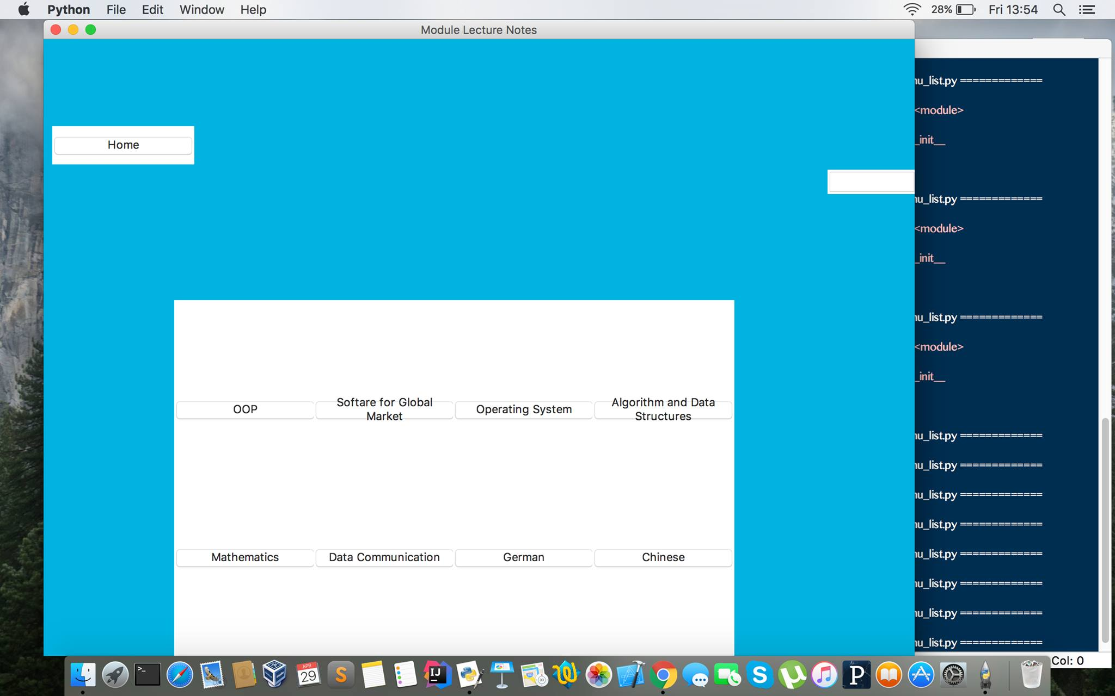

## 3.2 Internationalization and Localization

## Localisation refers to the adaptation of a product or application to meet the cultural and language requirements of a specific country, geographic location or ethnic group.

## I did try to add this in to my page and tried to get it to work multiple times and it just would not run so I left it out of my end product apologies one of out team members got it working so atleast there that.