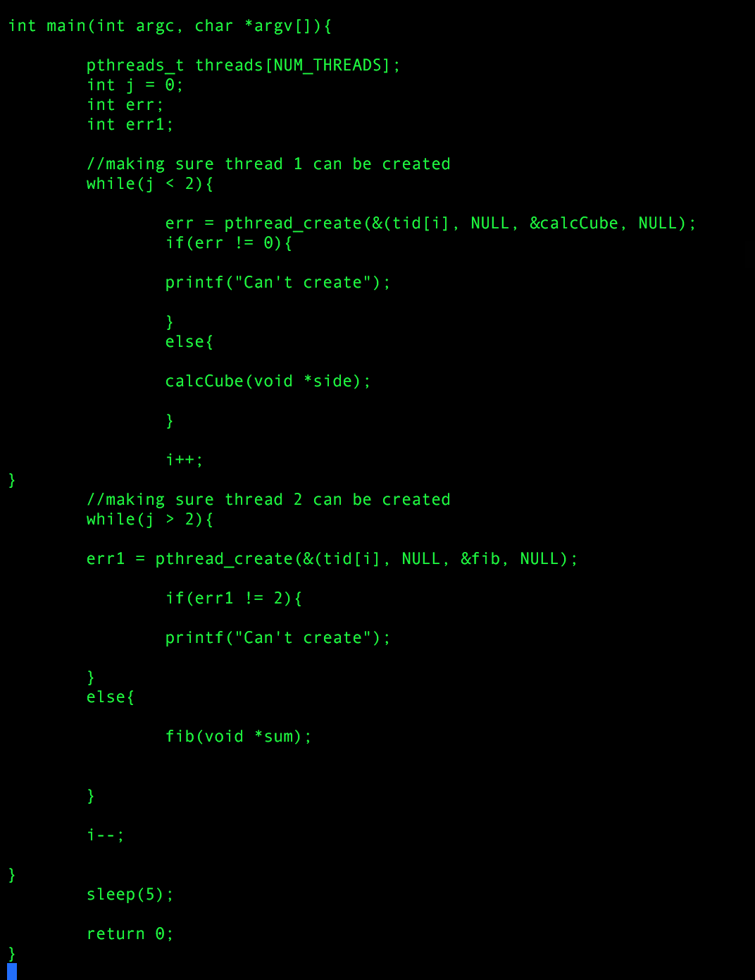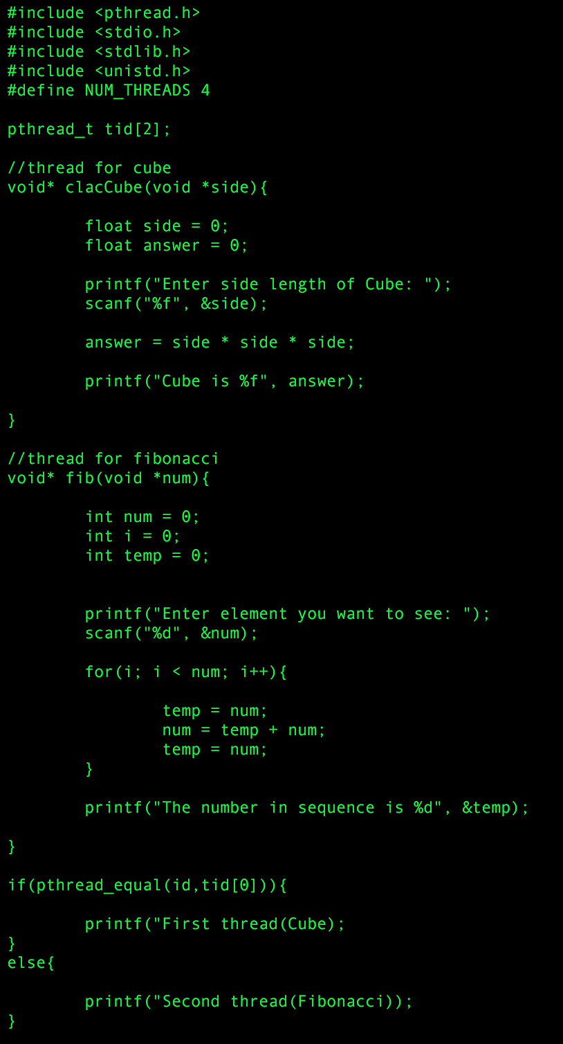

The ouput should go into each thread and execute when the user inputs the numbers they wish to see.