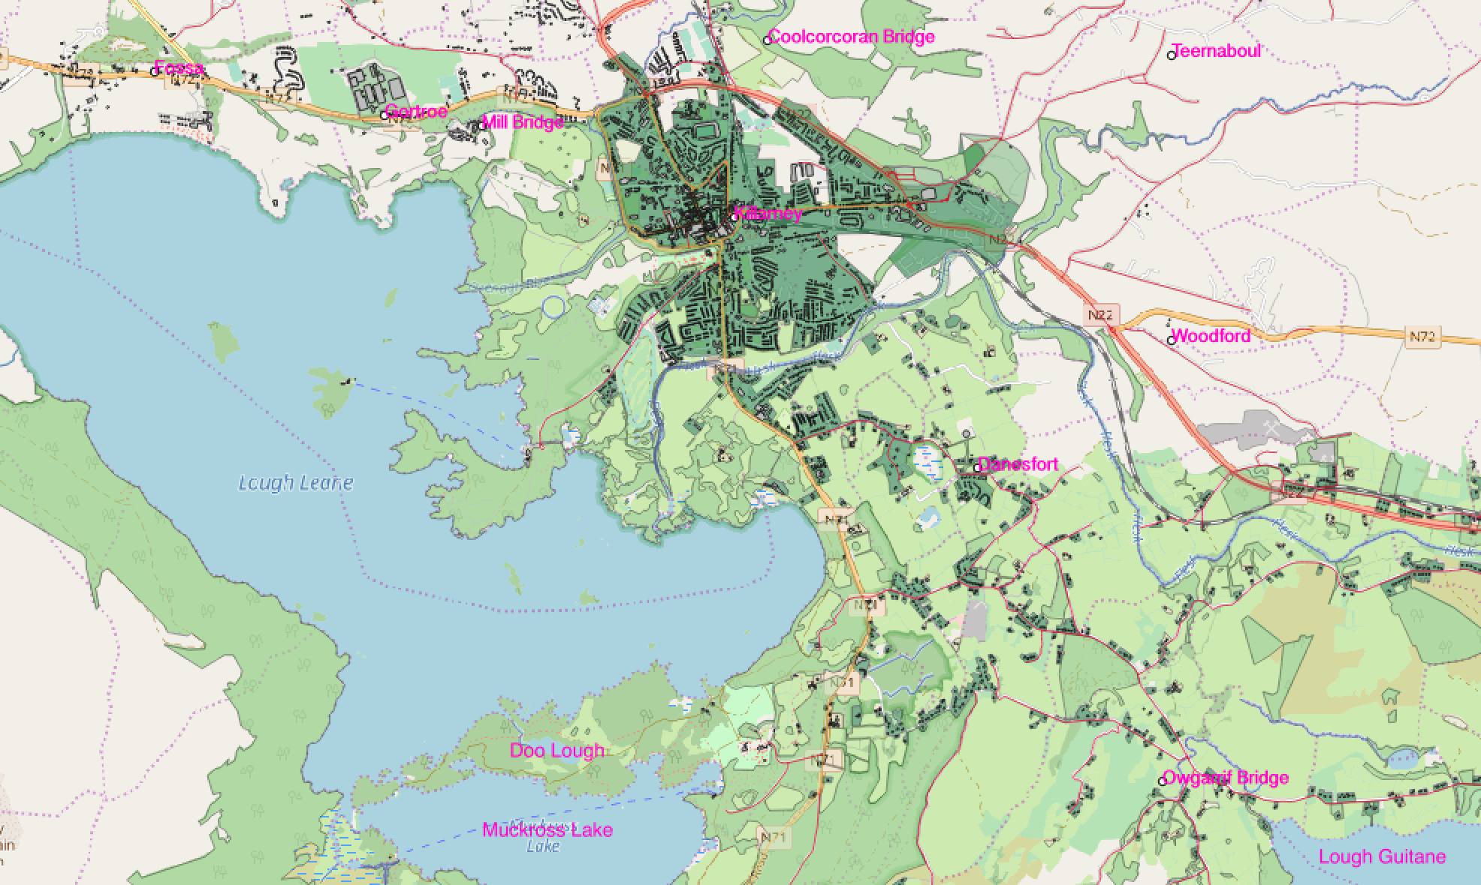**Killarney**

**Legend**

**Water**

**Primary Roads**

**Secondary Roads**

**Places**

**Residential**

**Farmland**

**Forest**

**Author:** Céin O’Rourke

**Date:** 8/3/2018

**CRS:** TM65/Irish Grid

**1:60,000**